 City University

ASSIGNMENT

ON

FUTURE OF PROCESSOR

COURSE TITLE : COMPUTER ARCHITECTURE

COURSE CODE : 413

SUBMITTED TO:

ATAUS SAMAD

LECTURER

DEPARMENT OF CSE

CITY UNIVERSITY

**SUBMITED BY:**

ZULKAR NINE

ID: 163432601

BATCH: 43

SUBMITTED DATE: 25-06-2019

Introduction:

A processor or Central Processing Unit (CPU) is an electronic circuit that can execute computer programs.

The tech world is arguably the most competitive it has ever been. Computers are always getting better, faster and more powerful. This is thanks to tech companies constantly working to bring out the next best thing. The heart of a computer is its processor and some may argue that the processor makes the device. With that said, where can we see the future of processors heading? The future is definitely bigger and brighter, with exciting and powerful computers on the horizon. Processors are constantly evolving and growing in terms of speed and power.

Processors come in many types and with many intended uses. While much attention is focused on high performance processors in servers and workstations, by actual count they are a small percentage of processors produced in any year.

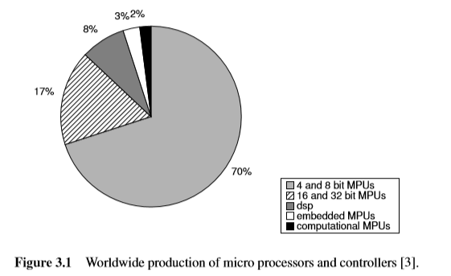

**What is Processor:**

A processor is the logic circuitry that responds to and processes the basic instructions that drive a computer. The four primary functions of a processor are fetch, decode, execute and write back.

Basic Concepts in Processor Architecture:

The processor architecture consists of the instruction set of the processor. While the instruction set implies many implementation (microarchitecture) details, the resulting implementation is a great deal more than the instruction set. It is the synthesis of the physical device limitations with area-time-power tradeoffs to optimize speciﬁed user requirements.

The arithmetic logic unit (ALU), which carries out arithmetic and logic operations on the operands in instructions.

The floating point unit (FPU), also known as a math coprocessor or numeric coprocessor, a specialized coprocessor that manipulates numbers more quickly than the basic microprocessor circuitry can.

Registers, which hold instructions and other data. Registers supply operands to the ALU and store the results of operations.

L1 and L2 cache memory. Their inclusion in the CPU saves time compared to having to get data from random access memory (RAM).

Working of processor:

The working of processor mainly consist four steps i.e. Fetch, Decode, Execute and Write back.

•Fetch: During the fetch step, the processor retrieves program instructions from memory.

•Decode: In this step, the instruction is broken down into parts.

•Execute: In the execute step, CPU performs the operation implied by the program instructions.

•Write back: During the write back step, the Processor writes back the results of execution, to the computer's memory.

[**Processor Generation**](https://www.assignmentpoint.com/science/computer/assignment-on-generation-of-computer-processor.html)**:**

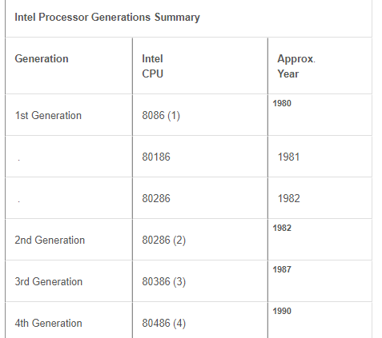

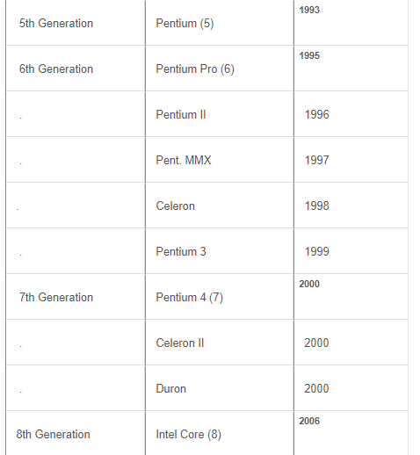

**Processor Features:**

Looking at the best processors of 2018-2019 there are some great options from both Intel and AMD. Intel’s Skylake -X range of processors offers insane core counts. One of their most basic in the line is the Core i9-7900X, which has a phenomenal 10 cores. The power continues to grow, however, with their most powerful processor to date, the Core i9-7980XE. This mighty processor features an unbelievable 18 cores. The release of this processor last year completely blew away any competition from AMD.AMD did put up a good fight though. They released their Ryzen Threadripper range, which comes with a great deal of power too. The line features 8, 12 and 16-core processors, respectively. While there have been incredibly powerful releases from both Intel and AMD, these come at a price. Processors with over 8 cores cost a small fortune and are not practical for mainstream computer users. These processors are definitely targeted at a small cross-section of the computer market.

What is single, double and multi core processors?

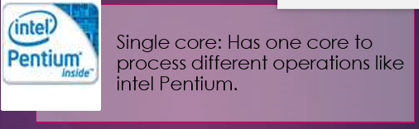

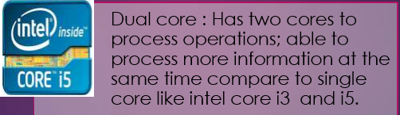

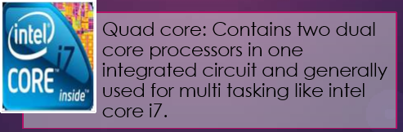

What are the future expectations about processor ?

* Tomorrow, processor will be more energy efficient than present time.
* They have high clock speed like 10 to 15 GHz and have 8 to 10 cores with hyper threading or new equivalent technology.
* Their size will be more small than today’s processors i.e. nano processor will come in place of micro processor.
* They will be more cheaper and reliable than compare to present time.

**In the first of a series of "2020 Vision":**

I have come to the conclusion that too many of us have no clue where we are going with technology. Rather, we are just busily moving forward and don't know if we are even moving in the right direction. It would seem that with our extensive experience in traveling we would understand a basic concept " to travel to a distant place requires two points:

Where I am

Where I want to end up at

The same goes for technology "we need to know where we are going to move in the right direction. So, I have challenged several of our senior technologists to think about what the state of the art will be in the year 2020. You might say that we need to have 20/20 vision for the year 2020. I have invited a number of technologists to provide their point of view (POV) of what the state of the art in IC technology will be in the year 2020, and I'm interested to hear what you have to say on the topic. But, since this is my blog, I will have the first and last word on what the year 2020 will hold for us.

So, here are my first thoughts on the topic.

Processing elements will be single clock domains. After many years of assuming that Moore's law would give us faster and faster clock speeds, we have finally concluded that clock speed is no longer our friend. In fact, we should have noted that 15 years ago, but as we move forward, processing elements will be of the size that the CPU can communicate with all of its resources in one clock cycle.

Systems will be made up of multiple processing elements. Integrated systems will be made up of many heterogeneous processing elements, each being a "single clock domain" processor.

The processing elements will be arranged in a similar style as FPGAs today.

We will take advantage of the third dimension. Integration using stacked die techniques (SIP) will be just as common as fully integrated SoC.

All will be programmed with a high-level language. The development environment will have the ability to take into account all of the resources in the system. That is the microprocessors, DSPs, accelerators, peripherals, analog signal processors, analog peripherals, RF and other things I have forgotten about.

IC designs will consist of smaller teams (5 to 10 designers) taking a shorter amount of time (6 to 12 months) to do the hardware design. Reuse will be the norm. While I am at it, let me explain that there are two definitions of "Reuse":

1. I'll do such a good job on my design that everyone after me will use it.

2. I don't have time to reinvent the wheel, so I need to find something that is close enough to what I need to meet the schedule.

Unfortunately we use the first definition more than the second. Small design teams with short schedules will require us to use the latter definition. And, yes, there are companies already adopting this concept of reuse.

The bulk of the innovation will be in the software on top of the hardware.

Hardware will become part of the platform on which innovative designers will develop their ideas.

So, this is a sketch of how I see 2020. After a couple of POV papers from others at TI, I will come back with a conclusion. My colleagues will dive into topics such as programmability, tools and SoCs in the next few blogs. If you would like to share your view of 2020 with me, please comment or send me a private note.

Conclusion:

Multi-core processors represent an important new trend in computer architecture. Decreased power consumption and heat generation also helpful. Minimized wire lengths and interconnect latencies. So this is the way how modern computing is done.

With such powerful processors already available on the market and in production, it raises the question of where Intel and AMD can go next. The future of processors will see a continued increase in size and power. A feature that will only be met by a continued growth in the number of cores within the processor. With that said, there are arguably more revolutionary changes on the horizon for processors. With Intel’s focus on changing their approach for the future, we could see a totally different kind of processor soon. Depending on how long it takes to develop processors like Tangle Lake and Loihi, the market may soon be full of unrecognizable CPUs. As with most things in the tech world, with high power comes a high price. There is a continuing growth and variety of processor powers and speeds, but for a high cost. High power and multi-core CPUs are definitely not marketed to the mainstream user yet. This may not be the case for long though, as more powerful multicore processors will become the prerequisite in personal laptops. The future of processors really will mean more power for everyone.

We predict that, when it comes to their processors, 2020 will bring upgrades in power to all kinds of computers and mobile devices.