**Itroduction :**

In computing, a **server** is a [computer program](https://en.wikipedia.org/wiki/Computer_program) or a [device](https://en.wikipedia.org/wiki/Computer) that provides functionality for other programs or devices, called "[clients](https://en.wikipedia.org/wiki/Client_(computing))". This [architecture](https://en.wikipedia.org/wiki/Systems_architecture) is called the [client–server model](https://en.wikipedia.org/wiki/Client%E2%80%93server_model), and a single overall computation is distributed across multiple processes or devices. Servers can provide various functionalities, often called "services", such as sharing data or [resources](https://en.wikipedia.org/wiki/System_resource) among multiple clients, or performing computation for a client. A single server can serve multiple clients, and a single client can use multiple servers. A client process may run on the same device or may connect over a network to a server on a different device

**Types of Server :**

1. Database Server

2. File Server

3. Mail Server

4. Print Server

5. Web Server

6. Game Server

7. Application Server

**Organization Based Server :**

1. Small Organization Server

2. Medium Organization Server

3. Large Organization Server

**Small Organization Server :**

# Momentum Server E5 2620 (Enterprise)

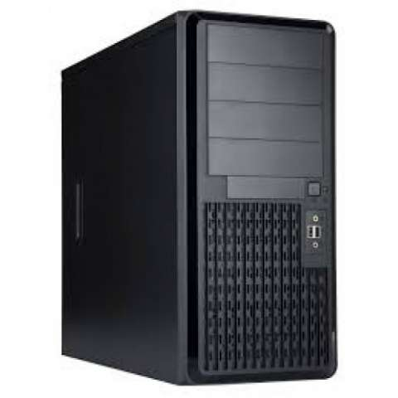

|  |  |
| --- | --- |
| **Brand** | Momentum Server |
| **Model** | Server E5-2620 (Enterprise) |
| **Processor** | 1x Intel Xeon E5 2620v4 Processor (8CORE) |
| **RAM** | 1x16GB DDR4 ECC 2133Bus Server Memory [Max Support 256GB] |
| **Storage** | 2x1TB SSD SATA [Max Support 10 SATA Port |
| **Main Board** | EP2C612D16C-4L Server Board with Intel C612 chipset |
| **ODD** | SATA DVD RW |
| **Casing** | N-WIN PV689/ PL052 Padestal Server Chassis |
| **Clock Speed** | [2.1GHz, 20MB Intel Smart L3 Cache, 8Core/16 Thread, QPI 8GT/s, LGA-2011 Socket, 14nm, 85w TDP] |
| **PSU** | with 550watt real rated Server Grade PSU |
| **Cost** | 190,000 Taka |

**Medium Organization Server :**

**Momentum Workstation**

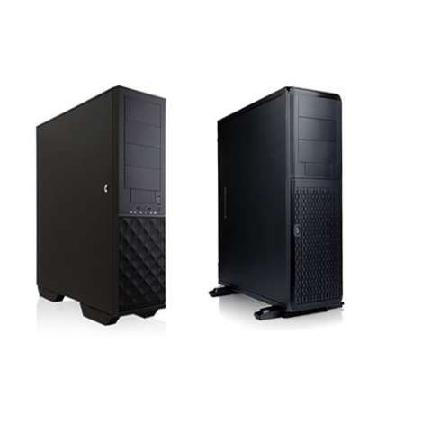

|  |  |
| --- | --- |
| **Brand** | Momentum Workstation |
| **Model** | Momentum Workstation E5-2630 |
| **Processor** | 2xIntel Xeon E5 2630v4 Processor (10CORE) |
| **RAM** | 2x16GB DDR4 ECC 2133BUS Server Memory [Max Support 256GB] |
| **Storage** | 500GB X1 SSD& 2x2TB SATA[Max Support 10 SATA Port] |
| **Main Board** | EP2C612WS Workstation Board with Intel C612 chipset |
| **Graphics** | Quadro M4000 8GB DDR5 256bit 1,664 CUDA coresNvidia Chipset |
| **Lan** | Integrated 2xGigabit LAN, RAID Support-0,1,5,10 |
| **ODD** | SATA DVD RW |
| **PSU** | 2X800watt real rated Redundant Server Grade |
| **Clock Speed** | [2.2GHz, 25MB Intel Smart L3 Cache, 10Core/20Thread, QPI 8.GT/s, Intel TB,LGA-2011 Socket, 14nm, 85w TDP] |
| **Casing** | In Win PV689/PL052Server chassis |
| **Cost** | 380,000 Taka |

**Large Organization Server :**

[R281-G30 (rev. 400)](https://www.gigabyte.com/Rack-Server/R281-G30-rev-400)

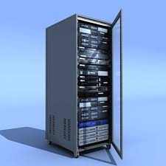

|  |  |
| --- | --- |
| Dimensions (WxHxD, mm) | 2U 438 x 87.5 x 730 |
| Motherboard | MR91-FS0 |
| CPU | 2nd Generation Intel® Xeon® Scalable and Intel® Xeon® Scalable Processors Intel® Xeon® Platinum Processor, Intel® Xeon® Gold Processor, Intel® Xeon® Silver Processor and Intel® Xeon® Bronze Processor CPU TDP up to 205W |
| Socket | 2 x LGA 3647 Socket P |
| Chopset | Intel® C621 Express Chipset |
| Memory | 24 x DIMM slots DDR4 memory supported only 6-channel memory architecture RDIMM modules up to 64GB supported LRDIMM modules up to 128GB supported Supports Intel® Optane™ DC Persistent Memory (DCPMM) 1.2V modules: 2933( 1DPC)/2666/2400/2133 MHz  Maximum verified DCPMM configuration:  * Ambient temperature 35°C * 2nd Generation Intel® Xeon® Scalable processor 205W (Max.) * DCPMM 256GB x12 pcs  DCPMM installation locations: DIMM_P0_( A1, B1, C1) DIMM_P0_( D1, E1, F1) DIMM_P1_( G1, H1, I1) DIMM_P1_( J1, K1, L1)  NOTE:  1. 2933MHz for 2nd Generation Intel® Xeon® Scalable Processors only 2. Intel® Optane™ DC Persistent Memory for 2nd Generation Intel® Xeon® Scalable Processors only 3. The maximum number of DCPMM that can be installed is based on a maximum operating (ambient) temperature of 35°C 4. To enquire about installing a greater number of DCPMM, please consult with your GIGABYTE technical or sales representative |
| LAN | 2 x 1Gb/s LAN ports (Intel® I350-AM2) 1 x 10/100/1000 management LAN |
| Video | Integrated in Aspeed® AST2500 2D Video Graphic Adapter with PCIe bus interface 1920x1200@60Hz 32bpp, DDR4 SDRAM |
| Audio |  |
| Storage | 24 x 2.5" SATA/SAS hot-swappable HDD/SSD bays LSI SAS35x36 expander Bandwidth: SATAIII 6Gb/s or SAS 12Gb/s per port Default configuration supports: 0 x SAS/SATA drives |
| SATA | 1 x 7-pin SATA III 6Gb/s with SATA DOM supported By using pin_8 or external cable for power function |
| Power Supply | 2 x 2000W redundant PSUs 80 PLUS Platinum  AC Input: - 100-127V~/ 12.5A, 50-60Hz - 200-240V~/ 12.5A, 50-60Hz  DC Output: - Max 1008W/ 100-127V~ +12V/ 84A +12Vsb/ 2A - Max 2004W/ 200-240V +12V/ 167A +12Vsb/ 2A |

Reference :

1. Intorduction

<https://en.wikipedia.org/wiki/Server_(computing)>

1. Small & Medium Organization server

<https://www.village-bd.com/momentum-server-e5-2620-enterprise>

1. Large Organization server

https://www.gigabyte.com/Rack-Server