Different kind of Sensors and work operation

SMOKE SENSOR:

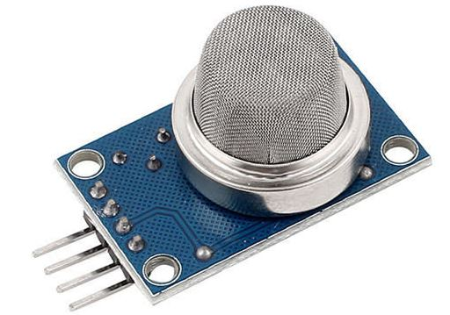

This type of sensor detects the smoke or any types of Gas present in the atmosphere (depends on the type of sensor) and usually they indicate the smoke / gas presence by means of change in output voltage. This type of sensor uses Optical test or Ionization to detect the gas presence in atmosphere. In Optical testing the sensor uses Infrared beam to monitor the atmosphere and when smoke enters the sensor IR beam gets scattered. The scattered IR beam alerts the sensor module and gives corresponding output. In Ionization method chemicals are used inside the sensor that tend to react with smoke and other gases. Successful chemical reaction indicates the presence of Smoke and therefore alerting the user by giving corresponding output.

**Commonly used:** MQ-5

## LASER SENSOR:

## 

These are sensors that uses Laser in order to perform the intended purpose. Usually Laser sensors are used in Distance measurement, detecting obstacle, inspecting surface of products and so. This Laser sensor comprises of a Laser source which emits the beam and a receiver to detect the incident beam. The receiver can be placed either in the direction of beam or returning path of beam after reflection of the beam. This type of sensors are also used as proximity sensors to detect the distance between the source and obstacles.

**Commonly used:** KY-008

## ULTRASONIC SENSOR:

## 

This sensor uses Ultrasonic waves as a medium to detect the distance or range. This sensor consists of a Ultrasonic wave transmitter which generates the wave. The transmitted wave bounces back by any medium or obstacle and returns to the sensor where it will be sensed by receiver. Now the distance between the sensor and obstacle is calculated based on the time it for the wave between transmission and reception. The further the obstacle is the longer the time delay between transmission and reception.

**Commonly used:** HC-SR04

## VIBRATION SENSOR:

## 

These sensor modules are extremely handy in detecting vibrations in machines, surfaces etc. This sensor pretty much works like a switch. When there is no vibration sensed it act’s like a open switch whereas when vibration is sensed it acts like a closed switch. This opening and closing of switch feeds output to an MCU or comparator to make the detecting more meaningful.

**Commonly used:** SW420 and SW801

## SOUND SENSOR:

## 

## Popularly known as Microphone, this sensor converts sound to electrical signals. In a Microphone when the sound waves hit the diaphragm it vibrates based on the energy of the sound wave. This movement makes the coil attached to diaphragm to move back and forth as well. This coil was fixed around a permanent magnet so when the coil moves it produces electrical signal proportional to the sound energy input. This sound energy is later amplified and used.

## CURRENT SENSOR:

## 

This sensor measures the flow of current in your circuit. This type of sensors are extremely useful in power and monitoring applications. This sensor works on the principle of Hall effect similar to the one we saw above. When current flows through the terminals it develops a magnetic field proportional to the flow of current. This magnetic field is translated to electrical signal which can be calibrated to figure out the current flowing through the terminals. There are also Current sensor which doesn’t require physical connections across the terminals to measure the current flow.

**Commonly used:** ACS712, TA12-100

## HEART BEAT SENSOR:

## 

They sense the heart beat in a human body. We all knew heart pumps blood with each and every beat of heart. This blood flow can be sensed via arteries that lies close to the skin (in the fingers and in the ears. This sensor transmits light to the these spots looking for change in volume of blood flowing through arteries. When the blood volume in the arteries changes, it alters the light intensity as well. This light intensity is measured by a receiver and based on the number of times the change in intensity occurs determines the number of beats in a minute.

**Commonly used:** AD8232, KY-039

## ACCELEROMETER:

## 

## These are the ones which can be used to measure acceleration in other words rate of change of velocity. These sensors can also sense gravitational pull because of the force it exerts on all the things on earth. Therefore it is used in acceleration, Orientation and vibration sensing applications. This sensor usually measures acceleration by means of capacitance between plates that’s internally set up. Here some plates are fixed while other plates were set up in a way it moves when forces act on it. When the plates move it affects the capacitance value and therefore changing the output reading. There are sensors which use piezoelectric crystals which generates voltage when forces act on it.

## **Commonly used:** ADXL335

### IR SENSOR

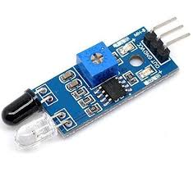

## The small phototchips having a photocell which are used to emit and detect the infrared light are called as IR sensors. IR sensors are generally used for designing remote control technology. IR sensors can be used for detecting obstacles of robotic vehicle and thus control the direction of the robotic vehicle. There are different types of sensors which can be used for detecting infrared lights.

### TOUCH SENSOR

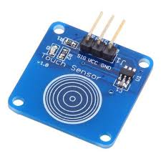

## Touch sensors can be defined as switches that are activated by the touch. There are different types of touch sensors that are classified based on type of touch such as capacitance touch switch, resistance touch switch, and piezo touch switch.

## **PRESSURE SENSOR**

## 

## A pressure sensor senses the pressure applied ie, force per unit area, and it converts into electrical signal. It has a high importance in weather forecasting. There are various Pressure sensors available in the market for many purposes. For example, if there is any water leaks in the residential or commercial areas, a pressure sensor is need to be installed to check if there is any leaks and measures the pressure. Another eg, all the smartphones, wearables have these barometric pressure sensor integrated into them.

## **PROXIMITY SENSOR**

## 

## A proximity sensor is a sensor able to detect the presence of nearby objects without any physical contact. A proximity sensor often emits an electromagnetic field or a beam of electromagnetic radiation and looks for changes in the field or return signal. Most common application of this sensor is used in cars. While you are taking the reverse, it detects the objects or obstacles and you will be alarmed. Also, it is used in retails, museums, parking in airports, malls, etc. Inductive, Capacitive, Photoelectric, and Ultrasonic are the types of proximity sensor. The inductive sensors detect the metal target whereas, the photoelectric and capacitive sensors detect the plastic and organic targets. In smartphones, it senses the user’s face is near the phone during a phone call.  Si114x and Si1102 are typical examples of Proximity sensors used in IoT.

## MAGNETIC FIELD SENSOR:

## 

This sensor is used to measure the strength of a magnetic field. This sensor generates voltage equivalent to the strength of magnetic field. Most of the sensor works on the principle of Hall Effect, when a magnetic field is applied across an electrical conductor it produces voltage potential across the conductor. This voltage potential is then calibrated to obtain the strength of magnetic field.

**Commonly used:**SEN41, M687

## FLOW METER SENSOR:

## 

This type of sensors measure the flow of water through a pipe or other mediums. There are many types of flow meter. Commonly used ones are Inductive flow meter, Doppler flow meter, Turbine flow meter, Mass flow meter and so. Out of all Inductive flow meter is more popular among enthusiasts. In an Inductive flow meter a pin wheel is placed in the path of water flow and the wheel rotates based on the water flow. The rotation of pin wheel induces a magnetic field which is sensed by Hall sensor. Then this magnetic field is translated to appropriate electrical signal.

**Commonly used:** YF series sensors

## OPTICAL SENSOR:

## 

This type of sensor uses IR to detect obstacles and surfaces. Here in this sensor IR beam is produced from the source and a receiver is placed adjacent to the transmitter. When there is an obstacle or surface within the proximity IR beam gets bounced back and it is therefore detected by the receiver. Based on the detected beam the output of the sensor will be in a state to indicate the presence of obstacle. But one thing to remember is that this sensor won’t work on black surface since it will absorb the IR light.

## MOISTURE SENSOR:

## 

This is a common type of sensor used to measure the moisture present in the soil. This sensor uses the property of capacitance developed between two plates to measure the moisture present in the soil. This sensor measures the dielectric permittivity of the soil probed which is the water content present in the soil. Upon measuring the dielectric permittivity the sensor generates the voltage based on this. There are also moisture sensor which applies voltage between two electrodes and measures the resistance provided by the soil. Higher the water content, less the resistance it offers to current flow. Dry soil offers high resistance to the current flow. By this way Sensor measures the amount of water content present in the soil.

## COLOR SENSOR:

## 

This type of sensor is used to detect the colors around the surrounding. This sensor basically works by lighting up the objects for color detection by means of LED’s. Each color reacts to light in a different way. The reflected color from the object goes into array of Photodiodes inside the sensor. These Photodiodes are covered with three different color filters R,G,B. Output current from these Photodiodes is used to obtain the RGB values of the color.

**Commonly used:** TCS3200.