## ASSIGNMENT

## ON

Traffic Control and Vehicle Speed Monitoring System

COURSE NAME: SYSTEM PROGRAMMING

COURSE CODE: CS 401

SUBMITTED TO:

Sharmin Akter

LECTURER

DEPARTMENT OF CSE

SUBMITTED BY:

ZULKAR NINE

163432601

43RD BATCH

DEPARTMENT OF CSE

SUBMITTED DATE: 22-07-2020

Traffic Control and Vehicle Speed Monitoring System

***Abstract*—Road safety is a concern of all authorities. As result traffic is becoming one of important problems in big cities in all over the world. Another safety concerns are excessive speed which results in accidents, injuries, death, as well as damage in public property. Some of the traffic concerns are congestions and accidents which have caused a huge waste of time, property damage and environmental pollution. This research paper presents a novel intelligent traffic management system and speed control system based on Internet of Things. The Internet of Things is based on the Internet, network wireless sensing and detection technologies to realize the intelligent recognition on the tagged traffic object, tracking, monitoring, managing and processed automatically.** **The system consists speed and location of vehicles are determined accurately by using ultrasonic sensor. In the proposed system, if the speed of the car reaches 95% of the specified speed limit of the road, the system will warn the driver by sending a light packet means will be punished if the speed exceeds.**

INTRODUCTION

In recent years popularity of private motor vehicles is getting urban traffic more and more crowded. As result traffic monitoring is becoming one of important problems in big smart-city infrastructure all over the world. Some of these concerns are traffic congestion and speed control system. Any type of congestion on roads ultimately leads to financial losses. Therefore, there is an urgent need to improve traffic management and vehicle speed control system. The appearance of the Internet of Things (IoT) provides a new trend for intelligent traffic development and speed control system. This research proposes to employ the IoT, agent and other technologies to improve traffic conditions and relieve the traffic pressure with speed control system. Information generated by traffic IoT and collected on all roads can be presented to travelers and other users.

Through collected real-time traffic and speed data, the system can recognize current traffic operation, traffic flow conditions, can predict the future traffic flow, Speed and location of vehicles are determined accurately. The system may issue some latest real-time traffic information that helps drivers choosing optimal routes. Therefore, the system can precisely administrate, monitor and control moving vehicles. Constructing an intelligent traffic system based on IoT has a number of benefits such improvement of traffic conditions, reduction the traffic jam and management costs, high reliability, traffic safety and Speed with location of vehicles are determined accurately.

Such traffic IoT must include every element of traffic such as roads, bridges, tunnels, traffic signals, vehicles, and even drivers. All these items will be connected to the internet for convenient identification and management through sensor devices, such as RFID devices, infrared sensors, global positioning systems, laser scanners, etc. Traffic IoT provides traffic information collection and integration, supporting processing and analysis of all categories of traffic information on roads in a large area automatically and intelligently

Ultrasonic Sensors (US)work on a standard similar to radar or sonar which appraise attributes of a target by explicating the echoes from radio waves or sound waves apiece. US create highfrequency sound waves and appraise the echo which is accepted by the sensor. The sensors calculate the time interval between sending and receiving signal to determine the distance to the target. Systems usually use a transducer which generates sound waves in the ultrasonic extent, by converting electrical energy into sound, then when the echo is received, the sound waves are converted to electrical energy that can be measured and displayed. In US were used to design a new low-cost ultrasonic radar system that helps to map the environment blindly. In the authors propose a radar made with the US, and develop specific libraries aiming to interface the sensors produced for Arduino. In order to detect objects in its defined range, an ultra-sonic sensor, servo motor, and Arduino were used in.

INTERNET OF THINGS

During past few years recent communication paradigm - the internet of things - has gained significant attention in academia as well as in industry because it represents an enormous opportunity for cost savings and new revenue generation across a wide range of industries. The main reasons behind this interest are its capabilities. IoT can be used to create a world where all smart objects of our everyday life are connected to the Internet and interact with each other with minimum human involvement to reach a common goal. The term Internet of Things was first appeared by Kevin Ashton in the context of supply chain management.

Gartner forecasts that the IoT will reach 26 billion units by 2020, up from 900 million just five years ago, and this will impact the information available to supply chain leaders. According to Cisco ‘s study, cities all over the world are to claim $1.9 trillion in value from IoT over the next decade by building smarter cities based on smarter infrastructure, through providing optimal traffic management, parking, and transit services.

Other necessary components include cloud, data modeling, storing, processing, and communication technologies. The major wireless technologies used to build wireless sensor networks are wireless personal area network (Bluetooth), wireless local area network (Wi-Fi), wireless metropolitan area network (WiMAX), wireless wide area network (3G/4G mobile networks) and satellite network (GPS). Data collected by the high nodes are sent to mobile static nodes (readers). Readers send the data to wireless low-end computational devices (base stations). These devices perform a certain amount of processing on the sensor data. Then data sent to high-end computational servers through the internet (or other network) to be processed further and there data will be shared and stored.

STRUCTURE OF PROPOSED SYSTEM

The proposed trafic control & speed control system aims to monitor the speed of vehicles precisely.

**The application layer includes the following subsystems:**

1. Smart Traffic control centres with artificial Intelligent (AI) and remote management
2. Vehicle Guidance and Road Information Management Subsystem: monitoring number of vehicle on one road, tracking vehicle's violation, sending warning massages, guide drivers to avoid possible crowded sections based on the prediction of the traffic network, real-time traffic navigation, etc. It allows tracing the location of a vehicle fast and accurate and optimizing traffic scheduling.
3. When the vehicle reaches 95% of the allowable specified speed of road, the system warns the driver. If the vehicle exceeds the deliberate speed, the system takes a digital image of the vehicle and the license plate. The ambulances (or fire engines) are excluded because the speed is necessary in this case to save lives.

METHODOLOGY

The proposed trafic control & speed control system aims to monitor the speed of vehicles precisely:

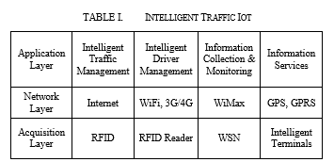

Intelligent Traffic Iot

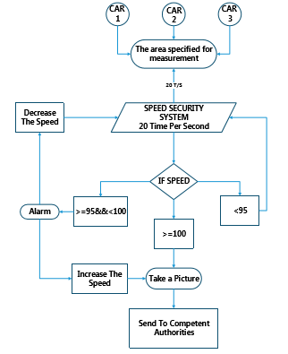

Algorithm of Speed Security System.

MANAGING WORKFLOW

* System on the will be backed by a communication backbone with IT support at the command center.
* All data will be stored in cloud-based system with dynamic usage model and analysed with all for better traffic monitoring.
* Better coordination between the system and on-ground personnel.
* Automatic numberplate recognition camera (ANPR) system.
* speed detection radars and monitoring mechanism.
* signalised pedestrain crossing.
* stop-line violation detection system.
* Lane monitoring system.

EXPERIMENTAL RESULTS

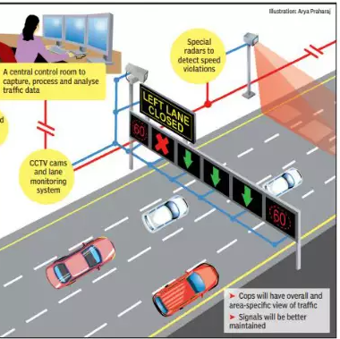

* It will help in optimisation of traffic flow without changing the existing road network.
* Minimum need for personnel on ground prosecutions will be automated
* publish address system will detect and warn you at the signals if you are stepping on the yellow line or stopping at zebra crossing. System will ensure timely dissenmination of traffic information.
* Analysis of vehicle speed and pattern at signal

ADVANTAGES

* Increase transporation system efficiency
* Improve safety
* Reduce fuel consumption and environment cost
* increase economic productivity
* create an environment for ITS market

CONCLUSIONS

This paper presents a real-time traffic information collection, and vehicle speed monitoring system architecture to solve the problem of real-time monitoring and controlling road vehicles.