**Domain Model**

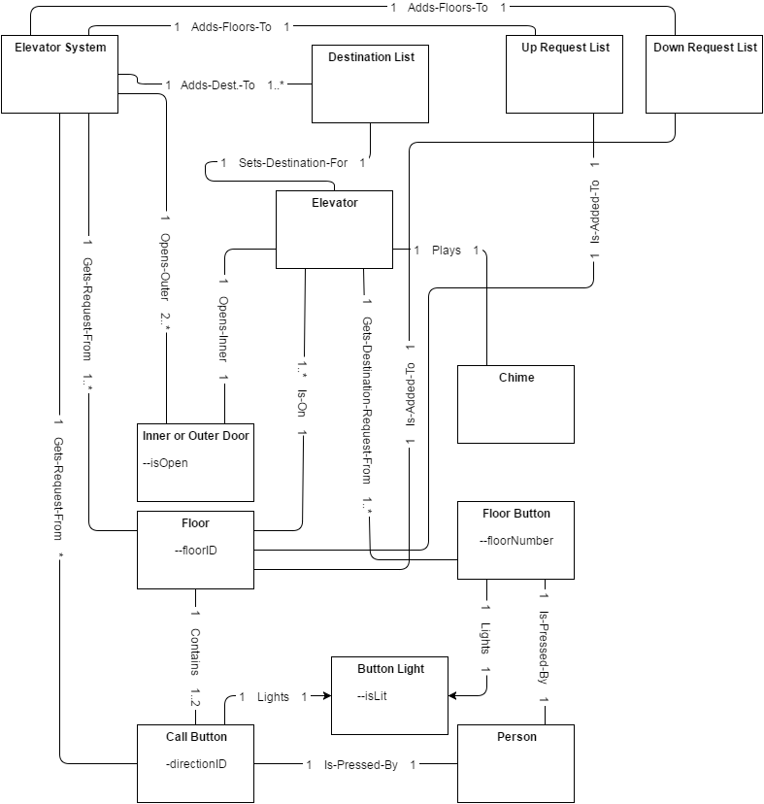

**Contracts**

**Operation: callElevator()**

* Pre: A person is on a Floor
* Post:
  + An association was formed between a Floor *f* and the Up Request List *ul* or the Down Request List *dl*.
  + A Call Button *cb's* Button Light *b's isLit*attributewas set to True

**Operation: getNextFloor()**

* Pre: N/A
* Post:
  + An association was formed between an Elevator *e* and Destination List *dl*
  + An association was destroyed between a Floor *f* and the Up Request List *ul* or the Down Request List *dl*.

**Operation: arrivedAtFloor()**

* Pre: An association exists between Elevator and Destination List
* Post:
  + An association was destroyed between Elevator and Destination List
  + A Call Button *cb's* Button Light *bl's**isLit* attribute was set to False
  + A Floor Button *fb's* Button Light *bl's* *isLit* attribute was set to False
  + The Elevator System set the Outer Door *od[j][k]'s isOpen* attribute to True
  + An Elevator *e[i]* set the Inner Door *id's* *isOpen* attribute to True

**Operation: selectFloor()**

* Pre: A person has entered an elevator
* Post:
  + A Floor Button *fb's* Button Light *bl's* isLit attribute was set to True
  + An association was formed between Elevator and Destination List

**Operation: addFloor()**

* Pre: N/A
* Post:
  + An association was formed between Elevator *e* and Destination List *dl*

**Interaction Diagrams**





**Interaction Diagrams (cont…)**





