
NATIONAL UNIVERSITY OF MODERN LANGUAGES ISLAMABAD
UXD Project Presentation

Name | Zulqarnain Hassan | Mor / Aft | Afternoon
Class, Section | 6 Sem | Subject | UXD - Lab
Roll No. | SP21379 | Batch | BSSE-32

Assigned Topic/Project Title: E-Learning App
Details (with Figma link): https://www.figma.com/design/xnBbKMXApmgzpHYgU6IRgc/E-Learning-app?node-id=0-1&t=EENcgDrH8PqZ1ICK-1

Marks Obtained:
Remarks:

Report on time:
Presented in Class: Yes / No
Overall UX/UI:
Usability:
Flow (Wireframing):
Extra features: yes
Any missing features:

Design UI:
Annotation:
Colour:
font:
Alignment:
Gutters:
Merging:
Icons:
Grids:

Issues:

Onboarding Screens
• Splash Screen: Shows the app's logo and name, creating a first impression when the app launches.
• Onboarding Screens: Briefly introduce key features like flexible learning, ease of use, and personalized study plans.
• Call-to-Action Buttons: Encourage users to continue, sign up, or log in after learning the app's benefits.

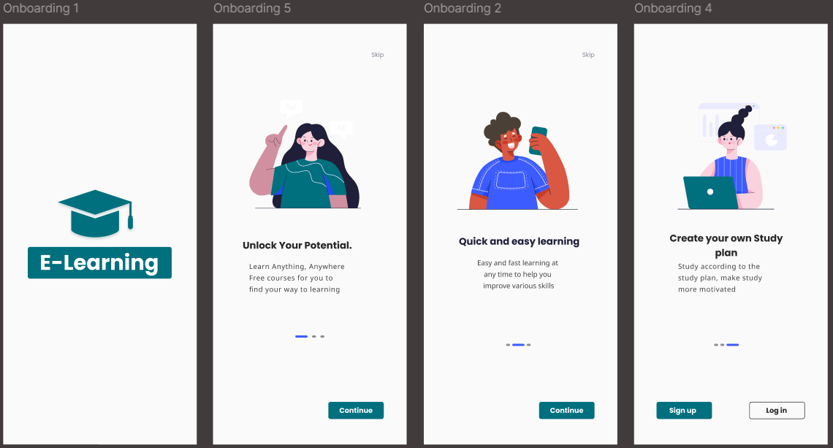

registration process
a step-by-step registration process with personal, contact, and security verification stages. It also includes a clean and intuitive login interface with social login options for easy access.
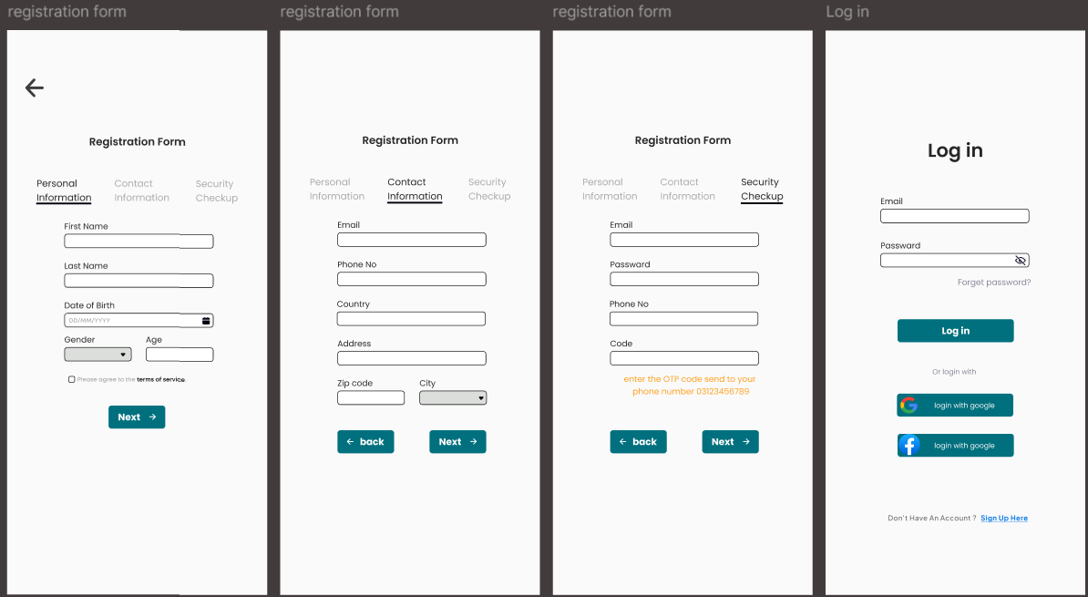
Home Screen
Displays daily learning progress, featured topics, live sessions, and popular courses for quick access.
Users can explore new categories and get personalized recommendations.
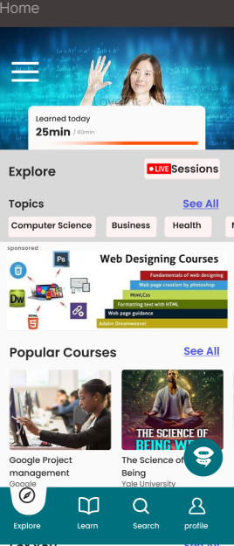

Learn Screen
Shows enrolled courses with progress tracking and options to view saved or downloaded content.
Helps learners stay organized and resume courses easily.
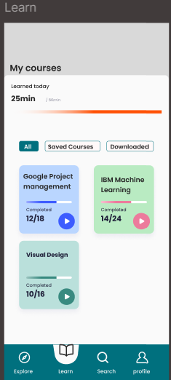

Search Screen
Allows users to search for courses with suggestions, recent activity, and popular keywords.
Offers a streamlined interface for discovering new learning opportunities.
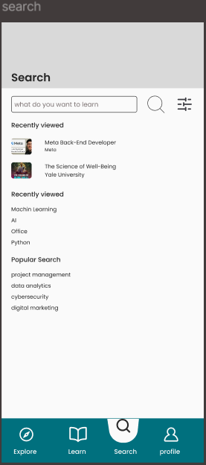

Profile Screen
Displays user information, achievements, and settings like payment method and logout.
Provides access to personal controls and account customization.
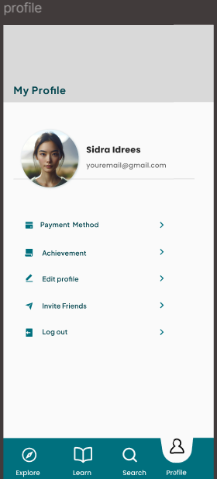
Search Result Screen
Displays a list of courses matching the user's query along with relevant details like course provider and duration.
Includes quick access to recently viewed items and popular search terms for easy navigation.
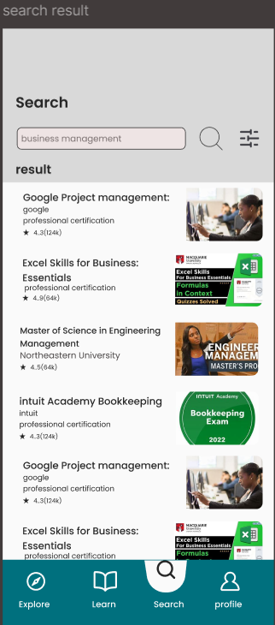
Filter on Search Result
Allows users to refine search results using filters like category, difficulty level, duration, or course provider.
Enhances the user experience by helping learners find the most relevant courses faster.
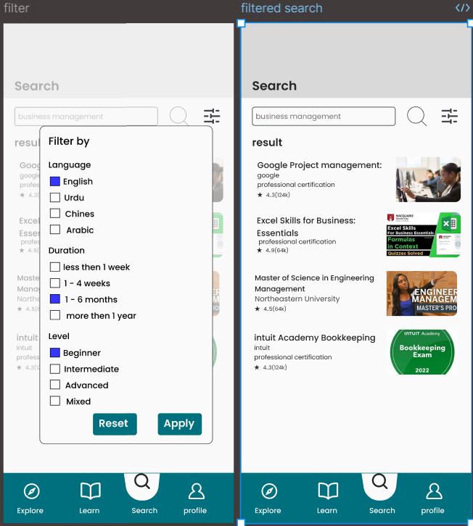
Log Out Screen
Accessed from the profile screen, it confirms the user's intention to log out of the app.
Ensures secure session end with a simple confirmation message and navigation back to the login screen.
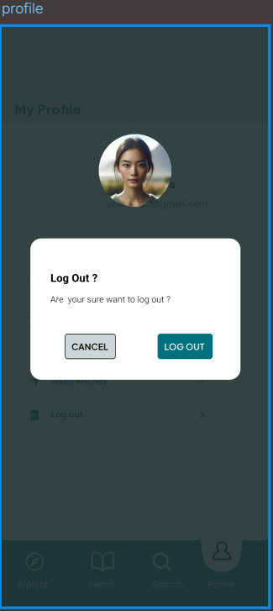

Edit Profile Screen:
Allows users to update their personal information such as name, email, profile photo, and password.
Ensures user profiles remain accurate and up-to-date with an intuitive editing interface.
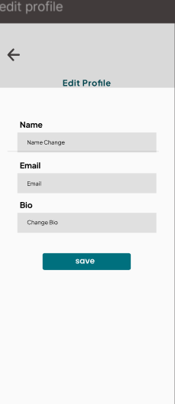
Achievement Screen:
Displays user accomplishments like completed courses, milestones, and badges earned through learning progress.
Motivates learners by visually tracking success and celebrating their achievements.
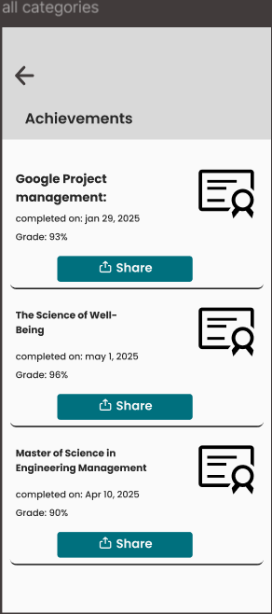
Live Session List Screen
Shows a list of ongoing and upcoming live sessions with key details like title, instructor, and start time.
Users can join live sessions in progress or set reminders for upcoming ones directly from the screen.
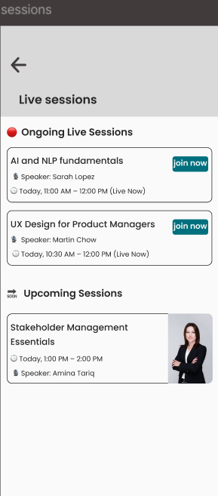
Live Session Streaming Screen
Displays the live video stream alongside an interactive live chat for real-time engagement with the instructor and peers.
Includes controls for volume, full screen, and a participant list to enhance the learning experience.
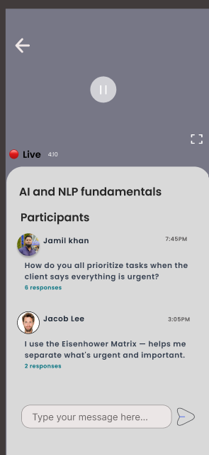
AI Assistant Chatting Screen
Provides a smart chat interface where users can ask questions and receive instant, AI-generated answers related to their courses.
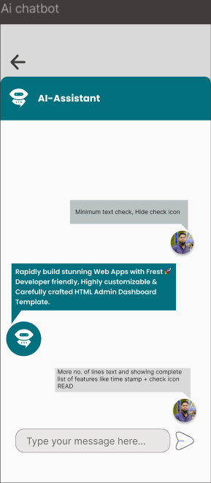

Course Category Screen
Displays a list of course categories like Programming, Design, Business, etc., each with a thumbnail and course count.
Users can tap a category to explore all related topics and available courses in that domain.

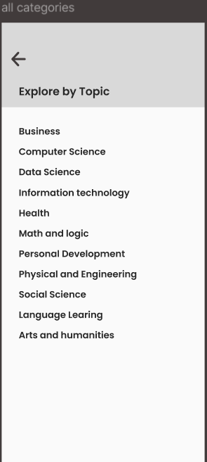

Course Details Screen:
Shows comprehensive information about the course, including title, price, duration, language, and difficulty level.
Also features a course description, instructor profile, and an enroll button for immediate access.
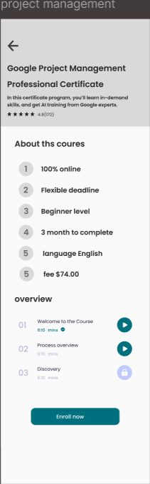

Demo Video Overview Screen
Provides a short preview video giving an overview of the course content, teaching style, and learning outcomes.
Helps users evaluate the course before enrolling, with controls for play, pause, and full-screen viewing.
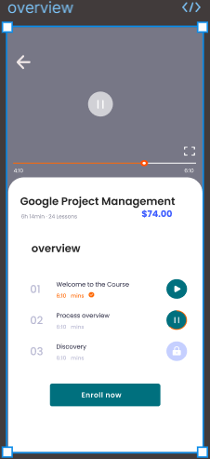

Payment Selection Screen
Displays various payment methods including Credit/Debit Card, Jazz Cash, EasyPaisa, and other wallets. Users can select their preferred option to proceed.
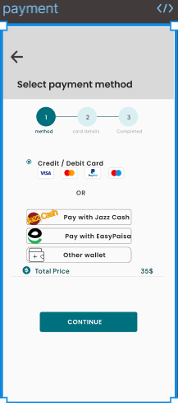
Card Details Screen
Allows users to enter card information such as Card Number, Expiry Date, and CW Number. Includes a toggle for saving card details for future use.
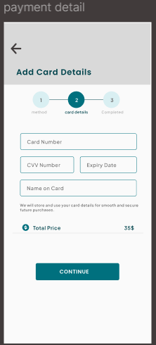
Transaction Completed Screen
Confirms successful payment with a congratulatory message and prompts the user to start their learning journey with a "START LEARNING" button.
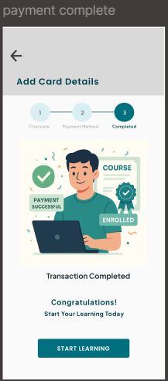
Course Overview Screen
Displays the course title (e.g., "Google Project Management") and organizes content by weeks. Includes sections for Notes, Assessments, and Discussions to track progress.
Provides a structured layout for each week (e.g., Week 01, Week 02) with placeholders for Notes, Assessments, and Discussions, allowing users to navigate and input data easily.
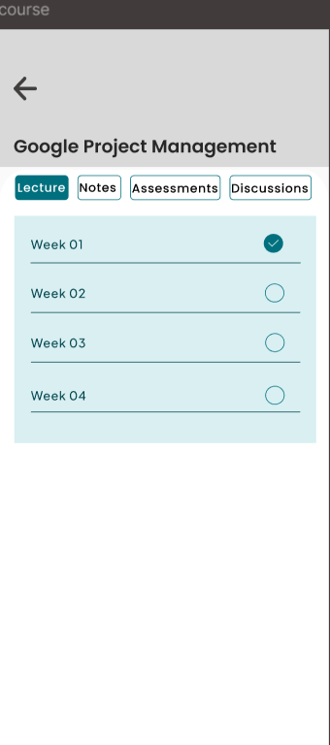
Video Lecture Screen
Displays the course title ("Google Project Management") and allows navigation between weeks (e.g., Week 1, Week 2). Shows the currently playing lecture (e.g., "Lecture 1: Introduction") with video playback controls.
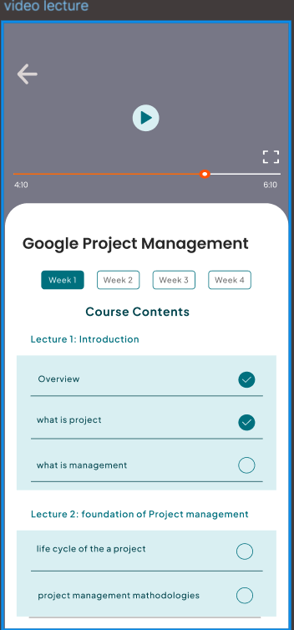

Notes Overview Screen
Displays a list of available lecture notes (e.g., "Introduction to Project Management," "Project Life Cycle") with brief descriptions. Includes a download icon (PDF) next to each note for offline access.
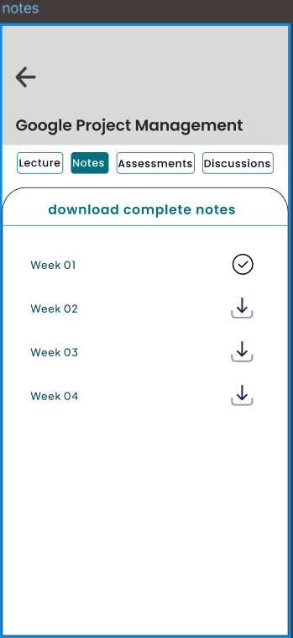
Quiz Screen
Presents timed multiple-choice or short-answer questions to test learners' understanding of the course material.
Includes progress tracking, instant feedback, and a score summary upon completion.
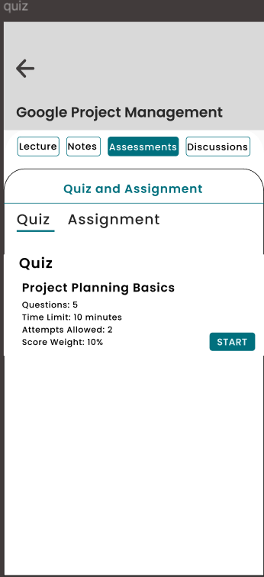
Assignment Screen
Displays assignment details such as instructions, submission deadline, and file upload options.
Allows users to submit their work directly and view feedback or grades from instructors.
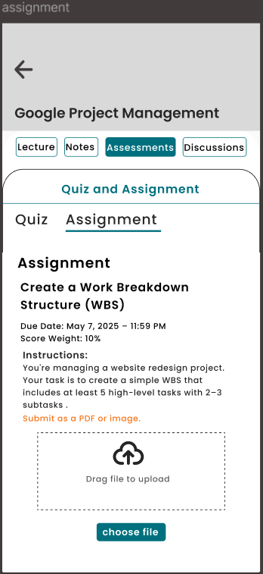

Peer Chat Screen
Enables real-time messaging with peers or instructors. Features a chat interface with sent/received timestamps, read receipts, and file-sharing options (e.g., PDFs, links). Includes a search bar to find past conversations.
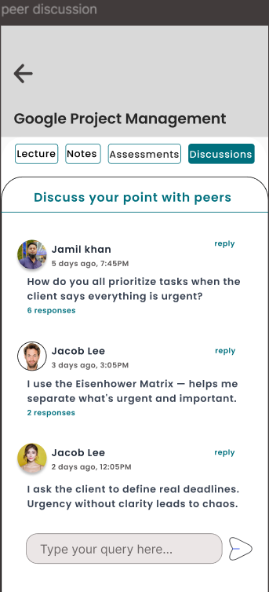

Computer Science Category Overview Screen
Displays a broad selection of popular courses and certifications (e.g., IBM Full Stack, Google Project Management) with icons, ratings (e.g., "41(103)"), and providers (e.g., Google, IBM). Users can filter by "All," "Popular," or "Professional Certification."
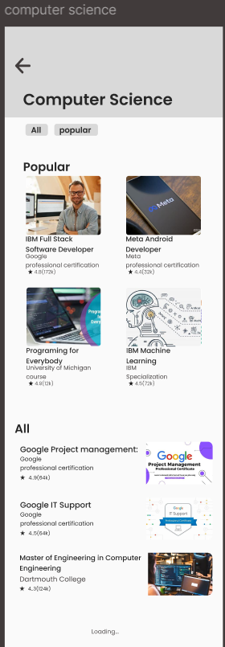

Message Screen
Shows a list of received messages from instructors, system notifications, or peers within the app.
Each message includes a sender name, timestamp, and a preview.
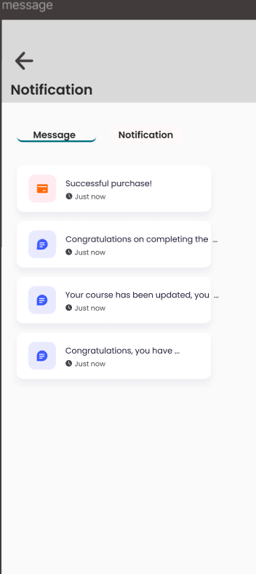
Notification Screen:
Displays real-time alerts for course updates, new messages, assignment deadlines, live session reminders, and achievements.
Each notification includes an icon, brief description, and timestamp, with the option to mark as read or view details.
