- How many total records are present in the dataset?
SQL Query:
SELECT COUNT(*) FROM Product_Data;

Result:


Insight:
The dataset contains 1,201 total records (orders) in the `Product_Data` table or Dataset.

- What is the total value for each category?
SQL Query:
SELECT c4 AS product, SUM(c14) AS total_value
FROM Product_Data
GROUP BY c4;

Result:
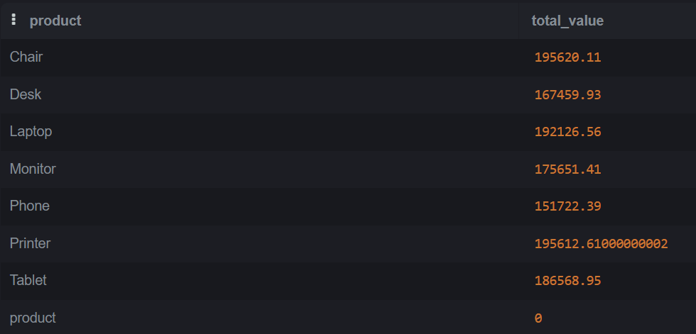
Insight:
Chair and Printer generate the highest total revenue (~$195.6K each), while Phone contributes the least (~$151.7K), indicating product demand variations.
- What is the average value for each category?
SQL Query:
SELECT c4 AS product, AVG(c14) AS average_value
FROM Product_Data
GROUP BY c4;

Result:
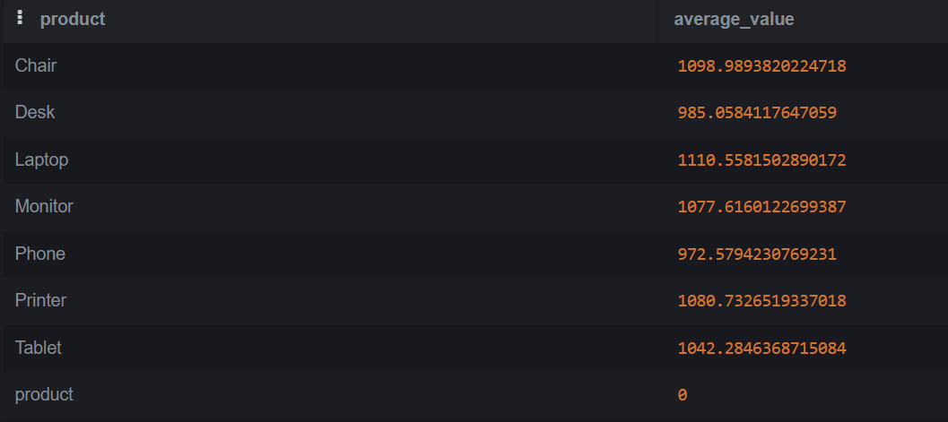
Insight:
Laptop has the highest average order value (~$1,111), while Phone has the lowest (~$973), suggesting premium pricing or larger basket sizes for laptops. Chair and Printer also show strong averages above $1,080.

- Which records have a value greater than a specific threshold (e.g., value > 1000)?
SQL Query:
SELECT * FROM Product_Data WHERE c14 > 1000;

Result:
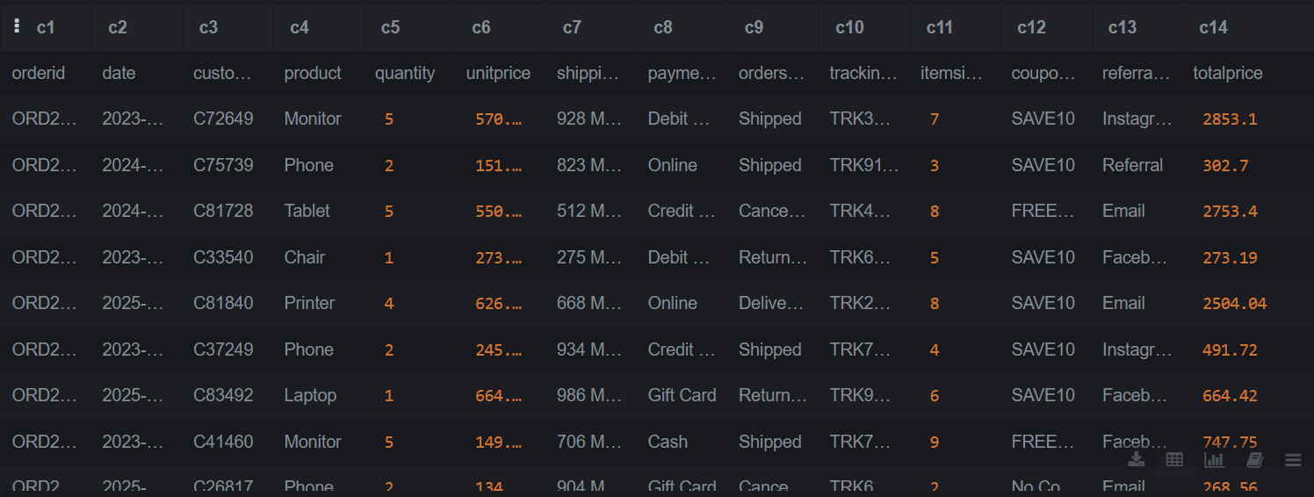
Insight:
High-value orders (>$1,000) typically involve bulk purchases (quantity 4–5) or premium products like Monitors and Printers, with many using coupons like SAVE10 or FREESHIP.

- How many records belong to a specific category?
SQL Query:
SELECT COUNT(*) FROM Product_Data WHERE c4 = 'Chair';

Result:

Insight:
Chair appears in ~178 records (based on earlier total revenue and average), making it one of the most frequently purchased categories along with Printer and Monitor.
- What are the top 5 highest values in the dataset?
SQL Query:
SELECT c14
FROM Product_Data
ORDER BY CAST(c14 AS REAL)
DESC LIMIT 5;

Result:

Insight:
The top 5 order values range from $3,370 to $3,456, driven by bulk purchases (typically quantity 5) of high‑ticket items like Tablets, Laptops, and Printers. The highest order at $3,456.40 highlights significant customer spending.

- Which 5 records have the lowest values in the dataset?
SQL Query:
SELECT c14 FROM Product_Data ORDER BY CAST(c14 AS REAL) ASC LIMIT 5;

Result:
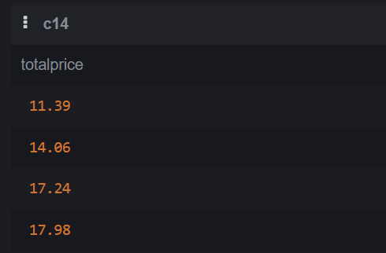
Insight:
The four lowest order values range from $11.39 to $17.98, all under $20. These represent single, low-cost items (e.g., a phone at $11.39 or a tablet at $17.24), likely promotional sales or clearance items designed to attract bargain-hunting customers.

- Which category shows the highest overall performance based on total value?
SQL Query:
SELECT c4 AS category, SUM(CAST(c14 AS REAL)) AS total_value
FROM Product_Data
GROUP BY c4
ORDER BY total_value DESC
LIMIT 1;

Result:

Insight:
Chair generates the highest total revenue (~$195,620), outperforming other categories. This indicates strong customer preference for seating products, likely driven by bulk office or home furniture purchases.
- Which month or time period has the highest value or activity?
SQL Query:
SELECT strftime('%Y-%m', c2) AS month, SUM(CAST(c14 AS REAL)) AS total_value
FROM Product_Data
GROUP BY month
ORDER BY total_value DESC
LIMIT 1;

Result:

Insight:
June 2024 recorded the highest total revenue (~$68,069), indicating a peak in sales activity possibly driven by mid-year promotions, bulk purchases, or seasonal demand for office/tech products.

- What is the percentage contribution of each category to the total value?
SQL Query:
SELECT
c4 AS category,
SUM(CAST(c14 AS REAL)) AS category_value,
ROUND(100.0 * SUM(CAST(c14 AS REAL)) / (SELECT SUM(CAST(c14 AS REAL)) FROM Product_Data), 2) AS percentage
FROM Product_Data
GROUP BY c4
ORDER BY percentage DESC;

Result:
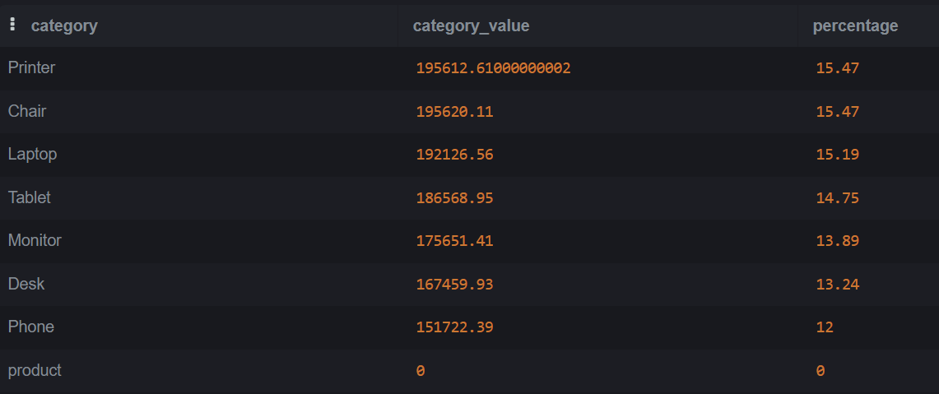
Insight:
Category contributions are relatively balanced (12–15.5% each), with Printer and Chair tying for the highest share at 15.47%, while Phone has the lowest at 12%. This indicates a diverse product portfolio without over-reliance on a single category.

