Penguin Water War

Game Design Document

Revision: 0.0.4

GDD written by

Alex Lötscher

Daniyal Dehghany  
Danja Künzle

Kegan Hürlimann

Philipp Mathis

# Index

Index 2

Overview 5

Summary 5

Aesthetics and style 5

Gameplay 6

Gameplay 6

Win/Lose Condition 6

Input 6

Rules 7

References and influences 7

Target audience 7

Targeted platforms 7

Monetization model 7

What sets this project apart? 7

Graphics & Art 8

General 8

Characters (Penguins) 9

Interface 9

Menu 9

Game 9

Music & Sound 11

Music 11

Sound 11

Story and Characters 11

Story 11

Characters 11

Generally 11

Emperor penguins 11

Chinstrap penguins 12

Rockhopper penguins 12

Jackass penguins 12

Game Elements 13

Penguin (Player) 13

Properties 13

Behaviors 13

Relationships 13

Water cannon 13

Properties 13

Behaviors 13

Relationships 13

Destroyable ice platforms 13

Properties 13

Behaviors 14

Relationships 14

Mechanical platforms 14

Properties 14

Behaviors 14

Relationships 14

Items (Powerups) 14

Properties 14

Behaviors 14

Maps 15

Map 1 (ice land) 15

Map 2 (research station factory) 15

Map 3 (Mixed) 16

Modes 17

Default 17

Speed mode 17

Team mode (2vs2) 17

Team 18

Alex Lötscher 18

Daniyal Dehghany 18

Danja Künzle 18

Kegan Hürlimann 18

Philipp Mathis 18

Production Pipeline 18

Game Engine 18

Asset Tools 18

Development milestones 18

Prototype 18

First playable 18

Content 18

Beta 19

Release 19

Schedule 19

Assets Needed 20

2D 20

3D 20

Sound 20

Code 20

Animation 21

Reference Lists 22

# Overview

## Summary

Penguin Water War is a local multiplayer (Single Screen) action party game for 2-4 players.

The goal is to shoot the other players out of the map with help of a water cannon.

## Aesthetics and style

The game plays in a friendly and playful fantasy South Pole region. There are also mechanical platforms from research stations which brings in some dynamics to the maps.

It’s a 3D game with low poly cartoony graphics, much like Gang Beasts:  
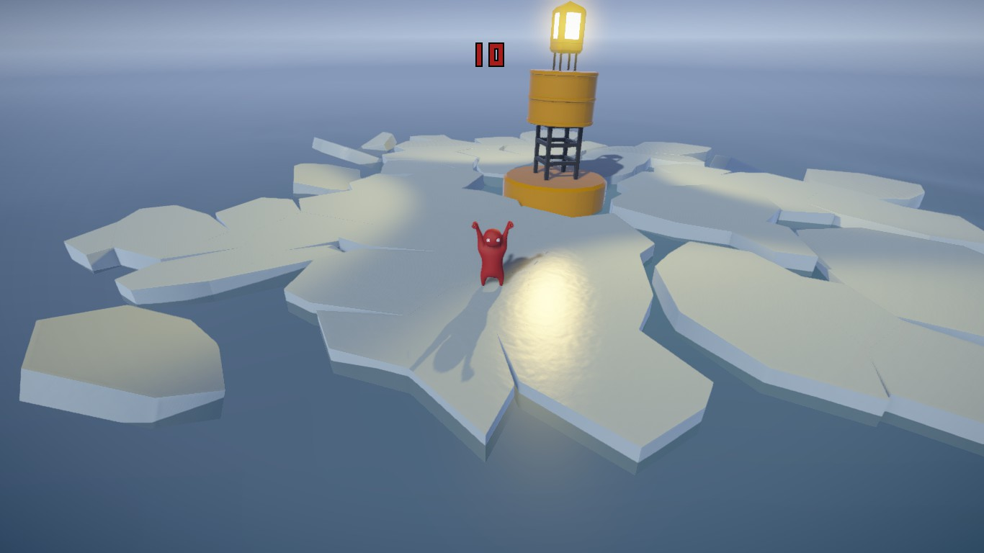  
(irri, 2015)

# Gameplay

## Gameplay

Before the game starts, the players can choose the mode and their penguin species.

While playing, the players can move on the map and shoot the other players. They also must look out for changes in the map (platforms and destroyable ice). While charging the water cannon, all players see the range of the impact. The range and power of the water cannon hit, increases while charging.

After a while, if the round not already ended, some powerups spawn. This powerups (e.g.: increased movement/reload speed) can be collected and are automatically activated to the player.

The players must pay attention to the following things: walk around & not falling of the map, shooting the other players and not get hit by other players.

## Win/Lose Condition

Players who fall of the map are out of the current round. The last player standing on the map wins this round (last man standing) and gets a point. The player who get five points first wins the game.

On a draw (if more than one player survives after timer is on zero) nobody gets a point. But the players who already fell of, loses one point (minus points possible).

## Input

There are not a lot of inputs options needed. The recommended input device is a gamepad.

The player can move around with an analog stick or the arrow keys. One button is needed to jump. With another button the water cannon can be charged (holding button down) and activated (release button). While charging, the direction can be changed but the player cannot move around.

A mapping of a DualShock Controller could look like this (see controller description below):

K (Left analog Stick): Move and rotate

G (Right analog stick): Could also be used for rotating, but not intended

F Cross (X): Jump

F Square or Circle: Charge and shoot water cannon

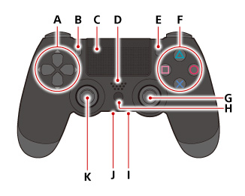

(Sony Interactive Entertainment Inc., 2019)

## Rules

* Players can’t move while charging the water cannon
* Players can’t move or rotate while in the air
* If a player falls of the map (by himself or by any players water cannon) he is out of the current round
* The last player who doesn’t fall of the map wins this round and gets a point
* The first player that gets five points wins the game
* Different types of powerups are stackable. But only one powerup per type
* If a powerup of one type is already active, powerups from this type can’t be picked up again until the effect is expired.

# References and influences

* Super Mario Sunshine (water cannon)
* Lance A Lot
* Gang beasts

# Target audience

The target audience are people who want to have fun or competition with/against their friends. The game is free, but gamepads are highly recommended (if player on PC). The game also fits to a younger audience as the game art is friendly. A game lasts about 15 to 30 minutes.

# Targeted platforms

The targeted platforms are PC (highest priority), PS4 and Xbox One. The game is optimized to play with gamepads.

# Monetization model

The game will be released on Steam for 15$ per unit.

# What sets this project apart?

* Penguins fighting in the Antarctic
* Penguins fighting with water cannon

# Graphics & Art

## General

It’s a 3D game that plays in a fantasy South Pole / Antarctica setting. There is not only ice and water, but also different platforms from research stations.

The feeling and colors should be friendly and playful.

Most used colors are white (ice), blue (sky & water).

The platforms and research stations constructions are in a friendly bright brown or grey.

The art is low poly, clean and cartoony much like Gang beasts:

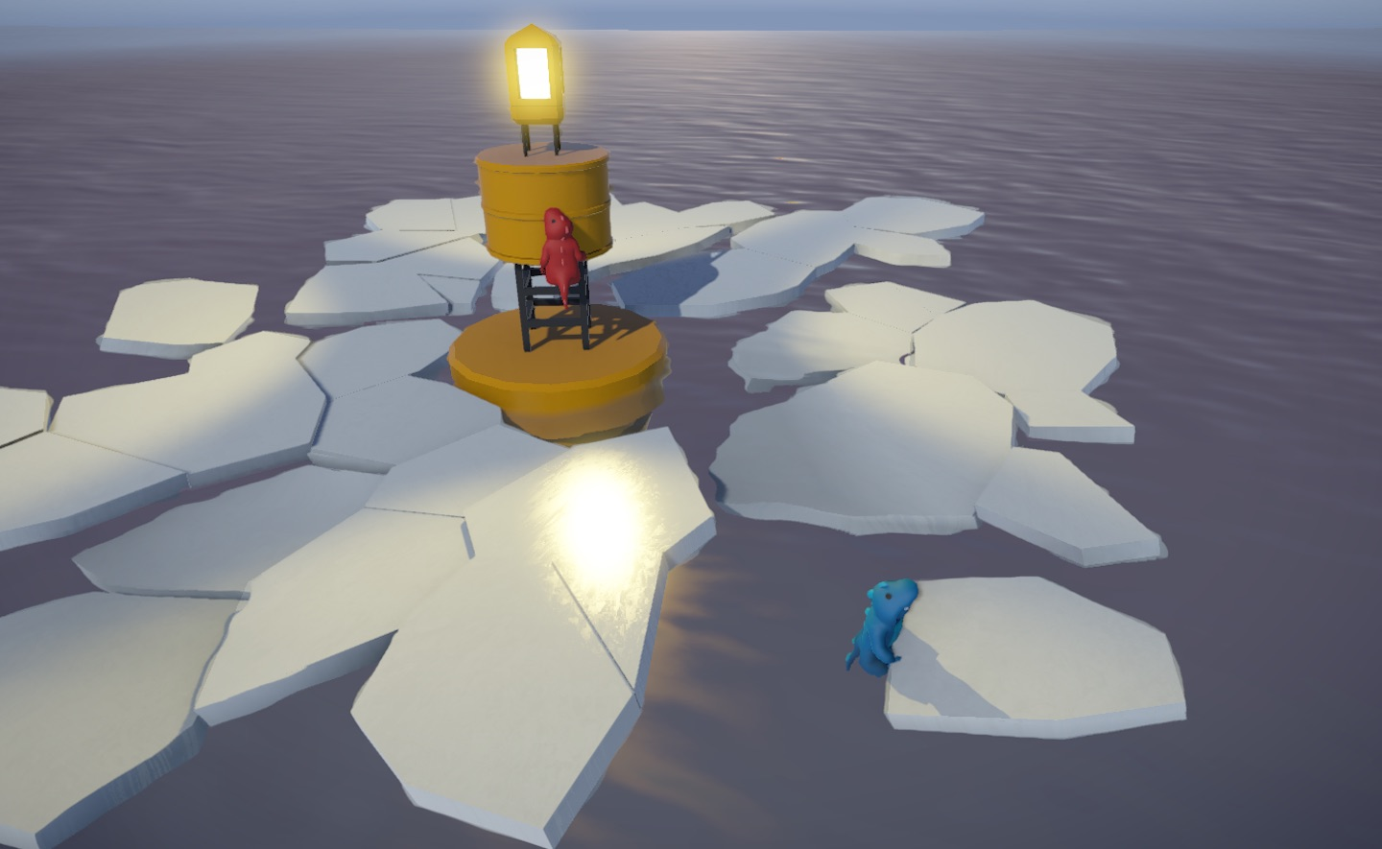

(Boneloaf, 2015)

To make the game maps more friendly and interesting, there can also be little funny, unrealistic items (just for the look), wooden boxes (with collision) or Obstacles (not movable).

## Characters (Penguins)

The penguins are also low poly and can look a bit unrealistic in favor for craziness.

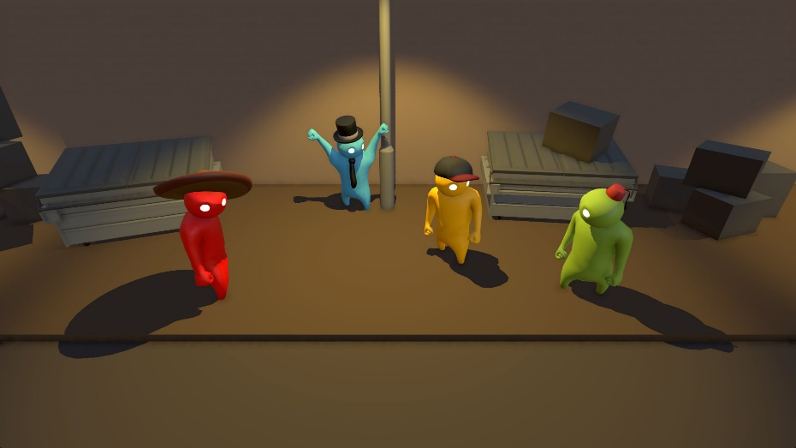

(Sony Interactive Entertainment Inc., n.d.)

The penguins always have the color of their player (green, red, blue, yellow). But they will have hats or other cosmetics to differentiate themselves. Maybe little variations in scale/size.

First look (not final):

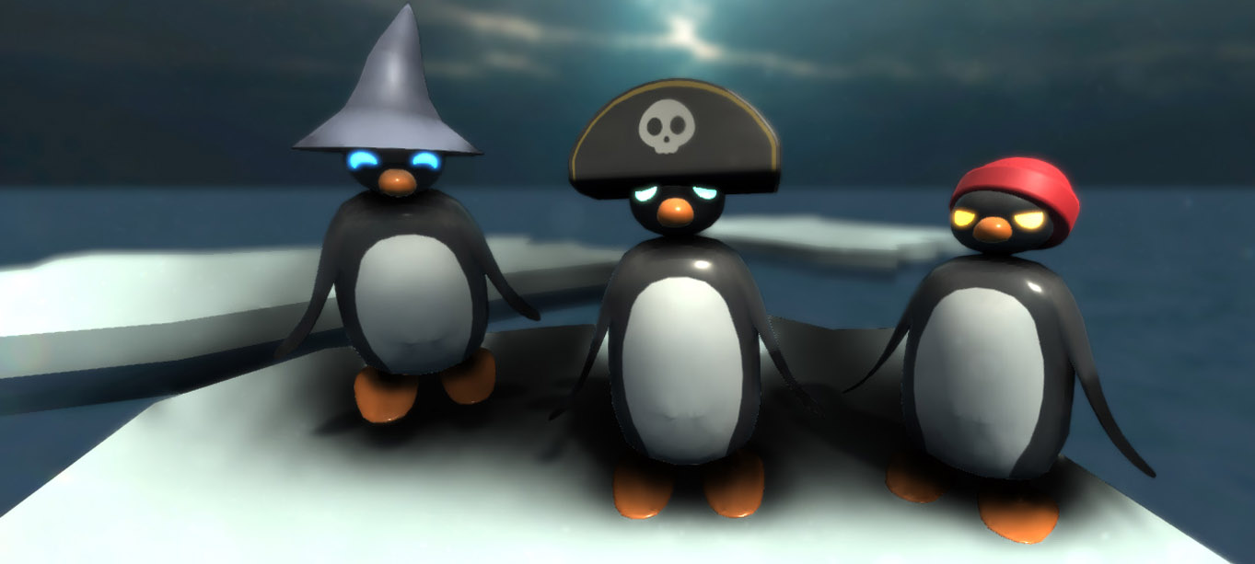

## Interface

### Menu

The menu is very simple. At the first screen there is a “Start Game”, “Settings” and “Exit” button.

After the “Start Game” button is selected the next screen with the mode selection appears.

As last step, every player can choose a penguin species. The colors of the players are fixed. Players can also choose the same penguin species.

### Game

The UI in the game only shows the remaining time of current round and some player information (color, penguin species, amount of won rounds and active powerups.

The players should always be seen in the middle of the map (see number 6 on pictures below). This must be solved via map design or camera settings.

A two player game looks like this:

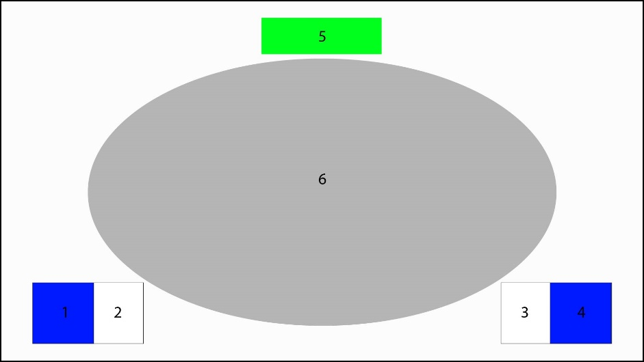

1. Penguin Avatar Player 1 + Color of player
2. Amount of won rounds and additional info (e.g. current powerups)
3. Same as 2. but for player 2
4. Same as 1. but for player 2
5. Timer: Remaining time of current round
6. Space where all players should be seen

The UI for a four-player game looks similar, however the info boxes of player 1 and player 2 slide up, so player 3 and 4 are bottom left and bottom right:

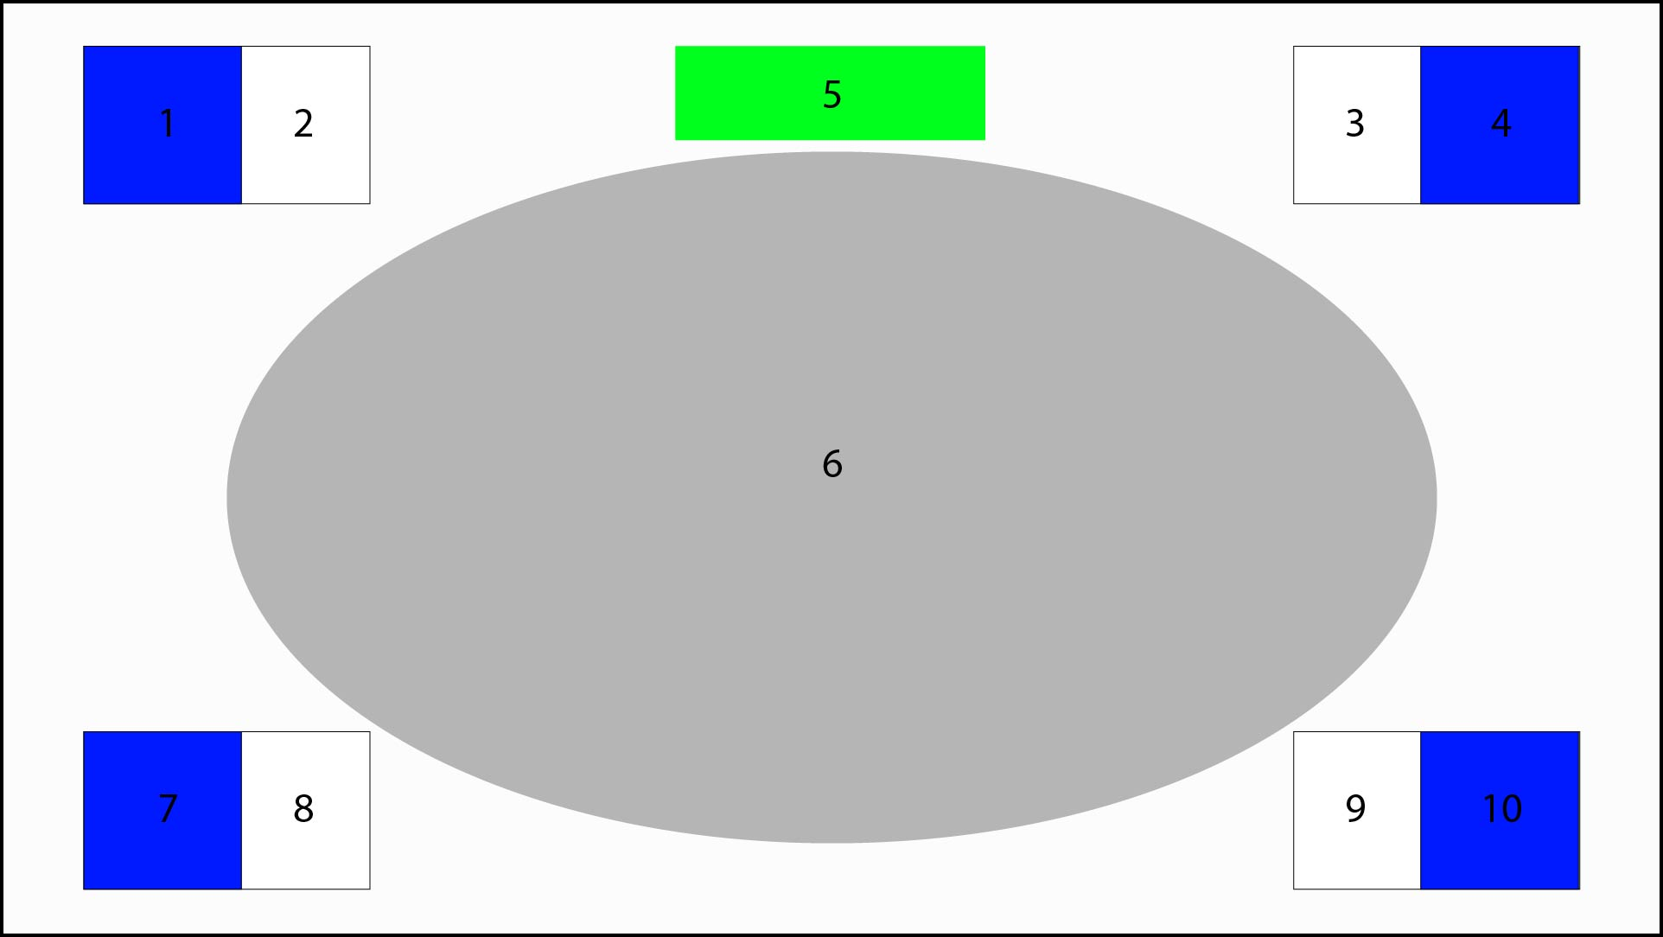

1. Penguin Avatar Player 3
2. Player 3 information
3. Player 4 information
4. Penguin Avatar Player 4

After a game ends, a little overview of the winner and the points of the other player appears. Then a rematch with the same settings can be started.

# Music & Sound

## Music

The music is used in the menu and game as normal background music. It should create a funny, playful and friendly reaction.

## Sound

The sound should underline the actions in a funny and playful way. The most important sound effect is the one from the water cannon charging and firing, so other players can recognize this sound and plan their next action.

# Story and Characters

## Story

The South Pole changed…

Because of the global warming, the nice and cold places in the South Pole are decreasing drastically.

So, the different penguin species must fight for these valuable spots. The only thing they can use to fight with, is a huge water cannon.

There are four different penguin species in the game: emperor penguin, chinstrap penguins, rockhopper penguin and jackass penguin.

## Characters

### Generally

There are only penguins in the game. Generally, the penguins don’t like to talk but they make funny penguin sounds. There are all pugnacious because they want to have their own nice spot.

### Emperor penguins

Emperor penguins are the tallest and heaviest penguins of all penguin species. But their weight also makes them a little bit slower, then the other species (no impact on gameplay).

They are known as merciless slayers in the penguin world. But in reality, they are soft and gentle. They only started to fight because the other penguin species attacked first.

### Chinstrap penguins

The Chinstrap penguins are not the smartest out of all species. Sometimes they try to crack stones with their bald head. That’s why they are also called “Stonecracker penguins”.

Because of their lower intelligence they often get offended by other penguin species. They now want to make others pay for that.

### Rockhopper penguins

The Rockhopper penguins are much smaller than the other penguin species. But they compensate this with their intelligence.

They always plan their next move ahead. The other species hates to play chess against one of the rockhopper penguins (they always win).

### Jackass penguins

Normally just seen in South Africa, the jackass penguins had to move to the Antarctic.

They are called the “outsiders” and get hated, because they look such different than the other penguin species.

The jackass penguins just want to survive. Luckily, they love to shoot other animals (learned in South Africa). So just give them a nice big water cannon and they’re happy.

# Game Elements

## Penguin (Player)

### Properties

* Position
* Direction
* Movement speed
* Specie
* Color
* Active powerups
* Water cannon charge time

### Behaviors

A player can move, rotate and jump freely on the map. While he is charging with his water cannon he can’t move and jump (only rotate to aim).

If a player gets hit by the water cannon of another player, he is pushed away by the power and range of the water cannon.

### Relationships

* Water cannon: equipped and usable
* Platforms: walkable/jumpable

## Water cannon

### Properties

* Power
* Range
* Impact area (by power and range)
* Timeout duration (refill/reload)

### Behaviors

A water cannon can be charged and fired. The greater the charge, the greater the power and range. After a shot is fired, the next shot is locked until a certain time (timeout duration). The timeout is shown visually by a bar above the penguins.

### Relationships

Each player has a water cannon equipped.

## Destroyable ice platforms

### Properties

* Position
* Range / Collision
* Timer

### Behaviors

An ice platform has a fixed place on the map. After the timer is expired, the platform will glow, fibrate and make a sound (so the players are warned). After another 5 seconds the platform will be destroyed (falls into water).

### Relationships

Players can move and jump on it, while not destroyed.

## Mechanical platforms

### Properties

* Start/End position
* Current position
* Speed

### Behaviors

Mechanical Platforms have a fixed start and end position on the map, in which they move in a certain speed.

### Relationships

Players can move and jump on it.

## Items (Powerups)

### Properties

* Position
* Spawn timer
* Effect duration
* Effect multiplier
* Effect type
  + Movement speed increasing
  + Jump power increasing
  + Water cannon power or range increasing
  + Water cannon reload speed increasing
  + Water cannon charge speed decreasing

### Behaviors

After a certain amount of time, items will spawn at random positions (several positioning areas are defined on the map). The items can be collected by the player and will get activated directly. The different effects of this powerups are stackable (only one stack per effect). The effect will last for a certain amount of time.

# Maps

## Map 1 (ice land)

This maps only consist of ice. But some of the ice areas getting destroyed after a recent time of play. At first, it’s easy to move around). After a while the map gets smaller and smaller.

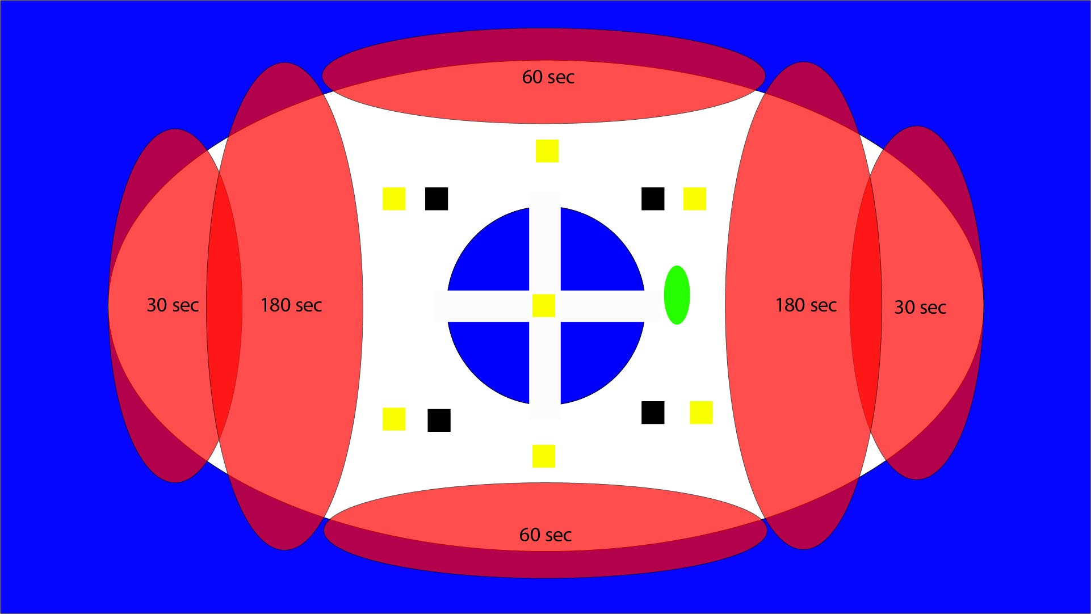

*Blue: Water*

*White: Ice*

*Red: Destroyable ice platforms (getting destroyed after 30, 60 or 180 seconds)*

*Brown: Mechanical platform areas-> moves in this area*

*Black: Obstacles*

*Grey: Research Factory*

*Yellow: Powerup spawn points*

*Green: Penguin (Player) size*

## Map 2 (research station factory)

This map is divided in four ice islands. Between these islands, there are different mechanical platforms from a research station, which brings the players on the other side.

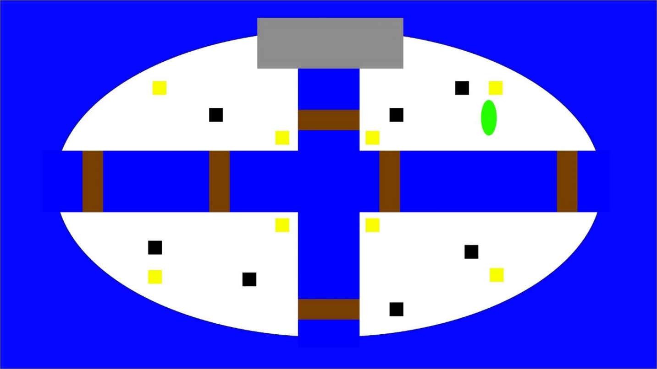

## Map 3 (Mixed)

This map is a mixture of ice areas and mechanical platforms. This map offers the most action.

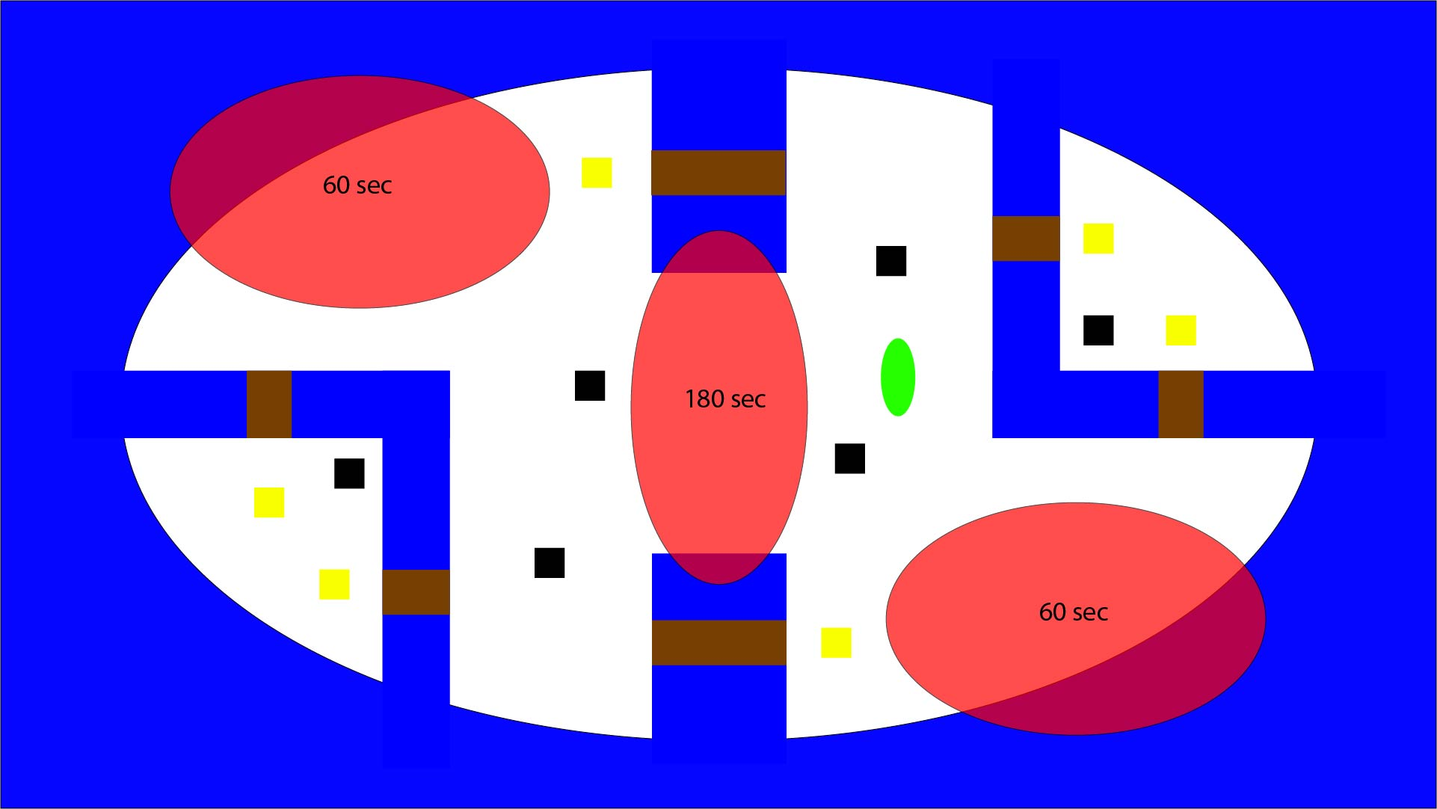

# Modes

In each mode the map will be selected randomly and changed after a round is over.

## Default

In the default mode, the players fight until one player gets five points and wins this game.

## Speed mode

In the speed mode, everything gets faster: Players movement, water cannons charge/reload time and the moving platforms.

## Team mode (2vs2)

In this mode 2 players fighting against 2 other players. The map can be selected.

# Team

## Alex Lötscher

Project lead, game design, QA

## Daniyal Dehghany

Level design, level programming

## Danja Künzle

UI, core programming

## Kegan Hürlimann

Level design, sounds & music

## Philipp Mathis

Core programming, 3D modelling and animations

# Production Pipeline

## Game Engine

Unity will be used as Game Engine (version 2019.3.1f1).

## Asset Tools

<https://www.soundsnap.com/>

<https://www.gamedevmarket.net/>

## Development milestones

### Prototype

* Penguin movement
* Water cannon

### First playable

* First map (without any effects)
* Powerups
* Timer
* Win-/Lose condition

### Content

* Penguin model and animations
* Water cannon model und animations
* Map 2 and 3
* Destroyable ice platforms
* Mechanical platforms
* Obstacles

### Beta

* Testing and optimization

### Release

* Polish and release

## Schedule

**21.02.2020**: Penguin Movement and Water cannon

**28.02.2020**: Win-/Lose condition and round mechanic (timer and points)

**06.03.2020**: Map 1 & Powerups

**13.03.2020**: Map 2 & 3 with dynamic elements (destroyable ice platforms, mechanical platforms)

**19.03.2020**: Menu & UI (simple and functional) -> Prototype ready

**25.03.2020**:Prototype testing

**27.03.2020**: UI (final), sound & music

**03.04.2020**: 3D models & animations

**10.04.2020**: Testing, bugs and buffer

**15.04.2020**: Polish and finish

**16.04.2020**:Release

# Assets Needed

## 2D

* Textures
  + Menu & UI
  + Map textures

## 3D

* Characters
  + Emperor penguin
  + Chinstrap penguins
  + Rockhopper penguin
  + Jackass penguin
* Weapon
  + Water cannon
* Items
  + Powerup box (one is enough, effects will be random)
* Environmental
  + Mechanical platforms
  + Ice platforms
  + Obstacles (wooden/steel boxes)

## Sound

* Ambient
  + Water
  + Wind
  + Destroyable ice platforms
  + Mechanical platforms
* Player sounds
  + Character Movement (move and jump)
  + Character hit by water cannon
  + Water cannon charging
  + Water cannon shoot
  + Character out of map (death)
* Menu
  + Change option
  + Select option
  + Select Penguin

## Code

* Player Script
* Map Script
* Menu Script

## Animation

* Environment Animations
  + Destroyable ice platforms
  + Mechanical platforms
* Character Animations (Penguin)
  + Move
  + Jump
  + Water cannon charge & shoot

# Reference Lists

* irri (2015). Step 1:"The Bouy Stage" is reccommended. [image] Available at: https://steamcommunity.com/sharedfiles/filedetails/?id=470652616 [Accessed 18 Feb. 2020].
* Sony Interactive Entertainment Inc. (2019). Front. [image] Available at: https://manuals.playstation.net/document/en/ps4/basic/pn_controller.html [Accessed 18 Feb. 2020].
* Boneloaf (2015). Stages ice map. [image] Available at: https://www.steamkiwi.com/article=18291/patch-notes-for-the-gang-beasts-026-unstable-alpha-build [Accessed 18 Feb. 2020].
* Sony Interactive Entertainment Inc. (n.d.). gang-beasts-screen-03-ps4-eu-06may16. [image] Available at: https://www.playstation.com/de-ch/games/gang-beasts-ps4/ [Accessed 18 Feb. 2020].

Revision History

**v0.0.4 – 18.02.2020**

Add reference lists

**v0.0.3 – 16.02.2020**

Add/Merge inputs from Philipp Mathis

**v0.0.2 – 15.02.2020**

Add/Merge inputs from Danja Künzle

**v0.0.1 – 30.01.2020**

First version