Final Project
- Normalization report -
PROG2111

Name: Zumhliansang Lung Ler | Sungmin Leem | Nick Turco)
Course: Software Engineering Technology
Date of Submission: 30 November 2025
TABLE OF CONTENTS

Phase 3: Normalization 3
Original Data (Unnormalized Form) 3
First Normal Form(1NF) 4
Second Normal Form(2NF) 5
Third Normal Form(3NF) 6
Phase 4: DDL statement 9

Phase 3: Normalization

Original Data (Unnormalized Form)
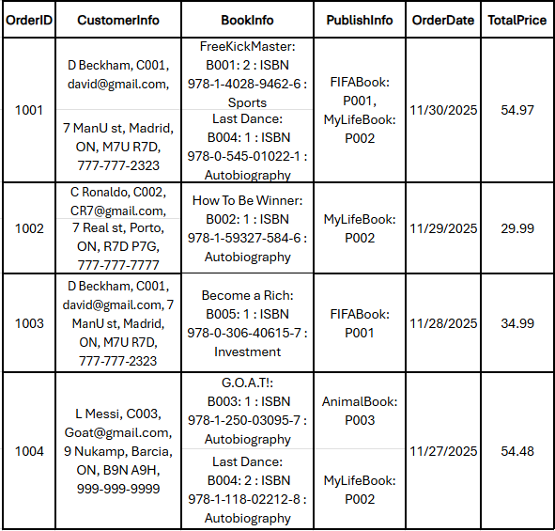
Issues and Redundancy
- Multiple Values in One Cell: The CustomerInfo column has name, ID, email, and address all together. We cannot search for just a name or email.
- Repeating Groups: The BookInfo column has multiple books separated by commas. It is hard to know how many books were sold.
- Redundancy: The same customer information (D Beckham) is repeated in rows 1001 and 1003.

First Normal Form(1NF)

Do:
- Split Information: We separated CustomerInfo into CustomerID, CustomerName, Email, Address, and Phone. We did the same for BookInfo
- Removed Repeating Groups: For Order 1001 (which has 2 books), we created two separate rows. Now, each row has only one book.

-Order
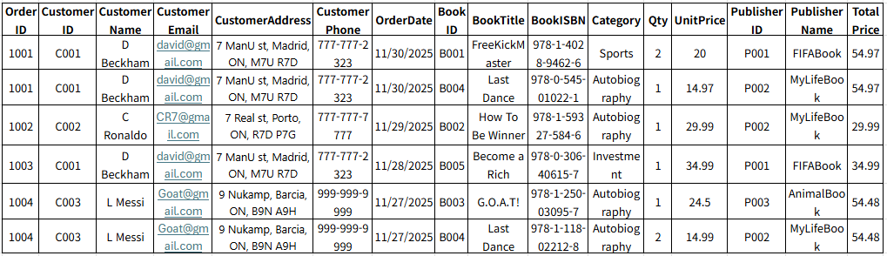

Second Normal Form(2NF)

Problem: The Primary Key is (OrderID, BookID).
- CustomerName depends only on OrderID. It has nothing to do with BookID. This is a partial dependency.
- BookTitle depends only on BookID. It has nothing to do with OrderID.
Solution: We split the table into three parts:
- Orders Table: Keeps information about the order (Customer, Date) → depends on OrderID.
- Books Table: Keeps information about the book (Title, Category, Publisher) → depends on BookID.
- OrderDetails Table: Keeps Qty because quantity depends on both Order and Book.

- Orders
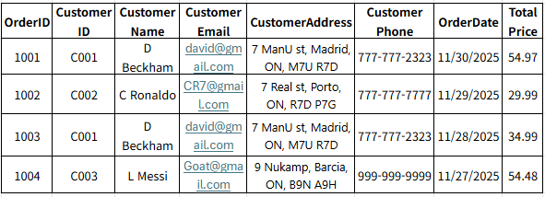

- Books
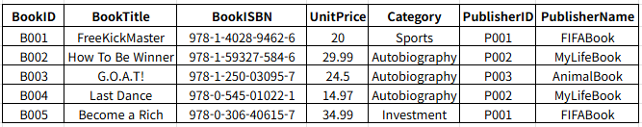
- OrderDetails
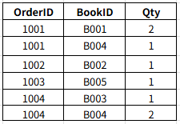

Third Normal Form(3NF)
Problem:
- In the Orders table, CustomerName depends on CustomerID, not OrderID. (OrderID → CustomerID → CustomerName). This is a transitive dependency.
- In the Books table, PublisherName depends on PublisherID, and Category (name) is repeated text.

Solution: We moved these dependent columns to their own tables.
- Created a Customer Table. Now Orders only keeps CustomerID.
- Created a Publisher Table. Now Books only keeps PublisherID.
- Created a Category Table. Now Books only keeps CategoryID.

- Customer
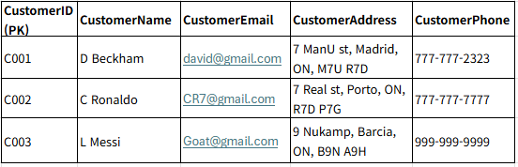
- Book
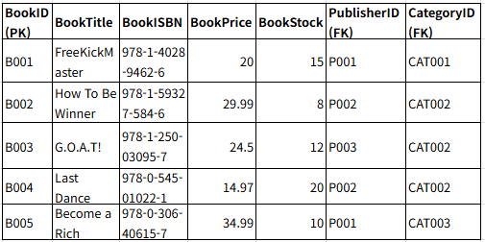

- Order
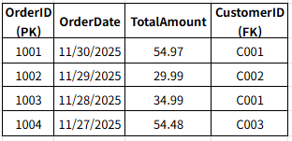

- OrderDetail
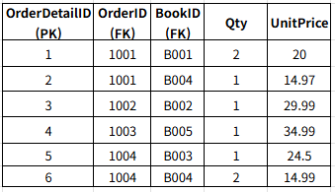

- Publisher
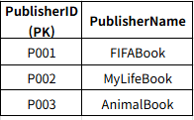

- Category
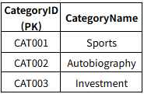

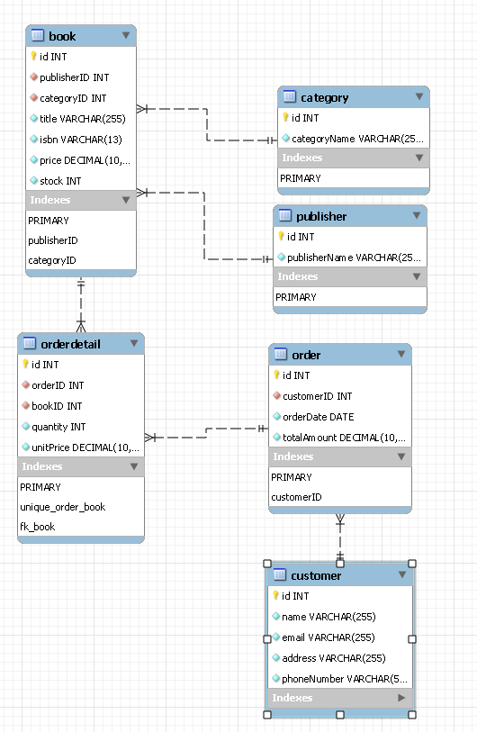
Phase 4: DDL statement

