Index.html

<li class="nav-item">

<a class="nav-link me-lg-3" href="#awards">AWARDS</a>

</li>

<li class="nav-item">

<a class="nav-link me-lg-3" href="#experience">EXPERIENCE</a>

</li>

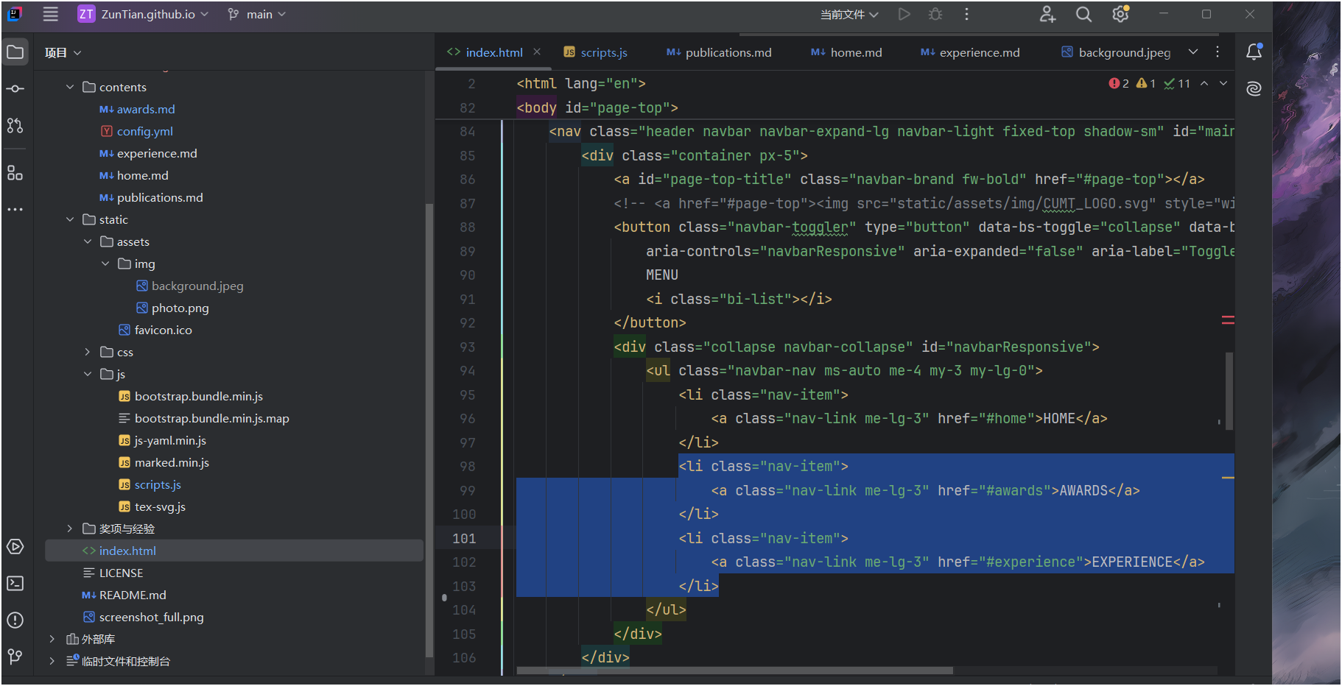

<!-- Awards -->

<section class="bg-gradient-primary-to-secondary-light mt5 md5" id="awards">

<div class="container px-5">

<header>

<h2 id="awards-subtitle"><i class="bi bi-award-fill"></i>AWARDS </h2>

</header>

<div class="main-body" id="awards-md"></div>

</div>

</section>

<!-- Awards -->

<!-- Experience -->

<section class="bg-gradient-primary-to-secondary-dark mt5 md5" id="experience">

<div class="container px-5">

<header>

<h2 id="experience-subtitle"><i class="bi bi-briefcase-fill"></i> EXPERIENCE </h2>

</header>

<div class="main-body" id="experience-md"></div>

</div>

</section>

<!-- Experience -->

