COMP 6771 Image Processing

Course Project

Zunao Hu

40232982

Part I: review of Two papers on Retinal vessel extraction

The automated extraction of vessels in retinal images holds great potential in facilitating computer-aided diagnosis and treatment of common eye diseases.[1]In their respective studies, Bob Zhang et al. and Eysteinn Már Sigurðsson et al.[2] proposed distinct methods for retinal vessel extraction. Zhang introduced a novel method utilising the matched filter(MF) with first-order derivative of Gaussian(FDOG), whereas Sigurðsson presented an information fusion method, combining the local minimum features and edge detection, to leverage the two essential vessel properties. Both of their researches demonstrated high accuracy and robust performances, offering innovative ideas to the field. Furthermore, compared to other methods, theirs maintained low computational costs.

The main process of their approaches can be seen in the following charts. Zhang used a Matched filter on the retinal image, and used its response to the FDOG function to adjust and apply the threshold on the filtered image. After preprocessing, Sigurðsson used information fusion to combine the responses of images to local minimum detection and edge detection, and applied classification to obtain the results.



Both approaches included performance demonstrations on the DRIVE database, employing accuracy metrics presented in clear tables. Additionally, both studies include the presentation of Receiver Operating Characteristic (ROC) curves. Sigurðsson further provides tables displaying the outcomes of the parameter tuning process, showcasing the achieved optimized accuracy.

On the DRIVE database, Sigurðsson’s method has achieved higher accuracy. It could be attributed to the presence of both healthy and pathological images in the DRIVE database, where Zhang's method may exhibit a lesser advantage in handling healthy cases. Another reason could be the difference in the emphasis of feature extraction. Zhang attempted to leverage the symmetric characteristics of vessels and their response to FDOG, and Sigurðsson concentrated on features related to darker appearances and edges. In the case of the DRIVE database, the latter might have suited better. In addition, the preprocessing step in Sigurðsson’s method may mitigate the influence of noise on the final accuracy.

Reference:

[1] Bob Zhang, Lin Zhang, Lei Zhang, Fakhri Karray,

Retinal vessel extraction by matched filter with first-order derivative of Gaussian,

Computers in Biology and Medicine,

Volume 40, Issue 4,

2010,

Pages 438-445,

ISSN 0010-4825,

https://doi.org/10.1016/j.compbiomed.2010.02.008.

[2] Eysteinn Már Sigurðsson, Silvia Valero, Jón Atli Benediktsson, Jocelyn Chanussot, Hugues Talbot, Einar Stefánsson,

Automatic retinal vessel extraction based on directional mathematical morphology and fuzzy classification,

Pattern Recognition Letters,

Volume 47,

2014,

Pages 164-171,

ISSN 0167-8655,

https://doi.org/10.1016/j.patrec.2014.03.006.

Part II: re-implementation of the main algorithm of paper 1.

Result Demonstration:

For better calculating the accuracy, the cropping has been done to compare only the Region of Interest.

(1) Train_21

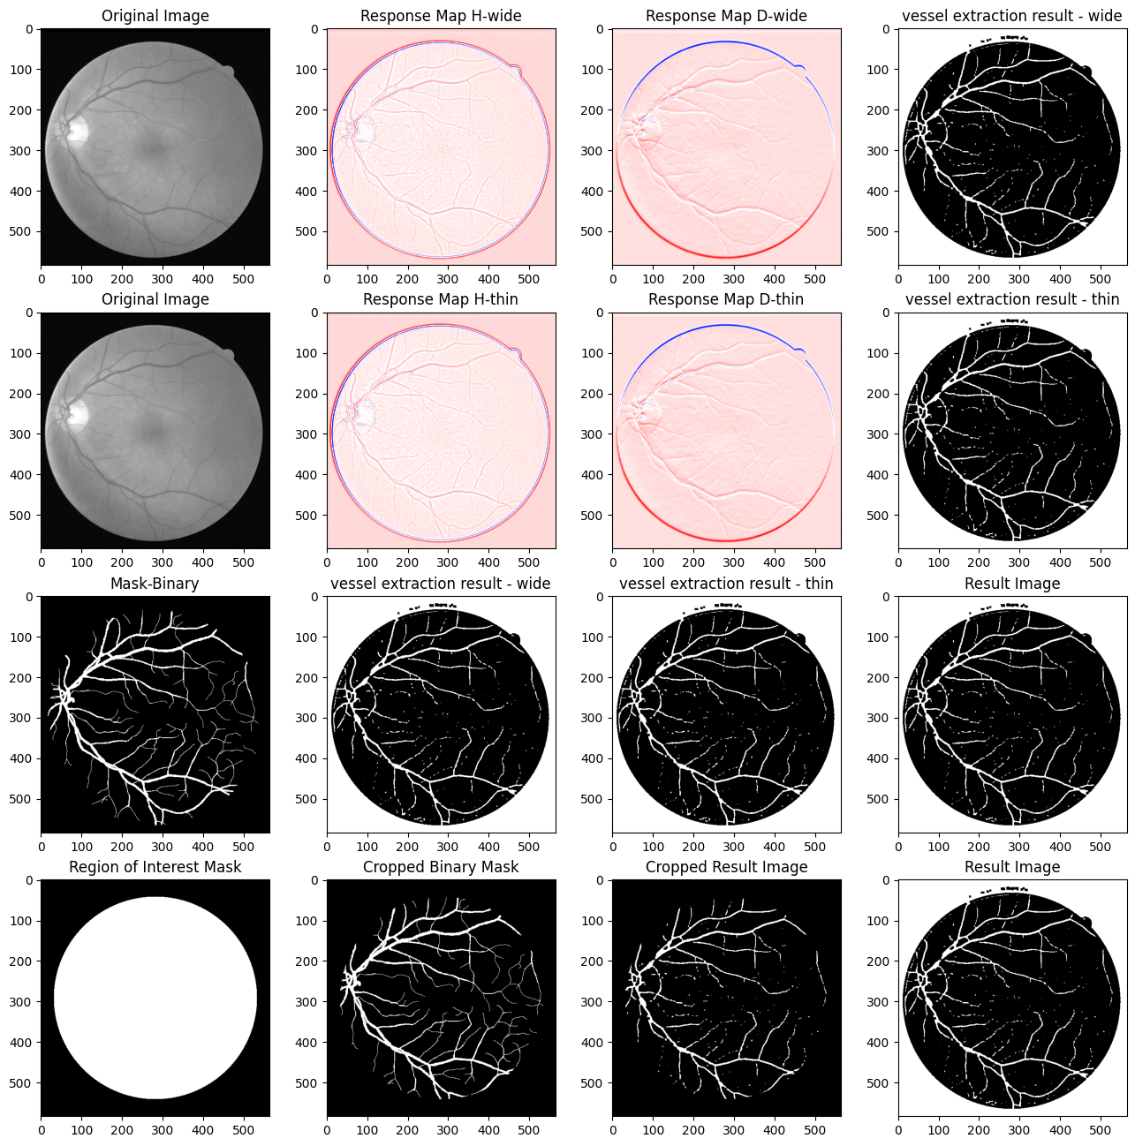

Figure 1. Processing of training image 21

(2) Train_22

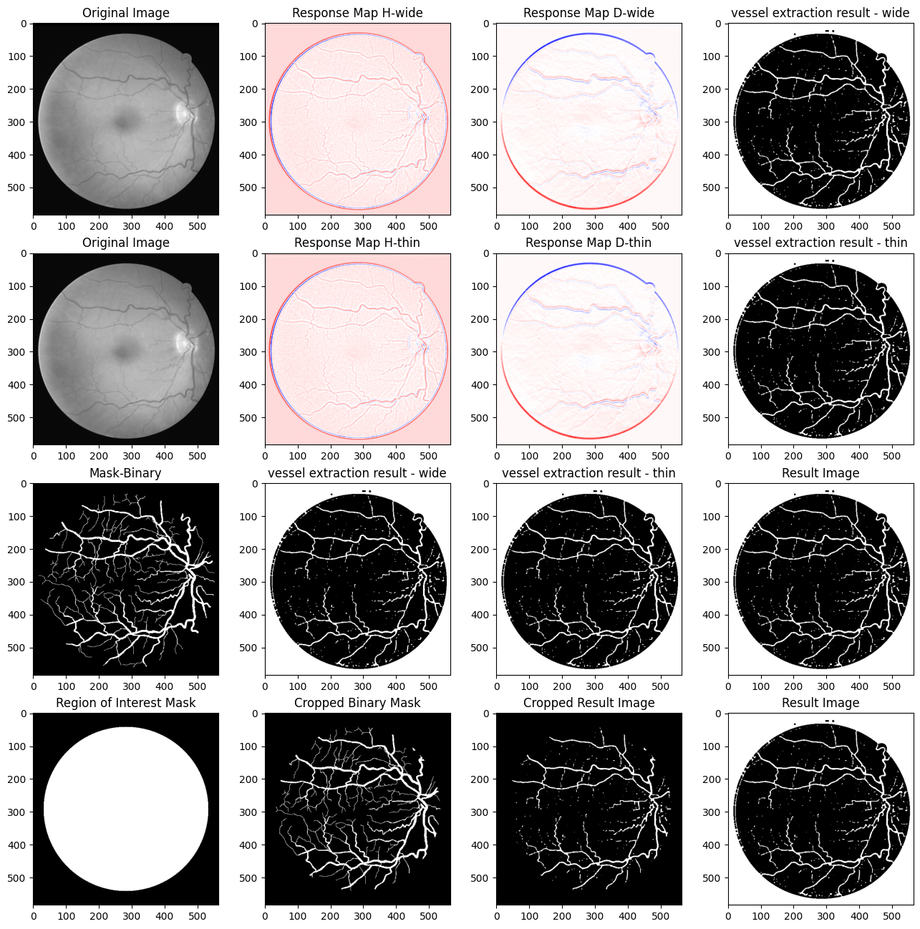

Figure 2. Processing of training image 22

(3) Train_23

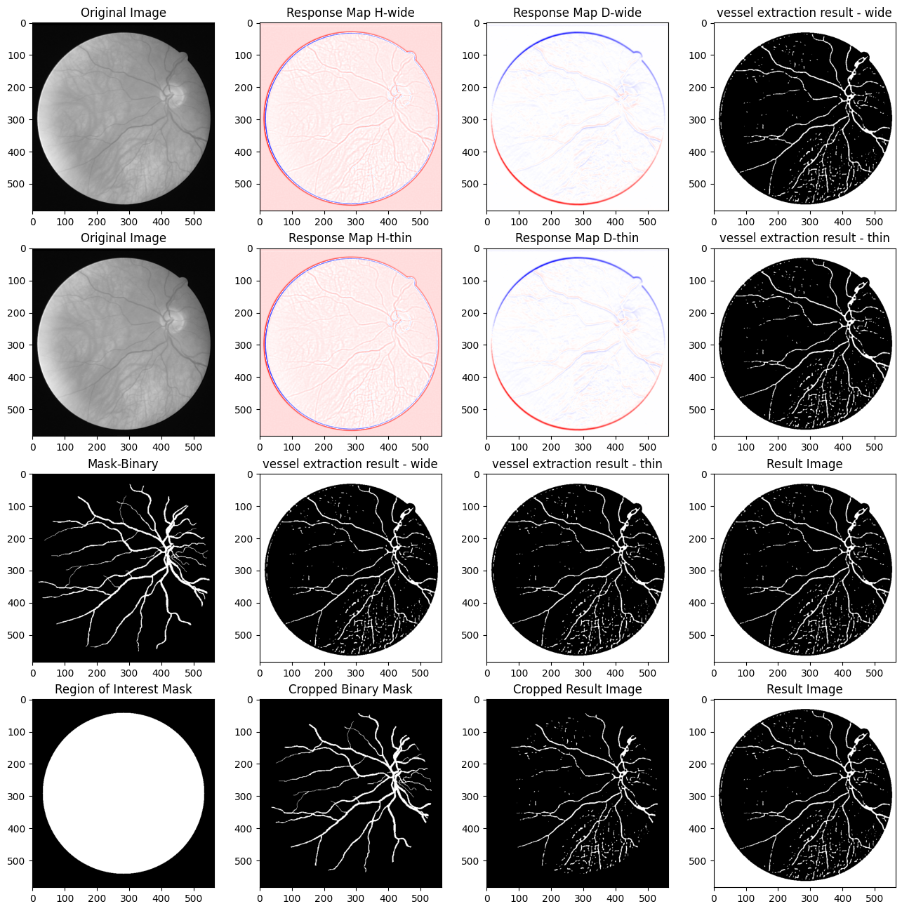

Figure 3. Processing of training image 22

Validation:

(1) Performance evaluation:

Since the training images and the mask images can be found in the DRIVE dataset, five pairs of images have been selected and processed using the method mentioned in the paper.

By selecting a circular region of interest and comparing the values of the result image and mask image within that region, we can calculate the True Positive Rate(TPR), False Positive Rate(FPR) and accuracy of our results.

| **Image number** | **TPR** | **FPR** | **Accuracy** |
| --- | --- | --- | --- |
| 21 | 60.90% | 1.12% | 94.45% |

Table 1. TPR, FPR and accuracy of training image 21

(2) Parameter tunings

We can try tweaking the values of different parameters to see how it impacts the performance of our system. Attempts to tweak the sigma(s) and L have been done, but it turns out that the change is not quite obvious. Therefore, we select threshold adjusting constant c, size of mean filter W in adaptive threshold, and the number of rotating matched filters for our parameter tuning.

Nine sets of parameter tuning are performed and the results are as follows:

| **Parameter** | **Image 21** | **22** | **23** | **24** | **25** | **Average** |
| --- | --- | --- | --- | --- | --- | --- |
| c = 0.4  W: 31  Rotation = 16 | 94.45% | 92.75% | 93.66% | 90.16% | 90.52% | 92.31% |
| c = 1  W:31  Rotation = 16 | 84.50% | 83.27% | 81.61% | 88.71% | 82.56% | 84.13% |
| c = 2  W:31  Rotation = 16 | 15.34% | 18.29% | 13.17% | 21.23% | 18.87% | 17.38% |
|  | | | | | | |
| c = 0.4  W = 19  Rotation =16 | 94.47% | 92.77% | 93.66% | 90.19% | 90.53% | 92.32% |
| c = 0.4  W = 31  Rotation = 16 | 94.45% | 92.75% | 93.66% | 90.16% | 90.52% | 92.31% |
| c = 0.4  W = 43  Rotation = 16 | 94.46% | 92.76% | 93.64% | 90.19% | 90.52% | 92.31% |
|  | | | | | | |
| c = 0.4  W = 31  Rotation = 8 | 58.12% | 60.94% | 57.63% | 69.52% | 58.23% | 60.89% |
| c = 0.4  W = 31  Rotation = 16 | 94.45% | 92.75% | 93.66% | 90.16% | 90.52% | 92.31% |
| c = 0.4  W = 31  Rotation = 32 | 94.45% | 92.75% | 93.66% | 90.16% | 90.52% | 92.31% |

Table 2. Results of parameter tuning

The value of c is best when it is smaller than the value…

W impacts the quality of extraction, but not much…

We can see that fewer rotations results in…, probably because…

More rotations also …, probably because…

(3) Comparison:

Comparing with other methods in the paper(I am just gonna use the tables in the paper)

Discussion: give reasons why our implementation is worse/better.

| **Method** | **Accuracy** |
| --- | --- |
| 2nd Humanobserver | 0.9473 |
| Staal | 0.9442 |
| Soares | 0.9466 |
| Matched filter | 0.9284 |
| Martinez-Perez | 0.9344 |
| Zhang’s implementation | 0.9382 |
| Our implementation | 0.9231 |

Table 3. Comparison with other methods

Discussion:

(1) The pros of the implemented method:

a. The method is concise and efficient. There is no training required, so that running time is shorter than methods like neutral networks.

b. The processes of applying MF filter and FDOG filter are pretty similar, which saves some work for the implementation part.

c. It has achieved relatively high performances in case of accuracy. The algorithm has successfully segmented the structural information of retinal vessels.

(2) The cons of the implemented method:

a. It does not deal with noise very well. Could be because of the fact that the method does not include any preprocessing steps or denoising strategies.

b. It could use some post-processing like closing.

c. The two sets of filters for wide and thin vessel extractions do not show apparent differences in performance when applied on the DRIVE dataset. …

(3)The main difficulties in the reimplementation process:

a. There are no descriptions on the preprocessing step. In the paper, the given example outcomes show great performance despite the noise that is present in the input images. However, in our case, the influence of noise can still be seen. I have tried using a median filter to get rid of it, but it turns out even small median filters are likely to erase part of thin vessels. Therefore, it would show better outcomes if the author can show how he did preprocessing to deal with that.

b. There are not enough details given in the paper about how the matched filter is applied. Zhang mentioned in his paper that he rotated the matched filter but did not specify how many rotations he did to achieve the best outcomes.

c. Not all the parameters Zhang recommended work the best on the test retinal images. For example, when the parameter c, which controls the thresholding, is set as the author’s reference value, the outcomes will be mostly black, meaning the thresholding value is set too high and most of the information has been erased. After changing c to around 0.4, the results are much better.

Another example is that the two sets of matched filters, which are designed to focus on extracting wide vessels and thin vessels respectively, do not show very different performances on their own tasks. Both have similar performances extracting both thin and wide vessels. Even after tweaking the parameters of both filters, the outcomes do not change very much.

d. There are multiple variations of the DRIVE datasets. …