**Real Time Sign Language Detection for Deaf and Mute using OpenCV and CNN**

Kartik Tripathi, Md Zunad Alam Department of Computer Science Sharda University,

Greater Noida

Shursti Sanket, Gunjan Aggarwal Department of Computer Science Sharda University,

Greater Noida

**Abstract-** **According to World Health Organization, over 5% of the world’s population have hearing and speaking disabilities. The main form of communication for deaf and mute people is sign language. This may make it difficult for them to communicate on a daily basis. To overcome this difficulty, sign language may be translated into text. The proposed system is designed to recognize American Sign Language and translate it into text. A picture of a hand writing the necessary alphabet is fed into the system as input. The histogram of the input image is then calculated using the Bhattacharyya Distance Metric, and it is compared to the statistical features of previously saved images. The proposed system processes images using OpenCV as a tool. After checking the related letter of the images whose histogram resembles the input image's the most, the associated letter is printed. The system's adoption will be a minor step towards eradicating the social communication gap that exists between sign language non-users and deaf-mute users.**

**Keywords:** Convolutional Neural Network (CNN), Computer Vision, Hand Gesture, Deaf people, Sign language Recognition (SLR), ISL (Indian Sign Language),

1. **INTRODUCTION**

Sign language detection is the process of recognizing and interpreting sign language gestures in order to translate into written language. This technology is particularly useful for facilitating communication between deaf or hard of hearing individuals and those who do not know sign language. There are many different sign languages in use around the world, each with its own grammar and

vocabulary. Some of the most widely used sign languages include American Sign Language (ASL), British Sign Language (BSL), and Indian Sign Language (ISL). There are several different methods for sign language detection, including using computer vision techniques to detect and recognize hand and body movements, and machine learning algorithms to interpret and translate the gestures into written or spoken language. Computer vision techniques involve analyzing video footage or images of the signer and tracking the movement of the hands and body. This can be done using various types of sensors such as cameras and depth sensors, and by applying techniques such as image processing and pattern recognition. Machine learning algorithms are trained on large datasets of sign language gestures to learn how to recognize and interpret different signs. These algorithms use various techniques such as deep learning and natural language processing to recognize and translate the signs into text or speech. Sign language detection has the potential to revolutionize the way that deaf and hard of hearing individuals communicate with the hearing world[1]. Additionally, it can be applied to increase accessibility in a range of contexts, including healthcare, education, and public transportation. However, there are still challenges in the development of this technology, such as the need for more robust and accurate detection algorithms, and the need for greater standardization of sign language vocabulary and grammar. Learning sign language is a valuable skill for anyone looking to communicate with deaf or hard of hearing individuals, and it can also be a way to enhance communication skills in general. Many resources are available to help individuals learn sign language, including books, online courses, and classes offered through community organizations and schools.

1. **RELATED WORK**

Sign language detection is an active area of research, and there have been many studies and projects aimed at developing more accurate and effective methods for recognizing and interpreting sign language gestures. Researchers have identified a variety of hand gestures using a variety of methodologies that were used in a variety of fields. Several techniques were employed to recognize various hand movements, along with vision-based methods, data glove-based methods, soft computing techniques like neural networks and genetic algorithms, and other techniques like PCA and canonical analysis. The three major categories of recognition techniques are methods for hand segmentation, methods for extracting features, and methods for gesture recognition. This study presents the conventions of American Sign Language through the use of an accelerometer and semi-structured data[2]. It belongs to "deaf culture" and contains a unique system of inside jokes, puns, etc. It is really comprehending someone's speech is challenging English speaker who is Japanese. The Swedish sign language is ASL speaker finds it extremely challenging to understand. ASL consists of over 6000 gestures for everyday speech using finger spelling employed to convey cryptic words also proper nouns. The communication gap between the silent group and the rest of society is reduced by the "Hand gesture detection and speech converter system for stupid people" proposal[3]. The proposed approach translates voice into language. Some examples of related work in sign language detection include:

**Hand Gesture Recognition:** Many researchers have focused on developing computer vision techniques for recognizing hand gestures in sign language. This involves analyzing video footage of a signer and tracking the movement of the hands, fingers, and other body parts to detect and recognize specific signs. Techniques used in this area of research include optical flow analysis, feature extraction, and machine learning algorithms.

**Sign Language Translation:** In addition to detecting and recognizing sign language gestures, researchers have also focused on developing systems that can translate these gestures into spoken or written language. This involves using machine learning algorithms and natural language processing techniques to analyses the gestures and convert them into text or speech.

**Wearable Technologies:** Another area of research in sign language detection involves the use of wearable technologies such as gloves and wristbands to track hand and finger movements in real-time. These technologies can be used to provide more accurate and real-time sign language recognition, making it easier for deaf and hard of hearing individuals to communicate with the hearing world.

**Sign Language Datasets:** To support the development of sign language detection algorithms, researchers have also created large datasets of sign language gestures. These datasets are used to train and test machine learning algorithms, and they help researchers to better understand the complex grammar and syntax of sign language.

Overall, there is a significant amount of ongoing research and development in sign language detection, and the field is expected to continue to grow as new technologies and algorithms are developed.

1. **LITERATURE SURVEY**

**Mr. J. J et al.,** [4] The authors discussed various hand gesture and sign language detection and recognition that have been put forth in the past by numerous researchers. For the dumb and the deaf, sign language is their sole form of communication. These persons with physical disabilities use sign language to express their emotions and ideas to others.

**Sruthi, R Rao et al.,** [5] With the help of this study's work, average people can use a sample hand gesture detection system to better connect with special persons. The aforementioned research work is concerned with the problem of real-time gesture identification in the sign language used by the deaf community. The problem is based on the processing of images and utilizes Color Classification, Skin Detection, Segmentation Methods, Picture Filtering, and Feature Matching techniques. This system recognizes gestures from American Sign Language (ASL), including the letters and some of its sentences.

**Pramada, Sawant** **et al.,** [6] The barrier that is put up between people who are disabled or handicapped and the average person is one of our society's biggest flaws. The only method we can disseminate ideas or a statement is through interaction, yet those who have disabilities (such those who are deaf or foolish) find it challenging to interact with others in a typical way. Many people who are deaf or dumb rely on sign language as their primary form of communication. To make it easier for the deaf to interact with the hearing community, sign language recognition (SLR) tries to automatically translate sign languages. With the aid of the SURF method and image processing, this method recognizes and extracts hand 23 motion features. MATLAB software is used for all of this work. This method makes it simple to instruct a deaf and mute individual.

**Arora et al.,**[7] A technique for image processing (the identification of skin and marker pixels) has been utilized to recognize English alphabetic sign language without needing the hand to be exactly aligned to the camera. This system uses a simple and highly accurate coordinate computation, color calibration, and pattern matching algorithm for segmentation, the threshold used to extract features, and recognition. However, users must wear a particular colour band on their fingers.

**Rugia S.T. Kamal et al.,**[8] The overall goal of the project is to make communication simpler between regular people and persons who are deaf or dumb by accurately translating sign language to voice or text. The mute and the deaf communicate through sign language, but it can be confusing to anyone who are not familiar with it. Therefore, a gadget that can convert gestures into speech and text must be created. This will be a big step in enabling deaf and mute persons to interact with the general public.

**Tahir Khan** **et al.,**[9] The application of contemporary methods considerably broadens the potential applications of conventional microscopic techniques in the forensic area, enabling the collection of essential quantitative data in forensic studying the pedological phases and identifying the mineral phases, or the option of organic phase analysis directly in the SEM chamber.

**Cao dong et al.,**[10] In this study, the researcher recognized American sign language using Microsoft Kinect. A depth camera serves as the Kinect sensor in order to recognize the ASL alphabet. A distance adaptive technique was applied during the feature extraction procedure. Support vector machine and RF classifier methods are employed for classification. The data was trained using an ANN network.90% of the time, the system was accurate.

**Manisha U. Kakde et al.,**[11] In the paper, it was discussed how body language and manual gestures have been used to develop sign language recently. The three processes that the majority of sign language recognition systems incorporate are pre-processing, extraction of features, and classification. Scale-invariant feature transforms (SIFT), neural networks (NN), support vector machines (SVM), and others are classification techniques used for recognition.

**K. Dixit et al.,**[12] The approach for automatic sign recognition utilizing shape-based characteristics is described in this study. The hand region is separated from the images using Otsu's thresholding method, which selects an optimal threshold to reduce the variance of threshold black and white pixels within a class. Hu's invariant moments are used to split the hand region, and its features are computed. These features are then fed into an artificial neural network for categorization. The system's performance is evaluated using Accuracy, Sensitivity, and Specificity.

**A. Y. Dawod et al.,**[13] Using Indian sign language, the author of this essay suggested a system that would convert hand gestures into the appropriate text messages to enable communication between hearing people and deaf and dumb people (ISL). After testing is finished, the system will be put into use on the Android operating system and made accessible as an application for mobile devices like smartphones and tablets. The main objective is to develop an algorithm that can instantly translate dynamic gesture to text.

**P. R. Kumar et al.,**[14]The approach suggested in includes separating the hand motions from the original colour visuals. Using the Chan-Vese (CV) active contour model, the segmented hand positions' shape was manipulated, yielding a 92.1% identification rate.

**A. G. Ambekar et al.,**[15]A feature matrix with elliptical Fourier descriptors was constructed from the segmented hand motions and extracted forms, and an artificial neural network trained on the back propagation approach was used to classify the features. The suggested 4 camera model's average recognition rate for sign language recognition is around 92.23%.

**M. Kumar et al.,**[16]The most effective approach for transliterating 24 static ASL alphabet movements is demonstrated in this research study (“Letter J and Z are not included since they need hand movement”). The translation of 10 fixed ASL number motions into English text and handling of video pixels are therefore required. The main goal is to make a humanoid or machine-readable English document out of 24 fixed ASL alphabets and numerals.

1. **PROPOSED WORK**

The proposed system's framework is depicted in Fig. 1. As shown in Figure 1, the suggested system is divided into three phases: training, testing, and recognition. During the training phase, a multi-class supported vector machine is used to train each class (SVM). Human object moment and structural form descriptors are integrated to produce a combinational feature representation from the input data in the testing phase after pre-processing. Throughout the recognition stage, a variety of classes are employed to evaluate an input gesture. The outcome with the most probable group is chosen in order to identify the gesture. Following recognition, the meaning of the training images is ultimately shown on the screen. After the input image has been recognized, its meaning is finally shown on the screen.

**Data Collection:** The first step in sign language detection is to collect data. This can involve recording videos of sign language gestures using a camera or a sensor, or collecting data from wearable technologies such as gloves or wristbands that track hand and finger movements.

**Data Pre-processing:** Once the data has been collected, it needs to be pre-processed. This involves cleaning the data, removing noise, and normalizing the data to ensure that it is consistent and can be used effectively for analysis.

**Feature Extraction:** Feature extraction involves identifying the key features in the sign language gestures that can be used for analysis. This can involve identifying the shape and movement of the hands and fingers, as well as other body movements that are important for sign language recognition.

**Model Development**: After the data has been pre-processed and the key features have been extracted, machine learning algorithms can be used to develop a model for sign language detection. The choice of algorithm depends on the specific task and the available data. Popular algorithms include Convolutional Neural Networks (CNNs), and Support Vector Machines (SVMs).

**Model Training and Validation:** The model must then be trained and validated using the supplied data. By splitting the information into two separate data sets, On the training dataset, the approach was developed, and the testing set can be used to evaluate its performance. This process can be repeated multiple times to fine-tune the model and improve its accuracy.

**Model Deployment:** The model can be implemented for usage in practical applications after being trained and validated. This can involve integrating the model into a mobile application, a wearable device, or other assistive technologies.

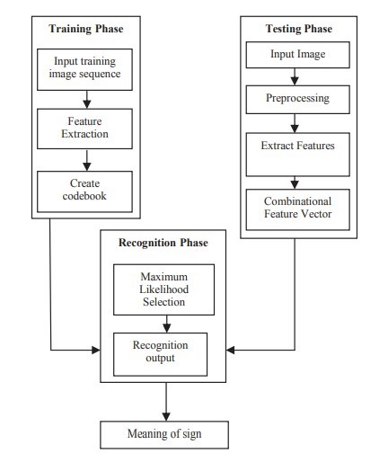**Model Evaluation:** Finally, it is necessary to assess how well the model is working. This involves testing the model on new data and measuring its accuracy and other performance metrics. This feedback can be used to further improve the model and make it more accurate and effective for sign language detection.

**Fig.1.Block Diagram of sign language recognition system**

1. **ALGORITHMS**

There are several algorithms and techniques used in sign language detection, including computer vision and machine learning. Here are some of the commonly used algorithms for sign language detection:

**Convolutional Neural Networks (CNN):**

Convolutional neural networks, sometimes known as deep neural networks Artificial neural networks, largely utilized for categorization of photos, grouping them in accordance with their resemblance and is capable of recognizing objects. These Algorithms can recognize people, street signs, objects, cancers, and other features of visual information. Using convolutional networks to capture text, use the optical character recognition (OCR). It enables analogue and digital devices to process natural language papers that have been handwritten and contain symbols for pictures be written down. The introduction of LeNet architecture will executed using Convolutional architecture[17]. CNN represents significant developments in computer vision (CV), and applications for robots, drones, security, and self-driving automobiles medical evaluations and therapies for those who are blind.

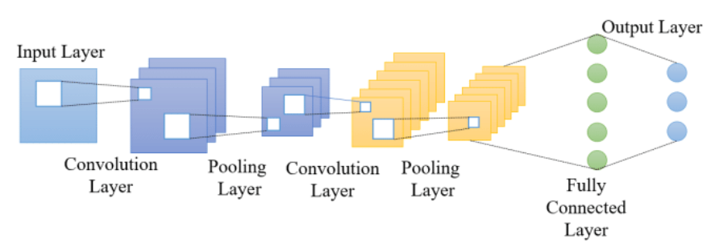

**Fig.2.Architecture of CNN**

**Deep Learning:** A part of machine learning called deep learning includes teaching neural networks that are artificial to learn from a lot of data. It is a potent method for resolving challenging issues in fields including speech recognition, processing natural languages, and computer vision. Deep learning's capacity to dynamically learn complex features from input information, without the need for manual data engineering, is one of its main advantages. Machine learning algorithms can now do tasks like object recognition and image categorization better than human specialists, which has led to advancements in fields like image recognition.

**Support Vector Machines (SVMs):** Machine learning algorithms of the SVM variety are employed for categorization jobs. In sign language detection, SVMs can be used to classify the sign language gestures into different categories based on the features extracted from the video footage or images.

**Haar Cascade Classifiers:** Haar Cascade Classifiers are a computer vision technique used for object detection. In sign language detection, Haar Cascade Classifiers can be used to detect and recognize the hand and body movements in the video footage.

**Random Forests:** Several decision trees are combined in the Random Forests ensemble learning process to increase classification accuracy. Random Forests can be used in sign language recognition to categories the sign language motions based on the features collected from the video or picture data. These algorithms can be used in combination with each other, depending on the specific task and the available data. The accuracy and effectiveness of the algorithms depend on several factors, such as the quality of the data, the complexity of the sign language vocabulary and grammar, and the robustness of the detection algorithm.

1. **RESULT**

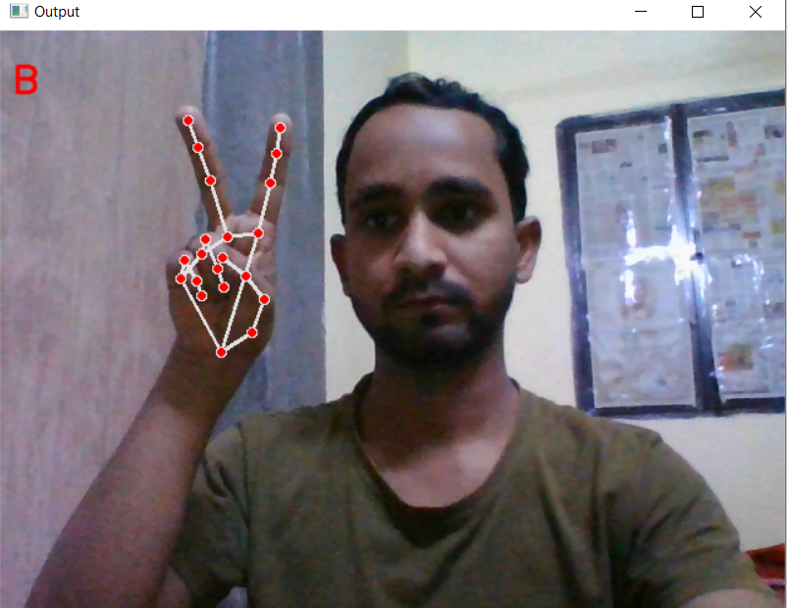

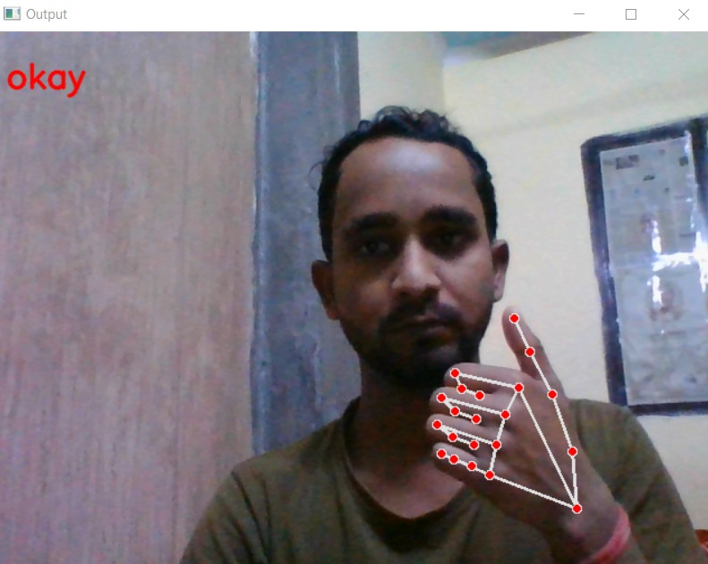

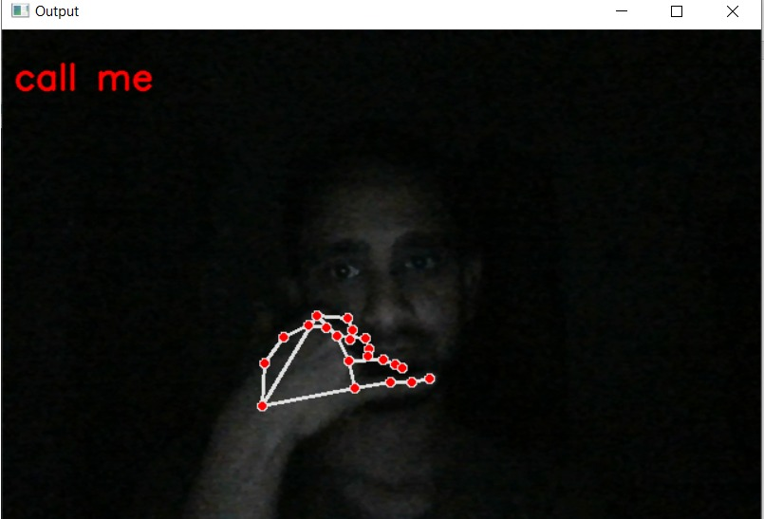

1. **CONCLUSION AND FUTURE WORK**

This review article examines a number of sign language recognition strategies based on sign acquisition methods and sign identification approaches. For sign analyses, vision-based approaches, and sign identification methods, artificial neuron networks make a good candidate. A method for comprehending a collection of produced signs and translating them into text or voice with the essential context is the Sign Language Recognition (SLR) system. Successful human-machine interactions could serve as a demonstration of the significance of gesture recognition. In this study, we tried to create a convolutional neural network-based model. Because of this, the accuracy rate is roughly 95%. Future work should improve the Image Processing component to enable two-way interaction, i.e., the system should be able to translate between sign language and standard language and the other way around.

**REFERENCES**

[1] A. Thakur, P. Budhathoki, S. Upreti, S. Shrestha, and S. Shakya, “Real Time Sign Language Recognition and Speech Generation,” *J. Innov. Image Process.*, vol. 2, no. 2, pp. 65–76, Jun. 2020, doi: 10.36548/jiip.2020.2.001.

[2] D. Golekar, R. Bula, R. Hole, S. Katare, S. Parab, and A. Professor, “SIGN LANGUAGE RECOGNITION USING PYTHON AND OPENCV,” *www.irjmets.com @International Res. J. Mod. Eng.*, 1179, [Online]. Available: www.irjmets.com

[3] P. V. V. Kishore, M. V.D. Prasad, C. R. Prasad, and R. Rahul, “4-Camera model for sign language recognition using elliptical fourier descriptors and ANN,” *Int. Conf. Signal Process. Commun. Eng. Syst. - Proc. SPACES 2015, Assoc. with IEEE*, no. April, pp. 34–38, 2015, doi: 10.1109/SPACES.2015.7058288.

[4] M. J. J. Godwin, P. S, N. S, and S. S. R, “Support Vector Machine based Image Classification for Deaf and Mute People,” *Int. J. Adv. Eng. Res. Sci.*, vol. 5, no. 4, pp. 46–52, 2018, doi: 10.22161/ijaers.5.4.7.

[5] R. Sruthi, B. V. Rao, P. Nagapravallika, G. Harikrishna, and K. N. Babu, “Vision Based Sign Language By Using Matlab,” pp. 3–6, 2018.

[6] S. Pramada, “Intelligent Sign Language Recognition Using Image Processing,” *IOSR J. Eng.*, vol. 03, no. 02, pp. 45–51, 2013, doi: 10.9790/3021-03224551.

[7] S. Arora and A. Roy, “Recognition of sign language using image processing,” in *International Journal of Business Intelligence and Data Mining*, 2018, vol. 13, no. 1–3, pp. 163–176. doi: 10.1504/IJBIDM.2018.088428.

[8] “View of A Hand Gesture Recognition System for Deaf-Mute Individuals”.

[9] B. Tahir Khan under supervision of Amir Hassan Pathan, “Hand Gesture Recognition based on Digital Image Processing using MATLAB,” *Int. J. Sci. Eng. Res.*, vol. 6, no. 9, p. 338, 2015, [Online]. Available: http://www.ijser.org

[10] C. Dong, M. C. Leu, and Z. Yin, “American Sign Language alphabet recognition using Microsoft Kinect,” *IEEE Comput. Soc. Conf. Comput. Vis. Pattern Recognit. Work.*, vol. 2015-Octob, no. April 2020, pp. 44–52, 2015, doi: 10.1109/CVPRW.2015.7301347.

[11] Manisha U. Kakde, Mahender G. Nakrani, and Amit M. Rawate, “A Review Paper on Sign Language Recognition System For Deaf And Dumb People using Image Processing,” *Int. J. Eng. Res.*, vol. V5, no. 03, pp. 590–592, 2016, doi: 10.17577/ijertv5is031036.

[12] K. Dixit and A. S. Jalal, “Automatic Indian Sign Language recognition system,” *Proc. 2013 3rd IEEE Int. Adv. Comput. Conf. IACC 2013*, no. February 2013, pp. 883–887, 2013, doi: 10.1109/IAdCC.2013.6514343.

[13] A. Y. Dawod, “Hand Gesture Recognition based on Isolated and Continuous Sign Language,” no. September, pp. 1–11, 2018.

[14] P. V.V and P. R. Kumar, “Segment, Track, Extract, Recognize and Convert Sign Language Videos to Voice/Text,” *Int. J. Adv. Comput. Sci. Appl.*, vol. 3, no. 6, 2012, doi: 10.14569/ijacsa.2012.030608.

[15] U. Patel and A. G. Ambekar, “Moment Based Sign Language Recognition for Indian Languages,” *2017 Int. Conf. Comput. Commun. Control Autom. ICCUBEA 2017*, pp. 1–6, 2018, doi: 10.1109/ICCUBEA.2017.8463901.

[16] M. Kumar, “Conversion of Sign Language into Text,” *Int. J. Appl. Eng. Res.*, vol. 13, no. 9, pp. 7154–7161, 2018, [Online]. Available: http://www.ripublication.com

[17] T. D. Sajanraj and M. V. Beena, “Indian Sign Language Numeral Recognition Using Region of Interest Convolutional Neural Network,” *Proc. Int. Conf. Inven. Commun. Comput. Technol. ICICCT 2018*, no. Icicct, pp. 636–640, 2018, doi: 10.1109/ICICCT.2018.8473141.