# Power BI in Teams for End Users

# Creating a Power BI Report

Introduction

In this lab, you will use the auto create report feature in Power BI in Teams to create a report. Data will come from a [[Financial Sample spread sheet](https://view.officeapps.live.com/op/view.aspx?src=https%3A%2F%2Fdownload.microsoft.com%2Fdownload%2F1%2F4%2FE%2F14EDED28-6C58-4055-A65C-23B4DA81C4DE%2FFinancial%2520Sample.xlsx&wdOrigin=BROWSELINK)](https://go.microsoft.com/fwlink/?LinkID=521962).

Objectives

After completing this lab, you will be able to:

* Auto-create a Report
* Update report to suit business requirements

Pre-requisites

* Confirm access to the Finance spreadsheet by visiting the link [Finance spreadsheet](https://go.microsoft.com/fwlink/?LinkID=521962)
* Obtain the credentials the instructor assigned to you
* Teams installed in your workstation

Estimated Time

30 Minutes

## Exercise 1: Open Power BI app in Team

In this exercise, you will access Power BI app through Teams.

### Tasks

1. Open Teams Application and sign in using the credentials provided.
2. Select **More added apps (...)** in the left navigation bar, then search for and select **Power BI**.

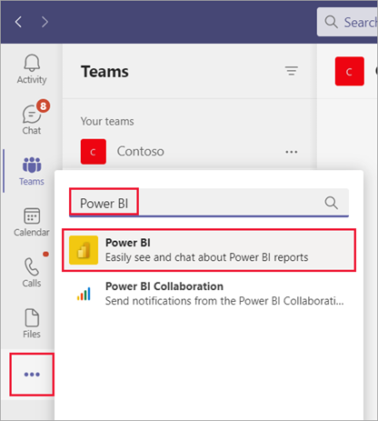

1. To keep the app available in Teams, pin it to the Teams navigation pane by right clicking the Power BI icon in the Teams navigation pane, and select Pin.

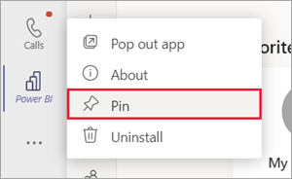

1. Now, click the Power BI app icon on the left navigation pane on Teams.

1. Notice Power BI Page will show. Pop out Power BI app in Teams by right clicking on the Power BI icon, and selecting “Pop out app”

1. Notice a new window pop up, showing Power BI. Maximise the new window.

### Congratulations!

You have successfully completed this exercise.

## Exercise 2: Create a Workspace

In this exercise, you will create a workspace to host Power BI content on.

### Tasks

1. To create a new workspace, click on the Workspaces selection from the navigation bar on the left. Then select Create a workspace

1. When prompted, input the below. Then click Save.

Workspace name: PBI Workshop Initials

1. Notice a new workspace created.

### Congratulations!

You have successfully completed this exercise.

## Exercise 3: Creating a Power BI Report

In this exercise, you will auto-generate a report connecting to data from excel.

### Tasks

1. Click on the Home selection on the navigation on the left.

1. To create a report, click on the  icon on the Home page.
2. From the selection, click on “Paste or manually enter Data”

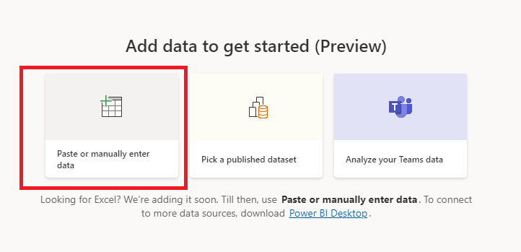

1. Open the link [Finance spreadsheet](https://go.microsoft.com/fwlink/?LinkID=521962), and copy columns A-P and rows 1-701. Paste into the input table, starting in the header row and change name to Sales data.

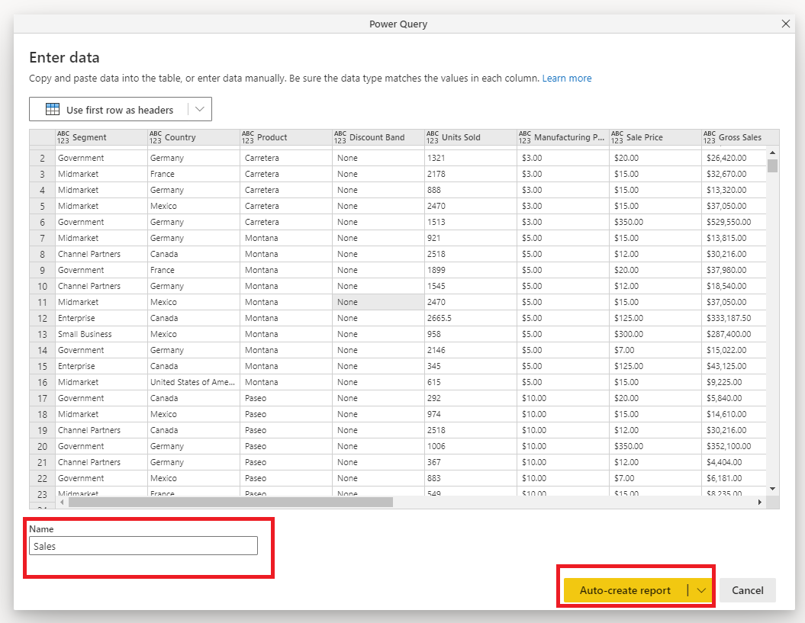

1. You should see the following auto-generated report

1. On the ribbon on the upper left corner, click **Save**.

1. When prompted, input and select the following:

Report name: Sales

Workspace: PBI Workshop [Initials]

Click Save.

### Congratulations!

You have successfully completed this exercise.

## Exercise 4: Personalise a visual in View Mode (Optional)

In this exercise, you will personalise a visual on view mode.

### Tasks

1. Notice the first visual on the left corner, which is “Sum of units sold by product” chart. We are interested in seeing the proportion of units sold by product but also by discount band instead.
2. To get this insight, hover on the upper right corner of the visual, and select the Personalize this visual icon  to change the chart type.
3. Under Visualisation type, select “100% stacked bar chart”

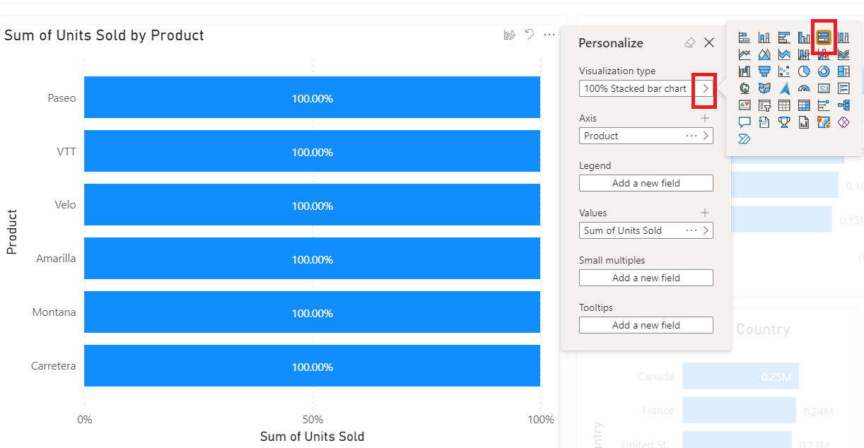

1. Then, add a legend, by double clicking “Add a new field” under Legend, and select “Discount band” from the field list option

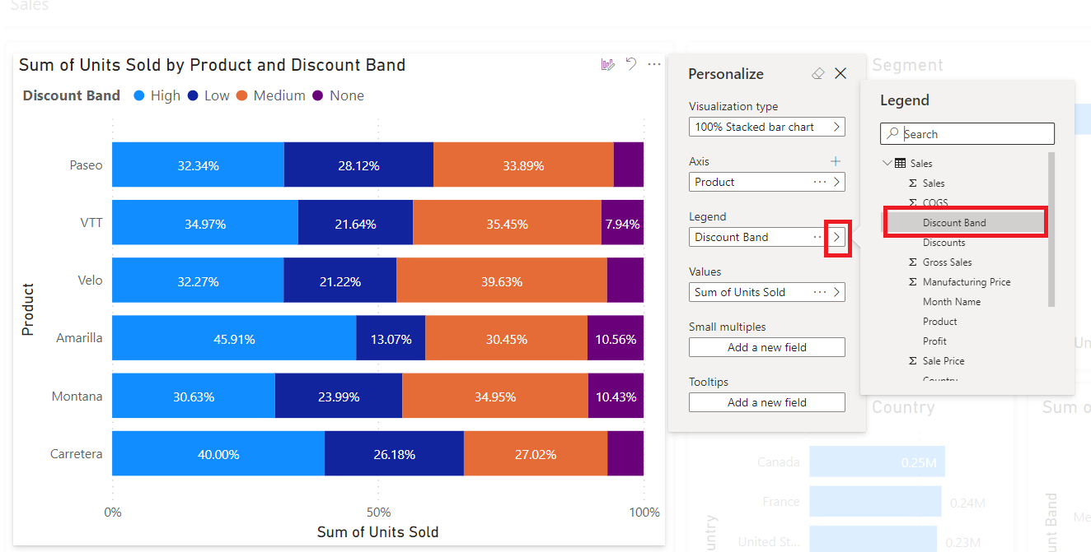

### Congratulations!

You have successfully completed this exercise.

## Exercise 5: Updating the Power BI Report (Optional)

In this exercise, you will further modify the auto-created report in the Power BI app in Teams in Edit Mode. You will explore reformatting visuals such as adjusting visuals’ colours and position based on the importance to the story we want to tell.

### Tasks

1. On the Power BI app in Teams, navigate to the Sales Summary report. Click on Edit.



1. When prompted to Switch to edit mode, click on Continue.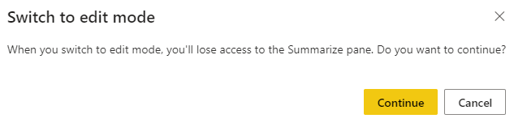
2. Notice that you are now in edit mode in Power BI
3. We want the focus to be on Country so resize Sum of Units Sold by segment visual to similar size of the visual below it.

1. Swap the positions of the visuals for Segment and Country:

1. Now we want to add narrative about the Sum of Units Sold by Country visual. Right click the units sold by country visual and click on Summarize:

1. Power BI will create a “Smart Narrative” for this visual. Place it next to the visual Sum of Units Sold by Country Visual.

1. Like the other Power BI visuals, the Smart Narrative visual is also dynamic depending on any filtering. Try filtering the Sum of Units sold to France by selecting the France bar on the visual. Notice the Smart Narrative visual change based on the filter applied.
2. Deselect the France bar on the visual.
3. Click on the Smart Narrative visual and notice that underlined elements are fully dynamic and linked to datapoints: Graphical user interface, application

   Description automatically generated
4. Add a title to the Smart Narrative Visual, by toggling On the Title property on the Visual Panel. Expand the Title property by clicking on it. Under Title Text, type “Summary”

1. Modify the color of the bars of the Sum of Units Sold by County visual. First, select the visual (1), and click on the Visual Format Pane (2) , expand Data colors (3)

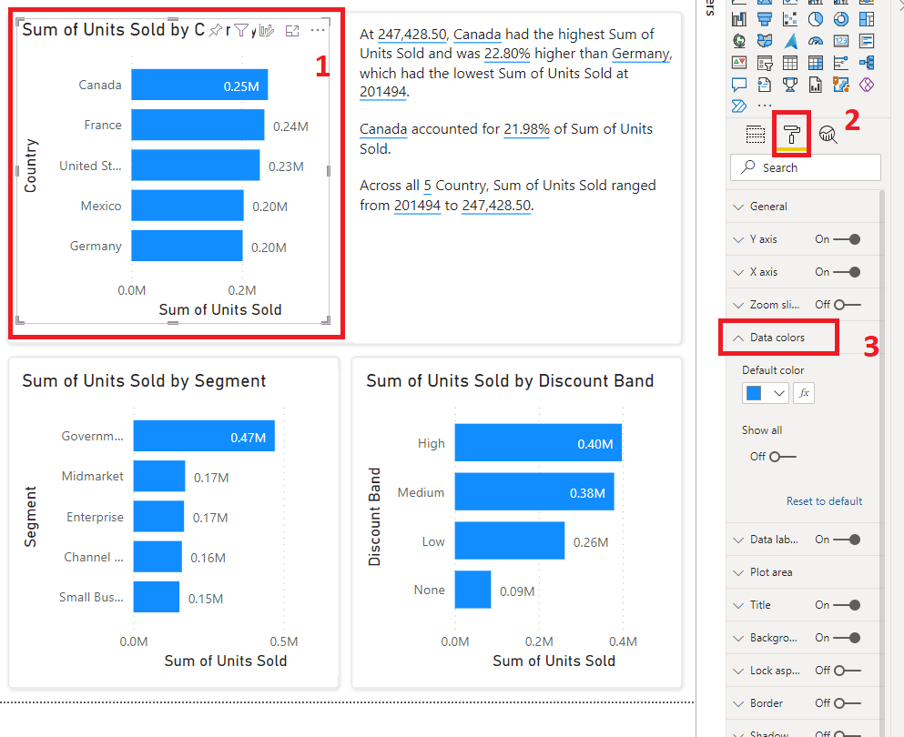

1. Select the Conditional Formatting, icon Graphical user interface, application

   Description automatically generated under Default Color.
2. Notice a pop show. Apply the selection as shown below:

Format by: Color Scale

Based on field: Units Sold

Summarisation: Sum

Minimum value color

Maximum Value color

Selection should match below:

Click OK.

1. On Format Pane, toggle the legend to turn off, as it is not needed when there are data labels in this case.

1. The Visual should look like below

1. Notice that we have one multi row card visual on the upper right corner of the report showcasing the total number of Units sold.

This is a good metric to show, but we also care about sales. Click this visual and add the Sales field to field well of the visual like below.

1. Resize the width of the visual to expand and show both sales and units sold

1. Add a slicer to the page

1. On the slicer, drop the Year field on the field well.
2. Ensure the Slicer type is a “List” by clicking on the dropdown on the upper right corner of the visual and selecting “List”.

1. Change the format of the slicer to Horizontal by click on the Visual pane, select Format options, and then expand General. Under Orientation, select Horizontal.

1. Resize the slicer, and position as below. See how it works by clicking each year

1. Rename the page by navigating to the page ribbon below on the report, and double click Page 1 and type “Summary” .

1. Let’s save our progress by clicking on the Save button.



### Congratulations!

You have successfully completed this exercise.

## Exercise 6: Enhancing the report (Optional)

In this exercise, you will create a second page on the report, this time exploring one of the visuals powered by AI and updating visual interactions.

### Tasks

1. Add a new page on your report by clicking on the + button A yellow square with a cross on it

   Description automatically generated with low confidence on the page ribbon. Rename the new page to “Sales Analytics”
2. Create a Line chart of Sales by Date by clicking on the chart on the Visual Pane. Graphical user interface, application

   Description automatically generated
3. On the field well of the added visual, drag the Date field into the Axis field well and the Sales field on the Values field well.

1. Change the Date hierarchy by clicking on the drop down arrow next to Date on the Axis field well and select Date.

1. Your visual should look like below. Resize accordingly.

1. Create a decomposition tree by clicking on Decomposition tree visual from the visualizations pane

1. Drag Sales into the “Analyze” field well, and Product, Segment, Country, Discounts band into the “Explain by” field well

1. On the visual, click the + icon next to Sales and navigate to High value.

Note that this visual uses AI capabilities to find the best category to split into. The light bulb denotes that AI is being used. This is good because it is dynamic with filtering, so in this example High value breaks out into segment by default, but if a filter is applied it can automatically adjust to a different dimension if one is more appropriate. Resize the visual as appropriate.

1. Hit the + on Government and expand by High value, and then the + on Low and expand by High value to expand one more step. You should have a visual look like the below

1. Click on Small business and enterprise to see how the visual reacts. Select Government again.
2. Click on any period from the line chart and note how it is highlighting the Decomposition tree:

1. This does not give us the full benefit of the decomposition tree so you need to edit the interaction to be a filter rather than a highlight. To do so, in the banner select Visual interactions and enable Edit interactions:

1. Click on the Line chart, with it selected, click on the Filter icon on the decompostion tree.

This will enable the decompostion tree to filter by the period(s) selected in the line chart and re-run the AI splits.

1. Try selecting a period from the line chart and see how this interacts with the decomposition tree.
2. Return to Summary and click save to save your progress.
3. To return to Home, click on “Close”

1. Navigate to the workspace created in the previous exercise.

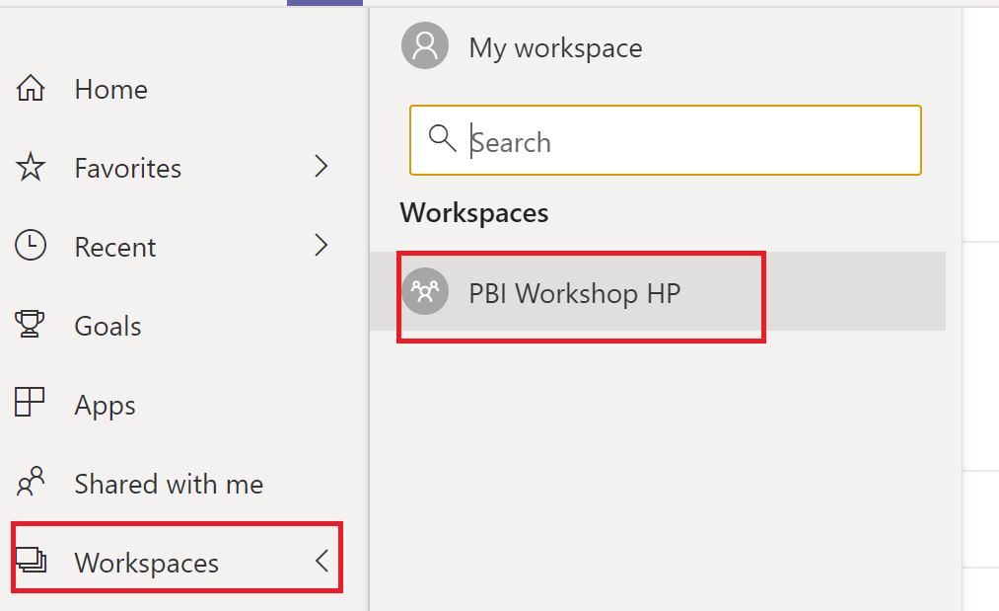

1. Notice 2 artefacts, a report, and a dataset in the workspace as a product of the previous activities.

### Congratulations!

You have successfully completed this exercise.

## Exercise 7: Creating goals

In this exercise, you will create a goal from using data from a dataset you have access to.

### Tasks

* 1. On the workspace, click on +New and select scorecard

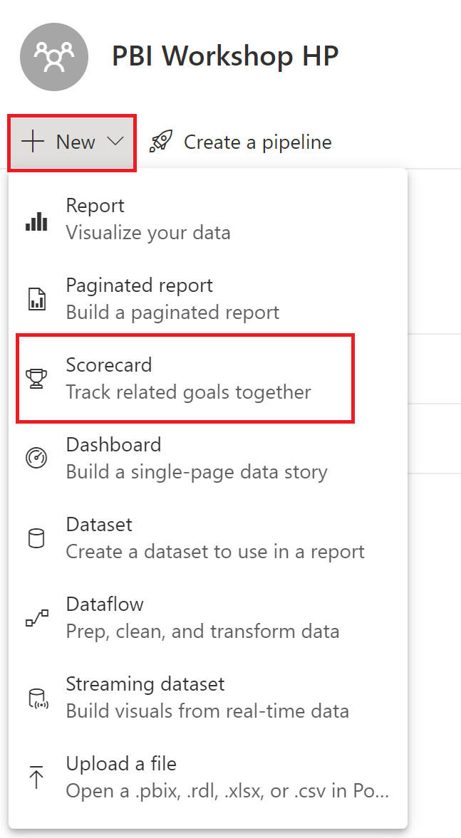

* 1. When prompted, input the following:

Scorecard name: Sales KPI

Workspace: PBI Workspace Initials

Click Create.

* 1. Create +New goal. Make the following selections:

**Goal Name**: Type “Sales”

**

On the pop-up, select the Sales Report Name then Next

Then on the report pop-up, select the multi row card visual, and under the measure dropdown, select Sales. Click Connect

**Target**: 120000000

**Status**: On Track

**Start Date**: 1/1/2022

**End Date**: 31/12/2022

* 1. Click Save.

### Congratulations!

You have successfully completed this exercise.

# Distributing Content in Teams

Introduction

In this lab, you learn how easy it is to bring Power BI sharing and distribution experiences to the Microsoft Teams channels all we collaborate in daily.

Objectives

After completing this lab, you will be able to:

* Create an App
* Share insights using Chat in Teams
* Pinning report as a tab
* Sharing PBI link in Teams
* Searching for content in Teams
* Pin report tab in meeting

Estimated Time

30 Minutes

## Exercise 1: Creating an App

In this exercise, we will create an App in Power BI in Teams to aid in distribution of content.

### Tasks

1. A pre-requisite to share Power BI content via teams is to ensure users you will share content to have access to the Power BI content.
2. On the workspace you created, create and app by clicking on the Create app button on the upper right. Shape, rectangle

   Description automatically generated with medium confidence
3. Add a description on the Setup page.
4. On Permissions page, select Access to “Entire Organization” and leave default selections.

1. When prompted. Click Publish

1. Once successfully published, click on “Go to App” to install the app

### Congratulations!

You have successfully completed this exercise.

## Exercise 2: Share insights using Chat in Teams

In this exercise, we will look at how we can use the Chat in Teams option.

### Tasks

1. On the landing page of the app, select the bar graph of Paseo product on the “Sum of Units Sold by Product” visual. Then click on the ellipse, select Chat in Teams

1. Notice a pop-up show up asking who you want to chat in teams with. Send to you seat mate by typing their username in the textbox

Notice that the URL shared is a “deep link” - meaning, that the filters we applied for the product **Paseo** will all be preserved and passed back to Power BI when our colleagues click the URL, permitting that they have access to view the reports content.

1. Click Share.
2. Go ahead and click the link you sent to your seat mate. Now you can see the visual shared will be spotlighted on the report so that it is the area of focus when the link is clicked.

### Congratulations!

You have successfully completed this exercise.

## Exercise 3: Pinning report as a tab in a channel

In this exercise, we will pin a report as a tab in a Teams Channel

### Tasks

1. On teams, create a teams channel
2. Create a team from scratch, and select Org-wide
3. Name the teams channel “Workshop [initials]”
4. Navigate to the pop-out window for the Power BI App
5. At the top right of our toolbar select the Pin option, to pin this report as a tab in a channel.
6. Graphical user interface, application

   Description automatically generated
7. In the dialog window, we’ll complete the following fields: Tab name we’ll type in Sales Overview, Select place to pin to we’ll select an existing Teams group and Select a channel choose General – once complete press Add to continue.

1. And success! We can select the Go to the tab option now to view, our pinned report.

1. In the Teams channel’s tabs, we now see the Sales Overview has been added and is now a click away in the channels where our team collaborates every day. If we select the tab name, we also have some additional options like Pop out tab to maybe place the report onto a different monitor or Expand tab to go full screen.

1. And on the top right of our window is the Chat icon, where once pressed, we can begin typing responses and tagging others in our Teams channel to provide commentary around our reports.

### Congratulations!

You have successfully completed this exercise.

## Exercise 4: Share a Power BI link preview in Microsoft Teams

In this exercise, we will share a Power BI link report preview for those occasions where our colleagues simply want a quick link to the report.

### Tasks

* 1. In the Teams channel you created, we can create a New conversation A picture containing graphical user interface

     Description automatically generatedor reply to an existing thread, let’s start a new conversation by clicking the button to proceed.
  2. Below the Start a new conversation, are various Microsoft Teams apps that have been enabled, we’ll navigate to the Power BI icon where we can now search for content whether it be a single report, a dashboard or a collection of multiple reports and dashboards in an App. Let’s select the Sales report. Click send.

* 1. We now have a link preview in our conversation and can include the message – “Here’s the report you were asking about!”. Then click send.

* 1. Notice a new conversation can be viewed. Our colleagues could either Open the report or Subscribe to notice of the content in their e-mail inbox as a reminder to periodically check in for the latest updates.

* 1. And once we press the Open option in our link preview, we are taken directly to the report without ever having to leave Teams!

### Congratulations!

You have successfully completed this exercise.

## Exercise 5: Search for Power BI content in Teams

In this exercise, we will be exploring how to search for Power BI content in Teams.

### Tasks

1. In the Search bar at the top of Teams, type in @Power BI to begin a search for the Power BI content you need.

1. It may already be pre-populated with some of your most recent content. Select Sales.
2. The link preview is now available once again to Open our content directly in Teams alongside one of our personal favorites – and the ability to easily copy this card to a clipboard. We’ll select this option now, this way if we want to share the link in a quick chat with a colleague or prepare an important e-mail to the team in Outlook Online, a rich experience is now presented for your recipients.

1. Navigating back into a Teams channel or chat, if we were to start a new conversation and paste the contents of our clipboard, our adaptive card is available once again.

### Congratulations!

You have successfully completed this exercise.

## Exercise 6: Pin report as a tab in a meeting

Now that we’ve explored how to easily share and collaborate in our Teams channels and chats, let’s learn how to bring these experiences to our team meetings.

### Tasks

1. In the side-rail of Teams select the Calendar option first and then in the top right select the chevron next to New meeting and then the Schedule a meeting option.

1. Within the New meeting window, type in the meeting title of Monthly Review, we’ll add ademo user in the Add required attendees field and within the reoccurrence drop-down select the Monthly option. Once complete, select the Saveoption to create a new meeting.

1. Back in our Teams calendar view a new meeting has been created. To bring the interactive and collaborative experiences of Power BI to our meetings, we’ll alternate select (right click) the meeting event go to Edit and then Series.

1. At the top of our meeting, there are new tabs like Breakout rooms for members to gather in small groups for lively conversation and brainstorming sessions or Attendance to generate a report of attendees. To add new a tab to our meeting occurrence select the “+” symbol.



1. In the Add a tab dialog window, there as expansive list of apps that we can add to enrich our meetings – and using the search option at the top, we’ll type in Power BI and then select the icon to proceed.

1. In the Power BI dialog window, we’ll expand the App list to find our report titled Sales. Type Sales Overview under Tab name. Then select Save once complete.

1. Returning to the side rail of Teams and selecting the Calendar option again – we can review all our upcoming meetings on our calendars – and to drill into their agendas, attendees and more beforehand we’ll select our Monthly Review meeting event.
2. And at the top of our meeting, we can now select the Sales Overview tab to ensure that our team will always have the right data needed to make collaborative data driven decisions during our meeting.



### Congratulations!

You have successfully completed this exercise.