


Submitted By:
Zunaira Noor
ONLINE CAKE BAKERY MANAGEMENT

Table of Contents
- Introduction
- Problem Statement
- Objectives of the System
- Scope of the Project
- Solution Implementation
- System Architecture
- Functional Requirements
- Non-Functional Requirements
- Modules Description
- Database Design
- Frontend Design
- Backend Design
- Project Demonstration
- Demonstration Outcome
- Conclusion

1. Introduction
Online Cake Bakery Management System is a web-based application developed to digitalize bakery operations. The main purpose of this system is to reduce manual work and provide an easy and efficient way to manage bakery business activities. This system allows customers to browse different cakes and place orders online. At the same time, the admin can manage cakes, customer information, orders, and delivery persons. This improves efficiency, accuracy, and customer satisfaction.

2. Problem Statement
Traditional bakery systems mostly depend on manual record keeping. Orders are written in registers which can lead to errors, data loss, and mismanagement. Customers also do not get proper order tracking or variety options. To overcome these problems, the Online Cake Bakery Management System is developed to automate the entire bakery process and provide a reliable online solution.

3. Objectives of the System
The main objectives of this project are:
- To automate bakery management system
- To provide online cake ordering facility
- To maintain proper records of customers and orders
- To reduce human errors
- To improve overall customer satisfaction

4. Scope of the Project
The scope of this project includes:
- Online cake browsing and ordering
- Admin management of cakes and orders
- Customer data management
- Delivery person management and assignment

5. Solution Implementation

Frontend
- HTML
- CSS

Backend
- Java

Database
- MySQL

Development Tools
- VS Code
- NetBeans
- Web Browser

6. System Architecture
The system follows a three-tier architecture:
- Presentation Layer
This layer includes HTML and CSS pages where users interact with the system.
- Application Layer
This layer is developed using Java and contains the business logic of the system.
- Data Layer
This layer uses MySQL database to store and manage system data.

7. Functional Requirements
Functional requirements describe what the system can do:
- User registration and login
- View cake list
- Place cake orders
- Admin login
- Add, update, and delete cakes
- View and manage customer orders
- Assign delivery person to orders

8. Non-Functional Requirements
Non-functional requirements describe system quality:
- User-friendly interface
- Secure login system
- Fast response time
- Reliable and secure data storage

9. Modules Description

Admin Module
The admin module allows the administrator to:
- Login securely
- Manage cakes (add, update, delete)
- View customer orders
- Assign delivery persons

Customer Module
The customer module allows users to:
- Register and login
- View available cakes
- Place cake orders

Delivery Person Module
This module manages delivery staff:
- Store delivery person details
- Assign orders to delivery persons
- Manage delivery status

10. Database Design
The database is designed using multiple tables to store information efficiently.

Admin Table
- admin_id
- username
- password
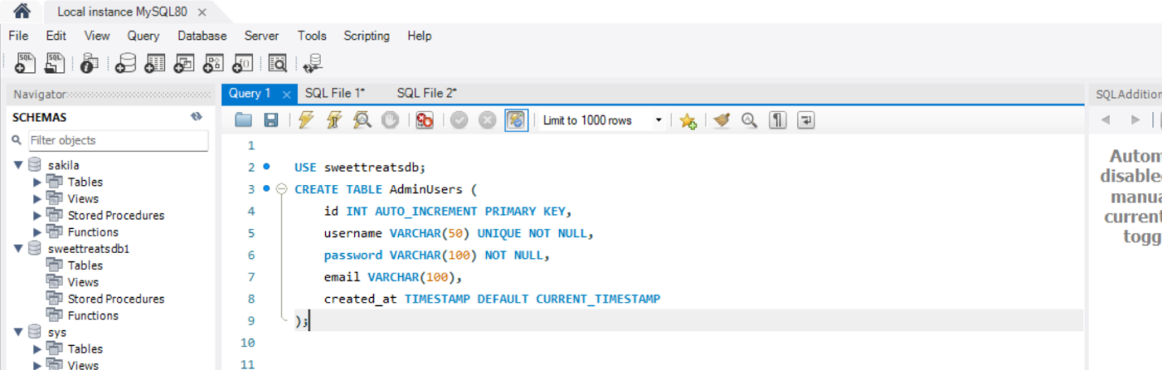

Customer Table
- customer_id
- name
- email
- phone
- address
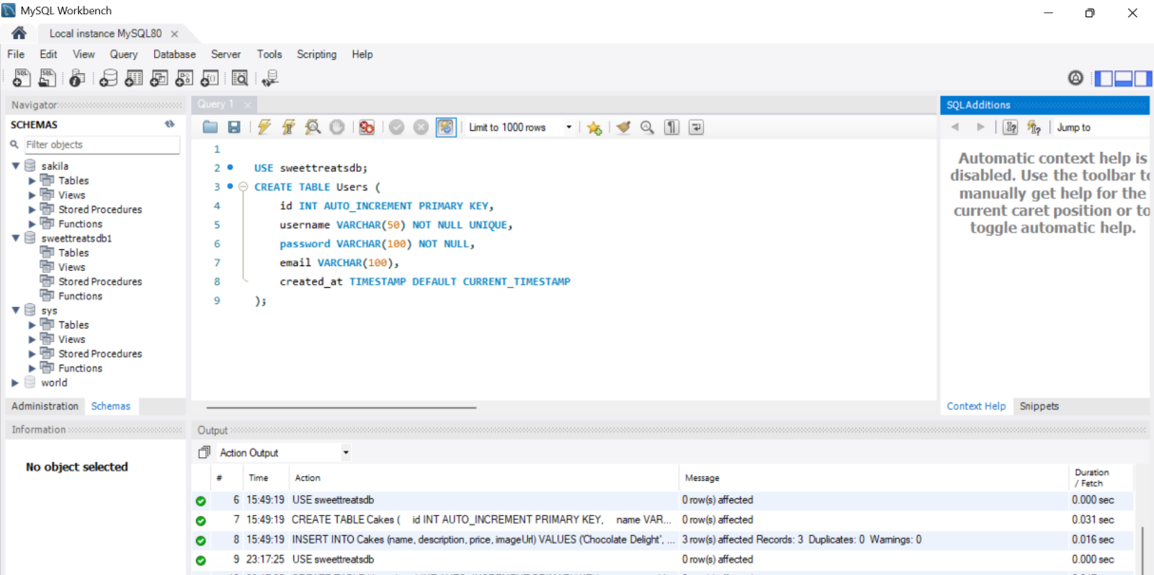

Cake Table
- cake_id
- cake_name
- price
- description
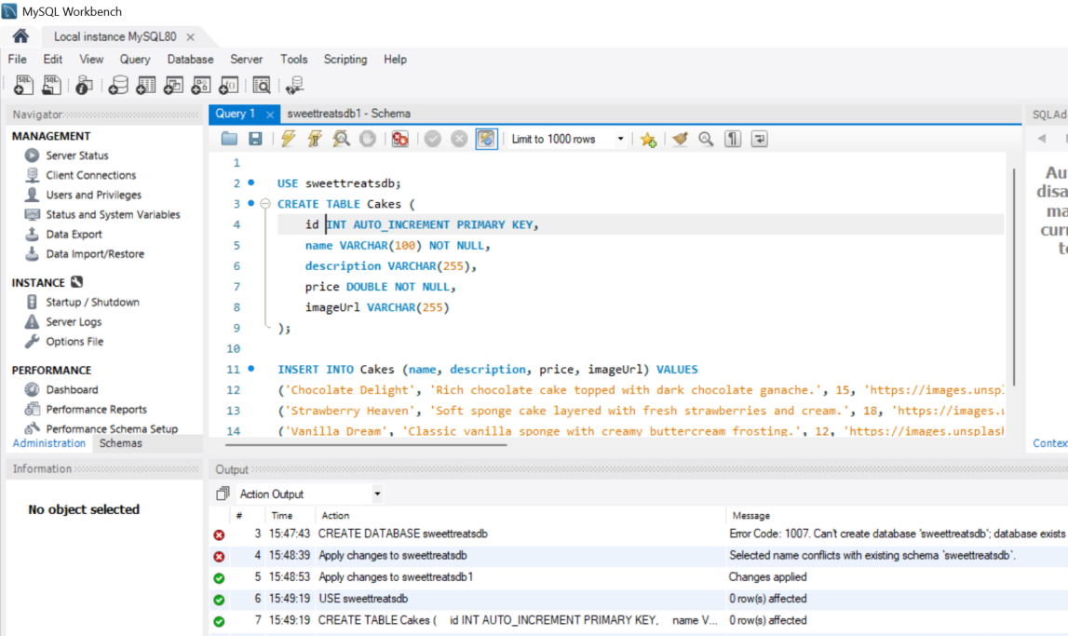

Order Table
- order_id
- customer_id
- cake_id
- order_date
- order_status
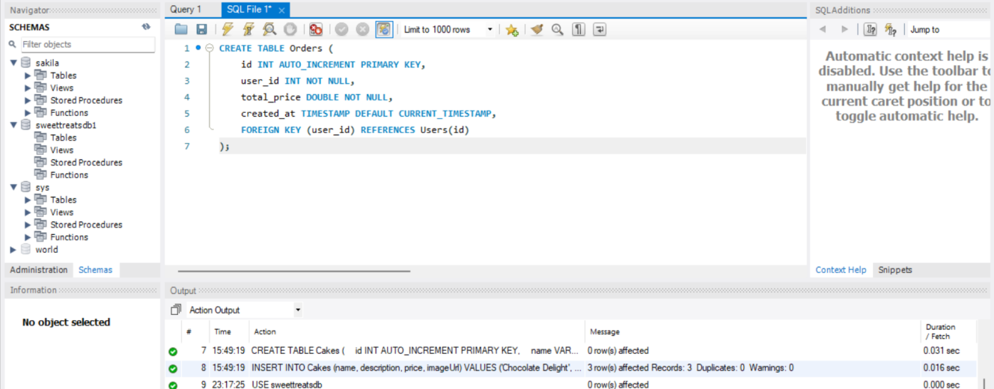

Delivery Person Table
- delivery_person_id
- name
- phone
- vehicle_type
- availability_status
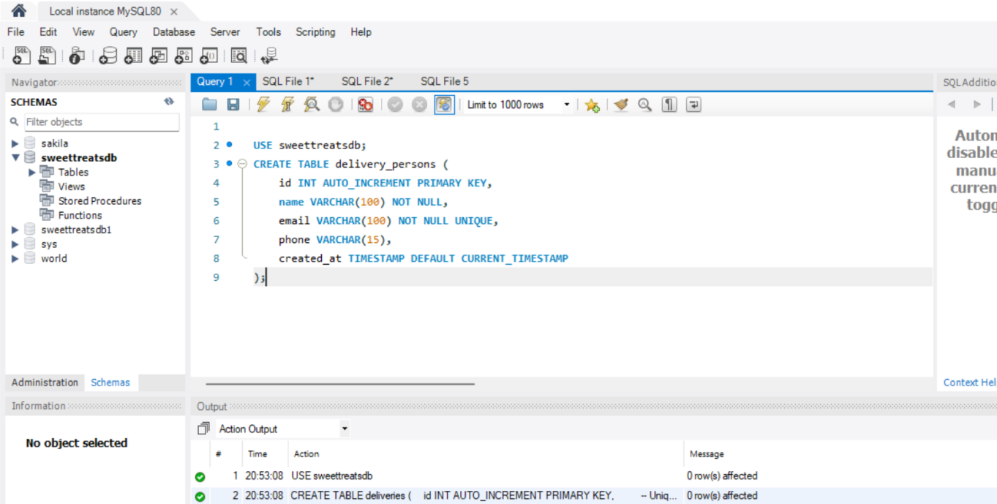
All tables are connected using primary keys and foreign keys.

11. Frontend Design
The frontend of the system is developed using HTML and CSS. The design is simple, clean, and user-friendly. Users can easily navigate through pages, view cakes, and place orders without any difficulty.

12. Backend Design
The backend is developed using Java. It handles user authentication, order processing, and database communication. Java ensures system security, reliability, and smooth performance.

13. Project Demonstration
The project demonstration presents the complete working of the Online Cake Bakery Management System in a real-time environment. The demo is structured to show end-to-end functionality, from user interaction at the GUI level to backend processing

- Home Page
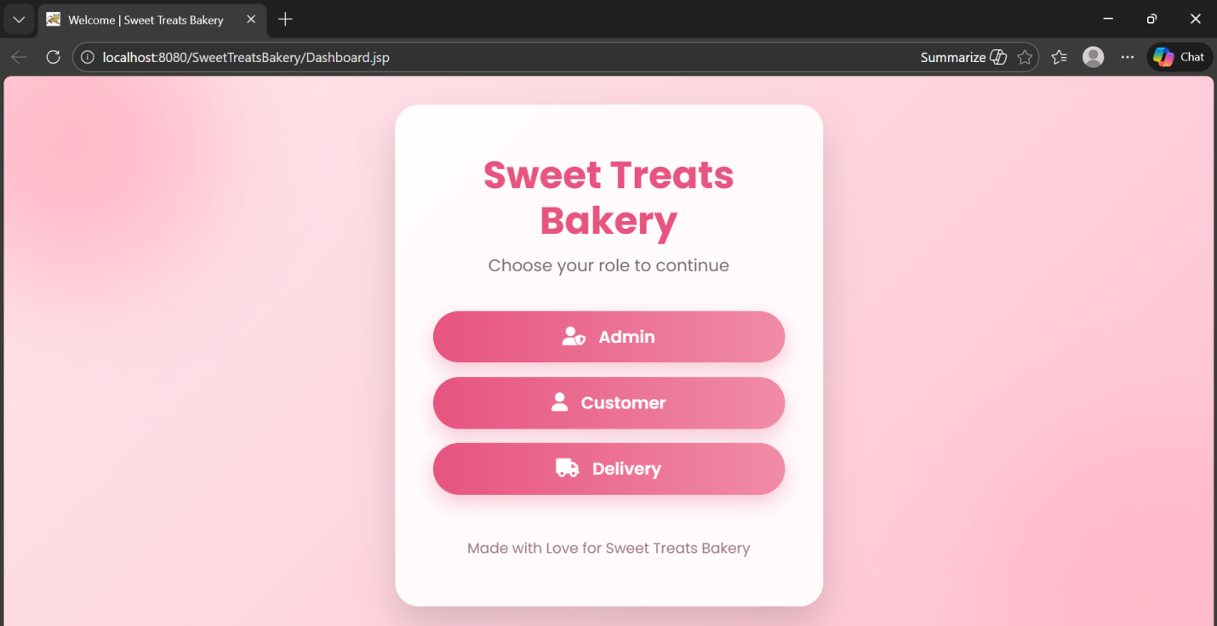
- Admin Login Page
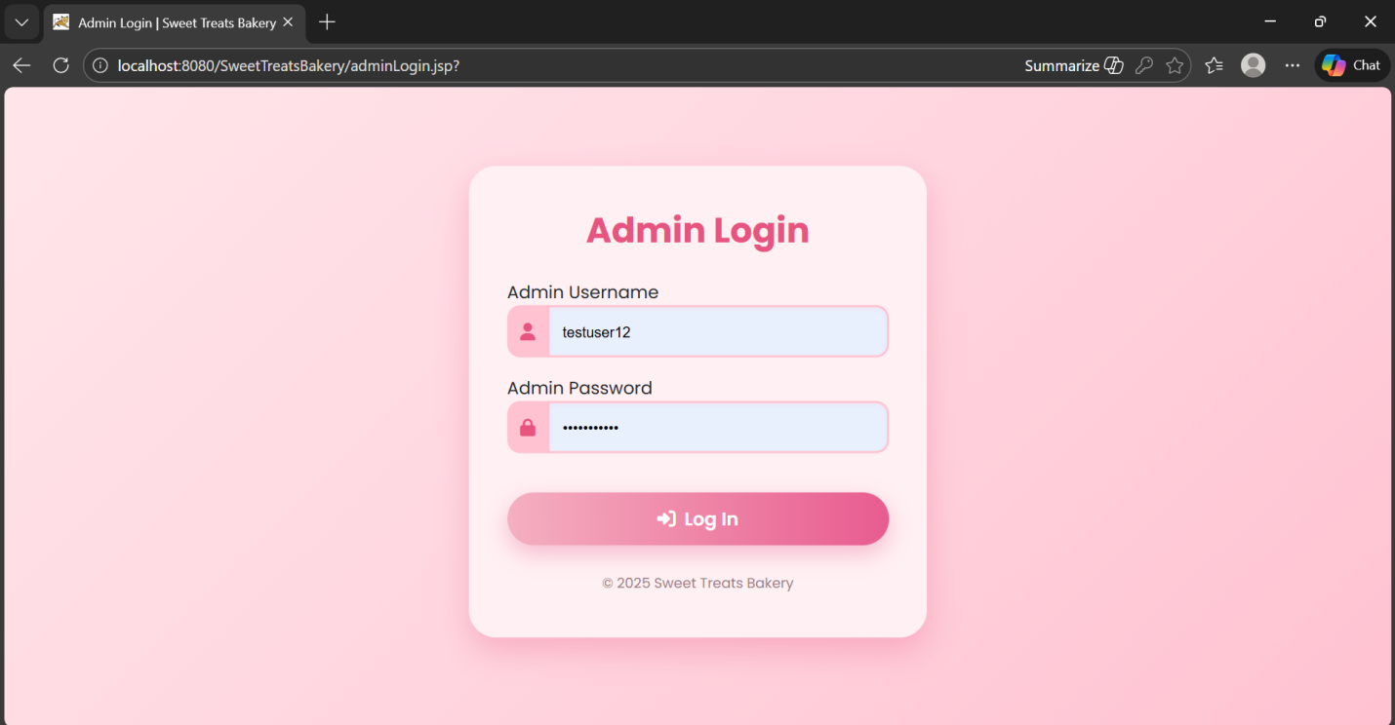
- Admin Dashboard
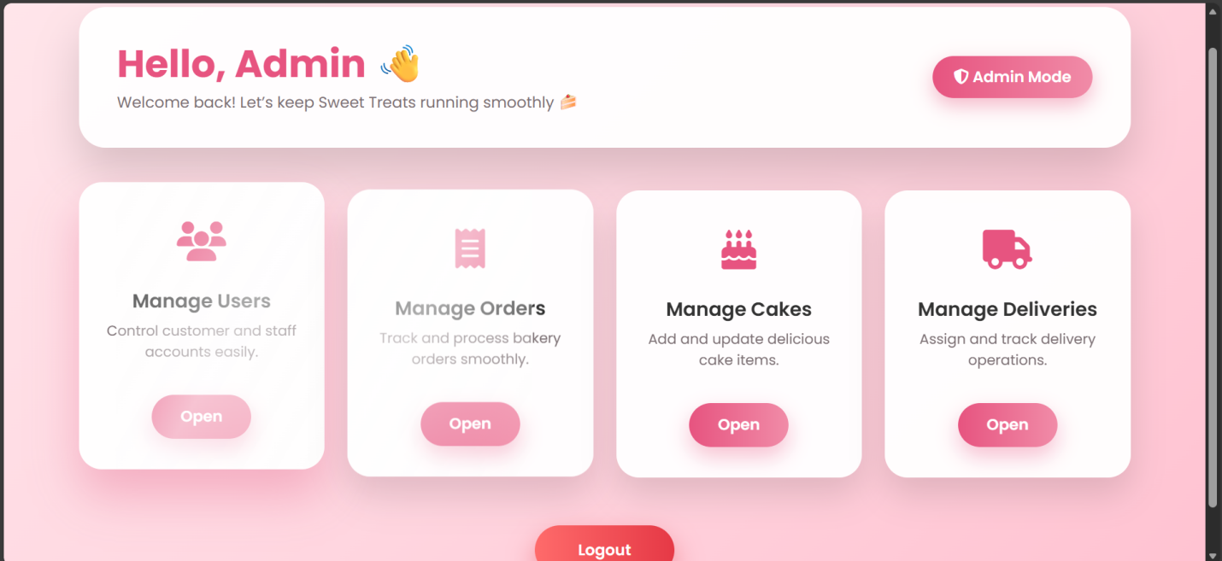
- Admin Manage Users
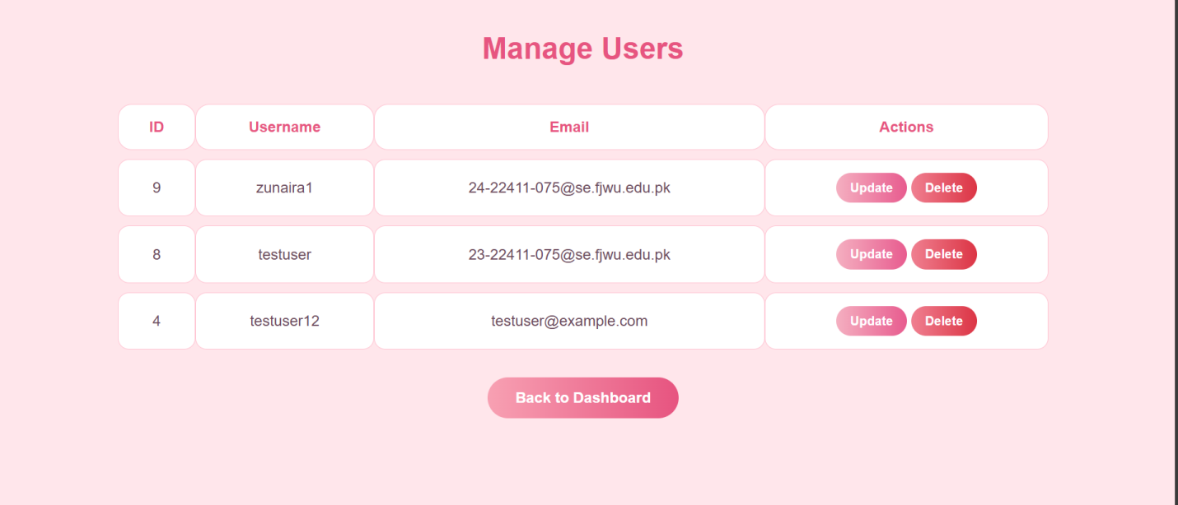
- Admin Manage Orders
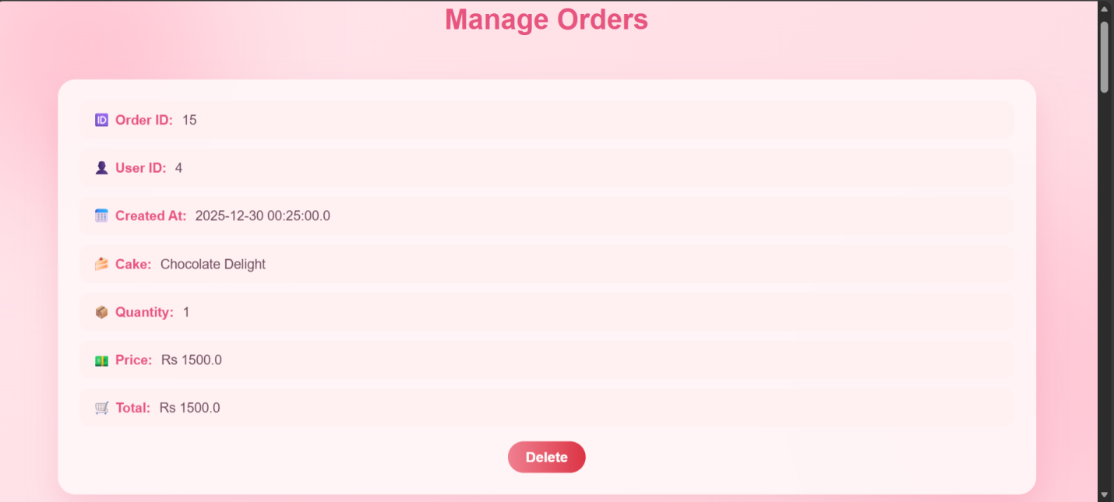
- Admin Manage Cakes
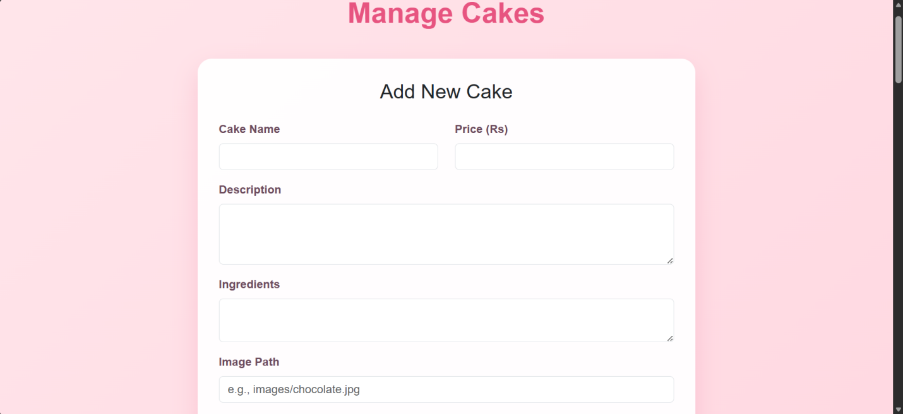
- Admin Manage Deliveries
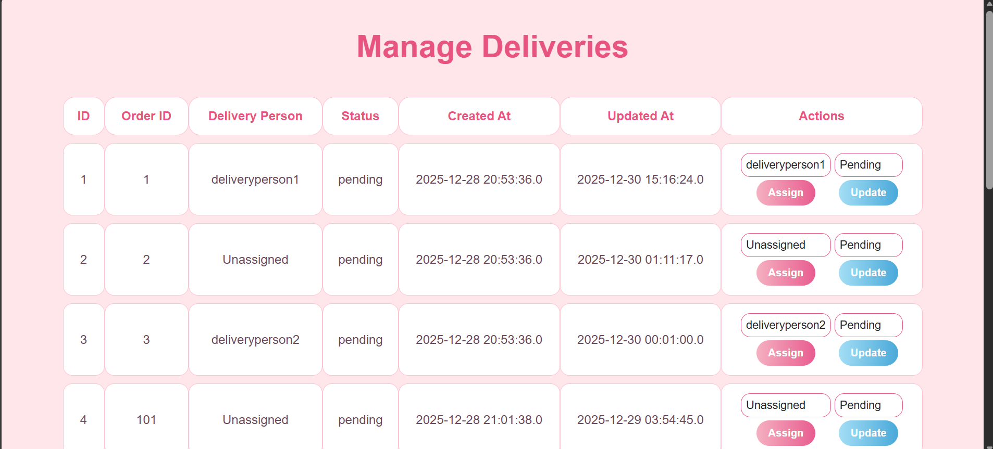
- Cake Listing Page
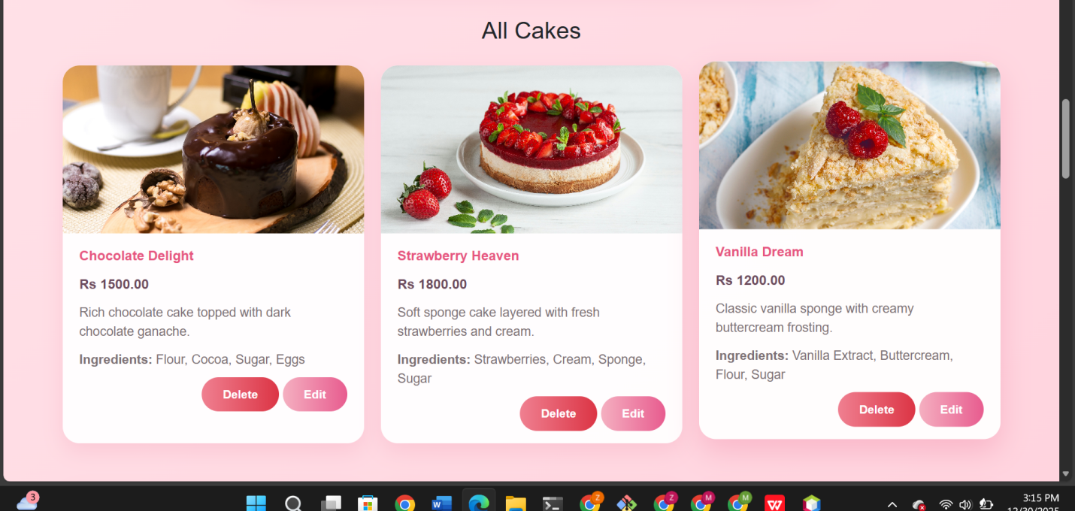
- Order Page
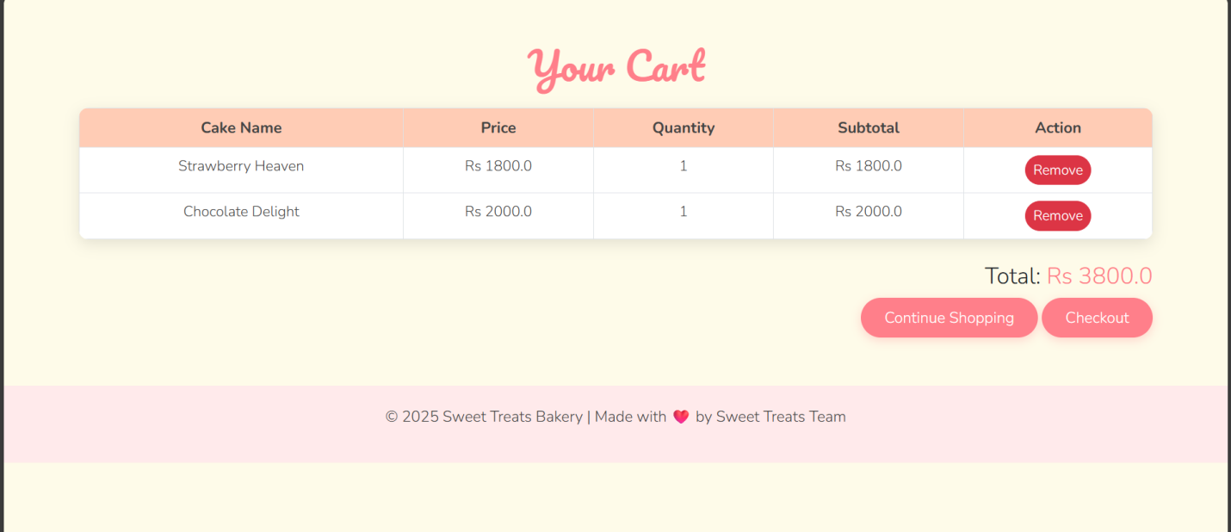
- Delivery Person Login
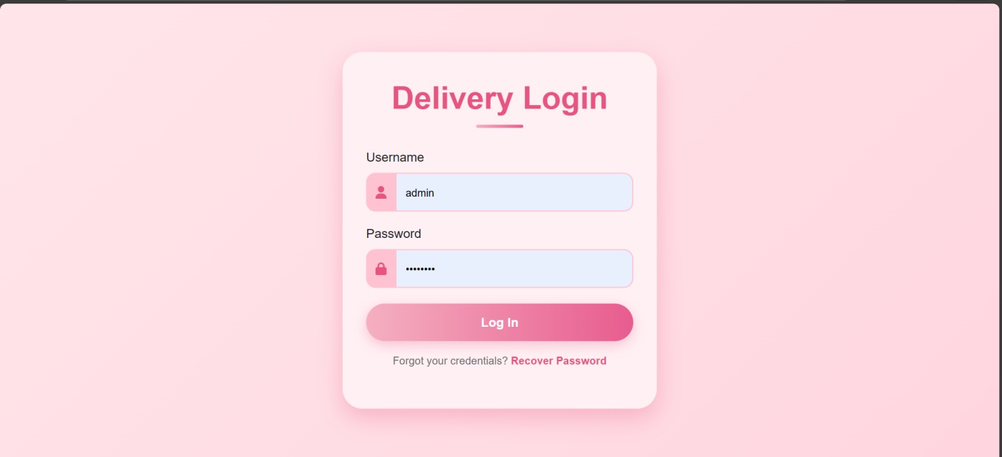
- Delivery Person Dashboard
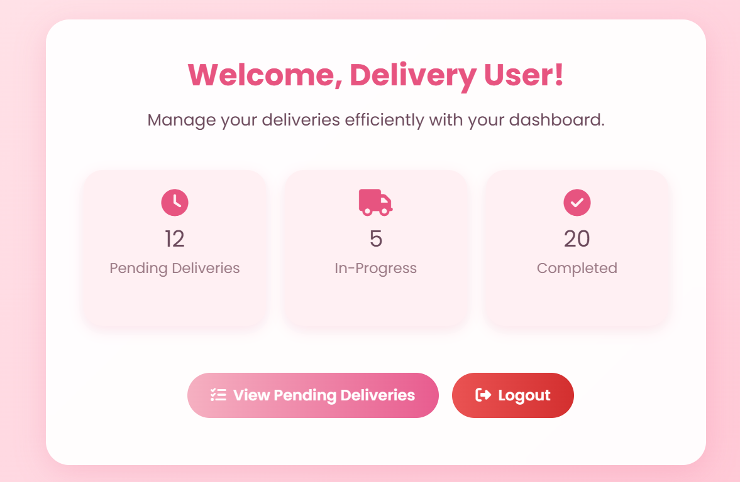
- Pending Deliveries
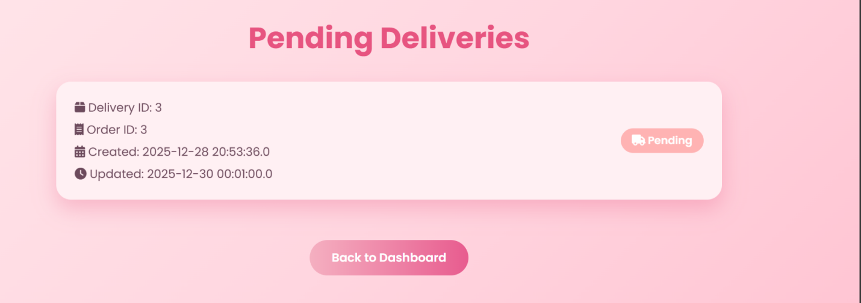

14. Demonstration Outcome
The demonstration concludes by validating that the Online Cake Bakery Management System is fully functional, user-friendly, and suitable for a real-world product-based business. The system successfully integrates GUI design, backend logic, and database management, fulfilling Complex Engineering Problem requirements.

15. Conclusion
Online Cake Bakery Management System is a complete and efficient solution designed to modernize bakery operations. This system successfully replaces the traditional manual system with a digital platform that is easy to use and reliable. Customers can conveniently browse cakes and place orders online, while the admin can efficiently manage cakes, orders, customers, and delivery persons. The addition of the delivery person module ensures proper order handling and timely delivery. The use of HTML and CSS provides a user-friendly interface, while Java ensures strong backend processing and security. MySQL database allows proper data storage and management. Overall, this project meets its objectives successfully and proves to be a practical solution for bakery businesses. It also helped in improving programming, database, and system design skills.

