Fatima Jinnah Women University
Department of Software Engineering


SUBJECT: CC LAB
SUBMITTED TO: SIR SHOAIB
SUBMITTED BY: ZUNAIRA NOOR
REGISTRATION NO: 2023-BSE-075
SEMESTER: V-B

Task 1 — GitHub CLI Codespace Setup & Authentication
Install GitHub CLI:
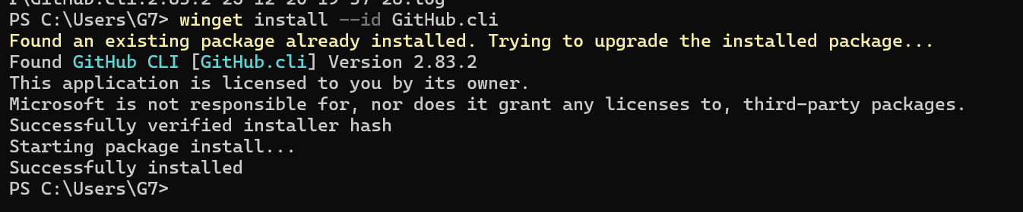
Authenticate GH CLI for Codespaces:
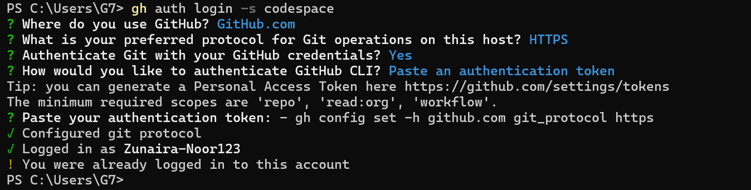
List available codespaces:
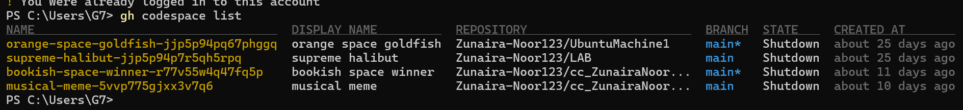
Connect to a codespace via SSH:
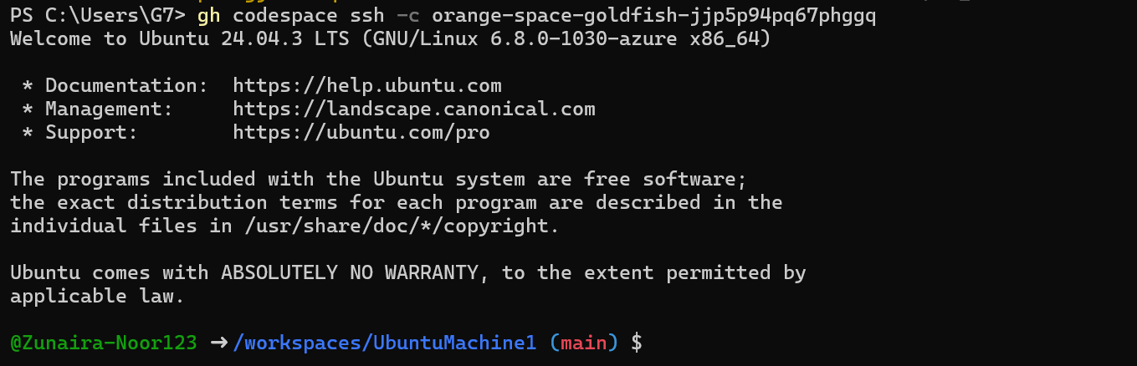
Task 2 — Install AWS CLI, Terraform CLI, Provider Setup
- Install AWS CLI
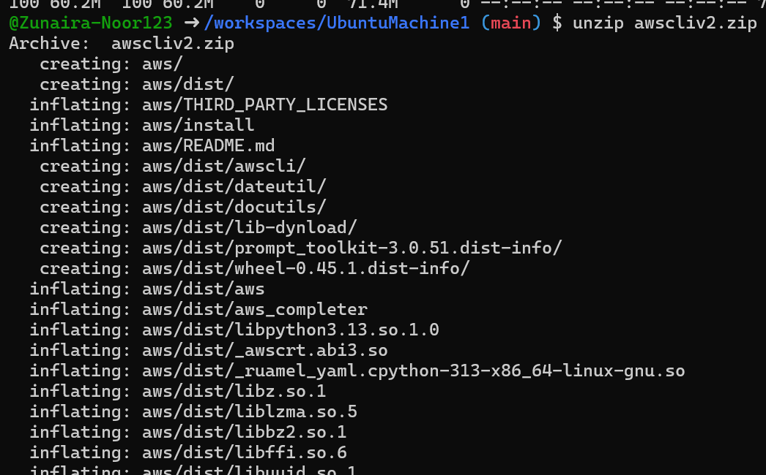
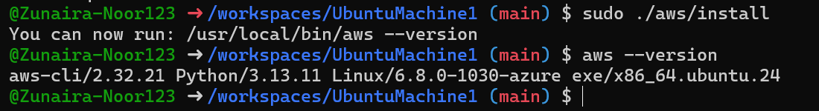
Configure AWS CLI:
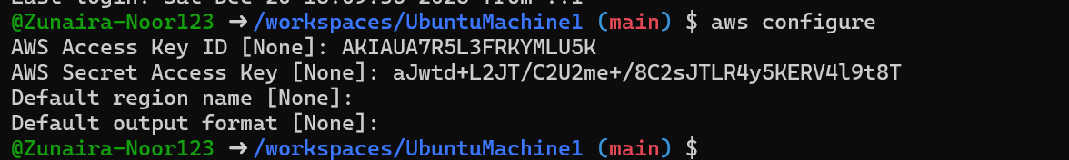
check config files:
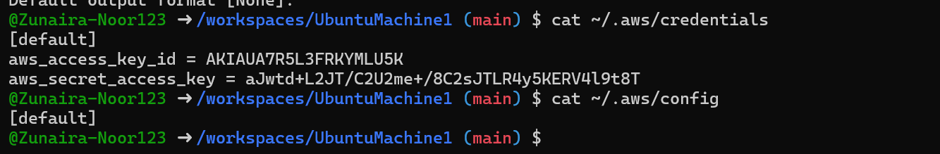
Verify AWS CLI connectivity:
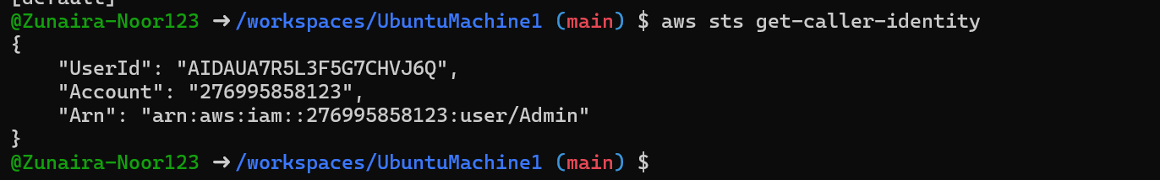
Install Terraform CLI
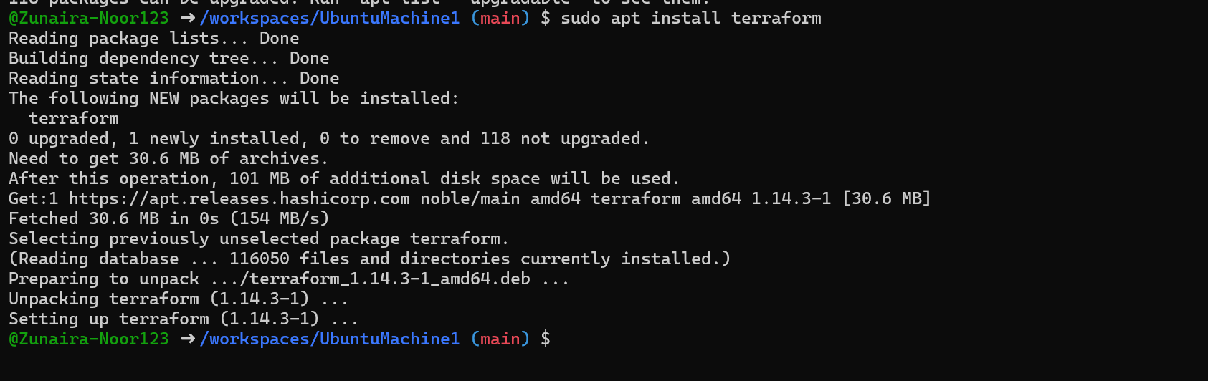
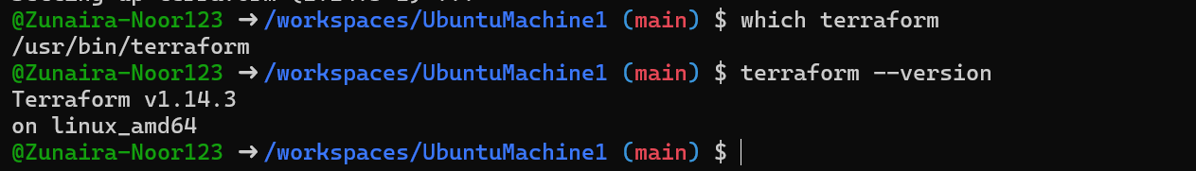
Create main.tf using Vim:
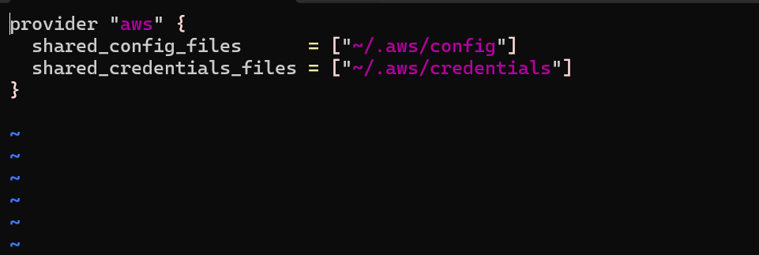
Initialize Terraform:
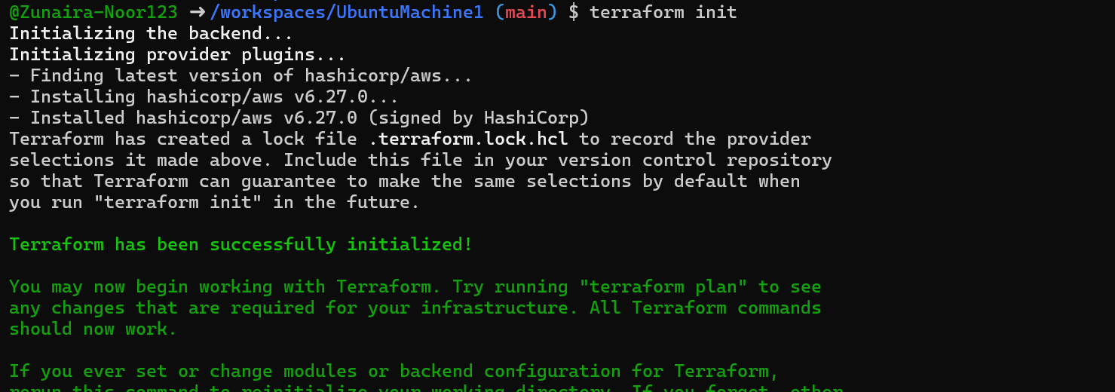
Show contents of .terraform.lock.hcl:
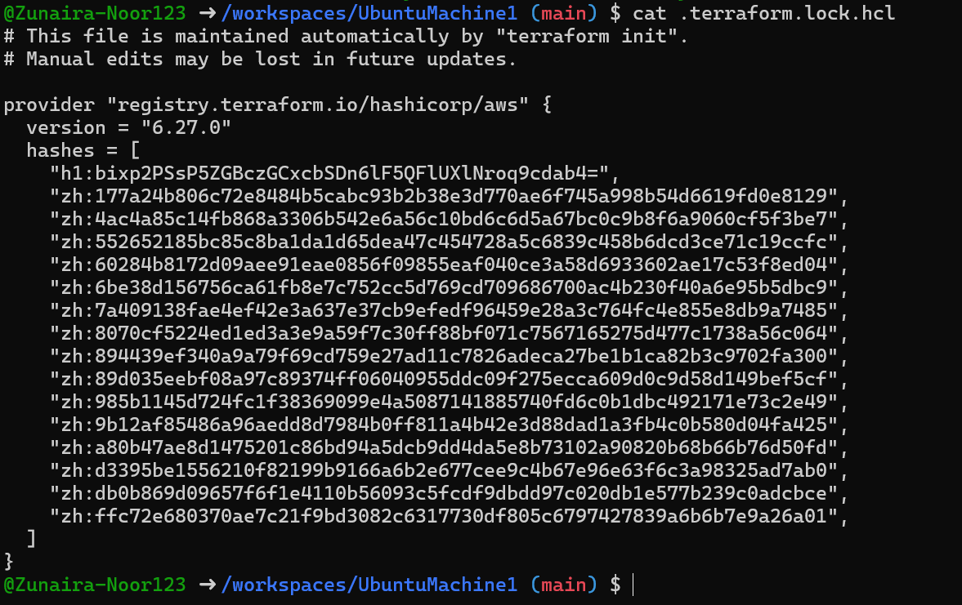
Show contents of .terraform/ directory:
Task 3 — VPC/Subnet Creation, Initialization, Verification
Edit main.tf to add:
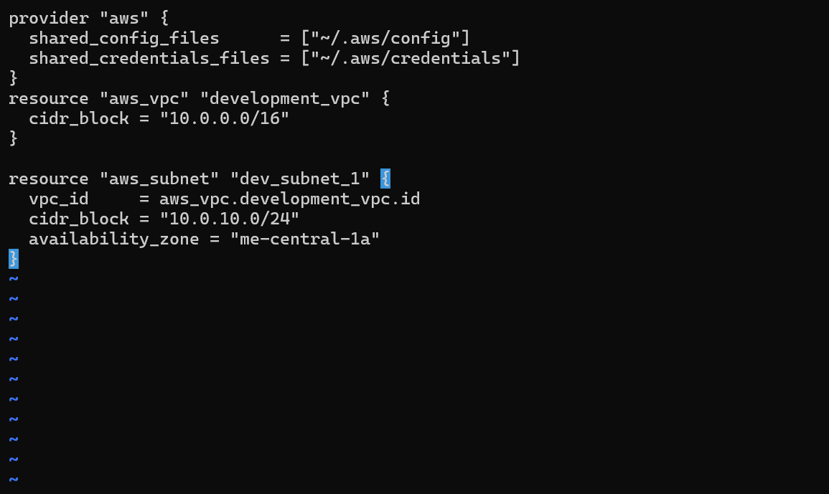
Run:
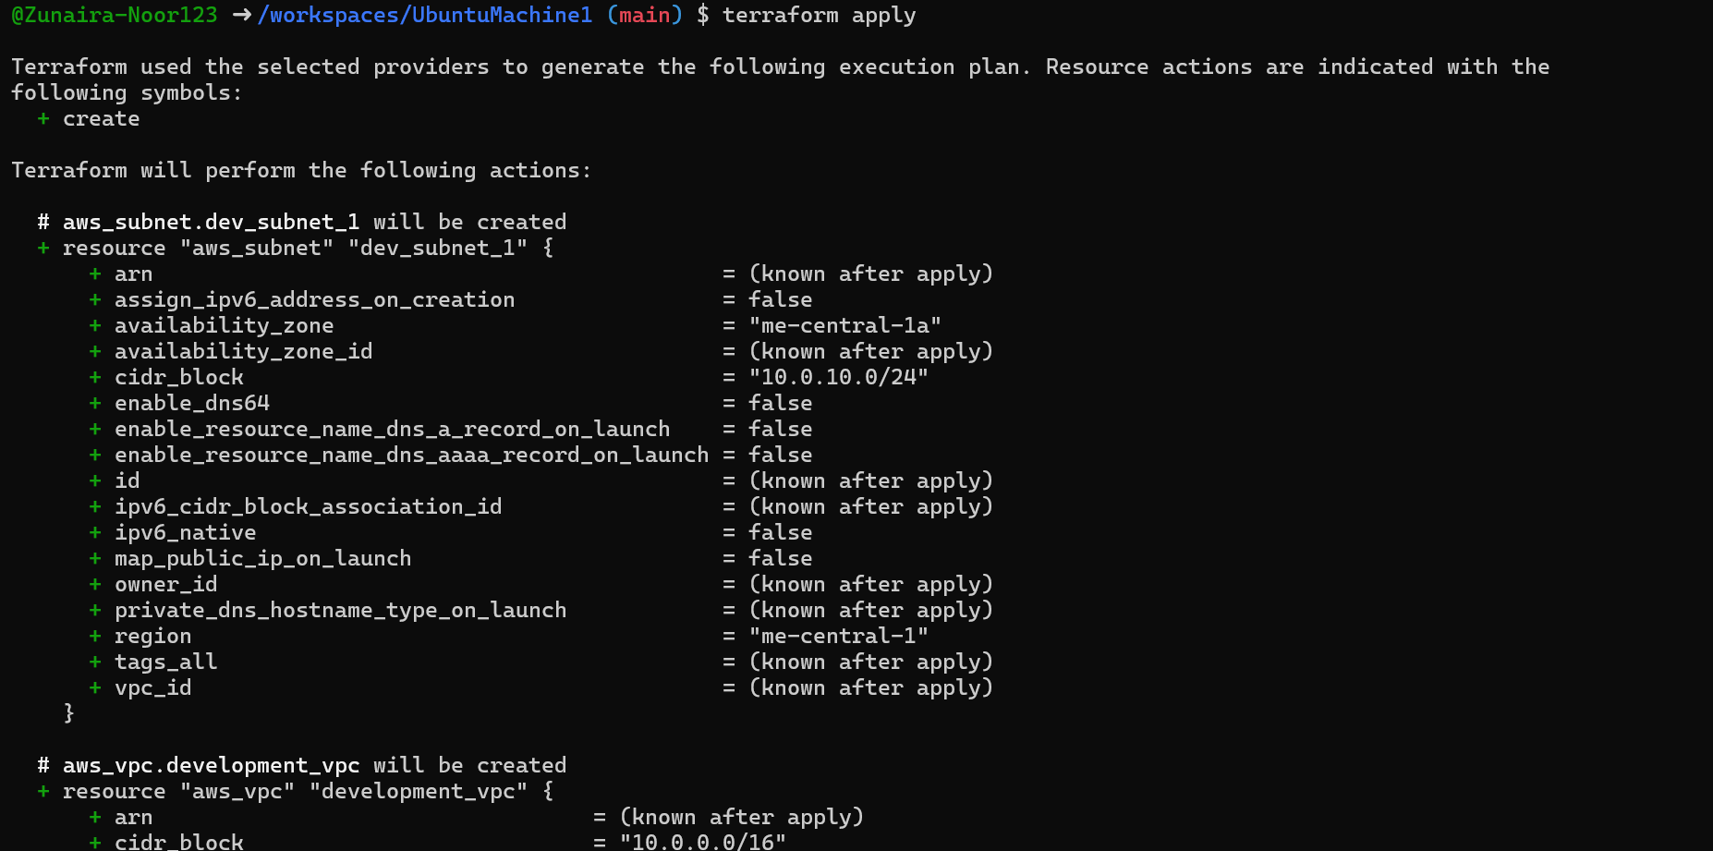
Verify resources using AWS CLI:
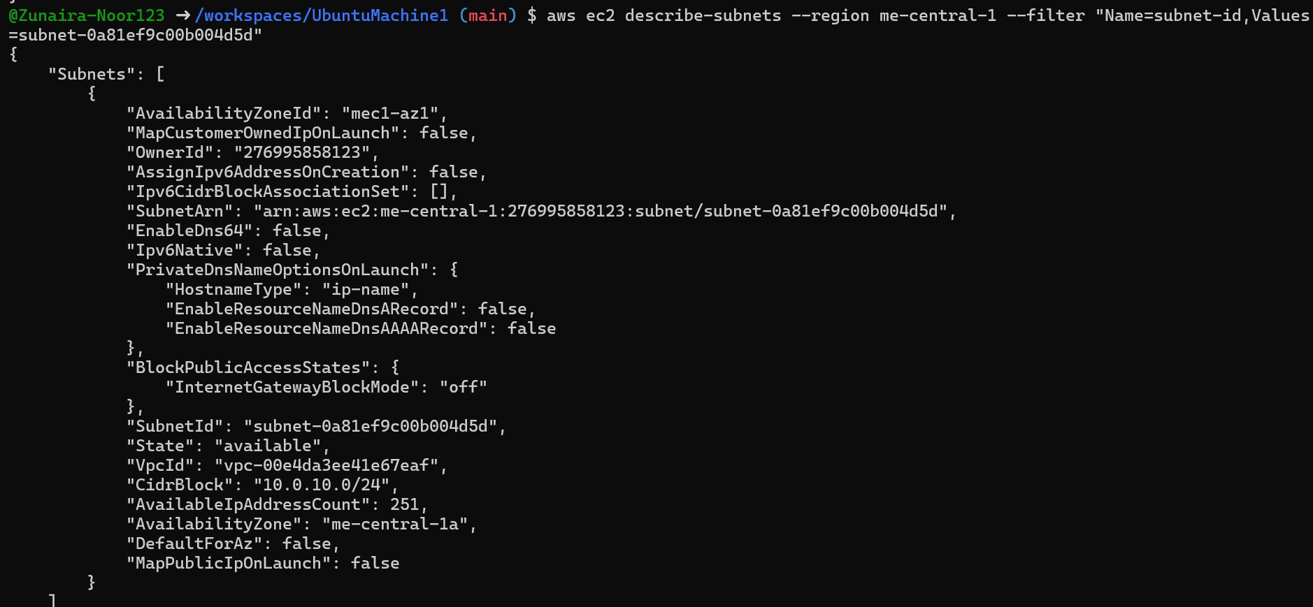
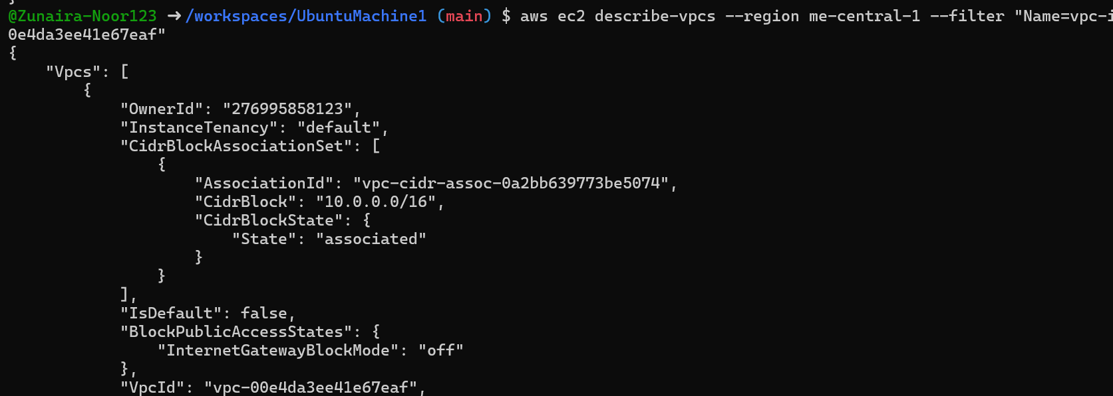
Task 4 — Data Source, Targeted Destroy, Tags
Add to main.tf:
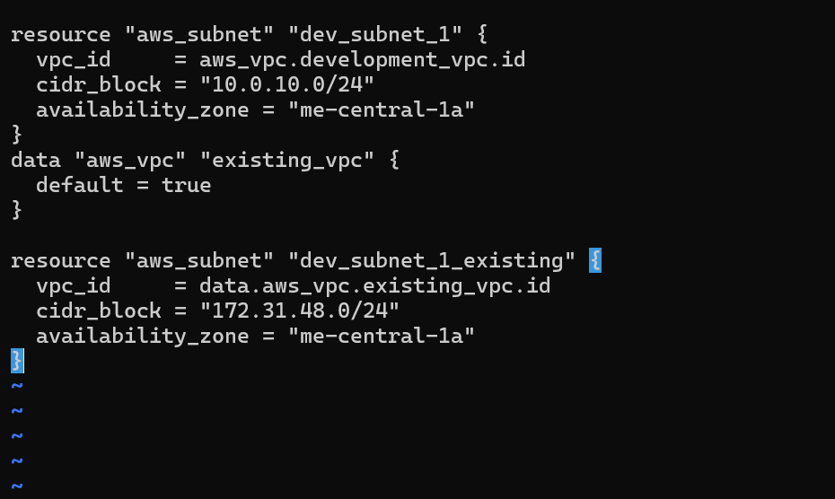
Apply configuration:
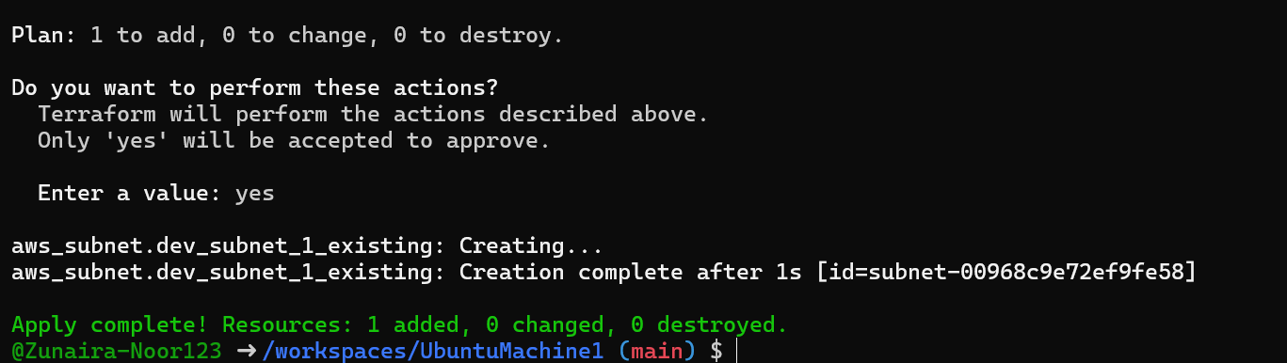
B. Targeted Destroy & Refresh
- Destroy only one resource:
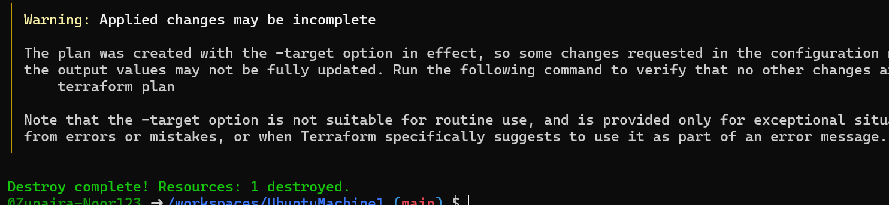
Refresh state:
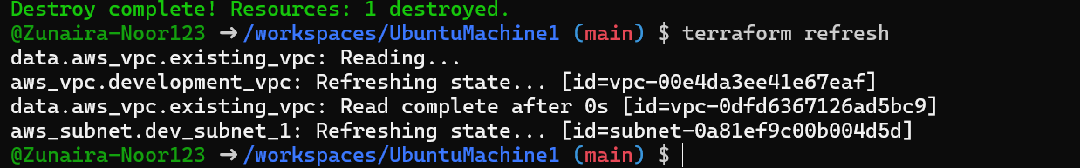
Re-apply configuration:
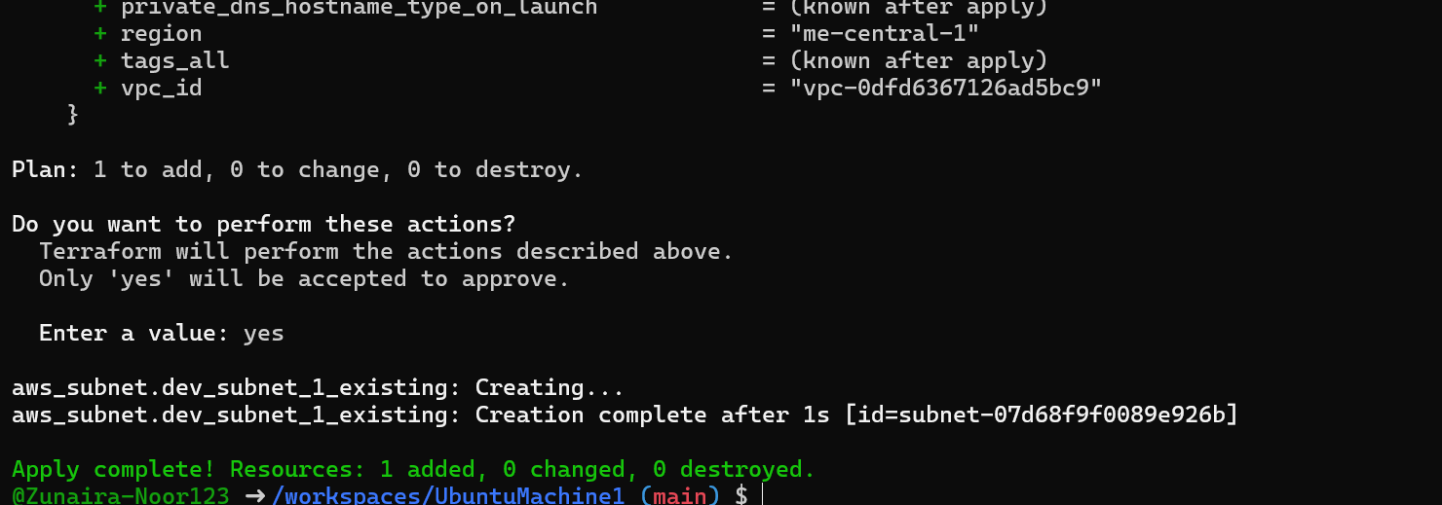
Destroy all resources:
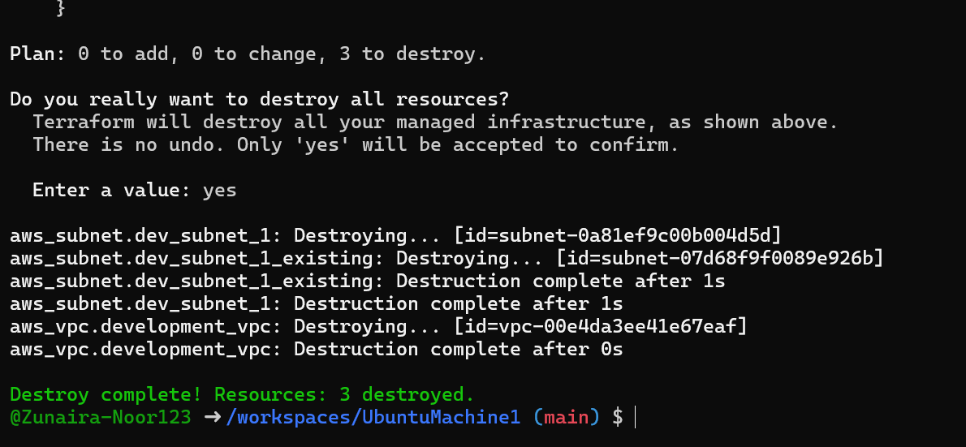
Plan configuration:
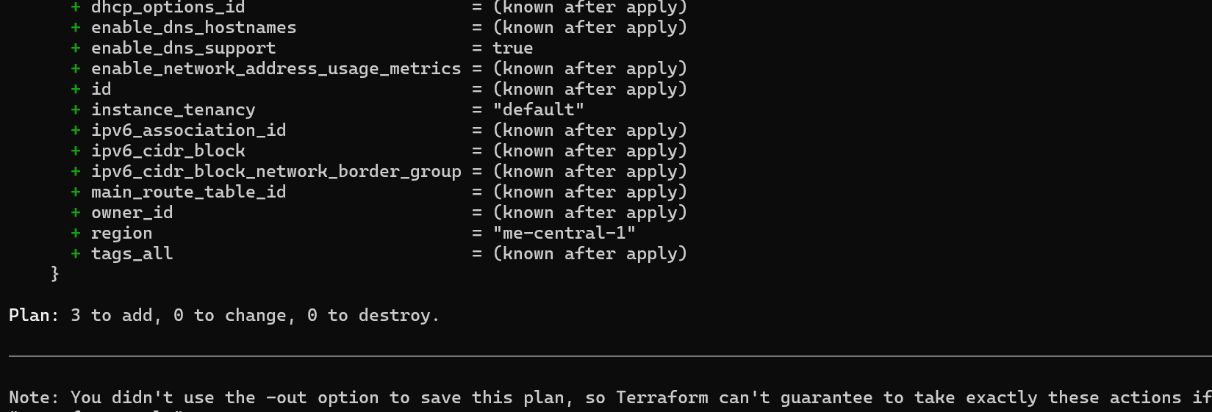
Apply again:
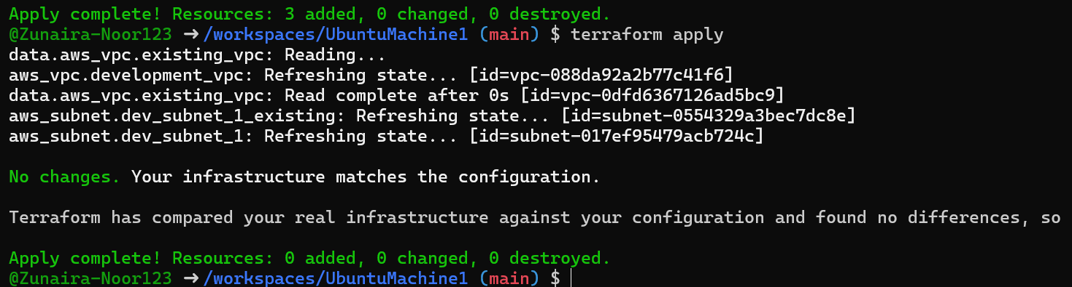
C. Tagging Resources
- Modify main.tf to add tags:

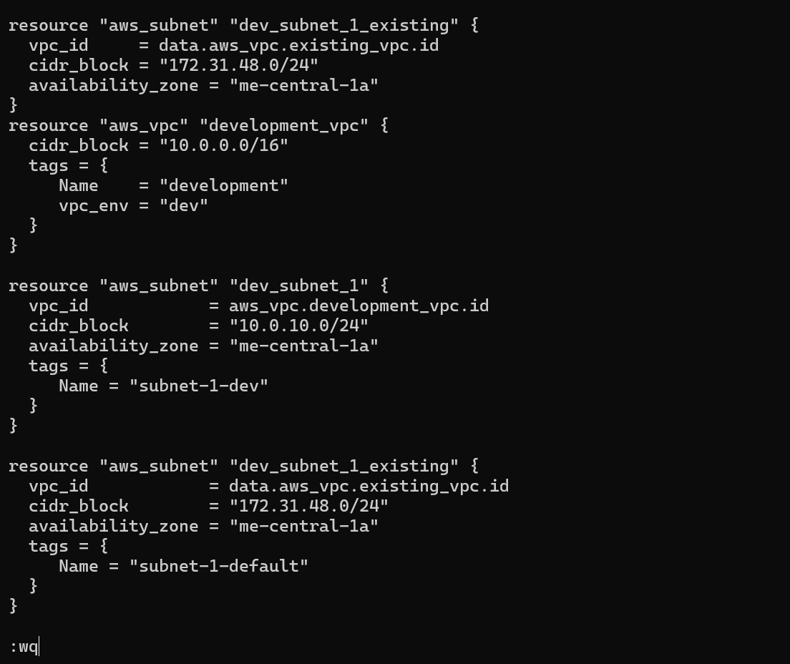
Run:
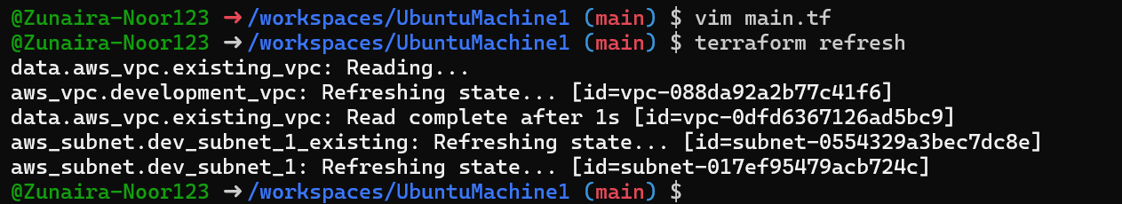
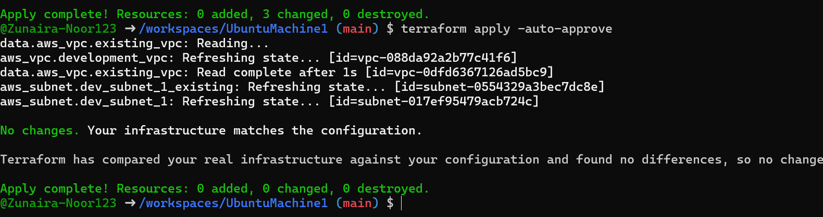
Remove vpc_env = "dev" tag from development_vpc resource, re-plan/apply:
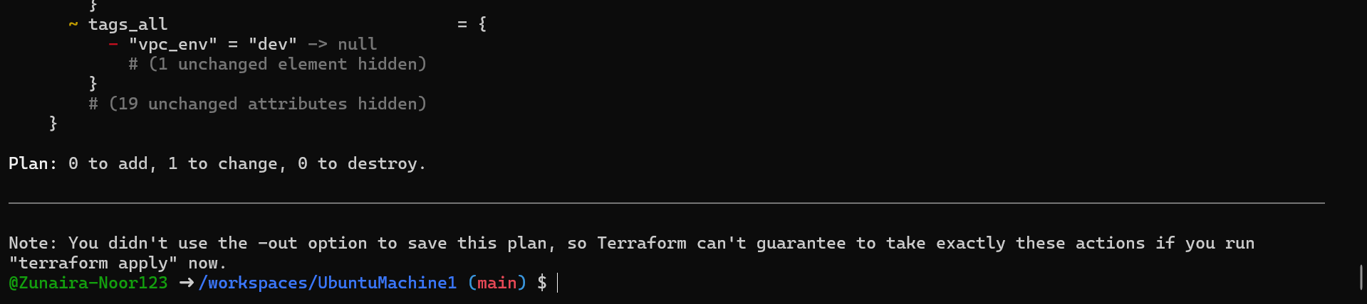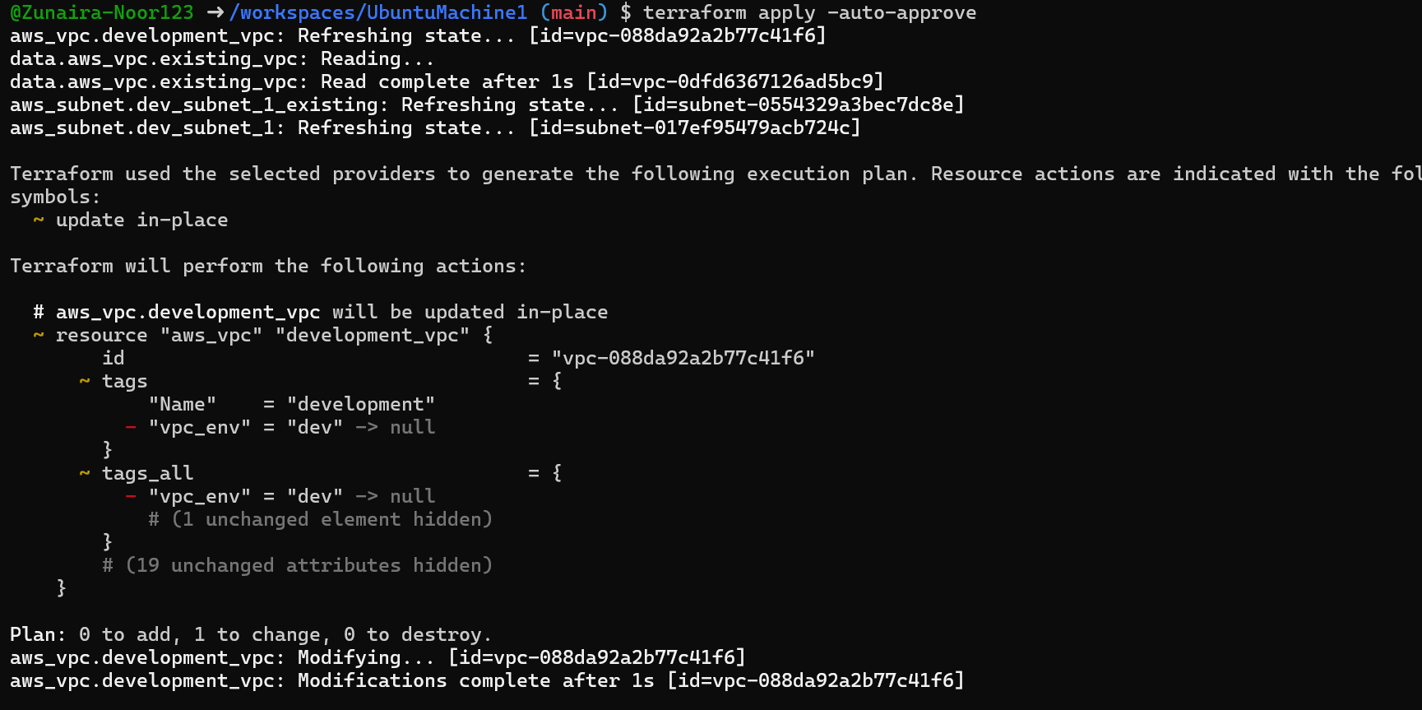
Task 5 — State File Inspection & Terraform State Commands
- Destroy all resources:
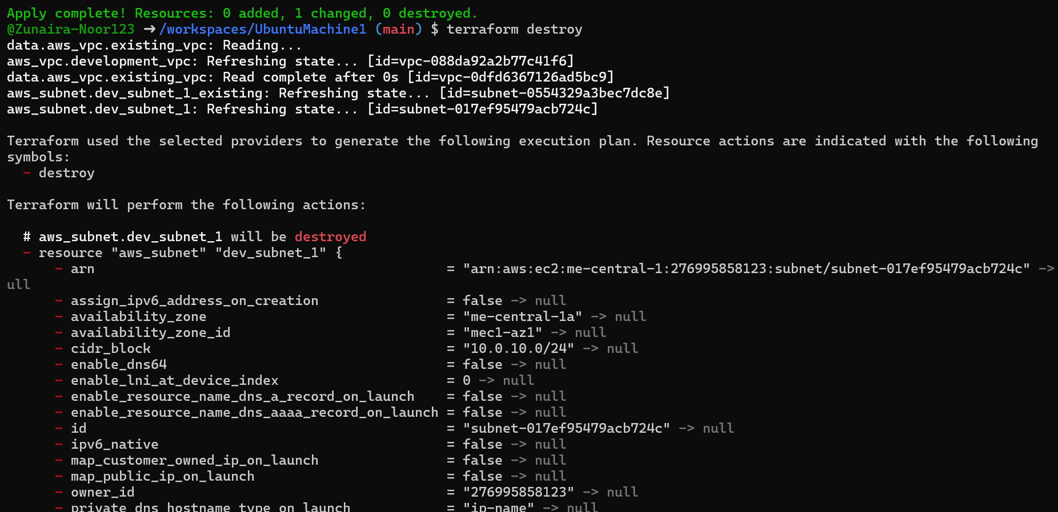
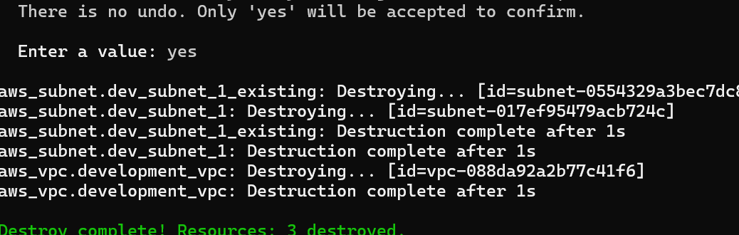
Inspect state files after destroy:
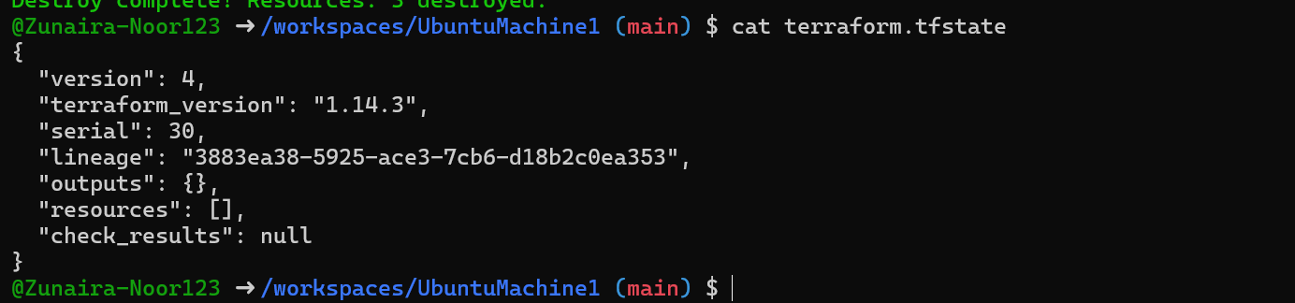
Run:
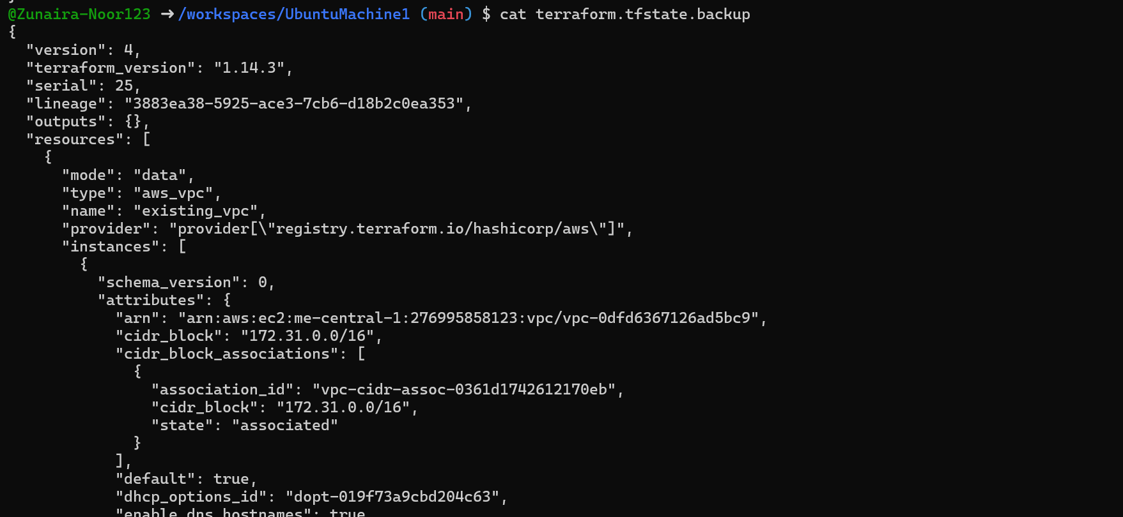
Recreate resources:
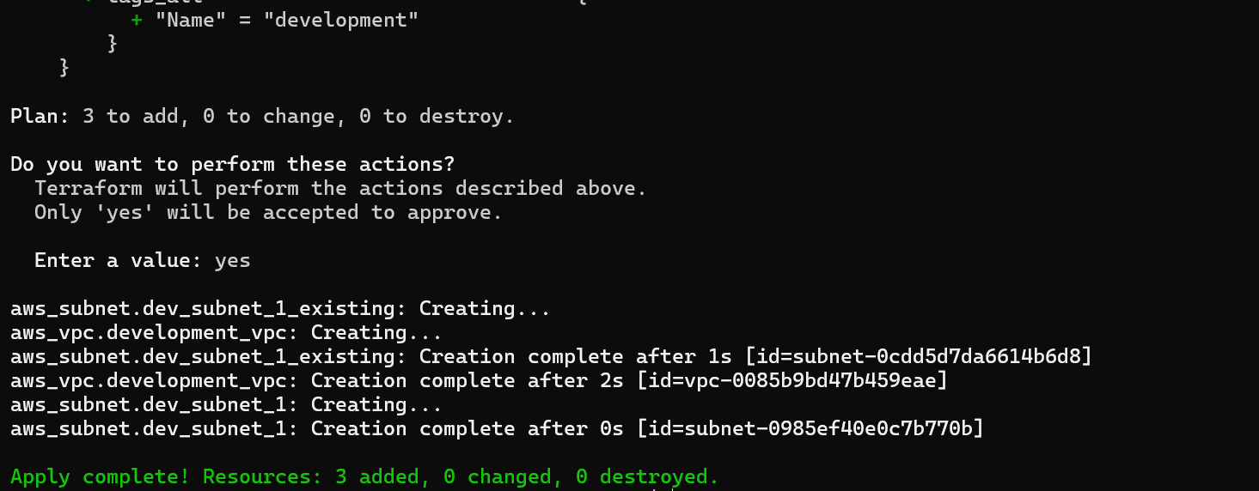
View state file
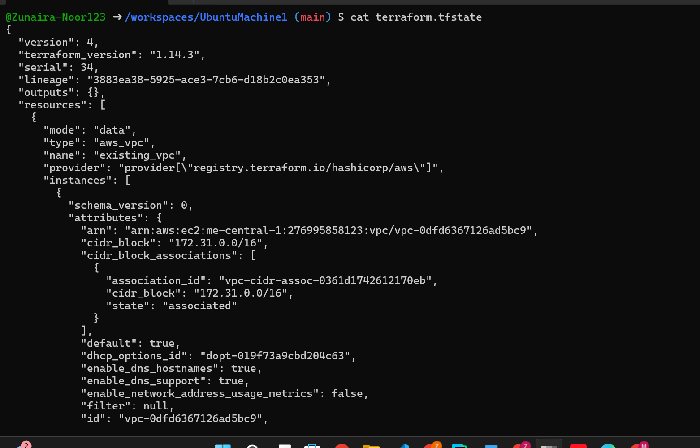
Run:
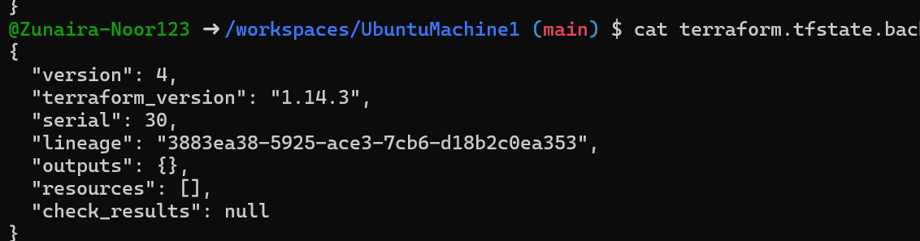
List resources:
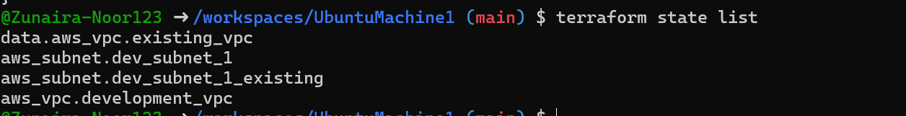
Show full attributes:
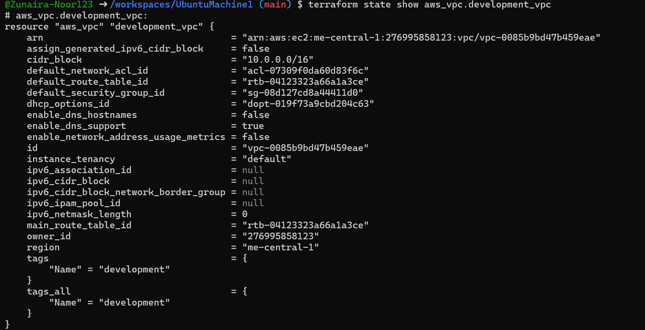
Task 6 — Terraform Outputs & Attributes Reporting
- Add outputs in main.tf
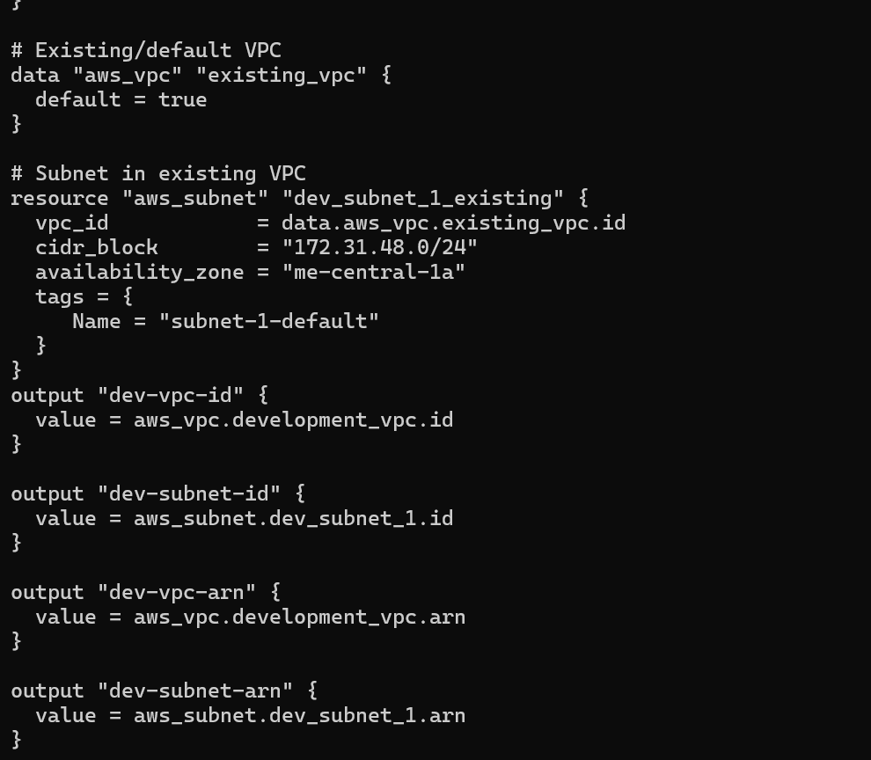
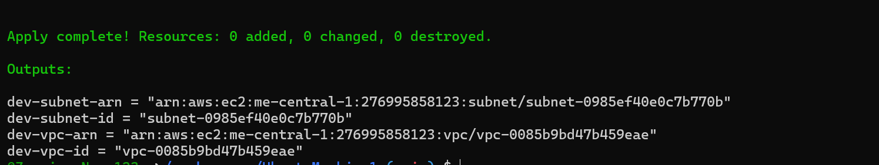
Edit main.tf again:
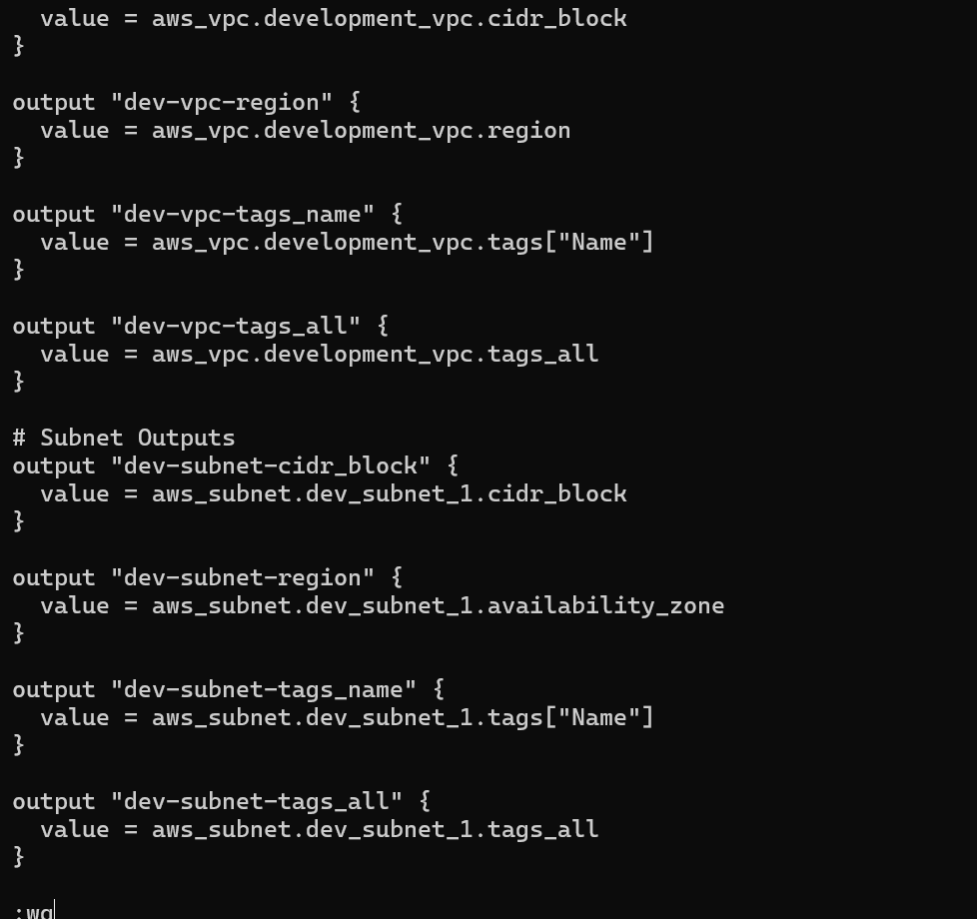
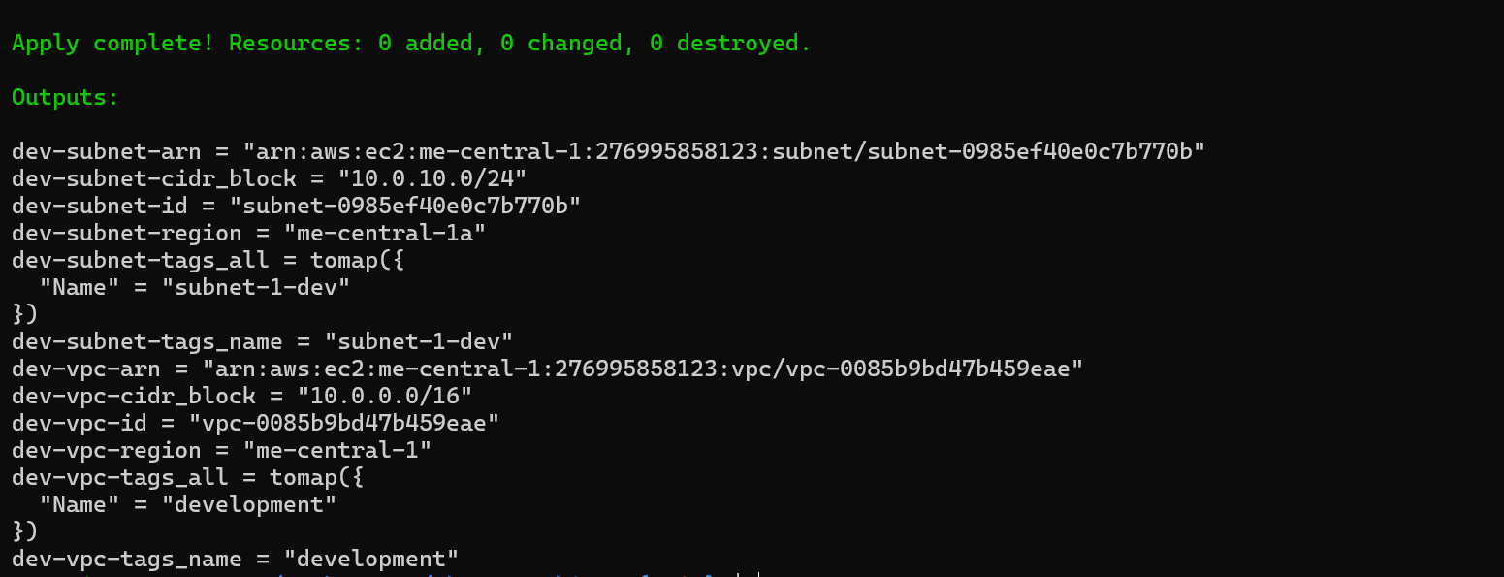
Cleanup — Delete Resources & State Verification
- Destroy all resources:
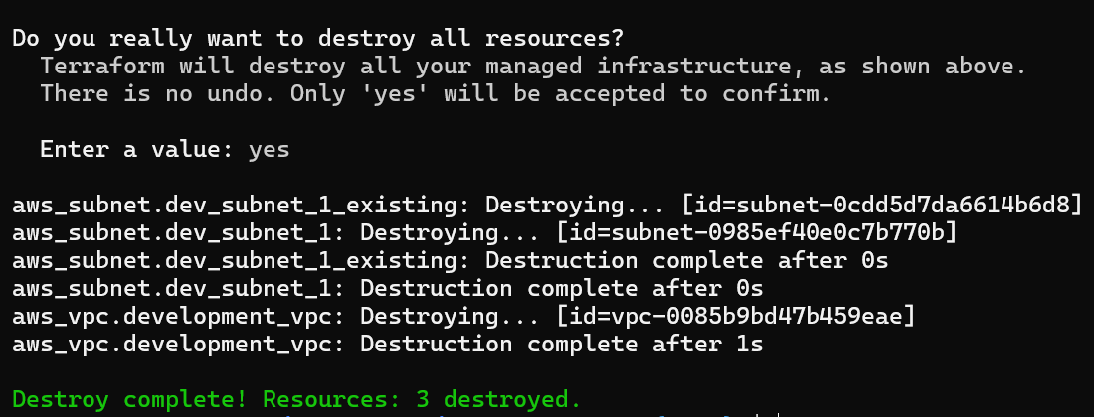
Inspect state files:
