Fatima Jinnah Women University
Department of Software Engineering


SUBJECT: CC LAB
SUBMITTED TO: SIR SHOAIB
SUBMITTED BY: ZUNAIRA NOOR
REGISTRATION NO: 2023-BSE-075
SEMESTER: V-B

Task1: (Local desktop) Install GitHub CLI (Windows example via winget):
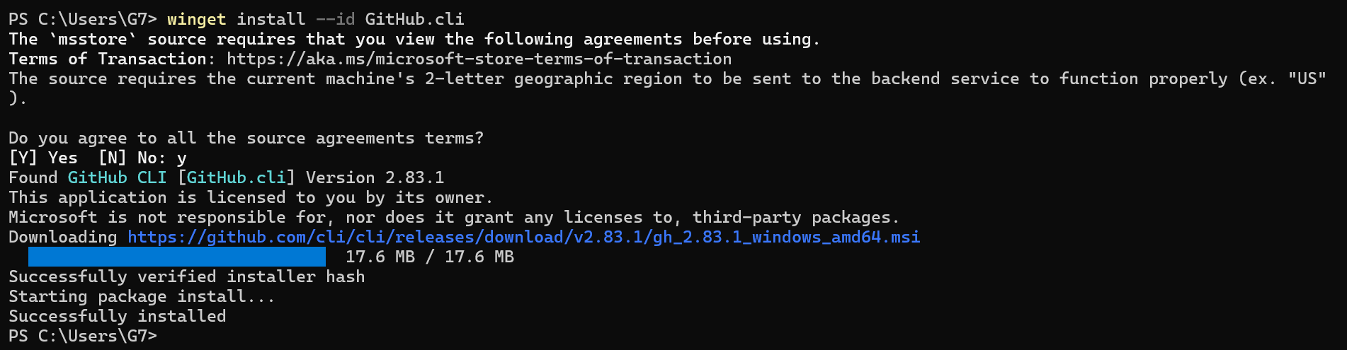
(Local) Authenticate GH CLI for Codespaces:
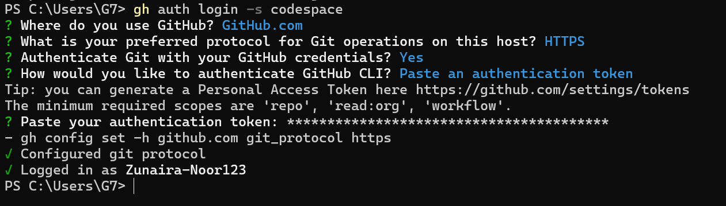
(Local) List available Codespaces (optional verification):
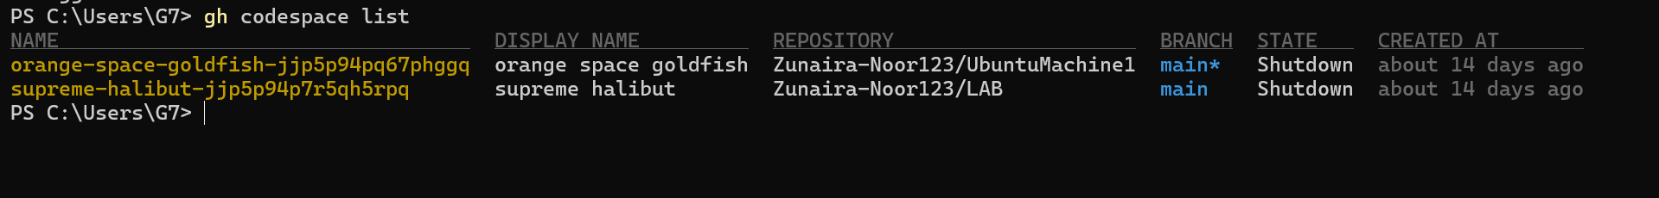
(Local) Create or connect to a Codespace. To create a new codespace from the current repo:
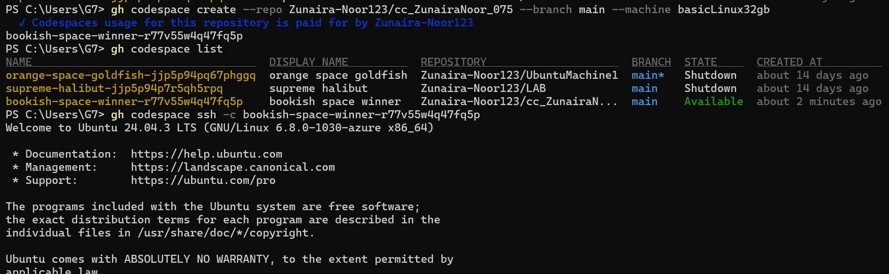
Task 2 — Install AWS CLI inside the Codespace and configure it
Download and install AWS CLI:
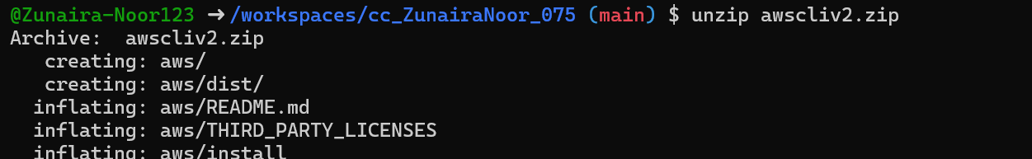
Verify installation:
Configure the AWS CLI (you will provide Access Key ID and Secret Access Key for a user with permissions, or use root/IAM user you prepared for the lab):
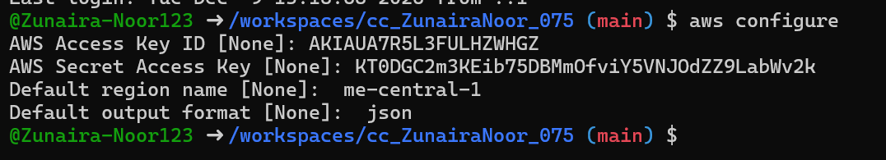
Verify credentials/config files:
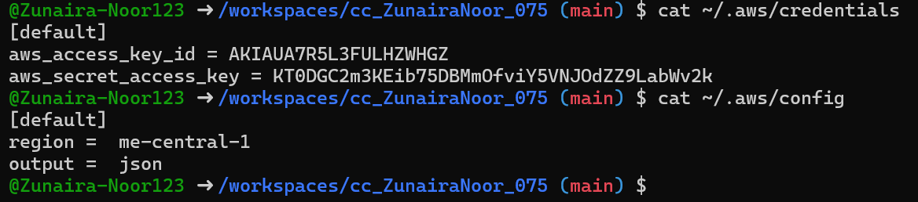
Verify connectivity (you should see a JSON result showing your caller identity):
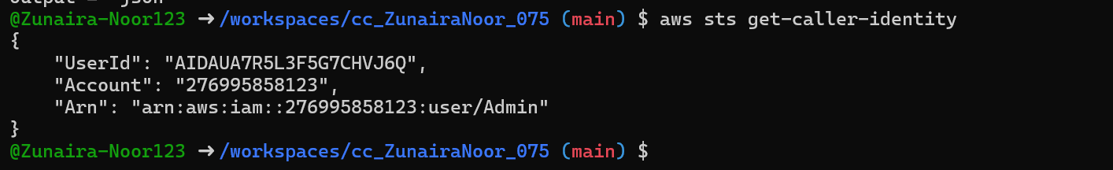
Task 3 — Create security group and add ingress rules using Codespace IP
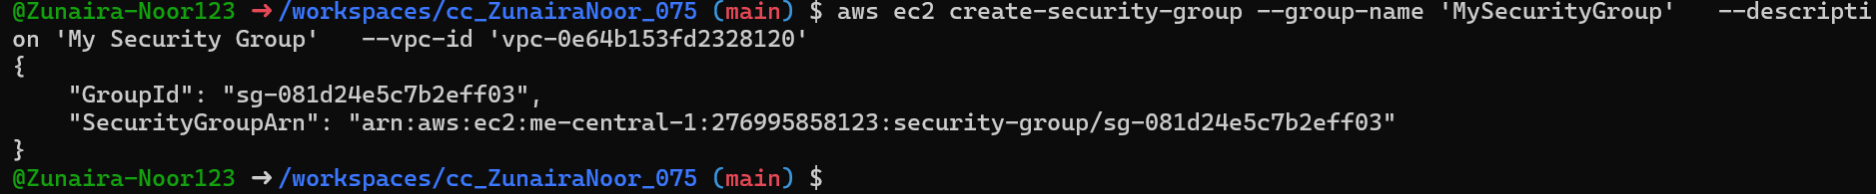
Inspect the security group (initially ingress will be empty or default):
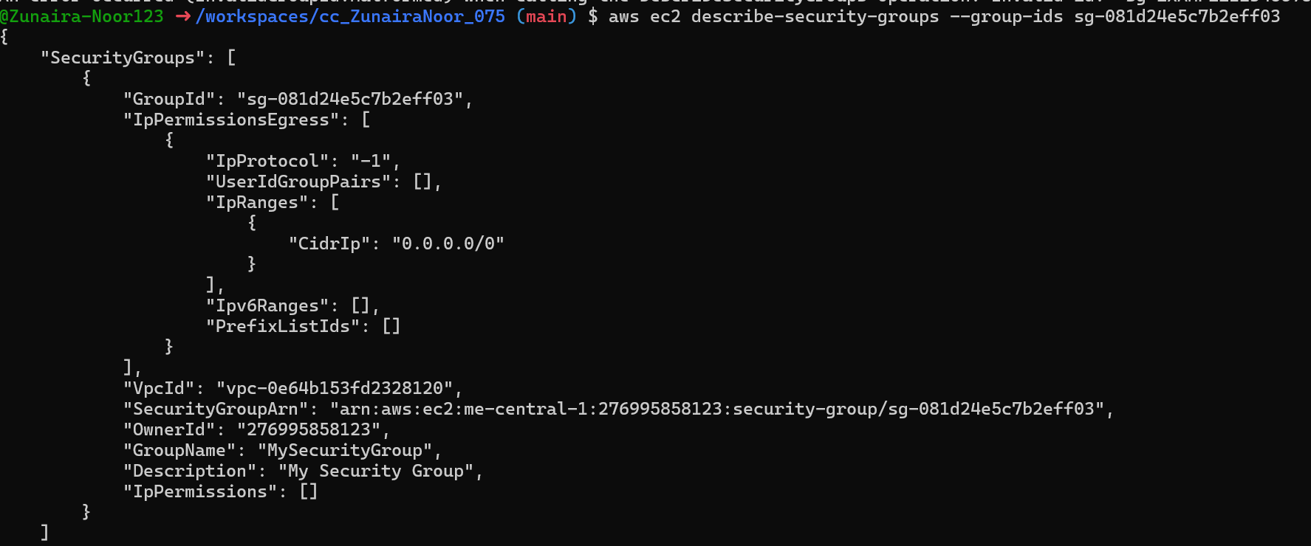
Get your Codespace public IP (from inside the Codespace):
Authorize SSH inbound on port 22 from your Codespace IP:
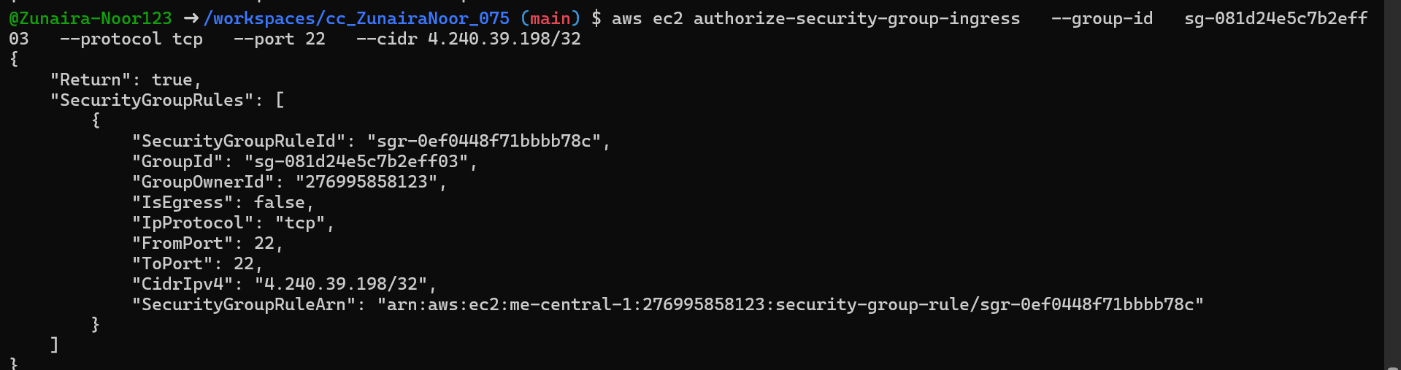
Verify ingress rule appears:

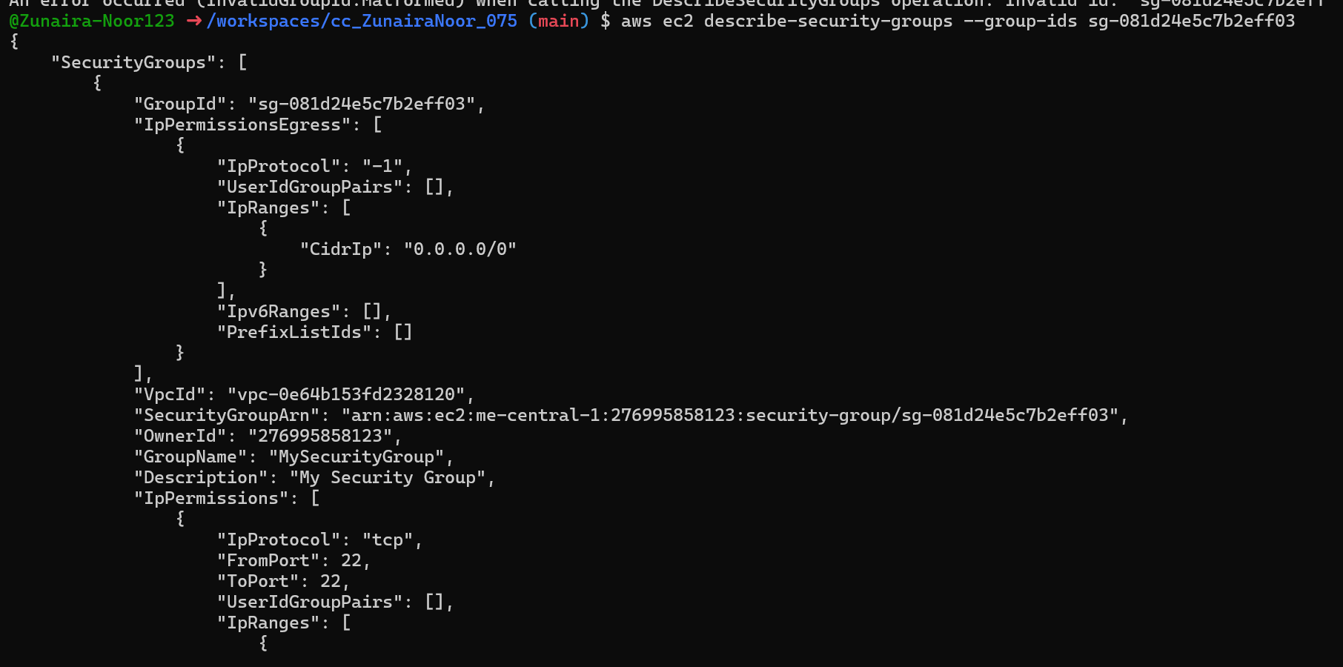
Add an HTTP rule (port 80) using ip-permissions JSON:
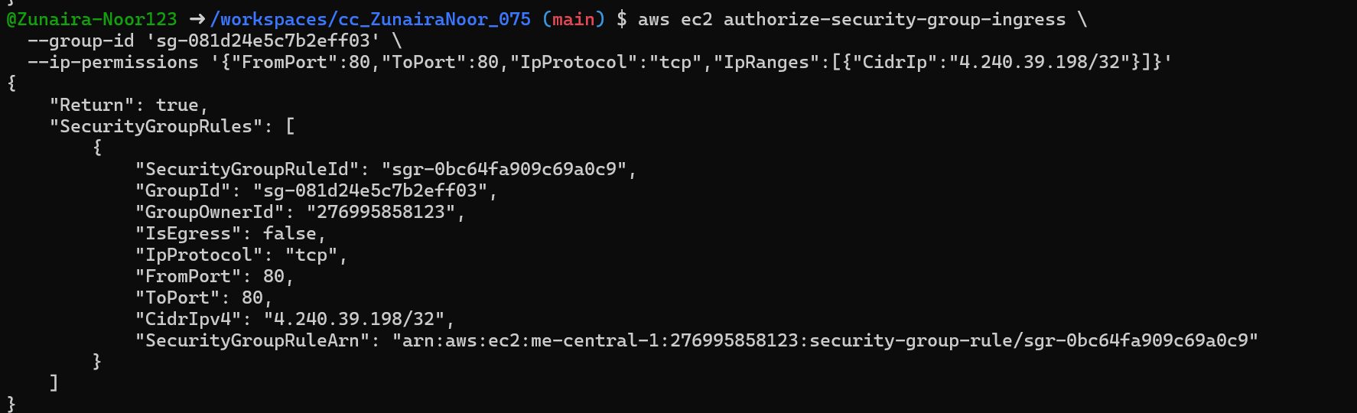
Verify both ingress rules are present:
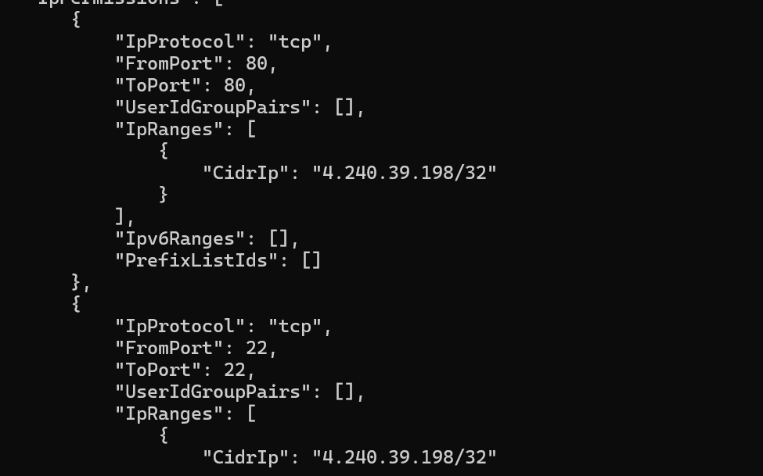
Task 4 — Create a key pair, describe key pairs, and launch EC2 instance
Create the key pair and save the PEM file into the Codespace workspace:
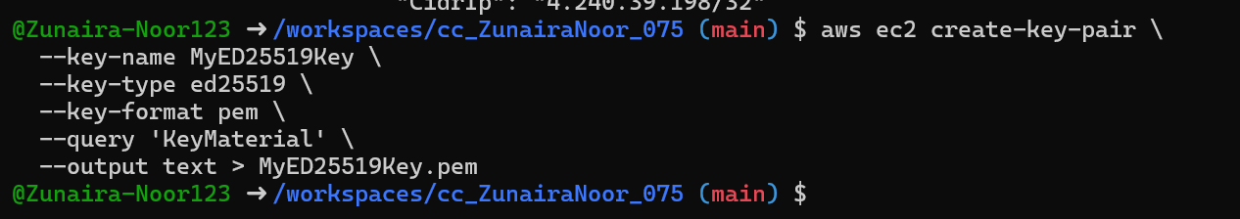
View created key pairs:
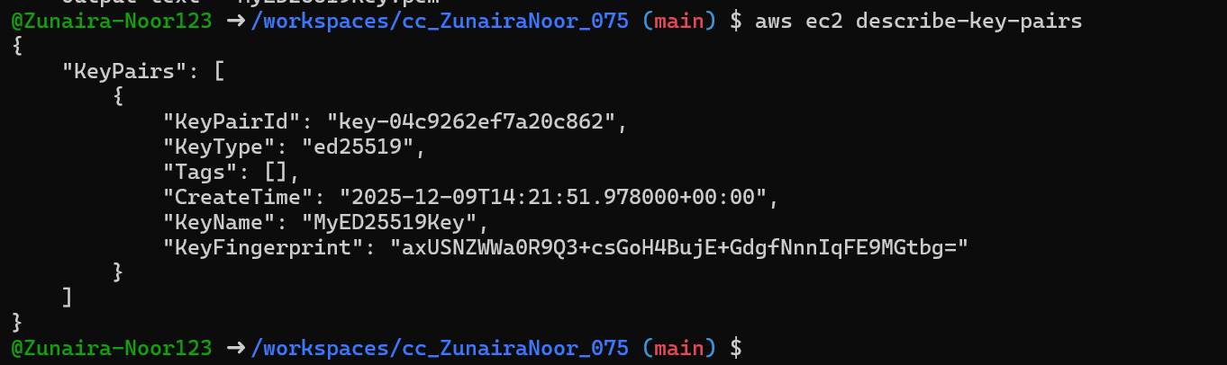
Launch an EC2 instance (example values — replace IDs with ones from your account/region):
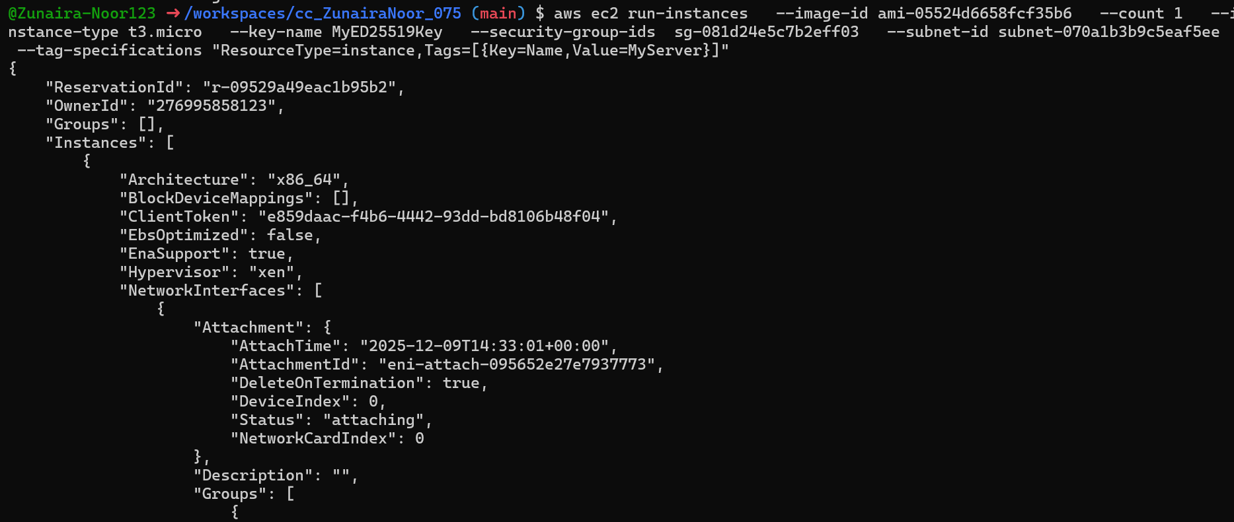
Get the public IP address of your instance:
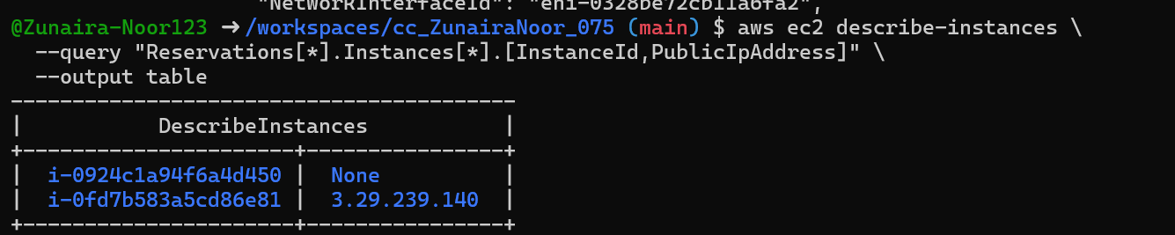
Attempt SSH into the instance from the Codespace or from a machine whose IP is allowed in the security group:
Task 5 — Understand AWS describe-* commands
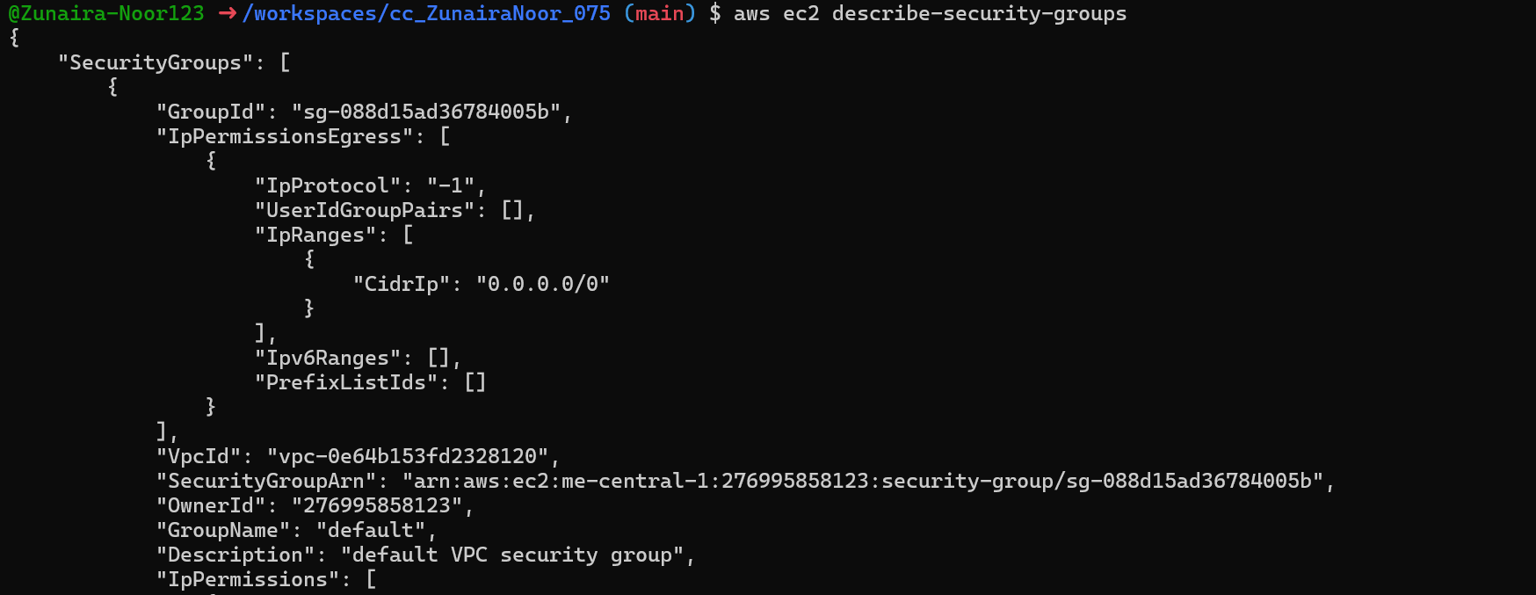
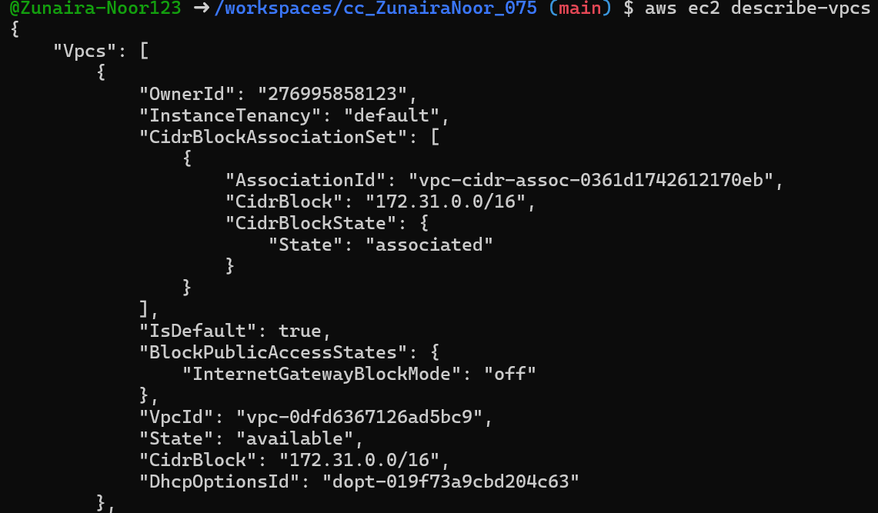
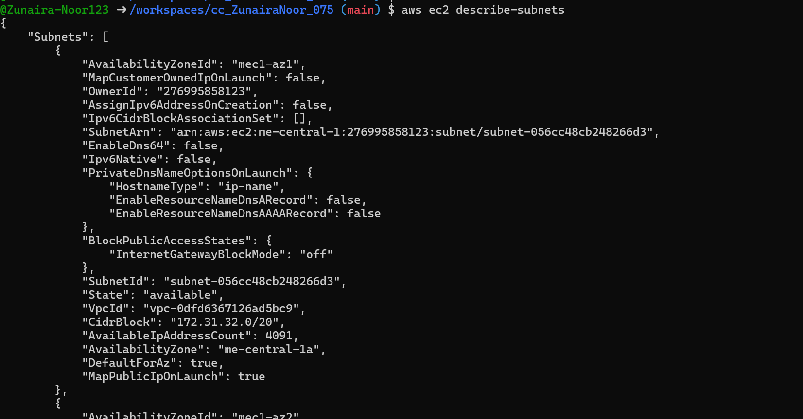
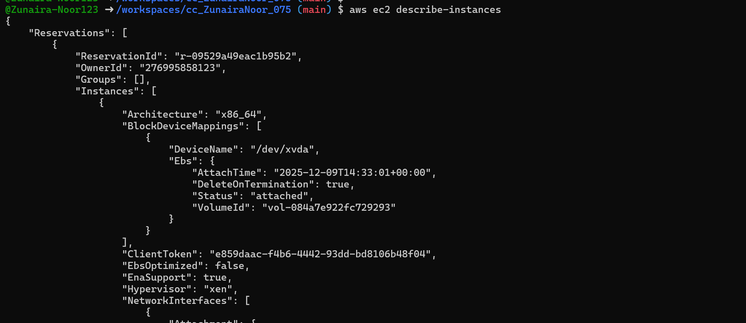
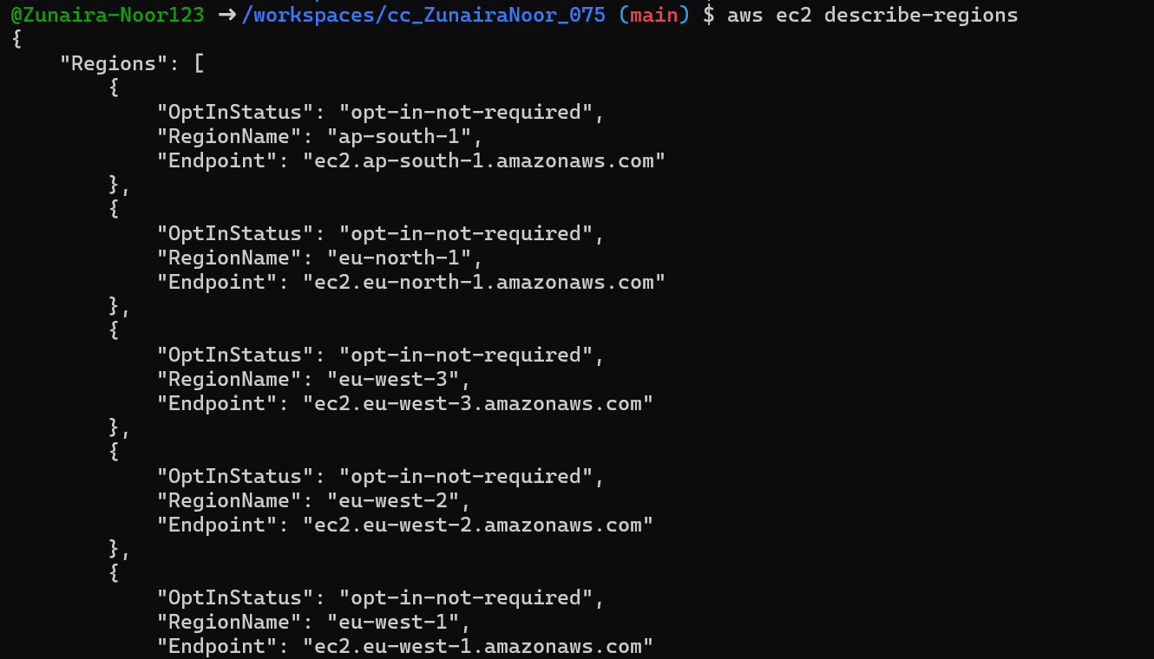
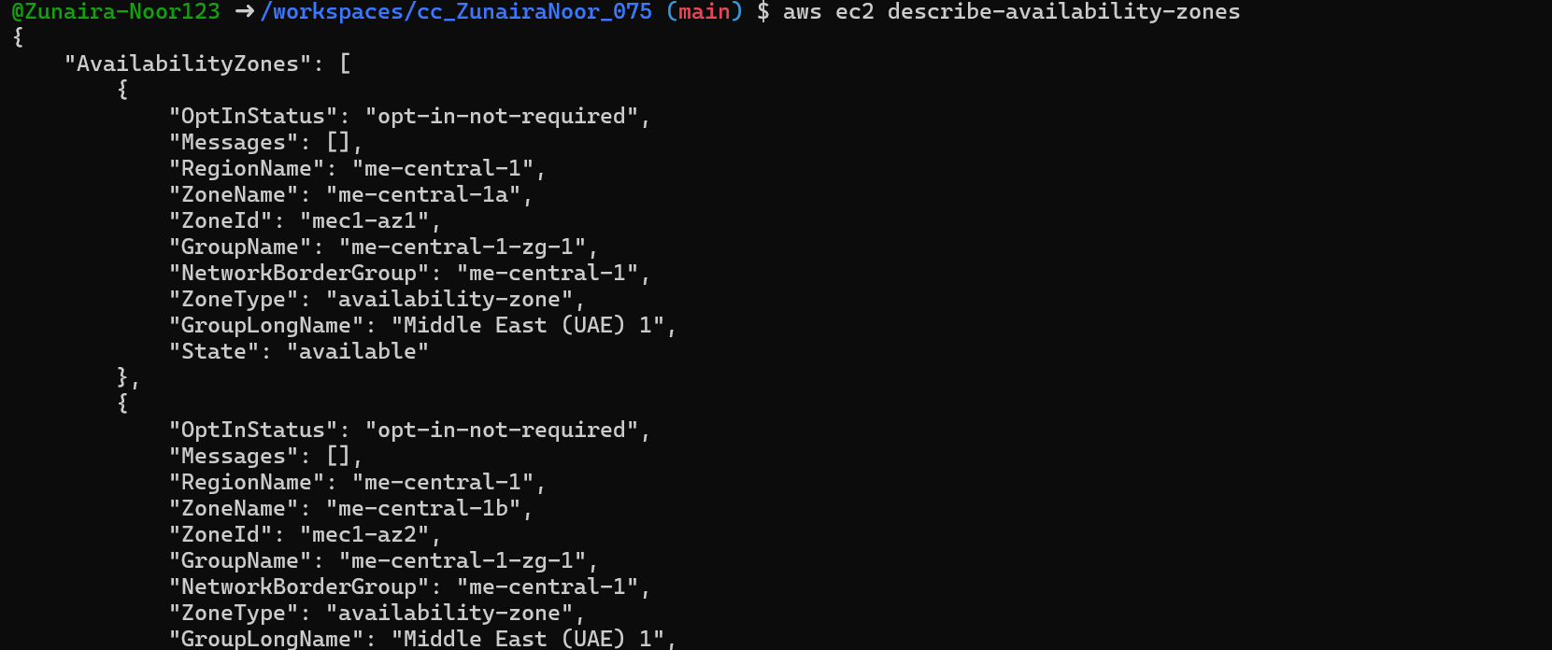
Task 6 — IAM: create group, user, attach policies, create console login & keys
Create group:
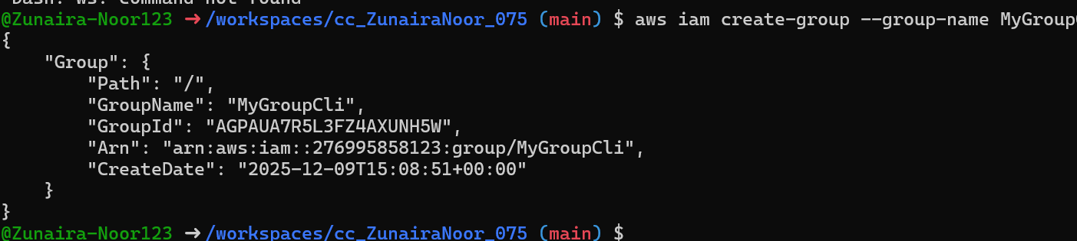
Get group details:
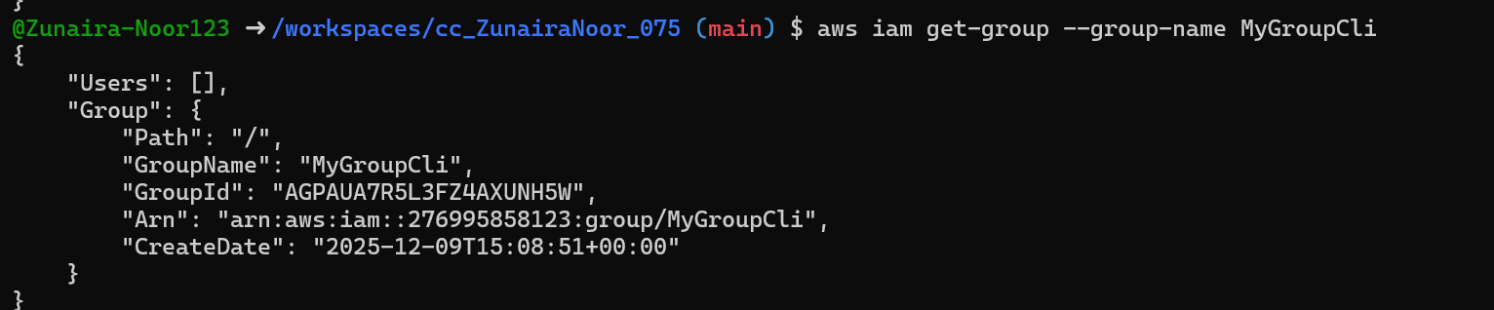
Create user:
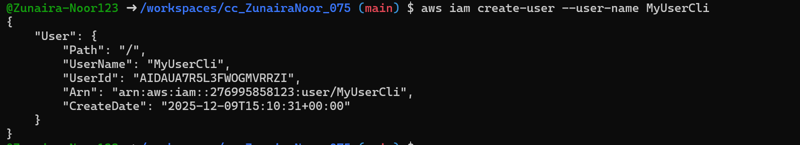
Get user details:
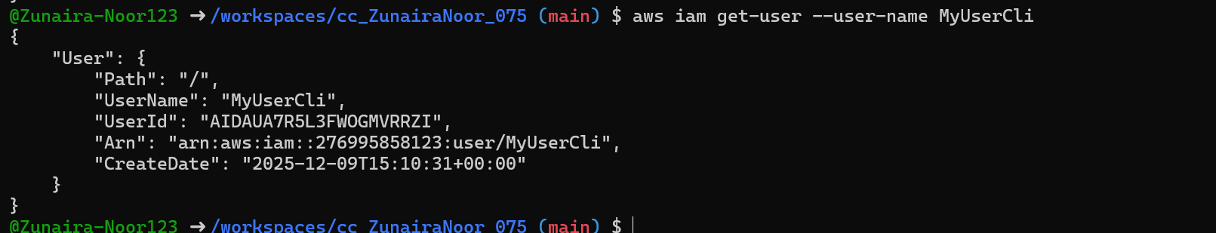
Add user to group:
See group again:
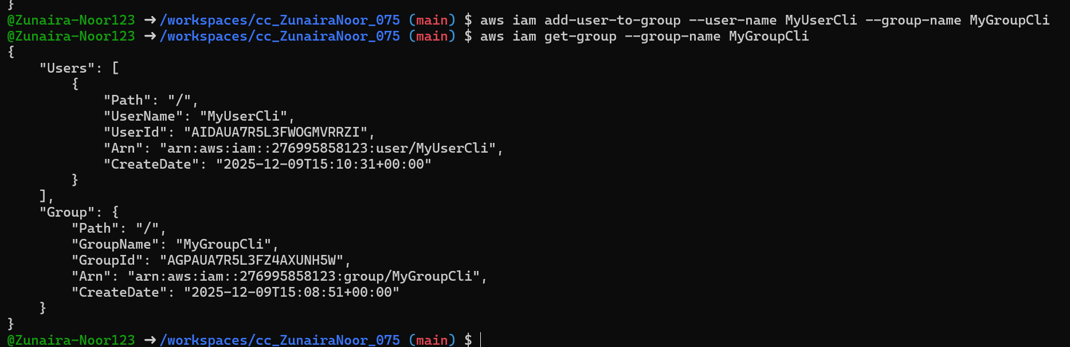
List policies that mention EC2:
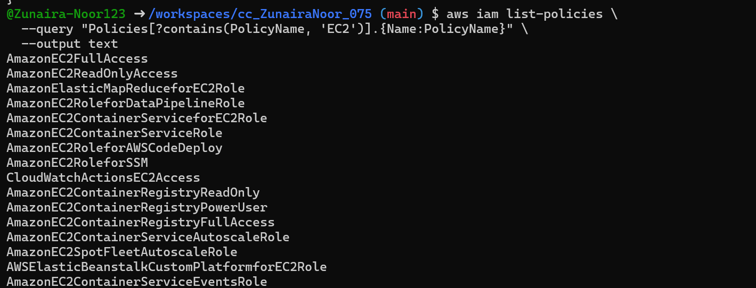
Get ARN for AmazonEC2FullAccess (example query):
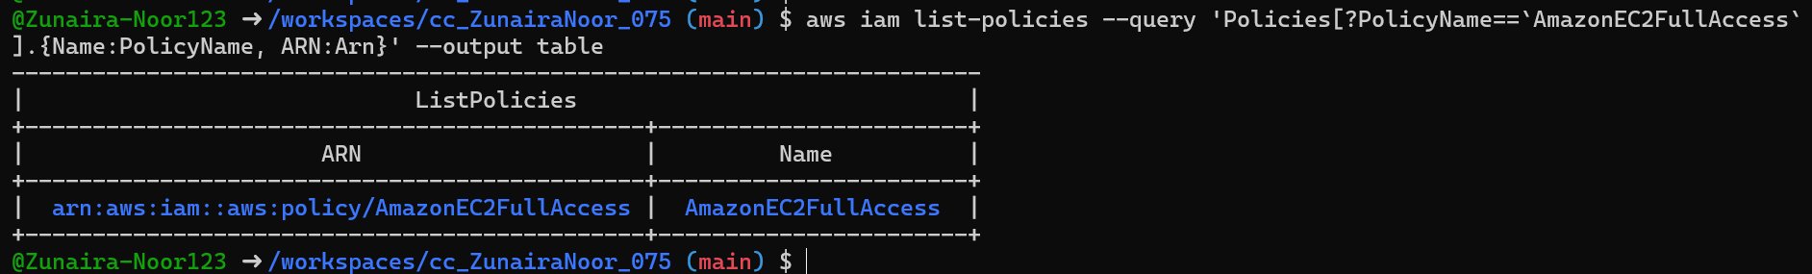
Attach policy to group (use the ARN you retrieved):
List attached policies for the group:
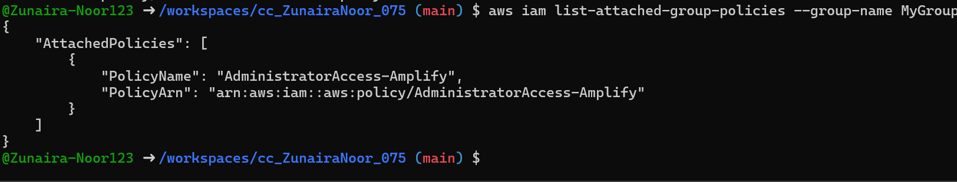
Create a console login profile for the user:
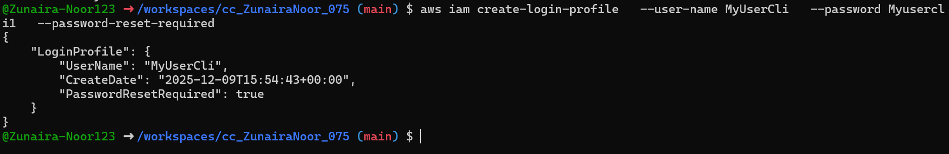
If the user cannot change password, attach IAMUserChangePassword to the group temporarily:
After the user logs in and resets password, detach that policy:
Create access keys for the user (save AccessKeyId and SecretAccessKey securely):
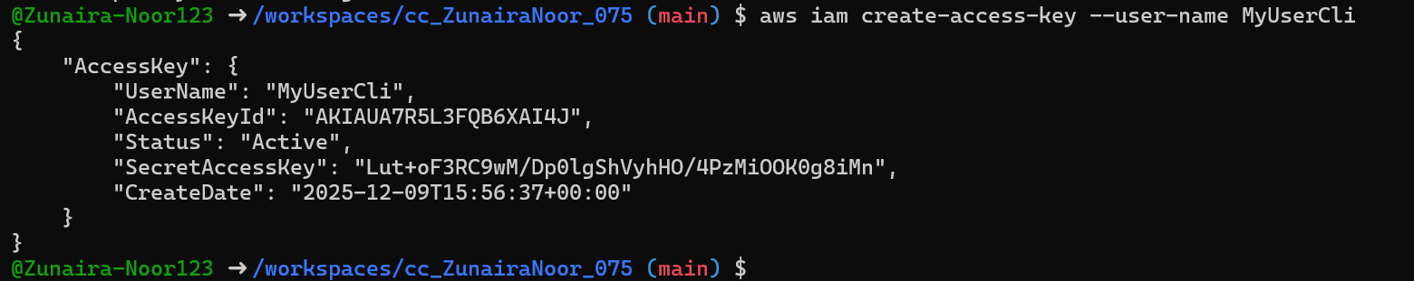
List access keys:

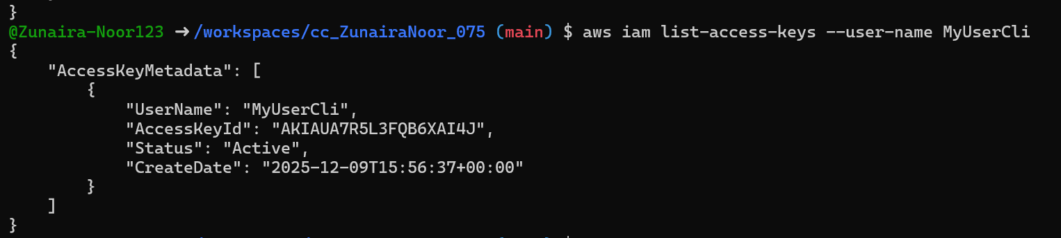
Use environment variables to authenticate as that user in the Codespace:
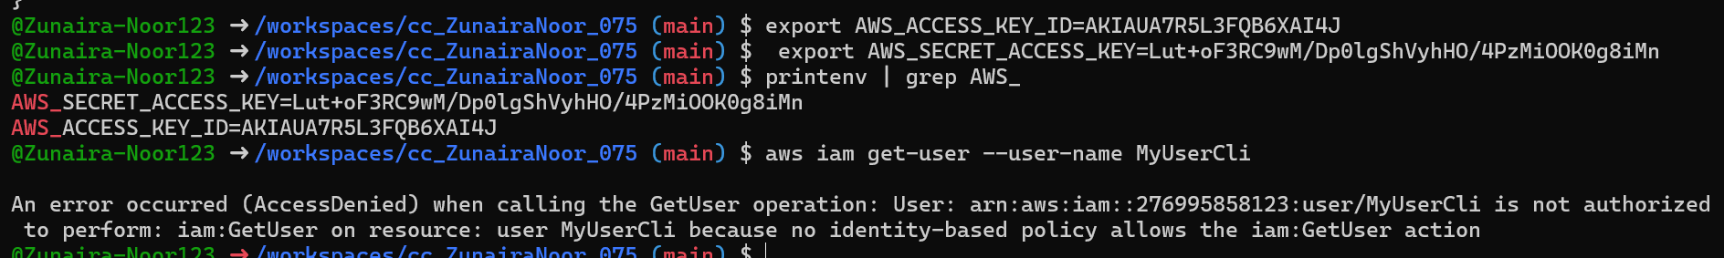
After clearing or switching credentials, repeat get-user and save
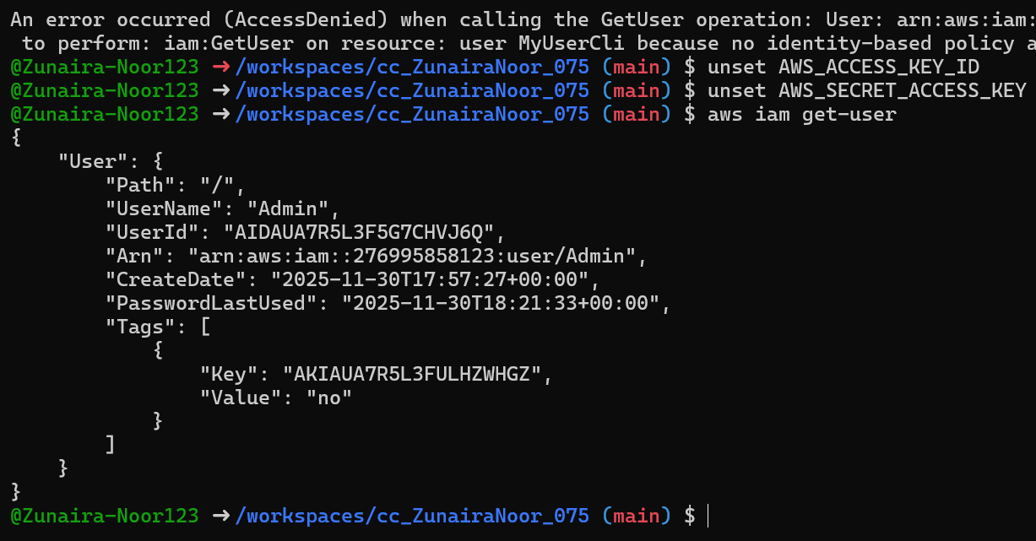
Task 7 — Filters: query with filters to find instances and their attributes
Goal: Use filters and queries to list specific instances and attributes.
Examples (run each and take a screenshot immediately after):
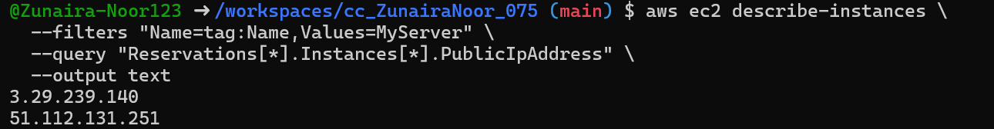
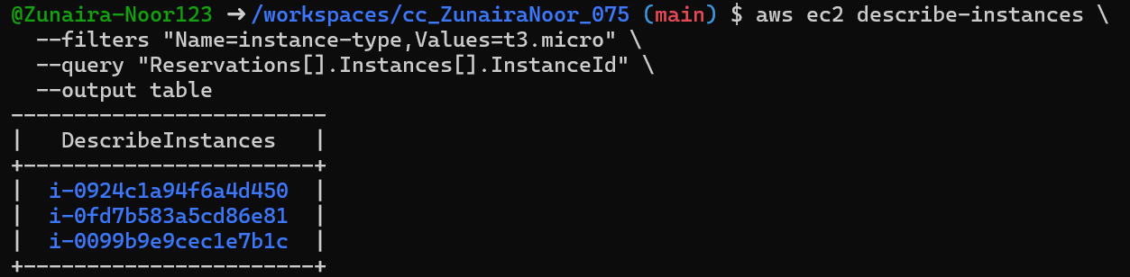
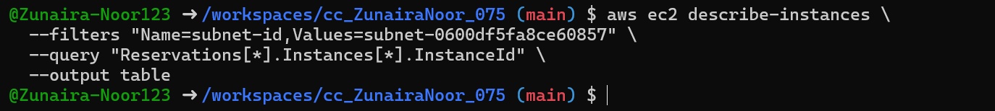
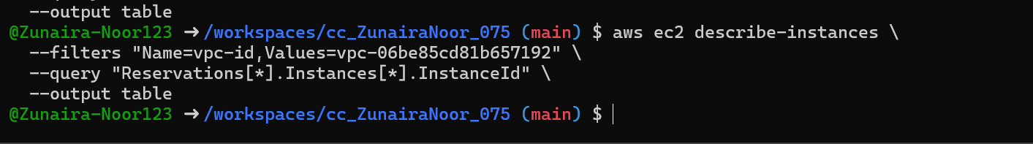
Task 8 — Use --query to format outputs for reporting
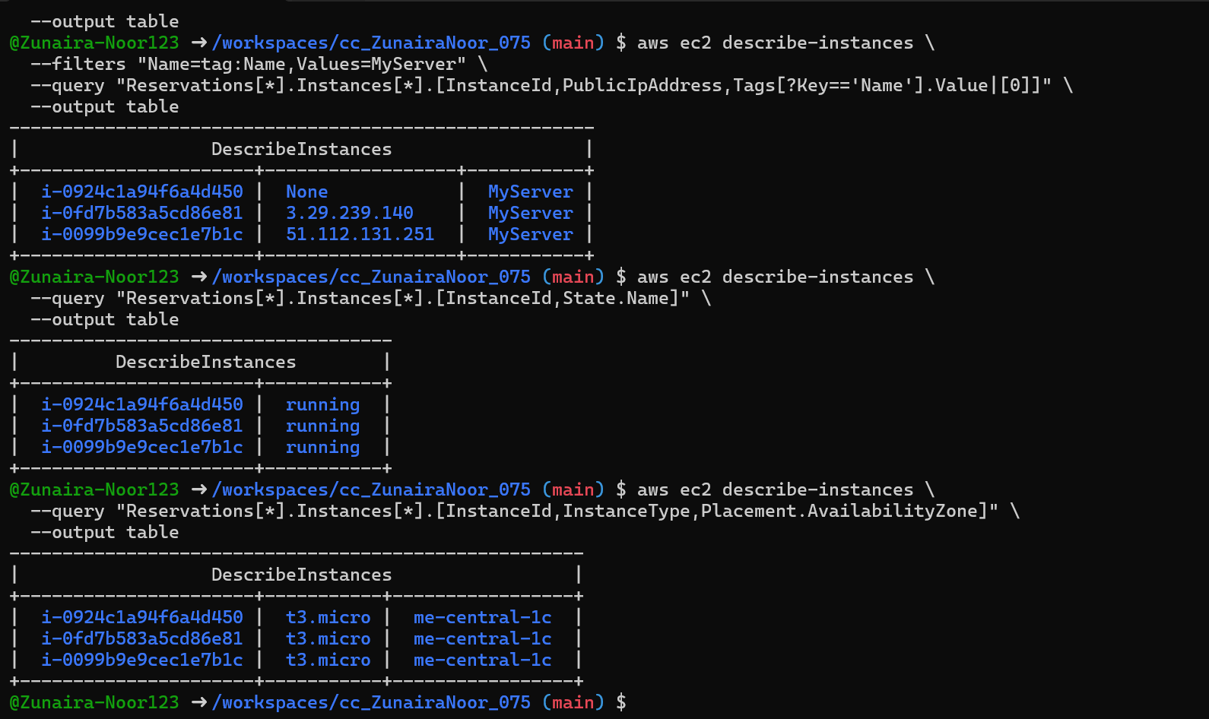
Cleanup — Remove resources to avoid charges
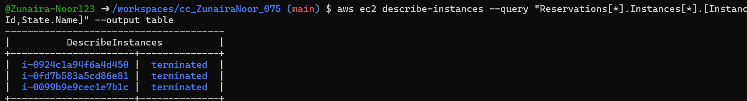
Delete EBS volumes & snapshots (if any):
Delete security group and key pair:
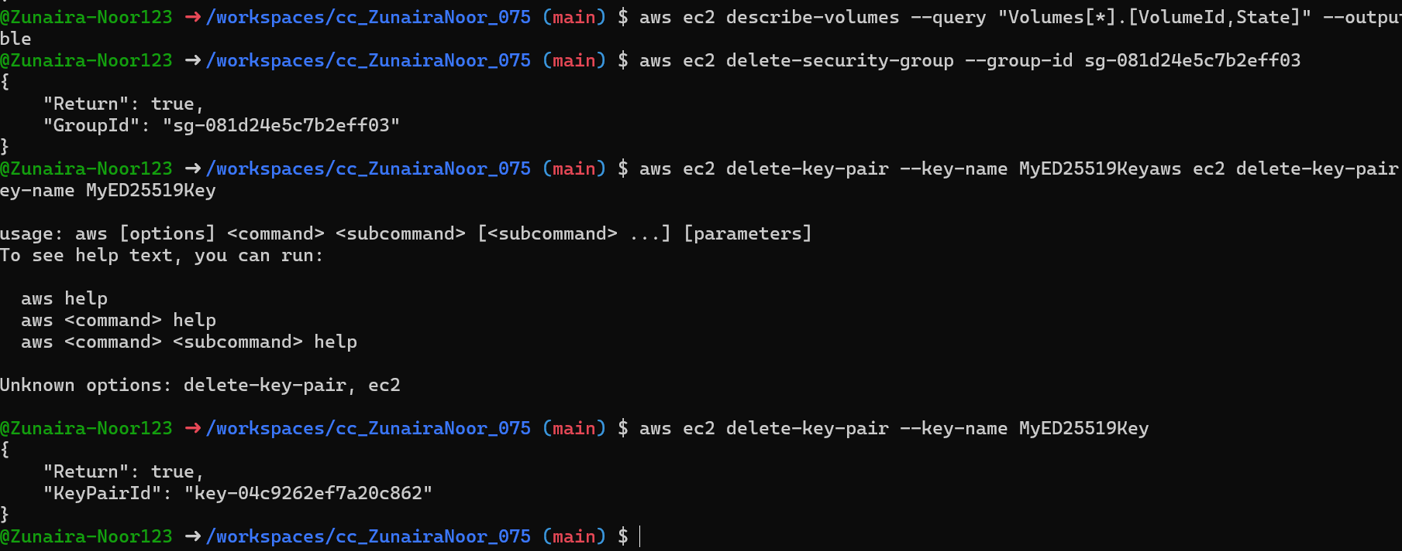
Remove IAM users, access keys, groups:
