Fatima Jinnah Women University
Department of Software Engineering

SUBJECT: CC LAB
SUBMITTED TO: SIR SHOAIB
SUBMITTED BY: ZUNAIRA NOOR
REGISTRATION NO: 2023-BSE-075
SEMESTER: V-B

Task 1
- Run the java command to see what the system suggests:
- Use the suggested apt command (copy the exact package name suggested by the system). Example (replace with the name shown on your VM):
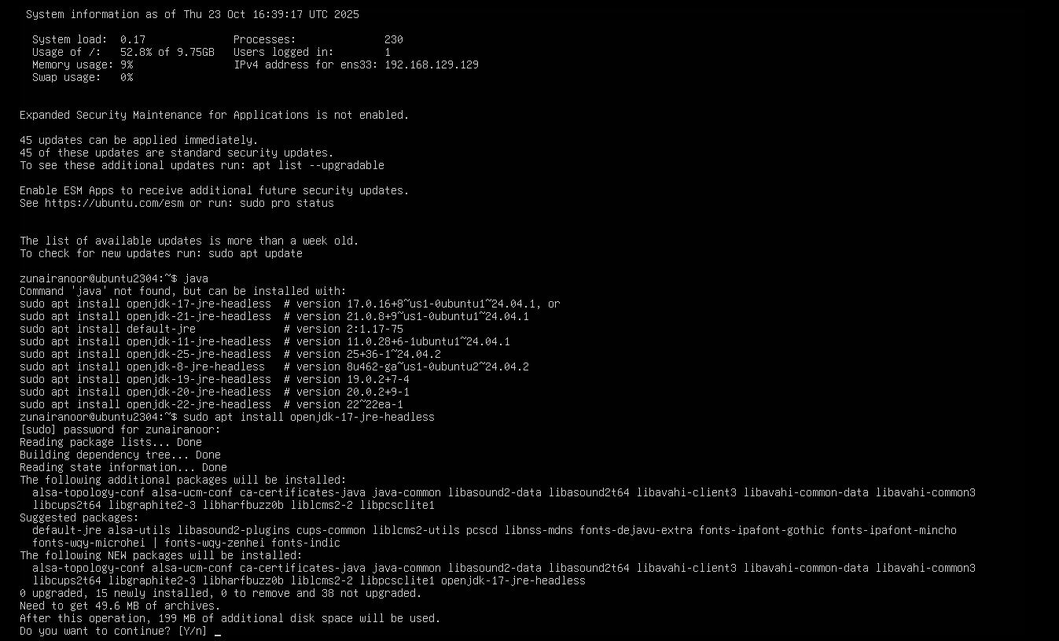
- Verify Java is installed and check version:
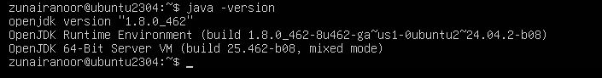
- Remove the Java package using apt remove (use the same package name you installed):

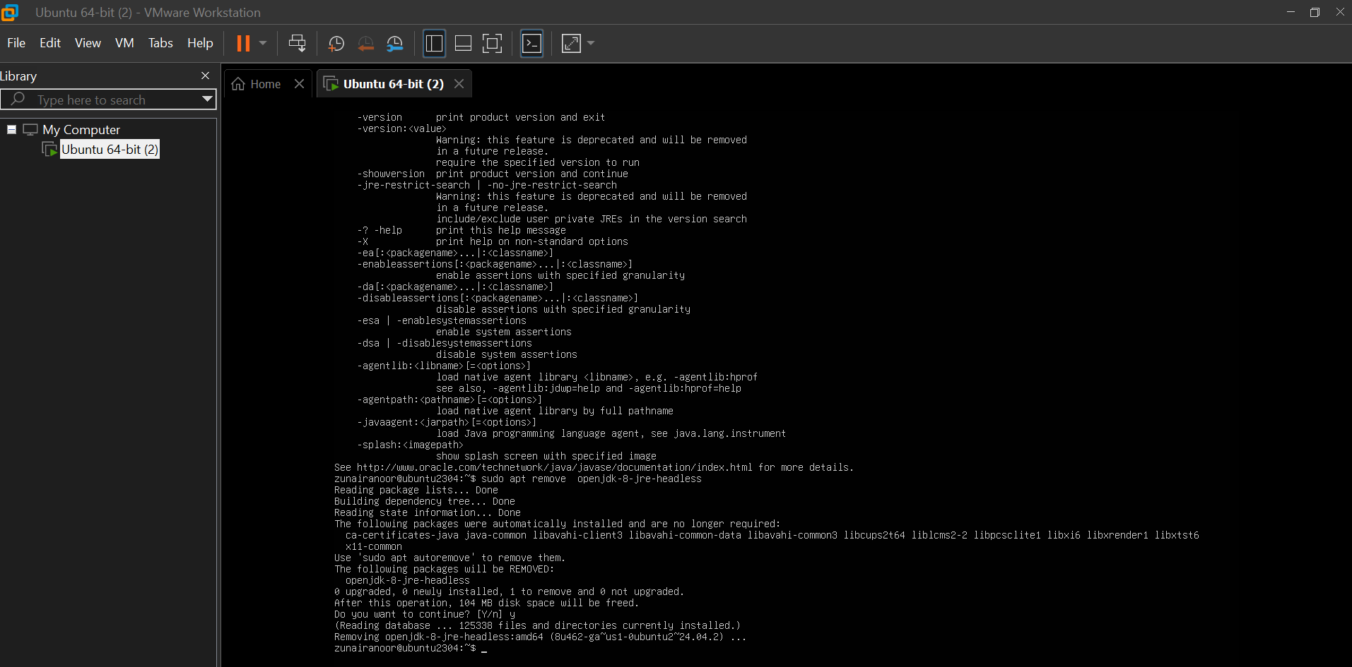
- Confirm java is no longer available (run java again) — it should again indicate "not found" or suggest installation:

- Clear the shell's command hash cache so the shell forgets cached command locations (run as your regular user — no sudo required):
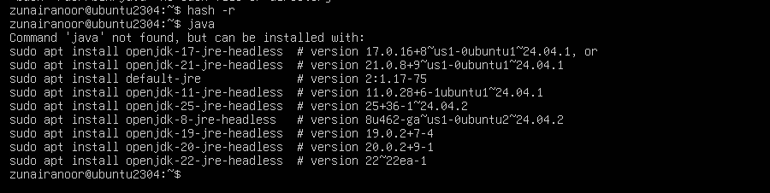
Task 2 - Install & remove Java using apt-get (explicitly)
- Install Java using apt-get (choose a common package, e.g., default-jre — or the same package you used in Task 1):

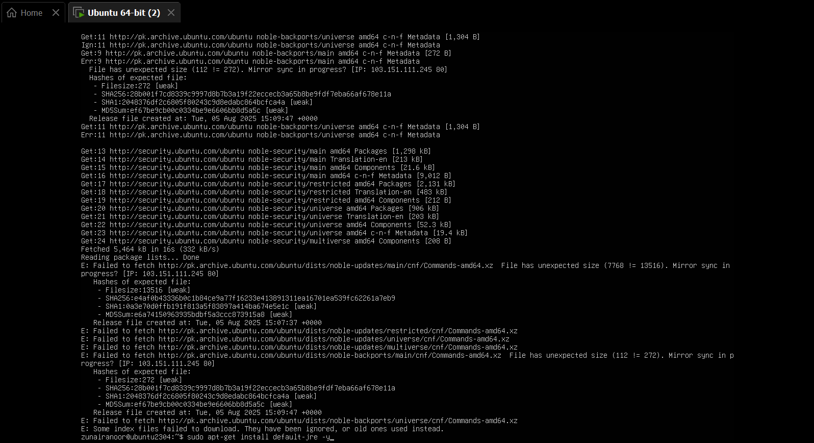
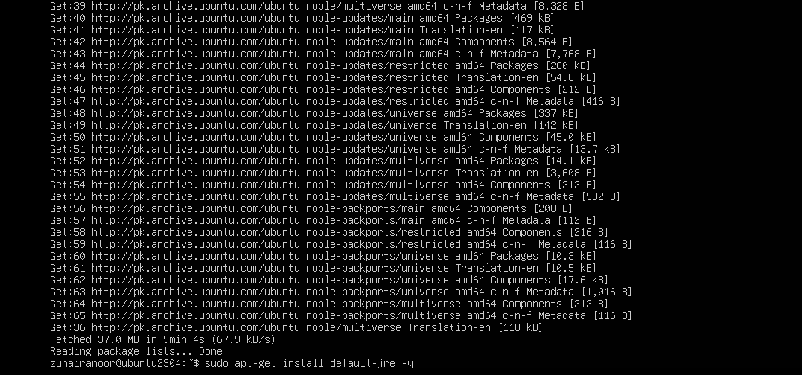
- Verify Java version again:
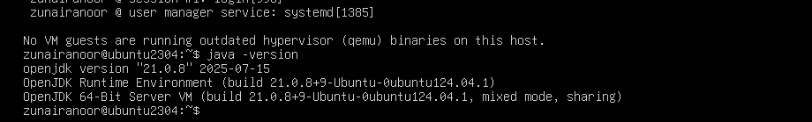
- Remove Java using apt-get remove:
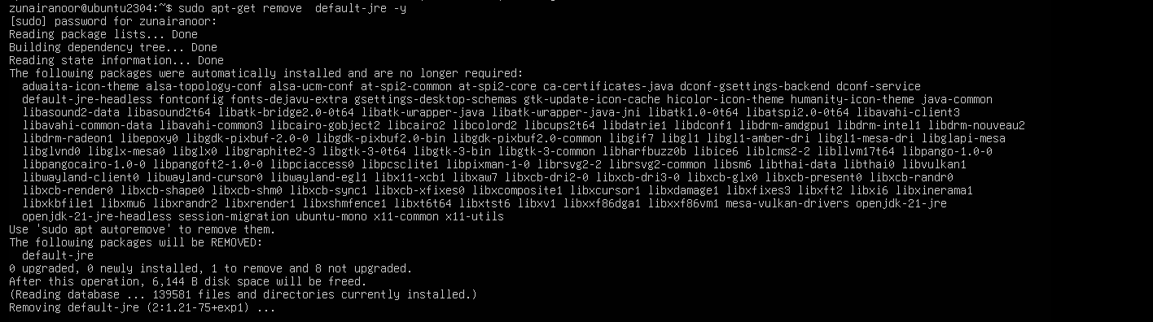
- Clear the terminal hash cache and confirm java is missing:
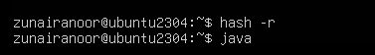
Task 3 - apt update vs apt upgrade - run & explain
- Update the package index (this downloads the latest lists of available packages):
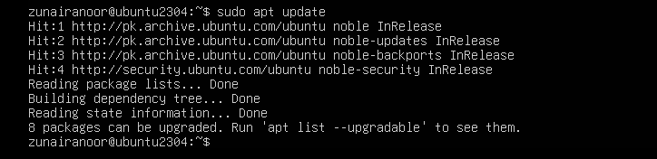
- Upgrade installed packages (this installs available updates for currently installed packages):
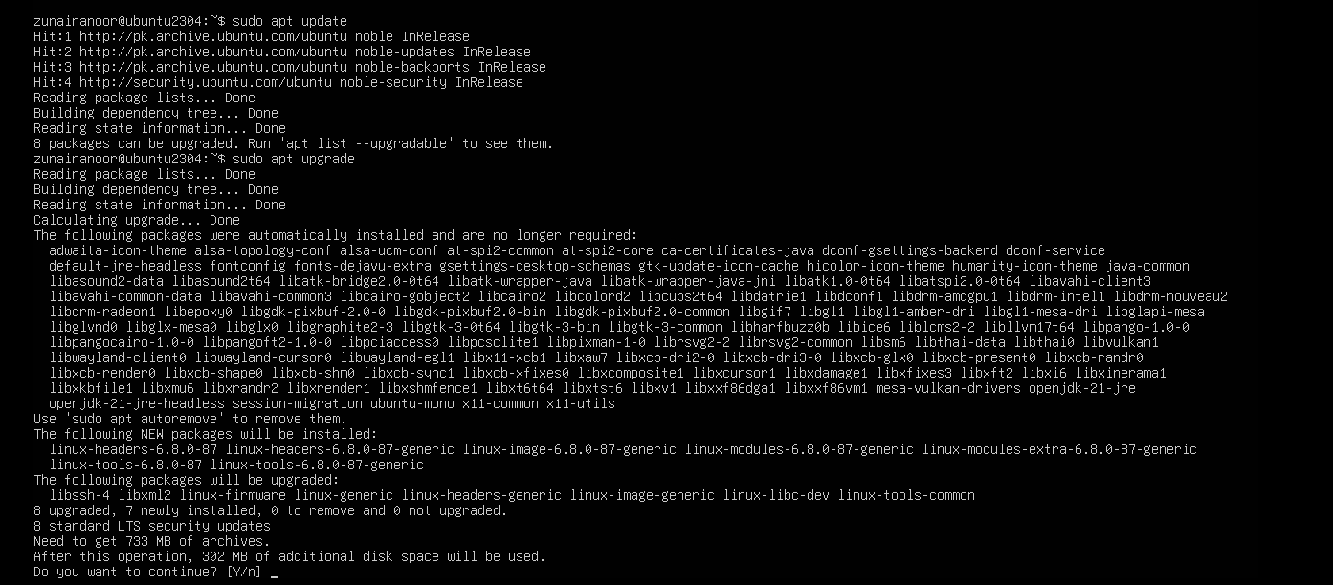
Write a short 3–5 sentence explanation describing the difference between apt update and apt upgrade
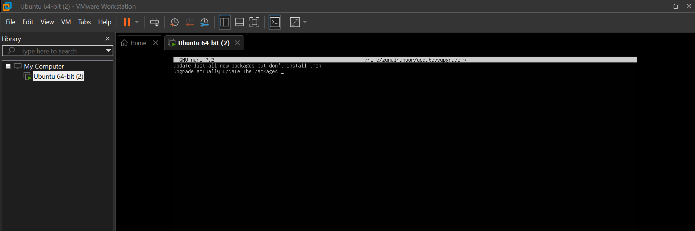
Task 4 - Install Visual Studio Code via snap on CLI and verify (DO NOT remove Code)
- Install VS Code via snap (snap may require sudo):
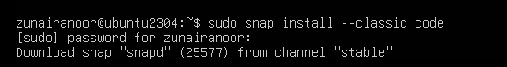
- Verify snap shows the package is installed:
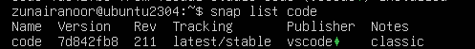
- Check the installed application's version. On some systems code --version is available; also check snap info:
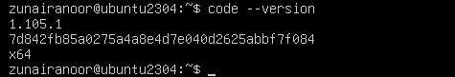
- If the code binary is not in PATH, show where the snap placed it:
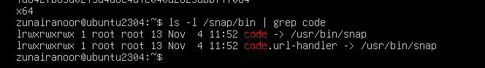
Task 5 - Install XFCE GUI + XRDP - minimal desktop and remote access (GUI) and launch VS Code
- From your host, open your preferred terminal (for example: Windows Command Prompt, PowerShell, macOS Terminal, or Linux Terminal) and connect to the VM using SSH. Example:
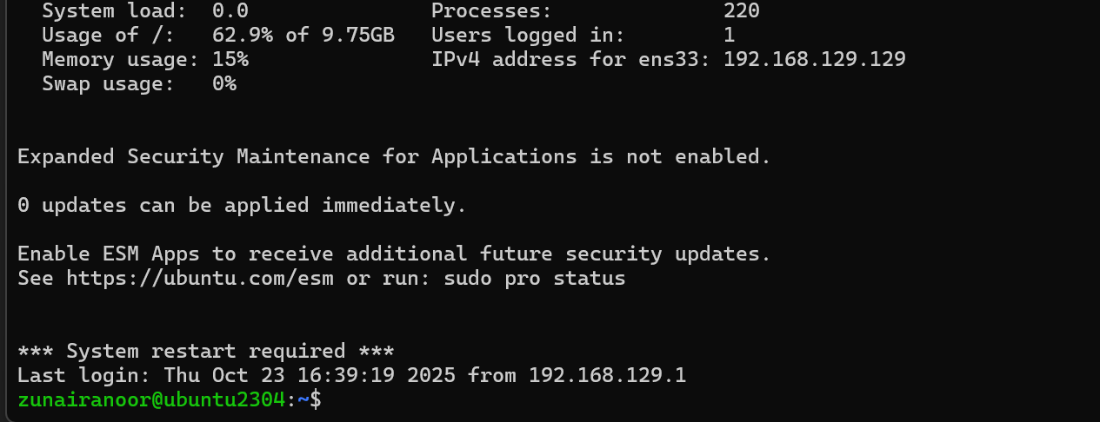
- Update the server (download package lists and apply upgrades):
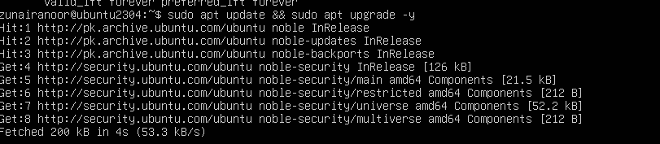
- Install XFCE and XFCE goodies (lightweight desktop):
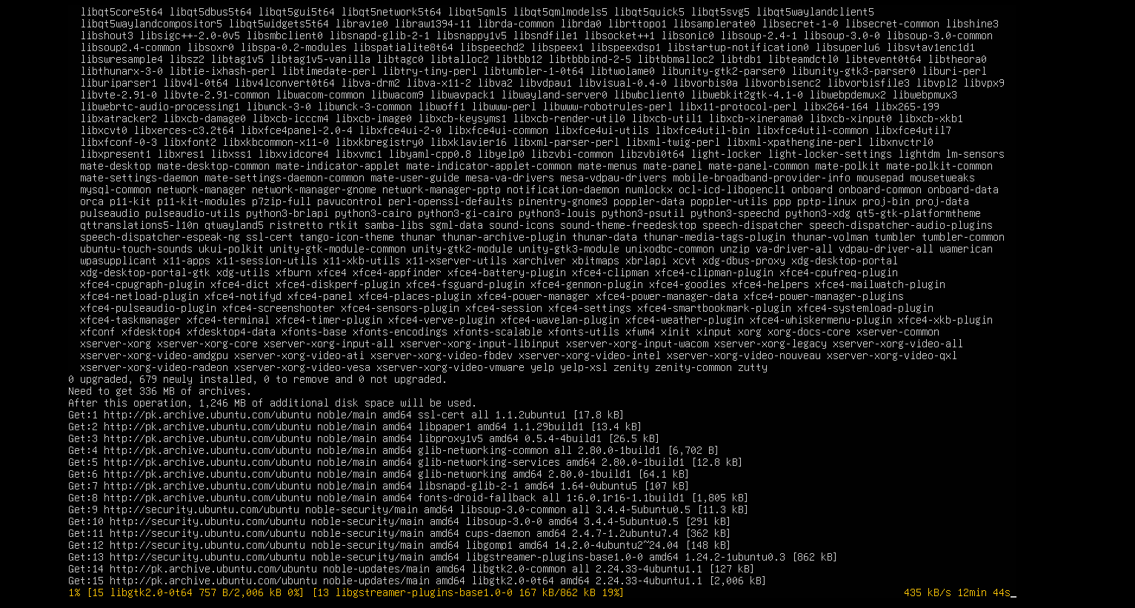
- Install and enable XRDP (Remote Desktop Protocol server):
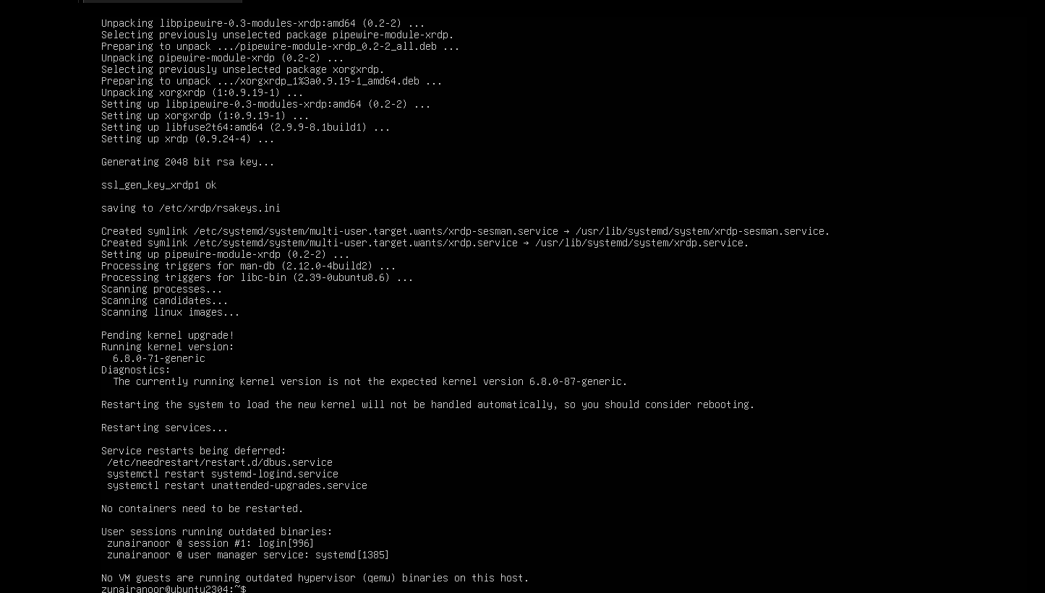
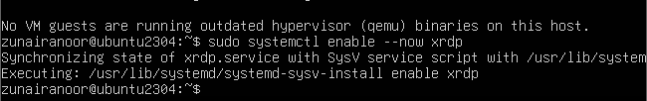
- Verify XRDP status:
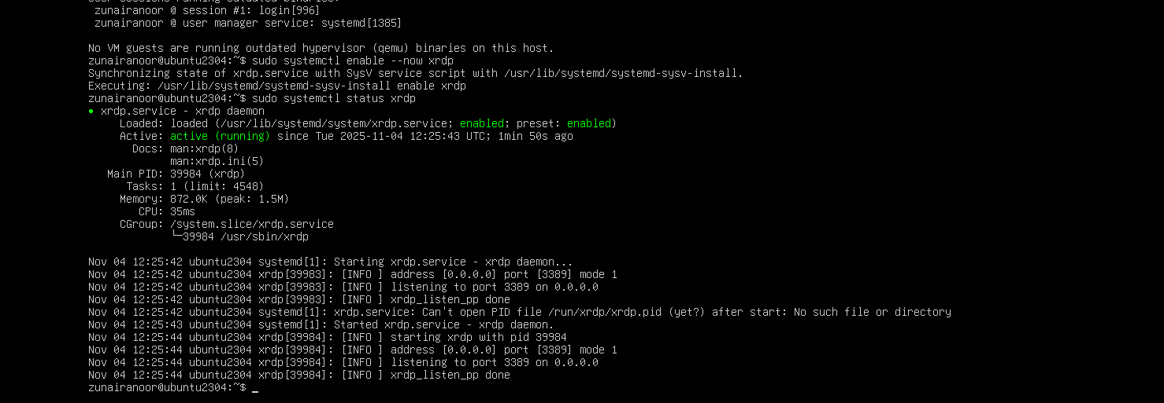

- Configure XRDP to use XFCE session:
- From a Windows host or RDP client, connect with Remote Desktop (mstsc) to your server IP and login using your Ubuntu username/password. Capture a screenshot of the remote desktop or the RDP session window (if allowed by your environment)
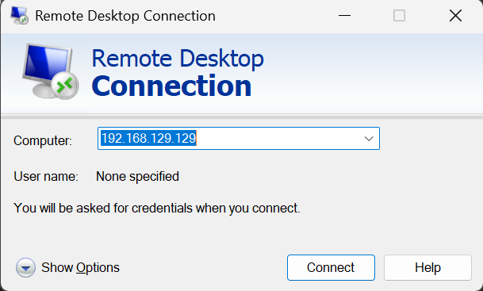
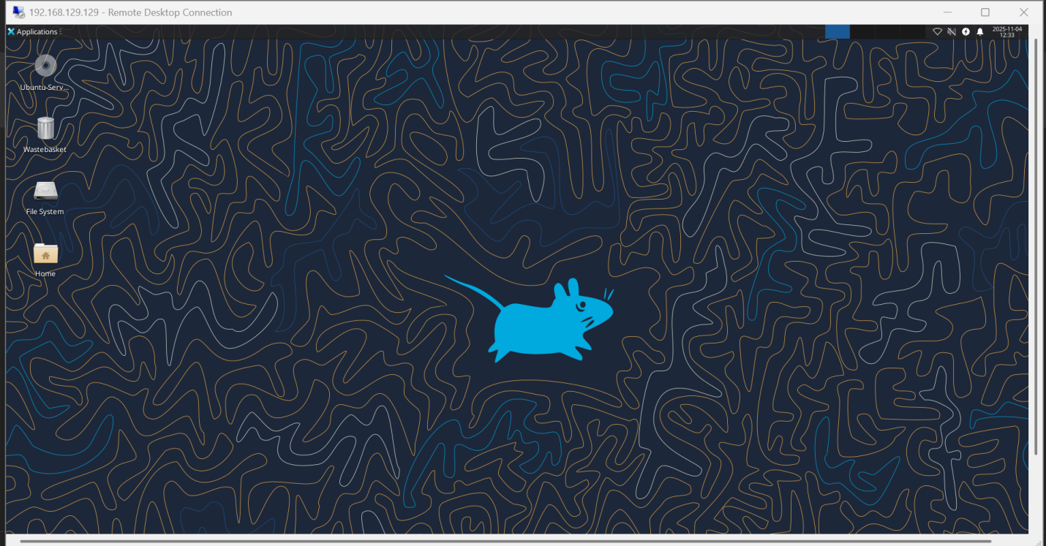
- After you are in the GUI (local console or RDP session), launch Visual Studio Code (installed in Task 4) from the GUI menu or a terminal inside the GUI. Example command from a GUI terminal:
- 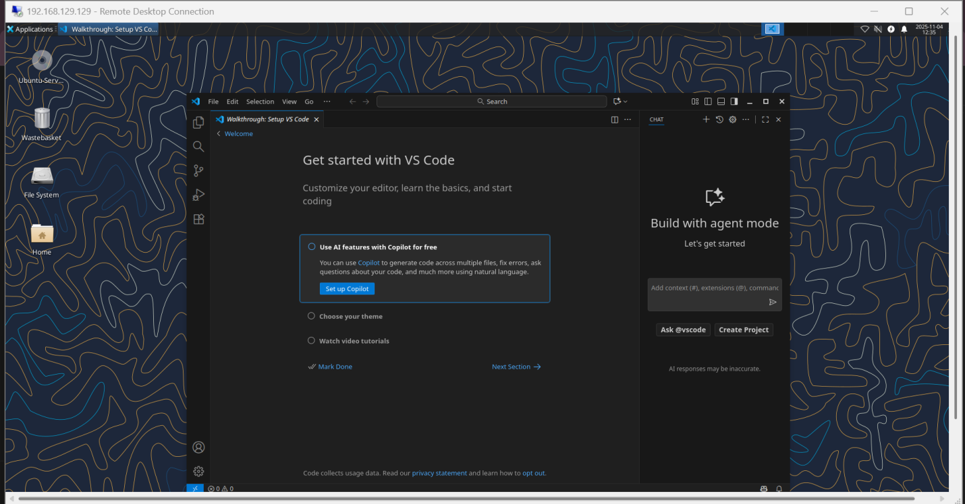

Task 6 - Install lightdm-gtk-greeter and GUI verification - start GUI, open VS Code, take snapshot, then end (GUI)
Install LightDM and Greeter
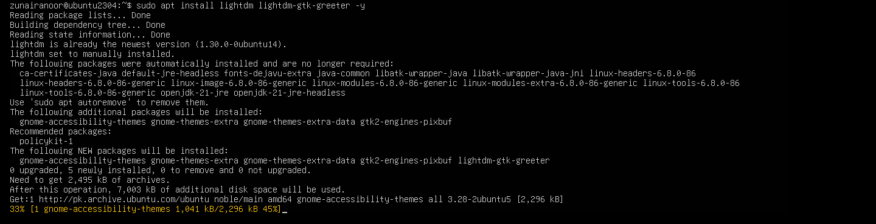
- Install LightDM and greeter using Host Terminal:

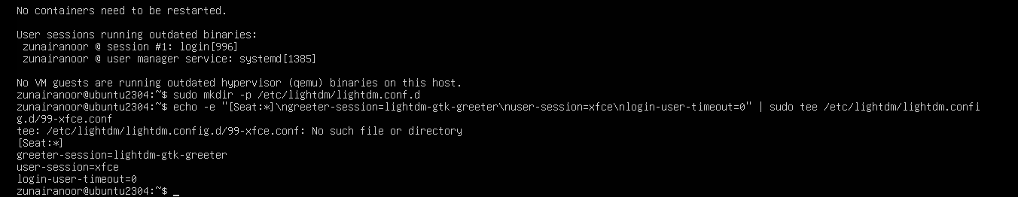
- Create LightDM config to use XFCE:
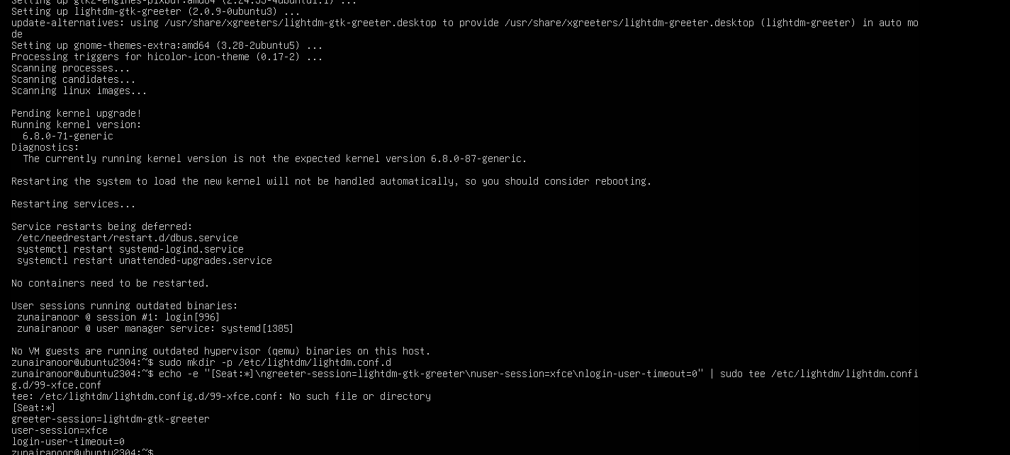
- Clean up problematic session files and permissions:
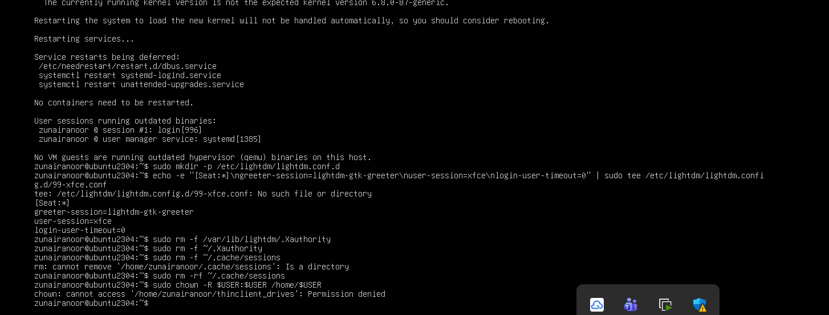
- Restart LightDM:
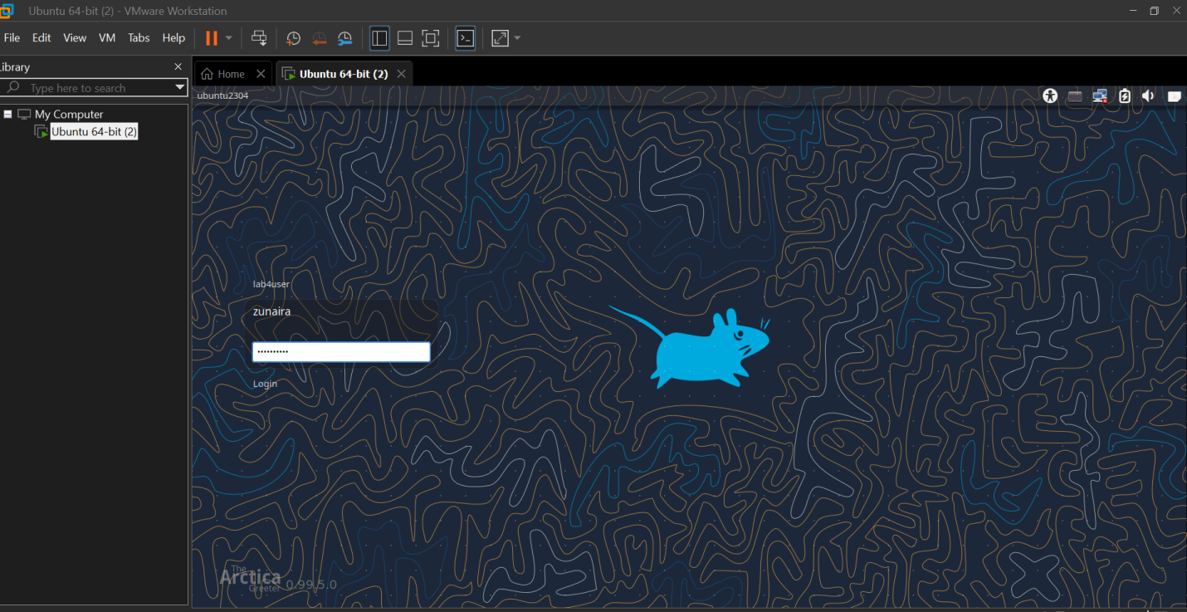
- (Learning step — first command must be the install attempt) Attempt to install Google Chrome directly to see the failure when the repo/key are missing:
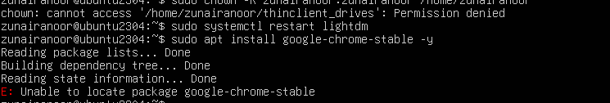
- Inspect apt configuration so you understand why install failed. List the /etc/apt directory:
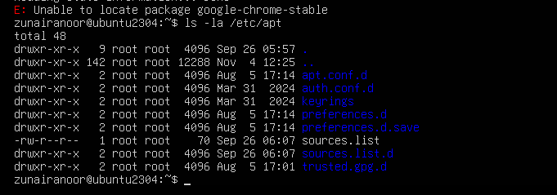
- View the main /etc/apt/sources.list:
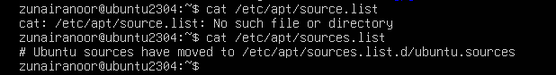
- List files under /etc/apt/sources.list.d:
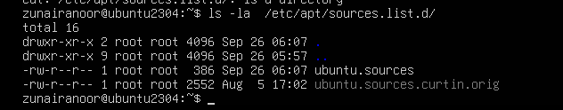
- If there is a file named ubuntu.sources (or similarly named source file), display it to see whether Chrome's repo is present:
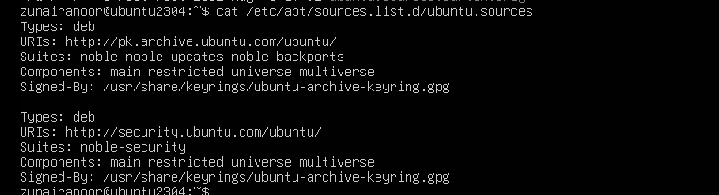
Add Chrome repository metadata to a sources file (method A — using ubuntu.sources). Open or create the file and append the stanza
