Fatima Jinnah Women University
Department of Software Engineering

SUBJECT: CC LAB
SUBMITTED TO: SIR SHOAIB
SUBMITTED BY: ZUNAIRA NOOR
REGISTRATION NO: 2023-BSE-075
SEMESTER: V-B

Task 1
- Print all environment variables:
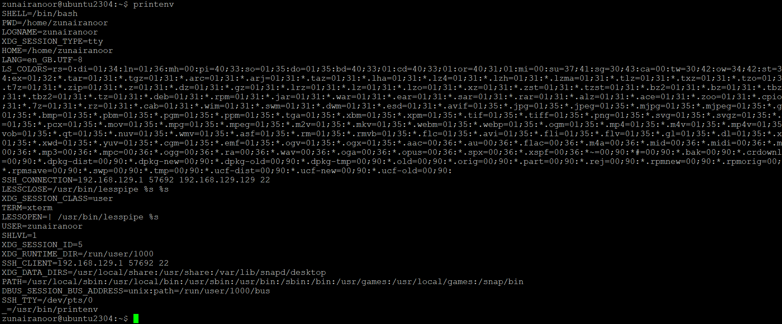
- Filter for SHELL, HOME and USER — run these greps together and capture one combined screenshot:
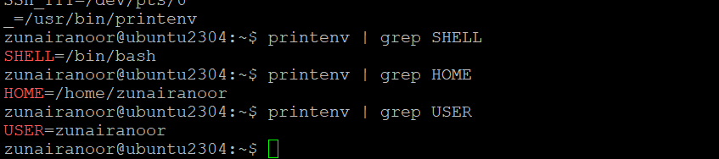
Task 2 — Export DB_* variables temporarily and observe scope
- Echo the three variables (run the three echo commands together) and capture one screenshot showing their outputs:
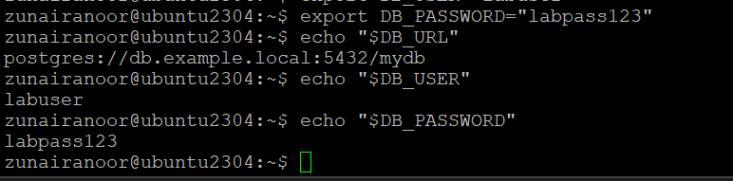
- Show all DB_ variables with a single grep command (capture that output):
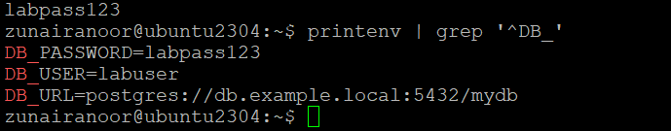
- Close the bash session (e.g., exit) and reopen a new terminal. Verify the variables are gone by running the echo(s) and the grep together; capture both checks in one screenshot:
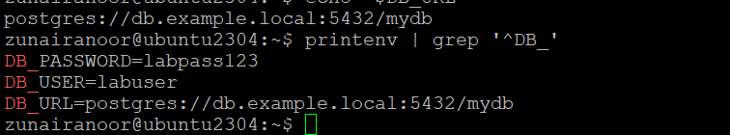
Task 3 — Make DB_* variables persistent in ~/.bashrc
- Open ~/.bashrc in an editor and append the three export lines. Capture the editor showing the three lines added (single screenshot):
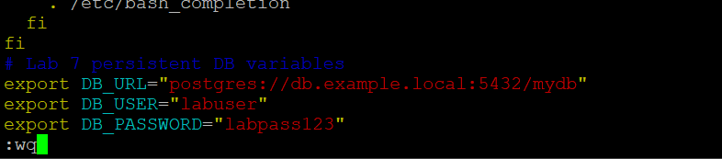
- Source ~/.bashrc and capture the source command in one screenshot together with the next verification commands (grouped): run source ~/.bashrc and then immediately run the three echoes and a single grep, capturing all of these in one screenshot:
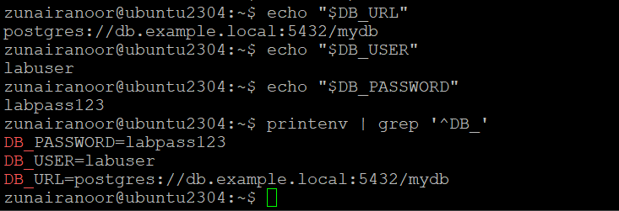
- Close and reopen terminal. Verify persistence by running one echo and the grep together — capture both in one screenshot:
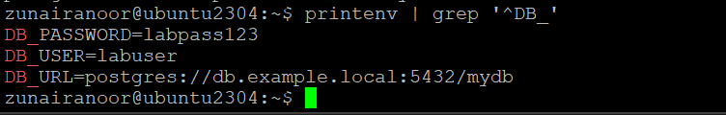
Task 4 — System-wide environment variable, welcome script, and PATH
- View /etc/environment:
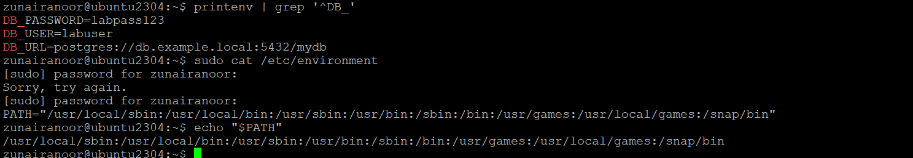
- Edit /etc/environment and add Class:
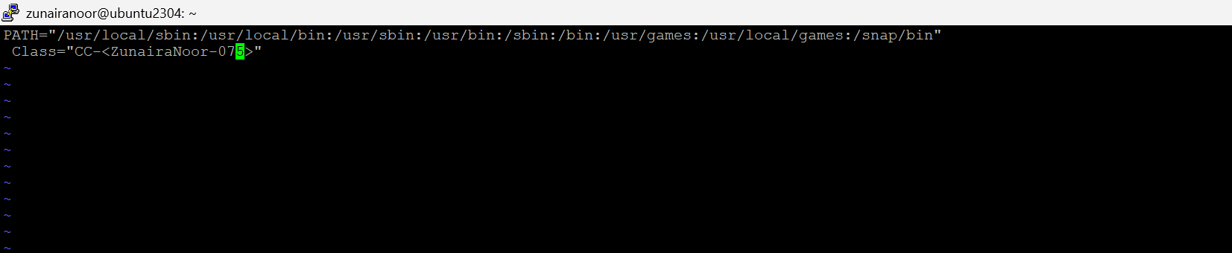
- Re-login or open a new shell and show Class and PATH together (grouped prints): run echo $Class and echo $PATH together and capture in a single screenshot:
- Create welcome script at your home directory (~/welcome) and make it executable (capture the heredoc creation and chmod together in one screenshot if possible):
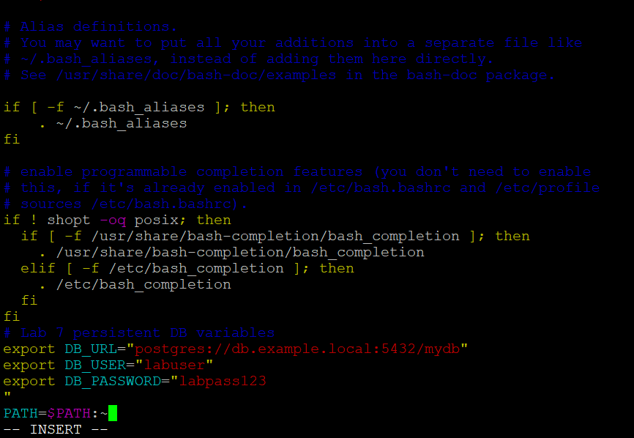
- Apply the change and run welcome — capture these runtime commands in a separate screenshot (must be taken separately from the editor screenshot):
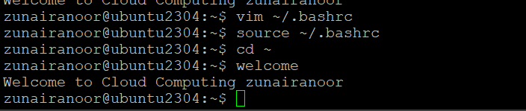
Task 5 — Block and allow SSH using ufw (firewall)
- Enable ufw and show status (group both commands in one screenshot if you run them together):
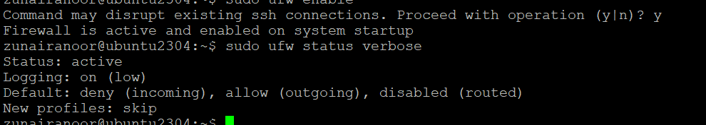
- Deny TCP port 22 and show status (run deny and status numbered together and capture in one screenshot). Use short form as requested:
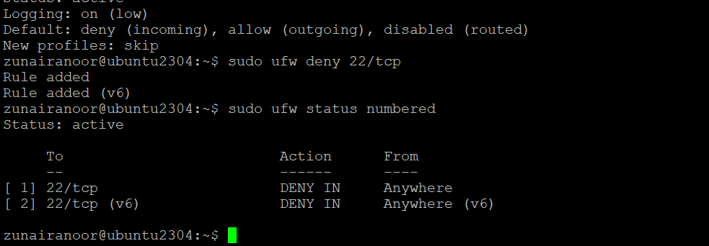
- From Windows host attempt to SSH (expected to fail) — capture the host-side SSH attempt in one screenshot:
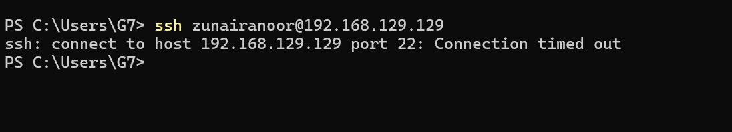
- Allow SSH back and reload, then show status (group allow, reload, status in one screenshot if run together). Use short form as requested:
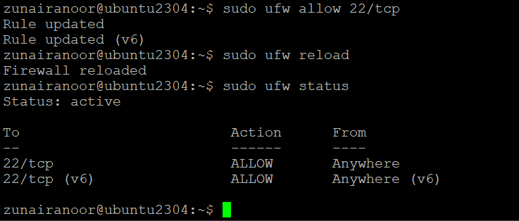
- From Windows host attempt SSH again (should succeed) — capture successful login in one screenshot:
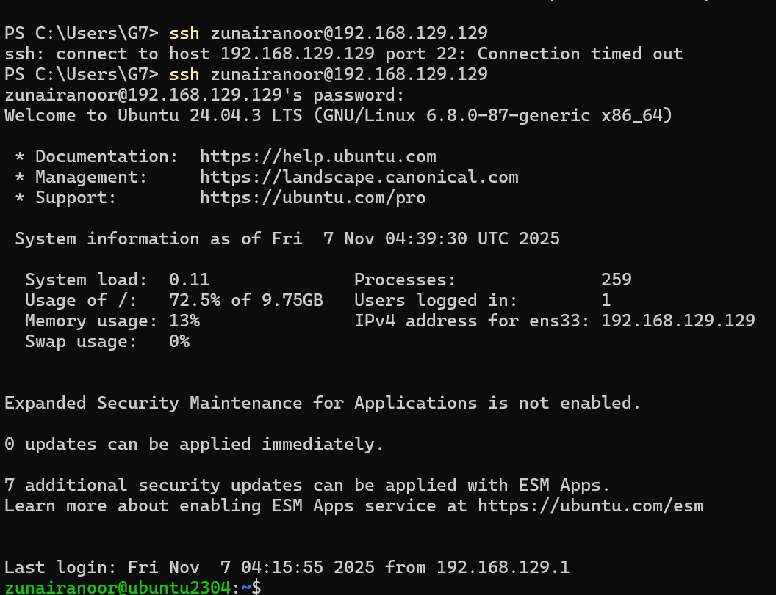
Task 6 — Configure SSH key-based login from Windows host
- Generate ed25519 key pair (if needed) and show the generated files in one screenshot (run ssh-keygen and then list ~/.ssh):
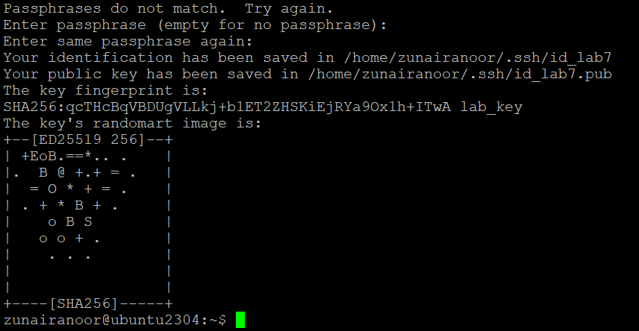
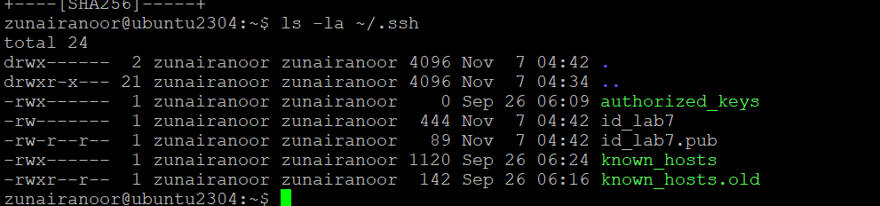
- Clear the known_hosts file content and verify it is empty (single screenshot):
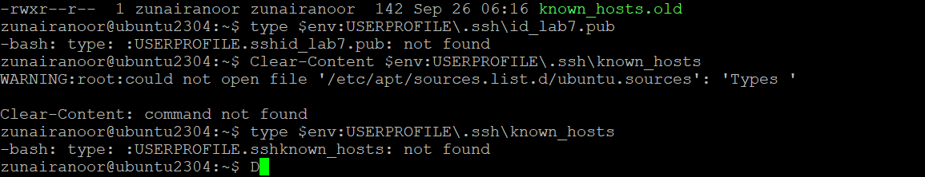
- Connect to the Ubuntu server using the standard SSH command (this will prompt to accept the server host key because known_hosts is empty). Capture the connection prompt/accept step in one screenshot:
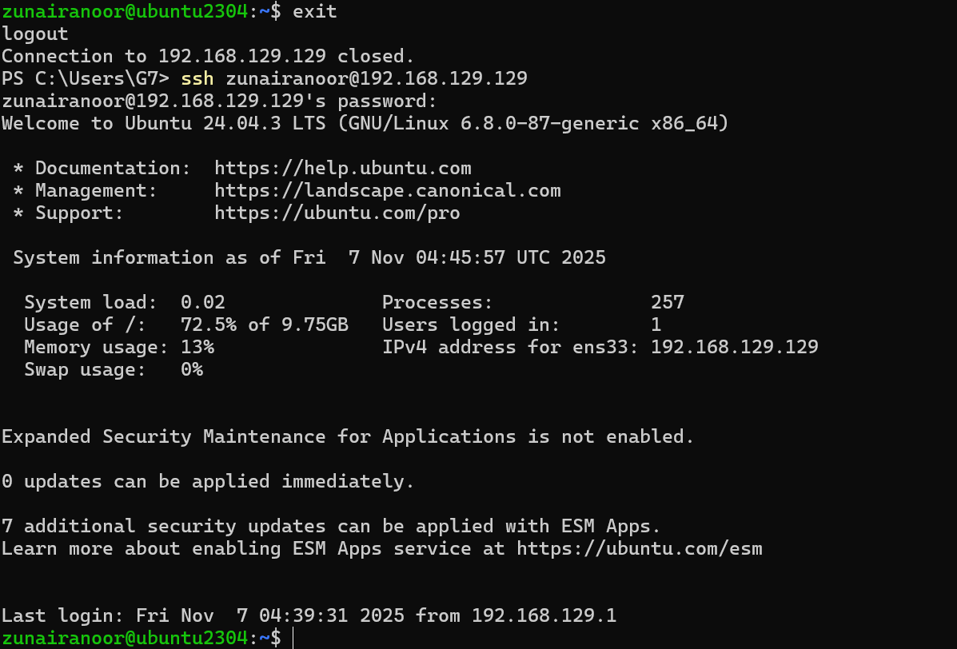
- After the successful connection, view the known_hosts file to show the server host key was added (single screenshot):
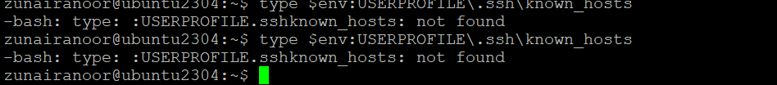
B. On Ubuntu server — group related server-side commands
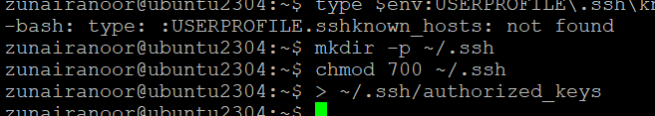
- Append the public key, set file permissions, and show the resulting authorized_keys (capture commands and resulting file content in one screenshot):
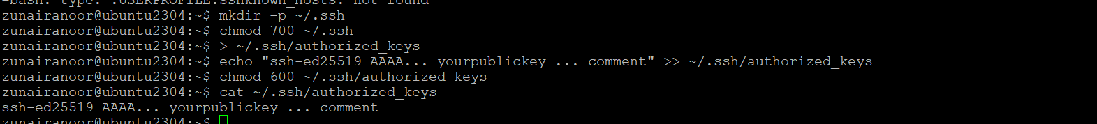
- From Windows host test passwordless login (capture successful login in one screenshot):
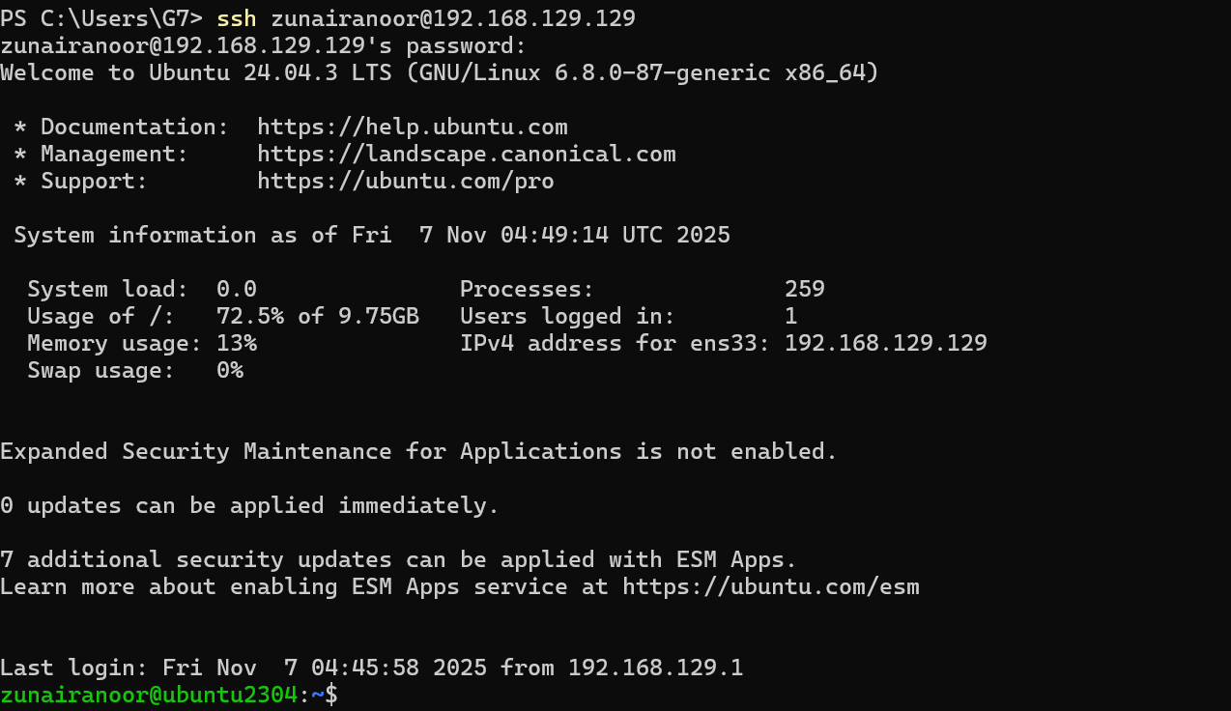
- Also demonstrate explicit identity usage (single screenshot):
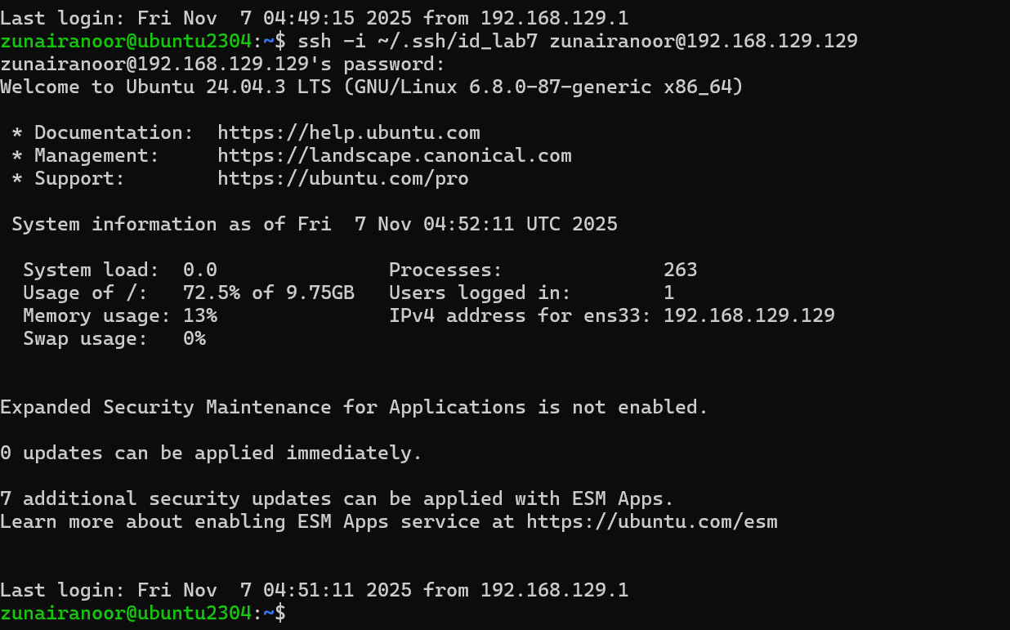
Exam Evaluation Questions
Show all environment variables
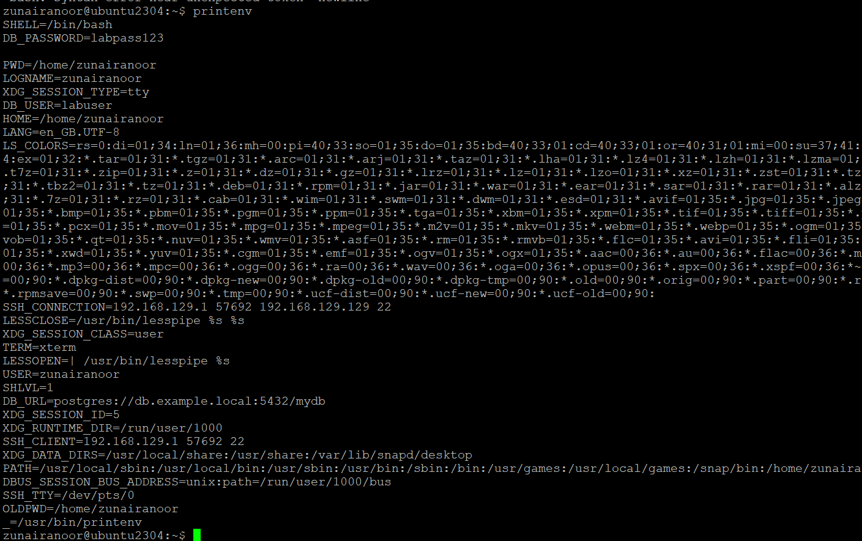
Filter out specific variables
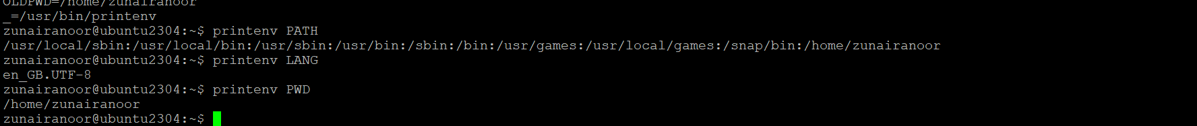
Q2: Short-lived Student Info
Goal: Create temporary environment variables that disappear after closing the session.
Steps
- Set three variables

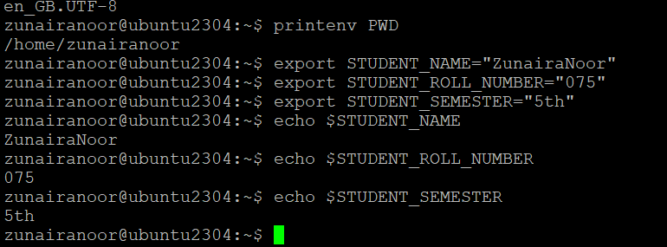
Verify using printenv with grep
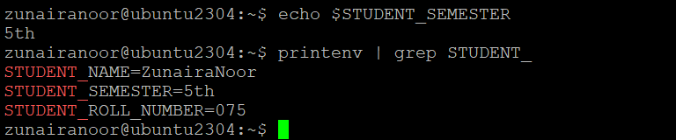
Close terminal → Open new one
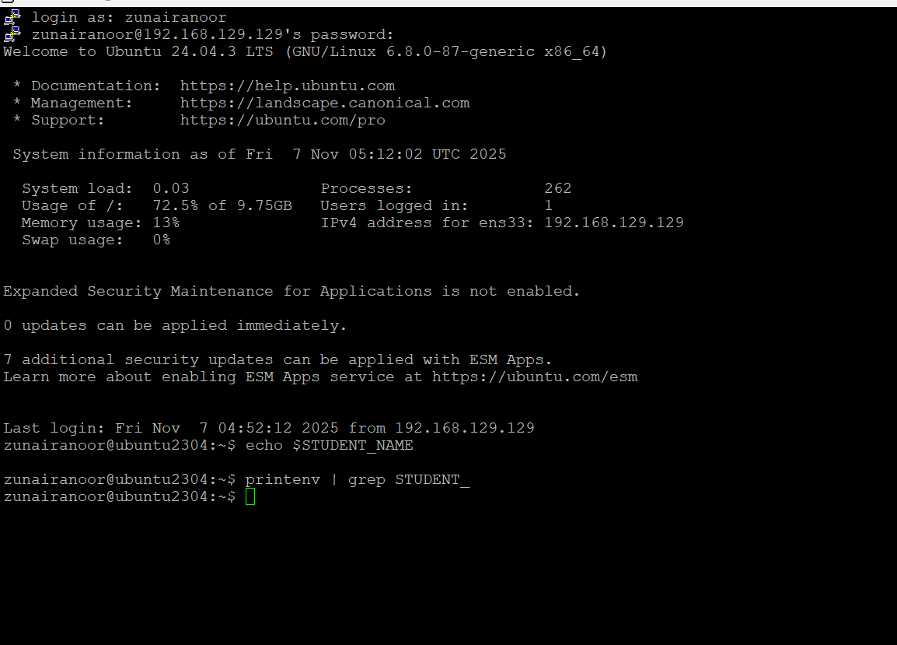
Q3: Make It Sticky (Persistence Check)
Edit your ~/.bashrc
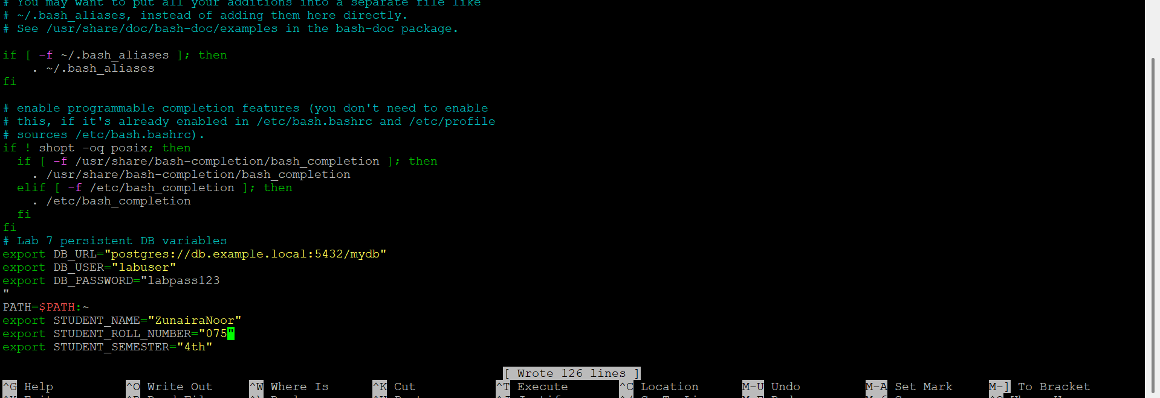
Reload configuration
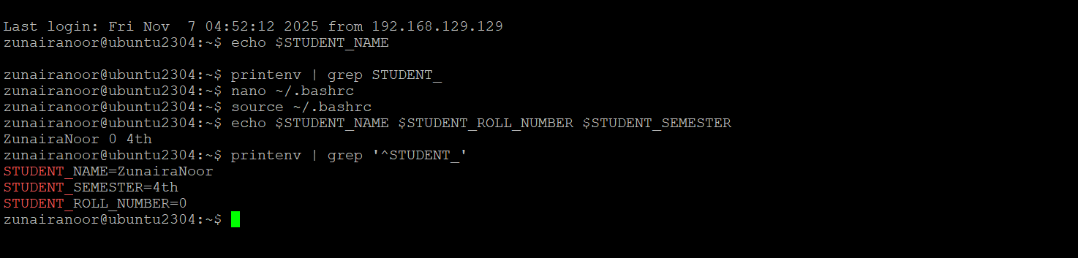
Close terminal → open new one
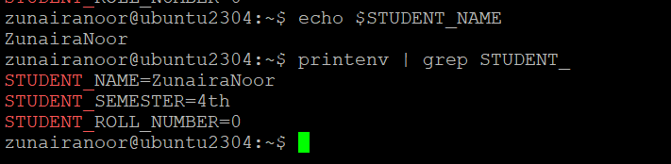
Q4: Firewall Rules — Block & Restore Ping (ICMP)
Goal: Use ufw to block and allow ICMP ping traffic.
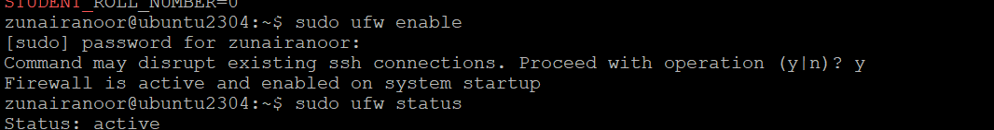
Block ping
