Fatima Jinnah Women University
Department of Software Engineering



SUBJECT: CLOUD COMPUTING
SUBMITTED TO: SIR SHOAIB,SIR WAQAS
SUBMITTED BY: ZUNAIRA NOOR
REGISTRATION NO: 2023-BSE-075
CLASS: BSSE IV-B

LAB NO 3
Task 1 – Verify VM resources in VMware
Confirm the VM resources that were allocated in Lab 1.
Steps
- Open VMware Workstation and locate the Ubuntu Server VM you used in Lab 1.
- Inspect VM settings and note the following (no commands required for GUI): VM name, RAM, CPU, disk, and network adapter type.
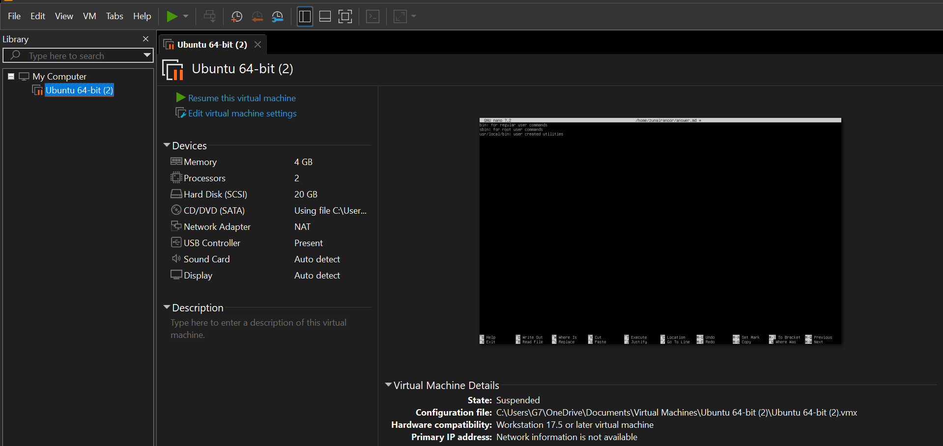

Task 2 – Start VM and log in (use your preferred host terminal method only)
Use a single preferred host-terminal method to connect to the VM. Do not switch between methods during the task.
Steps
- Start (or resume) the VM in VMware Workstation on your host.
- From your host, open your preferred terminal (for example: Windows Command Prompt, PowerShell, macOS Terminal, or Linux Terminal) and connect to the VM using SSH.
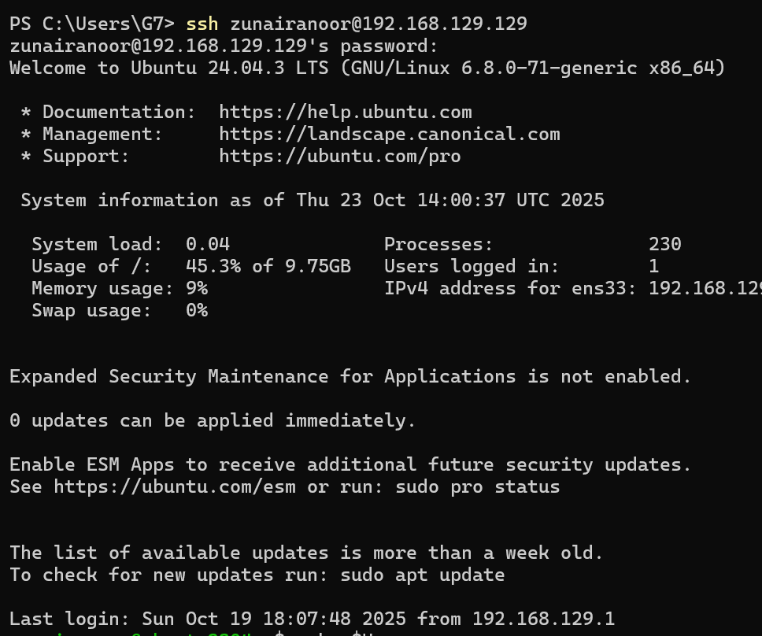
- After logging in, run both commands and capture them together in a single screenshot:
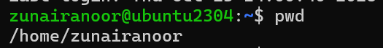
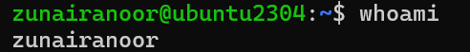

Task 3 – Filesystem exploration — root tree and dotfiles
Explore Linux filesystem layout and hidden files. Capture outputs using screenshots only (do not create text files). For the short explanation required in this task, write the paragraph in an editor and capture it as a screenshot (answers_md.png) — do not supply the .md file.
Steps (run inside VM terminal)
List root directory contents:
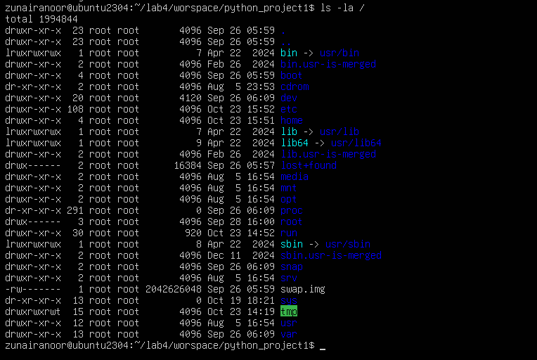
ls -la /bin
ls -la /sbin
ls -la /usr
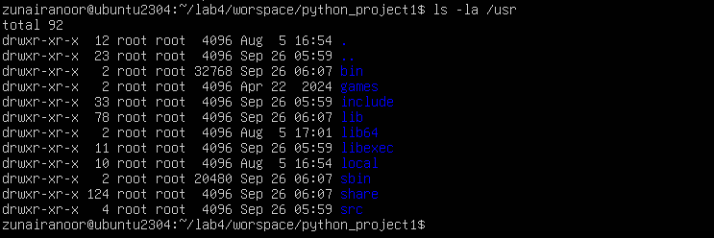
ls -la /opt
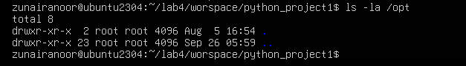
ls -la /etc
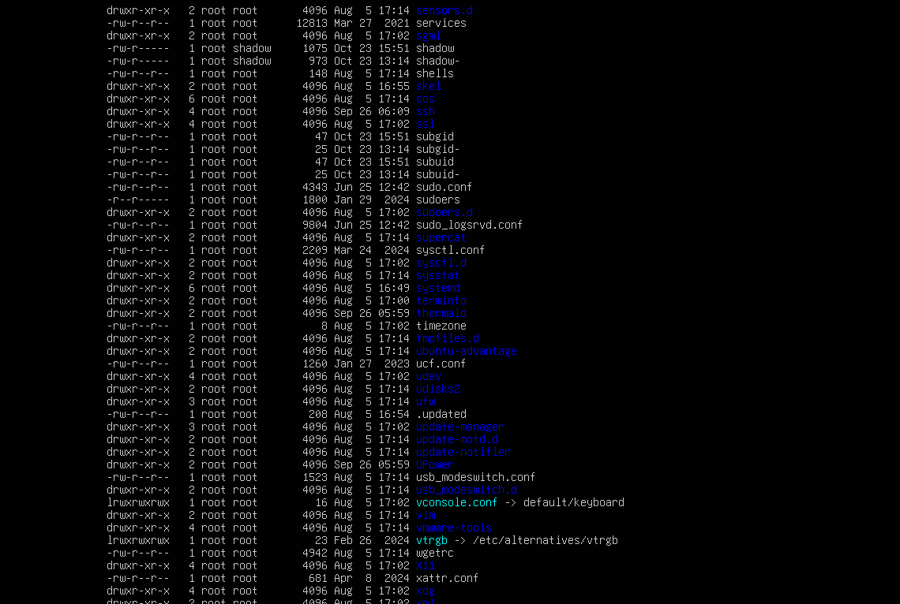
ls -la /dev
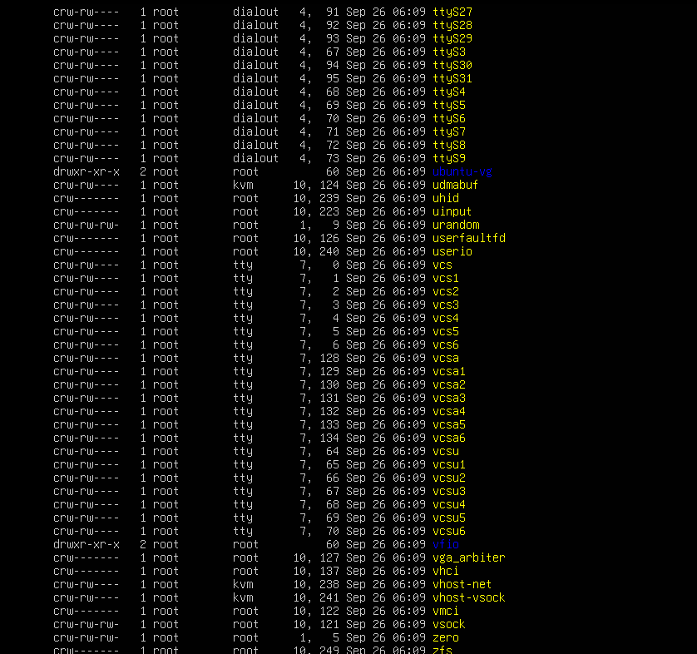
ls -la /var
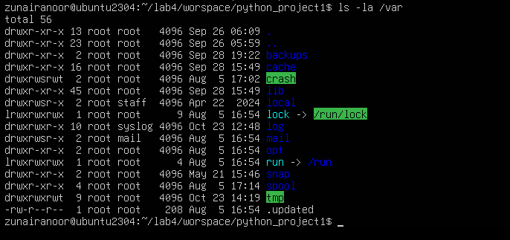
ls -la /tmp
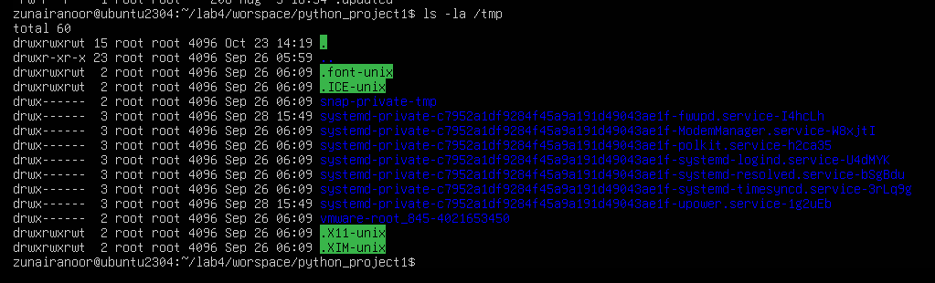
ls -la ~
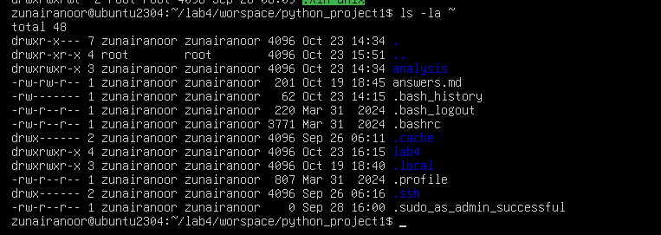
Write a short paragraph (3–5 sentences) that explains the difference between /bin, /usr/bin and /usr/local/bin. Open your editor:
nano ~/answers.md
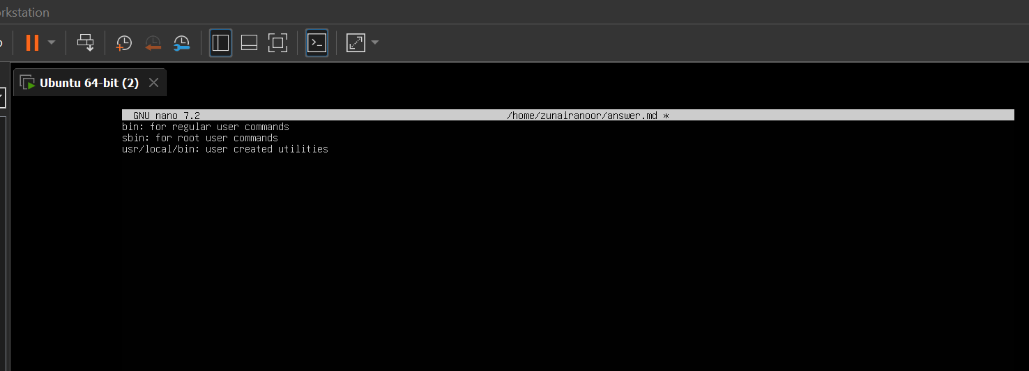

Task 4 – Essential CLI tasks — navigation and file operations
Practice basic commands used daily on Linux systems. Use screenshots only for evidence.
Steps (inside VM terminal)
Create a workspace and navigate:

Create files using an editor (open each editor session and save a screenshot showing content):
nano README.md
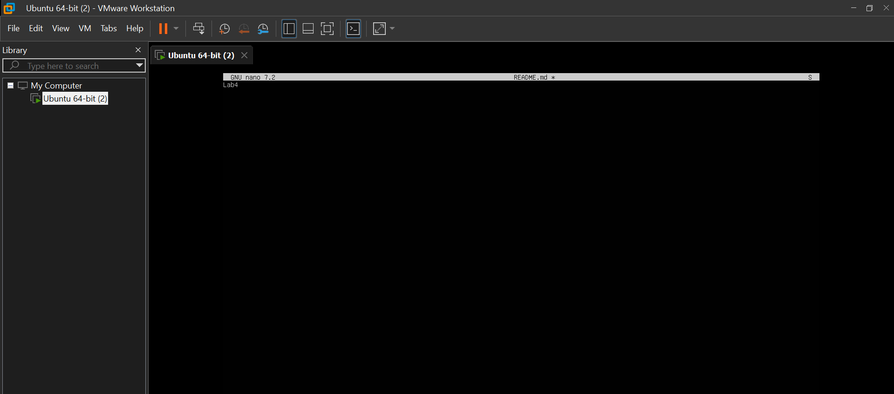
nano main.py
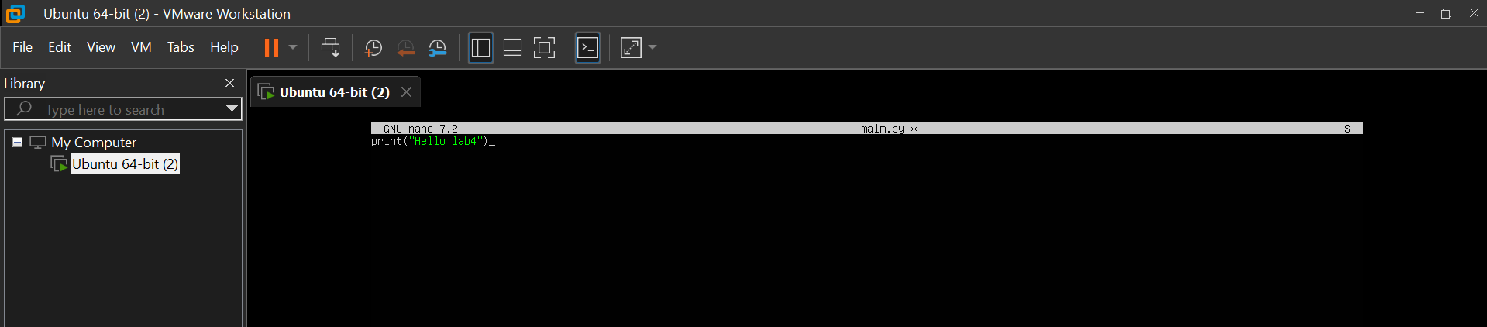
nano .env
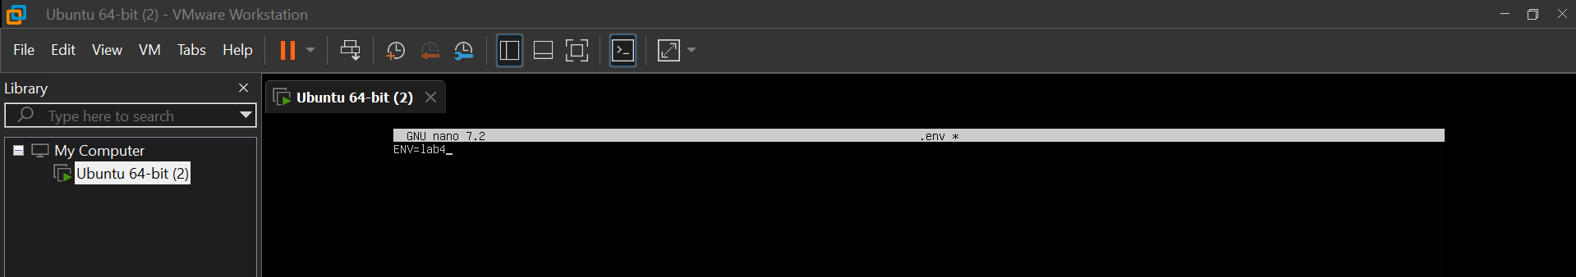
ls -la
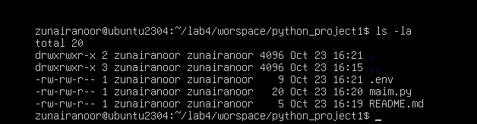

cp README.md README.copy.md
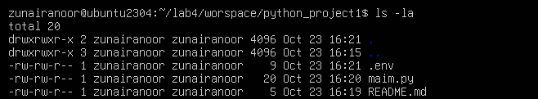
mv README.copy.md README.dev.md
rm README.dev.md
mkdir -p ~/lab4/workspace/java_app
cp -r ~/lab4/workspace/python_project ~/lab4/workspace/java_app_copy
ls -la ~/lab4/workspace
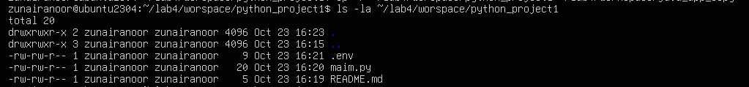
Use command history and tab completion:
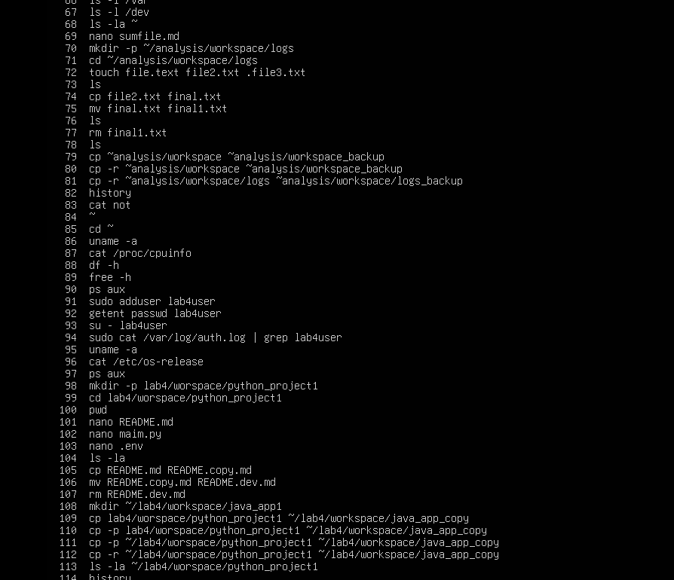
Task 5 – System info, resources & processes
- Kernel and OS:

- CPU (ensure model name visible):
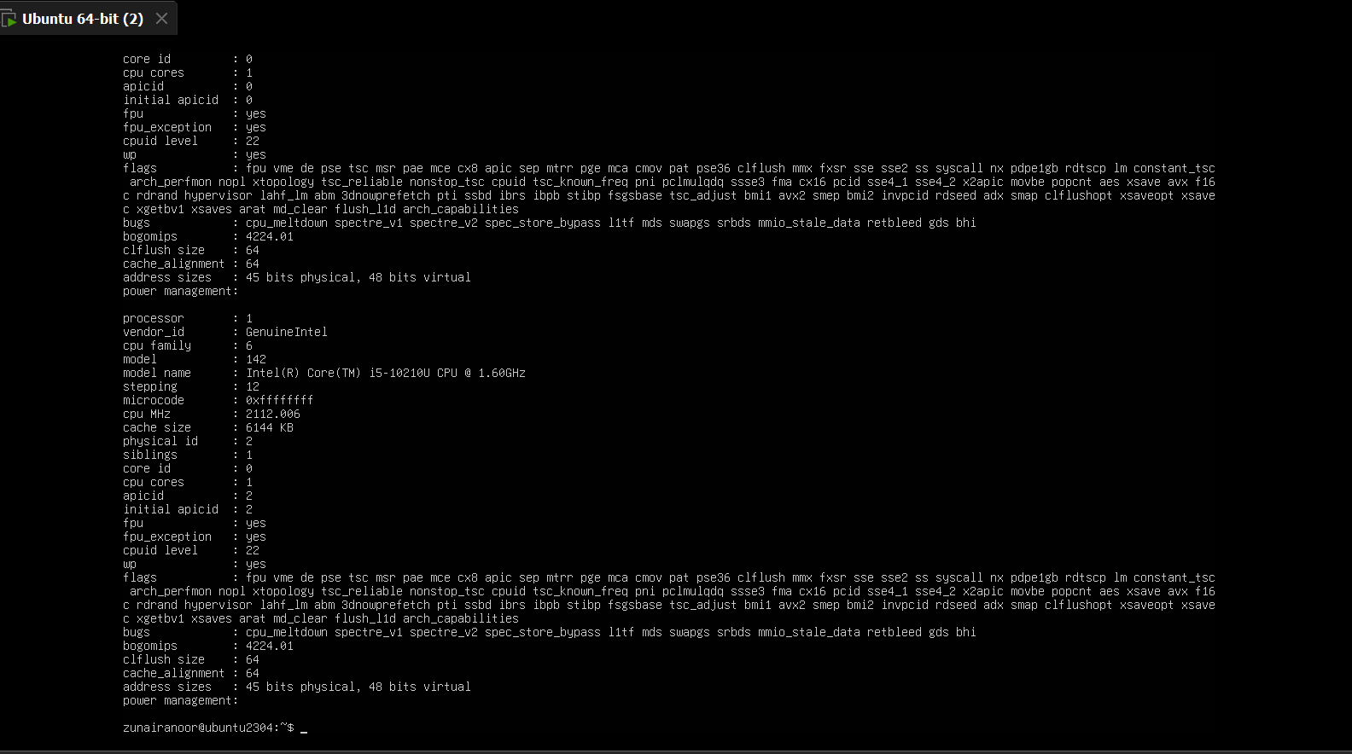

- Memory:
- Disk:
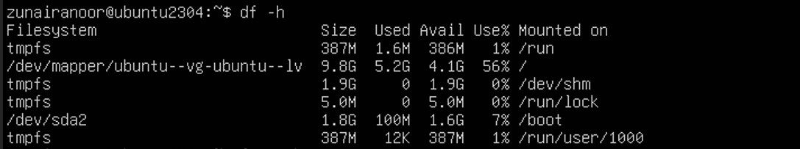
- View OS release information:
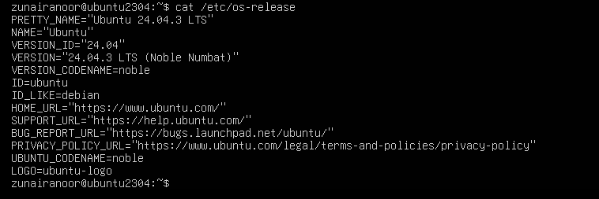
- Processes (show top lines of ps output):
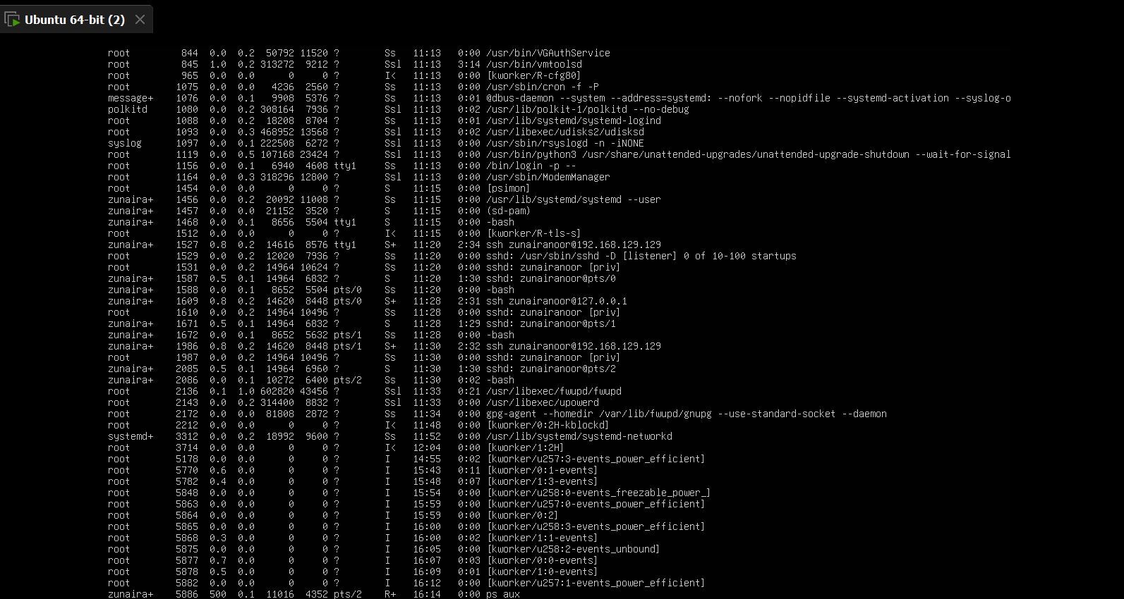
Task 6 – Users and account verification (no sudo group change)
Create a non-root user and verify the account exists. This task does NOT add the created user to the sudo group.
Steps (inside VM terminal)
- Create a new user named lab4user:
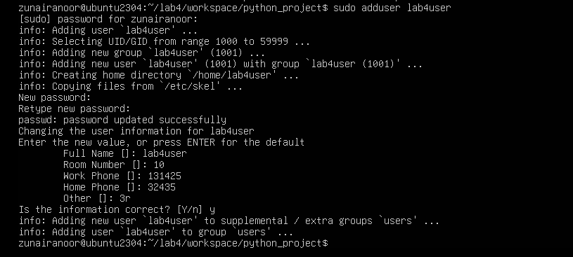
- Verify the user entry:

- Switch to the new user to verify login:
- From the new user you may attempt a sudo command to show that sudo is not available for this account (expected failure), e.g.:
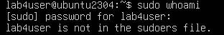
- Return to the original user:
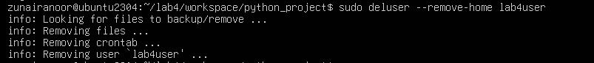
Bonus Task 7 – Create a small demo script using an editor and run it
- Open an editor to create the script:
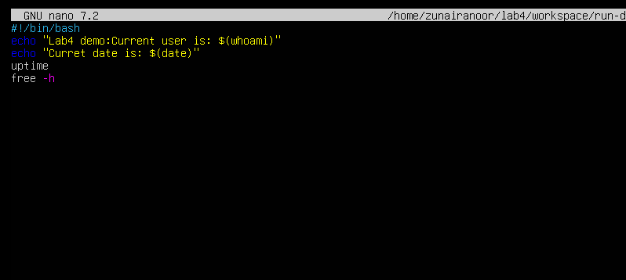
- Make the script executable:
- Run the script as your regular user:

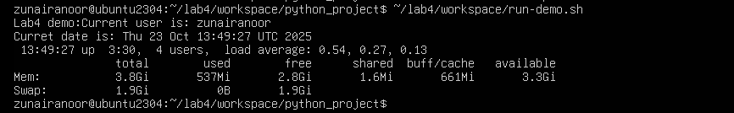
- Optionally run it with sudo:
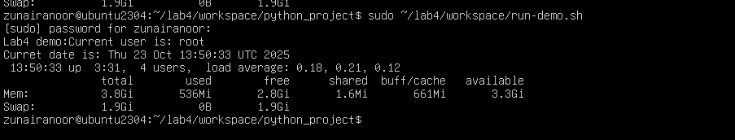
Exam Evaluation Questions
1. Remote Access Verification (Cyber Login Check)
Scenario:
You are part of a SOC (Security Operations Center) investigating unauthorized access to a Linux server hosted on VMware. Prove you can securely connect and verify your identity.
Steps:
- Connect to the Ubuntu VM remotely from your host terminal.
  - Q1_remote_connection.png
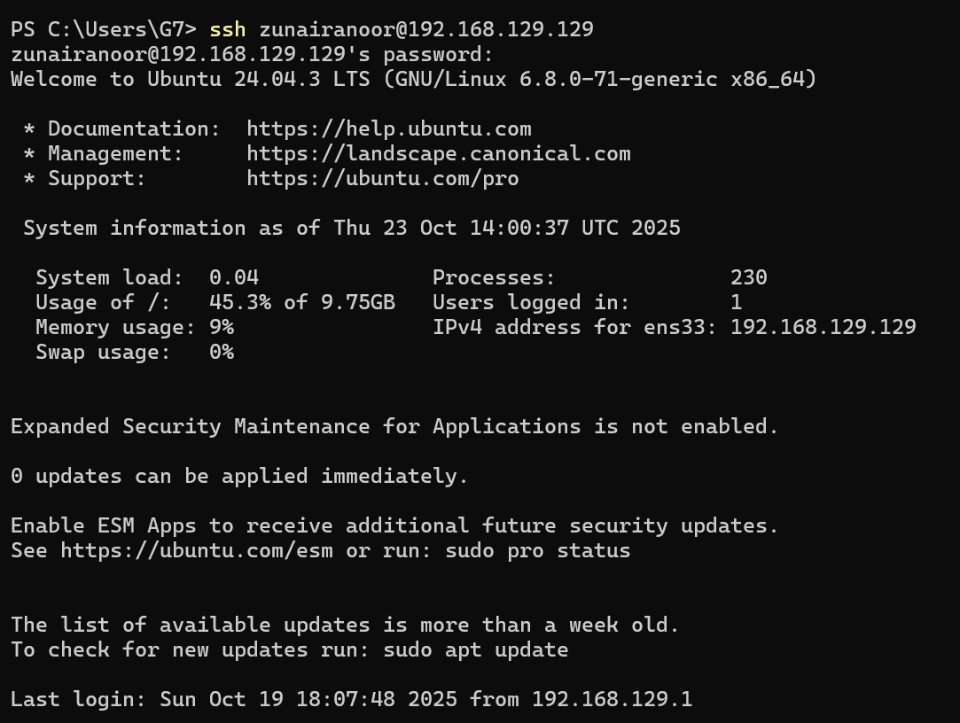
- Verify your current user and home directory path.
  - Q1_user_verification.png
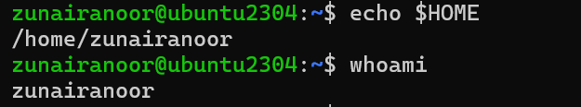
- Confirm you are connected to the correct host machine.
  - Q1_host_confirmation.png

2. Filesystem Inspection for Forensic Evidence
Scenario:
The incident response team suspects malicious files in system directories. You must explore the filesystem to locate and document the system’s structure.
Steps:
- Display the contents of the root directory.
  - Screenshot as Q2_root_listing.png
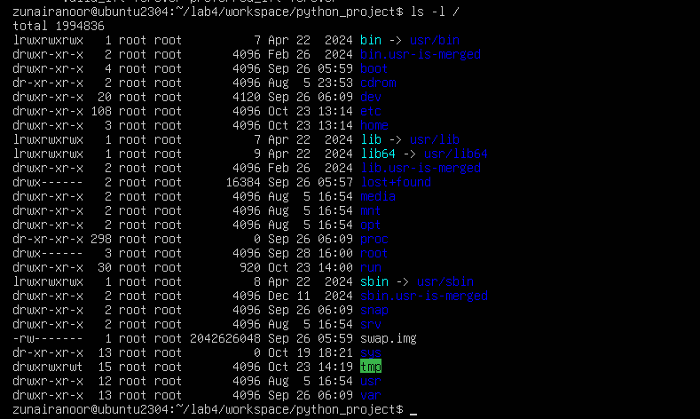
- Display the OS version and release information.
  - Screenshot as Q2_os_version.png
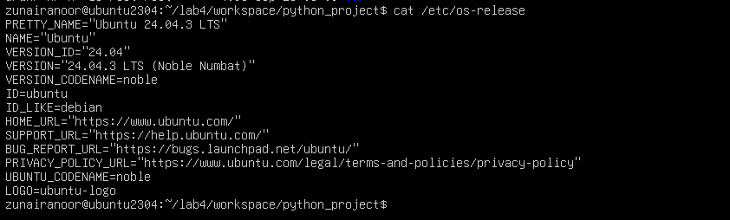
- Explore and record directory listings for /bin, /sbin, /usr, /opt, /etc, /dev, /var, and /tmp.
  - Screenshot as Q2_directory_evidence.png
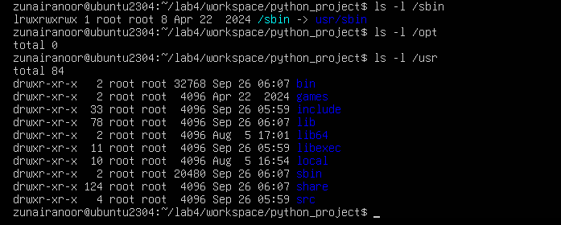
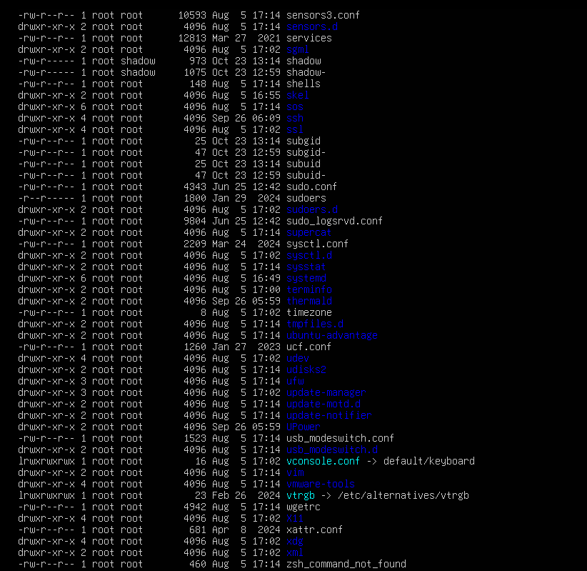
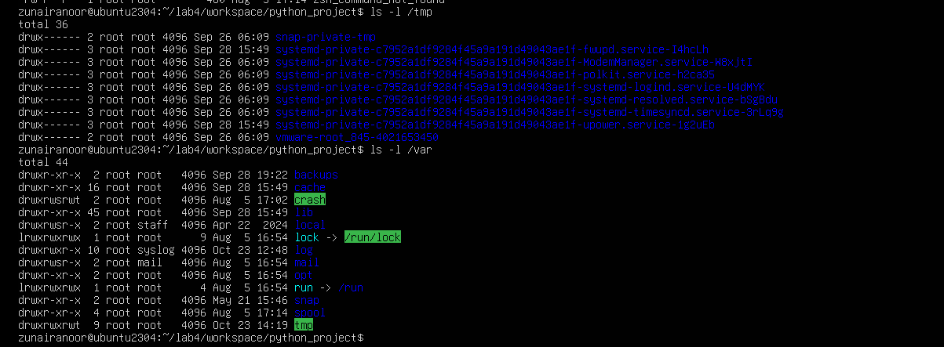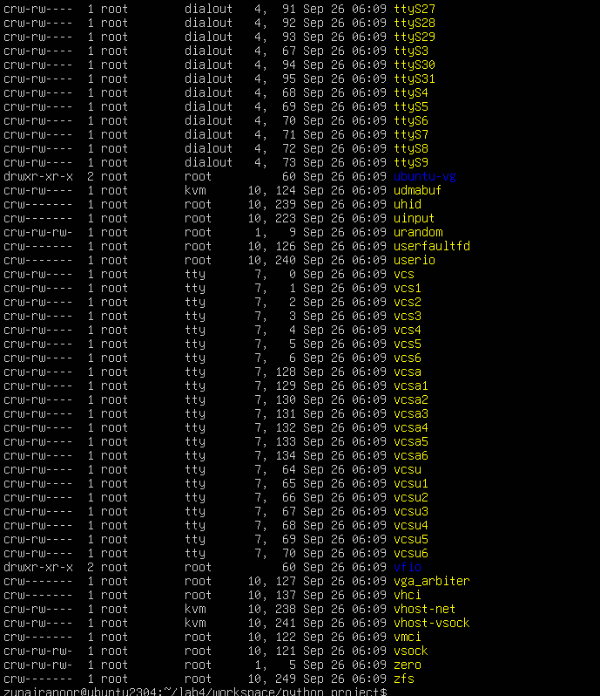
- Display all hidden files in your home directory.
  - Screenshot as Q2_hidden_files.png
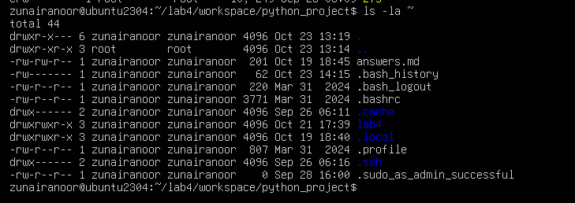
- Create a markdown file summarizing your findings on key binary directories.
  - Screenshot as Q2_report_file.png
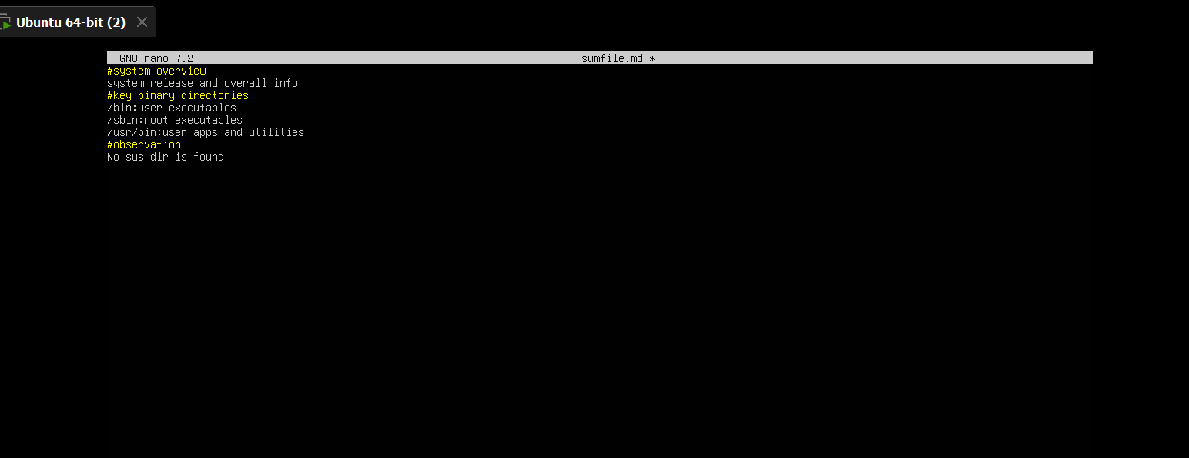
3. Evidence Handling & File Operations
Scenario:
You are creating a sandbox environment to safely analyze and handle suspicious files collected from a compromised system.
Steps:
- Create a structured folder hierarchy under your home directory for analysis.
  - Screenshot as Q3_workspace_created.png

- Create three text files, including one hidden file, in your workspace.
  - Screenshot as Q3_files_created.png
- Create a backup copy of one file, rename it, and then delete it after verification.
  - Screenshot as Q3_backup_handling.png
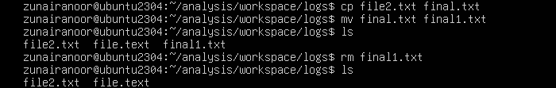
- Copy the entire workspace as an evidence backup folder.
  - Screenshot as Q3_workspace_backup.png
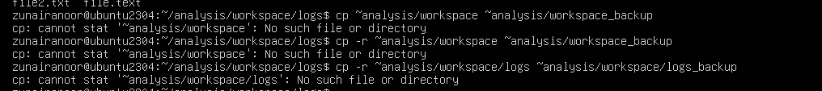
- Display your command history to document all actions performed.
  - Screenshot as Q3_command_history.png
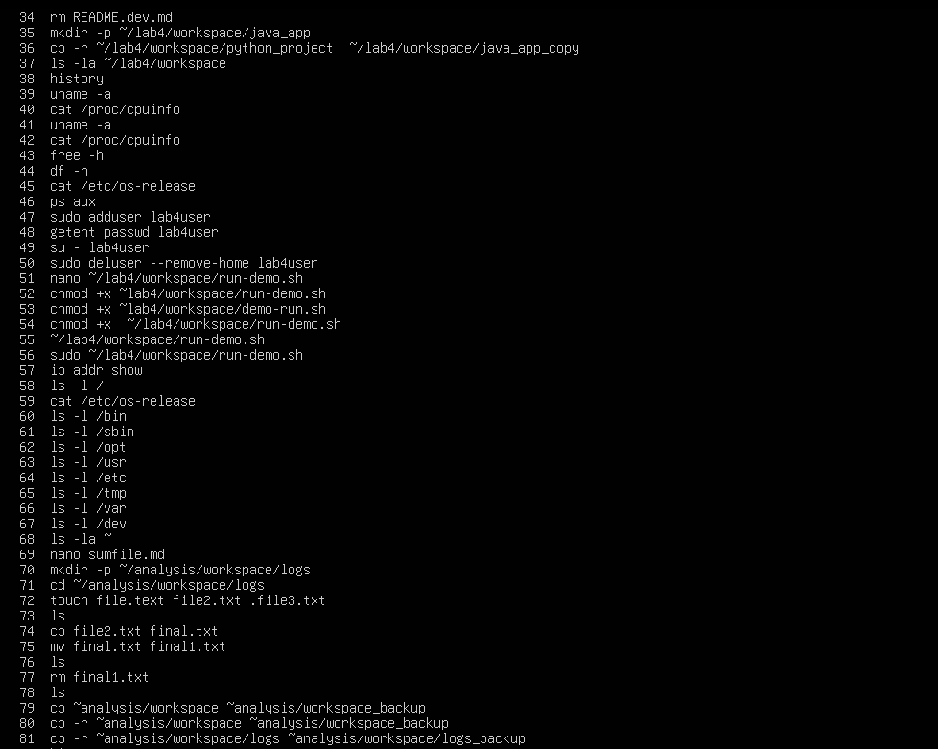
- Demonstrate Linux auto-completion by typing a partial command or filename.
  - Screenshot as Q3_autocomplete.png
4. System Profiling and Process Monitoring
Scenario:
You are investigating a potential malware infection that is consuming excessive resources on the Linux VM.
Steps:
- Display the system’s OS and kernel version for the investigation report.
  - Screenshot as Q4_system_info.png
- Display CPU, memory, and disk usage information.
  - Screenshot as Q4_resource_info.png
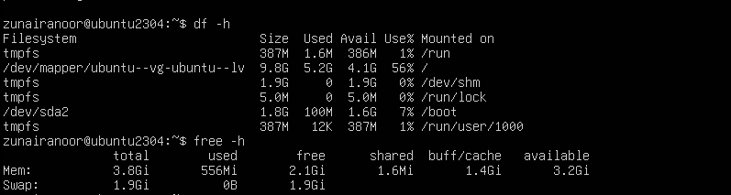
- Display all active running processes to identify suspicious activity.
  - Screenshot as Q4_process_list.png
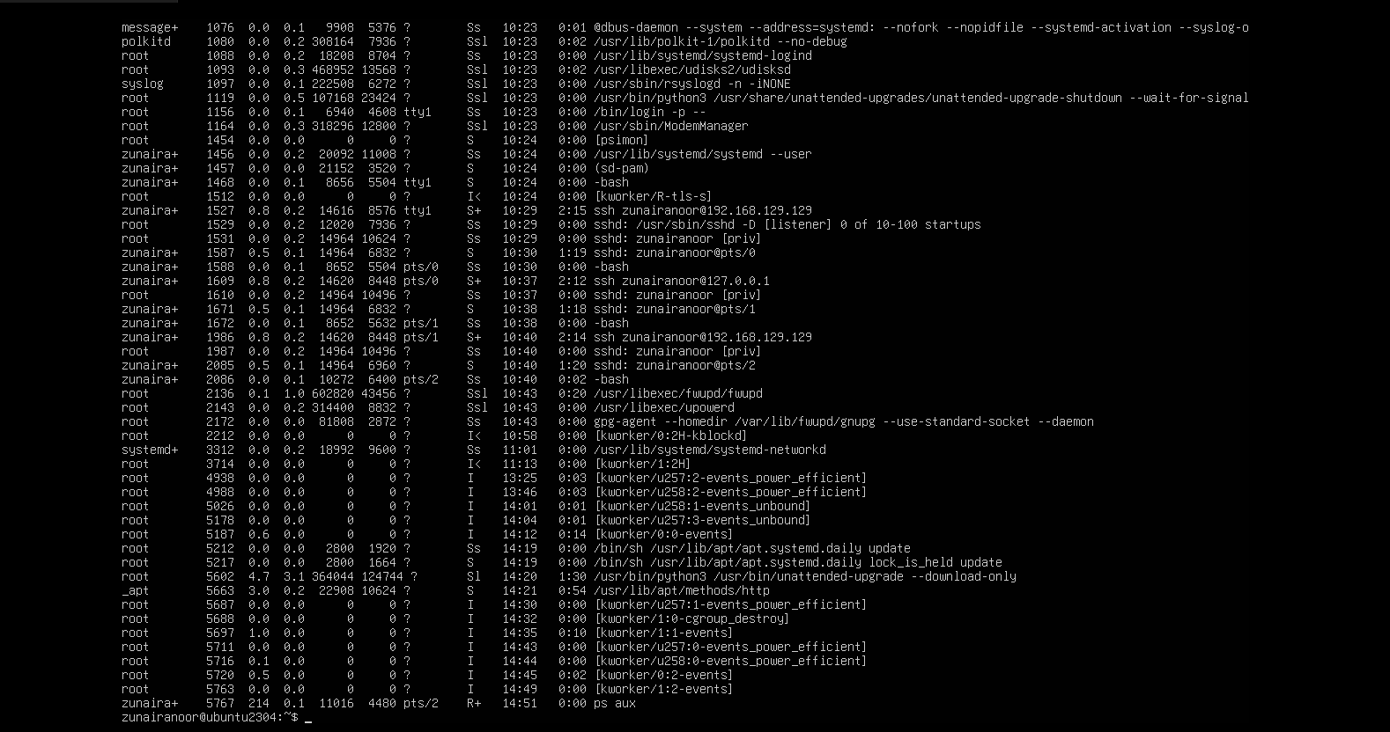

5. User Account Audit & Privilege Escalation Simulation
Scenario:
You are performing a user activity audit on a compromised Linux server.
The SOC suspects a newly created account (lab4user) may have been used for unauthorized access.
Your task is to simulate the account creation, perform privilege tests, and analyze authentication logs for forensic evidence.
Steps:
- Create a new test user named lab4user.
  - Screenshot as Q5_user_created.png
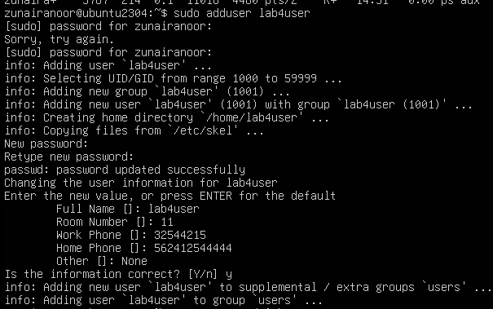
- Verify that the new user record exists in the system’s user database.
  - Screenshot as Q5_user_verified.png
- Log in as lab4user and confirm successful login.
  - Screenshot as Q5_user_login.png
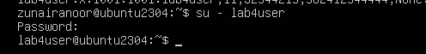
- Attempt to run an administrative command as lab4user (expect permission denied).
  - Screenshot as Q5_permission_denied.png
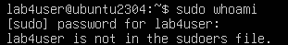
- Switch back to your main analyst account.
  - Screenshot as Q5_switch_back.png
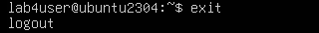
- Inspect the system authentication logs located at /var/log/auth.log to determine whether the lab4user account attempted any logins (successful or failed).
  - Screenshot as Q5_authlog_analysis.png
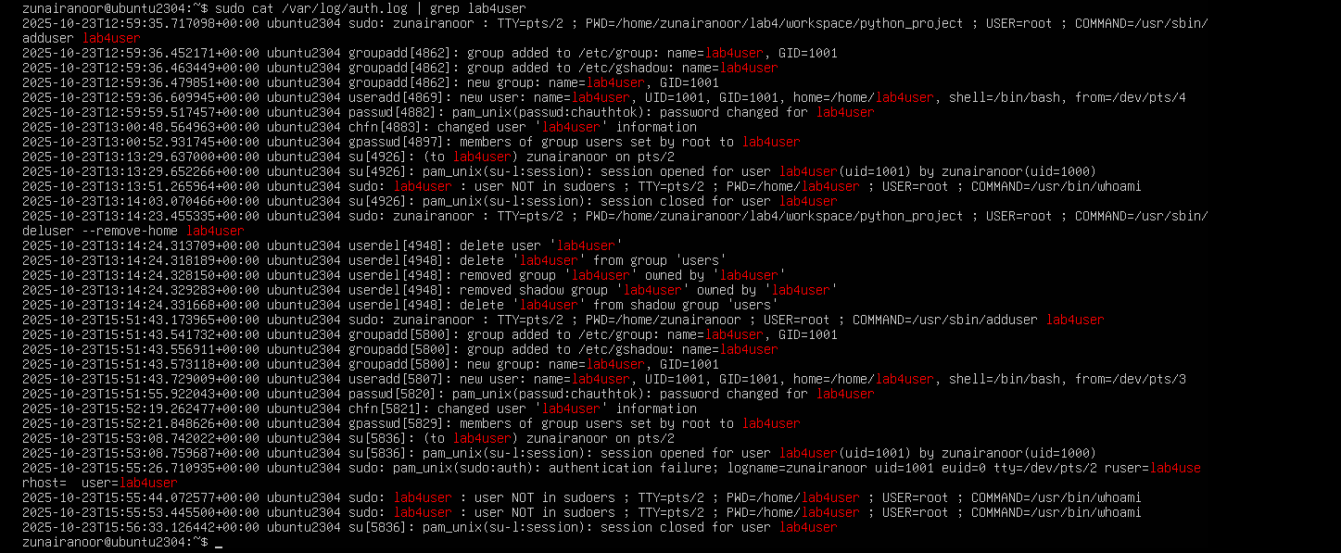
- (Optional) Remove the lab4user account after the audit and verify deletion.
  - Screenshot as Q5_user_removed.png

