**LAB #1 TASKS**

**Task 1**  
• Create a TensorFlow tensor with random float values. Calculate the sum, mean, and maximum of the tensor.

Hint: Use tf.reduce_sum(), tf.reduce_mean(), tf.reduce_max().

• Create a 3D TensorFlow tensor. Access and print a specific element, a 2D slice, and a 1D slice.

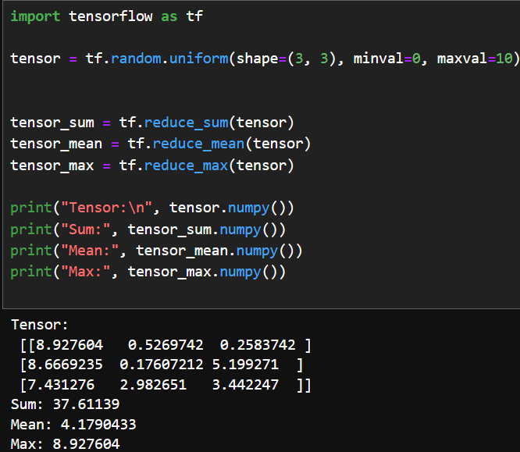**CODE:**

**OUTPUT:**

**TASK 2**

Create a TensorFlow function called tensor operations that takes two tensors as input and performs the following arithmetic operations:  
1. Addition (tensor1 + tensor2)

2. Subtraction (tensor1 - tensor2)

3. Multiplication (tensor1 * tensor2)

4. Division (tensor1 / tensor2)

The function should return the results of these operations as a dictionary with the following keys:   
• "addition"

• "subtraction"

• "multiplication"

• "division"

Test your function with the following tensors:

tensor1 = [10, 20, 30]

tensor2 = [5, 10, 15]

**CODE:**

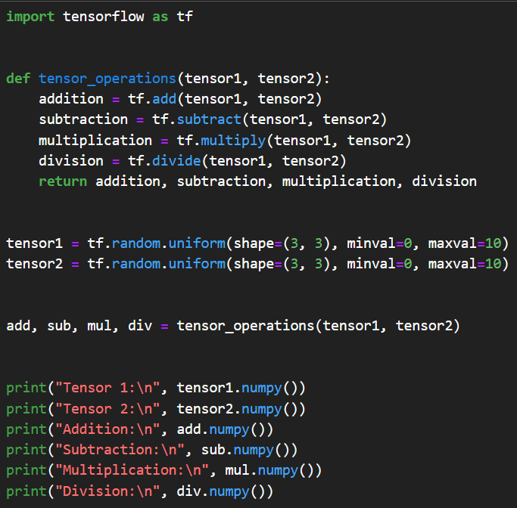

OUTPUT:

**TASK 3**1. Create a NumPy array with random float values. Sort the array in ascending and descending order.

Hint: Use np.sort() and array slicing.

2. Create a 2x2 NumPy matrix. Calculate its transpose and inverse. Hint: Use np.transpose() and np.linalg.inv().

3. Create a 2D NumPy array. Calculate the sum of each row, the mean of each column, and the standard deviation of the entire array **CODE:**

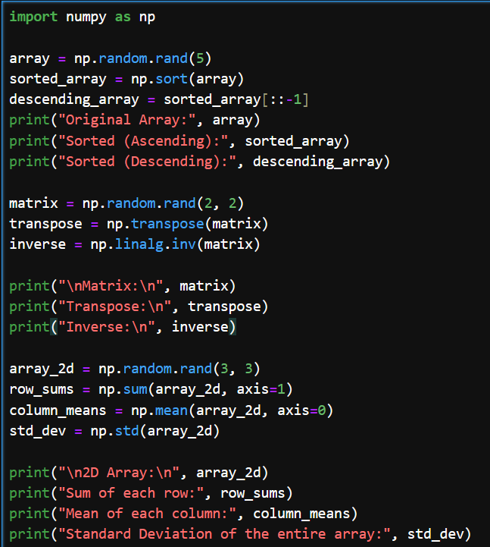

OUTPUT:

