**Lab 05**

**Objective: Implementing Multi-Layer Neural Network Using Keras**

To implement a neural network with multiple hidden layers and understand how hidden layers help the model learn better patterns

**Lab Tasks.**

Task 1: Change the number of neurons in both hidden layers (e.g., try [3, 2], [6, 4], or [2, 1]) and observe: • Training accuracy • Predictions • Does the performance improve or drop? 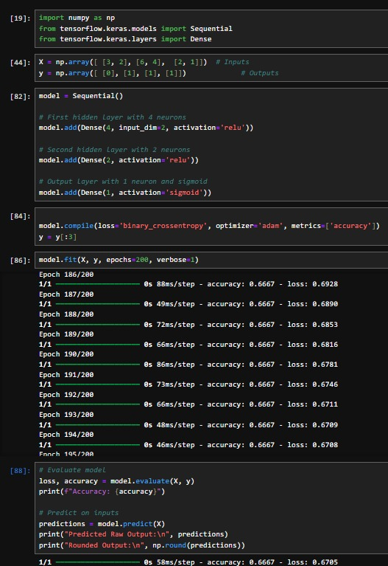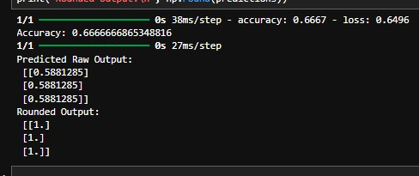

Task 2: 1. Replace relu with tanh in both hidden layers. 2. Replace relu with sigmoid in both hidden layers. Compare: training time, accuracy, and predictions

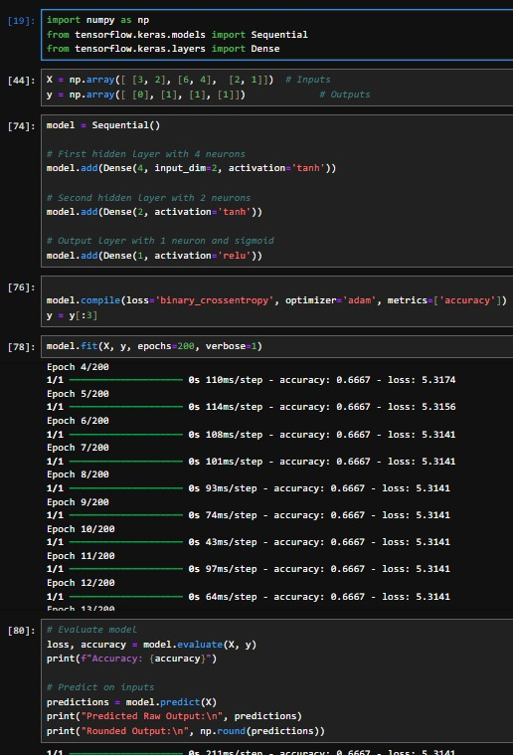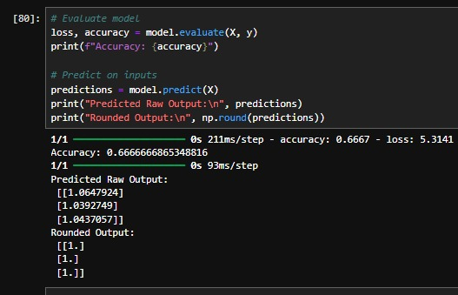

Task 3: Change the optimizer: • Try sgd, rmsprop, or adamax in place of adam

