using System;

using System.Collections.Generic;

using System.Linq;

using System.Text;

using System.Threading.Tasks;

namespace ConsoleApplication19

{

class Program

{

static void Main(string[] args)

{

counter p1 = new counter();

counter p2 = new counter();

p1.get_count();

p2.get_count();

Console.WriteLine("\n*****************\n");

p1.in_count();

p2.in_count();

p2.in_count();

p1.get_count();

p2.get_count();

}

class counter {

private int count;

public counter() {

count = 0;

}

public void in_count() {

count++;

}

public void get_count() {

Console.WriteLine(count);

}

}

}

}

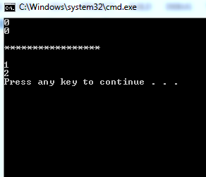

using System;

using System.Collections.Generic;

using System.Linq;

using System.Text;

using System.Threading.Tasks;

namespace ConsoleApplication19

{

class Program

{

static void Main(string[] args)

{

triangle t1 = new triangle();

triangle t2 = new triangle();

t1.width = 4.0; t1.height = 12.9;

t1.style = "rigth";

Console.WriteLine("\nInformation of t1\n");

t1.showdim();

t1.showstyle();

t1.showarea();

Console.WriteLine("\nInformation of t2");

t2.showdim();

t2.showstyle();

t2.showarea();

}

class Twodshaped

{

public double width;

public double height;

public void showdim()

{

Console.WriteLine("Width and height are", width, "and", height);

}

};

class triangle: Twodshaped

{

public string style;

public double area;

public void showarea() {

double a;

a = width * height / 2;

Console.WriteLine("Area is:", a);

}

public void showstyle() {

Console.WriteLine("Style is:",style);

}

}

}

}

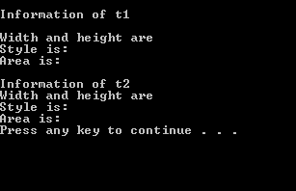

using System;

using System.Collections.Generic;

using System.Linq;

using System.Text;

using System.Threading.Tasks;

namespace ConsoleApplication19

{

class Program

{

static void Main( )

{

triangle t1 = new triangle();

triangle t2 = new triangle();

t1.width = 4.0;

t1.height = 4.0;

t1.style ="right";

t2.width =12.3;

t2.height = 23.3;

t2.style = "isocales";

Console.WriteLine("\nInformation of t1\n");

t1.showdim();

t1.showstyle();

Console.WriteLine("Area:" +t1.showarea());

Console.WriteLine("\nInformation of t2");

t2.showdim();

t2.showstyle();

Console.WriteLine("Area is:" +t2.showarea());

}

class Twodshaped

{

public double width;

public double height;

public void showdim()

{

Console.WriteLine("Width and height are:" +width, "and" +height);

}

}

class triangle: Twodshaped

{

public string style;

public double showarea() {

return width * height / 2;

}

public void showstyle() {

Console.WriteLine("Style is:" +style);

}

}

}

}

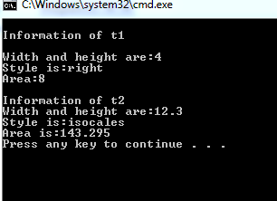

using System;

using System.Collections.Generic;

using System.Linq;

using System.Text;

using System.Threading.Tasks;

namespace ConsoleApplication6

{

class Program

{

static void Main(string[] args)

{

triangle t1 = new triangle();

triangle t2 = new triangle();

Console.WriteLine("Information for T1");

t1.height = 8.8;

t1.width=9.8;

t1.style = "right";

t1.showArea();

t1.showdim();

t1.showstyle();

Console.WriteLine("Information for T2");

t2.height = 8.7;

t2.width = 4.8;

t2.style = "Equlietral";

t2.showArea();

t2.showdim();

t2.showstyle();

Console.WriteLine("\n****Zunairkhan****\n");

}

}

public class twodshape {

public double height, width;

public void showdim()

{

Console.WriteLine("height:{0} ", +height);

Console.WriteLine("Widht:{0}", +width);

}

}

public class triangle :twodshape{

public string style;

public double area;

public

void showArea() {

area = width * height / 2;

Console.WriteLine("\nArea is:{0} ",+area);

}

public

void showstyle() {

Console.WriteLine("Style is:{0} ",style);

}

}

}

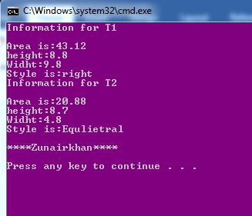

using System;

using System.Collections.Generic;

using System.Linq;

using System.Text;

using System.Threading.Tasks;

namespace ConsoleApplication6

{

class Program

{

static void Main(string[] args)

{

triangle t1 = new triangle();

triangle t2 = new triangle();

Console.WriteLine("Information for T1");

t1.height = 8.8;

t1.width=8;

t1.style = "right";

t1.showArea();

t1.showdim();

t1.showstyle();

Console.WriteLine("Information for T2");

t2.height = 8;

t2.width = 4;

t2.style = "Equlietral";

t2.showArea();

t2.showdim();

t2.showstyle();

Console.WriteLine("\n****Zunairkhan****\n");

}

}

public class twodshape {

public double height, width;

public twodshape() {

height = 0;

width = 0;

}

public twodshape(int a, int b) {

height=a;

width = b;

}

public void showdim()

{

Console.WriteLine("height:{0} ", +height);

Console.WriteLine("Widht:{0}", +width);

}

}

public class triangle :twodshape{

public string style;

public double area;

public triangle():base(){}

public triangle(double a, double b) :base() {

}

public

void showArea() {

area = width * height / 2;

Console.WriteLine("\nArea is:{0} ",+area);

}

public

void showstyle() {

Console.WriteLine("Style is:{0} ",style);

}

}

}

