**Name: Zunaisha Noor**

**Roll no : BIET-F21-049**

**Subject : Data Communication and Computer Network**

**Topic : ACL**

**Network :**

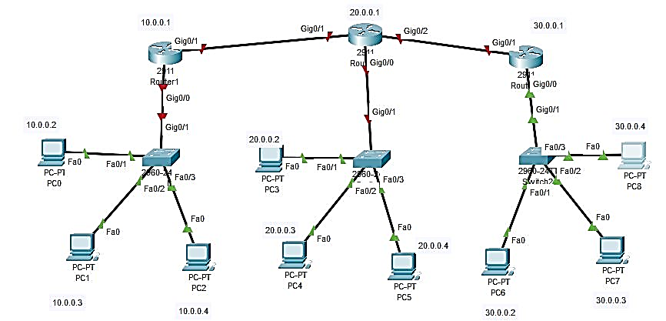

Figure Network

**Router 3 ACL Configuration:**

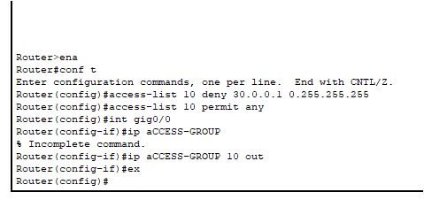

Figure Router 3 CIonfiguration

**PC 8 IP Address Configuration:**

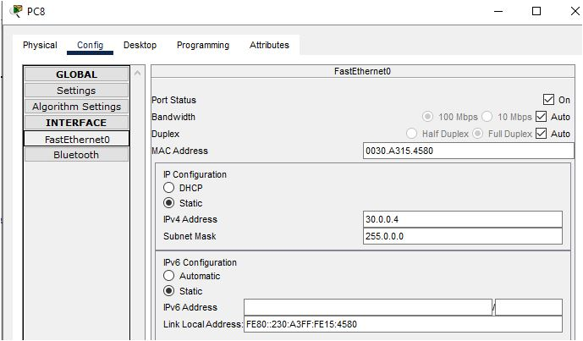

pFigure PC 8 IP Configuration

**Ping:**

