# Lab Tasks

Solve the following tasks.

## Task 1

Write a recursive function to calculate the factorial of a number.

Code:

<!DOCTYPE html>

<html lang="en">

<head><title>Lab Task 1</title></head>

<body>

<h1>Factorial of a Number</h1>

<script>function factorial(num){

if (num==0 || num==1){return 1;}

else{return num * factorial(num-1);}}

fact=factorial(4);

console.log("Lab Task 1");

console.log("Factorial of a 4 is ");

console.log(fact);

</script></body></html>

## Task 2

Create a function called **calculateArea** that takes the radius of a circle as an argument and returns the area of the circle. Use the formula: **Area = π * r^2.**

**Code :**

<!DOCTYPE html>

<html lang="en">

<head><title>Lab Task 2</title>

</head><body>

<h1>Area of Circle</h1><script>

function calculateArea(radius){

const pi=3.14;

area=pi*radius*radius;

return area;}

Area=calculateArea(5);

console.log("Lab Task 2");

console.log("Area of Circle when Radius = 5");

console.log(Area);</script></body></html>

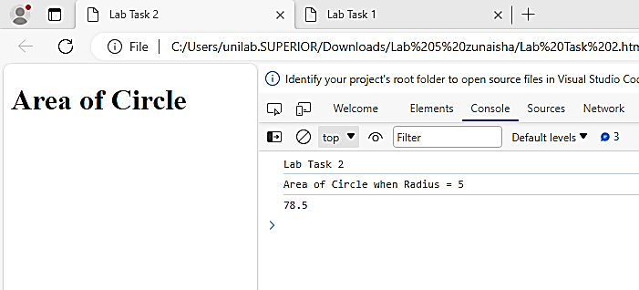

## Task 3

Create a nested loop to print a pattern of asterisks (*) as follows:

Code:

<!DOCTYPE html>

<html lang="en">

<head><title>Lab Task 3</title></head><body>

<h1>Right Angle Triangle</h1>

<script>

console.log("Lab Task 3");

console.log("Right Angle Triangle");

for(var i=0;i<=10;i++){let pattern='';

for(var j=0;j<=i;j++){pattern+='*';}

console.log(pattern);}

</script></body></html>

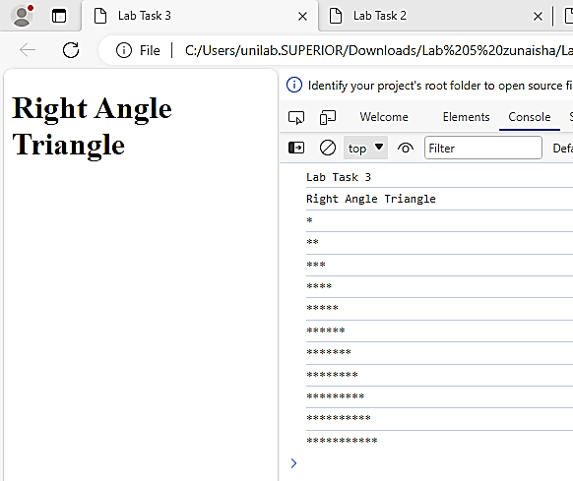

## Task 4

Write a JavaScript function that takes a number as an argument and returns "Positive" if it's greater than 0, "Negative" if it's less than 0, and "Zero" if it's exactly 0.

<!DOCTYPE html>

<html lang="en">

<head><title>Lab Task 4</title></head><body>

<h1>Type of a Number</h1>

<script>

var num1=5; var num2=-5;

function number(num){

if (num>0){var a="positive"; return a;}

else{var b="negative"; return b;}

console.log("Lab Task 4");

console.log("Type of Number Positive or Negative");

type=number(num1);

console.log("Type of Number ", num1, "is", type);

type=number(num2);

console.log("Type of Number -", num1, "is", type);</script></body></html>

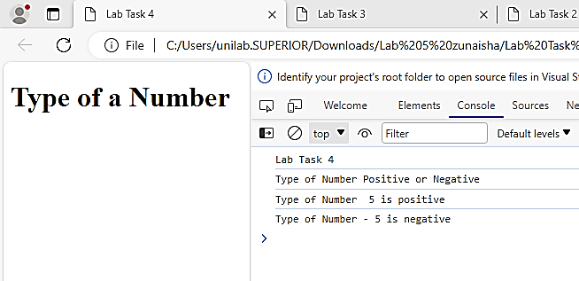

## Task 5

Create a variable **num1** and set it to 5. Create another variable **num2** and set it to 10. Write JavaScript code to display the sum, difference, product, and quotient of these two variables.

Code:

<!DOCTYPE html>

<html lang="en">

<head><title>Lab Task 5</title></head><body>

<h1>Type of a Number</h1><script>

var num1=5; var num2=10;

function sum(num1,num2){

var ad=num1+num2; return ad;}

function subtract(num1,num2){

var sub=num1-num2; return sub;}

function multiply(num1,num2){

var mul=num1*num2; return mul;}

function quotient(num1,num2){

var quot=num1 / num2; return quot;}

console.log("Lab Task 4");

console.log("Javascript Calculator");

add=sum(num1,num2);

console.log("Addition ", num1," + ", num2 ," = ",add);

sub=subtract(num1,num2);

console.log("Subtraction ", num1," - ", num2 ," = ",sub);

mul=multiply(num1,num2);

console.log("Multiplication ", num1," * ", num2 ," = ",mul);

quot=quotient(num1,num2);

console.log("Quotient ", num1," / ", num2 ," = ",quot);</script></body></html>

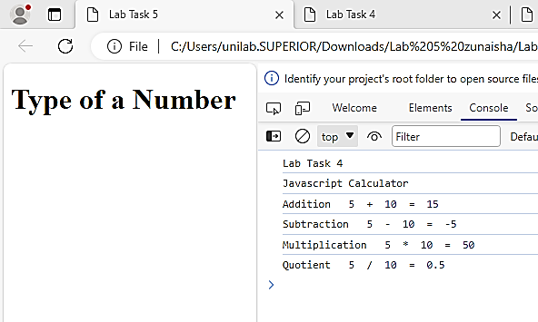

## Task 6

Create an object **person** with properties **name**, **age**, and **city**. Then, write a function that takes the **person** object as an argument and displays the person's information.

<!DOCTYPE html>

<html lang="en">

<head> <title>Lab Task 6</title></head>

<body>

<h1>Objects</h1>

<script>

const person ={

name:"Zunaisha",

age:19,

city:"Lahore",

}

function show(){

console.log(`My name is ${person.name}.`);

console.log(`I am ${person.age} years old.`);

console.log(`I live in ${person.city}.`);}

console.log("Lab Task 6");

console.log("Objects");

show(person);

</script>

</body>

</html>

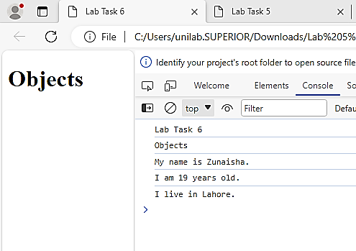

# Home Assignment

## Task 1

Create an array of numbers. Use the **filter** method to create a new array that contains only the even numbers from the original array.

<!DOCTYPE html>

<html lang="en">

<head><title>Home Task 1</title></head><body>

<h1>Array</h1><script>

var array = [11, 12, 13, 14, 15, 16, 17, 18, 19, 20, 21];

function filter_num() {

var even = []; var odd = [];

for (var i = 0;i<array.length; i++) {

if (array[i] % 2 == 0) {even.push(array[i]);} else {

odd.push(array[i]); }}return { even, odd };}

function display() {

  var result = filter_num();

var even=result.even; var odd=result.odd;

console.log("Total Array:"+array.join(', '));

console.log("Even Numbers: " + even.join(', '));

console.log("Odd Numbers: " + odd.join(', '));}

console.log("Home Task 1");

console.log("Even Number or Odd Number ");

display();</script></body></html>

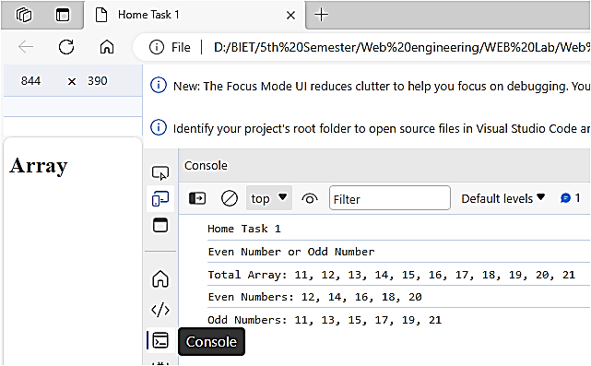

## Task 2

Write a JavaScript program to print all even numbers from 1 to 20 using a **for** loop.

<!DOCTYPE html>

<html lang="en">

<head><title>HomeTask2</title></head><body><h1>Even Numbers 1 - 20</h1>

<script> var array = [];

for (let i = 0; i <= 20; i += 1) {

 array.push(i); }

function filter_num(arr) {

var even = []; var odd = [];

for (var i = 0; i < arr.length;i++) {

if (arr[i] % 2 == 0) {even.push(arr[i]);} else {

odd.push(arr[i]);}}return { even, odd };}

function display() {

var result =filter_num(array);

var even =result.even;var odd=result.odd;

console.log("Total Array: " + array.join(', '));console.log("Even Numbers: " + even.join(', '));console.log("Odd Numbers: " + odd.join(', '));}console.log("Home Task 2");console.log("Even Number between 1 to 20");display();</script></body></html>

