1. First write your roll number in a single digit and then choose your class. For example, Roll Number is 023, then (0+2+3 = 5). 5 is the single digit and you will choose Class B.

* For 1 to 5 Class A
* For 6 to 8 Class B
* For 9 to 16 Class C

1. Make 3 networks of your choice as per your assigned class. The topology against the digit 5 is shown below.

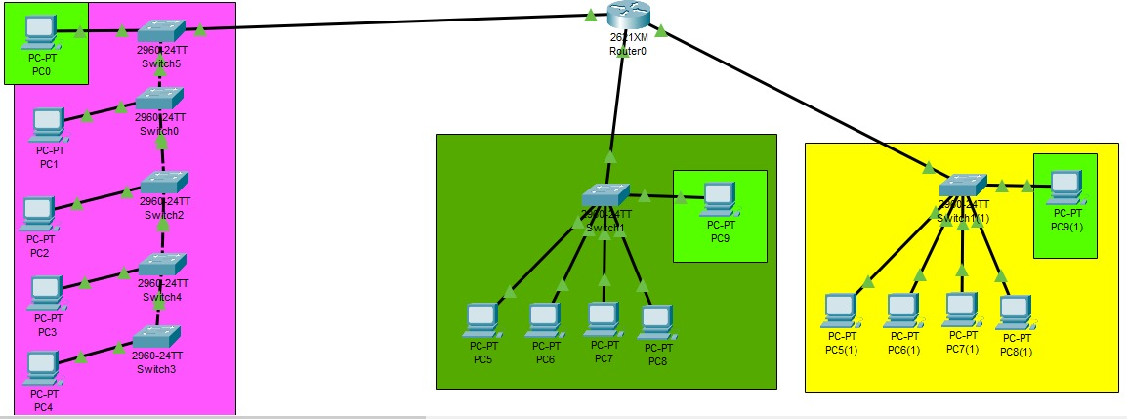

For example, if our digit is 5 then networks will be like this

**First network**

There must be switches (= single digit). There must be a single PC attached to a single switch.

Example if your digit is 5, you must add 5 switches in your 1st network and 5 pc (attach one Pc to each switch)

**Second Network**

You must only add one switch in this network and attach 5 PC (as your digit is 5)

**Third Network**

You also must add only one switch in this third and last network and add 5 PC (as your digit is 5)

1. **Configuration**
   1. Configure your 1st network as per your block /network which you have made in step 2
   2. Configure your 2nd network as per your 2nd block /networks which you have made in step 3
   3. Configure your 3rd network as per your 3rd block /networks which you have made in step 3
   4. Create subnets and assign IP addresses to your desired network.
   5. Each subnet can host 80 devices if it's a class C network and 200 devices if it's a class B or class A network.
   6. Configure a DHCP server for all networks.

At this stage you have designed three networks /LANS

**Your next task is to ensure communication between these three networks**

First, you must use Router for this purpose

Configure Router' three interfaces (connected to LANs)

>>> Assign IP Addresses to respective interfaces

>>> Change Port status from shutdown to "UP".

Next Task is to implement LAB WEEK-2 tasks in this Lab. For example, you must configure Switches and Router for management purpose like configure passwords, telnet services etc.

Test and Verify:

In the 1st Network, from any Host, telnet switch and Router. Take screenshots as well. (02 screenshots)

In the 2nd Network, from any Host, telnet switch and Router. Take screenshots as well. (02 screenshots)

In the 3rd Network, from any Host, telnet switch and Router. Take screenshots as well. (02 screenshots)

**\*Note:**

**Paste screenshots (step by step with description) showing your task completed.**

**Sample of a C Class IP Block / Network is shown below for your reference.**

|  |  |  |  |  |  |
| --- | --- | --- | --- | --- | --- |
| **Sub-Network** | **Device** | **Interface** | **IP Address** | **Subnet Mask** | **Gateway IP** |
| **LAN 1** | Router 1 | Fa0/0 | 192.168.10.30 | 255.255.255.224 | - |
| Switch 1 | VLAN 1 | 192.168.10.29 | 255.255.255.224 | - |
| Switch 2 | VLAN 1 | 192.168.10.28 | 255.255.255.224 | - |
| Switch 3 | VLAN 1 | 192.168.10.27 | 255.255.255.224 | - |
| Switch 4 | VLAN 1 | 192.168.10.26 | 255.255.255.224 | - |
| Switch 5 | VLAN 1 | 192.168.10.25 | 255.255.255.224 | - |
| Switch 6 | VLAN 1 | 192.168.10.24 | 255.255.255.224 | - |
| Switch 7 | VLAN 1 | 192.168.10.23 | 255.255.255.224 | - |
| Switch 8 | VLAN 1 | 192.168.10.22 | 255.255.255.224 | - |
| Switch 9 | VLAN 1 | 192.168.10.21 | 255.255.255.224 | - |
| PC 1 | Fa0/1 | 192.168.10.1 | 255.255.255.224 | 192.168.10.30 |
| PC 2 | Fa0/1 | 192.168.10.2 | 255.255.255.224 | 192.168.10.30 |
| PC 3 | Fa0/1 | 192.168.10.3 | 255.255.255.224 | 192.168.10.30 |
| PC 4 | Fa0/1 | 192.168.10.4 | 255.255.255.224 | 192.168.10.30 |
| PC 5 | Fa0/1 | 192.168.10.5 | 255.255.255.224 | 192.168.10.30 |
| PC 6 | Fa0/1 | 192.168.10.6 | 255.255.255.224 | 192.168.10.30 |
| PC 7 | Fa0/1 | 192.168.10.7 | 255.255.255.224 | 192.168.10.30 |
| PC 8 | Fa0/1 | 192.168.10.8 | 255.255.255.224 | 192.168.10.30 |
| PC 9 | Fa0/1 | 192.168.10.9 | 255.255.255.224 | 192.168.10.30 |

|  |  |  |  |  |  |  |  |
| --- | --- | --- | --- | --- | --- | --- | --- |
| **Sub-Network** | **Sub-net Range** | **Network Bit** | **Broadcast bit** | **Host per Sub-net** | **Usable Host** | **Subnet Mask** | **Gateway IP** |
| 192.168.10.0 | 192.168.10.0 – 192.168.10.29 | 0 | 29 |  |  | 255.255.255.224 | 192.168.10.1 |
| 192.168.10.30 |  |  |  |  |  |  |  |
| 192.168.10.60 |  |  |  |  |  |  |  |
| 192.168.10.90 |  |  |  |  |  |  |  |
| 192.168.10.120 |  |  |  |  |  |  |  |
| 192.168.10.150 |  |  |  |  |  |  |  |
| 192.168.10.180 |  |  |  |  |  |  |  |