SUPERIOR UNIVERSITY LAHORE



**NAME:** Zunaisha Noor

**ROLL #:** Biet-F21-049

**ASSIGNMENT # 1**

**SUBJECT:** Operating System

**Course Code:** TIT601460

**Topic:** Operating System

**SEMESTER:** 5th

**DEPARTMENT:** Faculty of Engineering and Technology

**SUBMITTED TO: Miss Sana**

**Question # 1:**

***Explain why an operating system can be viewed as a resource allocator?***

* Now-a-days all modern computers consist of processors, memories, timers, network interfaces, printers, and so many other devices.
* The operating system provides for an orderly and controlled allocation of the processors, memories, and I/O devices among the various programs in the bottom-up view.
* Operating system allows multiple programs to be in memory and run at the same time.
* Resource allocator includes multiplexing or sharing resources in two different ways: in time and in space.
* In time multiplexed, different programs take a chance of using CPU. First one tries to use the resource, then the next one that is ready in the queue and so on. For example: Sharing the printer one after another.
* In space multiplexing, Instead of the customers taking a chance, each one gets part of the resource. For example − Main memory is divided into several running programs, so each one can be resident at the same time.

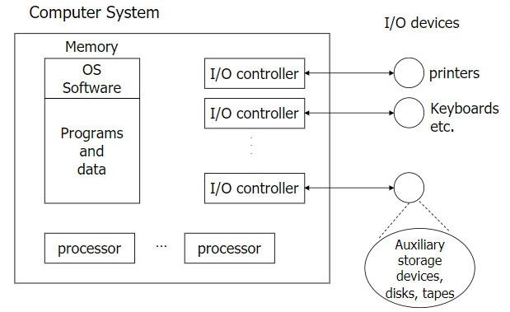

**Question # 2:**

***Describe the booting process in computer system?***

[Booting](https://en.wikipedia.org/wiki/Booting#:~:text=In%20computing%2C%20booting%20is%20the,before%20it%20can%20be%20executed.) is the process of loading an operating system. It’s the process that starts when we turn on the computer (using the power button or by a software command) and ends when the operating system is loaded into the memory.

1. **Running BIOS**

When we turn on the computer, there is no program inside the computer’s main memory (RAM), so the CPU looks for another program, called the [BIOS](https://en.wikipedia.org/wiki/BIOS#System_startup) (Basic Input/Output System), and runs it. The BIOS is a firmware that is located on the motherboard and is run by the CPU to start the

booting sequence:

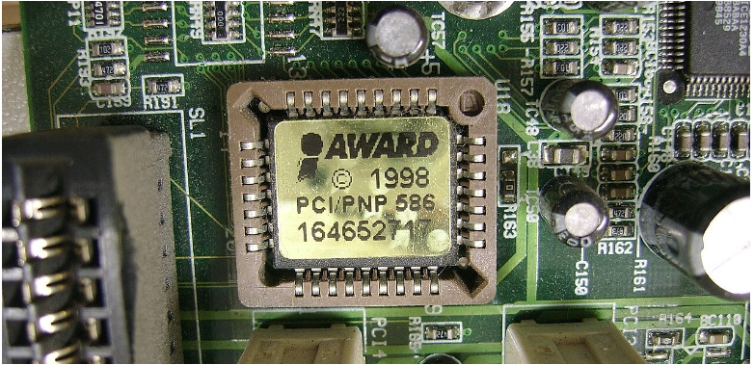

## **Running POST**

After the BIOS starts running, it starts a process called [POST](https://en.wikipedia.org/wiki/Power-on_self-test) (Power-On Self-Test) which tests all the hardware devices and makes sure there are no issues. Moreover, if POST finds some issues in the hardware, the booting process stops and the computer fails to boot.

## **Loading MBR to RAM**

After running POST, the BIOS proceeds to load the [MBR](https://en.wikipedia.org/wiki/Master_boot_record) (Master Boot Record) from the bootable device into RAM. The MBR consists of 512 or more bytes located at the very beginning sector of the bootable device (which can be an HDD, an SSD, or a flash drive).

Below is a simplified structure of the MBR:

## **Running the Bootloader**

After loading the MBR into RAM, the BIOS runs the first instruction loaded from the MBR. The first instruction is typically the bootstrap code, aka the bootloader, which is a program written in machine code that loads the operating system into RAM.

Each operating system has its own bootloaders. For example, [GNU GRUB](https://www.gnu.org/software/grub/), [LILO](https://en.wikipedia.org/wiki/LILO_(bootloader)) (Linux Loader), and [rEFInd](https://www.rodsbooks.com/refind/) are a few popular Linux bootloaders:

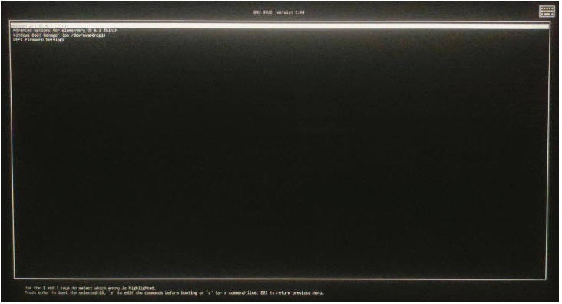

## **Running the OS**

Once the OS is loaded into the memory, the OS starts running. Further, the OS starts its own initialization (which includes loading device drivers, setting up libraries, etc). Finally, when the OS initialization is finished, the OS starts a shell that displays a login prompt to the user:

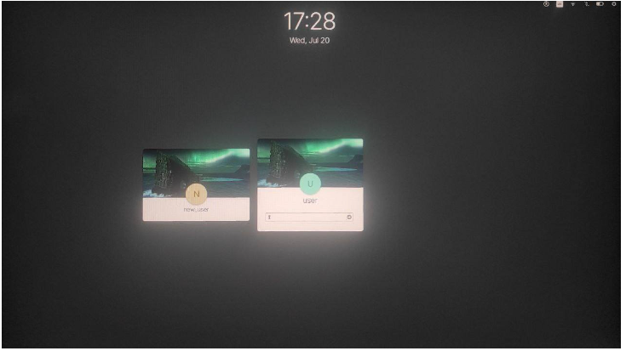

**Question # 3:**

***Does the OS really matter for programming? Which operating system is best for programming?***

Several computer programs normally run at the same time, all of which need to access the computer's processor (CPU), memory, and storage. It is the operating system that is responsible for coordinating all this and enabling all applications to get what they need.

***Advantages:***

|  |  |  |
| --- | --- | --- |
| **Windows 10** | **Linux** | **Mac OS** |
| **Antivirus** | **Open-source** | **Easy Installation** |
| **Affordable** | **Reliable.** | **High-tech Features.** |
| **Software Support** | **Highly secure** | **Facilitates Multitasking** |
| **Extended Battery Life** | **High Performance** | **iOS Development** |
| **Easy Upgrades** | **Easy Installation of Modules** | **Efficient Tech Support** |

***Limitations:***

|  |  |  |
| --- | --- | --- |
| **Windows 10** | **Linux** | **Mac OS** |
| **Mixed Drivers** | **Errors.** | **Unaffordable** |
| **Forces Updates.** | **Unsupported Software** | **Not recommended for Gamers** |
| **Speed Limitations** | **Limited Tech Support** | **Inflexible Upgrades** |

## Best OS For Programming In Various Career Domains

### Which OS is best for programming?

There is no specific operating system that is considered to be perfect for programmers. It mainly depends on the career domain, software used specification of your device, and your workplace culture. Still, programmers usually prefer Linux because of its versatility.

### How Linux is best for programming:

Yes, Linux is the best for programming as it compiles many programming languages significantly faster than windows. C++ and C codes will actually compile faster on a virtual machine running Linux on top of a computer running Windows rather than directly on Windows.

### How Apple or Windows is better for programming:

Apple is better for programming as it comes with a UNIX based command line. Programming becomes easier as you are allowed to run programs in almost any language. UNIX is also more secure by default as compared to Windows. Mac has proved itself to be safer against hacker tools such as malware, trojan horses, and viruses.

### How Ubuntu is good for programming:

Yes, Ubuntu is really good for programming. Ubuntu’s Snap feature makes it the best Linux operating system for programmers as it also finds wide applications in coordinating web-based services. Most importantly, Ubuntu is considered to be the best OS for programming because it comes with an in-built Snap Store.