**Name : Zunaisha Noor Roll no : Biet-f21-049 Course DCCN**

**Task:**

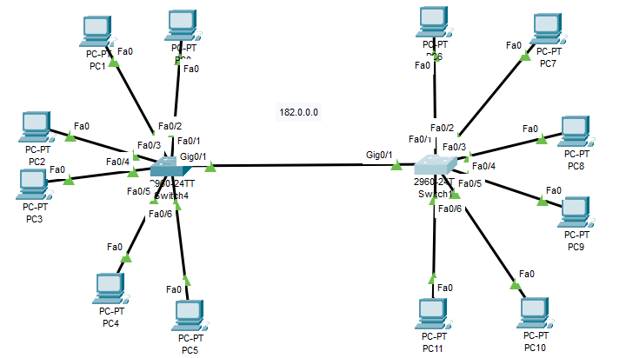

**Subnetting:**

**182.0.0.0**

**320 Host**

**Host:**

**2^9 = 128**

**Subnet Mask:**

**255.255.254.0**

**Table:**

|  |  |  |  |
| --- | --- | --- | --- |
| **Network-ID** | **Sub-net Range** | **BroadCast Bit** | **Usable Host** |
| **182.0.0.0** | **182.0.0.0 - 182.0.1.254** | **182.0.1.255** | **510** |
| **182.0.2.0** | **182.0.2.0 - 182.0.2.254** | **182.0.3.255** | **510** |
| **182.0.4.0** | **182.0.4.0 - 182.0.4.254** | **182.0.5.255** | **510** |
| **-** | **-** | **-** | **-** |
| **182.0.252.0** | **182.0.252.0 - 182.0.252.254** | **182.0.253.255** | **510** |

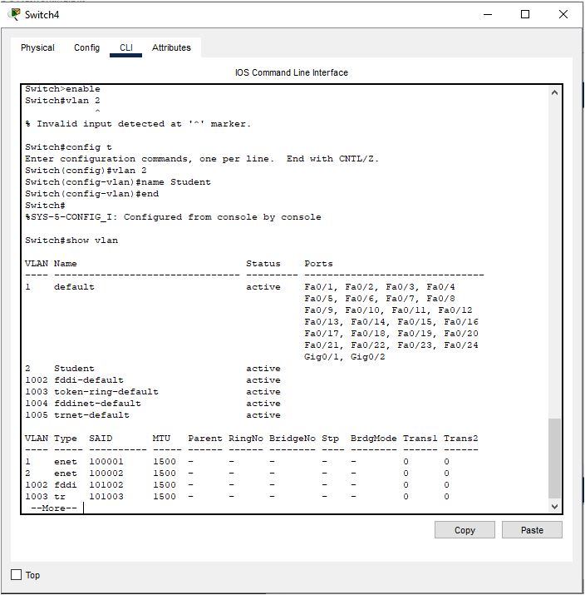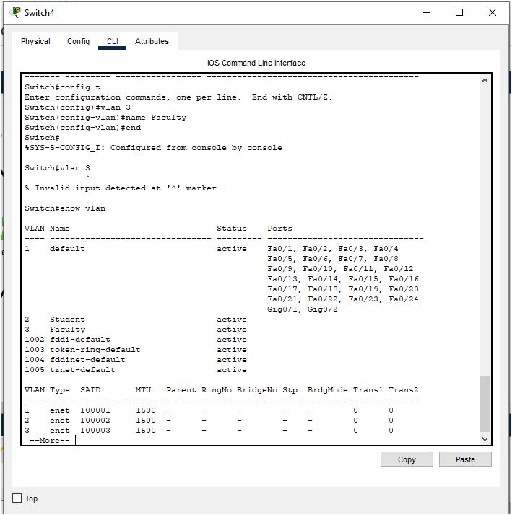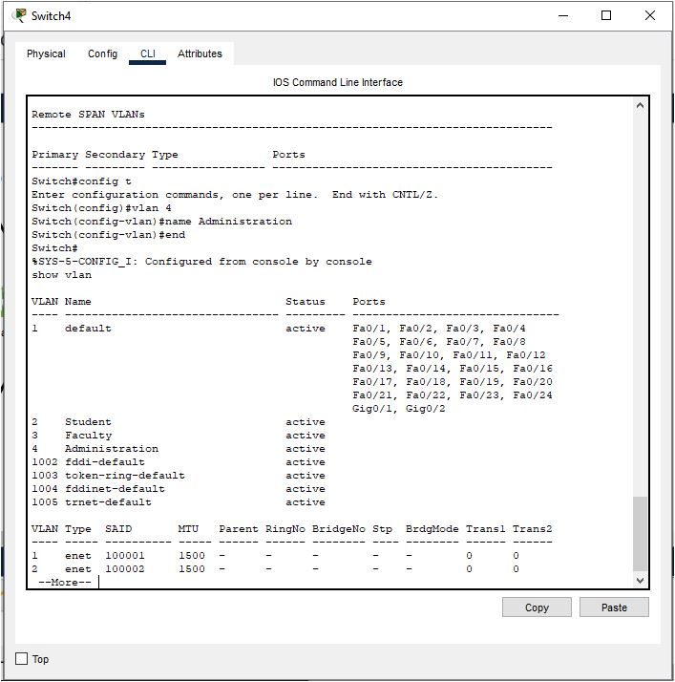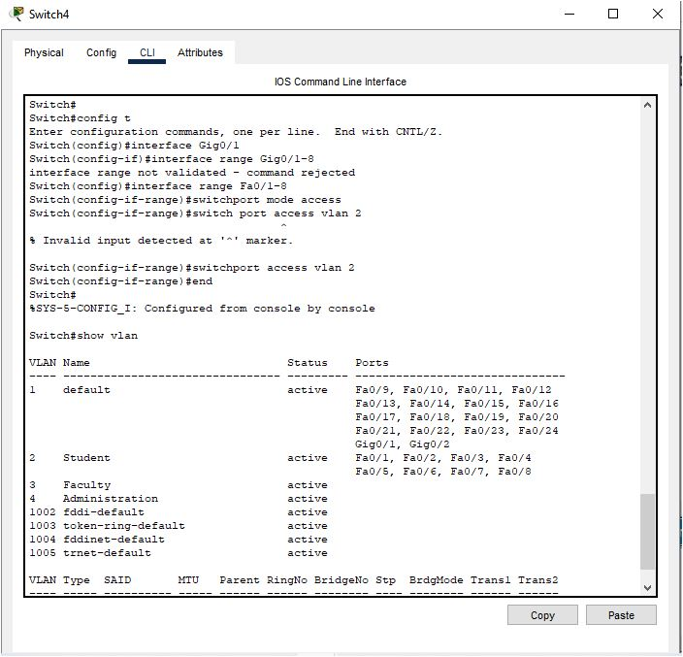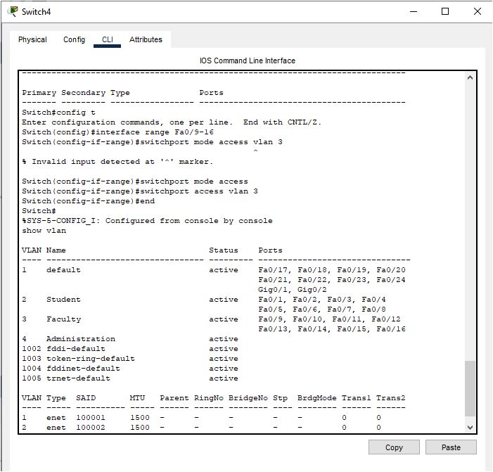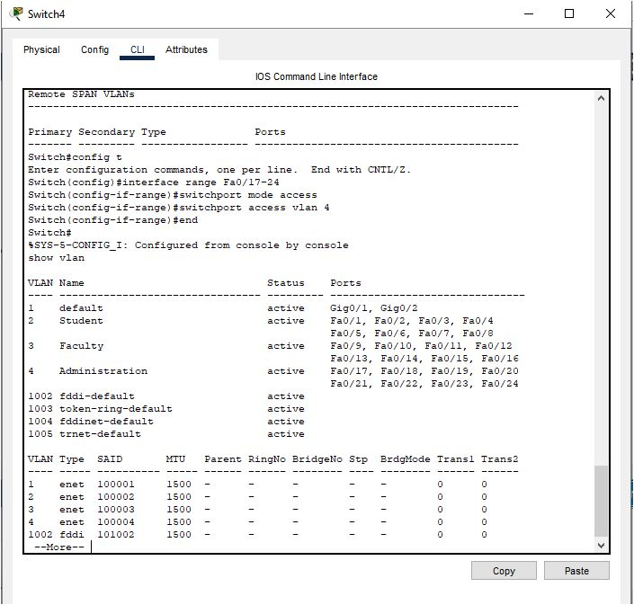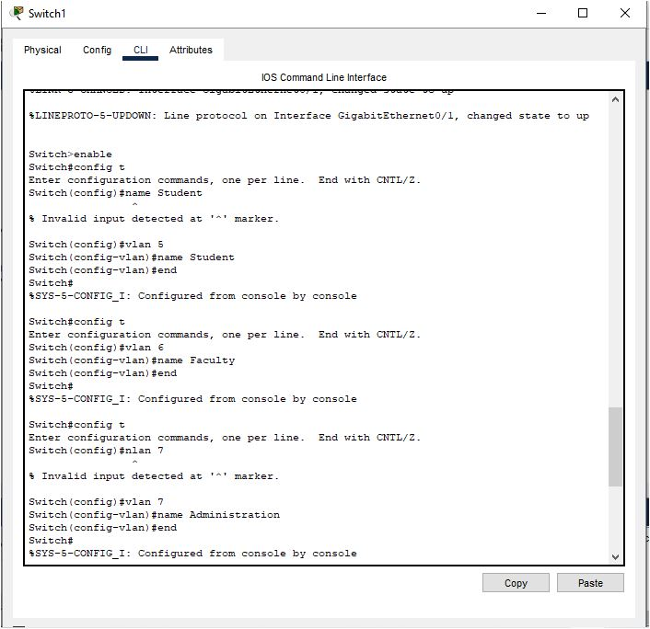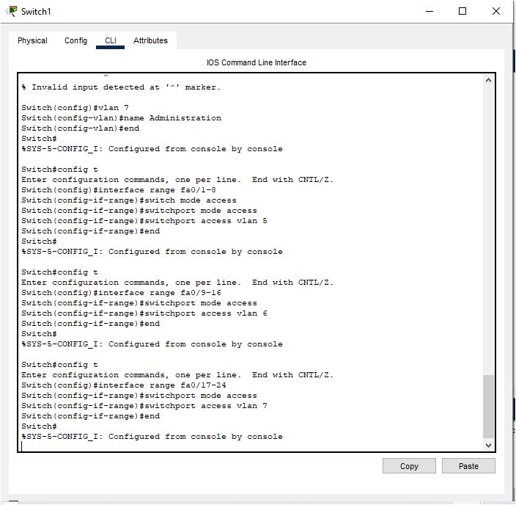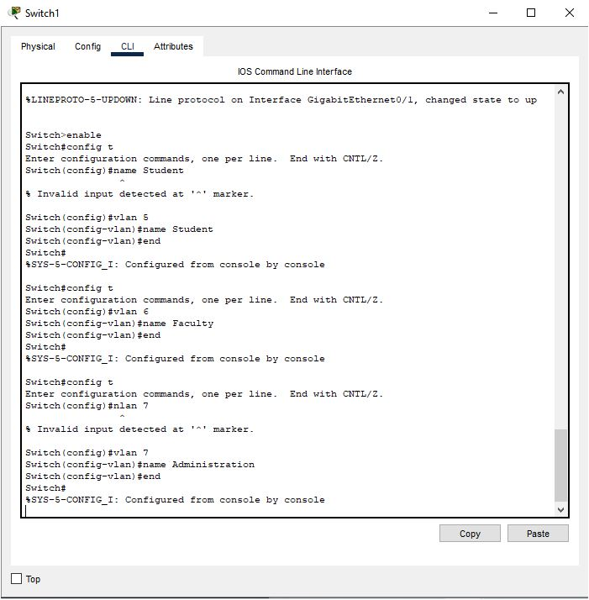

**Trunk:**

