Zunaisha Rao
2510224
BSCS-A
VP-Labno07
Taskno1:
Part A:
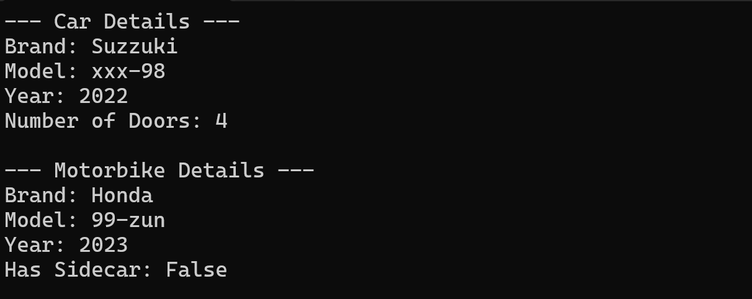
Part B:

