Appendix A

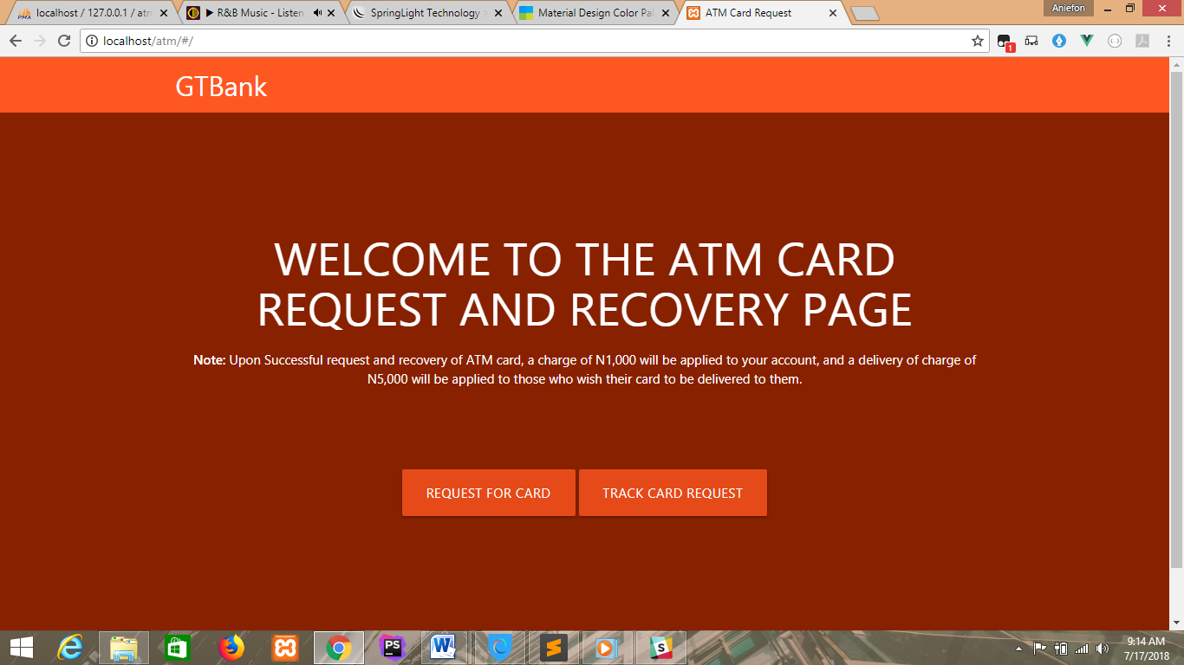

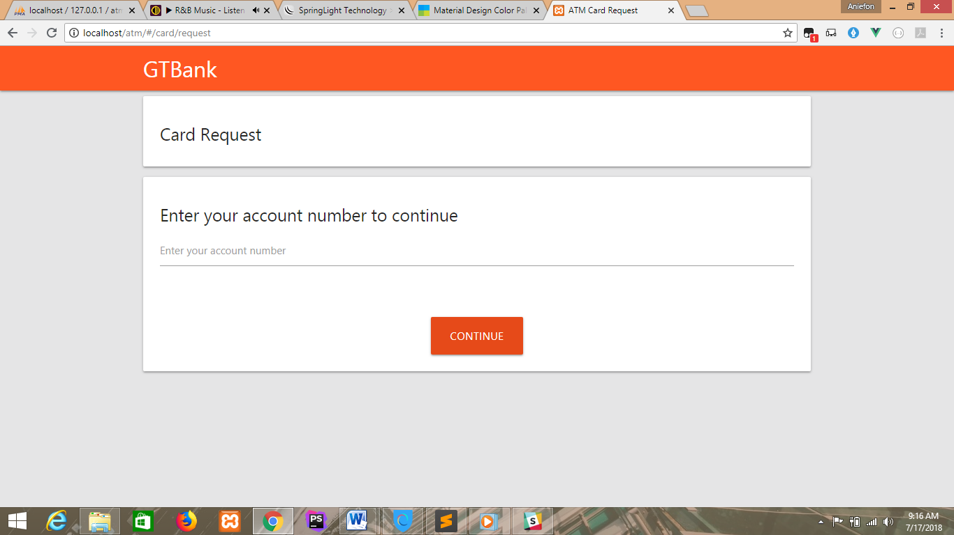

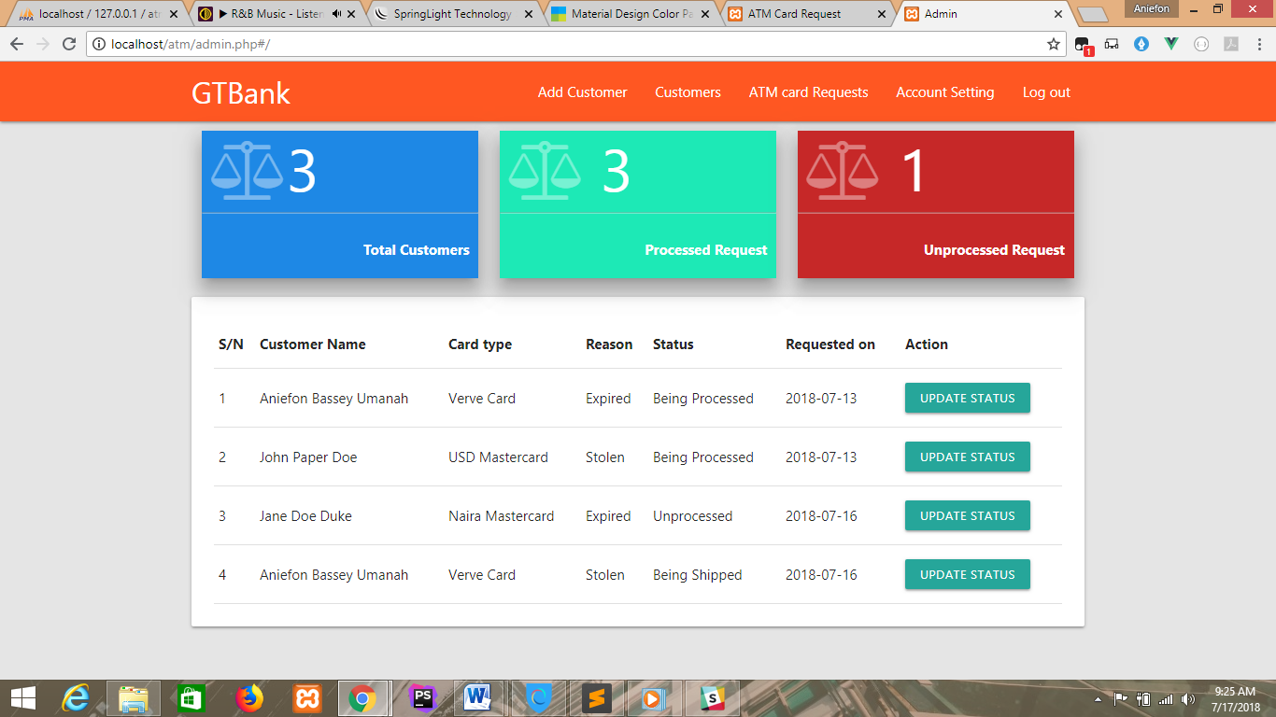

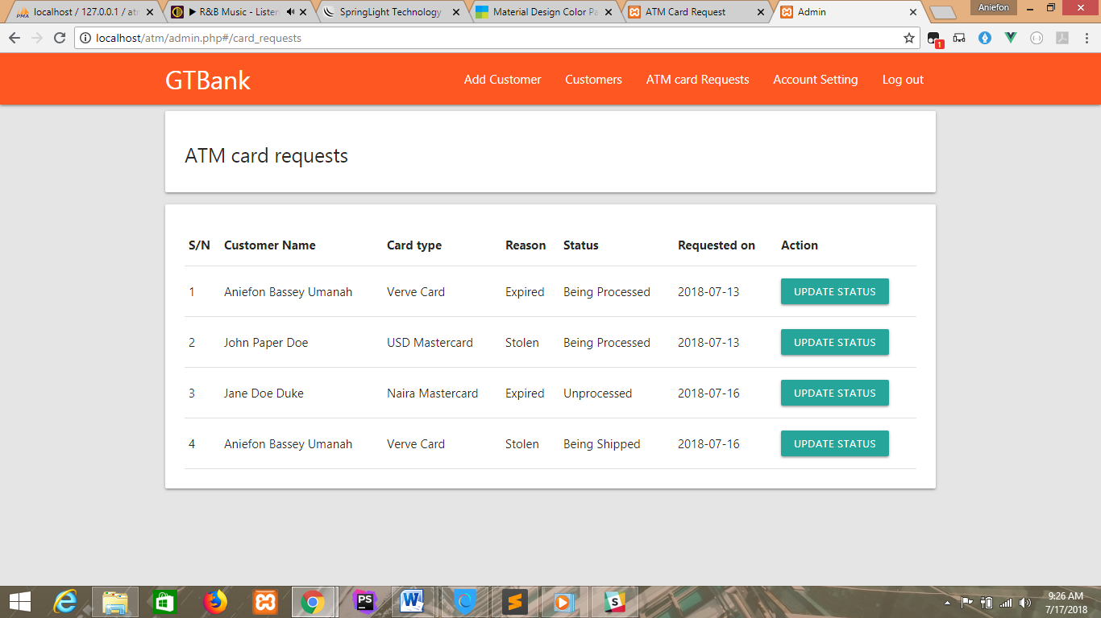

<?php

session_start();

require 'system/autoload.php';

if($_SERVER['REQUEST_METHOD'] =='POST'){

$admin = new \Controllers\AccountController();

if($admin->verifyAccount()){

$_SESSION['admin'] = 'loggedIn';

}else{

$error = 'Error';

}

}

?>

<!DOCTYPE html>

<html lang="en">

<head>

<meta charset="UTF-8">

<title>Admin</title>

<link rel="stylesheet" type="text/css" href="dist/css/font-awesome.min.css">

</head>

<body>

<?php if(isset($_SESSION['admin'])): ?>

<div id="admin">

</div>

<?php else:;?>

<nav class=" deep-orange accent-3">

<div class="nav-wrapper container ">

<a href="#" class="brand-logo">GTBank</a>

</div>

</nav>

<div class="main">

<div class="container">

<div class="row">

<div class="col offset-m3 m6">

<div class="card-panel">

<h5>Admin Login</h5>

<?php if(isset($error)):?>

<p class="red-text">Invalid Username or password</p>

<?php endif;?>

<form method="post" action="admin.php">

<div class="input-field">

<input type="text" id="username" name="username" class="validate" required/>

<label for="username">Username</label>

</div>

<div class="input-field">

<input type="password" id="password" name="password" class="validate" required/>

<label for="password">Password</label>

</div>

<div class="button">

<button class="btn btn-large">Login</button>

</div>

</form>

</div>

</div>

</div>

</div>

</div>

<?php endif ?>

<script type="text/javascript" src="dist/js/admin.bundle.js"></script>

</body>

</html>

<template>

<div class="card-panel">

<h5>Security Questions</h5>

<error-alert v-bind:message="errorMsg" ref="errorAlert"></error-alert>

<success-alert v-bind:message="successMsg" ref="successAlert" not-flash ></success-alert>

<form method="post" @submit.prevent="sendRequest($event)">

<div class="input-field">

<input type="text" id="qus1" class="validate" name="answer1" required/>

<label for="qus1">{{ question1 }}</label>

</div>

<div class="input-field">

<input type="text" id="qus2" class="validate" name="answer2" required />

<label for="qus2">{{ question2}}</label>

</div>

<div class="button">

<button type="submit" class="btn waves-effect btn-large">Request Card</button>

</div>

</form>

</div>

</template>

<script>

import ErrorAlert from '../../common/Alerts/ErorrAlert.vue';

import SuccessAlert from '../../common/Alerts/SuccessAlert.vue';

import axios from 'axios';

export default {

name: "SecurityQuestion",

components:{ErrorAlert,SuccessAlert},

data:()=>({

question1:'',

question2:'',

errorMsg:'',

successMsg:''

}),

methods:{

getQuestions(){

axios.get('api.php?request=get_questions&id='+this.$store.state.customer.id)

.then(res=>{

this.question1 = res.data.question1;

this.question2 = res.data.question2;

})

},

sendRequest(event){

//console.log('called');

const data = new FormData(event.target);

data.append('id',this.$store.state.customer.id);

data.append('card_type',this.$store.state.preference.card_type);

data.append('reason',this.$store.state.preference.reason);

axios.post('api.php?request=request_card',data)

.then(res=>{

const data = res.data;

console.log(data);

if(data.status == 'success'){

this.successMsg = `Card request was sent successfully your tracking code is <strong>${data.tracking_code}</strong>`;

this.$refs.successAlert.showAlert();

}else {

this.errorMsg = data.error;

this.$refs.errorAlert.showAlert();

}

})

}

},

created(){

if(!this.$store.state.customer.id)

this.$router.push('/card/request');

this.getQuestions();

}

}

</script>

<style scoped lang="scss">

@import "../../../sass/palette";

.btn{

background: $primary-color-dark;

}

.button{

text-align: center;

}

</style>

<template>

<div class="container white z-depth-2">

<form method="post" enctype="multipart/form-data" v-on:submit.prevent="registerCustomer($event)">

<error-alert v-for="message in errorMessages" not-flash v-bind:message="message"></error-alert>

<success-alert message="Customer was added successfully" ref="successAlert"></success-alert>

<error-alert v-bind:message="errorMessage" ref="errorAlert"></error-alert>

<div class="row">

<div class="col s12">

<div class="row">

<div class="col m3">

<div class="avatar-wrapper" title="Click to upload passport photograph" @click="showUploadDialog">

<div class="cover" v-show="noPassport">

<div class="cell">

<p>Upload Passport Photograph</p>

</div>

</div>

<img src="dist/images/avartar.png" ref="passportPhoto" class="responsive-img"/>

<input type="file" accept="image/*" @change="showPassport" name="passport" ref="passport"/>

</div>

</div>

</div>

</div>

<div class="input-field col m4">

<input type="text" name="last_name" v-model="customer.last_name" id="last_name" class="validate" required/>

<label for="last_name">Last Name</label>

</div>

<div class="input-field col m4">

<input type="text" name="first_name" v-model="customer.first_name" id="first_name" class="validate" required/>

<label for="first_name">First Name</label>

</div>

<div class="input-field col m4">

<input type="text" name="middle_name" v-model="customer.middle_name" id="middle_name" class="validate" required/>

<label for="middle_name">Middle Name</label>

</div>

<div class="col m4 input-field">

<select name="gender" id="gender" v-model="customer.gender" class="validate" required>

<option value="" disabled selected>Choose gender</option>

<option value="Male">Male</option>

<option value="Female">Female</option>

</select>

<label for="gender">Gender</label>

</div>

<div class="input-field col m4">

<input type="date" name="dob" v-model="customer.dob" id="dob" class="validate" required/>

<label for="dob">Date of Birth</label>

</div>

<div class="input-field col m4">

<input type="text" name="occupation" v-model="customer.occupation" id="occupation" class="validate" required/>

<label for="occupation">Occupation</label>

</div>

<div class="input-field col m4">

<input type="text" name="mobile_one" v-model="customer.mobile1" id="mobile_one" class="validate" required/>

<label for="mobile_one">Mobile 1</label>

</div>

<div class="input-field col m4">

<input type="text" name="mobile_two" v-model="customer.mobile2" id="mobile_two"/>

<label for="mobile_two">Mobile 2(optional)</label>

</div>

<div class="input-field col m4">

<input type="email" name="email" v-model="customer.email" id="email"/>

<label for="email">Email Address</label>

</div>

<div class="input-field col m4">

<input type="text" name="home_address" v-model="customer.address" id="home_address" class="validate" required/>

<label for="home_address">Home Address</label>

</div>

<div class="input-field col m4">

<input type="text" name="landmark" v-model="customer.landmark" id="landmark" class="validate" required/>

<label for="landmark">Landmark of Home Address</label>

</div>

<div class="input-field col m4">

<input type="text" name="state" v-model="customer.state" id="state" class="validate" required/>

<label for="state">State</label>

</div>

<div class="input-field col m4">

<input type="text" name="city" v-model="customer.city" id="city" class="validate" required/>

<label for="city">City</label>

</div>

<div class="col m4 input-field">

<select name="id_type" v-model="customer.id_type">

<option value="" disabled selected>Choose your option</option>

<option value="International Passport">International Passport</option>

<option value="Drivers Licence">Drivers Licence</option>

<option value="Voters Card">Voters Card</option>

<option value="National ID Card">National ID Card</option>

</select>

<label>Identification type</label>

</div>

<div class="input-field col s4">

<input type="text" name="id_number" v-model="customer.id_number" id="id_number" class="validate" required/>

<label for="id_number">ID Number</label>

</div>

<div class="input-field col s4">

<input type="date" name="issue_date" v-model="customer.issue_date" id="issue_date" class="validate" required/>

<label for="issue_date">Issue Date</label>

</div>

<div class="input-field col s4">

<input type="date" name="expiry_date" v-model="customer.expiry_date" id="expiry_date" class="validate" required/>

<label for="expiry_date">Expiry Date</label>

</div>

<div class="input-field col s4">

<input type="number" name="balance" v-model="customer.balance" id="balance" class="validate" required/>

<label for="balance">Opening Balance</label>

</div>

<div class="input-field col m6">

<select name="question1" v-model="customer.question1" id="question1" class="validate" required>

<option value="" disabled selected>Select Question</option>

<option value="What Is your favorite book?">What Is your favorite book? </option>

<option value="What is the name of the road you grew up on?"> What is the name of the road you grew up on?</option>

<option value="What is your mother’s maiden name?"> What is your mother’s maiden name?</option>

<option value="Where did you meet your spouse?"> Where did you meet your spouse?</option>

<option value="What is your favorite food?">What is your favorite food? </option>

</select>

<label for="question1">Security Question 1</label>

</div>

<div class="input-field col m6">

<input type="text" name="answer1" v-model="customer.answer1" id="answer1" class="validate" required/>

<label for="answer1">Security Answer 1</label>

</div>

<div class="input-field col s6">

<select name="question2" v-model="customer.question2" id="question2" class="validate" required>

<option value="" disabled selected>Select Question</option>

<option value="What Is your favorite book?">What Is your favorite book? </option>

<option value="What is the name of the road you grew up on?"> What is the name of the road you grew up on?</option>

<option value="What is your mother’s maiden name?"> What is your mother’s maiden name?</option>

<option value="Where did you meet your spouse?"> Where did you meet your spouse?</option>

<option value="What is your favorite food?">What is your favorite food? </option>

</select>

<label for="question2">Security Question 2</label>

</div>

<div class="input-field col s6">

<input type="text" v-model="customer.answer2" name="answer2" id="answer2" class="validate" required/>

<label for="answer2">Security Answer 2</label>

</div>

</div>

<div class="button">

<button class="btn btn-large waves-effect">Create Account</button>

</div>

</form>

</div>

</template>

<script>

import axios from 'axios';

import ErrorAlert from '../common/Alerts/ErorrAlert.vue';

import SuccessAlert from '../common/Alerts/SuccessAlert.vue';

export default {

name: "AddCustomerForm",

components:{ErrorAlert,SuccessAlert},

data:()=>({

noPassport:true,

errorMessages:[],

errorMessage:'',

customer:{

first_name:'',

last_name:'',

middle_name:'',

dob:'',

gender:'',

mobile1:'',

mobile2:'',

email:'',

occupation:'',

address:'',

landmark:'',

state:'',

city:'',

id_type:'',

id_number:'',

issue_date:'',

expiry_date:'',

balance:'',

question1:'',

question2:'',

answer1:'',

answer2:'',

}

}),

methods:{

showUploadDialog(){

this.$refs.passport.click();

},

showPassport(){

const reader = new FileReader();

reader.onload = event=>{

this.$refs.passportPhoto.src = event.target.result;

this.noPassport = false;

};

reader.readAsDataURL(this.$refs.passport.files[0])

},

registerCustomer(event){

const cusData = new FormData(event.target);

if(this.noPassport){

document.querySelector('.avatar-wrapper').style.borderColor = 'red';

// this.$refs.errorAlert.showAlert();

}else {

axios.post('api.php?request=add_customer',cusData).then(res=>{

const data = res.data;

if(data.status == 'success'){

Object.getOwnPropertyNames(this.customer).forEach((name)=>{

this.customer[name]='';

this.$refs.passport.value ='';

this.$refs.passportPhoto.src = 'dist/images/avartar.png';

document.querySelector('.avatar-wrapper').style.borderColor = 'lightgray';

this.noPassport = true;

});

this.$refs.successAlert.showAlert();

}else{

this.errorMessages = data.errors;

//this.$refs.successAlert.showAlert();

}

},

()=>{

})

}

}

},

mounted(){

this.$nextTick(function () {

var elems = document.querySelectorAll('select');

var instances = M.FormSelect.init(elems);

})

}

}

</script>

<style scoped lang="scss">

@import "../../sass/palette";

.avatar-wrapper{

border:solid lightgray 1px;

margin: 15px;

position: relative;

img{

padding: 10px;

}

.cover{

position: absolute;

text-align: center;

background: transparentize(gray,.6);

height: 100%;

padding-top: 30%;

cursor: pointer;

}

.cell{

p{

font-weight: bold;

color: black;

}

}

input[type='file']{

display: none;

}

}

.button{

text-align: center;

padding: 10px 0;

padding-bottom: 30px;

.btn{

background: $primary-color;

}

}

</style>