Visitor Arrivals and Hotel Guests in Macao
A simple comparison from January to June 2026
CISC7204 Data Science and Data Visualization
Assignment 01 Preliminary Project Proposal
ZUO ZIYI MC642637
Pair partner WANG TINGYUE MC642106

Research question
What is the relationship between monthly visitor arrivals and hotel guests in Macao during the first half of 2026? We will compare their monthly patterns and calculate a correlation coefficient. Our aim is to see whether the two indicators generally move together and identify months when they move in opposite directions.

Purpose
Tourism and hotels are closely related, but an increase in visitor arrivals may not come with an increase in hotel guests in the same month. We want to examine this using official data rather than assume the two series always follow the same pattern.
Outcomes: produce a clear comparison of six months of data and answer the research question with charts and a short explanation.
Skills: practise reading CSV files, checking data, joining tables by month, calculating descriptive statistics, drawing charts and using Pearson correlation. Joining tables with pandas merge.
Knowledge: understand what the two tourism indicators measure, why their patterns can differ and why correlation alone does not establish cause and effect.

Data and scope
We use two DSEC datasets: visitor arrivals and guests of hotel establishments. The study area is Macao, and the study period is January–June 2026. Each dataset has six monthly observations measured as counts. The source links and original downloads are provided with the notebook.
The input CSV files contain values extracted from the DSEC database snapshot retrieved on 20 September 2026. We use that same snapshot throughout. Hotel guest figures have been revised since an earlier news release, so its rounded half-year total will not be mixed with the current monthly data.

Tasks and methods
- Read and check the data. Load the two CSV files with pandas, inspect the month and count columns, and check missing values. Confirm that each input contains one row for each month from January to June.
- Combine the tables. Use pd.merge() to match rows by month. Check that all six months remain, then use describe() to summarise the two count columns.
- Draw a monthly count chart. Plot both series in millions on the same vertical scale to show their actual sizes and monthly patterns.
- Compare relative changes. Divide each series by its January value and multiply by 100. Plot these two indices on the same axis. An index of 90 means the count is 10% below January. Note where the two lines move in opposite directions.
- Examine the relationship. Use pandas corr() to calculate Pearson correlation and seaborn regplot() to show the six monthly pairs. Use the fitted line only as a visual summary.
- Explain and check the results. Write one or two paragraphs linking the charts to the question, then run the notebook from the beginning to confirm the outputs can be reproduced.
This project uses descriptive analysis. Six observations are too few for a reliable general conclusion about the tourism sector. We will not use rolling correlations or build a forecasting model. The two count measures represent different populations and do not identify which visitors stayed in hotels.

Main visualization and initial findings
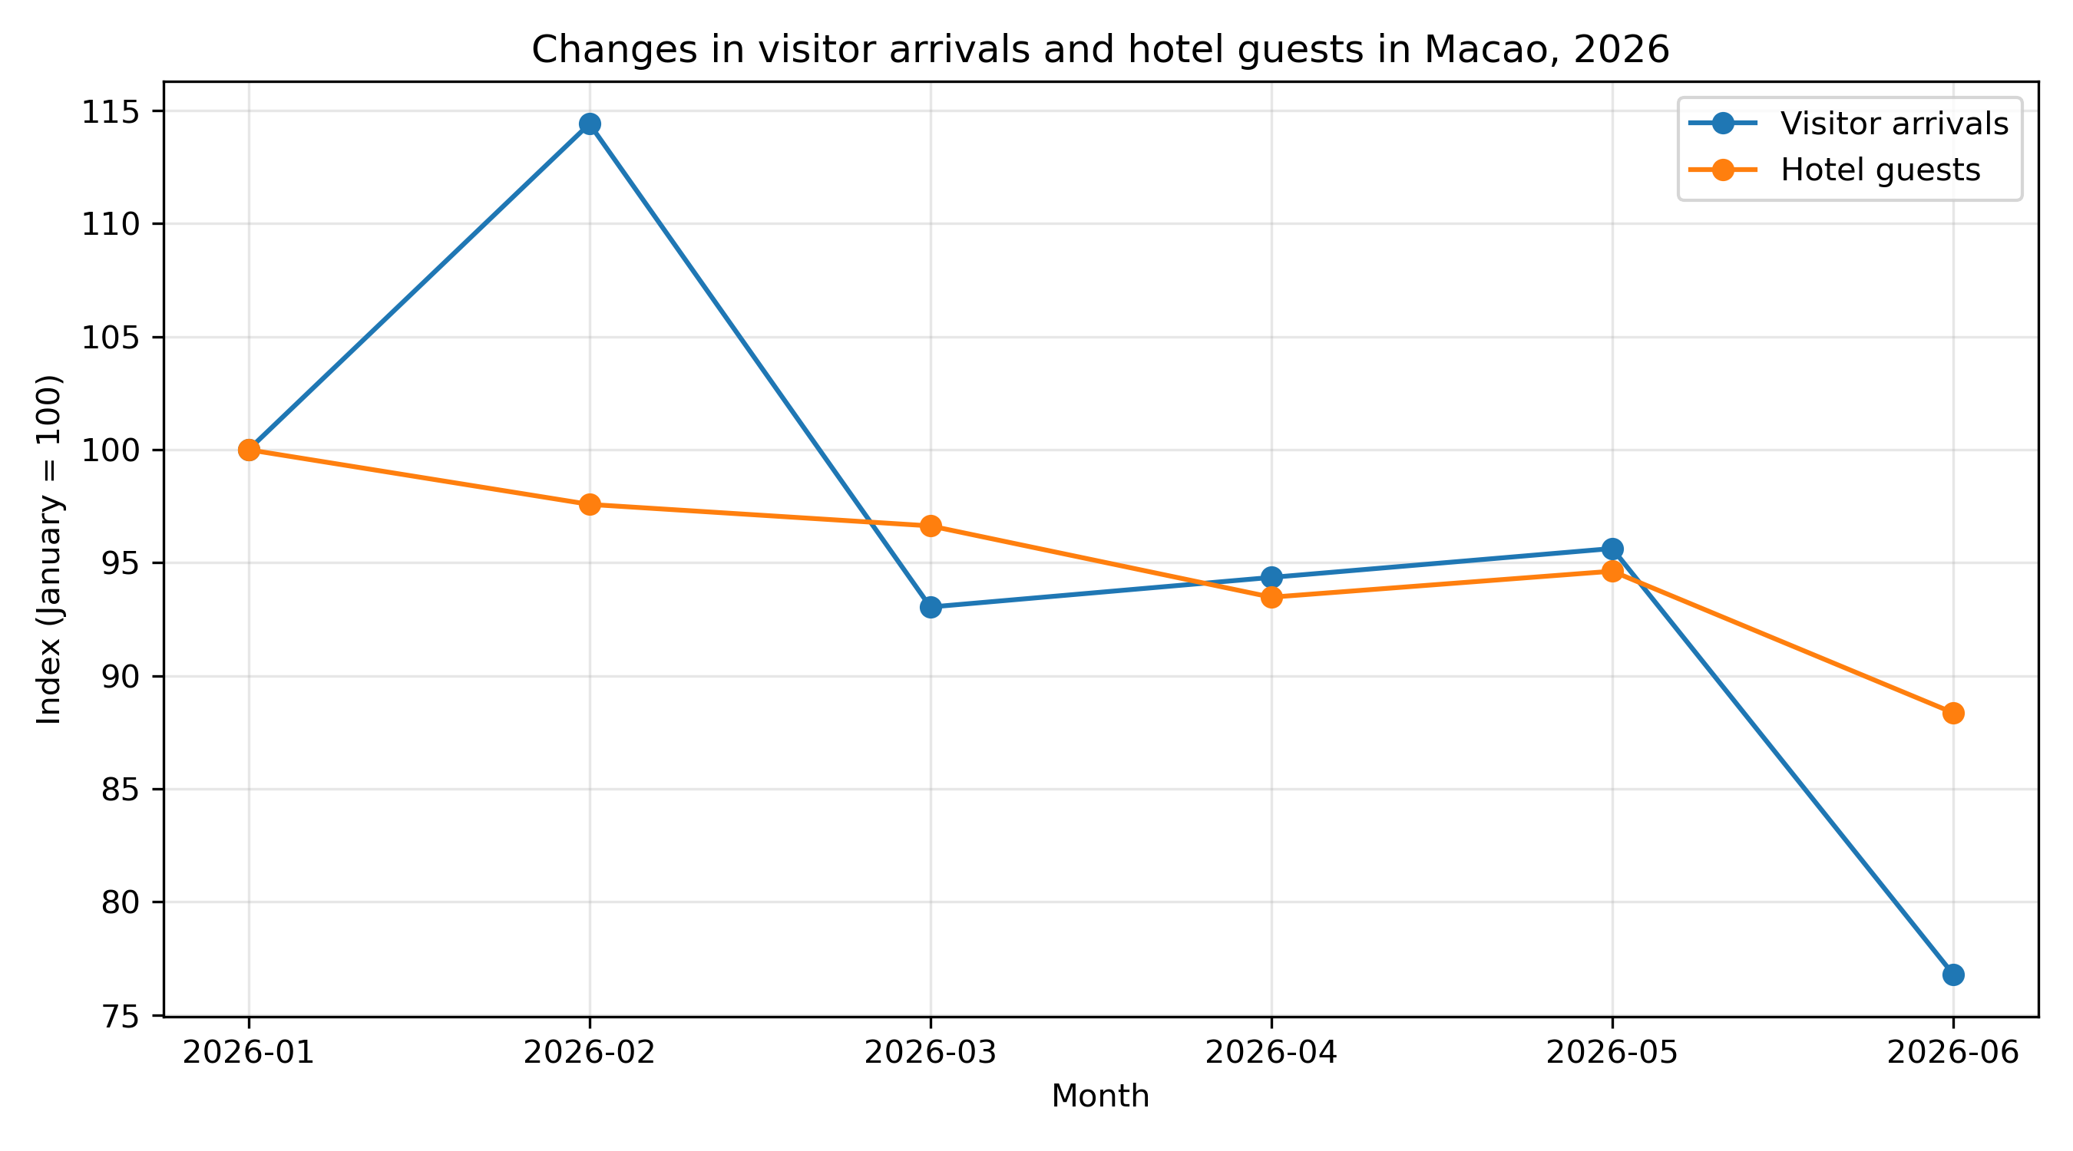
Figure 1. Monthly changes relative to January 2026. Source: DSEC snapshot retrieved on 20 September 2026.
The main line chart starts both series at 100 so that their relative movements can be compared on one scale. Visitor arrivals rise in February and April compared with the previous month, while hotel guests fall. Both series fall from February to March, rise from April to May and fall from May to June. The chart therefore shows that the two indicators do not always move together.
The initial Pearson correlation is approximately 0.79, showing a positive relationship across these six months. This supports a general association within this sample, but it does not mean that every monthly movement agrees. The short period and different definitions of the indicators also mean we cannot claim that visitor arrivals cause changes in hotel guests.

Deliverables and success criteria
We will provide two input CSV files, an executed Jupyter Notebook with comments and outputs, the main visualization, two supporting charts and a short written interpretation. The original source downloads and source notes will be kept with the files. Python 3, pandas, matplotlib and seaborn are sufficient for this work.
A successful project will use the correct six months, keep the units and sources clear, show readable charts and explain the results without making unsupported causal claims. The proposal and the notebook will use the same methods.

Collaboration
ZUO ZIYI will be the Project Coordinator, organise the source files, check the data and prepare the first line chart. WANG TINGYUE will be the Project Scribe and Project Liaison, record the analysis steps, prepare the correlation analysis and draft the interpretation. If clarification is needed, the liaison will contact the teacher. Both members will act as Project Progress Trackers, check the outputs and review the final submission.
We will keep one shared notebook, agree who is editing before making changes and discuss progress at least once a week while the project is active. Both members must understand the code and approve the interpretation.

Data references
DSEC visitor arrivals dataset
https://data.gov.mo/Detail?id=3546225a-2a34-4645-b01e-6752aed03993
DSEC guests of hotel establishments dataset
https://data.gov.mo/Detail?id=00eae9c4-a51d-4fa2-bd36-7e2db18374a8
Database endpoints and original JSON files are recorded in sources/README.txt. The notebook uses the prepared monthly CSV files so that the analysis can be reproduced without an internet connection.

