ARTIFICIAL INTELLIGENCE LABORATORY
Lab Assignment 5 : "Clustering with Gaussian Mixture EM and K-means"
Name | Shreetej Meshram
ID | 202352333

1. Aim
The aim is to cluster an unlabeled two-dimensional point set with a Gaussian mixture model trained by Expectation Maximization, and to compare that clustering with K-means on the same points. The data are three Gaussian clusters with different means and different standard deviations, 150 points in each cluster. The mixture uses diagonal covariance matrices, so each cluster may be stretched along x or along y, but not rotated. The comparison is used to show where the two methods disagree, and why the shape and the variance of a cluster cause that disagreement.

2. Question Discussion

2.1 The data
Each cluster is drawn independently from a normal distribution. The first is compact and nearly round. The second is wide along x and thin along y. The third is thin along x and tall along y. Because the covariance is diagonal, the level curves of each density are axis-aligned ellipses. Table 1 is the generator. The seed is 7, so the same 450 points are used for every figure in this report. After the points are drawn they are shuffled, and the true labels are kept only for the plots and the accuracy check. Both algorithms see the coordinates alone.

2.2 GMM-EM with a diagonal covariance
A Gaussian mixture says each point was produced by first picking a cluster with probability pi_k and then drawing from that cluster's Gaussian. With a diagonal covariance the density of cluster k at a point x is the product of two independent one-dimensional normals, one for each coordinate. The hidden variable is the cluster index. EM treats it as a fractional count.
Initialization picks three distinct data points as the means, sets every mixing weight to 1/3, and sets every cluster's variance vector to the variance of the whole cloud. The E-step computes the responsibility of each cluster for each point: the normalized product of the weight and the Gaussian density. The M-step updates the weight to the average responsibility, the mean to the responsibility-weighted average of the points, and each diagonal variance to the weighted mean squared deviation. The loop stops when the change in log-likelihood falls below 1e-5, or after 80 iterations. Eight random starts are run and the start with the highest final log-likelihood is kept, because EM can stop in a poor local maximum.

2.3 K-means, and why it is a different model
K-means alternates two steps as well. Each point is given to the nearest center under Euclidean distance, then each center is moved to the mean of its points. Fifteen random starts are used and the run with the smallest sum of squared distances is kept. Euclidean distance treats every direction the same and does not have a per-cluster variance. The decision boundary between two centers is the perpendicular bisector of the segment that joins them. A Gaussian with a large variance along x will still claim a point that sits far to the side of its mean, because that deviation is cheap under the Mahalanobis distance (x - mu)^2 / sigma^2. K-means will give that same point to whichever center is closer in ordinary distance, often the compact cluster. That is the disagreement this lab is built to show.

3. Code
gmm.py is the mixture. kmeans.py is Lloyd's algorithm. experiment.py draws the data, fits both models, aligns the arbitrary cluster indices to the true labels, and writes the figures. The snippets are the steps the assignment asks for: initialization, the E-step, the M-step, the convergence test, and the K-means update.

3.1 Initialization, E-step, M-step, convergence
Snippet 1 - gmm.py, one EM run
def _one_run(self, X, rng):
n, d = X.shape
k = self.n_components
means = X[rng.choice(n, k, replace=False)].copy()
var = np.tile(np.var(X, axis=0), (k, 1))
weights = np.full(k, 1.0 / k)
history = []
for _ in range(self.max_iter):
# E-step
log_joint = np.column_stack([
np.log(weights[j] + 1e-300) + log_gaussian_diag(X, means[j], var[j])
for j in range(k)
])
m = log_joint.max(axis=1, keepdims=True)
resp = np.exp(log_joint - m)
resp /= resp.sum(axis=1, keepdims=True)
ll = float(np.sum(m.ravel() + np.log(np.exp(log_joint - m).sum(axis=1))))
history.append(ll)
# M-step
nk = resp.sum(axis=0)
weights = nk / n
means = (resp.T @ X) / np.maximum(nk[:, None], 1e-12)
for j in range(k):
diff = X - means[j]
var[j] = (resp[:, j][:, None] * diff * diff).sum(axis=0) / max(nk[j], 1e-12)
var = np.maximum(var, 1e-8)
if len(history) > 1 and abs(history[-1] - history[-2]) < self.tol:
break
log_gaussian_diag evaluates the diagonal normal in the log domain, so a very small density does not underflow to zero before the clusters are compared. Subtracting the row maximum before the exponential is the stable way to turn those logs into responsibilities. The convergence test is the absolute change in the observed-data log-likelihood. Variances are floored at 1e-8 so a cluster cannot collapse onto a single point and make the density infinite.

3.2 K-means
Snippet 2 - kmeans.py, assignment and center update
labels = np.zeros(n, dtype=int)
for _step in range(max_iter):
dist = ((X[:, None, :] - centers[None, :, :]) ** 2).sum(axis=2)
new_labels = dist.argmin(axis=1)
new_centers = centers.copy()
for j in range(k):
members = X[new_labels == j]
if len(members):
new_centers[j] = members.mean(axis=0)
labels = new_labels
if np.allclose(new_centers, centers):
centers = new_centers
break
centers = new_centers
inertia = float(((X - centers[labels]) ** 2).sum())
if best is None or inertia < best["inertia"]:
best = {"labels": labels.copy(), "centers": centers.copy(), "inertia": inertia}
return best
The squared Euclidean distance is used only to choose the nearest center. The new center of a cluster is the coordinate-wise mean of the points assigned to it. If a start produces an empty cluster, that center is left where it was. The inertia of a finished run is the sum of squared distances to the assigned centers, and the smallest inertia across starts is the K-means solution reported here.

4. Results

4.1 True clusters and the unlabeled cloud
Figure 1 shows the same 450 points twice. On the left they are coloured by the cluster that generated them. On the right the labels are hidden. The wide cluster stretches across the lower right. The tall cluster stretches up the left side. The compact cluster sits near the origin, in the corner where those two arms would meet if they were longer. That corner is where a round distance and an elliptical density will not agree.
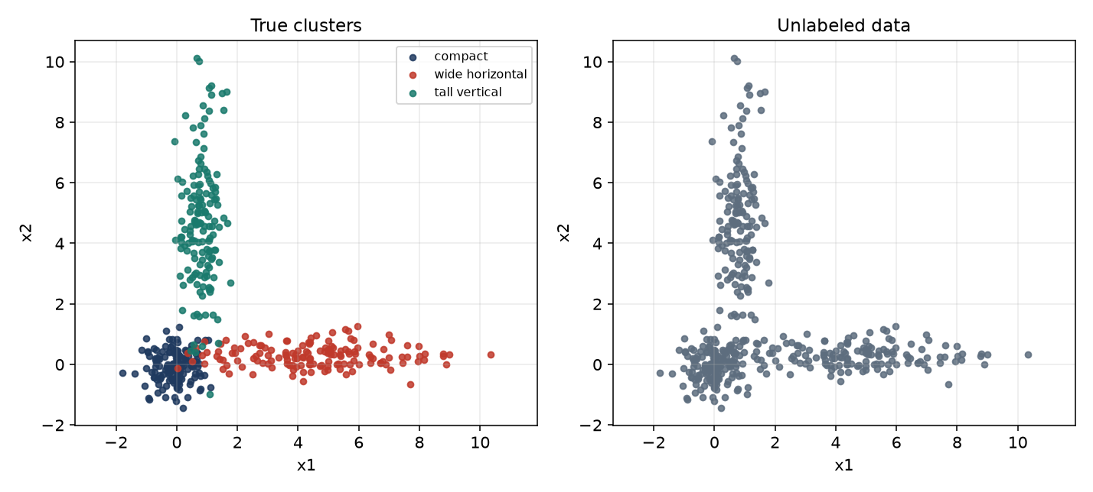
Figure 1. True clusters (left) and the unlabeled dataset given to both algorithms (right).
Cluster | Mean (x1, x2) | Std (x1, x2) | Points
compact | (0.00, 0.00) | (0.55, 0.55) | 150
wide horizontal | (4.50, 0.40) | (2.30, 0.38) | 150
tall vertical | (0.80, 4.80) | (0.38, 2.10) | 150
Table 1. Generating distributions. Seed 7. Covariances are diagonal.

4.2 Fitted mixture and the log-likelihood
The winning EM run used 23 iterations. The log-likelihood of the 450 points moved from -2078.61 after the first E-step to -1436.04 at convergence. Figure 3 is that curve: it rises and then flattens, which is what the convergence test is waiting for. Figure 2 shows the hard assignments (each point given to its largest responsibility) together with the 1-standard-deviation and 2-standard-deviation ellipses of the fitted diagonal Gaussians. The ellipses recover the shape of the generator. Table 2 puts the fitted parameters next to the values that were used to draw the data.
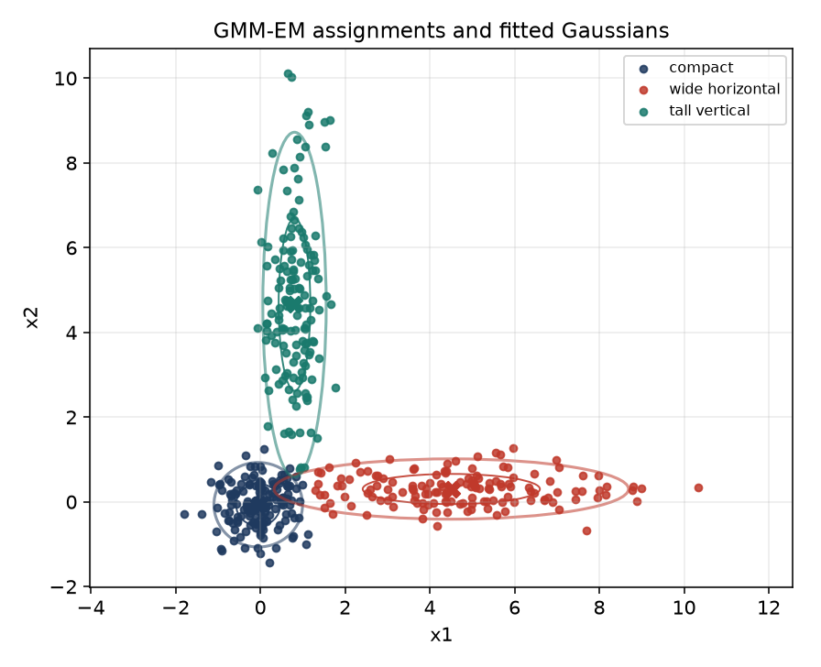
Figure 2. GMM-EM hard assignments. Ellipses are the fitted 1-sigma and 2-sigma contours. Crosses are the fitted means.
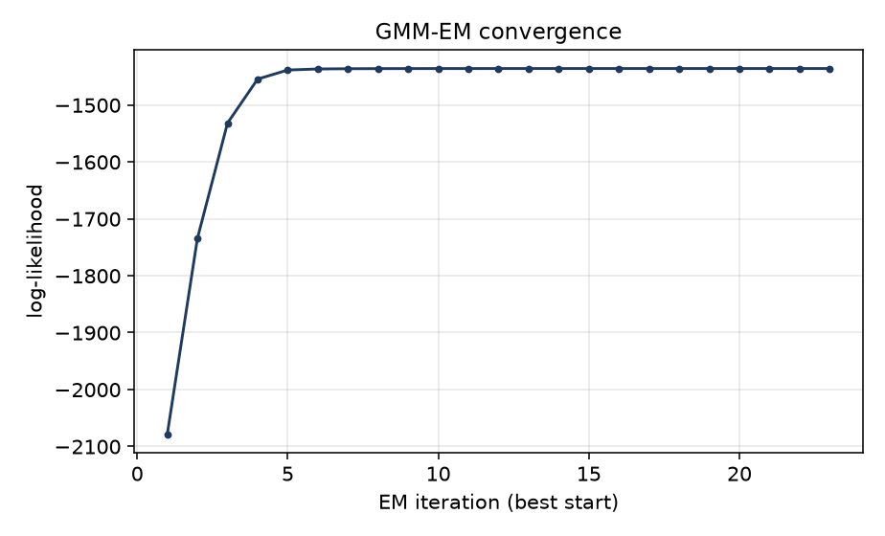
Figure 3. Observed-data log-likelihood of the best EM start.
Cluster | True mean | Fitted mean | True std | Fitted std
compact | (0.00, 0.00) | (-0.05, -0.07) | (0.55, 0.55) | (0.52, 0.50)
wide horizontal | (4.50, 0.40) | (4.51, 0.30) | (2.30, 0.38) | (2.09, 0.36)
tall vertical | (0.80, 4.80) | (0.81, 4.65) | (0.38, 2.10) | (0.37, 2.03)
Table 2. True parameters and the EM estimate. Component indices are aligned to the true labels.
After alignment, the hard GMM labeling matches the true cluster on 96.4% of the points. The fitted standard deviations stay close to the generator: the wide cluster is still wide in x (fitted std 2.09 against true 2.30) and the tall cluster is still tall in y (fitted std 2.03 against true 2.10). The mixing weights are 0.33, 0.33 and 0.33, close to the equal 1/3 that was used to draw the sample.

4.3 K-means on the same points
Figure 4 is the K-means partition. The crosses are the three centers. The inertia of the chosen start is 943.8. Matched against the true labels, K-means is correct on 87.8% of the points, against 96.4% for the mixture. The missing points are not scattered at random. They lie on the long arms.
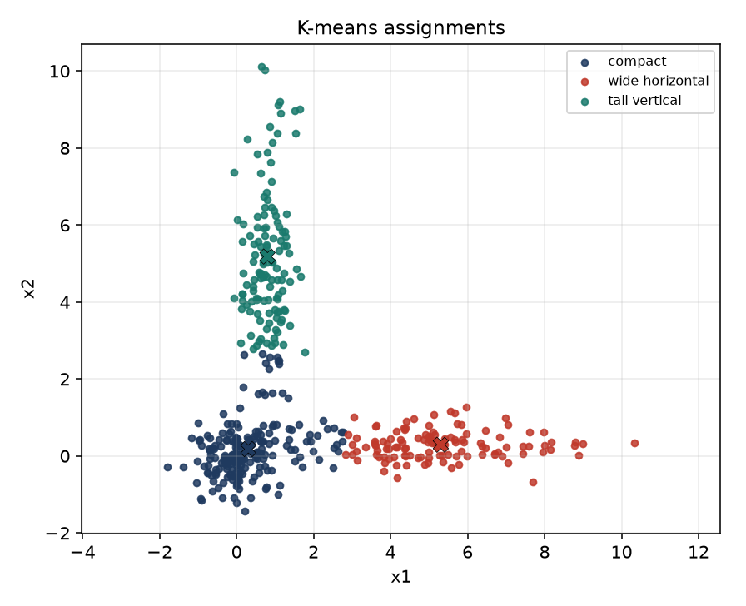
Figure 4. K-means assignments on the unlabeled data. Crosses are the learned centers.

4.4 Where the two assignments differ
After both labelings are aligned to the true clusters, they disagree on 45 of the 450 points. Figure 5 marks those points in the colour of the cluster that actually generated them, and leaves the agreeing points grey. Table 3 counts the disagreements inside each true cluster. Almost all of them belong to the two elongated clusters. The compact cluster contributes only 2 points.
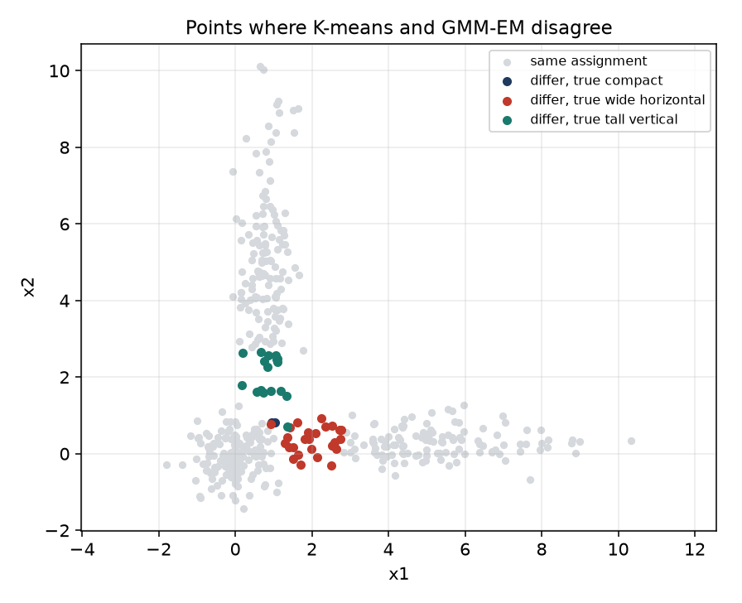
Figure 5. Points whose K-means label and GMM-EM label differ. Colour is the true cluster.
True cluster | Points | K-means differs from GMM
compact | 150 | 2
wide horizontal | 150 | 26
tall vertical | 150 | 17
total | 450 | 45
Table 3. Disagreements by the cluster that generated the point.
The reason is the shape. A point on the far left of the wide cluster can be closer, in Euclidean distance, to the compact center near the origin than to the center of the wide cluster. K-means therefore assigns it to the compact cluster. The mixture does not. Its fitted standard deviation along x for that cluster is about 2.09, so a large horizontal deviation is still likely under that Gaussian, while the same deviation is unlikely under the compact Gaussian, whose standard deviation is about 0.52 in both directions. The same thing happens on the vertical arm: a point high above the tall cluster is far from every center in raw distance, but it is cheap for the tall Gaussian because that Gaussian's variance along y is large. K-means has no variance parameter, so it cannot represent that stretch. It cuts the cloud with straight bisectors and clips the tails.
The two methods agree on the dense cores, where a point is close to its own mean in every direction. They separate exactly where the clusters stop being round. That is the content of Table 3: 26 disagreements on the wide cluster, 17 on the tall cluster, and 2 on the compact cluster.

5. Result
Three two-dimensional Gaussian clusters were drawn, 150 points each, with different means and different axis-aligned standard deviations. GMM-EM with diagonal covariances recovered those shapes: the log-likelihood rose from -2078.61 to -1436.04 in 23 iterations, and the hard labeling matched the true clusters on 96.4% of the points. K-means on the same unlabeled set matched the truth on 87.8%. The two labelings differ on 45 points, and 43 of those points belong to the two elongated clusters. K-means fails there because Euclidean distance ignores variance. The mixture keeps those tails because a diagonal covariance charges a deviation only relative to that cluster's own standard deviation.

5.1 Conclusion
EM is the right fit for a Gaussian mixture because the cluster index is hidden: the E-step estimates it, and the M-step updates the weight, the mean and the diagonal variance. K-means is the special case in which every cluster is forced to be spherical and of equal spread, and the assignment is hard at every step. On this sample the cores of the three clusters look the same to both methods. The arms do not. The plots and Table 3 are the evidence: the disagreements sit on the high-variance axes, which is where a diagonal Gaussian and a Euclidean center stop describing the same set of points

