
Application Penetration Test
<Engagement Name>

This report has been produced by <Vendor> for

DSG Adversarial Testing
KPMG US

PPA - <PPA>
PTI - <PTI>
RP - <RP>

<Type of Test, Initial/Retest/etc.>
<MONTH DD, YYYY>

This report is to assist with vulnerability remediation activities. This report does not carry an endorsement from the KPMG US Adversarial Testing Team.

This report is KPMG CONFIDENTIAL and for KPMG INTERNAL USE ONLY and its content cannot be shared or distributed in any form with a third-party client or vendor without initiating the client inquiry process.

Contents
Executive Summary 1
Background and Scope 1
Summary of Findings 1
Assessment Details 2
Detailed Findings 3
Appendix 8
Risk Rating Criteria 9
Terminology 10
Methodology 11
DSG Disclaimer Notice 12

Assessment Overview
Timeline
Assessment Start Date | <MM/DD/YYYY>
Assessment Completion Date | <MM/DD/YYYY>
Report Completion | <MM/DD/YYYY>
Team
Name | Role | Email
<First Last> | <Role, e.g. Tester @ Vendor> | <email>
<First Last> | <Role, e.g. Tester @ Vendor> | <email>
<First Last> | <Role, e.g. Tester @ Vendor> | <email>
<First Last> | <Role, e.g. Tester @ Vendor> | <email>
Report History
Name | Company | Date | Description
<First Last> | <Vendor> | <MM/DD/YYYY> | <Initial Draft>
<First Last> | <Vendor> | <MM/DD/YYYY> | <Revisions>
<First Last> | <Vendor> | <MM/DD/YYYY> | <Revisions>
<First Last> | <Vendor> | <MM/DD/YYYY> | <Peer Review>
<First Last> | <Vendor> | <MM/DD/YYYY> | <Final Review>

Executive Summary

Background and Scope
As part of the Digital Security Group’s (DSG) Adversarial Testing Program, <vendor> conducted a <dynamic automated or manual> vulnerability assessment and penetration test of the <application name> application.
The <vendor> team performed time-boxed security testing using a hybrid model of manual testing and automated scanning. For its automated analysis, <vendor> leveraged industry-standard tools, including HCL AppScan and other open-source testing software. The purpose of this engagement was to identify potential vulnerabilities within the application. The manual assessment complemented the automated scans, covering key areas such as information gathering, configuration management, authentication, authorization, session management, and input validation to identify security issues that could affect the application.
The <vendor> team identified a total of <number> findings (from both automated and manual testing), which were categorized across various severity levels. During the automated scan, the tools analyzed <number> links and generated <number> initial findings. Of these, <number> were validated and reported, <number> were deemed Informational, and the rest were confirmed as false positives.

Summary of Findings
During this assessment, <word number> (<#>) findings across all phases of testing were identified. Each finding has been classified into categories of Very High, High, Medium, Low, and Informational (<#> Very High, <#> High, <#> Medium, <#> Low, <#> Informational) based on the risk level.
The table below details the findings discovered during the assessment. Each finding has been assigned a risk rating based on its potential impact to the firm and the likelihood of exploitation. These ratings provide a baseline for prioritization but should be evaluated within the broader context of the organization's security posture and existing compensating controls. The results of this assessment represent a point-in-time analysis of the application's security.

Assessment Details
In addition to the findings summarized above, several assessment parameters provide context for the scope and configuration of the test. These details outline the environment, roles, and conditions under which the application was evaluated and should be considered when reviewing the overall results. The table below captures the key inputs and constraints of the assessment.

Limitations
<N/A, Details, etc.>

Additional Notes
<N/A, Details, etc.>

Detailed Findings
Finding 1# Insecure Direct Object Reference – CalcTransactions Endpoint
Very High
Dependency: Application
Status: Open
Description:
The /gettaxcalcbac/CalcTransactions endpoint is vulnerable to Insecure Direct Object Reference (IDOR). Authenticated users can access arbitrary transaction records and calculation data without proper authentication checks by manipulating the ‘id’ parameter. An attacker with valid session credentials can enumerate numeric client IDs and retrieve sensitive data belonging to other organizations. The application validates user authentication (via TC-BAC-DEV cookie) but fails to implement authorization checks that verify users have permission to access requested resources.
Affected Systems & Locations:
This is a multi-endpoint vulnerability affecting at least three critical endpoints:

- /gettaxcalcbac/ClientTaxLogic
- /gettaxcalcbac/ClientSelect/ViewClient
- /gettaxcalcbac/CalcTransactions

During testing, user with clientId=98 was able to successfully access sensitive data for clientId=30, clientId= 741 and multiple other client IDs by simply changing the numeric parameter value. The application responded with HTTP 200 and returned full page content with complete transaction records, tax configurations and client information without any permission denial.

This vulnerability represents a complete breakdown of multi-tenant data isolation and exposes: -

- Tax jurisdiction selections and configurations.
- Award type and plan code settings.
- Client transaction records and calculation results.
- Compensation and equity award data
- Advanced variable defaults
- Exchange rate configurations
- Client-specific business intelligence.

The vulnerability is systematic and fundamental to the application’s authorization architecture , not isolated to individual endpoints.
Reproduction Steps:

Step 1: Authenticate to the application using DP_AwardViewer account credentials
- Open browser and navigate to https://qa.gmsgetb.kpmglinkgo.com/gettaxcalcbac/Home
- Log in with DP_AwardViewer account valid credentials
- Obtain valid TC-BAC-DEV session cookie from Burp Suite HTTP history
- Cookie value: TC-BAC-DEV= r2nimttask4ajt4vlshlqcs3
- Note: Your actual clientId is 98
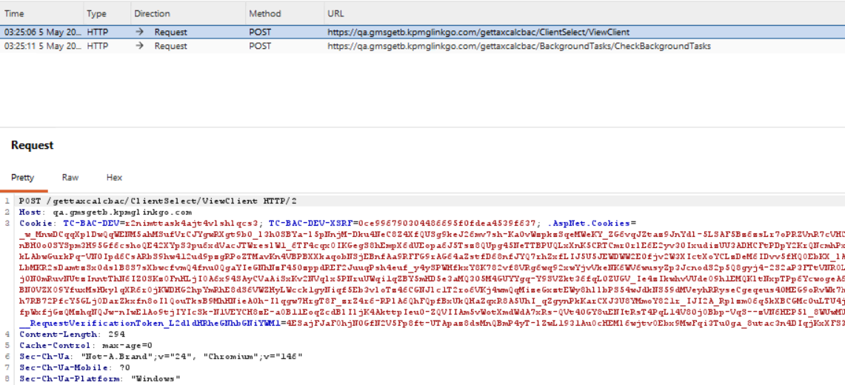
Step 2:
Test Endpoint 1 - ClientTaxLogic - Accessing own data. Execute: curl -v -b "TC-BAC-DEV= r2nimttask4ajt4vlshlqcs3""https://qa.gmsgetb.kpmglinkgo.com/gettaxcalcbac/ClientTaxLogic?id=98”. Expected: HTTP 200 (accessing your own data - this is correct)
- Verify: Page displays tax logic configuration for your client
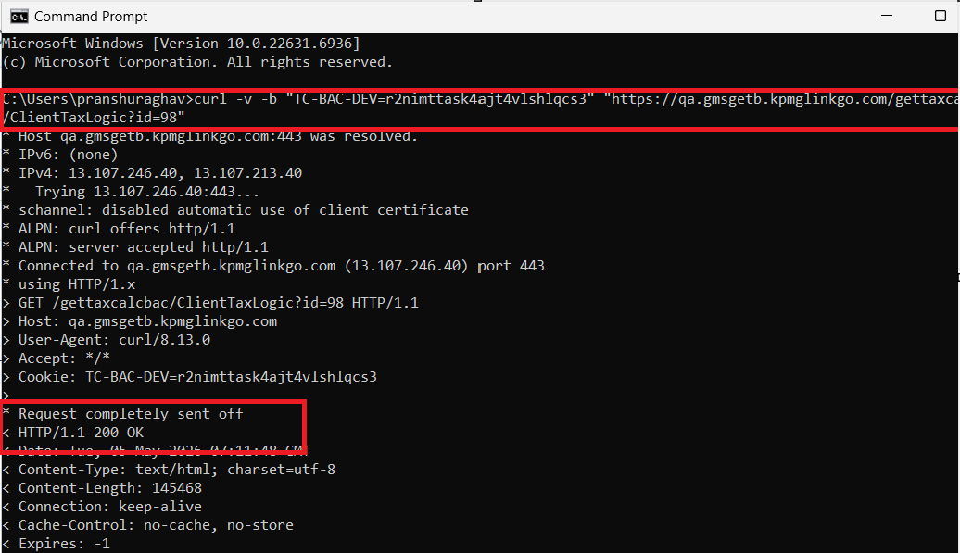
Step 3: Test Endpoint 1 - ClientTaxLogic - Accessing other user's data (EXPLOIT)
- Execute: curl -v -b "TC-BAC-DEV= r2nimttask4ajt4vlshlqcs3" "https://qa.gmsgetb.kpmglinkgo.com/gettaxcalcbac/ClientTaxLogic?id=30"
- Note: Changed id parameter from 98 to 30 (DP_ClientAdministrator account clientId)
- Observe: HTTP 200 response returned (VULNERABLE - should be 403)
- Observe: Full page content with clientId=30 tax logic displayed
- Observe: No authorization check, no access denial
- FINDING: Successfully accessed DP_ClientAdministrator account data with your credentials
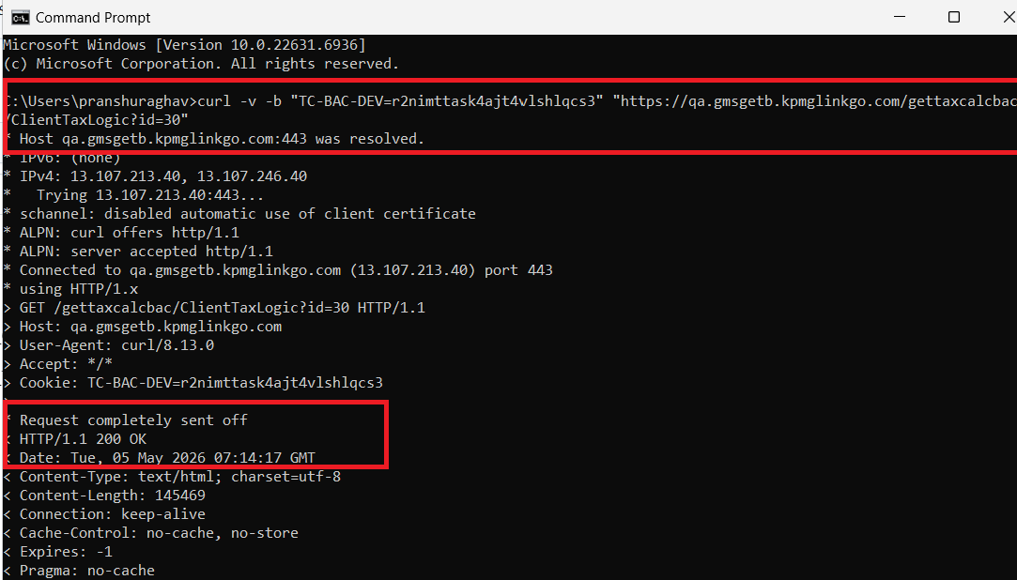
Step 4: Test Endpoint 3 - CalcTransactions - Accessing other user's data (EXPLOIT)
- Execute: curl -v -b "TC-BAC-DEV= r2nimttask4ajt4vlshlqcs3" "https://qa.gmsgetb.kpmglinkgo.com/gettaxcalcbac/CalcTransactions?id=30"
- Observe: HTTP 200 response returned (VULNERABLE)
- Observe: Full transaction records and calculations for clientId=30 displayed
- FINDING: Successfully accessed another client's transaction data
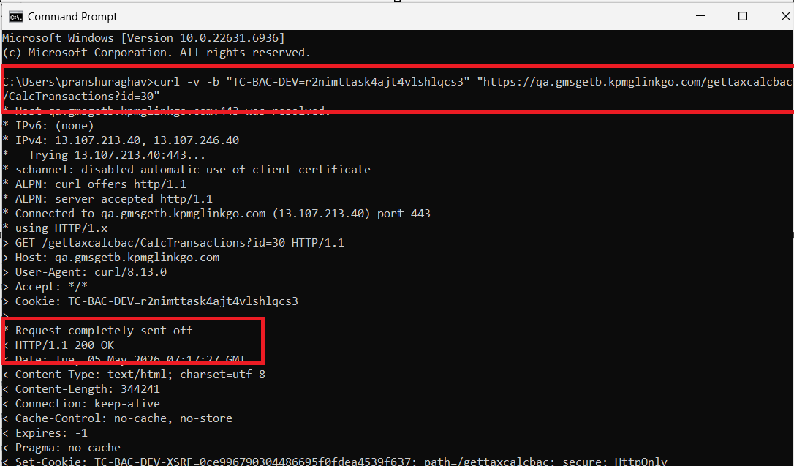
Step 6: Enumerate multiple client IDs (proof of systematic vulnerability)
- Execute: curl -v -b "TC-BAC-DEV= r2nimttask4ajt4vlshlqcs3" https://qa.gmsgetb.kpmglinkgo.com/gettaxcalcbac/ClientTaxLogic?id=1
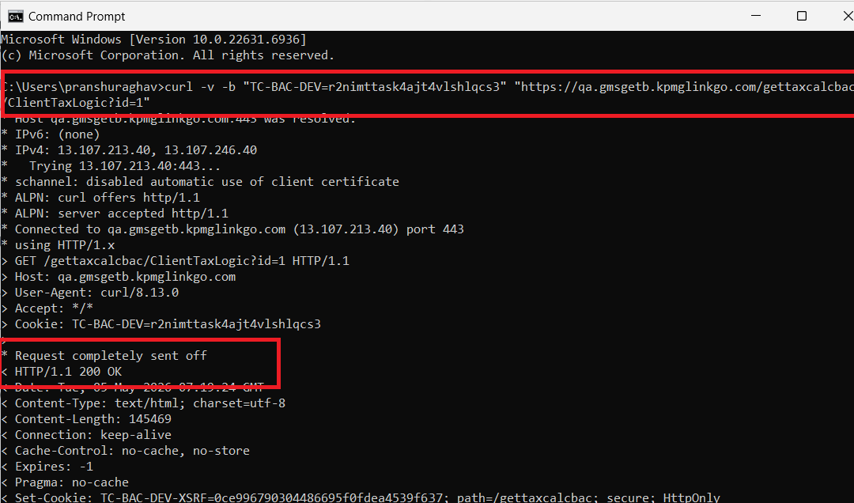
- Execute: curl -v -b "TC-BAC-DEV= r2nimttask4ajt4vlshlqcs3" https://qa.gmsgetb.kpmglinkgo.com/gettaxcalcbac/ClientTaxLogic?id=50
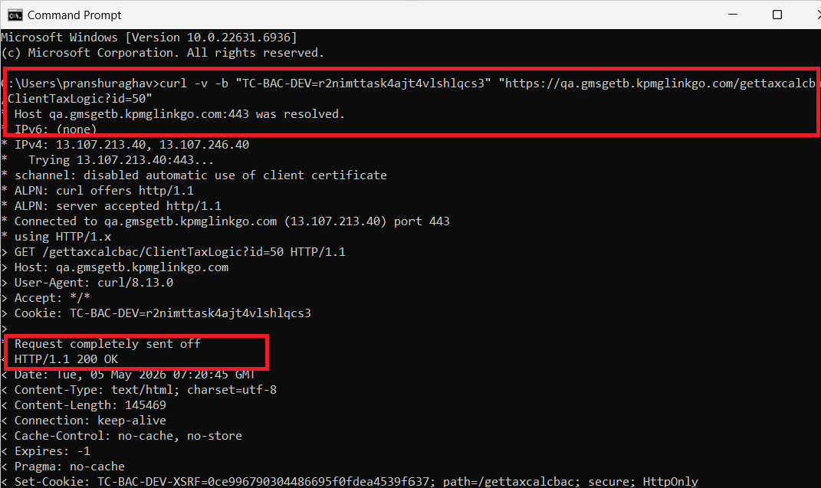
- Execute: curl -v -b "TC-BAC-DEV= r2nimttask4ajt4vlshlqcs3" https://qa.gmsgetb.kpmglinkgo.com/gettaxcalcbac/ClientTaxLogic?id=100
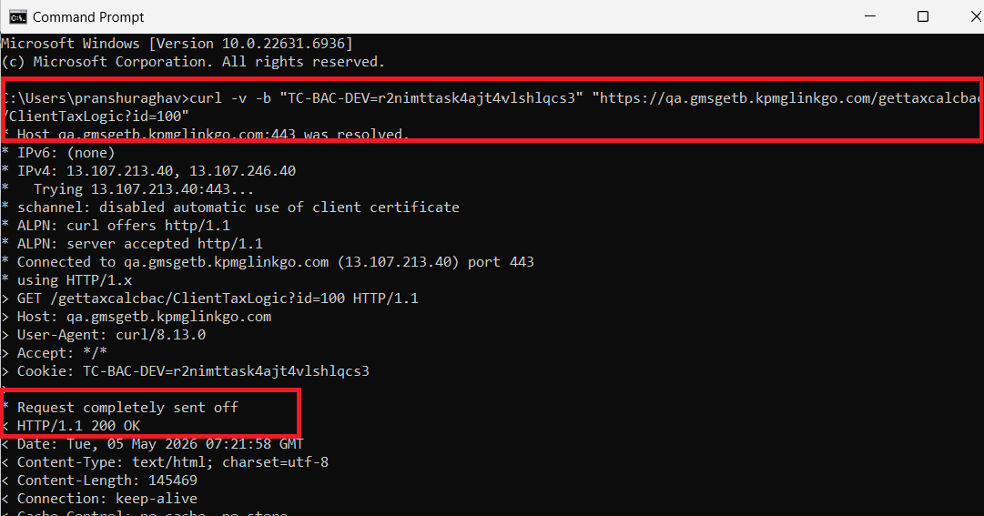
- Execute: curl -v -b "TC-BAC-DEV= r2nimttask4ajt4vlshlqcs3" https://qa.gmsgetb.kpmglinkgo.com/gettaxcalcbac/ClientTaxLogic?id=741
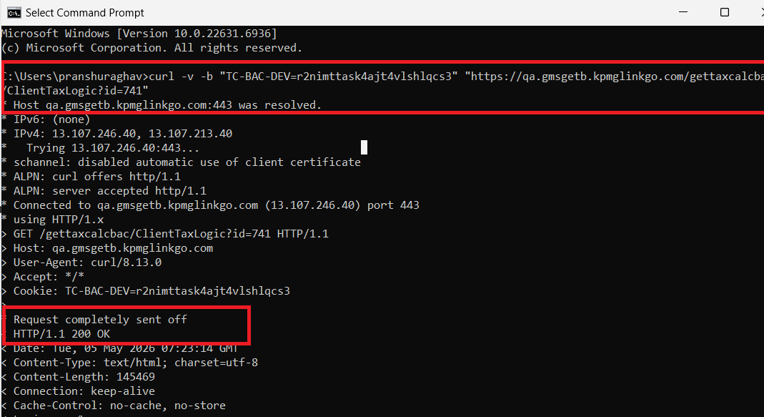
- Result: ALL requests return HTTP 200 with complete data for each client
- Finding: Systematic vulnerability - can enumerate and access ANY numeric client ID
Remediation:
- Implement Authorization Checks on All Vulnerable Endpoints.
- Create User-Client Mapping in Database.
- Implement Authorization Helper Method
- Add Audit Logging
- Replace Numeric IDs with UUID References (Long-term Fix)
- Implement Input Whitelist Validation
- Add Rate Limiting
Closing/Downgrading Justification:

Finding 2# Injection Vulnerability – Blind LDAP Injection
High
Dependency: Application
Status: Open
Description:
The application is vulnerable to Blind LDAP Injection, arising from improper handling of user-supplied input that is incorporated into backend LDAP queries without sufficient validation, sanitization, or parameterization.

LDAP (Lightweight Directory Access Protocol) is commonly used to interface with centralized identity stores such as Active Directory. In the current implementation, user-controlled parameters are dynamically embedded into LDAP query filters, allowing manipulation of query logic.

The vulnerability is classified as blind, meaning that:

The application does not return direct LDAP query results
However, variations in application responses (e.g., success/failure conditions, response timing, or behavioral changes) allow attackers to infer backend data and query execution outcomes

Through crafted payloads leveraging LDAP operators (e.g., *, |, &, (, )), an attacker can:

Modify authentication conditions
Expand query scope beyond intended constraints
Bypass logical checks enforced by the application

Given that LDAP is typically integrated with enterprise identity systems, exploitation may extend beyond the application boundary and impact organizational authentication infrastructure.
Affected Systems & Locations:
This is a multi-endpoint vulnerability affecting at least three critical endpoints:

- https://qa.gmsgetb.kpmglinkgo.com/gettaxcalcbac/login/index/
- https://qa.gmsgetb.kpmglinkgo.com/gettaxcalcbac/Home/QuickSear

Authentication bypass and unauthorized access
Enumeration of directory structures and user accounts
Exposure of sensitive identity attributes
Privilege escalation within the application or connected systems

Reproduction Steps:
Appscan Report finding
Remediation:
- Implement strict allowlist-based input validation
- Use parameterized LDAP queries or secure APIs
- Escape all LDAP special characters
- Apply least privilege access to directory queries
- Monitor and log abnormal query behavior
Closing/Downgrading Justification:

Finding 3# CSP Misconfiguration & Missing Security Headers
High
Dependency: Application
Status: Open
Description:
The application demonstrates a systemic failure in enforcing browser-based security controls, primarily due to a combination of:

- Content Security Policy (CSP) Weaknesses

- Missing CSP header on critical endpoints
- Inline script execution permitted (unsafe-inline)
- Missing or incomplete directives (default-src, script-src)
- Presence of invalid or ignored directives
- Trusted Types not enforced

- Missing Cross-Origin Security Headers

- Cross-Origin-Opener-Policy (COOP)
- Cross-Origin-Embedder-Policy (COEP)
- Cross-Origin-Resource-Policy (CORP)
- Referrer-Policy

These issues collectively indicate that client-side trust boundaries are not properly enforced, resulting in a weakened browser security model.

CSP is designed to act as a primary defense mechanism against client-side attacks, particularly Cross-Site Scripting (XSS). However, the current implementation is inconsistent and ineffective across multiple application components.

Additionally, the absence of cross-origin isolation headers weakens protections against:

- Cross-origin data leakage
- Side-channel attacks (e.g., XS-Leaks)
- Unauthorized resource sharing

This represents a systemic control gap rather than isolated misconfigurations.
Affected Systems & Locations:
https://qa.gmsgetb.kpmglinkgo.com/gettaxcalcbac/javascript/target
https://qa.gmsgetb.kpmglinkgo.com/gettaxcalcbac/login/enter
https://qa.gmsgetb.kpmglinkgo.com/gettaxcalcbac/login/index
https://qa.gmsgetb.kpmglinkgo.com/gettaxcalcbac/Home/QuickSear
https://qa.gmsgetb.kpmglinkgo.com/gettaxcalcbac/
https://qa.gmsgetb.kpmglinkgo.com/gettaxcalcbac/javascript/target
https://qa.gmsgetb.kpmglinkgo.com/
https://qa.gmsgetb.kpmglinkgo.com/gettaxcalcbac/SiteException

Reproduction Steps:
Remediation:
- Cache-Control: no-store
- Pragma: no-cache
Closing/Downgrading Justification:

Finding 4 # Exposure of Internal Artifacts and Application Structure
Very High
Dependency: Application
Status: Open
Description:
The application exposes internal system artifacts and structural information, which may aid attackers in reconnaissance and attack planning.

Combined Observations:
Accessible hidden directories:
.git, .svn, .bashrc, .profile, .mysql_history
Exposure of JavaScript files containing identifiable patterns (e.g., email addresses)
Indicators of potential source code disclosure

These findings suggest that:

Development or configuration artifacts may be present in the production environment
Proper access restrictions and file management practices are not enforced

While these issues do not directly enable exploitation, they provide valuable intelligence that can:

Reduce attack complexity
Enable targeted exploitation
Reveal underlying technologies and configurations
Affected Systems & Locations:
https://qa.gmsgetb.kpmglinkgo.com/ .mysql_history/
https://qa.gmsgetb.kpmglinkgo.com/gettaxcalcbac/login/ index/
https://qa.gmsgetb.kpmglinkgo.com/gettaxcalcbac/ login/
https://qa.gmsgetb.kpmglinkgo.com/gettaxcalcbac/login/ .profile/
https://qa.gmsgetb.kpmglinkgo.com/ .profile/
https://qa.gmsgetb.kpmglinkgo.com/gettaxcalcbac/ .profile/
https://qa.gmsgetb.kpmglinkgo.com/gettaxcalcbac/login/ .sh_history/
https://qa.gmsgetb.kpmglinkgo.com/gettaxcalcbac/login/ .svn/
https://qa.gmsgetb.kpmglinkgo.com/gettaxcalcbac/ .sh_history/
https://qa.gmsgetb.kpmglinkgo.com/ .sh_history/
https://qa.gmsgetb.kpmglinkgo.com/gettaxcalcbac/ .svn/
https://qa.gmsgetb.kpmglinkgo.com/ .svn/
https://qa.gmsgetb.kpmglinkgo.com/gettaxcalcbac/login/ .bashrc/
https://qa.gmsgetb.kpmglinkgo.com/ .bashrc/
https://qa.gmsgetb.kpmglinkgo.com/gettaxcalcbac/ .bashrc/
https://qa.gmsgetb.kpmglinkgo.com/gettaxcalcbac/login/ .git/
https://qa.gmsgetb.kpmglinkgo.com/ .git/
https://qa.gmsgetb.kpmglinkgo.com/gettaxcalcbac/login/ .mysql_history/
https://qa.gmsgetb.kpmglinkgo.com/gettaxcalcbac/ .git/
https://qa.gmsgetb.kpmglinkgo.com/gettaxcalcbac/ .mysql_history/
Reproduction Steps:
Appscan
Remediation:
Remove sensitive and unnecessary files from production
Restrict access to system directories
Return generic responses (e.g., HTTP 404)
Implement secure deployment and configuration management processes
Closing/Downgrading Justification:

Appendix

Risk Rating Criteria
Overall Risk Rating Matrix
Likelihood | Impact
 | Negligible | Minor | Moderate | Significant | Severe
Very High | Low | Medium | High | High | Very High
High | Low | Medium | Medium | High | High
Medium | Low | Low | Medium | Medium | High
Low | Low | Low | Low | Medium | Medium
Very Low | Informational | Low | Low | Low | Low

Likelihood * Impact Risk Rating  Risk Rating Value  Very High 25  High 15-20  Medium 7-14  Low 1-6  Informational 1 | Risk Rating is determined by multiplying Impact * Likelihood  Examples:  Likelihood Low (2) * Impact Moderate (3) = 6 (Low)  Likelihood High (4) * Impact Moderate (3) = 12 (Medium)  Likelihood Very High (5) * Impact Severe (5) = 25 (Very High)

Impact Rating Guidance
Severe | Typically reserved for compromise (e.g. data exfiltration, ransomware) of DC3-type datasets, passwords/credentials with access to significant resources, or complete takeover of a system which has significant impacts to KPMG for lateral-based movement/attacks and disruption to the business (e.g. RP0/RP1-rated systems such as Active Directory).
Significant | Typically reserved for compromise (e.g. data exfiltration, ransomware) of DC3-type datasets, passwords/credentials with access to significant resources, or complete takeover of a system which has significant impacts to KPMG for lateral-based movement/attacks and disruption to the business.
Moderate | Typically reserved for compromise (e.g. data exfiltration, ransomware) of DC2-type datasets or partial takeover of a system which has moderate impacts to the business (e.g. RP2-rated systems such as a Business Application).
Minor | Typically reserved for compromise (e.g. data exfiltration, ransomware) of low-risk datasets such as DC1 or partial takeover of a system which has low impact of disruption to the business (e.g. RP3/4-rated systems).
Negligible | Reserved to document findings which have no material impact to KPMG or the Business.

Terminology
Depending on likelihood and impact, the findings will be assigned to one of the following risk ratings:
Very High
Very high risk findings represent a severe weakness that can be easily exploited by an adversary, leading to a direct and immediate impact on the business. This could include a full system compromise, significant data exfiltration, or a widespread denial-of-service condition. Such vulnerabilities pose the highest level of security risk.
Immediate action is required. For systems not yet in production, remediation must be completed before the "go-live" date. For production systems, remediation must be completed within five (5) days of the preliminary report date.

High
A high risk finding indicates a significant weakness that, if exploited, could result in substantial damage to business assets or reputation. Exploitation may require more specific conditions or attacker skill than a critical finding but still presents a high degree of security risk.
For systems not yet in production, remediation must be completed before the "go-live" date. For production systems, remediation must be completed within thirty (30) days of the preliminary report date.

Medium
A medium risk finding points to a moderate security weakness. While it may not lead to a full system compromise on its own, it could be leveraged by an attacker in conjunction with other vulnerabilities to achieve a greater impact or could result in minor data leakage or service degradation.
For systems not yet in production, remediation should be completed before the "go-live" date. For production systems, remediation must be completed within sixty (60) days of the preliminary report date.

Low
A low risk finding identifies a minor security weakness that has a limited potential for impact. Exploiting such a flaw is often difficult or would result in minimal damage. These findings typically represent a minor security risk but should be addressed to maintain a strong security posture.
Remediation for low-risk findings is recommended to be included in the next scheduled product update or maintenance cycle.

Informational
An informational finding is an observation that does not represent an immediately exploitable vulnerability but highlights a deviation from security best practices, a configuration weakness, or unusual system behavior that could pose a risk in the future.
No formal Remediation SLA is defined for informational findings. These are provided for consideration to improve overall security hygiene.

Methodology
Our security assessment follows a structured methodology designed to provide comprehensive and rigorous testing, from initial discovery to final reporting.

Reconnaissance and Discovery
The engagement begins with defining the external attack surface. We conduct reconnaissance to map the client's internet-facing infrastructure, using a combination of public sources and specialized tools. The objective is to identify all associated IP blocks, hostnames, domains, and subdomains. This process reveals the full scope of potential targets and informs the subsequent stages of the assessment.

Threat Modeling and Analysis
Following discovery, each in-scope application is analyzed to create a comprehensive threat model. We map critical information flows, business logic, user roles, architectural dependencies (e.g., web servers, APIs, databases), and third-party components. This analysis allows us to identify likely threat actors, define key attack vectors, and prioritize testing efforts based on the application's unique risk profile.

Application Enumeration and Profiling
With the attack surface defined, we actively enumerate the target applications to build a detailed service and functionality profile. Using a variety of tools and manual techniques, we gather in-depth information about the application's structure, technologies, and exposed resources. This intelligence gathering is crucial for identifying specific modules, functions, and configurations that will be targeted during vulnerability testing.

Vulnerability and Security Control Analysis
This is the core testing stage where we execute a comprehensive vulnerability assessment to identify security weaknesses. Our methodology is guided by industry-standard frameworks, including the OWASP Top 10, CWE Top 25, and MITRE ATT&CK®. We employ a combination of automated scanning and rigorous manual testing to evaluate the effectiveness of existing security controls across several key categories:
- Information Gathering
- Configuration and Deployment Management
- Authentication and Authorization
- Session Management
- Input Validation and Sanitization
- Cryptography and Data Protection
This hybrid approach ensures we identify both known vulnerabilities and complex, logic-based flaws that automated tools often miss.

Exploitation and Impact Validation
This activity validates the real-world impact of vulnerabilities identified during the assessment. We perform controlled exploitation of discovered weaknesses to determine the severity and potential business impact. By simulating adversarial tactics, we demonstrate how an attacker could compromise the application, escalate privileges, or access sensitive data, providing clear evidence of the risk.

Mitigation and Remediation Strategy
Based on the findings from the engagement, we develop a comprehensive mitigation plan. This includes providing tactical recommendations for addressing each specific vulnerability, as well as strategic guidance on secure development practices to enhance the overall security posture of the application.

Reporting
The final activity involves documenting all observations, findings, and recommendations in a formal report. Each vulnerability is assigned a risk rating based on the Common Vulnerability Scoring System (CVSS v3.1) and mapped to relevant CWE identifiers. The report delivers a clear, actionable summary for stakeholders and detailed technical analysis for engineering teams.

DSG Disclaimer Notice
Cybersecurity threats are continually changing, with new vulnerabilities discovered on a daily basis, and no application can ever be 100% secure no matter how much security testing is conducted. This report cannot and does not protect against personal or business loss as the result of use of the applications or systems described. DSG offers no warranties, representations or legal certifications concerning the applications or systems it tests.

All software includes defects: nothing in this document is intended to represent or warrant that security testing was complete and without error, nor does this document represent or warrant that the application tested is suitable to task, free of other defects than reported, fully compliant with any industry standards, or fully compatible with any operating system, hardware, or other application. By using this reported information, you agree that DSG shall be held harmless in any event.

Non-Production and Production Testing Advisory
It is important for the customer to understand that the engagement testing in non-production environments such as UAT (User Acceptance Testing) or QC (Quality Control) represents what is found only in such environments. If there are inaccuracies, omissions, or changes made during or after the testing engagement; this may impact findings visibility and ultimately the accuracy of this report. It is equally important to note that UAT and QC environments should ultimately mimic the production environment. DSG pen testers, unless at the request of the customer, do not typically perform testing within a production environment for general stability and safety concerns. If production testing is a requirement by the SRM (Security Relationship Manager), please create a separate PTI (Penetration Testing Intake) form for as such and notify the DSG pen testers.

Modifications during Testing Engagements
If the customer performs any modifications or changes to the testing environment during an engagement, this may adversely impact the accuracy of the report and findings. Customers should be prepared to freeze changes where possible. If it is not possible, please notify the DSG pen testers of the intended change, time of change, and to which assets it will affect.

Scope of Findings Disclaimer
This report provides representative examples of vulnerabilities identified during the assessment. These examples should not be considered exhaustive. We recommend implementing a comprehensive, systemic remediation approach to address all potential instances of the identified issues, rather than limiting corrective actions to only the specific examples outlined in this report.

Contact us

Digital Security Group
Adversarial Testing
US-DLBPGAdversarialTestingAll@kpmg.com

