Observation: SAML Assertion Uses Correct Exclusive XML Canonicalization (exc-c14n) — Positive Finding
Result: No Vulnerability — Positive Observation | Status: Closed | Dependency: Microsoft Entra ID
Description
Testing included a review of the XML canonicalization algorithm used within SAML assertions issued by Microsoft Entra ID during the SSO authentication flow. Canonicalization in SAML refers to the process of converting an XML document to a standard form before computing its digital signature — the choice of algorithm directly determines resistance to XML Signature Wrapping (XSW) attacks.
The Burp Suite Inspector panel confirmed that the SAML assertion uses Exclusive XML Canonicalization (exc-c14n):
http://www.w3.org/2001/10/xml-exc-c14n#
This is the correct and recommended algorithm per the SAML 2.0 specification and NIST SP 800-63C. The table below explains why this matters:
Algorithm | Type | Security Assessment
xml-c14n# (Inclusive C14N) | Weak / Avoid | Includes parent namespace declarations — susceptible to XML Signature Wrapping (XSW) attacks
xml-exc-c14n# (Exclusive C14N) | ✅ Correct — Observed | Excludes unnecessary namespace context — SAML 2.0 spec recommended, XSW-resistant

The full set of cryptographic elements observed in the SAML assertion are all correctly configured:
SAML Element | Value Observed
CanonicalizationMethod | http://www.w3.org/2001/10/xml-exc-c14n#
SignatureMethod | http://www.w3.org/2001/04/xmldsig-more#rsa-sha256
Transform Algorithm | http://www.w3.org/2000/09/xmldsig#enveloped-signature
Transform Algorithm (C14N) | http://www.w3.org/2001/10/xml-exc-c14n#
DigestMethod | http://www.w3.org/2001/04/xmlenc#sha256

Why This Matters: Inclusive C14N (the weaker alternative) includes parent namespace declarations when computing the signature. An attacker can exploit this by wrapping the signed element inside a new parent with a different namespace, causing the signature to remain valid while the assertion content has been tampered with — a classic XML Signature Wrapping (XSW) attack. Exclusive C14N eliminates this attack vector by only including namespaces that are directly referenced.
Replay Testing Result: SAML replay was also tested (Finding 2) and confirmed blocked by Okta's one-time-use enforcement. Combined with the correct exc-c14n canonicalization, the SAML signature implementation is robust against both wrapping and replay attacks.
Tested Systems & Locations
https://login.microsoftonline.us/f9724c3f-5875-41b3-b99a-b6eee358ee32/saml2 (Microsoft Entra ID GovCloud SAML endpoint)
https://snyk-fedramp.okta.com/sso/saml2/ (Okta SP SAML endpoint)
Verification Steps
1. Configure Burp Suite to intercept all SSO traffic and complete a full login flow to app.snykgov.io.
2. In Burp HTTP History, locate the POST to login.microsoftonline.us returning HTTP 200 (row 37 in the screenshot).
3. Click the Response tab → Inspector panel → JSON Web Token tab.
4. In the Inspector panel on the right, locate the ds:CanonicalizationMethod element.
5. Confirm the Algorithm attribute reads: http://www.w3.org/2001/10/xml-exc-c14n# (highlighted in yellow in Figure 1).
6. Confirm SignatureMethod uses rsa-sha256 and DigestMethod uses xmlenc#sha256 — both strong algorithms.
Figure 1 — Burp Suite Inspector showing xml-exc-c14n# canonicalization algorithm (highlighted in yellow) within the SAML assertion
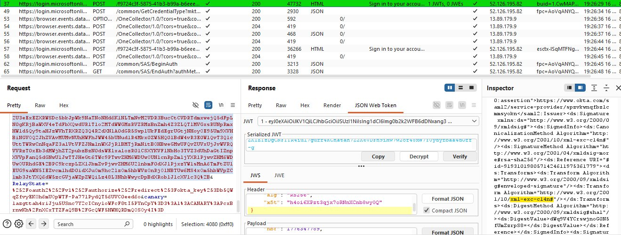
Recommendation
• No remediation required. The correct exc-c14n algorithm is in use and no change is needed.
• Include this as a positive control observation in the FedRAMP SSP — document that SAML canonicalization has been verified as exc-c14n and is resistant to XSW attacks.
• If the SAML configuration is ever changed or the IdP is migrated, re-verify the CanonicalizationMethod to ensure exc-c14n is retained.
Closing Justification
Closed — positive observation. The SAML implementation correctly uses Exclusive XML Canonicalization (exc-c14n) with RSA-SHA256 signatures and SHA-256 digest, meeting SAML 2.0 specification requirements and NIST SP 800-63C guidance. No vulnerability exists. This observation is documented to confirm that XML Signature Wrapping attack vectors were tested and found to be mitigated by the correct algorithm selection.

