Web App Technical Documentation
Symfony 5.4 LTS
Authentication & Authorizations




Table of contents
------------------------------------------------------------------------------------------------
1 – Introduction 3
1.1 – The purpose of this file 3
1.2 – Project Folder Architecture 3
2 – Authentication with Symfony 6
2.1 – What is Authentication ? 6
2.2 – Authentication Step By Step 6
2.3 – Authorizations with Symfony 6
2.4 – Configuring the Security Component 6
2.5 – How does authentication works behind the scene ? 6

1 – Introduction

1.1 – The purpose of this document
This documentation serves the only purpose of explaining the basic concepts of the project so that any developer can contribute to it. If you need more details, you can always check symfony’s official documentation. The principles covered in this file will be the following:
- Basic Symfony project architecture.
- Authentication & Authorizations in Symfony.
- Database interaction.

1.2 – Project Folder Architecture
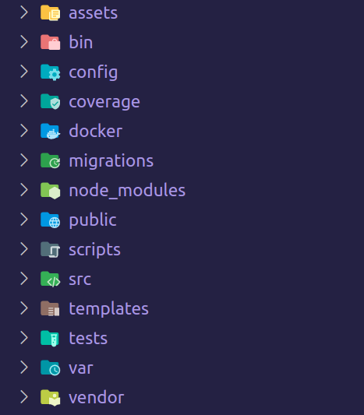

Here, we will cover every folder in the project and it’s purpose. We will also dive inside of certain directories to understand what each of their sub-folder does.

- Assets/ This folder contains all the public assets that will be required in the browser. Using Webpack Encore, we can transpile (build) our assets directly to our public/ dir. This means we can use pre-processors like Typescript or Sass, while still shipping only plain CSS and Javascript to the browser.
  - Controllers/ This folder is used by the Stimulus Javascript framework, but it is not used in this project, as twig is used to render the HTML.
  - Fonts/, Images/, /Styles As the name suggest, theses folders simply contains web assets.
- Bin/ Contains the CLI executables to interact with the project. (Symfony, PHPUnit, etc…).
- Config/ Contains all the project configuration, pretty much self-explanatory, the contained files describes the framework behavior depending on the app’s environment.
- Coverage/ Generated code testing coverage, this folder is regenerated each time you run PHPUnit.
- Docker/ Contains the project dockerfiles & custom config files.
- Migrations/ PHP files generated to run SQL Queries and update database schema to match with app’s entities. Keeping a history of all migrations is a good practice, in case you need to use an old backup of a prod database.
- node_modules/ NodeJS dependencies, theses should be downloaded when you start the project for the first time using the Makefile. You should not touch this folder unless you know what you are doing.
- Public/ The web app entrypoint, this is where all your assets will be transpiled to.
- Scripts/ Small scripts used to perform repetitive tasks without having to do it manually.
- Src/ This folder will contain all your PHP classes, divided between multiple sub-folders.
  - Controller/ Defines the method to call upon a request to a specific (or dynamic) endpoint. A controller should not contain any business logic, only use it to call the appropriate service method.
  - Entity/ Our most important classes, the ones we are going to store in database. Using Doctrine’s annotations, we can define each field in database and create our schema.
  - Fixtures/ Fake data which will be loaded in database in development environment, and before we run our tests.
  - Form/ The forms of our web app. Allow to simplify data validation & form rendering (+ caching).
  - Repository/ Allow to interact with a model (entity) more easily. There should be a repository for each entity you create (Repositories should be automatically generated when you use the Symfony CLI to create an entity).
  - Security/ The application authenticator. Allow users to stay authenticated between pages using session and passports.
  - Service/ The place where your business logic should be. You can use external services using dependency injection and follow the encapsulation principle to re-use methods.
- Templates/ This is where you are going to create your twig templates. You should have a sub-folder per controller.
- Tests/ Contains all the unit, integration, and end-to-end tests. Run them using the ‘make test’ command.
- Var/ Contains temporary files & folders.
- Vendor/ Composer dependencies installation directory. They should be downloaded when you start the project for the first time using the Makefile. You should not touch this folder unless you know what you are doing.

2 – Authentication with Symfony

2.1 – What is Authentication ?
In a web app, authentication is the way we are going to know which users each request we get comes from, and save it between multiple requests. There are mainly two ways to authenticate someone and persist it’s data in a web app. First is the Json Web Token, which will contain a generated string of characters in the cookies of the browser when making a request. The second option is the session authentication. Instead of authenticating the user from the token they sent to us, we use their PHPSESSID cookie to access the data we stored in their session.

2.2 – Authentication Step By Step
The authentication process with always be the same for all users, no matter their roles;
- User tries to access to a private resource, and gets redirected to login form.
- He then fills the form and submit it
- App Authenticator is triggered by the main firewall, and logs user into session if their credentials are valid.
- Session is then stored in Redis (In-Memory Key-Value pair database), and a PHPSESSID cookie is stored in the user’s browser.

2.3 – Authorizations with Symfony
Using Symfony, you can attribute roles to users. Theses roles can be used to allow users to access a page depending on theirs. The process of authorization is managed by the security config file. It manages the resources each role can access, using a routes and role hierarchy system.

2.4 – Configuring the Security Component
As the project grows, your security.yaml file should start to get bigger. If you ever need help about it’s configuration, don’t forget to check the Symfony docs, as they will go much deeper in the details than this file does.

2.5 – How does authentication works behind the scene ?

When a user is created from the web application (by filling a form for example) , multiple informations will be saved, including:
- The user’s username. This value is unique and two users cannot have the same one. This is the unique key used when logging in.
- The email. This value is also unique, but not used for authentication. However, this might be used in the future for a “reset password” feature.
- The password. This value will be hashed before being saved, which means the “plain text” version of the password will not be saved, while the hashed one is.
- Their role(s). As said in paragraph 2.3, a role is what gives a user the permission to perform an action.
All of theses informations will be saved in database, in the “user” table. The database is contained in a docker container, which you can access by running the following command from the project root.
scripts/container.sh <service-name> <command>

