INSY6112 Exam

Student Number: | ST10388340
Programme Code: | BCAD0701
Module Lecturer: | Zolile Ngwenya
Module Code: | INSY6112
Date of Submission: | 13-11-2025

I hereby declare that I did not plagiarise the content of this assignment and that this is my own work.
Assignment submitted via Turnitin: a(Tick the Box)

Table of Contents
1 Part 1.1 1
2 Part 1.2 1
3 Part 1.3 1
4 Reference List 2

QUESTION1
- Answered on answer sheet

QUESTION 2
- Answered on answer sheet

QUESTION 3
Q.3.1
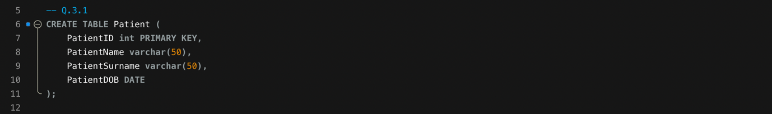
Q.3.2
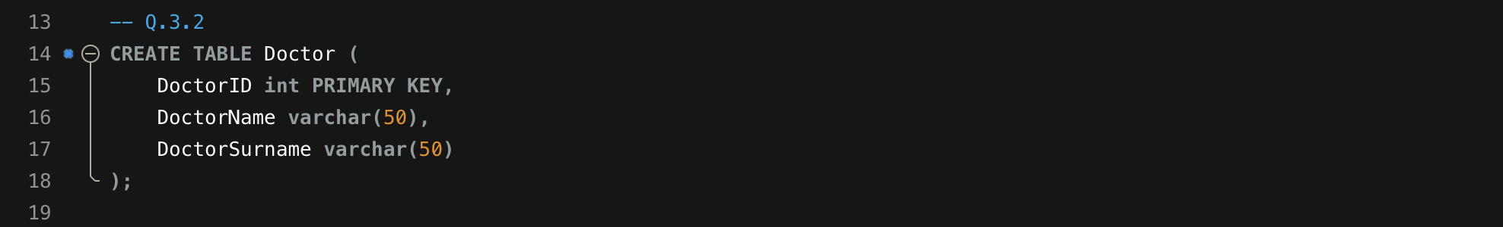
Q.3.3
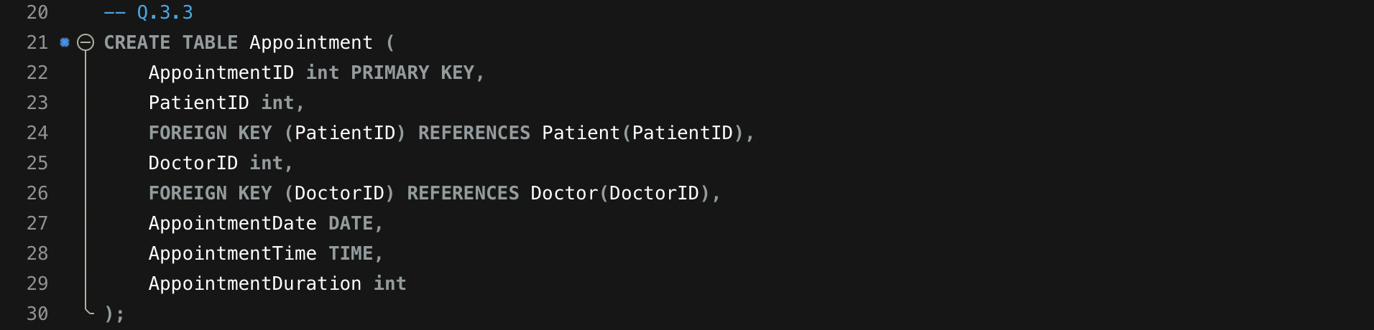

Q.3.4
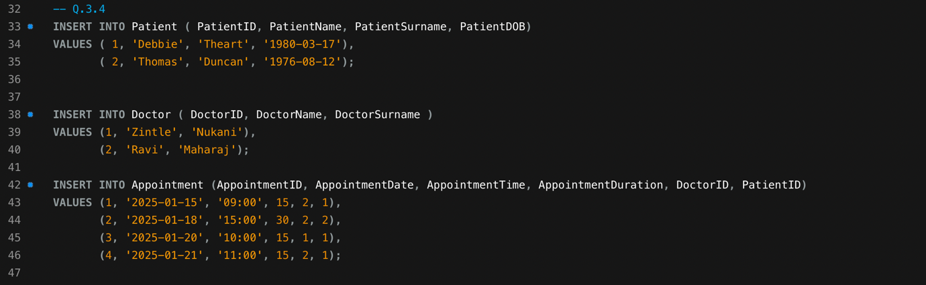
Q.3.5
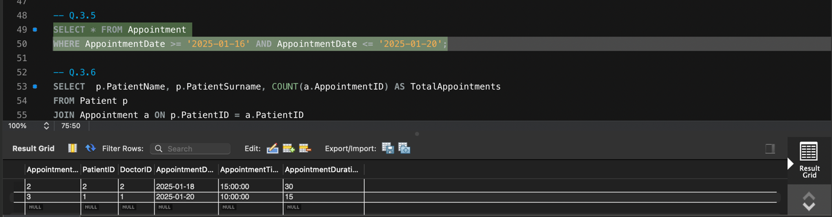
Q.3.6
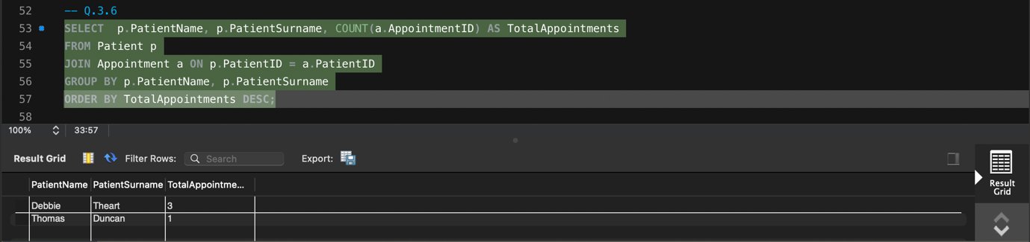

Q.3.7
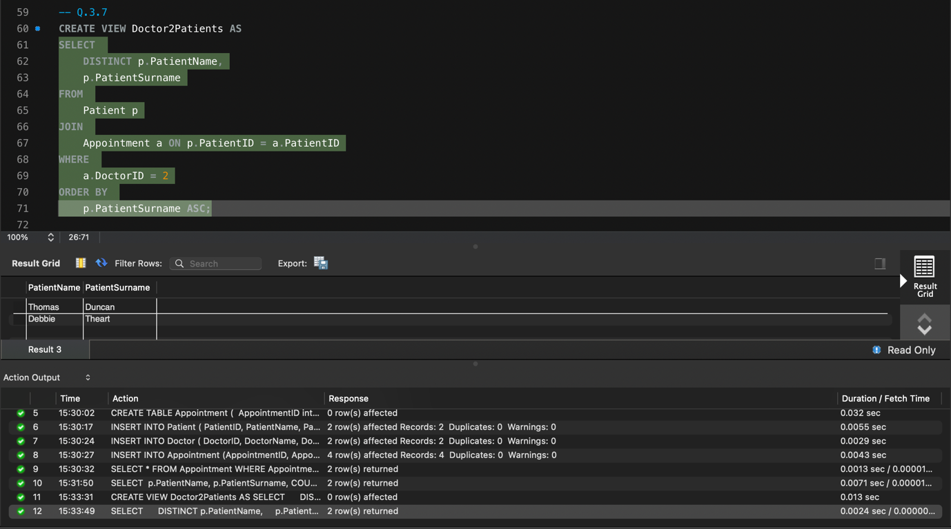

QUESTION 4
Q.4.1
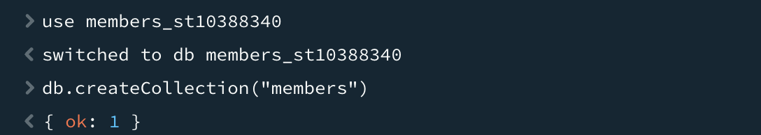
Q.4.2
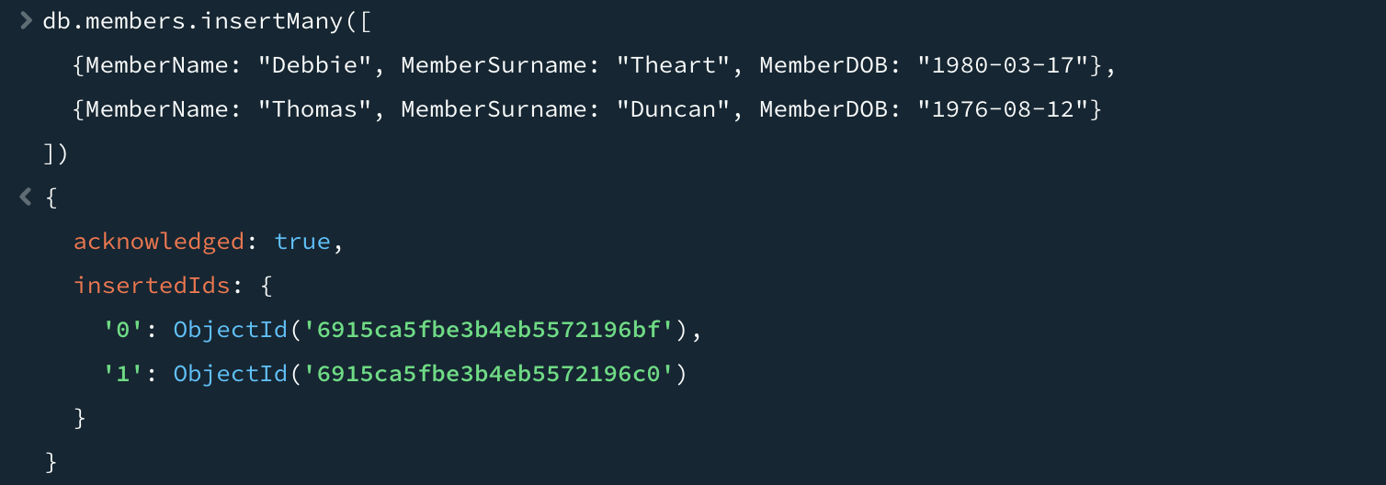
Q.4.3
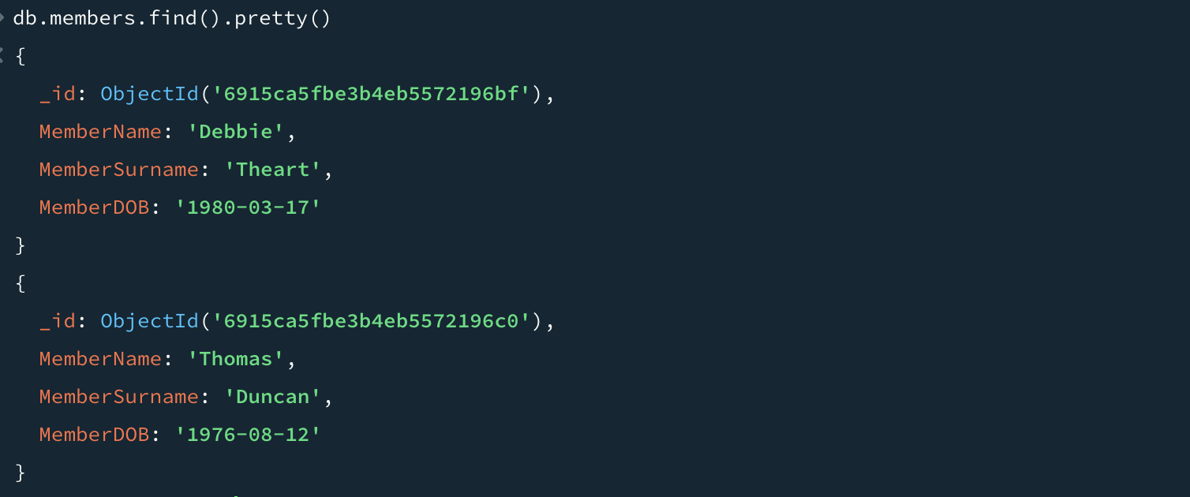
Q.4.4
