KaNiBa

Software Requirements Specification

Version 1.0

Table of Contents

1. Introduction 3

Purpose 3

Scope 3

Definitions, Acronyms, and Abbreviations 3

References 3

Overview 3

2. Overall Description 4

Use-Case Diagram 4

3. Specific Requirements 5

Functionality 5

External functions 5

Internal functions 5

Admin functions 5

Usability 5

Reliability 5

Performance 5

Supportability 6

Design Constraints 6

On-line User Documentation and Help System Requirements 6

Purchased Components 6

Interfaces 6

Licensing Requirements 6

Legal, Copyright, and Other Notices 6

Applicable Standards 6

4. Supporting Information 6

Software Requirements Specification

# Introduction

## Purpose

This documentation provides information about the software requirements of the project “KaNiBa”.

## Scope

We are the Team “KaNiBa”, which is short for Karlsruhe Nightlife and Bars ©. We are Philipp Fehrmann, Roman Knaute and Sebastian Zander. Our vision is to establish simple to use, HTML5 webbased service which allows users to get an overview of Karlsruhes student nightlife and bars. The goal is to extend the platform to include information such as news, user ratings, specials and also give the user the ability to easily interact with others by using their own profile. Also the service should be optimized for mobile access. Each feature can also be seen as independent subsystem, which enables the user to only use a subset of the available functions.

The technologies we want to use are mainly Java in combination with the Vaadin framework and a SQL-Database.

## Definitions, Acronyms, and Abbreviations

n/a

## References

n/a

## Overview

First in this SRS will be a description of our project. Under the topic Overall Discription you will find our Use Case Diagram with the most important functionalities. Next there is a short description of the previous hardware project.

Then we will explain its details regarding functionality, which you can see in the Specific Requirements. Last there will be a list of some supporting information, which will help us developing our software. This section will grow over time.

# Overall Description

## Use-Case Diagram

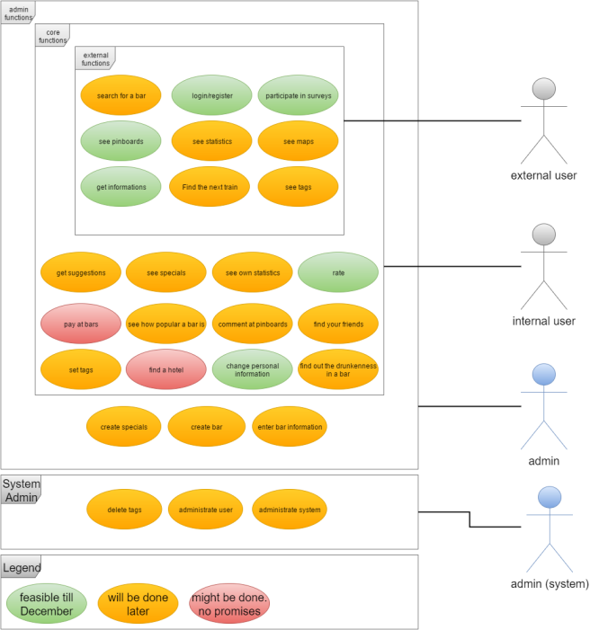

# Specific Requirements

## Functionality

### External functions

Rate: Every user is able to rate the bars.

Login/register: Every user is able to register and login to use advanced feature.

Participate in surveys: Surveys to improve the website will be shown to everyone.

See pinboard: Everyone is able to see the public pinboard of every bar.

See statistics: Everyone is able to the statistics of every bar.

See maps: Everyone is able to see maps of all supported bars.

Get informations: Everyone is able to get informations of all supported bars.

Find the next train: Everyone is able to get informations about the next train home.

See tags: Everyone is able to see tags.

### Internal functions

Get suggestions: find out which bars you might like.

See specials: See special events and offers.

See own statistics: Find out how many bars you visited and how much money you have spend.

Pay at bars: Use our prepaid-system to pay at bars using a QR-code.

See how popular a bar is: Find out where the biggest party goes on.

Comment at pinboards: write your own opinion to the website

Set tags: write tags to every supported bar.

Find your friends: See in which bar you friends are.

Find a hotel: User is able to find the cheapest hotel next to the bar

Rate tags: Rate how matching the tags are.

Find out the level of drunkenness in a bar : See if a location is equal to your drunk level and rate the average drunkenness

### Admin functions

Create specials: create special events and offers.

Delete tags: delete inappropriate tags.

Create bars: add new bars to the database.

Enter bar informations: enter and change the information for every bar.

Administrate user: change and delete user.

## Usability

Tbd

## Reliability

Tbd (depends on the used interfaces)

## Performance

Tbd

## Supportability

Tbd

## Design Constraints

Tbd

## On-line User Documentation and Help System Requirements

Tbd

## Purchased Components

Tbd

## Interfaces

Tbd

## Licensing Requirements

Tbd

## Legal, Copyright, and Other Notices

Tbd

## Applicable Standards

Tbd

# Supporting Information

[MySql](https://www.mysql.de/)

[Vaadin](https://vaadin.com/)

[Git](https://git-scm.com/)

[Tomcat-Server](http://www.tomcat.apache.org)

[Eclipse](http://www.eclipse.org)