[Logo] | LORMA COLLEGES  College of Computer Studies and Engineering  Bachelor of Science in Information Technology | [Logo]

CAPSTONE PROJECT PROGRESS REPORT

GENERAL INSTRUCTIONS
- Use this format for all progress report submissions.
- Encode the report clearly and concisely.
- Submit on or before the deadline set by the adviser.
- Attach photo documentation as required.

Report Details
Project / Capstone Title | SmartSpend: An AI-Assisted Multi-Modal Personal Financial Management Application for Filipino Users Using Agentic Large Language Model Architecture
Report No. | 05
Date Submitted | September 4, 2026

Members
# | Member Name
1 | Brix A. Directo — Lead Developer
2 | Cyrille John M. Rubis — UI/UX Designer & Documentation Lead
3 | Djaunathan Albert S. Madayag — Project Manager & QA Lead

Narrative
Describe the project's current status. Write each part in paragraph form.
1. Tasks Already Completed
What has the team finished since the last report?
Analyzed real device debug data (Debug Log, JSON backup, CSV export from Poco X6 Pro test device) and resolved 5 specific bugs confirmed on actual hardware:

Bug #1 — Lightweight Mode analytics: The 50/30/20 card, Tax+Savings card, and Allowance Overview were rendering using a stale ₱650 income value even when income tracking was OFF. Fixed by adding _incomeWalletMode state to AnalyticsScreen and gating all three income-dependent cards on that flag.

Bug #2 — Logging Consistency scoring: activeDays was computed from the user's first logged entry of the month, allowing a single entry on Sep 2 to award 25/25 "Logging every active day." Fixed by using daysPassed as the baseline (honest score). A grace period is preserved for users who start logging mid-month (after day 7). Applied to 3 locations in score_service.dart.

Bug #3 — FMS "See breakdown" tap: tapping the link navigated to the Profile screen top with no scroll. Fixed using a static flag ProfileScreen.scrollToFMS, a GlobalKey, and a ScrollController — the screen now auto-scrolls to the FMS section after data loads.

Bug #4 — AI language detection: the AI was replying in Taglish when the user wrote in English. Fixed by adding Rule 12 to the system prompt and updating the persona line to strictly match the user's input language.

Bug #5 — Score history chart: showed 2 data points with no explanation. Added a placeholder card explaining that scores are recorded each time the app is opened, prompting users to engage daily.

Created GitHub Actions CI/CD workflow (.github/workflows/release.yml): auto-builds all 3 APK variants and creates a GitHub Release on version tag push. Triggers on v*.*.* tags; uses Java 17 and Flutter 3.41.6.

Built and released v2.9.9 to GitHub. Rebuilt progress reports using the exact Lorma BSIT progress report template format.

Added UX/Behavioral backlog (8 items) and Document Tooling backlog (8 tools) to PROJECT_STATUS.md for future sprint planning.

2. Ongoing Activities
What is currently in progress?
Configuring GitHub Actions secrets (KEYSTORE_BASE64, KEY_PROPERTIES, GOOGLE_SERVICES_JSON, APP_CONFIG_DART) to activate the automated release pipeline. These signing credentials and API keys cannot be committed to the repository and must be set manually in GitHub Settings → Secrets.

Pre-Final Defense preparation: finalizing presentation slides and conducting full 8–9 minute demo rehearsal using the DEFENSE_GUIDE.md flow.

Google Docs manuscript: applying Fixes 11–16 (account type, target population, respondent criteria, validator roles).

SUS survey instrument finalization and respondent recruitment coordination for Week 7 administration.

3. Problems or Challenges Encountered
What issues or roadblocks came up?
GitHub Actions automated release workflow requires 4 secrets to be configured manually in repository settings before the first build can succeed — the keystore file, key.properties, google-services.json, and app_config.dart all contain signing credentials and API keys that cannot be committed to the public repository.

Logging Consistency score was returning inflated results (25/25) for users who log their first entry on day 1 or 2 of the month, because activeDays was computed relative to the first logged entry rather than the start of the calendar month.

4. Solutions Applied or Actions Taken
How were the above issues addressed?
GitHub Actions: the workflow file (release.yml) has been created, committed, and merged. Step-by-step secret configuration instructions are documented in the workflow file comments. Once the 4 secrets are set in GitHub Settings, future releases require only two commands:
git tag v2.9.X && git push origin v2.9.X

Logging Consistency: fixed the activeDays baseline to use daysPassed (days elapsed since the first day of the month). The grace period is preserved — if the user began logging after day 7 of the month, the span from their first entry is still used to avoid penalizing new users. The fix was applied consistently across FHS full mode, FHS lightweight mode, and FMS (3 files).

5. Next Steps / Plans Before the Next Report
What will the team do next?
Configure GitHub Actions secrets to enable the automated APK release pipeline.

Complete Pre-Final Defense preparation: finalize slides, conduct a full 8–9 minute timed rehearsal following the DEFENSE_GUIDE.md demo flow.

Apply remaining Google Docs manuscript fixes (Fixes 11–16).

Generate Figure 1.1 bar chart and obtain validator signatures for Appendix A.

Prepare SUS survey instruments and begin respondent recruitment (target: 30 respondents — 20 parents aged 35–55, 10 young professionals aged 21–35).

Photo Documentation
Attach clear photos showing actual progress of the project. Each photo should have a short caption describing what is shown.
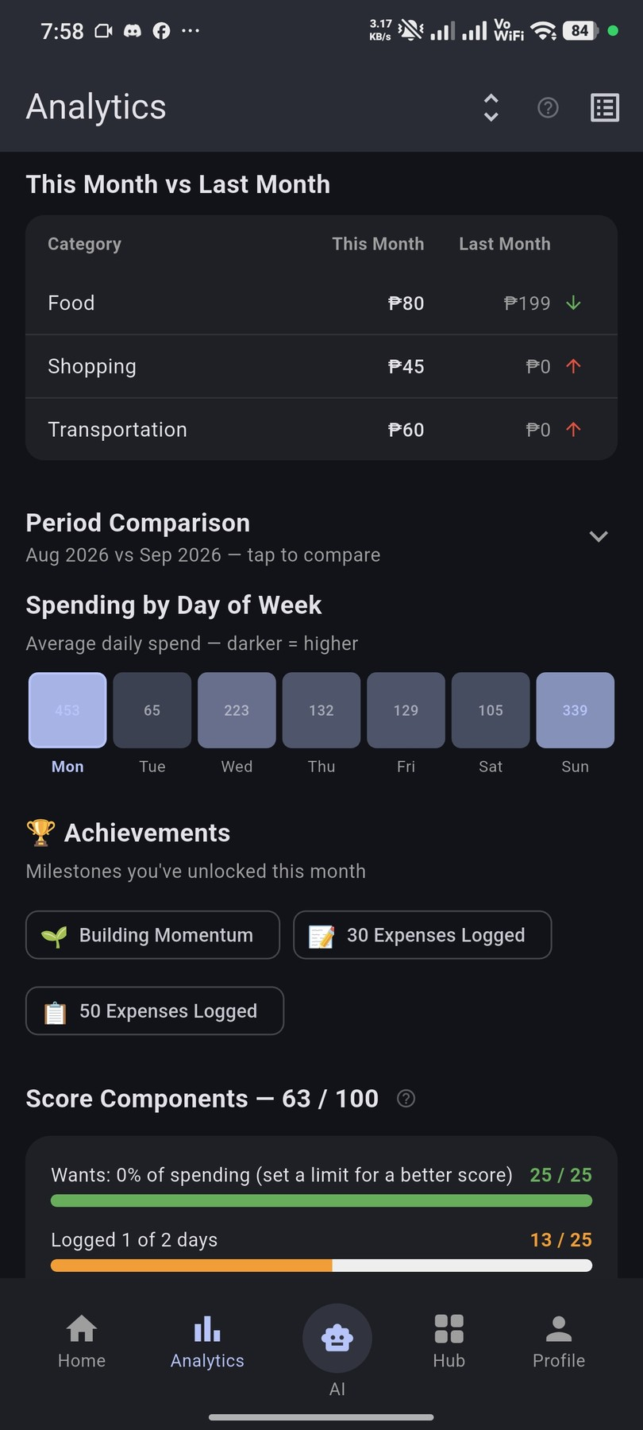 | 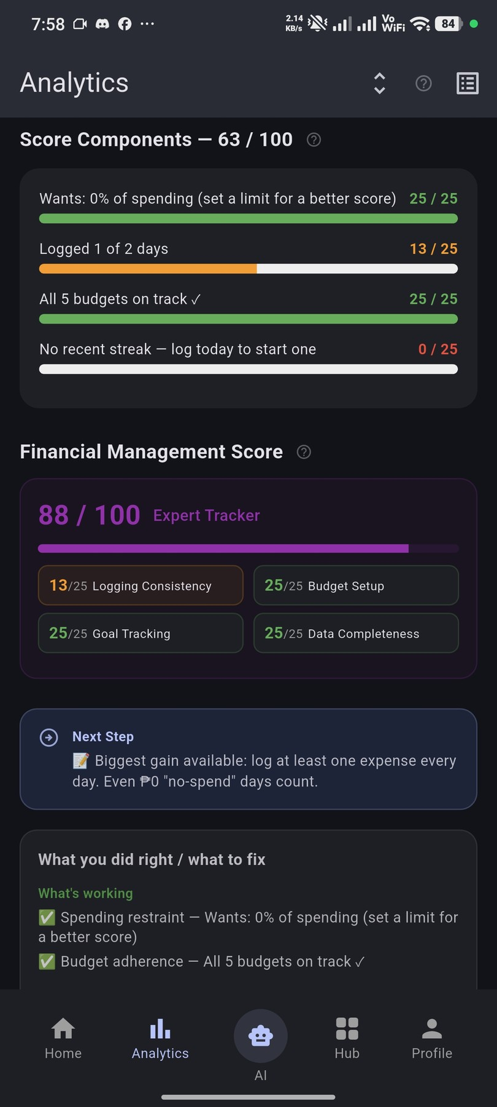
Analytics — This Month vs Last Month comparison + Spending by Day of Week heatmap (Mon ₱453 peak) + Score Components 63/100 partial view | Analytics — Score Components 63/100 full: Wants 25/25, Logging 13/25 (Bug #2 fix), Budgets 25/25, Streak 0/25 — FMS 88/100 Expert Tracker breakdown

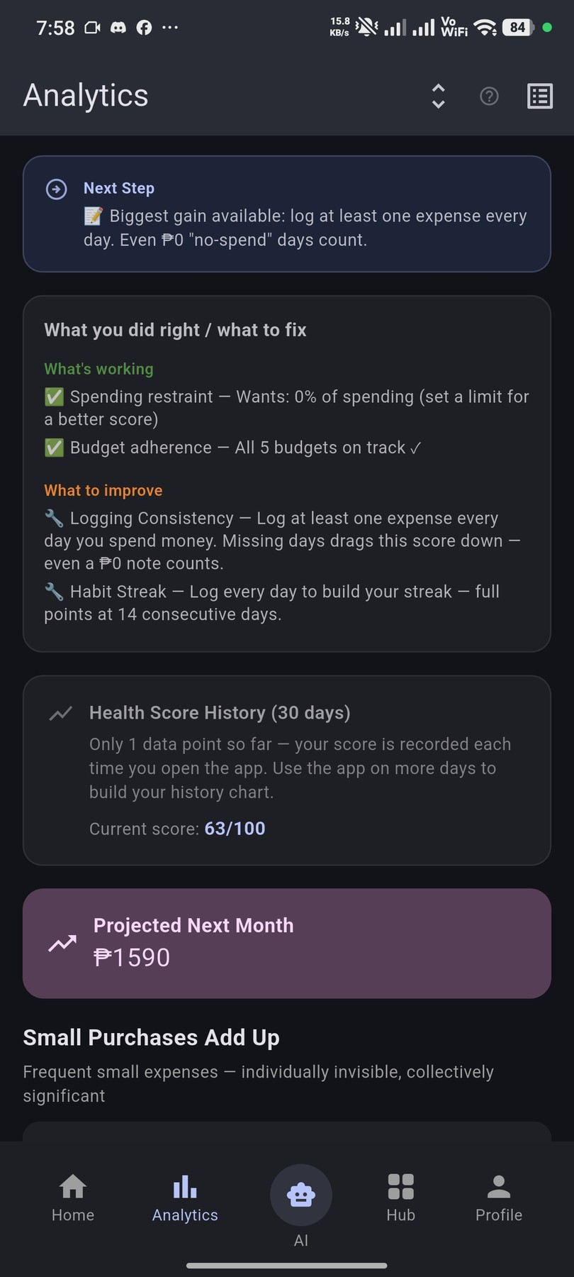 | 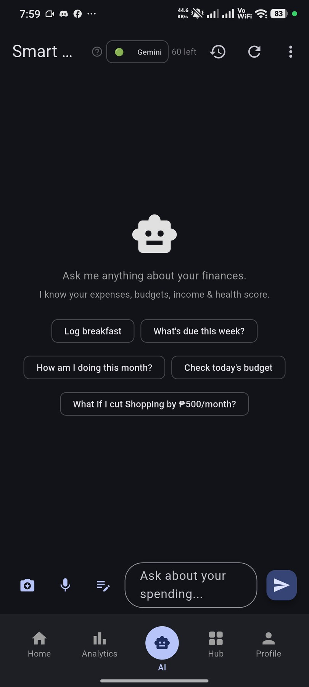
Analytics — "What you did right / what to fix" feedback panel, Health Score History (1 data point, Bug #5 fix), and Projected Next Month ₱1,590 | AI Chat screen — Gemini 3.1 Flash-Lite active (60 requests remaining), 5 quick-suggestion chips, Smart Import bottom sheet with 4 input modes

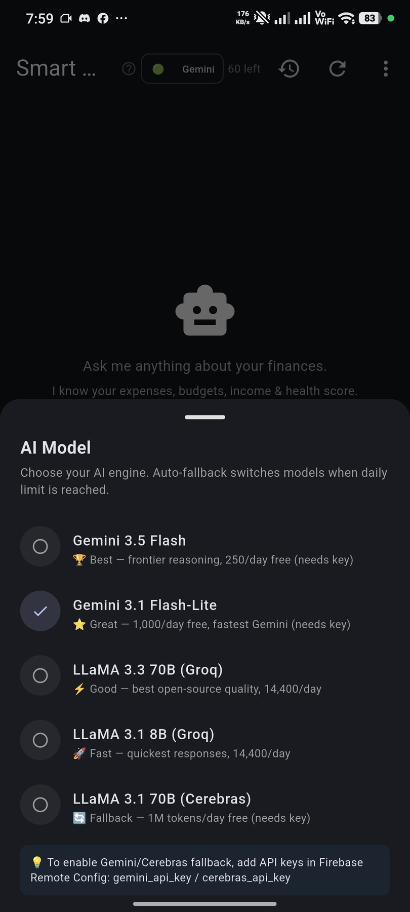 | 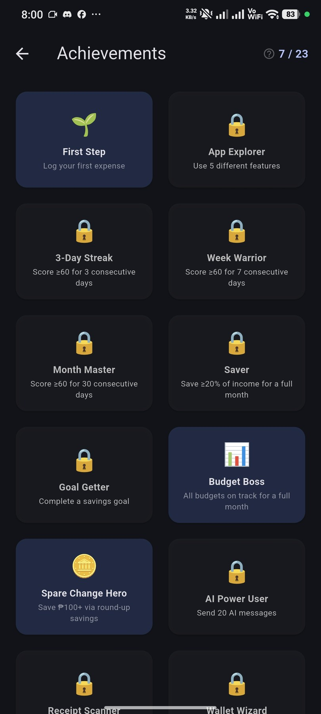
AI Chat — AI Model selector bottom sheet: Gemini 3.1 Flash-Lite selected (✓), showing all 5 available models with daily request limits | Achievements screen — 7 of 23 badges earned: First Step ✓, Budget Boss ✓, Spare Change Hero ✓; remaining badges locked with unlock criteria visible

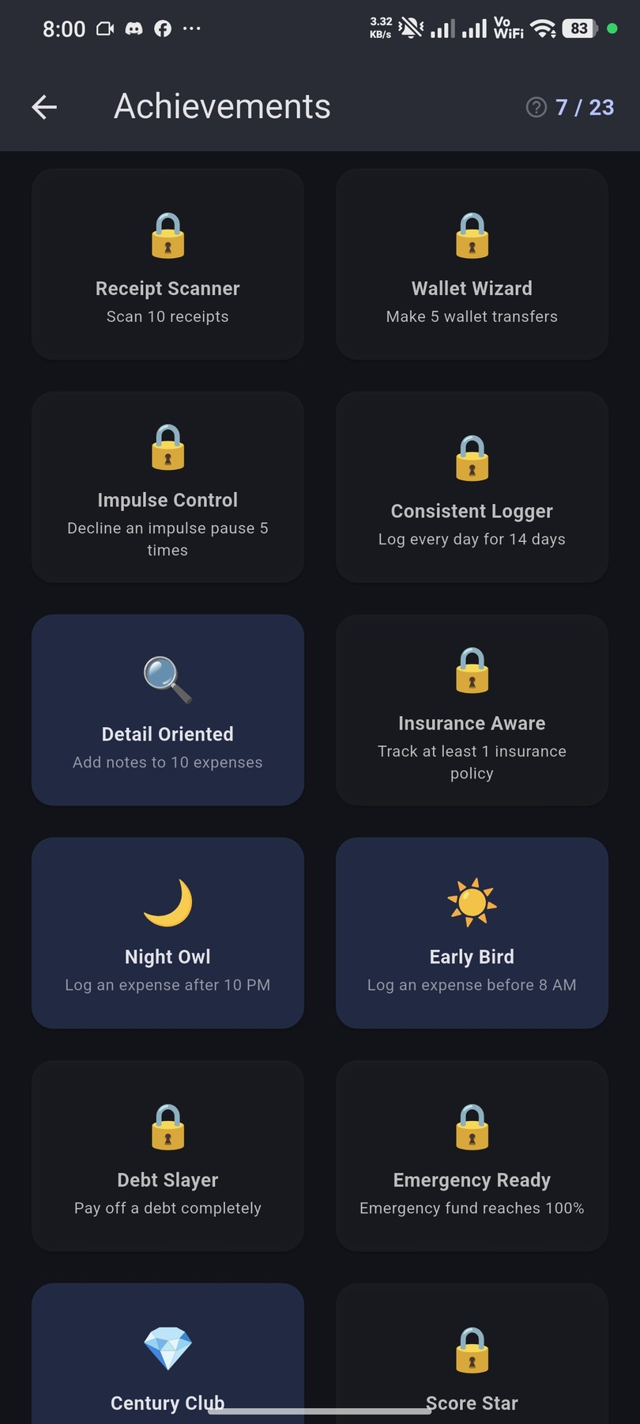 | 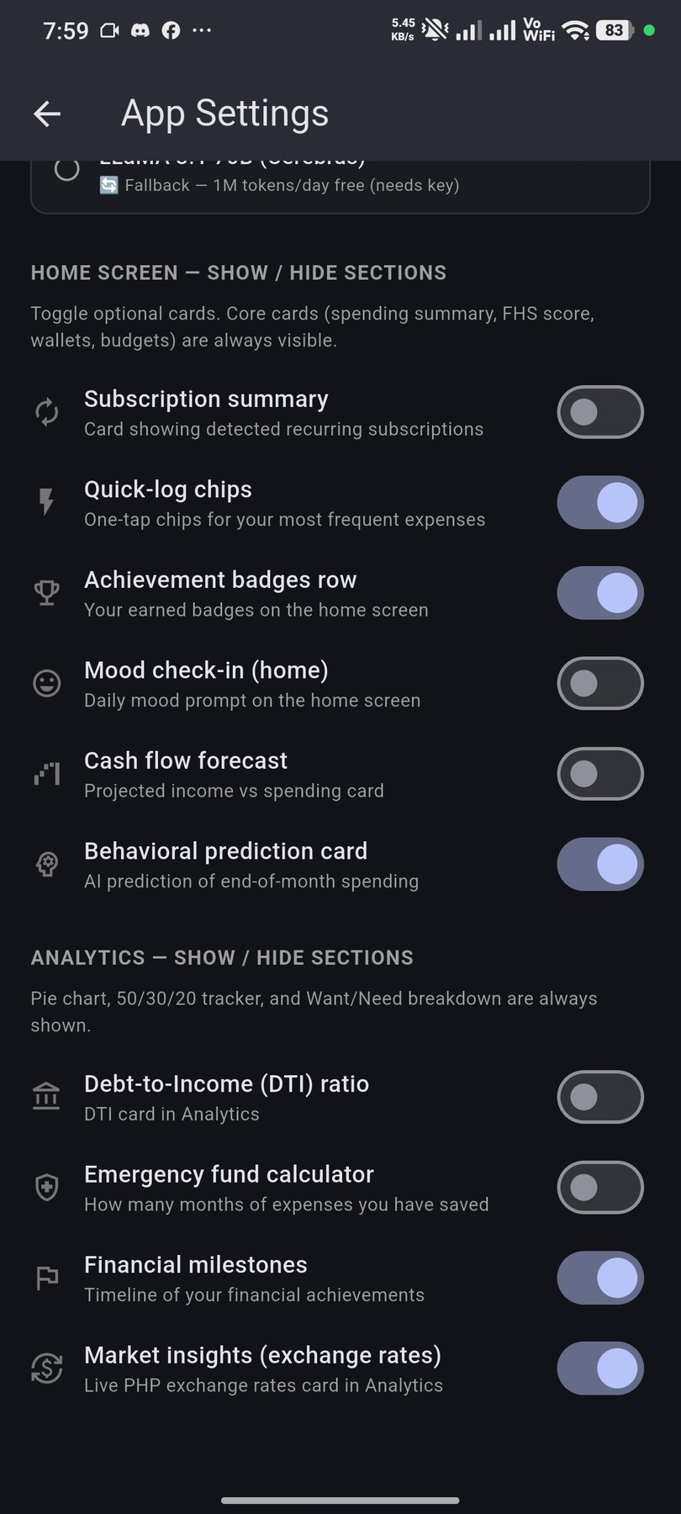
Achievements page 2 — Detail Oriented ✓, Night Owl ✓, Early Bird ✓, Century Club ✓ unlocked; Receipt Scanner, Consistent Logger, Insurance Aware still locked | App Settings — Home Screen show/hide section (Quick-log chips ON, Achievement badges ON, Behavioral prediction ON) and Analytics section visibility controls

Submitted by |  | Noted by

Brix A. Directo  Group Leader / Signature over Printed Name |  | Ellen F. Mangaoang, MIT  Teacher in Charge / Signature over Printed Name

