[Logo] | LORMA COLLEGES  College of Computer Studies and Engineering  Bachelor of Science in Information Technology | [Logo]

CAPSTONE PROJECT PROGRESS REPORT

GENERAL INSTRUCTIONS
- Use this format for all progress report submissions.
- Encode the report clearly and concisely.
- Submit on or before the deadline set by the adviser.
- Attach photo documentation as required.

Report Details
Project / Capstone Title | SmartSpend: An AI-Assisted Multi-Modal Personal Financial Management Application for Filipino Users Using Agentic Large Language Model Architecture
Report No. | 04
Date Submitted | September 3, 2026

Members
# | Member Name
1 | Brix A. Directo — Lead Developer
2 | Cyrille John M. Rubis — UI/UX Designer & Documentation Lead
3 | Djaunathan Albert S. Madayag — Project Manager & QA Lead

Narrative
Describe the project's current status. Write each part in paragraph form.
1. Tasks Already Completed
What has the team finished since the last report?
Completed a comprehensive documentation audit resolving 30+ inconsistencies across all project documents. Critical corrections included: screen count updated from 36 to 37, service count from 23 to 26, stale AI model names updated (GPT-4o to GPT-5.6, Claude 3.5 to Claude Fable 5), input modality count corrected from 7 to 6, and the Financial Management Score (FMS) formula fixed from 3×33.3 pts to 4×25 pts to match the actual implementation.

Implemented 6 AI coverage gaps identified through systematic audit:
(1) Added set_spending_limit agentic action — AI can now set daily, weekly, monthly, and yearly spending caps directly from natural language chat;
(2) Added add_insurance_policy action — AI can create SSS, PhilHealth, Pag-IBIG, and private insurance entries on command;
(3) Added Rule 12 (Taglish language triggers) to the system prompt across all 34 action types for Filipino-English mixed input;
(4) Budget queries now route to the smart model tier (LLaMA 70B or Gemini) instead of the fast 8B model for improved accuracy;
(5) set_budget fallback parser added for edge-case input formats;
(6) Auto-categorization rules injected into AI context for consistent category assignment.

Added Financial Management Score (FMS) mini-cards to both the Home screen (compact strip showing 88/100 Expert Tracker) and the Analytics screen (full 4-component breakdown). FHS "Unmeasured" label added when income tracking is disabled — displays as a grey chip with dashed progress bar.

Fixed ScanReviewScreen code duplication — removed a 295-line embedded class from smart_camera_screen.dart and replaced it with an import of the standalone file, eliminating a maintenance risk.

Fixed the recurring transaction "Add Recurring" button — the entry now saves directly to the database without navigating to a blank screen first.

Rebuilt SMARTSPEND_FINAL_V5.docx: 17 sections, 63 APA references, 7 embedded figures. Action count updated from 29 to 31 across all 12 documentation files. Released v2.9.8 to GitHub with 3 signed APK variants (arm64-v8a, armeabi-v7a, x86_64).

2. Ongoing Activities
What is currently in progress?
Manuscript revision: Chapters 1 through 4 complete in SMARTSPEND_REVISED_MANUSCRIPT.md. Google Docs version pending Fixes 11–16 from MANUSCRIPT_GUIDE.md covering account type flexibility, target population reframing, respondent criteria, and validator role descriptions.

Pre-Final Defense preparation: demo flow rehearsal targeting 8–9 minutes per DEFENSE_GUIDE.md Part 2. Presentation slides in progress.

SUS survey instrument finalization — targeting 30 respondents (20 parents aged 35–55, 10 young professionals aged 21–35) for Week 7.

3. Problems or Challenges Encountered
What issues or roadblocks came up?
Multi-item AI logging was silently failing for messages with common Filipino spelling variants and typos (e.g., "spen 30 for transport") — the max_tokens estimate was too low, and the multi-item detection regex did not match informal Tagalog verb forms.

The 50/30/20 analytics card and income-based overview cards were rendering using stale income data (₱650 set months prior) even when income tracking was OFF, producing meaningless budget percentages for the student user profile.

4. Solutions Applied or Actions Taken
How were the above issues addressed?
Multi-item fix: broadened the verb detection regex to catch typos and Tagalog variants (spen, spe, nagastos, ginastos); added connector-aware detection for comma-separated and "and"-joined entries; scaled token budget from 800 to 1,200 tokens based on item count; multi-item messages now route to the smart model tier. System prompt Rules 1 and 2 updated with explicit Filipino-language examples.

Lightweight Mode analytics fix: added _incomeWalletMode state field to AnalyticsScreen, populated from the database on _loadData(). All three income-dependent cards (50/30/20, Tax+Savings, Allowance Overview) are now gated on the _incomeWalletMode flag and hidden when income tracking is OFF.

5. Next Steps / Plans Before the Next Report
What will the team do next?
Week 5: Configure GitHub Actions secrets (KEYSTORE_BASE64, KEY_PROPERTIES, GOOGLE_SERVICES_JSON, APP_CONFIG_DART) to enable the automated APK release pipeline built this week.

Apply Google Docs manuscript fixes (Fixes 11–16): account type flexibility, target population reframing, respondent criteria, and validator role sections.

Generate Figure 1.1 bar chart using BSP financial literacy data and insert into Google Docs manuscript.

Obtain validator signatures on Appendix A validation certificates (survey content validator and technical/SUS validator).

Complete Pre-Final Defense presentation slides and conduct a full timed rehearsal using the DEFENSE_GUIDE.md script.

Photo Documentation
Attach clear photos showing actual progress of the project. Each photo should have a short caption describing what is shown.
 | 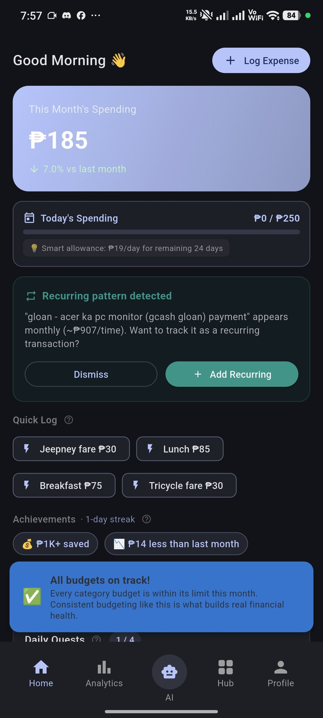
SmartSpend splash screen — app logo with tagline "Your AI Financial Assistant" on launch | Home screen — ₱185 monthly spending (7% below last month), recurring pattern alert, Quick Log chips (Jeepney ₱30, Lunch ₱85), and achievement badges

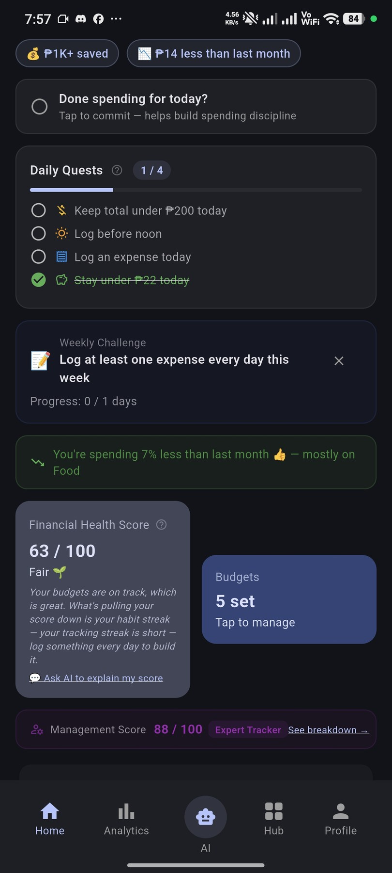 | 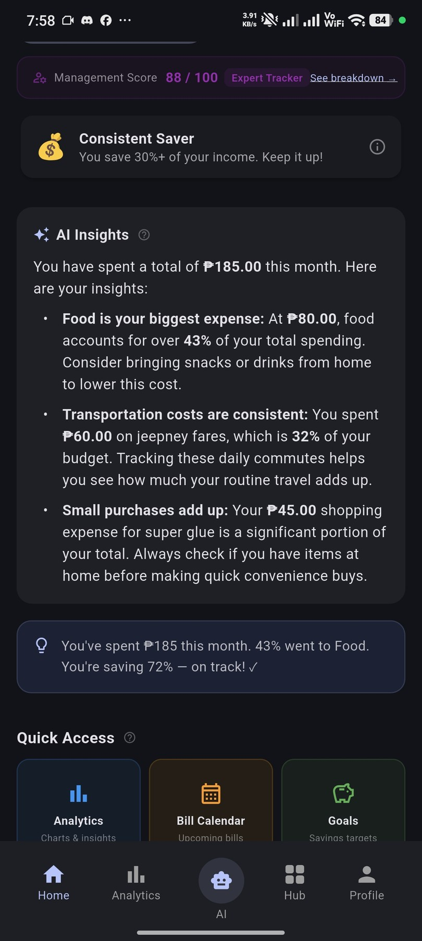
Home screen scrolled — Daily Quests (1/4 complete), FHS 63/100 Fair with AI explanation, FMS 88/100 Expert Tracker strip, and Budgets 5 set | Home screen — AI Insights card with 3 behavioral tips (Food 43%, Transportation 32%, Small purchases), Consistent Saver badge, and Quick Access grid

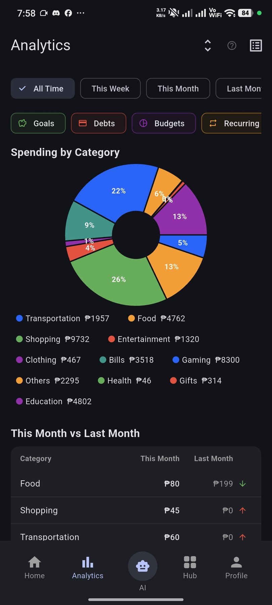 | 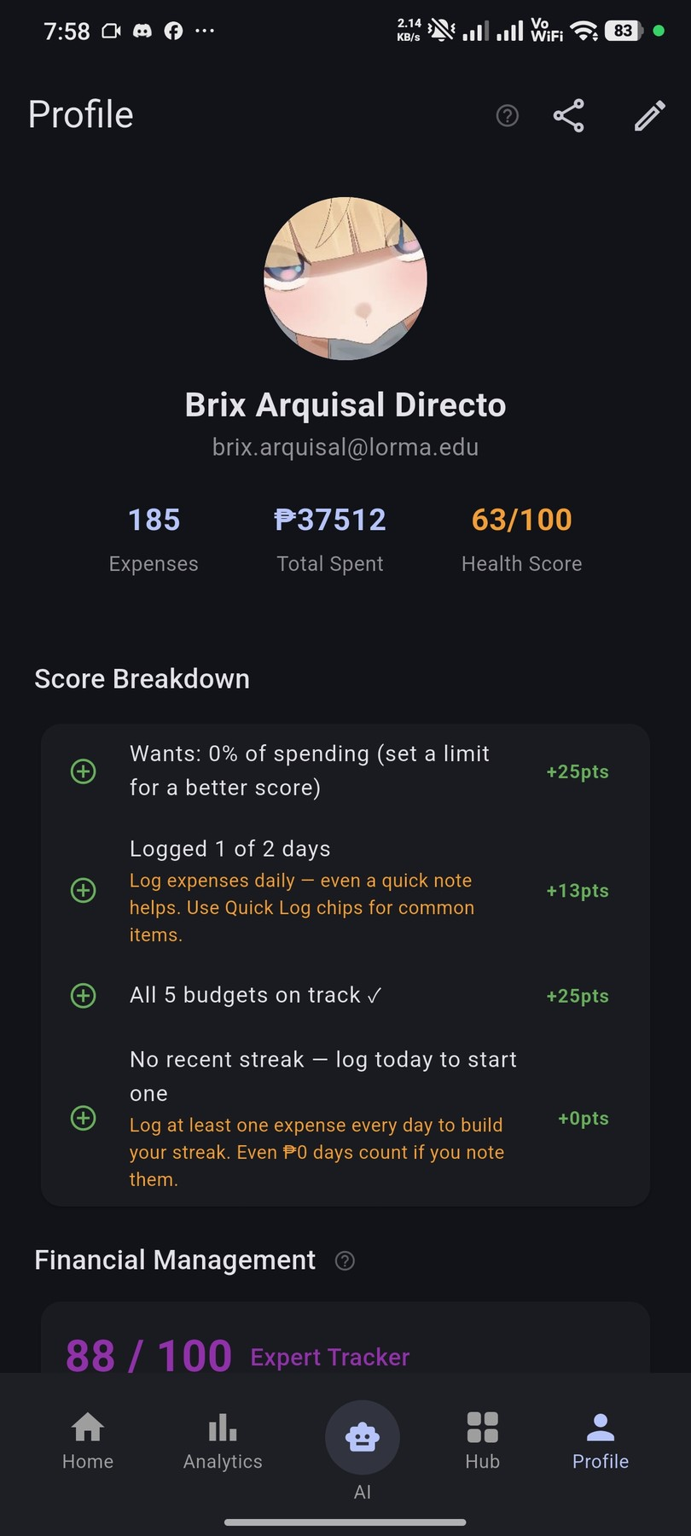
Analytics — Spending by Category donut chart (13 categories, All Time view): Shopping ₱9,732 leads, followed by Food ₱4,762 and Gaming ₱8,300 | Profile — Brix Arquisal Directo: 185 total expenses, ₱37,512 total spent, FHS 63/100 with 4-component Score Breakdown showing improvement areas

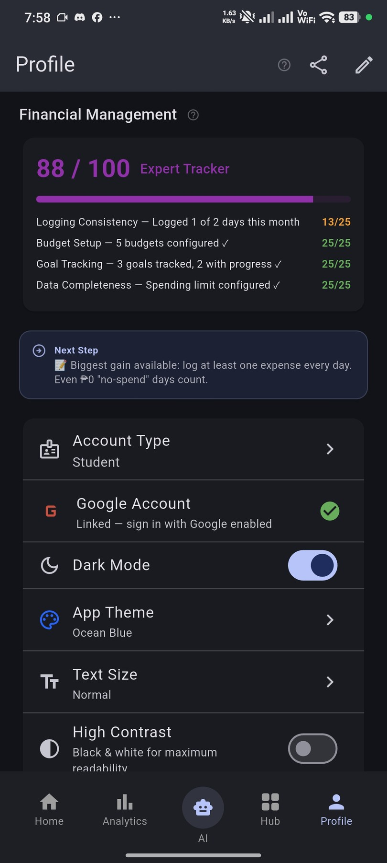 | 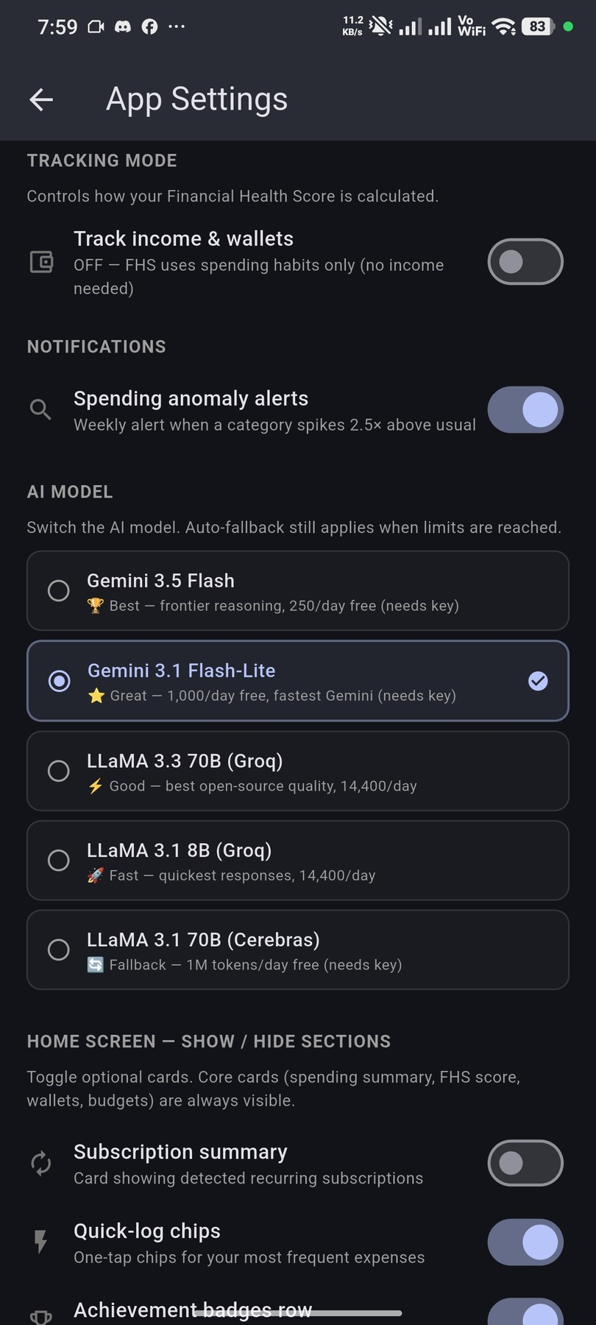
Profile — FMS 88/100 Expert Tracker: Logging 13/25, Budget Setup 25/25, Goal Tracking 25/25, Data Completeness 25/25 — account type: Student, Dark Mode ON | App Settings — AI Model section: Gemini 3.1 Flash-Lite selected (1,000/day free, fastest Gemini), with 4 fallback providers including LLaMA 3.3 70B and Cerebras

Submitted by |  | Noted by

Brix A. Directo  Group Leader / Signature over Printed Name |  | Ellen F. Mangaoang, MIT  Teacher in Charge / Signature over Printed Name

