SmartSpend Financial Health Score
Academic Basis, Formula Specification, and Verification Reference
Prepared for the capstone adviser, defense panel, and an independent financial-expert validator

Prepared by Team Lucid Frame
Directo, Brix A. · Rubis, Cyrille John M. · Madayag, Djaunathan Albert S.
Lorma Colleges — College of Computer Studies and Engineering
September 2026

Read This First — Plain-English Summary
This document answers one question a panel or a financial expert will ask within the first five minutes: “Did you just make this scoring system up, or is it based on something real?” The short answer is in the box below. Everything after it is the detailed, citable proof.
The short answer:
SmartSpend's Financial Health Score (FHS) is not invented from scratch. It draws on four already-published, already-used financial-health measurement sources — a U.S. government agency (CFPB), a U.S. nonprofit (Financial Health Network), an Australian bank and university research institute (CBA – Melbourne Institute), and a United Nations advisory working group (UNSGSA). The main design choice — computing the score from recorded transactions instead of a survey — follows CBA-Melbourne Institute's “Observed” scale, which is built from bank records. The UNSGSA note describes transaction-based measurement as promising but still early-stage and best used alongside surveys, which is exactly why SmartSpend calls its score a “Prototype”. Three of the four components (Savings Rate, Overspend Control, Budget Adherence) adapt the Save, Spend and Plan pillars of the FinHealth Score®; the fourth (Logging Consistency) and the two score adjustments are SmartSpend's own additions, and the document says so plainly. Section 10 lists what the score does not yet do, so a reviewer hears it from us first.

How this document is organized: Section 1 introduces the four source systems. Section 2 shows exactly which part of SmartSpend's formula came from which source, side by side. Section 3 is a diagram of that same mapping, for a one-glance version. Sections 4–5 give the full formula, including the two modes and the score adjustments, each with its own justification. Section 6 walks through one worked example, from raw inputs to the final number. Section 7 compares SmartSpend directly against the other systems. Section 8 explains the formal academic name used for the score. Section 9 is a checklist for anyone who wants to independently verify a claim. Section 10 states the score's limitations and the planned validation.

1 — The Four Source Systems
Four published financial-wellbeing measurement frameworks were reviewed before SmartSpend's formula was written. Between them they cover both of the two broad ways financial wellbeing gets measured: asking people how they feel about their finances (a subjective, survey-based approach), and calculating a score directly from a person's actual recorded financial activity (an objective, data-based approach).
Source System | Year | Basis | What It Does
CFPB Financial Well-Being Scale | 2015 (tech. report 2017) | Subjective (survey) | 5- or 10-question survey scored with Item Response Theory into a single 0–100 style score; measures how secure and in-control a person feels about their finances, not their transaction behavior.
FinHealth Score® (Financial Health Network) | 2021 | Subjective (survey) | 4 components — Spend, Save, Borrow, Plan — with 8 indicators (two survey questions each). Scores run 0–100 in three tiers: vulnerable (0–39), coping (40–79), healthy (80–100). Self-reported, but the pillar structure is widely reused.
CBA – Melbourne Institute Scales | 2018 | Both: Reported (survey) and Observed (bank data) | Publishes two scales. The Reported scale is a 5- or 10-question survey. The Observed scale sums five categorical bank-record measures (payment problems, frequency of low liquid balances, net spending, ability to raise funds for an unexpected expense, savings balance) and rescales the total to 0–100.
UNSGSA Financial Health Working Group note | 2021 | Policy guidance, not a scale | “Measuring Financial Health: Concepts and Considerations” (Gubbins, Mazzotta & Rhyne). Recommends survey-based modules as the main approach. Describes “hard data from accounts or transactions” as a fourth, early-stage approach, best treated as complementary to surveys.

Where SmartSpend sits among these:
SmartSpend's FHS follows the CBA-MI “Observed” approach: it is computed automatically from a user's own logged transactions, not a questionnaire. It adapts the Spend, Save and Plan ideas from the FinHealth Score® into components that can be calculated from transaction and budget data the app already has. The UNSGSA note supports exploring transaction data but calls it early-stage and complementary to surveys — so SmartSpend presents its score as a prototype, not a validated replacement for a survey scale.

2 — Component-by-Component Mapping
FHS Component | Source / Academic Basis | Formula (Full Mode)
Savings Rate | FinHealth “Save” pillar; 20% target from the 50/30/20 budgeting rule (Warren & Tyagi, 2005) | 25 × min(1.0, savingsRate / 0.20)
Overspend Control | FinHealth “Spend” pillar, indicator “Spend Less Than Income” (direct mapping) | 25 × (1 − (hardOverDays + softOverDays×0.5) / activeDays)
Budget Adherence | FinHealth “Plan” pillar; the zero-based-budgeting practice popularized by Ramsey (caveated as popular practice, not peer-reviewed) | 25 × (onBudgetCategories / totalBudgetedCategories)
Logging Consistency | SmartSpend's own addition — not drawn from FinHealth; grounded in self-monitoring / behavioral-tracking literature (self-determination theory) | 25 × (loggedDays / activeDays)

In plain terms: Savings Rate rewards a user for saving toward the widely-used 20% target; Overspend Control rewards staying within one's income, weighting a single large one-off purchase (“soft” overspend) as less severe than repeated, scattered discretionary overspending (“hard” overspend); Budget Adherence rewards staying inside category budgets the user has actually set; and Logging Consistency rewards simply keeping the app up to date, since a score is only as reliable as the data behind it.
Why four components of 25 points each?
Equal weights that add up to 100 follow the simplest published scoring method. The UNSGSA note describes it: CBA's 10-question Reported scale gives each question the same weight (0–4 points, 40 in total) and multiplies by 2.5 to land on 0–100, and it reports that such simple scores correlate very highly with model-based scores. The CBA-MI Observed scale likewise sums five measures and adjusts the total to 0–100. SmartSpend does the same with four components: 4 × 25 = 100. The weights are a design choice, not a statistically derived result (see Section 10).

3 — Academic and Conceptual Lineage (Diagram)
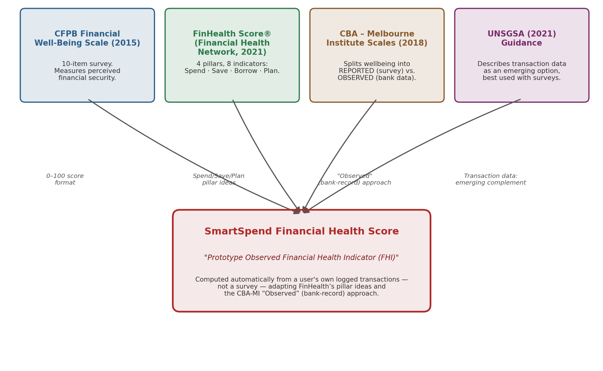
Figure 1. How each source system contributed to SmartSpend's Financial Health Score.

4 — Full Mode vs. Lightweight Mode
Not every user has a steady, trackable income — students and informal/gig workers often don't. Requiring income tracking to compute a score would leave those users without one, so SmartSpend offers two modes:
- Full Mode (income tracking on) — the four components above.
- Lightweight Mode (income tracking off) — Spending Restraint (vs. a user-set limit) replaces Savings Rate; Category Balance replaces Overspend Control, capping how concentrated spending is in one discretionary category (Bills, Health, and Education are excluded from this calculation so rent, tuition, and medical costs can't unfairly tank the score); Logging Consistency stays the same; Habit Streak (full credit at 14 consecutive logged days) replaces Budget Adherence, since a user without income tracking often hasn't set category budgets either.
The UNSGSA note cautions that scales built in one setting may need adapting to local realities, and cites BFA Global's Mexico scale, which avoided wording that presumed steady employment income. The Full / Lightweight split is SmartSpend's own design response to the same concern; it is not a feature of any source scale.

5 — Score Adjustments
Adjustment | Formula | Direction | Behavioral-Economics Basis
Warning Decay | min(15, 5 × decayDays) | − (subtracted) | Loss aversion (Kahneman & Tversky, 1979) and nudge/choice-architecture theory (Thaler & Sunstein, 2008) — repeated ignored overspend warnings compound the penalty. Only fires for discretionary overspend; a medical bill or tuition payment never triggers it.
Gap Adjustment | +2/day confirmed no-spend; −3/day unlogged-but-presumed-spent | ± (either direction) | Rewards verified restraint, penalizes silence that can't be distinguished from unreported spending — keeps the score honest about what is and isn't actually known.

Gap Adjustment is capped at +10 total (bonus) and −15 total (penalty) so a long streak in either direction cannot dominate the score on its own. The final score is clamped to the 0–100 range.
Read this before quoting the adjustments:
Warning Decay and Gap Adjustment are SmartSpend's own additions; none of the four source systems contains them. The citations show the behavioural principle each one draws on, not that the exact numbers (−5 per day, +2, −3) have been validated.

✅ Confirmed against the actual scoring code (Oct 6):
Overspend Control's “soft vs. hard” distinction and the Bills/Health/Education exemption on Warning Decay and Category Balance were checked directly against score_service.dart by the dev team and confirmed as currently shipping — both are accurately described above.

Theoretical Grounding for the Adjustments
Beyond the two specific behavioral-economics citations above, the adjustments and several other app features map onto four established frameworks, shown together here for a reviewer checking the psychological basis of the design rather than just the arithmetic:
Framework | Source | Where It Shows Up in SmartSpend | Core Idea
Nudge Theory | Thaler & Sunstein (2008) | Warning Decay; budget-threshold alerts | Small, non-restrictive prompts steer behavior without removing user choice.
Prospect Theory / Loss Aversion | Kahneman & Tversky (1979) | Warning Decay's compounding penalty | Losses are felt more strongly than equivalent gains, making a growing penalty a stronger behavioral signal than a flat one.
Self-Determination Theory | Deci & Ryan (2000) | Badges, quests, streaks (Logging Consistency / Habit Streak) | Autonomy-supportive, competence-building rewards sustain intrinsic motivation better than pure extrinsic pressure.
Technology Acceptance Model | Davis (1989) | Overall UI simplicity, agentic one-tap actions | Perceived ease of use and perceived usefulness jointly predict sustained voluntary use of a system.

6 — Worked Example
The chart below walks through one sample user over a 30-day period, showing how the four Full Mode components combine with the adjustments above into a single final score.
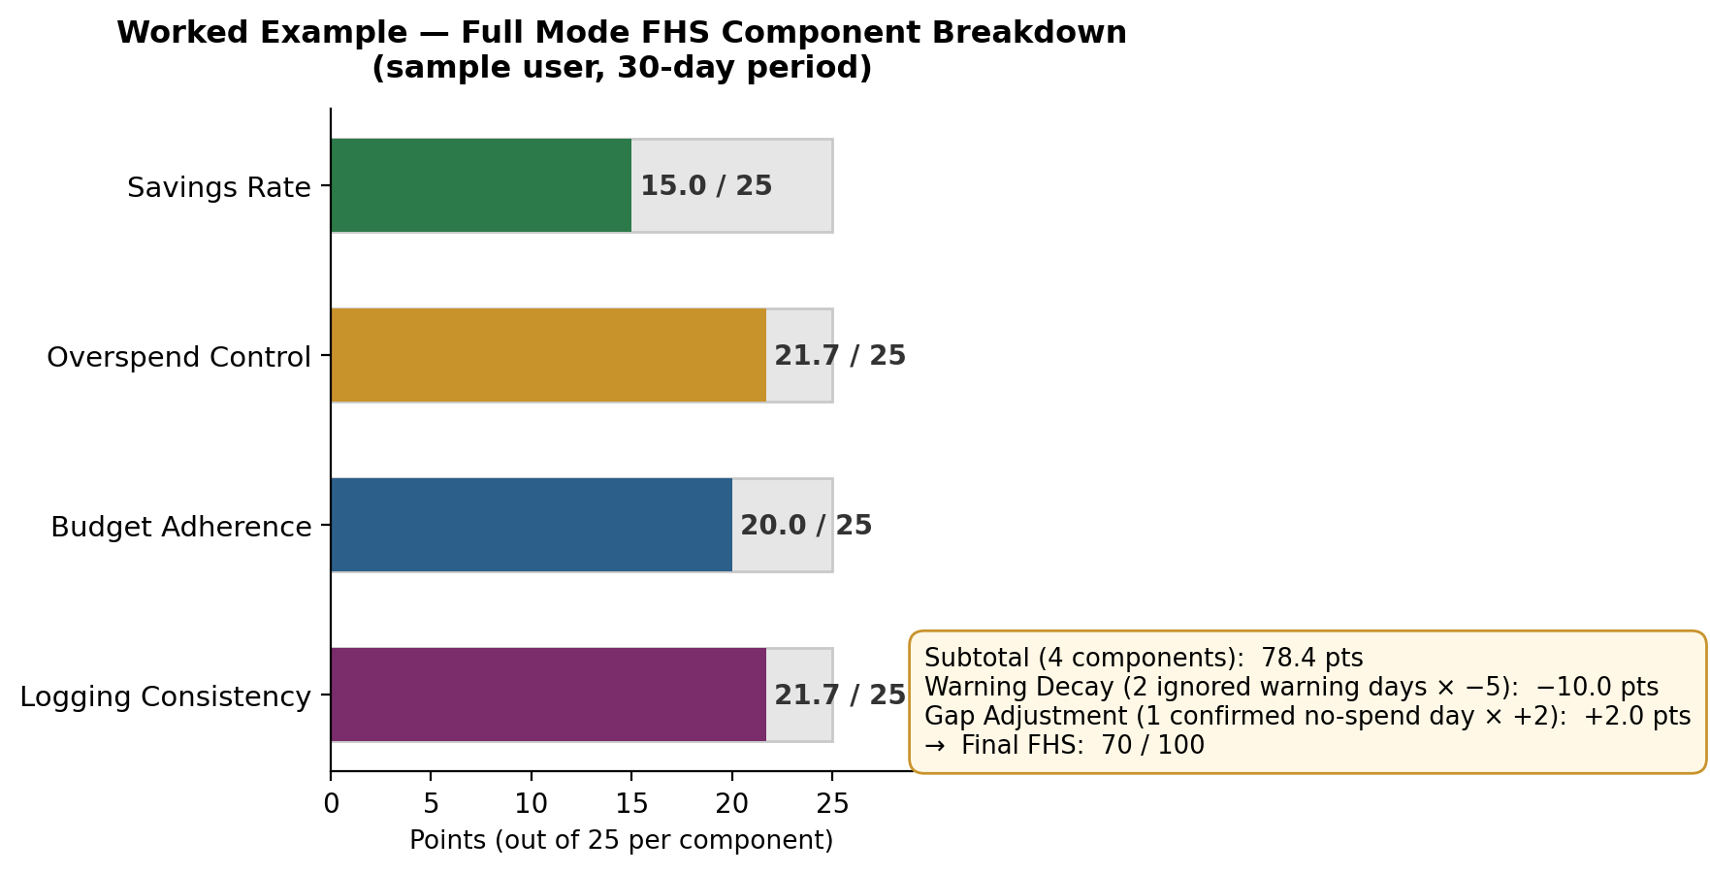
Figure 2. Worked example — Full Mode component scores, decay, gap adjustment, and final FHS.
Where each number comes from. The sample inputs are illustrative, chosen so the math reproduces the chart:
Line | Sample input | Calculation | Points
Savings Rate | Saved 12% of income | 25 × min(1, 0.12 / 0.20) = 25 × 0.60 | 15.0
Overspend Control | 30 active days; 3 hard-overspend days; 2 soft-overspend days | 25 × (1 − (3 + 2×0.5) / 30) = 25 × 0.867 | 21.7
Budget Adherence | 4 of 5 budgeted categories stayed within budget | 25 × 4 / 5 | 20.0
Logging Consistency | Logged transactions on 26 of 30 days | 25 × 26 / 30 | 21.7
Subtotal |  | 15.0 + 21.7 + 20.0 + 21.7 | 78.4
Warning Decay | 2 days with an ignored overspend warning | −5 × 2 | −10.0
Gap Adjustment | 1 confirmed no-spend day | +2 × 1 | +2.0
Final FHS |  | 78.4 − 10.0 + 2.0 = 70.4, shown as 70 | 70 / 100

This user scored well on Overspend Control, Budget Adherence, and Logging Consistency, but fell short on Savings Rate (15.0 of 25). Two ignored overspend warnings applied a −10-point Warning Decay, while one confirmed no-spend day added back 2 points — producing a final Financial Health Score of 70 out of 100.
The final 0–100 number is shown to the user with a plain-language label, not just a bare digit:
Score Range | Label Shown to User
90–100 | Excellent
80–89 | Great
65–79 | Good
50–64 | Fair
0–49 | Needs Attention

One more methodological note: the score is date-aware. A transaction logged late (e.g., entering yesterday's coffee run this morning) is attributed to the day it actually happened, not the day it was typed in — so backdating an entry cannot be used to dodge Warning Decay or the Gap Adjustment, and a user catching up on a backlog isn't penalized twice.

7 — Side-by-Side Comparison
Dimension | CFPB Scale | FinHealth Score® | CBA-MI (Observed) | SmartSpend FHS
Basis | Self-report survey | Self-report survey | Observed: bank records. Reported: survey | User-logged transactions inside the app
Output | Single score (IRT-scored, 0–100 style) | 0–100 from 8 indicators; three tiers | Observed: 0–100 sum of 5 bank-record measures | 0–100: 4 equal components + 2 adjustments
Structure | Single scale, no pillars | 4 pillars / 8 indicators | Reported + Observed dual scales | 4 components (Full or Lightweight Mode) + 2 adjustments
Data source | User's questionnaire answers | User's questionnaire answers | Bank transaction records (bank-verified) | User's own logged transactions (not bank-verified)

8 — Why “Prototype” and “Observed”
In academic framing, SmartSpend's score is deliberately named the “Prototype Observed Financial Health Indicator (FHI)” rather than presented as a validated instrument in its own right (the app UI keeps the simpler, user-facing name “Financial Health Score”). Two reasons:
- “Observed” signals, honestly, that this is the transaction-data-driven approach pioneered by CBA-MI, not a CFPB-style validated survey instrument — the two measure fundamentally different things and shouldn't be conflated.
- “Prototype” reflects that this is a first version built for a capstone project, not a peer-reviewed, population-validated scale, and that the UNSGSA note itself treats transaction-based measures as early-stage.
A third reason — direct compliance with Melbourne Institute's own terms:
Melbourne Institute's published Terms of Use for the Financial Wellbeing Scales state: “If you use the methodology in a different scale or modify it, we ask that you give your other / modified scale a different name.” (melbourneinstitute.unimelb.edu.au/research/wellbeing-and-economic-empowerment/projects/financial-wellbeing-scales). SmartSpend's FHS adapts the Observed-scale concept but is not the CBA-MI scale itself, so it follows that instruction directly — this is a stated rule the team is complying with, not just a caution of its own choosing.

9 — Verification Checklist
For the adviser, panel, or an independent financial-expert validator who wants to check any claim in this document directly against the original sources, rather than take the team's word for it:
Question to Check | Where to Check It
Is the CFPB Financial Well-Being Scale real, and is it a survey-based score? | Consumer Financial Protection Bureau (U.S. government agency): scale released 2015; “CFPB Financial Well-Being Scale: Scale Development Technical Report” (May 2017). Free on consumerfinance.gov. Also summarised in Table 1 of the UNSGSA note (below).
Does the FinHealth Score® really use Spend / Save / Borrow / Plan, 8 indicators, and tiers of 0–39 / 40–79 / 80–100? | Financial Health Network (U.S. nonprofit): FinHealth Score® toolkit and methodology at finhealthnetwork.org. The same facts are summarised in Table 1 of the UNSGSA note (below).
Does CBA – Melbourne Institute really publish an Observed (bank-record) scale next to a Reported (survey) scale? | Comerton-Forde, Ip, Ribar, Ross, Salamanca & Tsiaplias (2018), “Using Survey and Banking Data to Measure Financial Wellbeing”, CBA & Melbourne Institute Financial Wellbeing Scales Technical Report No. 1. The improved Observed scale (five bank-record measures, rescaled to 0–100) is in Technical Report No. 3. Free-tool page: melbourneinstitute.unimelb.edu.au/data-tools/tools/financial-wellbeing-scales
What does the UNSGSA actually say about transaction data? | Gubbins, Mazzotta & Rhyne (2021), “Measuring Financial Health: Concepts and Considerations”, UNSGSA Financial Health Working Group. See Part II, “Transaction Records and other Data Sources” (about pp. 14–16): early-stage, best viewed as complementary to surveys. See “Scale scoring” (about p. 13) for the equal-weight sum-and-rescale method. unsgsa.org/publications/measuring-financial-health-concepts-and-considerations
Is the 20% savings target a recognized figure, or did the team invent it? | The 50/30/20 budgeting rule — Warren, E., & Tyagi, A. W. (2005), All Your Worth: The Ultimate Lifetime Money Plan. A popular-finance rule of thumb, not a peer-reviewed statistic — cited only as the acknowledged source of the 20% figure.
Is loss aversion a real, citable concept behind Warning Decay? | Kahneman, D., & Tversky, A. (1979), Prospect Theory: An Analysis of Decision under Risk, Econometrica, 47(2), 263–292. Also Thaler, R. H., & Sunstein, C. R. (2008), Nudge. These support the principle only; the exact decay numbers are SmartSpend's own.
Does Melbourne Institute really require modified versions of its scale to be given a different name? | Confirmed — quoted directly from their published Terms of Use: “If you use the methodology in a different scale or modify it, we ask that you give your other / modified scale a different name.” melbourneinstitute.unimelb.edu.au/research/wellbeing-and-economic-empowerment/projects/financial-wellbeing-scales (see the “Terms of use” section on that page).

If a reviewer finds a discrepancy:
Every row above was checked directly against the published document or page it cites, including the exact wording of Melbourne Institute's Terms of Use. A reviewer should still confirm exact page numbers and current wording at the source, since terms pages can be updated. If a figure or attribution here does not match the source, tell the team so the manuscript can be corrected before submission.

10 — Limitations and Planned Validation
A reviewer will find these on their own, so they are stated here first. Each has a stated way it is handled now, or a next step.
Limitation | Why it matters | Handled now / next step
No “Borrow” component | FinHealth scores Spend, Save, Borrow and Plan. SmartSpend's four components cover Spend, Save and Plan; debt tracking exists in the app but does not feed the score. | State it openly. Future work: add a debt-load component.
No emergency-buffer measure | The UNSGSA definition includes resilience (capacity to absorb shocks), and CBA-MI Observed includes savings balance and ability to raise funds. Savings Rate measures a flow, not a buffer. | Future work: add months-of-expenses-covered.
Weights and thresholds are design choices | 25 points each, the 20% savings target, −5 per day, +2 and −3 were not derived statistically (unlike CFPB's IRT scoring). | They follow the published simple-sum method (Section 2) and each has a stated rationale.
Not yet validated against a survey scale | The UNSGSA note says survey and transaction-based measures are highly but not completely correlated. | Future work: give users the 5-question CFPB scale alongside the FHS and compare.
Data is user-logged, not bank-verified | CBA-MI Observed uses bank records. SmartSpend uses what the user records, so gaps are possible. | Logging Consistency and Gap Adjustment penalise or flag unlogged days.
The SUS study tests usability, not the FHS | The System Usability Scale measures how easy the app is to use; it says nothing about whether the score measures financial health accurately. | Keep claims to “prototype indicator” and “usability”.

