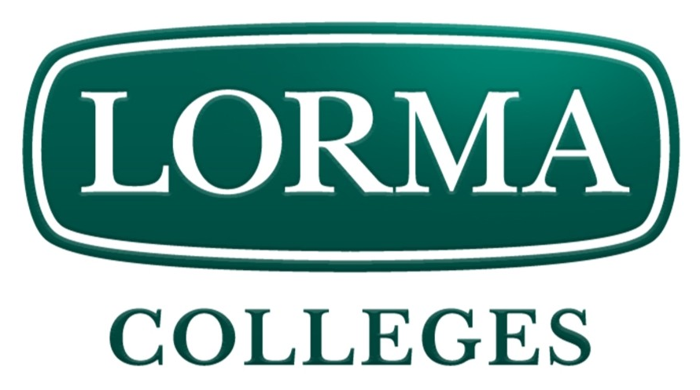 | 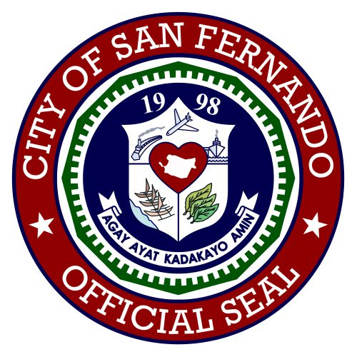 | 

CERTIFICATE OF VALIDATION
This is to certify that the survey questionnaire for the study entitled "SmartSpend: An AI-Assisted Mobile Financial Tracking and Advisory Application for Personal Financial Management," prepared by Directo, Brix A., Rubis, Cyrille John M., and Madayag, Djaunathan Albert S., BSIT students of Lorma Colleges, with the guidance of Dr. Ellen F. Mangaoang, DIT, research adviser, has been carefully reviewed, evaluated, and validated by the undersigned.
The instrument was assessed based on its relevance, clarity, accuracy, appropriateness, and alignment with the objectives of the study. The validator ensured that the survey items were suitable for measuring the financial management practices, budgeting challenges, and expense tracking behaviors of the target respondents — parents aged 35 to 55 and young professionals aged 21 to 35 in San Fernando City, La Union.
After thorough evaluation, the survey questionnaire is hereby certified as valid and appropriate for use in the conduct of the study, subject to the revisions and recommendations provided, if any.
Issued this ______ day of __________________, 2026.
Validated by:
______________________________________
______________________________________
______________________________________
______________________________________

