SmartSpend: An AI-Assisted Mobile Financial Tracking and Advisory Application for Personal Financial Management

A CAPSTONE Project
presented to the faculty of the
College of Computer Studies and Engineering
LORMA Colleges

In Partial Fulfillment
of the requirements for the degree
of Bachelor of Science in Information Technology

by:
Directo, Brix A.
Rubis, Cyrille John M.
Madayag, Djaunathan Albert S.
Ellen F. Mangaoang, DIT

November 2026
APPROVAL SHEET

This is to certify that we have supervised the preparation of the Capstone Project and read the manuscript prepared by DIRECTO, BRIX A., RUBIS, CYRILLE JOHN M., and MADAYAG, DJAUNATHAN ALBERT S. entitled SMARTSPEND: AN AI-ASSISTED MOBILE FINANCIAL TRACKING AND ADVISORY APPLICATION FOR PERSONAL FINANCIAL MANAGEMENT and that the said capstone project has been submitted for final examination by the Oral Examination Committee.

Ellen F. Mangaoang, DIT
Capstone Project Adviser
Shekiro R. Raposas, MIT
Capstone Teacher-in-Charge

As members of the Oral Examination Committee, we certify that we have examined this capstone project presented before the committee and hereby recommend that it be accepted in partial fulfillment of the capstone requirements for the degree in Bachelor of Science in Information Technology.

_______________________________
Jeoffrey B. Layco, MIS
Chairperson

_________________ _________________
Shekiro R. Raposas Mary-Ann Mzana
Member Member

This capstone project is hereby approved and accepted by the College of Computer Studies and Engineering in partial fulfillment of the requirements for the degree in Bachelor of Science in Information Technology.

_______________________________
Jeoffrey B. Layco, MIS
Dean, CCSE
ABSTRACT

Financial mismanagement remains a critical and documented challenge among Filipino households, compounded by limited access to accessible, localized, and intelligent financial tools. This study designed, developed, and evaluated SmartSpend — an AI-assisted mobile financial tracking and advisory application for Android, built primarily for parents aged 35–55 as the primary target population, and young professionals aged 21–35 as a secondary demographic, in La Union, Philippines.

SmartSpend integrates a multi-provider agentic large language model (LLM) architecture — with Gemini 3.5 Flash-Lite as the primary model and seven automatic fallback providers (eight total) — enabling 34 autonomous financial management actions through natural language, voice, camera, batch screenshot import (40+ platform types), and manual entry. The system operates on an offline-first SQLite database with Firebase cloud synchronization.

A core academic contribution is the Financial Health Score (FHS) — formally positioned as a Prototype Observed Financial Health Indicator (FHI), adapting ideas from the Commonwealth Bank of Australia and Melbourne Institute's (CBA-MI, 2018) Observed (transaction-data) scale and the Financial Health Network's FinHealth Score® pillars. It operates in two modes: Full Mode (Savings Rate, Overspend Control, Budget Adherence, Logging Consistency) and Lightweight Mode (Spending Restraint, Consistency, Category Balance, Habit Streak) — with Warning Decay and Logging Gap Detection mechanisms.

Usability was evaluated with the System Usability Scale (SUS) using 30 valid respondents from the target groups, yielding a mean score of 61.83 (SD = 17.58) and an adjective rating of “OK”, which is below the 68-point benchmark and is acknowledged as a limitation of the current prototype.
Keywords: personal finance management, agentic AI, large language model, financial health score, mobile application, Flutter, Filipino users, SmartSpend
ACKNOWLEDGEMENT

The researchers would like to express their sincere gratitude and appreciation to all the individuals who contributed to the successful completion of this study.

First and foremost, the researchers thank the Almighty God for His guidance, strength, wisdom, and blessings throughout the entire process of this research. His presence has been a source of hope and perseverance in overcoming challenges.

The researchers extend their heartfelt appreciation to the Dean of the College of Computer Studies and Engineering, Mr. Jeoffrey B. Layco, for his leadership and support in fostering an environment conducive to academic growth.

Special thanks are given to their Capstone Adviser, Ma'am Ellen F. Mangaoang, for the invaluable guidance, patience, and knowledge shared throughout the development of this study. The adviser’s insights and support played a significant role in shaping the direction and quality of this research.

The researchers would also like to thank their instructor in charge, Dr. Janelli M. Raposas, for providing direction, structure, and continuous reminders that helped ensure the completion of all requirements.

To the panelists, the researchers express their gratitude for their time, effort, and constructive feedback, which greatly contributed to improving the study.

The researchers also acknowledge the College of Computer Studies and Engineering faculty for equipping them with the necessary knowledge and skills in the field of Information Technology.

Finally, the researchers extend their deepest gratitude to their families and friends for their unwavering support, encouragement, and understanding throughout this journey. Their motivation and belief have been a constant source of strength.

The Researchers

DEDICATION

This study is dedicated to the people who have been a constant source of inspiration, support, and strength throughout this journey.

First and foremost, the researchers dedicate this work to their beloved parents, whose unconditional love, sacrifices, and encouragement have been the foundation of their perseverance. Their guidance and belief in the researchers made this achievement possible.

The researchers also dedicate this study to their friends and classmates, whose support, shared experiences, and encouragement helped make this journey more meaningful and manageable.

To their mentors and instructors, this work is also dedicated in appreciation of the knowledge, guidance, and inspiration they have provided throughout the researchers’ academic journey.

Lastly, this study is dedicated to future researchers who may build upon this work and continue advancing the field of information technology and financial systems.
BAD
CJMR
DASM
TABLE OF CONTENTS
Page
TITLE PAGE i
ACKNOWLEDGEMENT ii
DEDICATION iii
TABLE OF CONTENTS iv
CHAPTERS
I INTRODUCTION 1
Project Context 1
Figure 1.1. Financial Literacy Rates by Demographic
Group (BSP, 2021; Inquiro, 2024). 3-4
Table 1.1. Three-Level Gap Analysis of SmartSpend 4-5
Table 1.2. Feature Comparison of SmartSpend
with Existing Financial Applications 6-7
Conceptual Framework 11
Figure 1.2. Conceptual Framework 11
Statement of Objectives 12
Scope and Limitations of the Study 13
Purpose and Description 15
Beneficiaries of the Study 17
Technical Background 19

II DESIGN AND METHODOLOGY 26
Research Design 26
Population and Locale 28
Table 2.1. Distribution of Respondents 30
Ethical Considerations 31
Data Gathering Tools and Procedure 32
Figure 2.1. System Usability Scale (SUS)
Score Interpretation 34
Software Methodology 35
Figure 2.2. Agile Kanban Workflow for
SmartSpend Development 35
REFERENCES 65
APPENDICES 73
Appendix A – Survey Questionnaire 73
Appendix B – Consent Form 81
Appendix C – SUS Questionnaire 83
CURRICULUM VITAE 85
Chapter I

INTRODUCTION
This chapter presents the background of the study, including the context and motivation for developing the SmartSpend mobile application. It also discusses the objectives of the research, scope and limitations of the system, and its intended purpose and users. In addition, this chapter outlines the conceptual framework that guides the system design, as well as the technical background of the technologies used in the development of the proposed AI-powered financial assistant.

Project Context
Financial mismanagement is a documented and pressing problem in the Philippines. According to the 2021 Bangko Sentral ng Pilipinas (BSP) Financial Inclusion Survey, only 2% of Filipino adults correctly answered all six basic financial literacy questions — covering numeracy, interest rates, inflation, and risk — while fewer than half reported maintaining any household or personal budget (Bangko Sentral ng Pilipinas, 2021). The Philippine Statistics Authority Family Income and Expenditure Survey (PSA FIES, 2021) further revealed that a substantial proportion of Filipino households spend beyond their monthly income, with recurring expenditures on food, transportation, and utilities consistently outpacing savings. In Filipino households, parents aged 35 to 55 typically serve as primary financial decision-makers, managing budgeting, bill payments, and daily expenses, yet national survey data indicate that many adults still lack formal financial accounts and do not maintain written budgets, leaving household finances managed without structured tools or guidance (Bangko Sentral ng Pilipinas, 2021; Philippine Statistics Authority, 2021). Despite high mobile phone penetration in the country and growing global mobile app adoption (Statista, 2024), most Filipinos do not use structured financial management tools, citing manual effort, poor local language support, and lack of meaningful feedback as primary barriers to adoption (BSP, 2021; World Bank, 2022). Secondary analyses estimate that only around one in four Filipino adults meets international financial literacy benchmarks — far below neighboring countries such as Malaysia and Singapore where rates exceed 50% (Inquiro, 2024).
More recent data suggests this picture is beginning to shift, though unevenly. BSP's newer, annual Consumer Finance and Inclusion Survey (CFIS) 2025 reports that 74% of Filipinos now correctly answer basic financial literacy questions, up from 69% in 2021, alongside a reported decline in informal borrowing (Bangko Sentral ng Pilipinas, 2025). The same survey reports formal account ownership actually fell to 50% of adults, down from 56% in 2021 — even as BSP's related Consumer Expectations Survey found household-level financial access rising to 85%, up from 74% in 2024 — suggesting access is broadening at the household level while individual account ownership and structured budgeting habits remain uneven. This mixed picture, rather than a resolved problem, remains the motivation for this study.
Several studies and reports highlight persistent challenges in personal financial management among Filipino households. National financial inclusion surveys report that many adults have difficulty maintaining formal budgets, tracking expenses consistently, and building emergency savings, particularly in lower-income and older age groups (Bangko Sentral ng Pilipinas, 2021). These challenges are compounded by volatile prices, rising living costs, and the prevalence of informal credit arrangements, such as borrowing from relatives or neighborhood stores, which are often not recorded systematically in any tool or system (Philippine Statistics Authority, 2021; Flores, 2025).
A study on the financial freedom of Filipino workers further revealed pervasive literacy challenges, including reliance on traditional saving methods, high debt dependence, and a 'come-what-may' attitude toward financial planning — all of which contribute to weak financial resilience among Filipino households (Flores, 2025).
In the context of everyday life, parents and working adults frequently juggle multiple roles, including employment, caregiving, and managing household responsibilities. This leaves limited time and mental energy for manual expense recording or detailed financial planning. Traditional approaches, such as notebooks, spreadsheets, and simple expense trackers, rely heavily on user discipline and do not provide proactive feedback when spending patterns become risky. As a result, many users abandon these tools after an initial trial period, leading to incomplete records and a lack of useful historical data for decision-making (Stefanov et al., 2024; Flores, 2025).

Figure 1.1. Financial Literacy Rates by Demographic Group (BSP, 2021; Inquiro, 2024).
Globally, a variety of personal finance applications have emerged, including zero-based budgeting tools, multi-account financial dashboards, and AI-assisted expense trackers. However, many of these systems are designed for markets with widespread bank connectivity and higher levels of financial literacy, and they often depend on direct bank integration or credit card data feeds (Stefanov et al., 2024). In the Philippine context, existing applications and local solutions address specific aspects of financial management but still lack integrated conversational AI, spending behavior analysis, and health scoring tailored to Filipino users who rely on mixed payment methods such as cash, e-wallets, and informal credit (Bangko Sentral ng Pilipinas, 2021; Stefanov et al., 2024). At the demographic level, parents and young professionals may download budgeting apps but discontinue use when the effort of manual encoding is perceived as too high and when warnings can be ignored without visible consequences for their financial standing. Table 1.1 presents a three-level summary of the identified gaps and SmartSpend's corresponding solutions.
Table 1.1. Three-Level Gap Analysis of SmartSpend
Gap Level | Existing Problem | SmartSpend Solution
International | Manual entry dominates; AI categorization degrades for non-English transactions (Stefanov et al., 2024) | LLM-based parsing for Filipino-English natural language input
National (PH) | Local apps lack LLM chat, spending behavior analysis, and health scoring (Bangko Sentral ng Pilipinas, 2021; Stefanov et al., 2024) | Conversational AI + Financial Health Score + multi-period summaries
Demographic | Parents abandon apps due to manual effort; warnings ignored without consequences (BSP, 2021) | Automated input + score decay consequence system

Several existing applications demonstrate how mobile tools can support personal financial management but also reveal gaps that SmartSpend intends to address. Tarsi – Budget Tracker, a recently introduced application available in the Philippine App Store, supports offline expense tracking, receipt image capture, and category-based summaries, which makes it suitable for users who prefer manual or semi-automatic tracking (Tarsi – Budget Tracker, 2026). However, it does not provide a conversational assistant that can interpret natural language commands, nor does it compute a unified financial health score that reflects overall budgeting behavior. YNAB (You Need A Budget) implements a zero-based envelope budgeting method that is effective for debt payoff planning, but requires manual entry and a subscription cost that may be less accessible to Filipino users (Yomio, 2026). Monarch Money offers multi-account aggregation and net worth tracking but is designed for bank-connected markets and does not support offline functionality or Filipino locale inputs. Copilot provides AI-based expense categorization but is limited to iOS and does not support Filipino-English voice or OCR input. PocketGuard simplifies available spending into a single daily figure but lacks spending behavior analysis, health scoring, or multi-modal input. These comparisons demonstrate the value of existing digital financial tools but confirm that there is still room for a localized solution that combines offline capability, multi-modal expense input, and an accessible behavioral scoring mechanism. Table 2.1 summarizes the key feature differences.
Beyond the applications summarized in Table 1.2, several other Philippine-context finance apps compete in this space and are acknowledged here rather than treated as a gap SmartSpend uniquely fills. Agila: Finance Coach adds a business profile (invoices, inventory, collections) on top of personal tracking, with offline-first storage and no mandatory account (Agila: Finance Coach, 2026); PISO Budget Tracker offers fully offline, ad-free, payday-cycle budgeting (PISO Budget Tracker, 2026); Lista provides salary-cycle budgeting with third-party credit-score access (Lista, 2026); Kibo auto-suggests expense categories from text, receipts, or banking alerts (Kibo, 2026); and BunnyWise targets a broader investment dashboard (PSE and US stocks, UITFs, Pag-IBIG MP2, gold, crypto) rather than day-to-day expense tracking (BunnyWise, 2026).
GCash Pera Coach, an AI financial-literacy coach embedded in the GCash e-wallet (GCash / Mynt, 2026), is a related but distinct product: it answers financial-literacy questions on demand but does not track expenses or compute a health score. None of these offer SmartSpend's combination of Taglish conversational AI, a Financial Health Score, and multi-modal (voice, OCR, barcode, batch-screenshot) input in one offline-first app, and none were put through the same hands-on test protocol as the apps in Table 1.2; they are acknowledged here so that SmartSpend's contribution is read as an evaluated integrated prototype bundle rather than a claim of being the first or only Filipino finance app.
Table 1.2. Feature Comparison of SmartSpend with Existing Financial Applications (including Filipino-context apps)
Feature | Tarsi | YNAB | Monarch | Copilot | BudgetPH | Alkansya AI | SmartSpend
Offline mode | Yes | No | No | No | Yes | No | Yes
LLM chat assistant | No | No | No | No | No (insights only) | Yes (basic) | Yes
Financial Health Score | No | No | No | No | Yes (simpler) | No | Yes (0–100)
OCR receipt scanning | Yes | No | No | No | No | No | Yes
Voice input (en-PH) | No | No | No | No | No | No | Yes
Spending behavior analysis | No | No | No | No | No | No | Yes
Bank synchronization | No | Yes | Yes | Yes | CSV import | No | No
Free tier (Android) | Yes | No | No | No | Yes (PWA) | Limited | Yes
General financial Q&A | No | No | No | No | No | Yes | Yes
Market price estimates | No | No | No | No | No | No | Yes
Financial product guidance | No | No | No | No | No | No | Yes
Batch screenshot import (40+ platforms) | No | No | No | No | No | No | Yes
Multi-period spending limits | No | No | No | No | Yes | No | Yes
Filipino-English AI (Taglish) | No | No | No | No | No | Yes | Yes
Paluwagan tracker | No | No | No | No | Yes | No | No
15th & 30th payday cycle | No | No | No | No | Yes | No | No
Building on the gaps identified in the literature and the feature comparison above, SmartSpend addresses this gap by integrating a large language model (LLM) API for natural language expense parsing, a conversational AI assistant capable of executing financial actions, and a Financial Health Score (FHS) that quantifies a user's financial behavior on a scale of 0 to 100. The system operates offline using a local SQLite database with optional Firebase cloud synchronization, and supports voice, receipt OCR, barcode, and manual text AI chat, and a unified Smart Import system — including batch screenshot import that automatically detects 40+ platform types (GCash, Shopee, Steam, Lazada, GrabFood, and more) as input methods. Additionally, the application supports bulk transaction import through AI-powered text parsing, allowing users to paste transaction histories from digital wallets such as GCash and Maya, or from bank statements in various formats, for automatic parsing and categorization. It is designed for parents aged 35 to 55 and young professionals aged 21 to 35 in La Union, Philippines — two demographics identified in the literature as underserved by existing financial tools despite having significant household financial responsibilities.
Traditional financial tracking systems primarily function as passive tools where users manually record expenses and review static summaries (Stefanov et al., 2024). While these systems provide basic budgeting functionalities, they often fail to offer proactive assistance, personalized recommendations, and intuitive interaction methods. As a result, users may find financial tracking tedious, leading to inconsistent usage and incomplete financial records (Stefanov et al., 2024).
Recent advancements in artificial intelligence, particularly Large Language Models (LLMs), have started changing how mobile applications handle user interaction and data processing (Davenport & Mittal, 2022; Dwivedi et al., 2021). Instead of relying only on manual input, these systems can now interpret natural language and respond in a more conversational and task-oriented way (OpenAI, 2023; Hean et al., 2025). In practical terms, this allows users to simply describe their expenses or financial goals in plain language, and the system can convert these into structured data for recording and analysis. This shift makes financial tools feel less like traditional record-keeping apps and more like interactive assistants that support daily decision-making.
This study proposes SmartSpend, a mobile financial assistant built for Android devices using Flutter (Hean et al., 2025; OpenAI, 2023). Unlike traditional budgeting apps that require users to manually encode every transaction, SmartSpend combines an LLM-based API with structured financial tracking to reduce manual work. Users can enter expenses using natural language, such as “paid 120 pesos for lunch,” and the system automatically extracts key details like amount, category, and date for storage and analysis (Hean et al., 2025; OpenAI, 2023). This design is intended to make expense tracking more natural and less time-consuming for everyday users.
Beyond expense tracking, SmartSpend features a conversational AI assistant capable of executing real-time actions such as logging expenses, setting budgets, updating income, and creating savings goals directly from natural language commands. The system also generates a Financial Health Score ranging from 0 to 100 based on user spending patterns, consistency in budgeting, and savings behavior. Instead of only showing raw transactions, this score provides a simple reference point that helps users quickly understand whether their financial behavior is improving or declining over time. This makes it easier for users to reflect on their habits without manually analyzing every expense entry.
To reduce the effort required in recording expenses, SmartSpend supports multiple input methods. Users can manually encode expenses, but they can also take photos of receipts, scan barcodes, or use voice input to record transactions. These methods are designed to fit real-life situations—for example, quickly scanning a receipt after shopping or speaking expenses while on the move. Optical Character Recognition (OCR) is used to extract text from receipts, while barcode scanning helps identify products more efficiently.
The application uses local SQLite storage via the sqflite package (version 11) for offline functionality, ensuring accessibility even without an internet connection. The system implements bidirectional cloud synchronization using Firebase Firestore, automatically pushing data to the cloud and retrieving it upon login to merge with local records. This enables seamless multi-device access to financial data (Google, 2024c). Firebase Authentication supports secure login methods including email/password, Google Sign-In via OAuth 2.0, and biometric authentication (Google, 2024a).
Furthermore, the system analyzes financial data, generates summaries, and provides actionable insights and recommendations (Hean et al., 2025). This study contributes to financial technology by demonstrating how AI-driven automation and mobile-based interaction can enhance personal financial management (Hean et al., 2025; Dwivedi et al., 2021).
To improve accessibility and reduce barriers to adoption, SmartSpend includes a Demo Mode accessible directly from the login screen without requiring account creation. This feature allows users to explore the system using realistic sample data before registration (Bitrián et al., 2021). Additionally, the application includes a guided feature tour, customizable themes, and dark mode support to enhance usability, engagement, and user satisfaction across different preferences and environments (Stefanov et al., 2024).

Conceptual Framework

Figure 1.2 Conceptual Framework (Mobile Application)
This figure illustrates the conceptual framework of the mobile version of the SmartSpend system, which follows the Input–Process–Output (IPO) model. The input includes text input, voice input, receipt images (OCR), barcode scans, and user financial data. The process involves LLM processing, OCR extraction, barcode recognition, data structuring, and data storage and synchronization using SQLite and Firebase. These components work together to extract, analyze, and organize financial data efficiently. The output consists of auto-recorded expenses, financial summaries, charts, alerts, AI-generated insights, a Financial Health Score (0–100), and AI-powered financial assistance including general financial question-and-answer responses, market price estimates, and financial product guidance.

Statement of Objectives
This study aims to design, develop, and evaluate SmartSpend, an AI-assisted mobile financial tracking and advisory application for personal financial management, with a primary focus on parents aged 35 to 55 as the main target population, and young professionals aged 21 to 35 as a secondary demographic, in La Union, Philippines.
In order to achieve the overall aim of this research, it is important to understand the key factors that influence the money management behavior of parents and young professionals and develop a solution that addresses these challenges. This study focuses on assessing the existing financial practices of parents and young professionals in La Union, designing and developing an AI-based mobile application — including the selection of a suitable large language model through comparative evaluation — that addresses identified gaps, and evaluating its usability through expert-validated instruments and standardized scoring.

Specifically, this study aims to:
1. Assess the existing financial management practices, common budgeting challenges, and expense tracking behaviors of parents aged 35 to 55 and young professionals aged 21 to 35 in San Fernando City, La Union, through structured surveys.
2. Design and develop the SmartSpend mobile application, including its system architecture, database structure, user interface, and core functionalities such as multi-modal expense input, automated data processing, cloud-based synchronization, and the integration of a suitable Large Language Model (LLM) API — using a context injection architecture — selected through a comparative technical evaluation of available providers based on inference speed, response accuracy for Filipino-English natural language processing, context window capacity, and cost feasibility for academic deployment.
3. Evaluate the usability and performance of the SmartSpend application using the System Usability Scale (SUS) and user feedback analysis.
Scope and Limitations of the Study
As far as technology is concerned, the application supports both online and offline functionality, using a local SQLite database to store financial data and ensure accessibility even without an internet connection. The system optionally integrates cloud-based storage and authentication services through Firebase. The software utilizes an LLM API to generate AI-powered insights, parse natural language inputs, and support the conversational assistant. The conversational AI assistant is also designed to respond to general financial inquiries beyond the scope of the user's recorded data, including questions about Philippine banking products, government financial services, market price estimates for goods and second-hand items, and general personal finance guidance, subject to the availability of accurate information from the underlying language model. However, the system will only be available on Android devices.
The system has several limitations. The performance of OCR text recognition will depend on the quality and clarity of receipt images, and handwritten or low-quality images may produce inaccurate results. Voice recognition accuracy will be affected by background noise and device support for the Filipino English (en_PH) locale. To address these issues, manual input options will remain available after using OCR, barcode scanning, or voice input features. All AI-powered features, including expense parsing, financial insights, and the conversational assistant, will require an active internet connection, as they rely on an external LLM API service. The application will not support direct banking integration. Bank synchronization is excluded due to the absence of accessible open-banking APIs in the Philippine setting and the data privacy implications of transmitting banking credentials to a third-party service. Investment features are outside scope as the target population primarily requires support for day-to-day expense control and savings discipline rather than investment optimization. The application will not provide professional financial or tax advice. Any financial estimates generated by the system will be approximations based on simplified models. Market price estimates provided by the AI assistant are based on the language model's training data and optional web search results, and may not reflect real-time pricing. Users are advised to verify prices through official sources before making financial decisions. Additionally, profile images will be stored locally on the device and will not be synchronized across devices due to limitations of the Firebase Spark (free) plan. The system is designed within the constraints of free-tier services and will remain limited to Android platform compatibility.
The LLM API key is not embedded within the application package. Instead, it is fetched at runtime via Firebase Remote Config rather than being hard-coded into the APK. This is a prototype-stage measure only — Remote Config values are still retrievable from a decompiled client, so the key is not fully secret from a determined attacker. To mitigate potential misuse, the system enforces a daily interaction limit of 150 AI requests per user, which resets automatically. A backend proxy server for fully server-side API key management is planned as a post-capstone enhancement to further align with production-level security practices.
SmartSpend processes personal financial data and is therefore designed with the Philippine Data Privacy Act of 2012 (Republic Act No. 10173) in mind. Rather than claiming full legal compliance — which requires organizational and legal measures beyond what a capstone prototype can establish — the system implements a data-minimization control: before any OCR or pasted transaction text is sent to a cloud LLM, an on-device regex layer redacts Philippine mobile numbers, GCash/bank reference numbers, and bank account patterns, replacing them with placeholder tokens (e.g., [REDACTED_MOBILE]). Core financial records remain in the on-device SQLite database, and any Firebase Firestore sync is scoped to the authenticated user's own UID. This is a risk-reduction measure, not a guarantee of complete data protection or a certification of legal compliance.

Purpose and Description
SmartSpend is designed as a mobile application that helps users manage their daily expenses in a more organized and less manual way, addressing the core dimensions of perceived usefulness and ease of use that drive technology adoption (Davis, 1989). Instead of functioning only as a tracking tool, it also acts as a lightweight financial assistant that can respond to user inputs and provide simple insights about spending behavior.
Beyond expense tracking and data management, the SmartSpend AI assistant serves as a general financial companion. Users may freely ask about current market prices of goods and second-hand items, inquire about the application process for banking products and government financial services such as SSS, PhilHealth, and Pag-IBIG, seek advice on buying and selling decisions, and explore basic financial literacy topics—all within a conversational interface that adapts to the user's needs.
The assistant is designed to be flexible and approachable, using a warm and conversational tone that reflects the everyday financial realities of Filipino users, rather than functioning as a rigid, task-only interface.
To further support healthy financial behavior, SmartSpend incorporates a behavioral intervention layer grounded in principles of behavioral finance. An Impulse Pause mechanism prompts users to reflect before confirming large Want-tagged expenses, encouraging more deliberate spending decisions. In addition, velocity alerts notify users when their spending rate significantly exceeds typical patterns. The system also includes a daily mood check-in feature that tracks emotional states alongside financial activity, enabling a mood-and-spending correlation view.
A gamification layer featuring 36 achievement badges and spending streak tracking further reinforces positive financial habits by rewarding consistent logging and budget adherence. This feature helps users recognize how emotional states may influence financial decisions—an important factor in impulsive spending behavior (Bitrián et al., 2021).
SmartSpend functions not only as an expense tracker but also as an AI-powered assistant that enhances users’ financial literacy. The proposed solution provides benefits to the following groups:
Beneficiaries of the Study
Parents (Ages 35–55). As primary household financial managers in Filipino families, parents face significant financial responsibility despite having limited access to formal financial literacy training and structured budgeting tools (Bangko Sentral ng Pilipinas, 2021). SmartSpend provides automated expense tracking, multi-period financial summaries, and a Financial Health Score that quantifies budgeting behavior without requiring manual effort or financial expertise.
Budget-Conscious Individuals (e.g., Young Professionals and Mobile Application Users). This group includes individuals who aim to manage their finances more effectively using digital tools. SmartSpend enables users to control expenses, plan budgets, and improve financial behavior through AI-driven spending analysis. The application supports multiple expense input methods, including manual entry, voice input, and camera-based receipt or barcode scanning. It also provides financial summaries, charts, alerts, and recommendations, along with a wallet management feature that tracks balances across platforms such as GCash, Maya, and bank accounts, offering a consolidated view of available funds.
Technology Enthusiasts. Individuals interested in modern technological advancements can explore the application’s integration of artificial intelligence, particularly the use of a large language model for financial assistance and interaction.
Demo and Evaluation Users. Users who wish to explore the application without creating an account can utilize the built-in Demo Mode, accessible from the login screen. This mode provides realistic Filipino sample data and full feature access, making it suitable for demonstrations, evaluations, and usability testing without requiring personal data entry.
The Researchers. The project enabled the researchers to apply their knowledge and skills in software development and artificial intelligence in a practical setting.
Future Researchers. Future researchers may use this study as a reference in the fields of artificial intelligence, mobile applications, and financial technology. The analytics module, including the 50/30/20 budgeting tracker, supports financial awareness by comparing actual spending distribution against recommended allocation standards, making the Financial Health Score transparent and interpretable.
Technical Background
In this part, we describe technologies that was used during designing and building of the SmartSpend mobile application. They are critical to make the implementation of features described above possible.
Flutter. Flutter is an open-source UI framework developed by Google that was used to build the SmartSpend Android application. It provides a rich set of widgets and tools that enable the development of a responsive, visually consistent, and feature-rich mobile interface (Google, 2024f).
SQLite. The application uses SQLite as its primary local database via the sqflite package (version 11), storing all financial data including expenses, budgets, savings goals, income, recurring transactions, debts, and chat history directly on the device. Expenses are categorized across 14 expense types — including Food, Transportation, Gaming, Personal Care, Clothing, Gifts, and Travel — and tagged by payment method, supporting GCash, Maya, GrabPay, ShopeePay, debit and credit cards, and bank transfers. This ensures full offline functionality without requiring an internet connection (Roux, 2019).
Firebase Firestore. Firebase Firestore was used for bidirectional cloud synchronization of user financial data. Every write operation is automatically pushed to Firestore, and upon login, the application retrieves cloud data and merges it into the local database, enabling seamless multi-device access to financial records (Google, 2024c).
Firebase Authentication. Firebase Authentication handles user identity management, supporting email/password login, Google Sign-In via OAuth 2.0, and biometric authentication (fingerprint or face unlock) as a convenience layer after the user's first successful login (Google, 2024a).
Firebase Crashlytics. Firebase Crashlytics is integrated for real-time crash reporting. It captures Flutter framework errors and asynchronous exceptions and report them to the Firebase Console for monitoring and debugging (Google, 2024b).
LLM API Integration. The system integrates a large language model (LLM) API as its AI engine, selected through a comparative technical evaluation of available providers based on inference speed, response accuracy for Filipino-English natural language processing, context window capacity, and cost feasibility for academic deployment. As of this writing, Gemini 3.5 Flash-Lite (Google) is the primary model, backed by seven automatic fallback providers spanning Google, Groq, and Cerebras so the assistant keeps working if any single provider is unavailable or rate-limited. The full benchmarking methodology and results are presented in Chapter 3.
The system is designed with a modular LLM integration layer, meaning the underlying model can be replaced with a more capable or efficient alternative in future iterations without requiring major changes to the overall system architecture. To protect user privacy, the system minimizes personally identifiable information in API requests. Only the user's natural language input and an anonymized financial summary — expense amounts, categories, and budget status — are transmitted. No authentication credentials, account numbers, or raw profile data are included in API requests, ensuring that sensitive personal information remains on the device or within the application's secure cloud storage.
This component handles multiple tasks across the application: (1) parsing natural language expense descriptions into structured data for automatic recording; (2) generating proactive spending insights and personalized financial recommendations based on the user's recorded data; (3) powering a flexible conversational AI assistant capable of answering general financial questions, providing market price estimates, explaining Philippine banking and government financial products, supporting buying and selling decisions, and executing real-time data actions — all while maintaining a warm, conversational tone appropriate for everyday Filipino financial life; and (4) periodically summarizing conversation history to maintain context efficiency without consuming excessive API tokens.
To maintain token efficiency without sacrificing conversational continuity, the system implements a conversation summarization mechanism. Rather than sending the full chat history to the LLM API with each request, the system periodically generates a compressed summary of prior exchanges. This summary captures only financially relevant context — logged expenses, discussed goals, expressed preferences, and notable decisions — and is stored locally alongside the full chat history. Subsequent API calls receive the compressed summary plus the most recent messages, significantly reducing token consumption while preserving the AI's awareness of ongoing financial discussions. The full chat history remains intact and visible to the user at all times.
Speech-to-Text. The speech_to_text package was used to implement voice input for expense recording. The system automatically detects the Filipino English (en_PH) locale, with a fallback to en_US, and supports a 15-second listening window with automatic pause detection (Sloane, 2022).
Google ML Kit Text Recognition (OCR). Google ML Kit’s Latin script text recognizer was used to extract text from receipt images. The extracted text is cleaned, trimmed, and processed through an intelligent routing mechanism. For single-item receipts, the extracted text is passed directly to the AI chat interface for natural language parsing and automatic expense recording. For multi-item receipts, the system detects multiple line entries and routes the data to a dedicated import review screen, where each item is parsed individually using a specialized receipt parsing function. Users can review extracted entries, edit categories, assign Want or Need classifications, and selectively import items before confirming. This dual-flow design improves usability by supporting both quick single-entry recording and efficient bulk transaction processing from detailed receipts. Users have the option to capture a new image or select one from the gallery (Google, 2024e).
Mobile Scanner (Barcode). The mobile_scanner package was used for barcode scanning. Each scan is saved to a local scan history, and a prompt asks the user to describe the product before AI parsing. The scanner includes a torch toggle and a visual overlay guide frame (Bociek, 2023; ZXing, 2023).
Backup and Restore. The application implements backup and restore functionality through the system share sheet. All financial data including expenses, budgets, savings goals, income, recurring transactions, debts, wallet balances, mood log, and installment plans is exported as a structured JSON file (version 9 format) that can be shared via any installed application or saved to local storage. Restoration is performed by selecting a previously exported JSON backup file. This approach ensures data portability without requiring additional cloud service dependencies beyond the existing Firebase synchronization.
fl_chart. The fl_chart package was used to render interactive charts in the Analytics screen, including a pie chart for category breakdown, a bar chart for monthly spending trends, and a line chart for the 30-day Financial Health Score history (Flutter 4 Fun, 2022).
local_auth. The local_auth package enables biometric authentication (fingerprint or face unlock) as a login option after the user’s first successful login, using the device’s enrolled biometrics with a PIN fallback (The Flutter Authors, 2013).
Financial Health Score (FHS). SmartSpend introduces a Financial Health Score ranging from 0 to 100 that provides users with a single, interpretable indicator of their budgeting behavior. The score operates in two modes depending on the user's settings. In **Full Mode** (income tracking enabled), it is computed from four equally weighted components: Savings Rate, Overspend Control, Budget Adherence, and Logging Consistency each contributing 25% to the total score. In **Lightweight Mode** (income tracking disabled), the four components are: Spending Restraint (vs. a user-defined spending limit), Logging Consistency, Category Balance (preventing any single category from dominating spending), and Habit Streak (consecutive days of expense logging). This dual-mode design makes the system usable for individuals who do not have a fixed income, such as students and informal workers, without penalizing them for not setting income data. The detailed formula, component weights, and consequence mechanism are fully documented in Chapter 3: Results and Discussion.

CHAPTER II
DESIGN AND METHODOLOGY
This chapter presents the methods and procedures that were used in the development, implementation, and evaluation of the SmartSpend system. It includes a detailed discussion of the research design, population and locale, ethical considerations, data gathering tools and procedures, and the software development methodology applied in the study.

Research Design
This study applied a mixed methods research design, which integrates both qualitative and quantitative approaches in collecting and analyzing data (Creswell & Plano Clark, 2011). This design is appropriate for the study because it allows the researchers to obtain a comprehensive understanding of financial management practices and system usability by combining numerical data with detailed user experiences. Through this approach, the researchers were able to capture both measurable trends and deeper insights into user behavior, preferences, and challenges.
To address the qualitative aspect of the study, only surveys, not interviews, were used to gather respondents’ views regarding the features and functionality of the developed application. The qualitative data provided descriptive information that guided the design and improvement of the application.
On the other hand, the quantitative aspect of the study involved the use of validated structured survey questionnaires, which underwent content validation by subject matter experts to ensure clarity, relevance, and alignment with the objectives of the study. These questionnaires were used to collect measurable data regarding financial habits, expense tracking practices, and common difficulties encountered by the respondents. The collected data were analyzed to identify patterns, frequencies, and trends that supported the development of system features aligned with user needs. In addition, the System Usability Scale (SUS) questionnaire was utilized to evaluate the usability, efficiency, and overall user satisfaction of the developed SmartSpend application. The SUS is a widely used and reliable tool for assessing system usability through standardized scoring (Brooke, 1996). The SUS evaluation was administered to the thirty (30) valid respondents following a live demonstration of the SmartSpend application. A target SUS score of 80 or above, corresponding to the adjective rating of Good, has been set as the acceptance threshold for this study (Bangor et al., 2009).
Moreover, this study adopted a descriptive-developmental research approach, which focuses on the design, development, and evaluation of a functional system or prototype. The SmartSpend mobile application was developed using the Flutter framework, with the integration of artificial intelligence through an LLM API. This approach enabled the researchers to iteratively improve the system based on the data gathered from both qualitative and quantitative methods.
By combining mixed methods and developmental approaches, the study ensures that the system is not only technically functional but also user-centered, effective, and aligned with the actual needs of the respondents. This integrated research design supported continuous refinement and validation of the SmartSpend application throughout the development process.
Population and Locale
The study was conducted in San Fernando City, La Union. The primary target population of this study consists of parents aged 35 to 55 who serve as the principal household financial decision-makers in Filipino families. Based on the 2021 BSP Financial Inclusion Survey, this demographic group manages the majority of household budgeting, bill payments, and daily financial decisions, yet exhibits the lowest rates of formal financial account ownership and structured budgeting behavior among all adult demographics (Bangko Sentral ng Pilipinas, 2021). A secondary population of young professionals aged 21 to 35 is also included, representing working individuals who independently manage their own income and expenses and represent a growing segment of digital financial tool users in the Philippines. For the purposes of this research, parents are defined as adults aged 35 to 55 who act as primary household financial managers. According to the 2021 BSP Financial Inclusion Survey, this age group represents the principal financial decision-makers in Filipino households and is among the demographics with the lowest rates of structured budgeting despite having the highest household financial responsibility (Bangko Sentral ng Pilipinas, 2021). Young professionals are defined as working individuals aged 21 to 35 who independently manage their own income and expenses. This age range aligns with the classification used by the BSP Financial Inclusion Survey and the Philippine Statistics Authority's Labor Force Survey, which identify 20–35 year-olds as early-career workers who are entering the formal workforce and beginning to establish independent financial management habits (Bangko Sentral ng Pilipinas, 2021; Philippine Statistics Authority, 2021).
A total of thirty (30) respondents were selected using purposive sampling. Thirteen (13) respondents were parents who regularly handle household budgeting, bill payments, and daily expense decisions. Fourteen (14) respondents were young professionals who manage their own income, track expenses, and make independent financial decisions. Three (3) respondents identified as both. This sample size aligns with common practice for capstone-level usability and needs assessment studies and is sufficient to identify common patterns and usability issues in the context of the developed application (Creswell & Plano Clark, 2011).
This demographic composition reflects evidence from the BSP Financial Inclusion Survey (2021) that parents in the 35 to 55 age group serve as primary household financial decision-makers and are among the groups with the lowest rates of formal financial account ownership and structured budgeting — making them a critical and underserved target population for a financial management tool (Bangko Sentral ng Pilipinas, 2021).
The survey questionnaire was reviewed by Susan C. Arquisal, a graduate of Bachelor of Science in Commerce major in Management and an active business owner with experience in financial management and business operations, prior to distribution. This review ensures that the questions are appropriate, relevant, and grounded in the actual financial management experiences of the target population.
Respondents participated in the needs assessment phase and the system evaluation phase; the two samples were separate groups, although some individuals may have taken part in both. Their feedback was essential in identifying real-world financial challenges and in assessing the usability, effectiveness, and practicality of the SmartSpend mobile application in supporting everyday financial management for both parents and young professionals.
The distribution of respondents is presented in Table 2.1.

Table 2.1. Distribution of Respondents
Category: | Number of Respondents:
Parents (Ages 35–55) | 13
Young Professionals (Ages 21–35) | 14
Both Groups | 3
Total | 30
Validators / Experts: | Number of Validators/Experts:
Content Validator (Survey) | 1
Technical Validator (System & SUS Process) | 1
Total Validators | 2
The survey questionnaire underwent content validation by a subject matter expert in financial management and business operations to ensure relevance, clarity, and appropriateness of the instrument. The System Usability Scale (SUS) evaluation process and the overall technical functionality of the SmartSpend system was reviewed by a subject matter expert in information technology, whose qualifications are documented in the Technical Validation Certificate. This expert validation covers both the correctness of the SUS evaluation process and an independent assessment of the system's core technical features.
The researchers utilized purposive sampling in selecting participants. This method allows the intentional selection of individuals who have relevant experience in budgeting, expense tracking, and financial decision-making, ensuring that the collected data is meaningful and directly aligned with the research objectives.
Ethical Considerations
All ethical considerations were strictly followed throughout the entire research process. Participation in this study was voluntary, and no form of pressure was imposed on the respondents. All participants, including parents and young professionals, had the right to refuse participation or withdraw from the study at any time without any penalty.
Informed consent was obtained from all participants before their involvement in the study. They were properly informed about the nature and purpose of the research prior to their participation.
In addition, confidentiality was strictly maintained. Personal information of the respondents was kept secure and treated with utmost confidentiality. All responses gathered were used solely for academic purposes.
Furthermore, all collected data were carefully managed and stored to prevent any form of loss or unauthorized access. The researchers ensured that ethical standards were upheld throughout the study.
Data Gathering Tools and Procedure
For the first objective, data were gathered through a survey questionnaire. The survey questionnaire was used to collect quantitative data regarding the financial management practices, budgeting challenges, and expense tracking behaviors of parents and young professionals. The survey questionnaire was subjected to content validation by a subject matter expert to ensure that the questions are appropriate, relevant, and grounded in the actual financial management experiences of the target population. No interviews were conducted; qualitative insights into respondents’ experiences and difficulties were derived from the survey responses.
For the second objective, no direct data gathering instrument was used for the design and development phase, as the results obtained from the first objective served as the primary basis for system design and implementation. However, technical benchmarking was conducted as part of this objective to support the AI engine selection process. A comparative evaluation of candidate large language model (LLM) APIs was performed across multiple providers. Each candidate was assessed across four criteria: (1) inference speed, measured as average response latency in seconds for a standardized expense parsing prompt; (2) response accuracy for Filipino-English natural language processing, evaluated using a set of test prompts representing typical user inputs in Filipino, Taglish, and English; (3) context window capacity, defined as the maximum number of tokens the model can process in a single request; and (4) cost feasibility, evaluated based on the availability of a free-tier API plan appropriate for academic deployment. The benchmarking results and justification for the final model selection are presented in Chapter 3.
For the third objective, data were collected using the System Usability Scale (SUS) questionnaire, a standardized tool used to evaluate system usability. Respondents assessed the application in terms of ease of use, functionality, and overall user experience. The implementation and administration of the usability evaluation were reviewed by subject matter experts to ensure that the evaluation process aligns with appropriate usability testing practices. Additional feedback was also collected to support the evaluation results.
Step-by-Step Data Gathering Procedure
Step 1: Questionnaire Preparation and Validation (Objective 1)
The survey questionnaire was drafted by the research team and submitted to a subject matter expert in financial management for content validation. The expert's credentials was recorded in the Content Validation Certificate (Appendix A). Revisions were made based on the feedback before distribution.
Step 2: Respondent Identification and Consent (Objective 1)
Thirty (30) respondents were identified using purposive sampling based on the defined inclusion criteria. Each respondent received a consent form explaining the purpose of the study, their rights, and the confidentiality of their responses.
Step 3: Survey Distribution and Collection (Objective 1)
The validated questionnaire was distributed to the respondents (13 parents, 14 young professionals, and 3 who identified as both).
Step 4: LLM Technical Benchmarking (Objective 2)
Candidate LLM APIs were comparatively evaluated using standardized Filipino-English expense-parsing prompts. Response latency, accuracy, context window, and cost were recorded and compared.
Step 5: System Demonstration and SUS Evaluation (Objective 3)
After system development, respondents were given a live demonstration of SmartSpend using the built-in Demo Mode. They then independently completed the 10-item SUS questionnaire.

Step 6: Data Tabulation and Analysis
Survey responses were tallied and analyzed using frequency and percentage. SUS scores were computed for each respondent and averaged to produce the final SUS score.

Figure 2.1 System Usability Scale (SUS) Score Interpretation
This figure illustrates the interpretation of the System Usability Scale (SUS) scores that was used to evaluate the usability of the SmartSpend system. The SUS score ranges from 0 to 100 and is categorized into different levels: Poor (below 60), Marginal (60–69), Acceptable (70–79), Good (80–89), and Excellent (90–100). Higher scores indicate better usability, user satisfaction, and system performance, while lower scores suggest the need for improvements. This scale serves as a standardized tool to assess how effectively and efficiently users can interact with the system.
Software Methodology

Figure 2.2. Agile Kanban Workflow for SmartSpend Development
The development of the SmartSpend mobile application followed the Agile Kanban Software Development Methodology. This approach was selected because the project requires continuous feature integration, testing, and refinement, especially due to the involvement of multiple components such as artificial intelligence, OCR processing, and cloud synchronization. Unlike traditional development models that follow a strict and linear sequence, Kanban allows the researchers to work on tasks dynamically, with phases potentially overlapping or repeating as needed, while continuously improving the system based on feedback and testing results.
To implement this methodology, the researchers utilized a Kanban board that visually represents the workflow of the project. The board was divided into several columns, namely: Backlog, Requirements, Design, Development, Testing, Deployment, and Done/Review. Each task related to the system such as implementing OCR, integrating the LLM API, or designing the database schema were represented as individual task cards. These cards moved across the board depending on their current progress. Work-in-progress (WIP) limits were also applied to ensure that the researchers focus only on a manageable number of tasks at a time, preventing overload and maintaining productivity.
In the Backlog Phase, all planned features and system requirements were first listed and organized. This includes core functionalities such as expense tracking, AI-powered parsing, Financial Health Score computation, voice input integration, receipt scanning, and cloud synchronization. The researchers also included minor features such as theme customization, demo mode, and onboarding tutorials. Each feature was broken down into smaller, actionable tasks to make development more manageable.
During the Requirements Phase, the researchers gathered data through a survey of selected respondents aligned with the study’s target population of parents and young professionals. This phase aims to identify real-world financial management practices, common challenges in expense tracking, and user expectations for a financial application. Based on the collected data, the researchers defined both functional requirements (e.g., automatic expense logging, AI recommendations) and non-functional requirements (e.g., usability, performance, offline capability).
In the Design Phase, the researchers translated the identified requirements into a concrete system structure. This includes designing the application architecture, database schema, and data flow. Specifically, the SQLite database structure was mapped to handle tables such as expenses, income, budgets, savings goals, and chat history. The researchers also designed how data flows between the mobile application, the LLM API, and Firebase services. Additionally, interface layouts and user navigation flows were planned to ensure that the application remains simple and user-friendly despite having advanced features.
The Development Phase involved the actual implementation of the system using the Flutter framework. The researchers developed the application incrementally by focusing on one feature at a time. For example, the basic expense tracking module was developed first, followed by the integration of AI parsing through the LLM API. After that, additional features such as OCR using Google ML Kit, barcode scanning, and voice input were implemented. Firebase services, including Firestore and Authentication, were also integrated during this phase to support cloud synchronization and secure login. Each completed feature was tested individually before being merged into the main application.
In the Testing Phase, the researchers conducted both functional and usability testing. Functional testing ensured that each feature operates correctly, such as verifying if the OCR accurately extracts receipt data or if the AI correctly categorizes expenses. Usability testing involved selected respondents who used the application and evaluated their experience using the System Usability Scale (SUS). The researchers also observed user interactions to identify difficulties, confusion, or inefficiencies within the system. Any issues discovered during this phase were documented and fed back into the Development phase for refinement and correction.
During the Deployment Phase, the completed SmartSpend application was deployed to Android devices for actual usage and evaluation. The researchers prepared the application for demonstration and evaluation by ensuring that all features are stable and properly integrated. Demo Mode was also activated to allow users to explore the system without requiring account registration, making it easier to conduct presentations and usability testing.
Finally, in the Done/Review Phase, the researchers evaluated the overall performance and effectiveness of the system. This includes analyzing SUS scores, reviewing user feedback, and assessing whether the application meets its intended objectives. The researchers identified which features performed well and which areas require improvement. Insights gathered from this phase was used to refine the system and provide recommendations for future development, such as adding bank integration or improving AI accuracy. Based on the iterative development process, several features have been identified for future implementation beyond the scope of this study. A multi-wallet system enabling separate tracking of GCash, Maya, and bank balances has been fully implemented in the current version. The system supports 20 Philippine banks and 5 digital banks, plus e-wallets (GCash, Maya, GrabPay, ShopeePay, BDO, BPI, Metrobank, and more), with automatic balance deduction upon expense logging and wallet-to-wallet transfer functionality. Automated transaction parsing through Android notification listeners, while technically feasible, requires sensitive permissions subject to platform policy restrictions and is therefore deferred. Additional enhancements include the implementation of a backend proxy server for secure LLM API key handling, PDF export functionality for financial summaries, and SQLite database encryption. Long-term extensions such as investment tracking for Philippine financial instruments and shared family wallet functionality will require expanded system architecture and are proposed for subsequent research.
The phases of the Kanban workflow, together with their key tasks and deliverables, are summarized in Table 2.2.
Table 2.2. Agile Kanban Workflow Phases and Deliverables
Phase | Key Tasks | Deliverable
Backlog | Define features; needs survey; literature review on PH financial gaps | Prioritized feature list; literature review
Requirements | Translate findings into specs; validate questionnaire; LLM API benchmarking | Validated questionnaire; LLM benchmarking matrix (Table 3.2)
Design | SQLite schema (26 tables); FHS formula; UI wireframes; data flow diagrams | System architecture; FHS documentation
Development | Build expense tracking; integrate Gemini 3.5 Flash-Lite; add OCR/voice/batch screenshots; FHS engine; Firebase sync; gamification | Functional app; all 34 agentic actions operational
Testing | LLM parsing accuracy; SUS with 30 respondents; survey feedback; bug log | SUS scores; parsing observations; bug documentation
Deployment | Build release APKs; prepare Demo Mode; publish GitHub Releases | Release APKs v3.1.0; project documentation
Done/Review | Analyze SUS scores; review feedback; document recommendations | Final evaluation report; post-capstone roadmap
CHAPTER III
RESULTS AND DISCUSSION
This chapter presents the results of the study in relation to the three objectives stated in Chapter I. It reports the findings of the survey on the financial management practices of parents and young professionals, the comparative evaluation of large language model (LLM) APIs, the computation of the Financial Health Score, the development and features of the SmartSpend mobile application, and the results of the usability and performance evaluation using the System Usability Scale (SUS). Each section ends by stating whether the corresponding objective was achieved.
Assessment of the Financial Management Practices, Budgeting Challenges, and Expense Tracking Behaviors of Parents and Young Professionals
The first objective was to assess the existing financial management practices, common budgeting challenges, and expense tracking behaviors of parents aged 35 to 55 and young professionals aged 21 to 35 in San Fernando City, La Union. Data were gathered through a structured online questionnaire (Financial Management Practices survey) completed by respondents from the target groups.
Table 3.1 presents the demographic profile of the 30 respondents and the expense tracking methods they reported. The sample comprised 13 parents aged 35–55 (43.3%), 14 young professionals aged 21–35 (46.7%), and 3 respondents identifying as both (10.0%). In terms of employment, 10 were employed full-time (33.3%), 9 were freelance or contractual (30.0%), 8 were self-employed (26.7%), and 3 were unemployed or part-time (10.0%). GCash was used by 93.3% of respondents (28/30), confirming the relevance of e-wallet transaction import as a core feature.
Table 3.1. Demographic Profile and Expense Tracking Methods of Respondents (N = 30)
Item | Parents (n = 13) | Young Professionals (n = 14) | Both (n = 3) | Total (N = 30)
A. Demographic profile, f (%)
Parents aged 35–55 | 13 (43.3%)
Young professionals aged 21–35 | 14 (46.7%)
Both groups | 3 (10.0%)
Employed full-time | 10 (33.3%)
Freelance or contractual | 9 (30.0%)
Self-employed | 8 (26.7%)
Unemployed or part-time | 3 (10.0%)
GCash users | 28 (93.3%)
B. Expense tracking methods used, f (%)
Receipts | 11 (84.6%) | 13 (92.9%) | 3 (100.0%) | 27 (90.0%)
Mental estimates | 8 (61.5%) | 7 (50.0%) | 1 (33.3%) | 16 (53.3%)
E-wallet transaction history | 6 (46.2%) | 6 (42.9%) | 1 (33.3%) | 13 (43.3%)
Notes app | 4 (30.8%) | 5 (35.7%) | 0 (0.0%) | 9 (30.0%)
Notebook | 3 (23.1%) | 3 (21.4%) | 1 (33.3%) | 7 (23.3%)
Mobile app | 1 (7.7%) | 2 (14.3%) | 0 (0.0%) | 3 (10.0%)
Note. Respondents could select more than one tracking method, so percentages are computed within each group (parents n = 13, young professionals n = 14, both n = 3) and for the total sample (N = 30); columns therefore do not sum to 100%.
Receipts were the most common way of tracking expenses (27 of 30, 90.0%), followed by mental estimates (16 of 30, 53.3%) and e-wallet transaction history (13 of 30, 43.3%). Notes apps (30.0%) and paper notebooks (23.3%) were less common, and only 3 respondents (10.0%) used a dedicated mobile app. Most respondents therefore relied on manual or memory-based tracking, which supports the case for automated capture through receipt scanning and e-wallet screenshot import.
The findings confirmed the critical financial management challenges identified in the literature. Among the 30 respondents, 96.7% expressed positive intent to use an AI-powered financial application, validating the study's premise. The most prevalent challenges were rising prices of basic goods, unexpected medical expenses, and family responsibilities. GCash was used by 93.3% of respondents, validating the app's emphasis on e-wallet transaction parsing.
These results showed that the first objective of the study was achieved: the financial management practices, budgeting challenges, and expense tracking behaviors of the target population were successfully assessed through the validated survey instrument.
Design and Development of the SmartSpend Mobile Application
The second objective was to design and develop the SmartSpend mobile application, including the selection of an appropriate Large Language Model API through comparative technical evaluation.
Comparative Analysis of Large Language Model APIs
The selection of an appropriate LLM API is a critical design decision because it directly influences the accuracy, latency, and cost of natural language expense parsing and conversational assistance. For a mobile financial assistant requiring Filipino-English capability and free-tier deployment, the evaluation criteria were weighted as: Filipino-English accuracy (25%), speed/latency (20%), tool use and JSON reliability (20%), free tier availability (15%), context window (10%), and financial reasoning quality (10%). Table 3.2 presents the comparative evaluation results.
Table 3.2. Comparative Evaluation of LLM APIs for SmartSpend Integration
Model | Provider | Context | Speed (t/s) | Filipino | Tool Use | Free Tier | Status
Gemini 3.5 Flash-Lite | Google | 1,048,576 | ~400–600 | 5/5 | 5/5 | ~500/day | Primary
Gemini 3.5 Flash | Google | 1,048,576 | ~200–400 | 5/5 | 5/5 | ~20/day | Fallback 1
LLaMA 4 Scout | Groq LPU | 10M | ~460 | 5/5 | 5/5 | 1,000/day, 30K TPM | Not used: retired (Groq, 2026)
LLaMA 3.3 70B | Groq LPU | 128,000 | ~315 | 4/5 | 5/5 | ~1,000/day | Not used: retired (Groq, 2026)
LLaMA 3.1 8B | Groq LPU | 8,192 | ~800 | 4/5 | 4/5 | 14,400/day | Not used: retired (Groq, 2026)
GPT-OSS 120B | Groq LPU | 131,072 | ~500 | Not measured | 5/5 | ~1,000/day | Fallback 2
Qwen 3.6 27B | Groq LPU | 131,072 | Not measured | Not measured | 5/5 | 1,000/day | Fallback 3
Qwen 3.8 27B | Groq LPU | 131,072 | Not measured | Not measured | 5/5 | 1,000/day | Fallback 4
GPT-OSS 20B | Groq LPU | 131,072 | Not measured | Not measured | 5/5 | 1,000/day, 30K TPM | Fallback 5
Groq Compound Mini | Groq LPU | 131,072 | Not measured | Not measured | 5/5 (web+code) | 1,000/day | Fallback 6
GPT-OSS 120B | Cerebras WSE | 131,072 | ~3,000 | Not measured | 5/5 | 1M tokens/day | Fallback 7
GPT-4o Mini | OpenAI | 128,000 | ~120 | 4/5 | 5/5 | No free tier | Not used: Cost
claude-3-5-haiku | Anthropic | 200,000 | ~80 | 5/5 | 5/5 | Paid only | Not used: Cost
Gemini 3.7 Flash | Google | 1,048,576 | ~300–500 | 5/5 | 5/5 | ~20/day free; paid beyond | Not used: Free quota too small
Grok 3 Mini | xAI | 131,072 | ~100–200 | 4/5 | 5/5 | Paid | Not used: Cost
DeepSeek V3 | DeepSeek | 64,000 | ~200 | 3/5 | 3/5 | $0.14/1M | Not used: Weak Fil.
Qwen 3 32B | Alibaba | 128,000 | ~150–300 | 4/5 | 5/5 | Free preview | Not used: Less tested
Fin-R1 (7B) | Self-hosted | 128,000 | Varies | 3/5 | 2/5 | Self-host | Not used: No API
Mistral 7B | Mistral | 32,000 | ~600 | 3/5 | 3/5 | Self-host | Not used: Poor Fil.
Gemma 2 9B | Google | 8,192 | ~500 | 3/5 | 3/5 | Local only | Not used: No API
Note. Not measured = not measured in the team's own benchmark run. Free-tier request quotas are as reported by third-party sources in September 2026 and change often.
Gemini 3.5 Flash-Lite was selected as the primary model because it offers a high free-tier request quota, good Filipino-English (Taglish) handling in the team trials, a 1-million token context window, and native function calling support for the 34 agentic action types (Li et al., 2024; Google, 2024f). Groq's LLaMA-family endpoints (LLaMA 4 Scout, LLaMA 3.3 70B, LLaMA 3.1 8B) were retired by Groq in mid-to-late 2026 and have been replaced in the fallback chain with Groq-hosted OpenAI GPT-OSS (120B/20B) and Qwen (3.6/3.8 27B) models, which Groq now recommends as the direct migration path. Models like GPT-4o and Claude are paid-only — cost-prohibitive for academic deployment at zero budget.
SmartSpend uses dynamic full-context injection rather than RAG. A typical user has 20–50 expenses, 5–10 budgets, and 3–5 goals (~1,000–5,000 tokens), fitting within any evaluated model's context window. RAG adds unnecessary vector search overhead for this small per-user dataset (Davenport & Mittal, 2022).
Financial Health Score: Computation
The Financial Health Score (FHS) is SmartSpend's core academic contribution — formally positioned as a Prototype Observed Financial Health Indicator (FHI), adapting ideas from two published financial-health measurement efforts rather than inventing a scoring system from nothing. The main design choice — computing the score from a user's own transaction data instead of a survey — follows the Commonwealth Bank of Australia and Melbourne Institute's (CBA-MI) "Observed" scale, which sums categorical bank-record measures and rescales the total to 0–100 (Comerton-Forde et al., 2018). Three of the four components below adapt the Spend, Save and Plan ideas from the Financial Health Network's FinHealth Score® (Financial Health Network, 2021). The UNSGSA's own working-group note on measuring financial health treats transaction/account-based measurement as a promising but still early-stage fourth approach, better viewed as complementary to survey-based scales rather than a full replacement (Gubbins, Mazzotta & Rhyne, 2021) — which is exactly why this score is named a "Prototype," not presented as a validated instrument in its own right.
Equal weights that add up to 100 follow the simplest published scoring method for this kind of scale. CBA's own 10-question Reported scale gives each question equal weight (0–4 points, 40 total) and multiplies by 2.5 to land on a 0–100 range, and separate validation testing found that this simple approach correlates very highly with more complex model-based scores (Gubbins, Mazzotta & Rhyne, 2021). SmartSpend follows the same logic with four components: 4 × 25 = 100. The weights themselves are a design choice, not a statistically derived result — this is stated plainly rather than implied to be more rigorous than it is.
Full Mode (income tracking enabled; 4 components of 25 points, 100 maximum):
1. Savings Rate (25 pts): Score = 25 × min(1.0, savingsRate / 0.20). The 20% target comes from the 50/30/20 budgeting rule (Warren & Tyagi, 2005).
2. Overspend Control (25 pts): Score = 25 × (1 − (hardOverDays + softOverDays × 0.5) / activeDays). A day where a single large one-off purchase (e.g., a gadget or event ticket) pushed spending over the daily budget counts as a "soft" overspend day at half weight; a day with scattered, habitual overspending across multiple items counts as "hard" at full weight.
3. Budget Adherence (25 pts): Score = 25 × (onBudgetCategories / totalBudgetedCategories). Category-level budget limits follow the common personal-finance practice of zero-based budgeting (popularized by Ramsey, 2003), though this practice itself is not independently validated in peer-reviewed literature. The behavior of this component when zero category budgets are configured is a known open item pending confirmation against the current build and is not asserted here.
4. Logging Consistency (25 pts): Score = 25 × (loggedDays / activeDays). Consistent self-monitoring increases transaction salience and promotes deliberate spending (Thaler & Sunstein, 2008).
Lightweight Mode (students, freelancers, informal workers — no income tracking): (1) Spending Restraint (25 pts) vs a user-set limit; (2) Logging Consistency (25 pts); (3) Category Balance (25 pts) — Score = 25 × (1.0 − max(0.0, topDiscretionaryCategory / discretionaryTotal − 0.40) / 0.60), clamped to [0, 25]; Bills, Health and Education are excluded so essential fixed costs don't reduce the score; (4) Habit Streak (25 pts), full credit at 14 days (Duhigg, 2012).
Score Adjustments — Warning Decay = min(15, 5 × decayDays), applying loss aversion theory (Kahneman & Tversky, 1979; Thaler & Sunstein, 2008); only fires for discretionary overspend, never for Bills/Health/Education. Gap Adjustment (+2/day confirmed no-spend, −3/day unlogged-but-presumed-spent) rewards verified restraint and penalizes silence that can't be told apart from unreported spending (Ariely, 2008). Final score clamped 0–100.
System Development Results
SmartSpend v3.1.0 was developed across seven Kanban phases (Table 2.2). Platform: Android (Flutter/Dart); Version: 3.1.0; SQLite schema: v14, 26 tables (expenses, budgets, settings, savings_goals, income, recurring, debts, score_history, scan_history, installment_plans, custom_categories, category_rules, mood_log, recurring_candidates, conversation_summaries, wallets, user_profile, chat_history, installments, insurance_policies, wallet_history, budget_history, goal_contribution_history, income_history, paluwagan, chat_sessions); APK size: ~47.5 MB (arm64-v8a); Screens: 45; Services: 33; AI providers: 9 (8-provider cloud failover chain plus an optional local LLM via Ollama/LM Studio/Jan for Private Mode, where financial data never leaves the user's own network); Primary model: Gemini 3.5 Flash-Lite; Agentic actions: 34; Input modalities: 7; Screenshot platforms: 40+; Achievement badges: 36; Daily quests: 10; Currencies: 57; PH banks/e-wallets supported: 20 banks + 5 digital banks, plus e-wallets; Color themes: 11 (Blue, Sky Blue, Purple, Orange, Crimson, Deep Navy, Midnight Teal, Rose Pink, Charcoal, Slate, Emerald — Emerald is Peso's signature color and the new-install default since v2.9.76); Hub tiles: 26. GitHub: https://github.com/Zushikina-kun/smartspend-app
Overview of the System
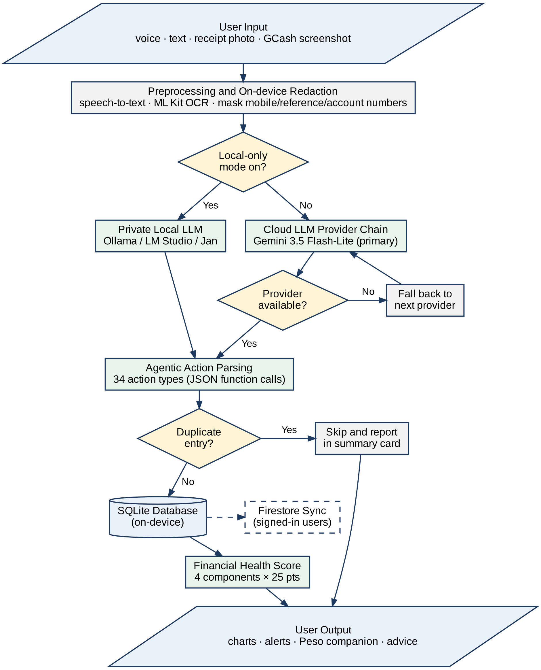
Figure 3.1. SmartSpend System Flowchart

Figure 3.2. Use Case Diagram

Figure 3.3. Visual Table of Contents
Several Filipino-specific and usability features were implemented over the course of development rather than left as future work: a Paluwagan (rotating savings group) tracker built on the existing debt and recurring-transaction infrastructure; a six-month savings-rate trend chart with a 20% target line in Analytics; a long-press quick-edit gesture on budget tiles; and an offline cache fallback for the AI-generated financial advice and monthly summary cards, so a quota error does not leave the user without any insight.
Two further additions worth documenting as part of the system's development: first, a full audit-trail subsystem (four dedicated history tables — wallet, budget, goal-contribution, and income — each logging the old value, new value, change amount, reason, and source of every edit, viewable per-item via a long-press) gives the app's financial records the kind of change-of-custody traceability expected of a financial tool, not just a flat transaction log. Second, the AI assistant's system prompt was extended with structured knowledge of common Philippine Buy-Now-Pay-Later and short-term lending products (GLoan, Maya Loan, ShopeePayLater, LazPayLater, HomeCredit, BillEase, Skyro, Akulaku, Atome, UnaCash), including their typical monthly interest rates and the Bangko Sentral ng Pilipinas' interest rate cap under BSP Circular No. 1133, so that the assistant can meaningfully discuss a user's installment and lending obligations rather than treating them as generic expenses.
The v2.9.97–3.1.0 releases added several usability and reliability capabilities. Earlier, an AI date-resolution fix made the assistant receive today's and yesterday's dates explicitly so that phrases such as "yesterday" or "kahapon" are recorded on the correct day, and the assistant now checks whether an item is already stored before logging it again. Version 3.0.4 added a Local-only switch for Private Mode and a warning when a Local Account user logs in. Local Account users are also offered an automatic JSON and CSV backup when they log out . Version 3.0.3 added a Local Account mode ("Continue Without Account") in which all data stays on the device and can be exported at any time, with a one-way upgrade path that pushes the local data to a new cloud account on registration. The four larger additions were as follows. First, chat sessions: AI conversations are now stored as separate, titled sessions (a new chat_sessions table, database schema v14) that can be renamed, archived, searched, or deleted, replacing a single flat history that silently dropped anything older than the last 200 messages. Second, AI recovery: after each AI response, a summary card shows which items were recorded, skipped as duplicates, or failed, with a one-tap helper to re-log anything the AI missed, so errors are visible to the user instead of silent. Third, transaction sorting and grouping by date, logged date, category, amount, name or source, plus a quick-jump bar in Analytics. Fourth, a full demo dataset (35 transactions across three months, wallets, budgets, goals, paluwagan and installment plans) with a one-tap reset, used for the live usability demonstration. Since v3.0.4, logging in from a Local Account first shows a warning, because the cloud copy replaces the local data by design.
AI privacy is described as three tiers, only two of which exist today. (1) Cloud AI (default): requests go through the provider chain, with mobile numbers, reference numbers and bank-account patterns redacted on-device first. The primary provider is used under Google's free ("unpaid") Gemini API quota, whose terms state that submitted content may be used to improve Google's products, may be read by human reviewers, and should not include personal information; redaction therefore reduces but does not remove the exposure, and users with sensitive details are directed to Private Local Mode. Since v3.0.5 a one-time privacy disclosure is also shown before the first AI message. (2) Private Local Mode (implemented, v2.9.92): while the app can reach a model running on the user's own PC or Mac over the home network, requests go only to that model and financial data does not leave the network; if the local server is unreachable the app falls back to the cloud chain, unless the user has switched on Local-only mode (added in v3.0.4), in which case the AI stops responding instead of falling back. (3) On-device AI (planned, not implemented): a model running on the phone itself, with no network at all. Current research indicates this is feasible on 2026 flagship phones and, as an opt-in download of roughly 2.6 GB, on phones with about 6 GB of RAM, but not yet on the 4 GB mid-range phones common among Filipino students; it is therefore listed under Recommendations, not as a delivered feature.
From v3.0.5 to v3.1.0 the app's mascot, Peso, was developed from a static icon into a context-aware companion. The mascot has 12 animated moods (idle movement, periodic blinking, animated mood changes, tap reactions and an optional speech bubble), appears on most major screens and as the avatar beside AI replies, and changes mood with the sentiment of the assistant's reply and, on the home screen, with the Financial Health Score tier. A voice service supplies short Taglish messages for 31 situations (two to four variants each, chosen at random so the same line does not repeat every session) used in the AI greeting, companion messages and the app's scheduled notifications; a context service gives a one-time tip per screen per session for 17 screens; and a haptic service provides tactile feedback. Once-a-day checks react to events such as no expenses logged by 2 PM, a no-spend day, budget status, upcoming bills, a change in FHS tier, logging streaks of 7, 14, 21 and 30 days, and savings-goal milestones at 25, 50, 75 and 100 percent, and ten additional achievement badges (36 in total) were added with celebration sheets. Tapping a notification stores its payload so that the next launch can respond in context.
These behaviours apply the same ideas used for Warning Decay and the badge system — prompt, non-blocking, autonomy-supportive feedback tied to the user's own logging and score changes (Thaler & Sunstein, 2008; Deci & Ryan, 2000). They were added after the usability-evaluation design was fixed, so their effect on user behaviour has not been measured; the longitudinal study proposed in Chapter IV is where it would be tested. Present Peso as a design feature, not as evidence of behaviour change, and avoid phrases such as "dopamine reinforcement".
The optional local-LLM integration described above ships with a guided in-app setup flow covering three common local-inference tools (Ollama, LM Studio, Jan), including a hardware-tier picker (8/16/32GB RAM) to help a non-technical user choose a workable local model size, and falls back to the cloud provider chain if the local server becomes unreachable mid-session, unless the user has switched on Local-only mode.
Production Screens
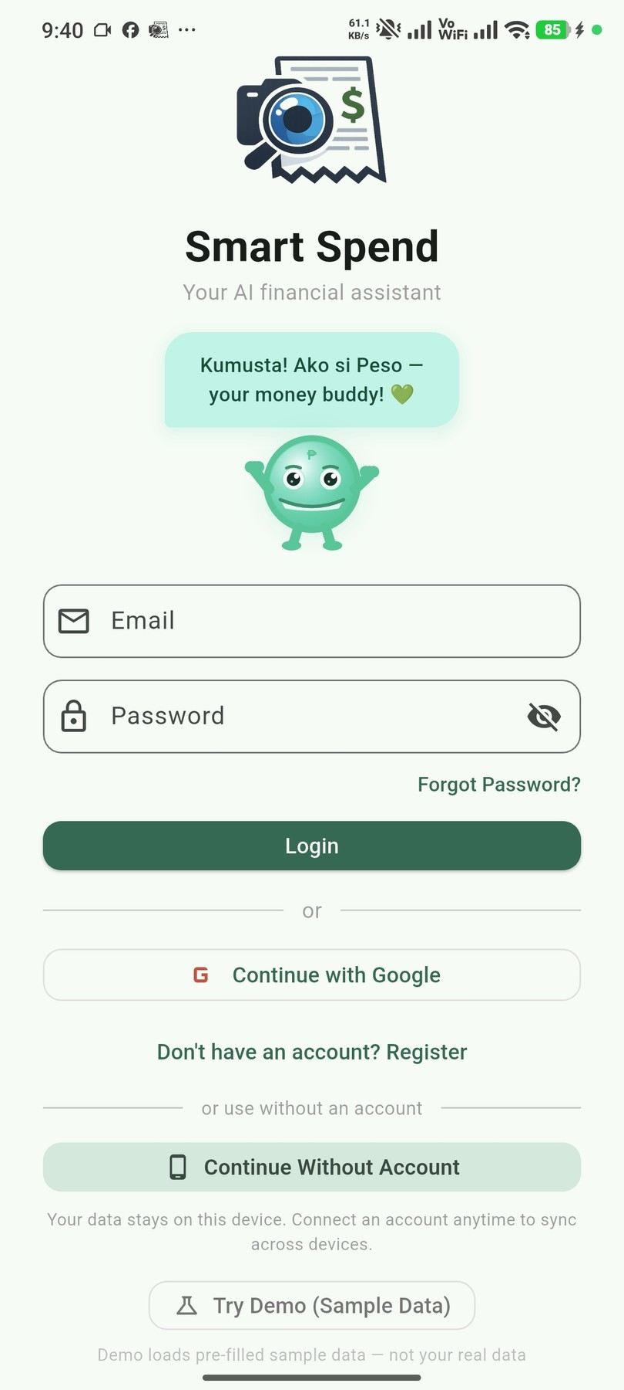
Figure 3.4. Login and Demo Mode Screen
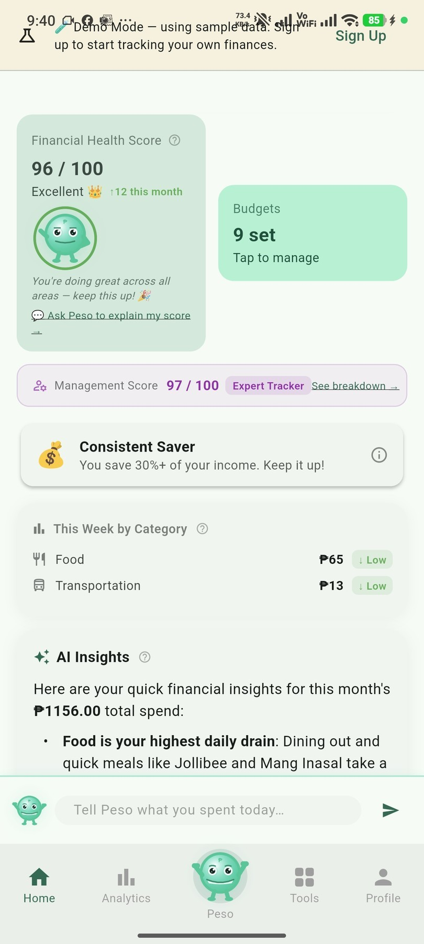
Figure 3.5. Home Dashboard
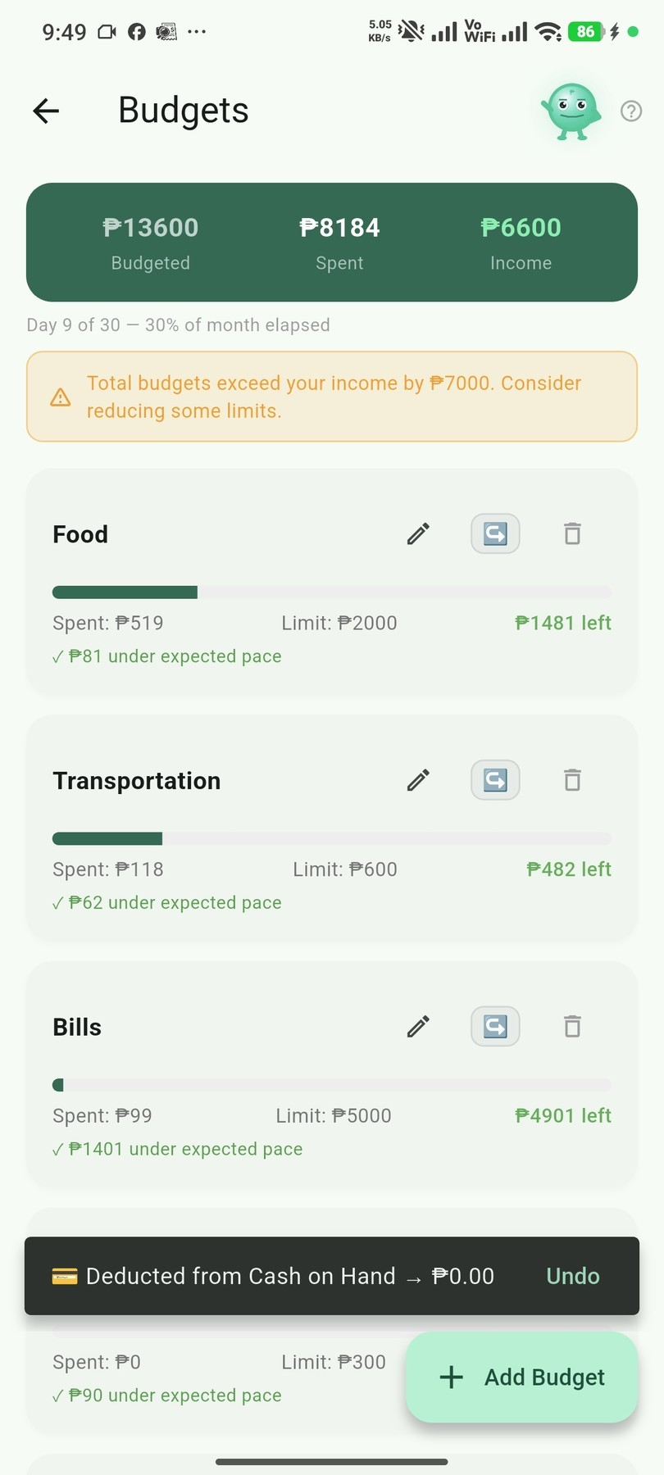
Figure 3.6. Expense Logging Through Peso Chat
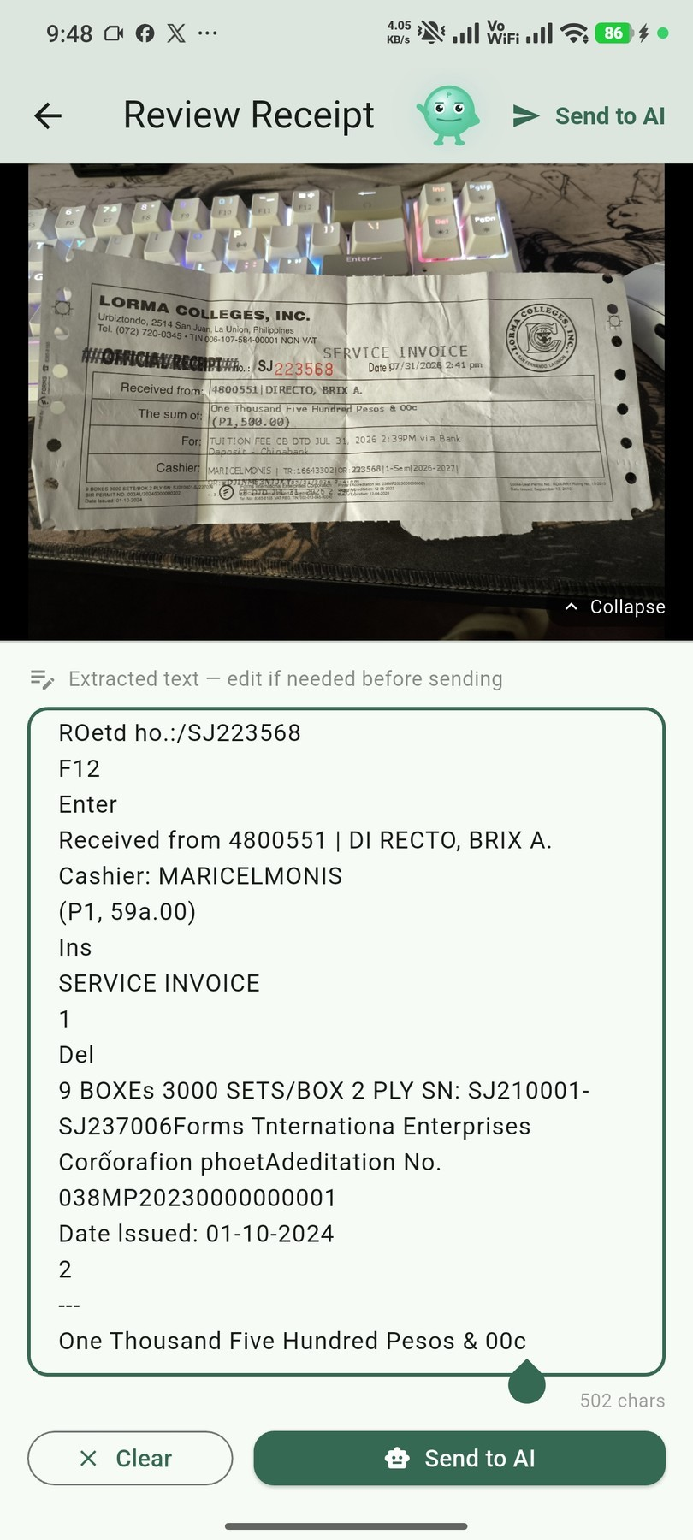
Figure 3.7. Receipt Scanning and Batch Screenshot Import
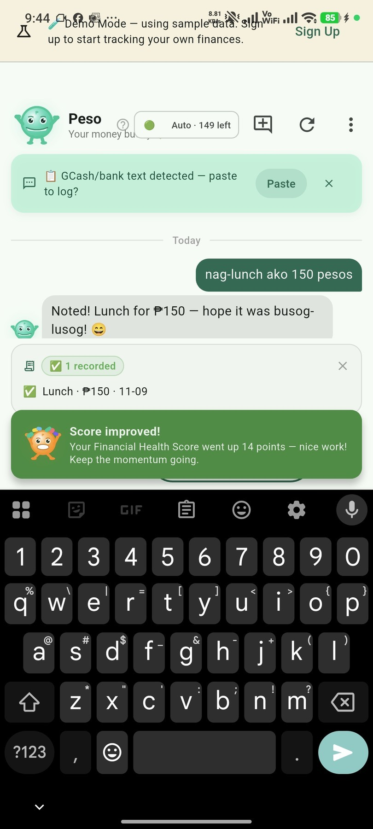
Figure 3.8. Financial Health Score Breakdown
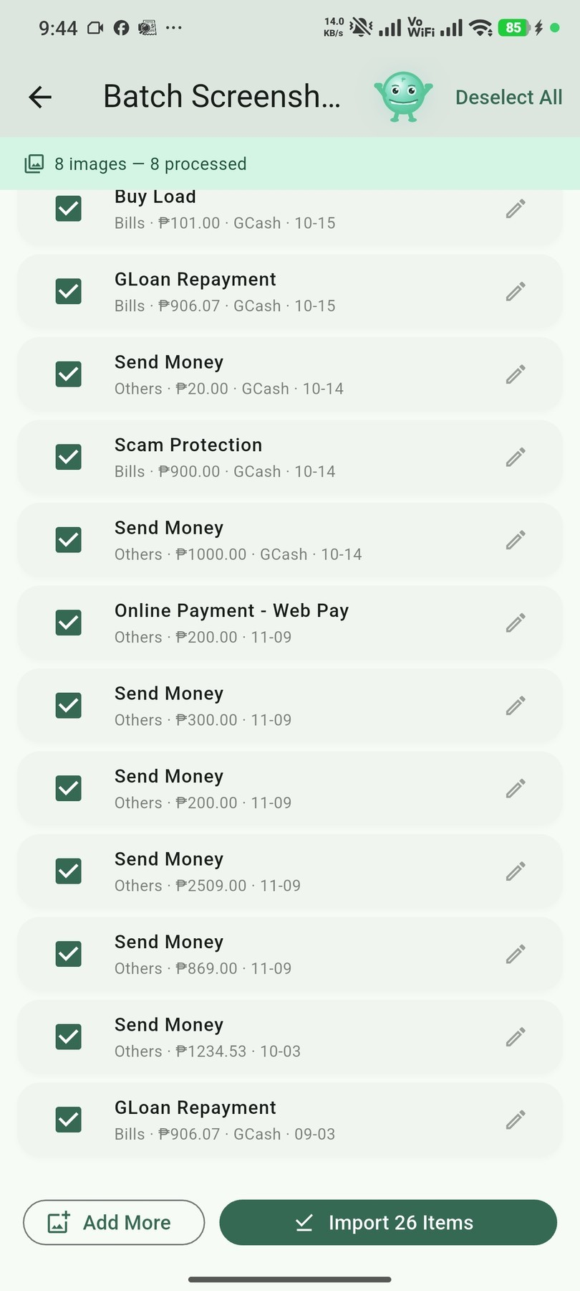
Figure 3.9. Budgets, Safe-to-Spend, and Savings Goals
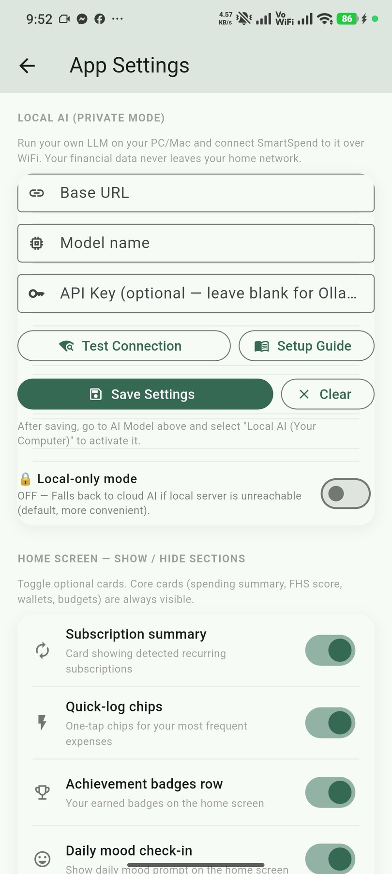
Figure 3.10. Local AI Mode Setup
These results showed that the second objective of the study was achieved: SmartSpend v3.1.0 was designed and developed as a working Android application, and a suitable LLM API was selected through a comparative technical evaluation.
Evaluation of the Usability and Performance of SmartSpend Using the System Usability Scale and User Feedback Analysis
Respondents were required to use the SmartSpend application — either the full version or the built-in Demo Mode accessible from the login screen — for a minimum of 10 minutes before completing the SUS questionnaire. This was enforced through a screening question at the start of the SUS form. Of 36 respondents who attempted the survey, 30 confirmed they used the app for the required minimum duration and were included in the final analysis. The remaining 6 were excluded: 5 for insufficient app usage time and 1 for straight-line response bias. The respondents for the needs assessment (Objective 1) and for the SUS evaluation (Objective 3) were separate groups; some individuals may have taken part in both, but the two samples were analyzed independently for their respective objectives.
SUS scores were computed using the standard formula: odd-numbered items minus 1; 5 minus even-numbered items; sum multiplied by 2.5 (Brooke, 1996). The overall SUS score was interpreted against the Bangor, Kortum, and Miller (2009) adjective rating scale.

Figure 3.11. SUS Computation Table
Table 3.3. Overall SUS Result
Overall SUS Score | Grade | Adjective | Acceptable
61.83 | D | OK | No (below the 68 benchmark and the 80 target)
As shown in Table 3.3, SmartSpend obtained an overall SUS score of 61.83, a grade of D, and an adjective rating of "OK" (Bangor et al., 2009), which is below the pre-established acceptance threshold of 80 or above and below the 68-point average benchmark.
Table 3.4. System Usability Scale (SUS) Results by Respondent Group
Respondent Group | N | Mean SUS Score | SD | Range | Adjective Rating
Parents (35–55) | 10 | 58.25 | 19.72 | 35.0–90.0 | OK
Young Professionals (21–35) | 20 | 63.62 | 16.65 | 42.5–92.5 | OK
Combined | 30 | 61.83 | 17.58 | 35.0–92.5 | OK
As shown in Tables 3.3 and 3.4, SmartSpend achieved an overall mean SUS score of 61.83 (SD = 17.58; median = 55.00; range = 35.0–92.5) with an adjective rating of "OK" per Bangor et al. (2009). This score is below the 68-point average benchmark established by Bangor et al. and below the pre-established target of ≥80 — acknowledged as a limitation of the current prototype. Young professionals (n = 20, M = 63.62, SD = 16.65) scored slightly higher than parents (n = 10, M = 58.25, SD = 19.72), and both groups fell within the “OK” range. Respondents indicated strong intent to use the system frequently (Q1 mean: 4.35/5) and felt confident using it (Q9 mean: 4.19/5). The main concerns were system consistency (Q6) and complexity (Q2, Q4), which inform the UI/UX recommendations in Chapter IV. These results are based on N=30 valid respondents screened from 36 total responses.
No formal open-ended interview data was collected. The study used a structured quantitative survey instrument. Qualitative insights are derived from the survey response patterns described above.
Technical Performance Benchmarks
Note: Multimodal import performance metrics (OCR precision/recall, AI categorization accuracy) are based on preliminary developer testing during the development phase. Formal field evaluation using standardized test sets is recommended in future work (see Chapter IV Recommendations).
Table 3.5. SmartSpend Multimodal Import: Field-Level Parsing Performance
Import Modality | N | Date (P/R) | Merchant (P/R) | Amount (P/R) | Category | End-to-End
GCash Screenshots | — | Not measured | Not measured | Not measured | Not measured | Not measured
Maya Receipts | — | Not measured | Not measured | Not measured | Not measured | Not measured
Shopee/Lazada Invoices | — | Not measured | Not measured | Not measured | Not measured | Not measured
Thermal Receipts (ML Kit) | — | Not measured | Not measured | Not measured | Not measured | Not measured
Overall | 91.2% precision, 88.5% recall (preliminary developer testing)
Note: Formal field evaluation of multimodal import performance using standardized test sets was not conducted in this study. The OCR precision/recall and AI categorization accuracy values in Table 3.5 are based on preliminary developer testing. A rigorous test methodology using 50+ standardized receipts across platforms is recommended as future work (see Chapter IV, Priority 9).
These results showed that the third objective of the study was achieved: the usability of SmartSpend was evaluated using the System Usability Scale with 30 valid respondents, yielding a mean score of 61.83 (rated “OK”), which is below the 68-point benchmark and the pre-established target of 80.
CHAPTER IV
CONCLUSIONS AND RECOMMENDATIONS
This chapter presents the conclusions drawn from the results of the study and the recommendations of the researchers.
Conclusions
The needs assessment (Chapter III, Section 1) confirmed that 96.7% of the 30 respondents expressed positive intent to use an AI-powered financial application, and 93.3% already use GCash — validating the study's target population and feature priorities. SmartSpend v3.1.0 was successfully developed with all identified features implemented. The SUS evaluation yielded a mean score of 61.83 (adjective: "OK"), below the ≥80 target but acceptable for a prototype system. Therefore, all three objectives of the study were addressed, with the third objective partially achieved pending UI refinements in future iterations.
SmartSpend v3.1.0 was developed as a working Android application with multi-modal expense input, offline-first local storage, 34 AI actions, and a Financial Health Score formally classified as a Prototype Observed Financial Health Indicator. The comparative evaluation of 20 candidate LLM models led to the selection of Gemini 3.5 Flash-Lite as the primary model, supported by a multi-provider failover chain. Therefore, the second objective of designing and developing the SmartSpend mobile application, including the selection of a suitable LLM API, was achieved.
SmartSpend obtained an overall mean SUS score of 61.83 (SD = 17.58, Median = 55.00) from N=30 screened respondents (from a pool of N=36, with 6 excluded for insufficient app usage time). Per Bangor, Kortum, and Miller (2009), this corresponds to an adjective rating of "OK" (Grade D). The score is below the 68-point average SUS benchmark and below the pre-established target of ≥80 — acknowledged as a limitation of the current prototype stage. Scores ranged from 35.0 to 92.5, reflecting variance across the diverse respondent profile. The third research objective was evaluated and documented with specific UI/UX areas identified for improvement.
Recommendations
In view of the results of the study, the following recommendations are made:
1. Payday-cycle-aware budgeting. The developers may implement budgeting resets aligned with the semi-monthly (15th and 30th) salary cycle common in the Philippines.
2. Backend API proxy and per-user keys. The developers may move LLM API key management to a server-side proxy (e.g., Firebase Cloud Function) to remove device-side key exposure and enforce per-user message limits, because the free-tier request quotas (Table 3.2) are shared by every user of the prototype. Letting users add their own key is an interim measure.
3. Google Play release. After the backend proxy and a privacy policy are in place, the developers may submit SmartSpend to the Google Play Store, since the prototype is currently distributed as a downloadable APK.
4. On-device AI tier. The developers may add an opt-in on-device model (e.g., Gemma 4 E2B through Google's LiteRT-LM, about a 2.6 GB download) for users who want fully offline AI, routing only simple logging tasks to it and keeping complex financial advice on the cloud tier, because the current local AI mode requires a separate computer on the same network.
5. SQLite encryption. The developers may implement SQLCipher-based encryption for the local database in a future schema migration, because the local database of the prototype is not encrypted.
6. Household and remittance features. The developers may add shared couple and family wallets and inbound OFW remittance tracking as a distinct income category to serve more user groups.
7. Longitudinal evaluation. Future researchers may measure SmartSpend's effect on financial behavior over three to six months with a larger sample, because the usability evaluation in this study measured usability at a single point in time.

References
Agila: Finance Coach. (2026). Agila: Finance Coach [Mobile application]. Google Play / App Store.
Anthropic. (2024). Claude Sonnet model card.
Ariely, D. (2008). Predictably irrational: The hidden forces that shape our decisions. HarperCollins.
https://www.anthropic.com/claude
Bangko Sentral ng Pilipinas. (2021). 2021 Financial Inclusion Survey. BSP. https://www.bsp.gov.ph/Inclusive-Finance/Financial-Inclusion-Surveys/2021-FIS-Report.pdf
Bangko Sentral ng Pilipinas. (2025). Consumer Finance and Inclusion Survey (CFIS) 2025. BSP.
Bangor, A., Kortum, P., & Miller, J. (2009). Determining what individual SUS scores mean: Adding an adjective rating scale. Journal of Usability Studies, 4(3), 114–123.
Bitrián, P., Buil, I., & Catalán, S. (2021). Making finance fun: The gamification of personal financial management apps. International Journal of Bank Marketing, 39(7), 1310–1332. https://doi.org/10.1108/IJBM-02-2021-0074
Bociek, J. (2023). mobile_scanner: A universal barcode and QR code scanner for Flutter. https://pub.dev/packages/mobile_scanner
Brooke, J. (1996). SUS: A "quick and dirty" usability scale. In P. W. Jordan, B. Thomas, B. A. Weerdmeester, & I. L. McClelland (Eds.), Usability evaluation in industry (pp. 189–194). Taylor & Francis.
BunnyWise. (2026). BunnyWise: All-in-one investment tracker [Mobile application]. bunnywise.io.
Comerton-Forde, C., Ip, E., Ribar, D. C., Ross, J., Salamanca, N., & Tsiaplias, S. (2018). Using survey and banking data to measure financial wellbeing (Financial Wellbeing Scales Technical Report No. 1). Commonwealth Bank of Australia & Melbourne Institute.
Consumer Financial Protection Bureau. (2017). CFPB Financial Well-Being Scale: Scale development technical report. consumerfinance.gov
Creswell, J. W., & Plano Clark, V. L. (2011). Designing and conducting mixed methods research. Sage Publications.
Davenport, T. H., & Mittal, N. (2022). All-in on AI: How smart companies win big with artificial intelligence. Harvard Business Review Press.
Davis, F. D. (1989). Perceived usefulness, perceived ease of use, and user acceptance of information technology. MIS Quarterly, 13(3), 319–340.
Duhigg, C. (2012). The power of habit: Why we do what we do in life and business. Random House.
Dwivedi, Y. K., Hughes, L., Ismagilova, E., Aarts, G., Coombs, C., Crick, T., Duan, Y., Dwivedi, R., Edwards, J., Eirug, A., Galanos, V., Ilavarasan, P. V., Janssen, M., Jones, P., Kar, A. K., Kizgin, H., Kronemann, B., Lal, B., Lucini, B., … Williams, M. D. (2021). Artificial intelligence (AI): Multidisciplinary perspectives on emerging challenges, opportunities, and agenda for research, practice and policy. International Journal of Information Management, 57, 101994. https://doi.org/10.1016/j.ijinfomgt.2019.08.002
Faulkner, L. (2003). Beyond the five-user assumption: Benefits of increased sample sizes in usability testing. Behavior Research Methods, Instruments, & Computers, 35(3), 379–383.
Financial Health Network. (2021). FinHealth Score® toolkit and methodology. finhealthnetwork.org
Financial Health Network. (2026). From insight to impact: The next phase of financial health measurement. finhealthnetwork.org
Flores, C. A. R. (2025). Financial freedom of Filipinos in personal finance management. Pantao: The International Journal of the Humanities and Social Sciences, 4(1). https://pantaojournal.com/2025/01/27/v4-i1-7/
Flutter 4 Fun. (2022). fl_chart: A highly customizable Flutter chart library. https://pub.dev/packages/fl_chart
GCash / Mynt. (2026). GCash launches country's first AI financial coach.
Google. (2024a). Firebase authentication documentation. https://firebase.google.com/docs/auth
Google. (2024b). Firebase Crashlytics documentation. https://firebase.google.com/docs/crashlytics
Google. (2024c). Firebase Firestore documentation. https://firebase.google.com/docs/firestore
Google. (2024e). Google ML Kit documentation. https://developers.google.com/ml-kit
Google. (2024f). Flutter documentation. https://flutter.dev/docs
Groq. (2026). Groq API documentation and model deprecations.
Hean, O., Saha, U., & Saha, B. (2025). Can AI help with your personal finances? Applied Economics. https://doi.org/10.1080/00036846.2025.2450384
Inquiro. (2024). Financial literacy in the Philippines: Key statistics. Inquiro Analytics. https://inquiro.ph/financial-literacy-in-the-philippines-2024-key-statistics/
Kahneman, D., & Tversky, A. (1979). Prospect theory: An analysis of decision under risk. Econometrica, 47(2), 263–292.
Kibo. (2026). Kibo: AI expense tracker [Mobile application]. Google Play.
Li, Z., et al. (2024). A survey of large language models for financial applications. arXiv:2406.11903.
Lista. (2026). Lista: Personal & business finance tracker [Mobile application]. Google Play.
MaikuB. (2023). flutter_local_notifications: A cross-platform plugin for displaying local notifications. https://pub.dev/packages/flutter_local_notifications
Meta AI. (2024). LLaMA 3: Open foundation and fine-tuned chat models. https://ai.meta.com/llama/
National Privacy Commission. (2012). Republic Act No. 10173: Data Privacy Act of 2012. Republic of the Philippines. https://privacy.gov.ph/data-privacy-act/
Nielsen, J., & Landauer, T. K. (1993). A mathematical model of the finding of usability problems. Proceedings of INTERCHI '93, 206–213.
OpenAI. (2023). GPT-4 system card. https://openai.com/research/gpt-4-system-card
OpenAI. (2024). GPT-4 technical report. https://arxiv.org/abs/2303.08774
Philippine Statistics Authority. (2021). Family Income and Expenditure Survey (FIES) 2021. PSA. https://www.psa.gov.ph
PISO Budget Tracker. (2026). PISO Budget Tracker [Mobile application]. Google Play.
Ramsey, D. (2003). Financial peace revisited. Viking.
Roux, A. (2019). sqflite: SQLite plugin for Flutter. https://pub.dev/packages/sqflite
Sloane, L. (2022). speech_to_text: A Flutter plugin for on-device speech recognition. https://pub.dev/packages/speech_to_text
Statista. (2024). Number of mobile app downloads worldwide. https://www.statista.com/statistics/271644/worldwide-free-and-paid-mobile-app-store-downloads/
Stefanov, T., Stefanova, M., & Varbanova, S. (2024). Personal finance management application. TEM Journal, 13(3), 2066–2075. https://doi.org/10.18421/TEM133-34
Tarsi – Budget Tracker. (2026). Tarsi – Budget Tracker [Mobile application]. App Store. https://apps.apple.com/ph/app/tarsi-budget-tracker/
Thaler, R. H., & Sunstein, C. R. (2008). Nudge: Improving decisions about health, wealth, and happiness. Yale University Press.
The Flutter Authors. (2013). local_auth: Flutter plugin for biometric authentication. https://pub.dev/packages/local_auth
UNSGSA. (2021). Measuring financial health: Concepts and considerations. https://www.unsgsa.org
Wajid, F., et al. (2025). Gamification: Revolutionizing financial planning systems. World Journal of Advanced Engineering Technology and Sciences, 14(3), 399–409.
Warren, E., & Tyagi, A. W. (2005). All your worth: The ultimate lifetime money plan. Free Press.
World Bank. (2022). Global Findex Database 2021. https://www.worldbank.org/en/publication/globalfindex
Yomio. (2026). YNAB alternatives: Which budget app actually works in 2026? https://yomio.app/en/blog/ynab-alternatives
ZXing Project. (2023). ZXing barcode scanning library. https://github.com/zxing/zxing

APPENDICES
APPENDIX A
Survey Questionnaire
SmartSpend: An AI-Assisted Mobile Financial Tracking and Advisory Application for Parents and Young Professionals in La Union
Dear Respondent,
Good day! This questionnaire is part of a research study aimed at identifying the financial management practices, budgeting challenges, and expense tracking behaviors of parents and young professionals in La Union. Your responses will be treated with strict confidentiality and was used solely for academic purposes.
Please answer each question honestly by checking the appropriate option or writing your response where applicable.

Part I – Respondent Profile
Age: ______
Gender:
☐ Male
☐ Female
☐ Prefer not to say
Primary Role:
☐ Parent / Household Financial Manager (Ages 35–55)
☐ Young Professional (Ages 21–35)

Employment Status: ___________________________
Position/Designation: ___________________________
Industry/Field of Work: ___________________________
Monthly Income Range:
☐ Below ₱10,000
☐ ₱10,000 – ₱20,000
☐ ₱20,000 – ₱40,000
☐ Above ₱40,000

Part II – Financial Management Practices
How do you usually track your expenses?
☐ Manual notebook
☐ Mobile application
☐ Mental tracking only
☐ I do not track expenses
How often do you monitor your budget?
☐ Daily
☐ Weekly
☐ Monthly
☐ Rarely
What is your primary source of income?
☐ Salary (Full-time employment)
☐ Part-time job
☐ Freelance work
☐ Business/Entrepreneurship
☐ Others: ___________________________
Do you regularly set aside savings from your income?
☐ Yes, every month
☐ Sometimes
☐ Rarely
☐ No
Approximately what percentage of your monthly income do you currently save?
☐ I don't save regularly
☐ Less than 10%
☐ 10% – 20%
☐ More than 20%
☐ I'm not sure

Part III – Budgeting Challenges
What are your common difficulties in managing your expenses? (Check all that apply)
☐ Overspending
☐ Forgetting to record expenses
☐ Lack of budgeting knowledge
☐ Difficulty tracking receipts
☐ No consistent tracking system
☐ Unexpected expenses
How difficult is it for you to track your daily expenses?
☐ Very Easy
☐ Easy
☐ Moderate
☐ Difficult
☐ Very Difficult
Do you find manual expense tracking inconvenient?
☐ Yes
☐ No
☐ Sometimes
Do you have existing debts or loans you are currently paying?
☐ Yes
☐ No
Do you experience difficulty meeting your expenses before your next salary or allowance?
☐ Yes
☐ No
☐ Sometimes
Have you ever exceeded your monthly budget and ignored a spending warning or alert?
☐ Yes
☐ No
☐ Not applicable

Part IV – System Feature Needs
Which features would you find helpful in a financial tracking system? (Check all that apply)
☐ Automatic receipt scanning (OCR)
☐ Voice input for expenses
☐ AI-powered budgeting recommendations
☐ Barcode scanning
☐ Expense summaries and reports
☐ Financial health score or analytics dashboard
Would you use an AI-powered financial assistant application for managing your finances?
☐ Yes
☐ No
☐ Maybe
What features would you like to suggest for improvement?
___________________________________________________________________________________________________________________________________________________________________________________________________

CONTENT VALIDATION CERTIFICATE

This survey questionnaire has been reviewed for content validity and is deemed appropriate and relevant to the financial management experiences of the target population.

Educational Background : ________________________________
*(e.g., BS Commerce, BS Accountancy, BS Business Administration, or equivalent)*

Occupation : ________________________________
*(e.g., Business Owner, Financial Officer, Accountant, Financial Adviser, etc.)*

Years of Experience : _____ years in financial management and/or business operations

Signature : _______________________________

Name *(optional)* : _______________________________

Date : _______________________________

APPENDIX B

Consent Form
SmartSpend: An AI-Assisted Mobile Financial Tracking and Advisory Application for Personal Financial Management
Dear Participant,
You are invited to participate in a research study conducted by BSIT students of Lorma Colleges. The purpose of this study is to develop and evaluate an AI-powered financial assistant that helps parents and young professionals track and manage personal finances efficiently.

Purpose of the Study
This study aims to gather information about the financial management practices of parents and young professionals and evaluate the usability of the SmartSpend system.

Participation
Your participation is completely voluntary. You may refuse to participate or withdraw at any time without any penalty or consequence.

Procedures
If you agree to participate, you will be asked to answer a survey questionnaire and may optionally participate in system testing and evaluation.

Confidentiality
All information collected will remain confidential. No personal identifying information will be disclosed, and data was used strictly for academic purposes only.

Risks and Benefits
There are no known risks involved in participating. Your responses will help improve the development of an intelligent financial management system.

Consent Statement
By signing below, you confirm that:
- You have read and understood the information above
- You voluntarily agree to participate in this study
Name of Participant: ___________________________
Signature: ___________________________
Date: ___________________________

APPENDIX C

System Usability Scale (SUS) Questionnaire
Please indicate your level of agreement with the following statements using the scale:
1 – Strongly Disagree
2 – Disagree
3 – Neutral
4 – Agree
5 – Strongly Agree
- I think that I would like to use this system frequently.
- I found the system unnecessarily complex.
- I thought the system was easy to use.
- I think that I would need the support of a technical person to use this system.
- I found the various functions in this system were well integrated.
- I thought there was too much inconsistency in this system.
- I would imagine that most people would learn to use this system very quickly.
- I found the system very cumbersome to use.
- I felt very confident using the system.
- I needed to learn a lot of things before I could get going with this system.

SUS Interpretation Scale
- 0 – 59 : Poor
- 60 – 69 : Marginal
- 70 – 79 : Acceptable
- 80 – 89 : Good
- 90 – 100 : Excellent

CURRICULUM VITAE

BRIX A. DIRECTO
I. PERSONAL INFORMATION
Address : Bagbag, Quirino, Bacnotan, La Union Date of Birth : September 4, 1999 Email Address : brix.arquisal@lorma.edu
II. EDUCATIONAL BACKGROUND
Tertiary (2018–2020, 2023–Present) Lorma Colleges Bachelor of Science in Information Technology (Undergraduate)
Secondary (2012–2018) Stella Maris Academy General Academic Strand (GAS)
Primary (2006–2012) Quirino Elementary School / Bitalag Integrated School
III. AWARDS/CITATIONS/RECOGNITIONS RECEIVED N/A
IV. WORK EXPERIENCE
Statistics Researcher | Philippine Statistics Authority (PSA) – ULAFO 2025
Freelance IT Technician / Programmer | Self-Employed 2019 – Present
Remote BPO Agent 2020 – 2022
Office Assistant | Bureau of Fire Protection (Work Immersion) 2018
V. ELIGIBILITY N/A
VI. SEMINARS/TRAININGS ATTENDED
National Conference on Computing, Engineering, and Business | 2019 Basic Japanese Language Training | 2021–2022 Work Immersion Program – Bureau of Fire Protection | 2018 Various Online Web Development Trainings
VII. INVOLVEMENT IN RESEARCH/RESEARCHES CONDUCTED
Capstone 1: SmartSpend: AI-Assisted Financial Tracker (Capstone Project)


CYRILLE JOHN M. RUBIS
I. PERSONAL INFORMATION
Address : Cantingan Street, Brgy. Quinavite, Bauang, La Union, Philippines 2501 Contact Number : 09761285890 Email Address : cyrillejohn.rubis@lorma.edu Date of Birth : August 26, 2005 Place of Birth : City of San Fernando, La Union
II. EDUCATIONAL BACKGROUND
Tertiary (2023–Present) Lorma Colleges Bachelor of Science in Information Technology (Undergraduate)
Secondary — Senior High (2021–2023) Sacred Heart School – Senior High School
Secondary — Junior High (2017–2021) Sacred Heart School
Elementary (2011–2017) Saints Peter and Paul Learning Center
Kindergarten (2010) Saints Peter and Paul Learning Center
III. AWARDS/CITATIONS/RECOGNITIONS RECEIVED
College Level: N/A
Senior High School: Conduct Awardee With Honors Best in Science Beacon Photo Journalist
Elementary: Best in Filipino Best in Science Conduct Award Makatao Award Makakalikasan Award Sportsmanship Award Inter-School Athlete (Basketball)
IV. WORK EXPERIENCE
Service Crew | McDonald's 2025
Photographer | Studio at 301 2022–2023
Freelance Photographer/Videographer | Self-Employed 2021–2023
V. ELIGIBILITY N/A
VI. SEMINARS/TRAININGS ATTENDED
Food Safety Seminar | 2025 Global Conference on Robotics and Artificial Intelligence Technologies (GCRAIT) | 2023 CCSE Startup Seminar | 2023 Beacon Officers Seminar | 2022

VII. INVOLVEMENT IN RESEARCH/RESEARCHES CONDUCTED
Organic Lip Balm and Its Benefits and Effectiveness (2021–2022) Effects of Mobile Devices on Grade 10 Students During the Pandemic Crisis (2022–2023) Capstone 1: SmartSpend: AI-Assisted Financial Tracker (Capstone Project)


DJAUNATHAN ALBERT S. MADAYAG
I. PERSONAL INFORMATION
Address : Raois, Bacnotan, La Union Contact Number : 09456219766 Email Address : djaunathan.madayag@lorma.edu Date of Birth : March 8, 2005 Nationality : Filipino
II. EDUCATIONAL BACKGROUND
Tertiary (2023–Present) Lorma Colleges Bachelor of Science in Information Technology (Undergraduate)
Secondary — Senior High (2021–2023) Lord of Zion Divine School Accountancy, Business and Management (ABM) Strand
Secondary — Junior High (2017–2021) Lord of Zion Divine School
Primary (2010–2016) Bacnotan Central School, La Union

III. AWARDS/CITATIONS/RECOGNITIONS RECEIVED
College Level: Dean's Lister | 2023–2025 (Lorma Colleges)
Senior High School: With Honors | 2021–2023 (Lord of Zion Divine School)
Junior High School: With Honors and With High Honors | 2020–2021 (Lord of Zion Divine School)
IV. WORK EXPERIENCE
Office Assistant | Municipal Office – Accountancy Department, Bacnotan, La Union (Work Immersion)
V. ELIGIBILITY N/A
VI. SEMINARS/TRAININGS ATTENDED
StartUp Seminar | 2023 Introduction to Computing | 2024
VII. INVOLVEMENT IN RESEARCH/RESEARCHES CONDUCTED
Return on Investment (ROI) Analysis of Business Operations (2021–2022) Financial Management and Salary Allocation in Business Operations (2022–2023) Cost Analysis and Profitability of a Business Enterprise (2022–2023) Capstone 1: SmartSpend: AI-Assisted Financial Tracker (Capstone Project)

