 | LORMA COLLEGES  College of Computer Studies and Engineering  Bachelor of Science in Information Technology | 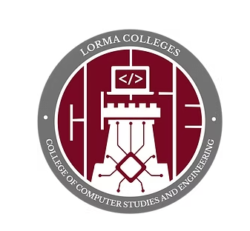

CAPSTONE PROJECT PROGRESS REPORT

GENERAL INSTRUCTIONS
- Use this format for all progress report submissions.
- Encode the report clearly and concisely.
- Submit on or before the deadline set by the adviser.
- Attach photo documentation as required.
Report Details
Project / Capstone Title
Report No.
Date Submitted
Members
# | Member Name
1
2
3
4
5
Narrative
Describe the project's current status. Write each part in paragraph form.
1. Tasks Already Completed
What has the team finished since the last report?

2. Ongoing Activities
What is currently in progress?

3. Problems or Challenges Encountered
What issues or roadblocks came up?

4. Solutions Applied or Actions Taken
How were the above issues addressed?

5. Next Steps / Plans Before the Next Report
What will the team do next?

Photo Documentation
Attach clear photos showing actual progress of the project. Each photo should have a short caption describing what is shown. Add more rows if needed.
[ Insert Photo 1 Here ] | [ Insert Photo 2 Here ]
Caption: | Caption:
[ Insert Photo 3 Here ] | [ Insert Photo 4 Here ]
Caption: | Caption:
[ Insert Photo 5 Here ] | [ Insert Photo 6 Here ]
Caption: | Caption:

Group Leader / Representative |  | Shekiro R. Raposas, MTS, MIS  Teacher in Charge

