[Logo] | LORMA COLLEGES  College of Computer Studies and Engineering  Bachelor of Science in Information Technology | [Logo]

CAPSTONE PROJECT PROGRESS REPORT

GENERAL INSTRUCTIONS
- Use this format for all progress report submissions.
- Encode the report clearly and concisely.
- Submit on or before the deadline set by the adviser.
- Attach photo documentation as required.

Report Details
Project / Capstone Title | SmartSpend: An AI-Assisted Multi-Modal Personal Financial Management Application for Filipino Users Using Agentic Large Language Model Architecture
Report No. | 07
Date Submitted | September 7, 2026

Members
# | Member Name
1 | Brix A. Directo — Lead Developer
2 | Cyrille John M. Rubis — UI/UX Designer & Documentation Lead
3 | Djaunathan Albert S. Madayag — Project Manager & QA Lead

Narrative
Describe the project's current status. Write each part in paragraph form.
1. Tasks Already Completed
What has the team finished since the last report?
Conducted full live walkthrough of the SmartSpend application on the Poco X6 Pro test device to verify all features are functional ahead of the Pre-Final Defense. All 5 core screens (Home, Analytics, AI Chat, Hub, Profile) confirmed working with real user data.

Verified the complete expense logging flow: the multi-modal Add Expense screen supports natural language input (e.g., "Ate at KFC 250 pesos"), Voice logging via microphone, and AI-powered Analyze mode. The form includes category selection from 14 built-in categories, Need/Want tagging, payment method selection, merchant/shop field, notes, receipt photo attachment, and custom tags (e.g., #capstone).

Verified Budgets module: 5 category budgets configured (Food ₱5,000, Education ₱1,650, Bills ₱990, Shopping ₱990, Gaming ₱1,299) totaling ₱9,929 budgeted against ₱650 income and ₱185 spent. Budget categories support both fixed ₱ and % of income modes. All 5 budgets are on track as of Day 7 of 30.

Verified Debts & Lending module: I Owe, Owed to Me, and Plans tabs all functional. Active plan: GCash GLoan for Acer KA272 PC Monitor — 2 of 9 months paid, ₱6,349 remaining at ₱907/month, due in 10 days. ShopeePayLater plan marked as fully paid (₱1,120). Add Debt form supports I Owe and They Owe Me modes with description, amount, due date, notes, and interest rate fields. Add Payment Plan form supports ShopeePaylater, GCash GLoan, HomeCredit, and other installment formats.

Verified My Wallets module: Cash on Hand ₱953, Landbank ₱500, GCash, Maya, and GoTyme Bank configured. Total liquid balance: ₱1,453. Add wallet supports 29 providers including GrabPay, ShopeePay, Coins.ph, PayPal, Wise, Tonik, UNO bank, and all major PH banks (BDO, BPI, Metrobank, PNB, RCBC, Security Bank, Chinabank, UnionBank, EastWest, Seabank, PSBank, Maybank, Cebuana, M Lhuillier, Palawan Pawnshop, Western Union, LBC, Tambunting, USSC).

Verified App Settings: Lite Mode, Auto-deduct wallets, Impulse pause, Budget alerts, Round-up savings, and Compact mode all confirmed functional. Spending anomaly alerts enabled. Home Screen and Analytics show/hide section toggles verified. AI model switch confirmed (Gemini 3.1 Flash-Lite active, 5 models available).

Verified Spending Limits: Daily, Weekly, Monthly, and Yearly cap fields accessible from Profile settings. Limits set and confirmed reflected on the Home screen spending card.

Configured GitHub Actions 2 of 4 secrets. Release pipeline partially active.

2. Ongoing Activities
What is currently in progress?
SUS survey administration in progress — targeting 30 respondents (20 parents aged 35–55, 10 young professionals aged 21–35). Instruments distributed; responses being collected.

Pre-Final Defense presentation slides: final polish and rehearsal. Full 8–9 minute timed run-through scheduled before submission deadline.

Cyrille: inserting all 4 figures into the Google Docs Working copy and completing the CV section for all 3 members.

Remaining GitHub Actions secrets configuration (KEYSTORE_BASE64, KEY_PROPERTIES) pending signing keystore transfer.

3. Problems or Challenges Encountered
What issues or roadblocks came up?
SUS respondent recruitment for the parent demographic (35–55 age group) is proving slower than expected — the target of 20 parent respondents requires direct outreach through faculty and community contacts, which is time-consuming during the pre-defense period.

Budgets total (₱9,929) exceeds the configured income (₱650) by ₱9,279, which triggers a budget warning in the app. This is intentional for the test device (demo data), but needs to be clearly explained during the defense demonstration to avoid confusion from the panel.

4. Solutions Applied or Actions Taken
How were the above issues addressed?
SUS recruitment: expanded outreach to include online survey distribution via class group chats and faculty referrals. The young professional demographic (10 respondents) is on track. A deadline of September 12 has been set to complete all 30 surveys before the defense date.

Budget warning: a verbal note has been added to the defense script (DEFENSE_GUIDE.md) acknowledging the demo data context — the panel will be informed that the ₱9,929 budget total reflects aspirational category limits set during testing, not the live student monthly budget. The app correctly flags the overage as a feature, not a bug.

5. Next Steps / Plans Before the Next Report
What will the team do next?
Complete SUS survey data collection (target: September 12, 2026). Tabulate results and compute SUS scores using the Brooke (1996) formula. Insert tabulated results and interpretation into Chapter III.

Submit Pre-Final Defense requirements: printed Compliance Matrix with panel signatures, final manuscript printout, and defense slide deck.

Conduct final full rehearsal of the 8–9 minute demo using DEFENSE_GUIDE.md. Assign speaking roles for each team member.

Complete remaining GitHub Actions secrets configuration to finalize the automated APK release pipeline.

Obtain validator signatures on Appendix A validation certificates and submit to the capstone coordinator before the defense date.

Photo Documentation
Attach clear photos showing actual progress of the project. Each photo should have a short caption describing what is shown.
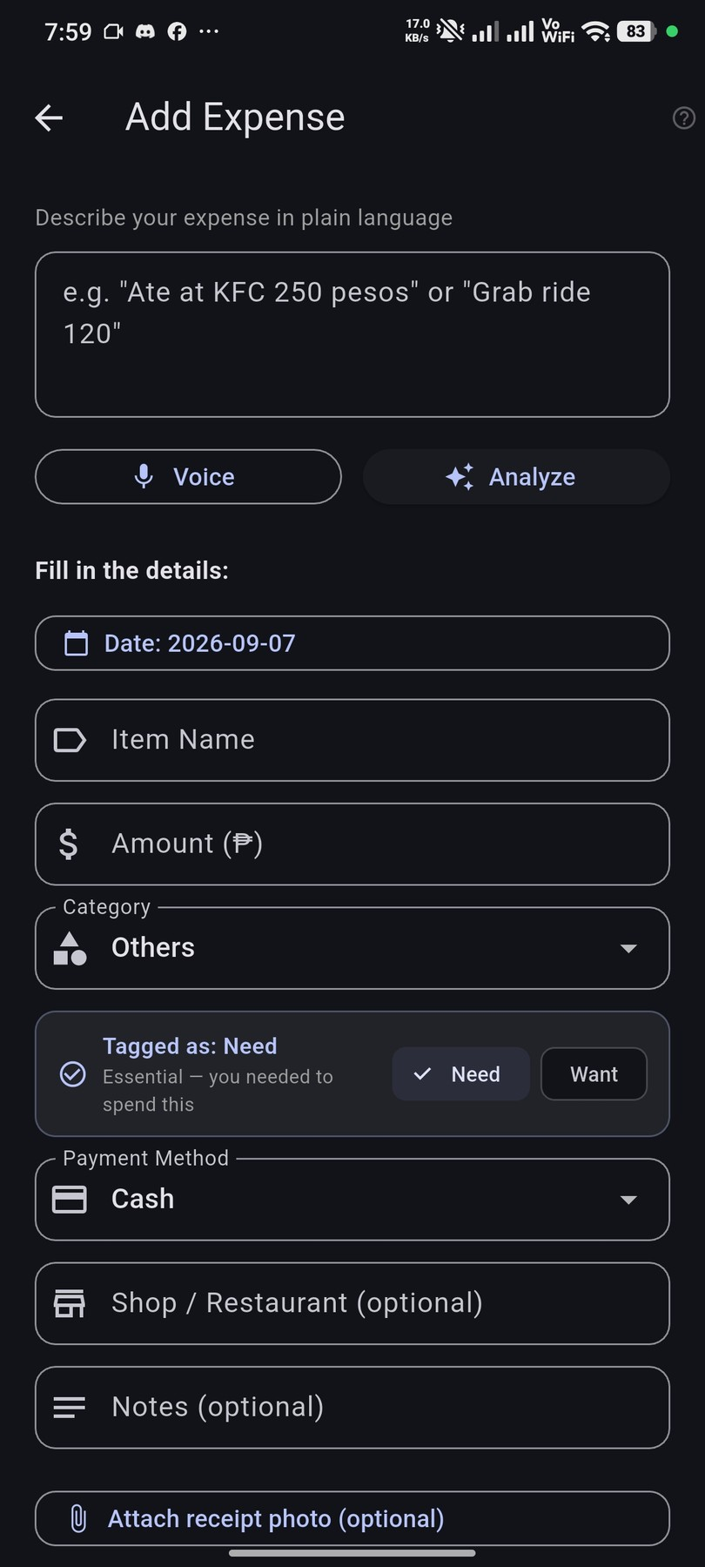 | 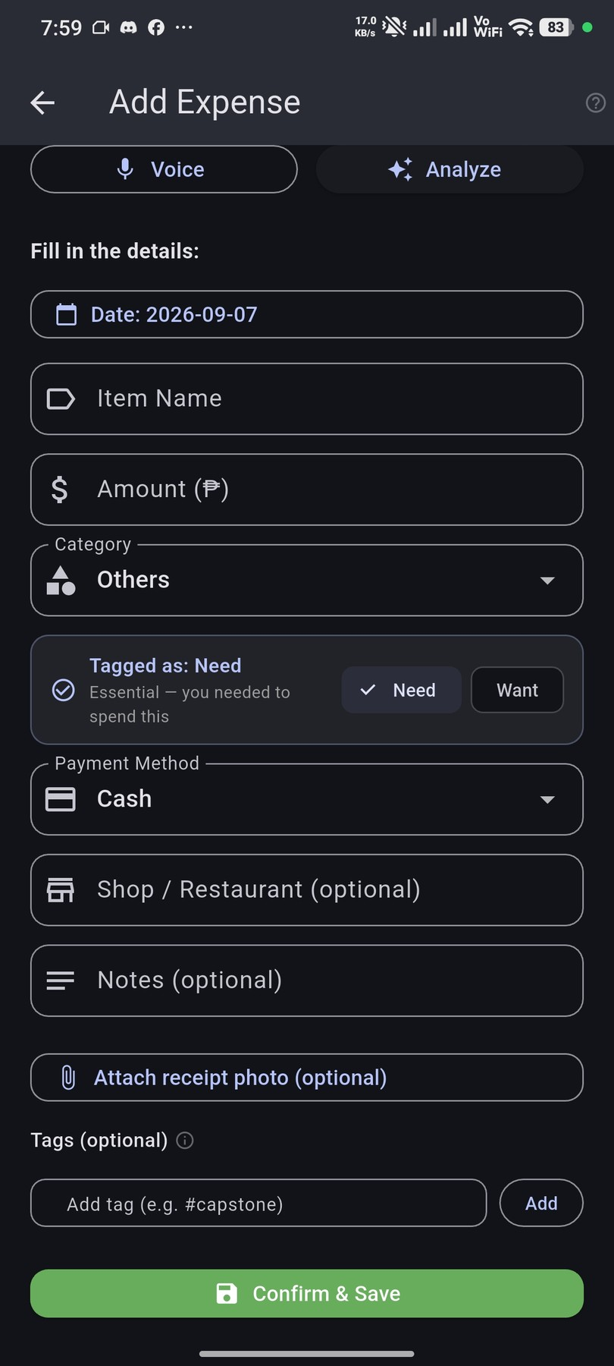
Add Expense screen — multi-modal logging: NLP text input, Voice and AI Analyze buttons, category selector, Need/Want tag, payment method, merchant, notes, and receipt attachment | Add Expense — form continued: Tags field (e.g. #capstone), and Confirm & Save button — supports fully manual or AI-assisted expense entry

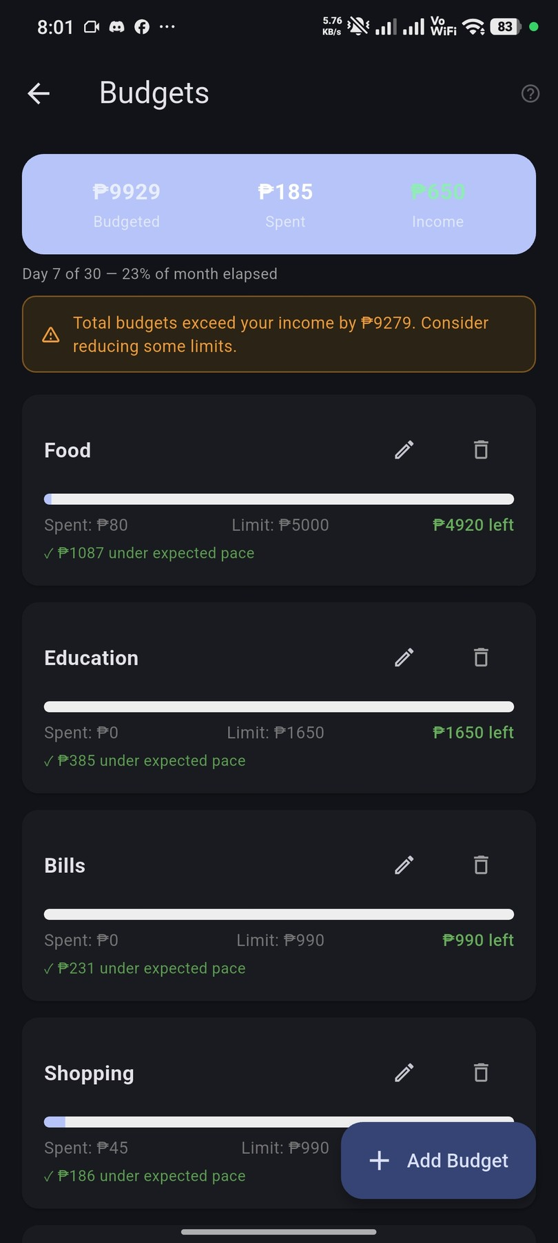 | 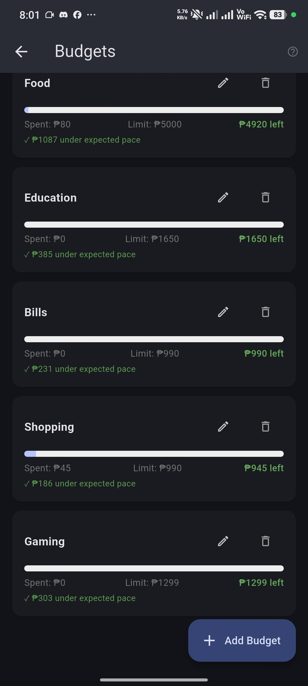
Budgets screen — ₱9,929 budgeted vs ₱185 spent vs ₱650 income, Day 7 of 30 (23% elapsed); 5 category budgets all on track with pace indicators | Budgets — all 5 configured: Food ₱80/₱5,000, Education ₱0/₱1,650, Bills ₱0/₱990, Shopping ₱45/₱990, Gaming ₱0/₱1,299 — all under expected pace

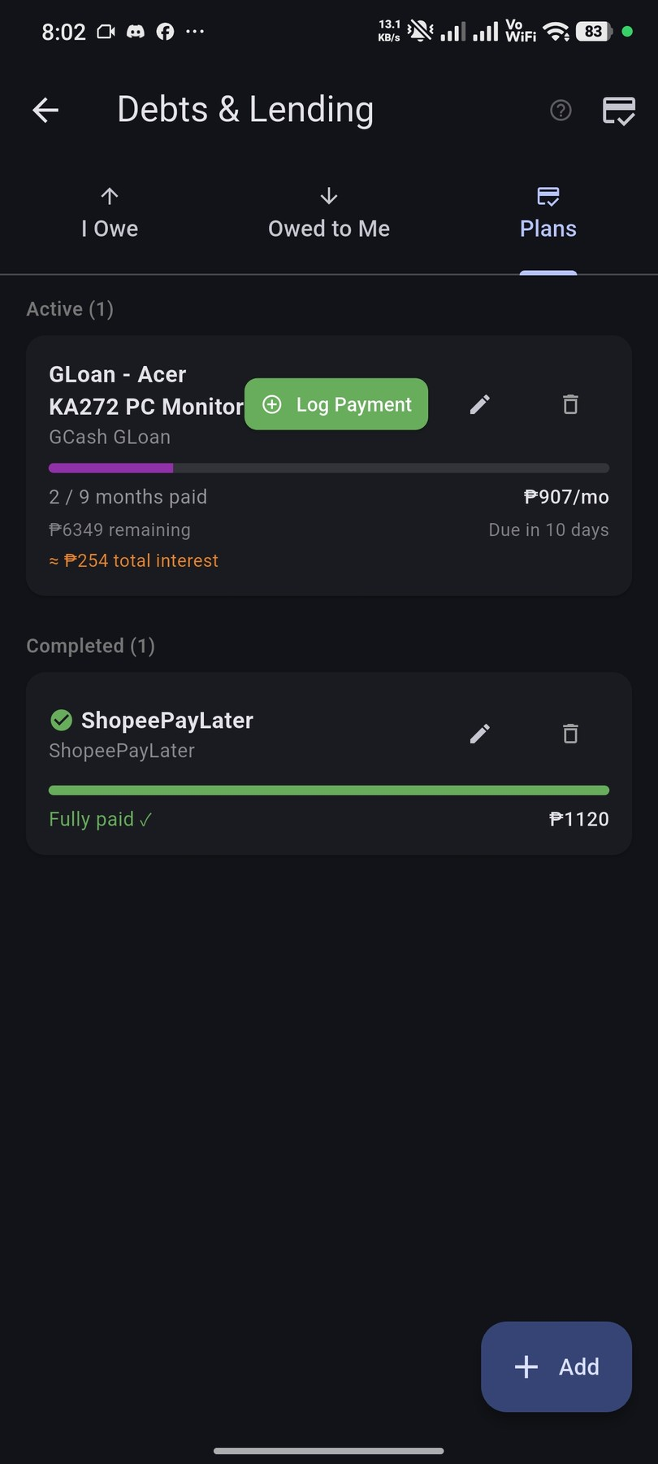 | 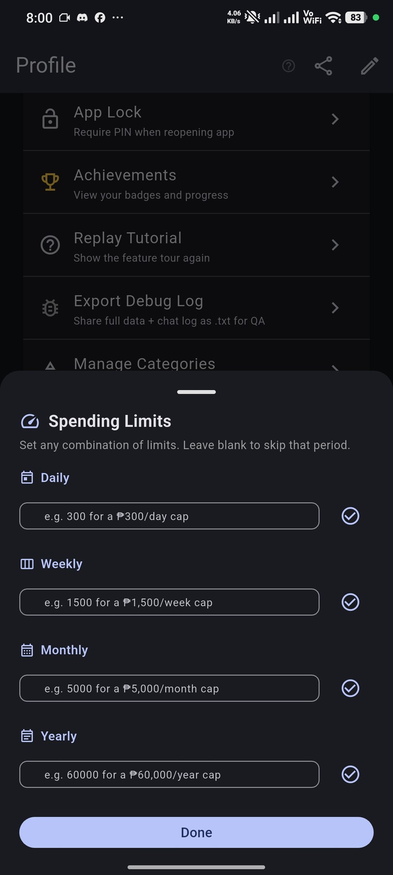
Debts & Lending — Plans tab: GCash GLoan (Acer KA272) active — 2/9 months paid, ₱6,349 remaining at ₱907/mo, due in 10 days; ShopeePayLater fully paid ✓ | Spending Limits — Daily, Weekly, Monthly, and Yearly cap input fields; any combination can be set; blank fields are skipped

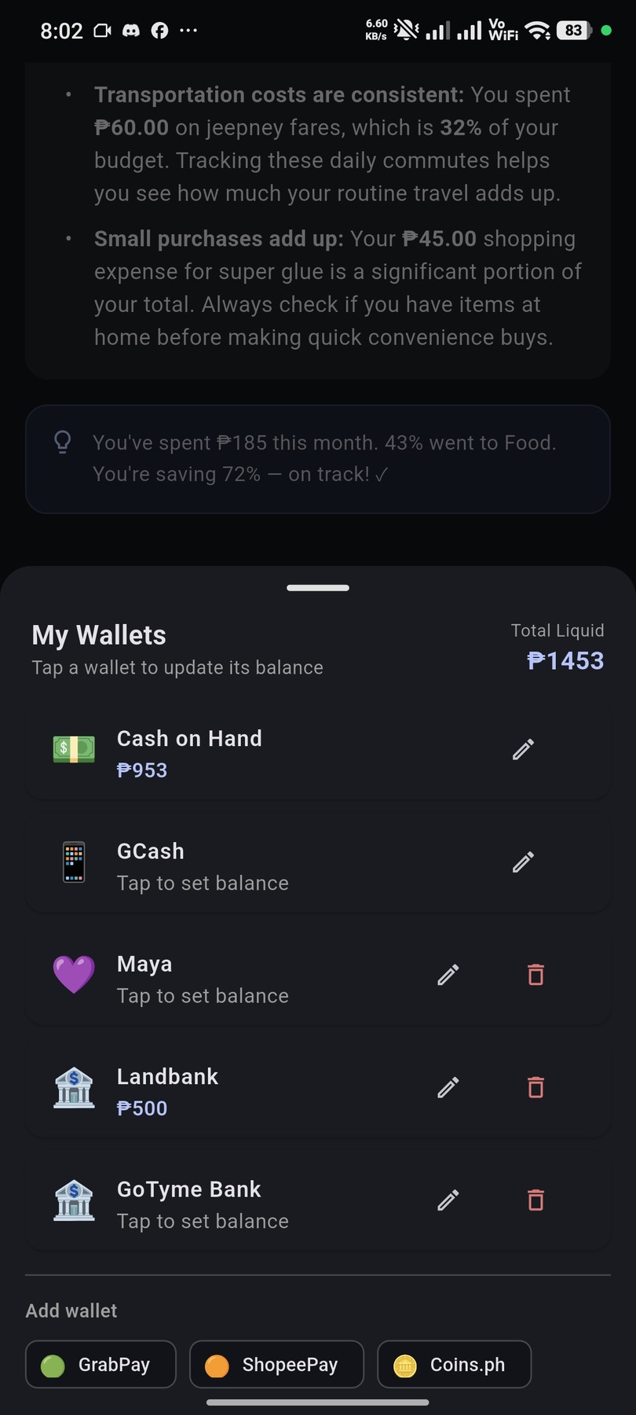 | 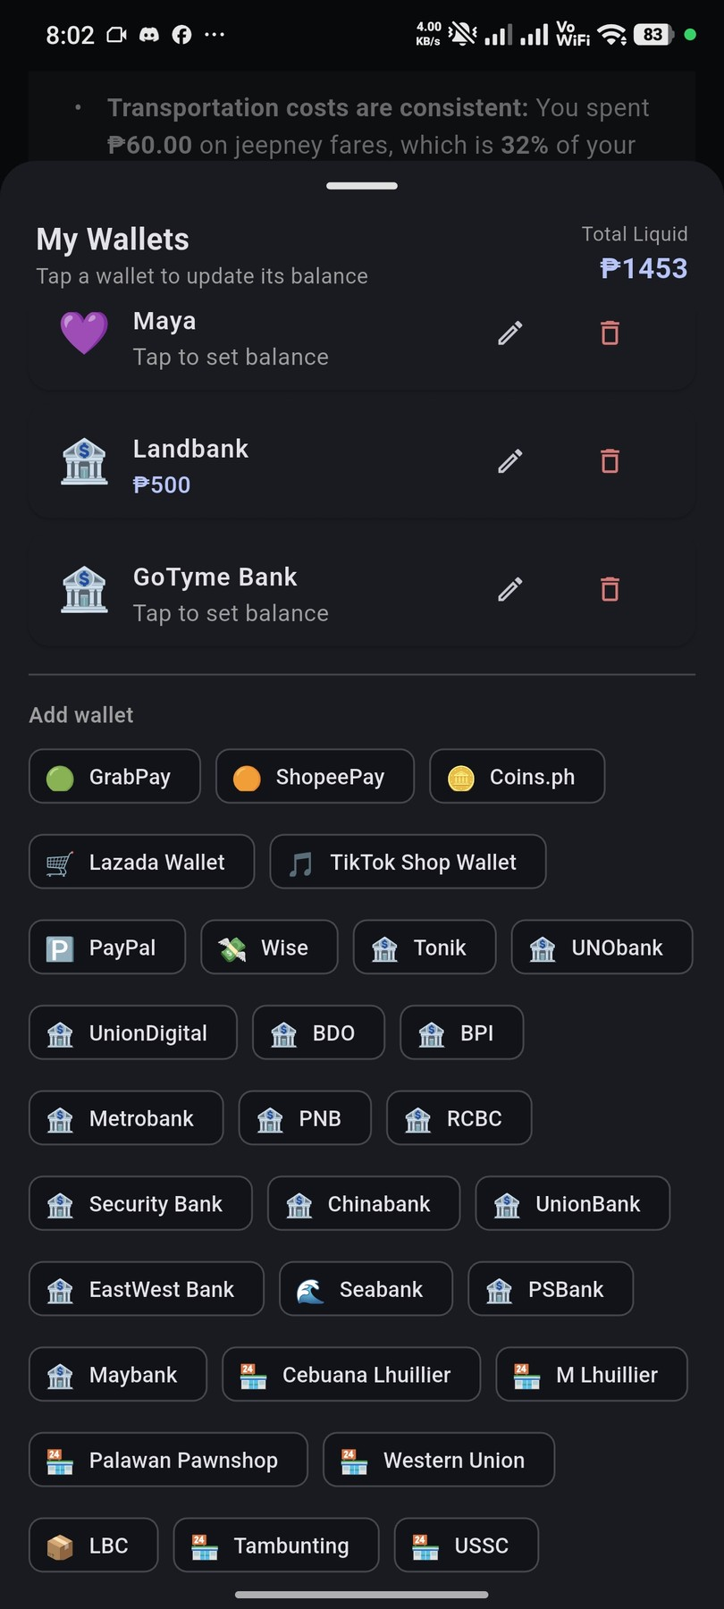
My Wallets — Total liquid ₱1,453: Cash on Hand ₱953, Landbank ₱500, GCash, Maya, GoTyme Bank configured; 29 wallet providers available to add | My Wallets — Add wallet options: GrabPay, ShopeePay, Coins.ph, Lazada, TikTok Shop, PayPal, Wise, Tonik, UNO, UnionDigital, BDO, BPI, Metrobank, PNB, RCBC, and 14 more

Submitted by |  | Noted by

Brix A. Directo  Group Leader / Signature over Printed Name |  | Ellen F. Mangaoang, MIT  Teacher in Charge / Signature over Printed Name

