LigTask: A 2D Game-Based Learning Platform for Enhancing Disaster Awareness and Preparedness

A Capstone Project Presented to the Faculty of the
College of Computer Studies and Engineering Lorma Colleges

In Partial Fulfillment
of the requirements for the Degree
of Bachelor of Science in Information Technology

By:
Mary Anne C. Abenoja Aimee Rachelle J. Arellano Janine Marielle G. Reyes Ellen F. Mangaoang, MIT

December 2025

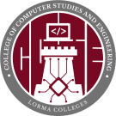
College of Computer Studies and Engineering LORMA COLLEGES
City of San Fernando, La Union
Tel. No. (072) 888-2616 loc. 325 and Fax No. (072) 242-3628
Center of Development for Excellence in I.T Education in Region I

APPROVAL SHEET

This is to certify that we have supervised the preparation of the Capstone Project and read the manuscript prepared by Mary Anne C. Abenoja, Aimee Rachelle J. Arellano, and Janine Marielle G. Reyes entitled LigTask: A 2D Game-Based Learning Platform for Enhancing Disaster Awareness and Preparedness, and that the said Capstone Project has been submitted for final examination by the Oral Examination Committee.

Ellen F. Mangaoang, MIT
Capstone Project Adviser

Janelli M. Mendez, DIT
Capstone Teacher-in-Charge

As members of the Oral Examination Committee, we certify that we have examined the capstone project and manuscript, presented before the committee on November 20, 2025 and hereby recommended that it be accepted in partial fulfillment of the capstone requirements for the degree in Bachelor of Science in Information Technology.

Jeoffrey B. Layco, MIS
Chairperson

Fe Marie Binas-o, MIS, LPT
Member

Johnny F. Verzola, MTS
Member
This capstone project is hereby approved and accepted by the College of Computer Studies and Engineering in partial fulfillment of the requirements for the degree in Bachelor of Science in Information Technology.

Jeoffrey B. Layco, MIS
Dean, CCSE

ABSTRACT

Disasters are constant threats to people, particularly in highly vulnerable nations such as the Philippines, where natural hazards often interrupt lives, livelihoods, and education. This study aimed at strengthening disaster awareness and preparedness among students and teachers in La Union, which covers five of the most common natural hazards in the Philippines, namely typhoons, earthquakes, floods, landslides, and volcanic eruptions, with mini-games being used to simulate the necessary safety measures. The study assessed the level of disaster awareness and preparedness of students and teachers in La Union; designed and developed an interactive 2D educational game that enhances preparedness for the most common disasters in the Philippines; and determined the usability of the developed game using MEEGA+. The system was developed using the game development life cycle.
The teachers had a higher level of disaster awareness and preparedness as compared to the students, as evidenced with the mean ratings of 3.86 to 4.86 respectively. The game was developed using Unity as the main engine, Figma for interface prototyping, and IbisPaint for creating characters, animations, and featuring interactive scenarios. The students agreed that the developed study was usable, as evidenced with an average weighted mean of 4.05 and 4.13, which means that the system has good player experience and user interface design.
LigTask shows how a 2D gamified approach can effectively increase disaster awareness and preparedness by making learning engaging and dynamic. By
educating players how to react responsibly in emergency circumstances, the game supports DRRM operations in schools and communities. With LigTask, students and teachers have a better understanding of disasters and be able to know what to do in terms of disaster. This may lead to community awareness and preparedness.

Keywords: Disaster Preparedness, Disaster awareness, 2D Educational Game, Mini-games, MEEGA+, Usability, Game Development Life Cycle (GDLC) , Disaster

ACKNOWLEDGEMENT
The researchers would like to express their sincere and deepest gratitude and appreciation to those who have contributed to the progress of this study.
First and foremost, they thank their beloved Almighty God for His abundant blessings, for always guiding them, and for giving them faith, courage, wisdom, and the willingness to continue this study.
To the Dean of the College of Computer Studies and Engineering and chairperson, Mr. Jeoffrey B. Layco, for his insightful contributions, exceptional leadership, and patience.
To their capstone adviser, Ellen F. Mangaoang, for sharing her knowledge with them and providing her full support, as well as for believing in their abilities to move forward with this study.
To their teacher in charge, Dr. Janelli M. Mendez, who offered clear direction throughout the requirement process and consistently guided them in aligning their work with academic standards.
To their panelists, Ms. Fe Marie Binas-O and Mr. Johnny F. Verzola, for their generous time and commitment in evaluating the LigTask project. Their insightful feedback, constructive critiques, and professional perspectives significantly contributed to refining and improving the study. The panelists’
guidance played a vital role in strengthening the overall quality, relevance, and effectiveness of the project.
To the College of Computer Studies and Engineering Department, the department’s dedication to academic advancement has equipped the researchers with the necessary tools and expertise for their future endeavors. Through quality instruction, mentorship, and hands-on learning experiences, the department has strengthened its technical skills and professional competence.
Finally, the researchers humbly thank their family and friends for their unwavering support and encouragement throughout this study. Their understanding and motivation played a vital role in helping the researchers overcome challenges and achieve success in their endeavors.
The Researchers

DEDICATION

We dedicate this study to the individuals whose ongoing support and encouragement have played a crucial role in the progress we have made so far. First and foremost, we express our deepest gratitude to our parents, whose continuous love, guidance, and belief in our potential have fueled our determination and kept us moving forward, even during challenging moments. Their unwavering support has been essential in reaching this stage of the study.
We also acknowledge the invaluable contributions of our friends, whose support, shared knowledge, and companionship have been crucial in the development of this work. Their encouragement and insights have been a steady source of motivation, making this journey more meaningful.
Lastly, we extend our thanks to our mentors, and the disaster management professionals, whose support, shared knowledge, and guidance have been crucial as we continue to explore and refine the foundations of this work. Their encouragement and insights have been a steady source of motivation, making this journey more meaningful.
MACA ARJA JMGR

 | TABLE OF CONTENTS
 |  | PAGE
TITLE PAGE |  | i
APPROVAL SHEET |  | ii
ABSTRACT |  | iii
ACKNOWLEDGEMENT |  | v
DEDICATION |  | vii
TABLE OF CONTENTS |  | viii
LIST OF FIGURES |  | x
LIST OF TABLES |  | xi
CHAPTERS

- INTRODUCTION
Project Context 1
Statement of Objectives 8
Scope and Limitation 9
Purpose and Description 10
Technical Background 11
- DESIGN AND METHODOLOGY
Research Design 13
Population and Locale 14
Ethical Considerations 17
Data Gathering Tools and Procedures 17
Software Methodology 19
- RESULTS AND DISCUSSION
Assessment on the Level of Disaster Awareness and 29

 | Preparedness of Students and Teachers
 | Designed and developed an interactive 2D educational game that enhances preparedness for the most common disasters in the Philippines | 45
 | Determined the usability of the developed game using MEEGA+ | 56
IV | CONCLUSION AND RECOMMENDATIONS
 | Conclusions | 64
 | Recommendations | 66
REFERENCES |  | 68
APPENDICES
A | Letter to Conduct Interview | 72
B | Interview Questions | 73
C | Transcript of Interview | 74
D | Survey Questionnaire Assessment of Disaster-Related Knowledge, Preparedness and Readiness, Adaptation, Awareness, and Risk Perception | 76
E | MEEGA+ Questionnaire for Digital Games | 79

PHOTO DOCUMENTATION 80
CURRICULUM VITAE 88
LIST OF FIGURES

Figure No. | Figure Name | Page
1 | Conceptual Framework of LigTask | 7
2 | Game Development Life Cycle | 20
3 | Storyboard for LigTask | 24
4 | Participant’s Disaster Experiences | 30
5 | Character Designing in IbisPaint | 47
6 | Character Emotions | 48
7 | Environmental Assets | 48
8 | Disaster and Hazard Assets | 49
9 | Interactive Objects and Task Items | 50
10 | Main Menu | 50
11 | Settings | 51
12 | Disaster Selection Screen | 52
13 | Narrative Example for Typhoon | 52
14 | Typhoon Mini-game | 53
15 | Flood Mini-game | 54
16 | Landslide Mini-game | 54
17 | Earthquake Mini-game | 55
18 | Quiz | 56

LIST OF TABLES

Table No. | Table Name | Page
1 | Distribution of Respondents | 15
2 | System Requirements for Playing the Game | 28
3 | Disaster-Related Knowledge of Students | 31
4 | Disaster Preparedness and Readiness of Students | 33
5 | Disaster Adaptation of Students | 34
6 | Disaster Awareness of Students | 35
7 | Disaster Risk Perception of Students | 36
8 | Summary: Disaster-Related Knowledge, Preparedness and Readiness, Adaptation, Awareness, and Risk Perception of Students | 37
9 | Disaster-Related Knowledge of Teachers | 39
10 | Disaster Preparedness and Readiness of Teachers | 40
11 | Disaster Adaptation of Teachers | 41
12 | Disaster Awareness of Teachers | 42
13 | Disaster Risk Perception of Teachers | 43
14 | Summary: Disaster-Related Knowledge, Preparedness and Readiness, Adaptation, Awareness, and Risk Perception for Faculty | 44
15 | Level of Usability of LigTask for Students | 58
16 | Level of Player’s Experience of Students | 60
17 | Table Summary: Usability and Player Experience of | 63
 | Students



CHAPTER I

INTRODUCTION

This chapter contained the background of this study, the project context, the conceptual framework, and the statement of objectives. This chapter also discussed the scope and limitations, and the technical background.

Project Context

A disaster, according to the International Federation of Red Cross and Red Crescent Societies, emerged from natural alongside man-made and technological hazards which surpassed a community's ability to maintain operational functions. Meanwhile, a hazard, defined by the IFRC (n.d.), represented any dangerous phenomenon, substance, human activity or condition, often resulting in such casualties ranging from death, injuries, property damage, and social, economic, and health impacts. Multiple hazards leading to disasters include typhoons, earthquakes, floods, landslides, and volcanic eruptions. The hazards mentioned are typical threats which persistently affected the Philippines. (OCD-NDRRMC, 2023)
Some catastrophic events have occurred in recent years. Hurricane Laura struck the southern part of the United States in 2020, destroying nearly 10,000 homes, causing chemical plant fires, and leaving over 568,000 people without power. Additionally, the hurricane caused 47 deaths and had an estimated damage of $19 billion (Pasch et al., 2021).
In the same year, an earthquake with a magnitude ranging from 6.6 to 7.0
struck in the Aegean Sea Earthquake struck near the Greek island of Samos, affecting both the countries Greece and Turkey. There were 117 deaths in Turkey, and two (2) in Greece, with over 1,600 others injured. The earthquake triggered a tsunami and was followed by aftershocks (Altunişik et al., 2021). Additionally, the Aegean Sea Earthquake in Vietnam also experienced severe flooding and flashflood events in 2025, where heavy rainfall triggered widespread flooding, landslides, and flash flood risks in northern and central regions.
Due to its geographic location, the Philippines is a country prone to hazards. The Pacific Ring of Fire, together with its Pacific Typhoon Belt position, exposed the country to constant threats of volcanic eruptions, earthquakes, typhoons, floods, and landslides (Asian Disaster Reduction Center (ADRC), n.d.).
The 2021 Philippine Disaster Report showed the Philippines suffered 80 natural disasters that led to property damage as well as human casualties, including fatalities. A notable example was Typhoon Odette, which struck the Philippines in 2021. According to a 2022 report by the IFRC, Typhoon Odette affected Southern Luzon, Visayas, and Mindanao with its strong winds, heavy flooding, and rain. The typhoon affected 2,991,586 families in Regions V, VI, VII, VIII, IX, X, XI, MIMAROPA, and Caraga, where it caused 405 deaths, 52 missing, 1,371 injuries, and 404,653 houses destroyed, while 1,704,205 houses received partial damage. The total agricultural damage from the typhoon was PHP 17.8 billion, while infrastructural damage was estimated at PHP 30 billion (NDRRMC as cited in IFRC, 2022).
Aside from typhoons, the Philippines is also highly vulnerable to other natural disasters such as earthquakes, as evidenced by the 2013 Bohol earthquake and subsequent seismic events in Cebu and nearby provinces, which caused casualties, infrastructure damage, and long-term disruptions to communities, further emphasizing the country’s classification as one of the most disaster-prone nations in the world (PHIVOLCS 2013).
A strong magnitude 6.9 earthquake occurred on 30 September 2025 of the coast of northern Cebu, Philippines, and is considered to be one of the strongest quakes in the area, leading to massive destruction of houses, government infrastructure, and services. The earthquake caused a huge loss of life and injuries, and displacement, since the buildings, roads, and bridges were destroyed or collapsed, and thousands of people were forced to go to evacuation centers or temporary housing (UNHCR, 2025). Indicated vast demand in emergency response and recovery services as societies grapple with cut-off infrastructure and repeated aftershocks in the days after the earthquake.
Tropical cyclone Kalmaegi (locally known as Tino) struck the Philippines in early November 2025, causing catastrophic rainfall and terrible flash flooding in the central provinces, especially in Cebu province. Rivers and waterways overflowed and flooded residential communities. The ensuing floods resulted in massive destruction, massive evacuation of hundreds of thousands of citizens, and more than a hundred confirmed deaths and many others with missing persons, leading to a state of national emergency declared by President Ferdinand Marcos
Jr. to hasten the provision of relief and mobilization funds. The powerful rains of the storm hit the communities, which were still recovering from other disasters, and the imperfection of flood control systems and disaster readiness was revealed (The Guardian, 2025).
Reports in the local government after the occurrence of Typhoon Tino said that it was the most severe flash flood in the history of Cebu because the heavy rains fell on river systems and low-lying places and inundated towns at an alarming rate, necessitating emergency rescues. It was reported that entire villages were washed away, properties and lives lost, and major road systems cut off, which added to the difficulty of the recovery efforts in the midst of pre-existing post-earthquake displacement. The catastrophic event of intense flooding highlighted the cumulative characteristic of simultaneous natural risks in the Philippines and the necessity of better disaster risk reduction and resilient infrastructure (ABS-CBN, 2025).
These events demonstrated the destructive nature of how hazards can be when they escalate into disasters, emphasizing the importance of disaster preparedness in preventing such casualties.
Disaster preparedness is the proactive measures that people, communities, and organizations undertake along with governments to optimize responses to disaster scenarios, aiming to reduce casualty numbers and safeguard economic stability (EU, 2023). The Philippines being a country with frequent natural hazards, disaster preparedness is essential to prevent casualties, reduce damage, and
ensure a faster recovery to communities.

Being one of the critical issues due to the significant vulnerability of the country such as the Philippines, it was necessary to determine novel and interesting methods of teaching people about this kind of disaster preparedness.
Educational video games provide dynamic, user-centered learning environments that allow users to experiment with problems, get quick feedback, and reflect on their choices. According to Utoyo (2021), simulation and strategy games provide systems thinking capabilities through their interactive gameplay which enables users to comprehend systems together with their resulting decisions.
Martinez et al. (2022) demonstrated that entertainment video games linked to supplementary activities lead to enhanced engagement levels as well as learning results, engagement, and motivations to subjects such as literature, language, and science. The results of this research hinted that learning is enjoyable with video games, and video games could also facilitate critical thinking, cooperation, and long-term memory of learning.
LigTask: A 2D Game-Based Learning Platform to Enhance Disaster Awareness and Preparedness, aimed at designing and developing a series of entertaining and educational mini-games that would raise the disaster awareness of the players and teach them significant precautionary measures. The game concentrated on the five most common disasters in the Philippines: typhoons, earthquakes, floods, landslides, and volcanic eruptions only.
LigTask is aligned with four (4) essential Sustainable Development Goals: SDG 4 for Quality Education, SDG 11 about Sustainable Cities and Communities, SDG 13 on Climate Action, and SDG 17 concerning Partnership for the Goals (United Nations, 2015). LigTask applied gamified learning to deliver accessible, interactive, and relevant disaster preparedness education. The game enhanced learning and recalling of significant safety practices by the users, and moreover, LigTask educated the players on disaster preparedness and response to frequent disasters in the Philippines. Through simulated scenarios, the game encouraged individual and household-level readiness, which in turn supported the development of safer and more resilient communities.
The developed game comprised short mini-games that put a fun and playful spin on real disaster situations. These games test how well players can make the right decisions in different disaster situations. The mini-games guided players through tasks such as preparing emergency supplies, securing homes, responding safely during disasters, and taking proper steps after the event. Each level challenges players to apply disaster preparedness knowledge in an interactive way.
Moreover, the game is consistent with the efforts to mitigate the effects of climate change as it helps to increase awareness about disasters and encourage people to prepare in advance. It equipped users with the information and confidence to respond in times of emergencies, reducing the risks and impacts of more intense and frequent natural hazards. LigTask’s success depended on the
collaboration with the disaster risk management agencies to ensure that the game is technically correct, relevant, and accurate. Cooperation with the responders and organizations contributed to maximizing the effect of the project be part of broader activities aimed at sustainable development. The Sustainable Development Goals are directly linked to the objectives of LigTask, illustrating how the project helps to support national and international action to enhance safety, education, and resilience in the face of disasters.
The conceptual framework of LigTask as seen in figure 1 shows how different parts of the game work together to promote disaster preparedness. It starts with user interactions and decisions, which lead to the mini-games.
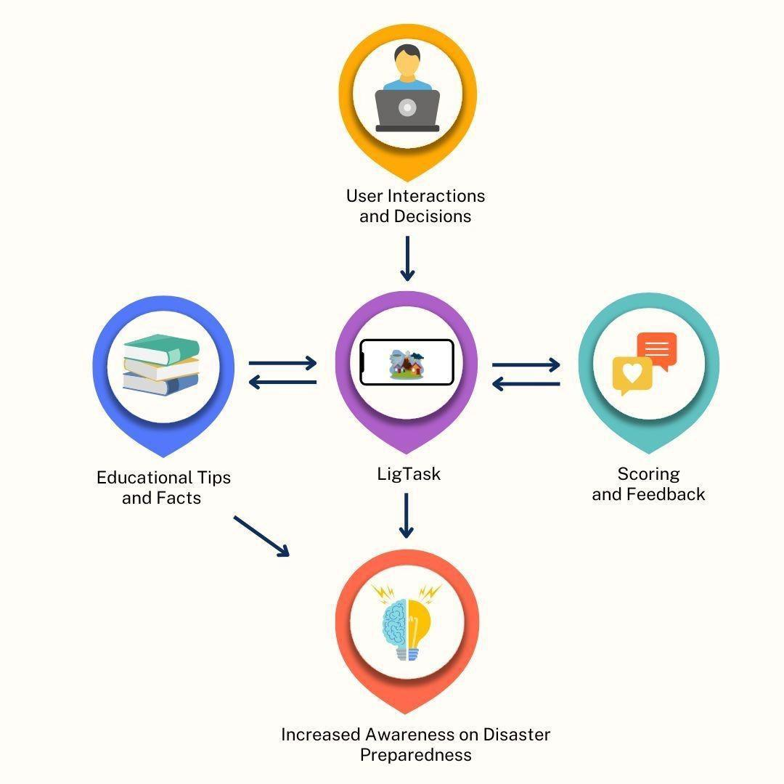

Figure 1. Conceptual Framework of LigTask
These mini-games are designed to test the player's reflexes and decision-making under pressure, especially as the timer speeds up each round. Informational facts and tips are integrated into the gameplay experience. These support what players learn in the mini-games by connecting to the tasks they do. The mini-games and educational information support the game's main goal of increasing awareness of disaster preparedness.
The mini-games are categorized per disaster type and further divided into Before, During, and After stages, ensuring players gain knowledge across different phases of disaster management. Each mini-game also features Easy and Hard modes, making the game accessible to beginners while still challenging advanced players.

Statement of Objectives
This study achieved to design and develop a disaster-readiness game that is both entertaining and educational to promote correct actions before, during, and after natural disasters. The game offers fun challenges that mirror important disaster-related activities, with educational tips between rounds to reinforce learning and emphasize safety procedures.
Specifically, the study achieved the following objectives:
- Assessed the level of disaster awareness and preparedness of students and teachers in the La Union;
- Designed and developed an interactive 2D educational game that enhances preparedness for the most common disasters in the Philippines; and
- Determined the usability of the developed game using MEEGA+.

Scope and Limitation
The objective of this study was to develop LigTask, a 2D mobile game that utilized simple and interactive mini-games to enhance disaster preparedness. To make learning enjoyable and convenient, the game had a cartoon-like theme with the five most frequent natural hazards in the Philippines - typhoons, floods, landslides, earthquakes, and volcanic eruptions - serving as the central focus.
Players participated in mini-games that required them to make decisions such as identifying an emergency go bag, duck, cover, and hold drills, and turning off electrical switches during storms. The mini-games aimed to remind the players of the general steps one needs to undertake in case of an emergency. The mini-games featured different actions that players need to perform before, during, and after a disaster, helping players build a complete understanding of disaster preparedness. After completing a level, players are required to answer a short quiz to assess what they have learned. The game emphasized simple, individual actions that are easy to learn and implement. The purpose was to raise awareness and promote disaster readiness through engaging gameplay.
The game was designed and developed for Android devices only, using simple graphics and a user-friendly interface. Instead of aiming for high-end
graphics or lifelike simulations, it primarily focused on being educative and engaging. Individual-level preparedness is the primary focus because such advanced topics as professional rescue activities and long-term recovery after a disaster were not covered, as well as all possible disaster scenarios. The study only included typhoons, earthquakes, floods, landslides, and volcanic eruptions.

Purpose and Description

LigTask was designed to educate users about disaster preparedness through an engaging and scenario-based mini-game. LigTask served not only as a game but also as an educational tool to improve awareness of disaster preparedness for younger audiences. The developed study proved beneficial to: Gamers. LigTask appealed to players who enjoyed lighthearted, short mini-games. Players responded quickly to emergency scenarios, making the experience both enjoyable and educational, and completed short quizzes to reinforce learning. General Public. People living in disaster-prone areas, particularly in the Philippines, benefited from the game's emphasis on disaster preparedness. The game delivered safety information in an entertaining manner. This allowed the players to better recall what to do in an emergency.
Students. LigTask helped students learn disaster preparedness in a fun and engaging way. Through mini-games and short quizzes, students can better understand the important steps they should take before, during, and after a disaster.
Teachers. LigTask was utilized as a supplementary teaching tool to introduce disaster preparedness more effectively by encouraging student participation and assessing understanding through interactive gameplay and quizzes.
Disaster Awareness Advocates and Educators. Disaster response organizations and educators applied the game with the purpose of supporting the awareness campaign, particularly in the case of addressing youth and casual audiences. It's a game-based learning approach, which assists in delivering key messages in an entertaining manner.
The Researchers. This study allowed the researchers to apply their skills in game development and ideas on the possible application of games as a learning tool. It is also an experience that they could draw upon in their future academic or professional projects.
Future Researchers. The project served as a reference or foundation for future studies related to educational games, disaster preparedness tools, or mobile learning applications. It inspires further innovations in combining gameplay with public safety education.

Technical Background

The tools utilized in the design and development of the disaster awareness and preparedness game LigTask are discussed in this section. All the tools are important in developing the features, graphics, and the general user interface along with the completion of the game.
Unity. Unity is the primary platform for LigTask development. Unity's built-in tools and features were used to create game scenes, control gameplay mechanics, and handle animations. Scripts were written in C# to manage game logic, player actions, and interactions with the environment.
Figma. Figma was used for designing the user interface (UI), and a plan for the layout of various screens in the game was made. It assisted in developing wireframes and prototyping to structure the flow of the game and make it user-friendly. Another technology that Figma facilitated is the collaboration of teams in the design process.
IbisPaint X. IbisPaint X was used to paint in order to draw and design the graphic aspects of the game. It consists of characters, backgrounds, and icons, among others. A wide range of brushes and tools offered by the app helped in creating colorful and engaging art that complemented the theme of disaster awareness and preparedness.
SQLite. SQLite was used as the local database system of the game. Since SQLite is lightweight and runs directly on the device, it is a practical choice for storing important data such as the total score and unlocked disasters.


CHAPTER II

DESIGN AND METHODOLOGY
This chapter presented the discussion on the procedures that were conducted in this study in terms of research design, population and locale, sampling method, data gathering tools and procedures, ethical considerations, and software development methodology.

Research Design

The researchers employed a mixed-method research design for the development of the study. Mixed-methods research design was an approach that integrates both qualitative and quantitative data collection and analysis within a single study. Using this approach, the researchers examine the “what” and “how much” using quantitative data, while also understanding the “why” and “how” from qualitative insights (Sharma et al., 2023).
For the qualitative methodology, interviews with disaster responders on disaster preparedness were conducted to gather qualitative and pertinent data relevant to the study. The interview ensured that the game’s content accurately aligned with the disaster preparedness procedures.
Quantitative data were collected for objective number 1, which is the assessment of disaster-related knowledge, preparedness and readiness, adaptation, awareness, and risk perception. Data were also collected for objective number 3, which is the usability of the developed game. The surveys measured the participants’ disaster preparedness knowledge and perceptions of the game’s
usability and effectiveness once it is developed. These surveys were used to assess how well the game engaged players and met its learning goals.
By integrating qualitative and quantitative inputs during the development and assessment stages, this study seeks to create a game that is not only informative but also entertaining, useful, and pertinent to the needs of communities in the Philippines that are prone to disasters.

Population and Locale

The study was conducted at the Province of La Union particularly in the municipalities of Naguilian, San Juan, and Bacnotan, La Union. A total of one hundred sixty-two (162) respondents participated in the study, consisting of one hundred fifty-two (152) students, seven (7) teachers, and three (3) disaster responders, as presented in table 1 (page 15). For objective number 1, a total of sixty-three (63) students were the respondents in the assessment of the level of disaster awareness and preparedness, where ten (10) students were from Naguilian National High School, while the remaining fifty-three (53) were from San Juan Senior High School – Stand Alone. Seven (7) teachers participated in the assessment of the level of disaster awareness and preparedness. Meanwhile, eighty-nine (89) students participated in the MEEGA+ usability testing, which comprised: seven (7) students from Naguilian National High School, fifty-five (55) students from Zaragosa Integrated School, and twenty-seven (27) students from Basic Inclusive Education Lorma Colleges. Additionally, the three (3) disaster responders participated in the expert interview to provide specialized insights. This
distribution ensured diverse representation across municipalities and respondent groups. This setting grounded the study in disaster-prone communities, making the findings directly relevant and beneficial for disaster preparedness initiatives in similar locales.
Purposive and random sampling were used in selecting the respondents. Disaster responders were selected through purposive sampling which is also referred to as judgmental sampling. The reason why this approach has been selected is that these professionals have the knowledge and experience required to give meaningful feedback on any essential safety actions in advance of the disaster, during, and after the disaster. The involvement of the disaster responders helped close the gap between the educational strategies and the real-life disaster management processes, so that the content of the game did not contradict the real-life emergency procedures.
The primary research instrument was the MEEGA+ evaluation framework to measure the experience of the students with the created educational game. The framework evaluates some of the fundamental dimensions, including engagement, Table 1: Distribution of Respondents

Respondents No. of Respondents
Students 152
Teachers 7
Disaster Responders 3
Total: 162

fun, perceived learning, usability, and general player experience. Student respondents were the only participants who were considered in the MEEGA+ assessment because the framework will help to obtain the opinion of learners towards educational games (Hassan, 2024).
On the other hand, random sampling was used to sample the students and the teachers. This type of sampling method gives equal chances to the members of the population to be selected, which is fair and diverse in terms of representation (Makwana et al., 2023). With the inclusion of participants with varying backgrounds in education, the study could get a very broad range of information on the issues of disaster preparedness. This assisted in boosting the validity and reliability of the results.
The role of the students in this research is very important since they were the main beneficiaries of the game. Their responses showed how LigTask is usable and educational in promoting disaster preparedness and awareness. Teachers play a crucial part in directing the pupils and making sure that disaster preparedness is incorporated in the educational setting. By engaging these three groups, the study achieved a balanced evaluation of LigTask. This ensures that the mobile game serves as an effective and engaging educational platform and accurately reflects situational relevance to disaster preparedness. This ensures that the system not only serves as an engaging educational platform but also reflects and situational relevant disaster preparedness practices.

Ethical Considerations

This study adhered to ethical standards to protect the rights and welfare of all individuals involved in the creation and assessment. The researchers utilized standardized instruments such as letters, questionnaires, surveys, and interviews (see Appendix A, B, D, and E) to collect data from respondents whose data is relevant to the objectives of our study. In this context, the researchers provided a clear and comprehensible explanation for obtaining consent prior to the use of the tools. This approach is a secure environment for gathering data and ensures informed consent, by which participants are fully aware of the study’s objective, procedures, and evaluation.
Significantly, Participants were fully informed that their involvement in the study was completely voluntary, and they could refuse or withdraw at any point in the research without facing any negative consequences. The researchers ensured that all information provided by respondents was kept confidential and anonymous. The collected data were used exclusively for this research and managed with the highest level of care to avoid any unauthorized access.

Data Gathering Tools and Procedures

Data were gathered by researchers using a variety of tools and techniques. Primary data were gathered through the distribution of survey questionnaires to teachers and students particularly from the municipalities of Naguilian, San Juan, and Bacnotan, La Union, as well as through interviews with the Disaster Risk Reduction Offices. Secondary sources of information included official disaster
safety guidelines and internet research. The gathered information guided the development of the game using Unity, it ensured that gameplay elements align with real-world disaster preparedness practices.
To meet the first objective, which is to assess the level of disaster preparedness of students and teachers, an interview guide (See Appendix B) was first administered to disaster responders. Also, a survey questionnaire was adopted and slightly modified from the study of Columna et al (2024) entitled “Assessment on Disaster Preparedness, Related-Knowledge, and Adaptation Among Intermediate-Level Students” (see Appendix D). The survey questionnaire was distributed using Google Forms. In order to support the design and development of LigTask, the questionnaire gathered general data regarding students' perception, experiences, preparedness for disasters, and interest in game-based learning. The information was useful in identifying prevalent knowledge gaps that the game needs to address.
For the second objective, the researchers used different tools to design and develop an interactive 2D educational game that enhanced preparedness for the most common disasters in the Philippines. The game animations and gameplay mechanics were built using Unity. The user interface (UI) and screen layouts were designed using Figma, which helped create wireframes and prototypes for a smooth, user-friendly experience. The visual elements, such as characters, backgrounds, and icons, were created with IbisPaint X, ensuring colorful and engaging artwork that fits the theme of disaster awareness and preparedness.
Lastly, SQLite was used to store and manage in-game data, such as the player's total score, available powerups, and total in-game currency. Playtesting was performed before the final evaluation to enhance the user experience and solve any technical issues.
For the last objective, which is to determine the usability of the developed game, the researchers administered the MEEGA+ questionnaire (see Appendix E) to eighty-nine (89) students. Meega+ (Method for the Evaluation of Educational Games for Computing Education) is a tool designed to assess user experience in educational games. It helped the researchers determine whether the players found the game educational, enjoyable, and easy to use. The feedback was utilized to identify if the game achieved the purpose of raising the students' knowledge and understanding of disaster awareness and preparedness. The results may also point to areas where future versions of the game should be working to correct.

Software Methodology

LigTask was designed and developed using the Game Development Life Cycle (GDLC) software methodology. The six (6) stages of the Game Development Life Cycle are Initiation, Pre-Production, Production, Testing, Beta, and Release, as presented in figure 2 (page 20). This method provided a structured, iterative process specifically made for video game development. Since it ensures that both gameplay and educational objectives were successfully met, it was suitable for LigTask, an instructional game focused on disaster preparedness. Considering that LigTask aimed to educate players while keeping them engaged through interactive

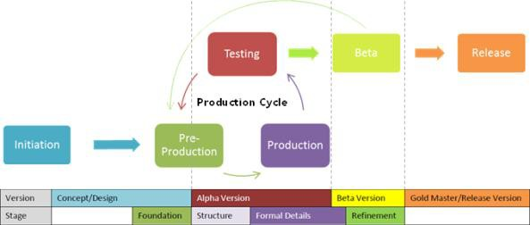

Figure 2. Game Development Life Cycle

mini-games, the Game Development Life Cycle is the most appropriate methodology. It offers a systematic flow that allows continuous improvements based on user feedback, ensuring that the final product is both informative and enjoyable.

Initiation Phase

The first phase formed the basis of the creation of LigTask's design and development. In this stage, the researchers brainstormed and determined the game type, target audience or players, kind of game, technical specifications, and initial scope and constraints, as well as the game theme. To be able to gather information, the researchers also conducted interviews with the disaster responders. The level of disaster awareness and preparedness of students and teachers was also assessed. This process guaranteed that the content was in accordance with the disaster situations in real life and in line with the needs of the community. Tally and weighted mean were utilized to assess the level of disaster
awareness and preparedness of the students and teachers. A 5-point Likert scale
was utilized to interpret the results of the survey. To assess the respondents' disaster-related knowledge, a mean range of 1.00-1.50 denotes no knowledge; 1.51-2.50 as limited knowledge, 2.51-3.50 as average knowledge, 3.51-4.50 as good knowledge, and 4.51-5:00 represents excellent knowledge.
Likert Scale | Mean Range | Descriptive Equivalent  Rating (DER) | Descriptive Interpretation
5 | 4.51 – 5.00 | Very High | Excellent Knowledge -
4 | 3.51 – 4.50 | High | Good knowledge
3 | 2.51 – 3.50 | Moderate | Average knowledge
2 | 1.51 – 2.50 | Low | Limited knowledge
1 | 1.00 – 1.50 | Very Low | No knowledge
The respondents’ disaster preparedness and readiness (page 22) were determined through the following values: a mean range of 1:00-1.50 denotes never manifested; 1:51-2.50 as seldom manifested, 2.51-3.50 as sometimes manifested, 3.51-4.50 indicates as often manifested, and 4.51-5.00 as always manifested.
This scale was used to determine the respondents’ level of disaster adaptation (page 22). A mean range of 1.00–1.50 is interpreted as never manifested, 1.51–2.50 as seldom manifested, 2.51–3.50 as sometimes manifested, 3.51–4.50 as often manifested, and 4.51–5.00 as always manifested.

Likert Scale | Mean Range | Descriptive  Equivalent Rating (DER) | Descriptive Interpretation
5 | 4.51 – 5.00 | Very High | Always manifested
4 | 3.51 – 4.50 | High | Often manifested
3 | 2.51 – 3.50 | Moderate | Sometimes manifested
2 | 1.51 – 2.50 | Low | Seldom manifested
1 | 1.00 – 1.50 | Very Low | Never manifested

The respondents’ disaster awareness was determined through the following values: a mean range of 1.00–1.50 is interpreted as never manifested, 1.51–2.50 as seldom manifested, 2.51–3.50 as sometimes manifested, 3.51–4.50 as often manifested, and 4.51–5.00 as always manifested.
Likert Scale | Mean Range | Descriptive Equivalent  Rating (DER) | Descriptive Interpretation
5 | 4.51 – 5.00 | Very High | Always manifested
4 | 3.51 – 4.50 | High | Often manifested
3 | 2.51 – 3.50 | Moderate | Sometimes manifested
2 | 1.51 – 2.50 | Low | Seldom manifested
1 | 1.00 – 1.50 | Very Low | Never manifested

Likert Scale | Mean Range | Descriptive  Equivalent Rating (DER) | Descriptive Interpretation
5 | 4.51 – 5.00 | Very High | Always manifested
4 | 3.51 – 4.50 | High | Often manifested
3 | 2.51 – 3.50 | Moderate | Sometimes manifested
2 | 1.51 – 2.50 | Low | Seldom manifested
1 | 1.00 – 1.50 | Very Low | Never manifested

To interpret the respondents’ disaster-risk perception, a mean score of 1.00–1.50 signified very negative perception, 1.51–2.50 indicates negative perception, 2.51 – 3.50 reflects an undecided or neutral perception, 3.51–4.50 denotes a positive perception, and 4.51–5.00 corresponds to a very positive perception.
Likert Scale | Mean Range | Descriptive  Equivalent Rating (DER) | Descriptive Interpretation
5 | 4.51 – 5.00 | Strongly Agree | Very positive perception
4 | 3.51 – 4.50 | Agree | Positive perception
3 | 2.51 – 3.50 | Neutral | Undecided
2 | 1.51 – 2.50 | Disagree | Negative perception
1 | 1.00 – 1.50 | Strongly Disagree | Very negative perception

Pre-Production Phase

During the phase of pre-production, the researchers converted the findings from the initiation phase into detailed plans for game development. This comprised the development of the structure of the game, setting learning objectives for each disaster, and gameplay elements such as game mechanics, narration flow, scenarios, scoring system, and quiz integration.
A low-fidelity storyboard as seen on figure 3 was created to illustrate the game's structure. This storyboard includes four main screens: the home screen, disaster selection, an example of a mini-game, and a summary score. On the disaster selection screen, players select from a range of disaster scenarios, and each corresponds to a different learning curve. In the sample mini-games, the players make choices during disaster situations while learning simultaneously. After playing, the summary screen showed the player’s score.
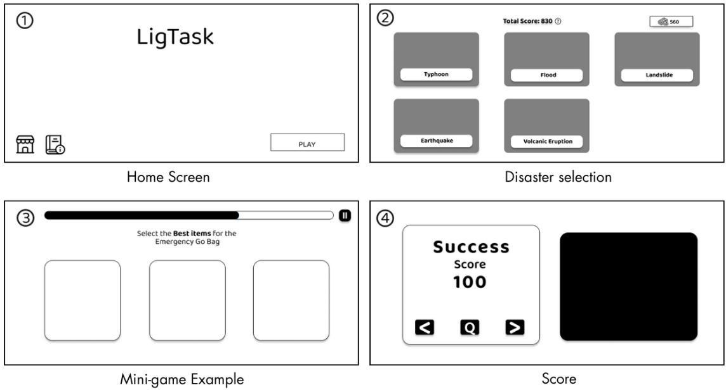

Figure 3. Storyboard for LigTask
This storyboard served as an initial blueprint to ensure that the navigation and visual hierarchy of the game are comprehensible and user-friendly. It also assisted the team in coordinating their work by providing a common understanding of the flow of the game before actual development took place.

Production Phase
The actual development of LigTask began in the production phase, implementing the plans and designs made during the earlier phases. The backgrounds of the game, animations, and logic of the game, specific to the scenario, were assembled using Unity. The user interface and screen layouts were designed using Figma because it was an easy and user-friendly program. Backgrounds, icons, and characters were created using IbisPaint X, which achieved the aim of providing visually appealing art that complements the theme of disaster awareness and preparedness. The database of the game was implemented using SQLite and includes the data on scores of players and in-game currency.

Testing Phase
After production, the game underwent testing by the researchers. Both functional testing and playtesting were employed to ensure that all aspects of the game are working as expected. Also, activities such as identifying bugs, testing gameplay, and receiving feedback on the difficulty, design, and flow of the game were undertaken before the release of the game to potential users. The researchers carefully analyzed the feedback to make necessary adjustments, improving both the user experience and educational effectiveness. This iterative
process helped ensure that the final version of the game is engaging, functional, and aligned with the learning objectives.

Beta Phase

Once the game passed internal tests, it was released to a selected group of students for beta testing under a soft launch. The students’ feedback and interactions with the game were monitored. This helped researchers to evaluate the functionality and readability of the game as well as the level of engagement. Also, any technical issues or challenges of user experience that had not been identified during the earlier testing phases were detected at the beta phase to be fixed and improved.
LigTask was officially launched to its target audience by administering MEEGA+ (Method for the Evaluation of Educational Games for Computing Education) to measure LigTask's overall usability. The MEEGA+ approach was intended for use by researchers, instructors, and game developers to assess the quality of games used in computer education (Petri, et al., 2018). The results of the MEEGA+ questionnaire helped determine how well the game met its objectives in terms of player satisfaction and learning impact and allowed the researchers to add further improvements to the game.
The usability of the developed project was determined by applying tally and the weighted mean. A 5-point Likert Scale (page 27) was utilized to interpret the results. A mean score ranging from 1.00 to 2.50 is interpreted as a “Very Poor”, and a mean score ranging from 2.51 to 5.00 is interpreted as a “Excellent”.

Likert Scale | Mean Range | Descriptive  Equivalent Rating (DER) | Descriptive Interpretation
5 | 4.51 – 5.00 | Strongly Agree | Excellent
4 | 3.51 – 4.50 | Agree | Good
3 | 2.51 – 3.50 | Neutral | Fair
2 | 1.51 – 2.50 | Disagree | Poor
1 | 1.00 – 1.50 | Strongly Disagree | Very Poor

Release Phase

In this phase, all feedback from the beta testing was reviewed. Final changes were made to improve the gameplay, user experience, and learning content based on the results of the MEEGA+ survey. Any bugs and technical problems found during testing were fixed to make sure the game worked properly and smoothly.
After all improvements were completed, the final version of LigTask was prepared for release. The game was checked to ensure that all disaster scenarios, game features, and instructions were working correctly. The final version was then uploaded to Google Drive so that users could easily access and download the game. Additional testing was conducted on different devices to confirm compatibility and performance. Feedback from the beta testers was documented to guide potential future updates. This phase ensured that LigTask was stable, complete, and ready for public use.
Table 2 shows the minimum system requirements needed to keep LigTask running efficiently and available to a wide range of users. These requirements enable stable gameplay across a variety of device types. The basic requirements provide necessary functionality, whereas the recommended criteria provide a more complete experience with improved performance and response.
Table 2. System Requirements for Playing the Game

System

Requirements
Minimum Recommended

OS Android 8.0 (Oreo) Android 10+

CPU 1.8 GHz quad-core Octa-core (Snapdragon 660 /
Helio G-series)

RAM 2 GB 3–4 GB

GPU Adreno 506 / Mali-T830 equivalent
Adreno 610 / Mali-G52
Storage 300 MB free 500 MB free



CHAPTER III

RESULTS AND DISCUSSION

The findings of developing and evaluating the LigTask educational game are presented in this chapter. It relates to the discussion of the results on the basis of the objectives of the study, which are the evaluation of disaster awareness and preparedness, the development of an interactive learning platform, and the assessment of its usability. The discussion is technical and educational where the game fosters awareness and readiness to students and teachers It also outlines the development process, user feedback, and the effectiveness of the game in improving disaster education by means of interactive gamified learning.

Assessment on the Level of Disaster Awareness and Preparedness of Students and Teachers
To address the first research objective, the researchers administered a survey questionnaire which was distributed through Google Forms (see Appendix D) to sixty-three (63) students and seven (7) teachers. The assessment was aimed at evaluating the level of disaster preparedness, knowledge, and adaptation of the respondents.
Inclusion of these groups offered a balanced approach to the aspect of disaster awareness, and the researchers could effectively compare the level of preparedness and adaptability of the students and teachers. Responses were collected and evaluated to determine the overall understanding of disaster awareness and preparedness and to identify areas that could be improved by the
LigTask educational game. This evaluation allowed the researchers to gain useful information about the current state of knowledge and adaptation concerning the disaster.
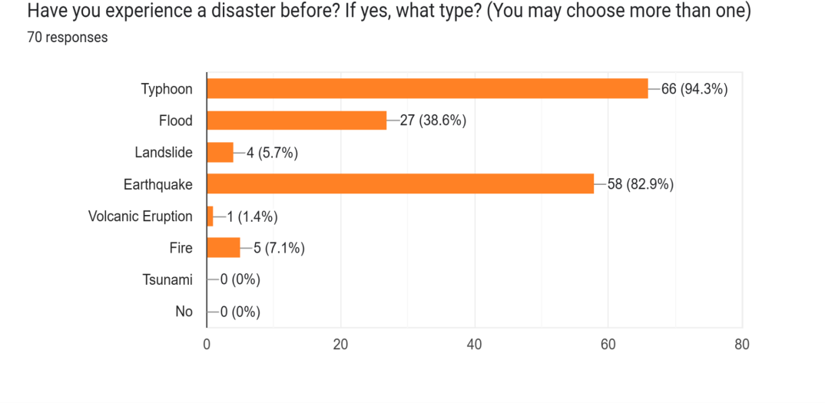
Based on the results shown in Figure 4, the survey revealed that most respondents had previously experienced disasters, particularly typhoons (94.3%) and earthquakes (82.9%). Other reported experiences included floods (38.6%), landslides (5.7%), fires (7.1%), and volcanic eruptions (1.4%), while none had encountered a tsunami (0%). These results indicate that participants are highly familiar with common natural hazards affecting their community. The prevalence of these experiences reflects the vulnerability of the Philippines, especially areas like La Union, to multiple natural calamities. These findings emphasize the relevance of developing the LigTask educational game, aimed at enhancing disaster awareness and preparedness knowledge and adaptive responses among students and teachers.

Figure 4. Participant’s Disaster Experiences
Table 3 shows the level of knowledge of the students regarding disaster-related knowledge, with an average weighted mean of 3.50, interpreted as a moderate and average level of knowledge. Indicator 3 got the highest mean rating of 3.79, while indicator 1 got the lowest mean rating of 3.14. This indicates that the respondents have good knowledge of disasters and have participated in disaster-related trainings and workshops. This implies that the training and seminars helped raise respondents' awareness.
Also, these findings point to some level of acquaintance with fundamental principles of disasters. Indicator "I know when a disaster will happen" implied that the students may not be well versed in the hazard signals, prediction, and early warning systems. This comes as no surprise, because this knowledge may demand Table 3: Disaster-Related Knowledge of Students
Indicators Mean Descriptive Equivalent
Rating (DER)
Descriptive Interpretation
- I know when a disaster will occur.
3.14 Moderate Average Knowledge
- I know disasters cannot be prevented.
- I have participated in disaster risk education training or workshops.
3.56

3.79
High High
Good knowledge Good knowledge

Average 3.50 Moderate Average knowledge

advanced training. In general, although the knowledge of the students in disaster-related areas is moderate, it is obvious that it is necessary to enhance it with the help of the systematic learning process, simulation-based exercises, and more profound exposure to DRRM concepts. This further implied that the students already have the basic knowledge of the concepts of disasters, but fail to exhibit higher or technical expertise on a consistent basis.
Table 4 (page 33) indicates that the students have a high disaster preparedness and readiness level, with an average weighted mean of 3.55, which is perceived to be of community activities related to disaster risk reduction. This is backed up by the result that students have participated in disaster risk education and training. This implies that the students or respondents value the importance of awareness and preparedness by attending community activities, education drives, and trainings.
Meanwhile, the lowest score of 2.79 was achieved by indicator 2, “I know the government will provide enough facilities after a disaster, and we will not face any problem”, which indicates confidence in post-disaster government facilities. This is an indication of doubt or a lack of knowledge regarding the real potential of government agencies to offer adequate post-disaster help. These findings indicate that better DRRM orientation programs are required to acquaint students with the role of the local government, resources, and emergency management systems.
Table 5 (page 34) presents the disaster adaptation of students as evidenced
with a rating of 3.87 with a descriptive equivalent rating of high, interpreted as often manifested. The most significant indicator, which acknowledges the importance of community activities in disaster risk reduction (4.06), emphasizes the sense of value of respondents to participation in disaster preparedness activities in groups.
The lowest indicator, which government offices need to address in the event

Table 4: Disaster Preparedness and Readiness of Students

Indicators Mean
Descriptive Equivalent Rating (DER)
Descriptive Interpretation
- I know the importance of disseminating experiences or knowledge of disaster.
- I know the government will provide enough facilities after a disaster and we will not face any problem.
- I am confident for reconstruction activities from the government after disaster.
- I know the importance of community activities for disaster risk reduction.
- I used to listen to experts or Disaster Risk Reduction (DRR) leaders who work or do activities for disaster management.
4.00

2.79

3.05

4.10

3.81
High

Moderate

Moderate

High

High
Often manifested

Sometimes manifested

Sometimes manifested

Often manifested

Often manifested

Average 3.55 High Often manifested

Table 5: Disaster Adaptation of Students

Indicators Mean |  | Descriptive  Equivalent | Descriptive  Interpretation
 |  | Rating (DER)
1. I am aware of shelter | 3.98 | High | Often
areas and open space in |  |  | manifested
case of a disaster.
2. I have information about | 3.71 | High | Often
which government offices |  |  | manifested
need to be contacted after
the disaster.
3. I have knowledge about | 3.73 | High | Often
disaster-prone areas. |  |  | manifested
4. I know the importance of
community activities for | 4.06 | High | Often
disaster risk reduction. |  |  | manifested

Average 3.87 High Often manifested

of a disaster (3.71), though already high, demonstrates potential improvement regarding the familiarity with agencies of DRRM and emergency communication guidelines.
Table 6 (page 35) presents the Disaster Awareness of Students, indicating an average mean of 3.69, with a descriptive equivalent of “High” with an “Often manifested” interpretation, indicating a high level of awareness among respondents. The top indicator-consciousness of disaster recovery as being vital (4.21) shows that the students possess a well-developed understanding of disaster management that extends beyond immediate response to include long-term recovery and resilience planning.
Table 6. Disaster Awareness of Students

Indicators Mean Descriptive Equivalent
Rating (DER)
Descriptive Interpretation
1. I used to participate in voluntary activities for disaster awareness campaigns.
3.38
Moderate
Sometimes manifested

- I am aware of retrofitting buildings  - I used to prepare emergency bags for disasters. | 2.94  3.57 | Moderate  High | Sometimes manifested  Often
4. I have a good relationship with my neighbors and | 3.83 | High | manifested Often
community.  5. I think repairing road blockages and | 4.16 | High | manifested  Often
transportation brakes is important.  6. I give priority to disaster awareness in local, regional, | 3.73 | High | manifested  Often
and national level.  7. I know how to recover after disaster is crucial work. | 4.21 | High | manifested  Often
 |  |  | manifested
Average | 3.69 | High | Often  manifested

The least indicator is the awareness of retrofitting buildings (2.94), which implies the lack of knowledge of the mitigation of structures. This could be an indication that even though students are represented as being aware of social and personal preparedness, they are not familiar with the technical mitigation of disaster preparedness. Thus, the inclusion of the issues concerning structural safety and mitigation measures in DRRM education could increase the general preparedness of students.
Table 7. Disaster Risk Perception of Students

Indicators Mean Descriptive Equivalent Rating (DER)
Descriptive Interpretation
- I am very sure that large-scale disasters will certainly occur in the next 10 years.
- My locality is safe from all kinds of disasters.
- I think my building is well designed and will withstand an earthquake event.
- I am sure that my sleeping space is secure during and after a disaster.
3.43

2.54
3.03

3.03
Neutral

Neutral Neutral

Neutral
Undecided

Undecided Undecided

Undecided

Average 3.01 Neutral Undecided

Table 7 shows the respondents’ disaster-risk perception, yielding an average weighted mean of 3.01, classified as Neutral and interpreted as Undecided. This implies that the respondents do not strongly agree or disagree with statements that refer to their own exposure to risks. Indicator 1 has the highest score with a rating of 3.43, which is the certainty of a large-scale disaster occurring within the following 10 years. This indicates that the respondents are aware of the possibility of the occurrence of disasters in the future. This awareness, however, does not always result in a high-risk perception on either an individual or community level. Indicator 2, which states that the respondents believe that their immediate surrounding is not affected by any disaster, got a rating of 2.54, further implying that the respondents are not sure whether they are safe where they are. These results indicate that a greater number of more
local hazard mapping efforts, community risk assessment, and school-based education, which is concerned with identifying the particular risks in the environment of the respondents is warranted.
Table 8 shows that students possess generally strong knowledge across the different aspects of disaster education, with an overall mean of 3.52, interpreted as moderate with good knowledge. The highest-rated indicator was Disaster Adaptation, with a rating of 3.87, interpreted as High and often manifested implies that students are confident in adjusting their behaviors and applying proper safety measures during disaster situations. This is followed by Disaster Awareness 3.69 and Disaster Preparedness and Readiness 3.55, with a descriptive equivalent of high and interpreted as often manifested, suggesting that students are familiar Table 8: Summary: Disaster-Related Knowledge, Preparedness and Readiness, Adaptation, Awareness, and Risk Perception of Students

Indicators Mean
Descriptive Equivalent Rating (DER)
Descriptive Interpretation
- Disaster-Related Knowledge
3.50 Moderate Average Knowledge
- Disaster Preparedness and Readiness
- Disaster Adaptation

- Disaster Awareness

- Disaster-risk Perception
3.55

3.87

3.69

3.01
High High High
Neutral
Often manifested Often manifested Often Manifested Undecided

Average 3.52 Moderate Average Knowledge

and after disasters. Meanwhile, Disaster-Related Knowledge obtained a moderate rating of 3.50, reflecting that although students understand basic disaster concepts, some factual knowledge gaps remain. The lowest rating was in Disaster-Risk Perception 3.01, with a descriptive equivalent of neutral and interpreted as undecided, showing that students may underestimate the likelihood or severity of disasters, which could affect how seriously they take preparedness efforts.
Overall, the findings indicate that while students demonstrate good levels of awareness, readiness, and adaptation, their understanding of disaster risks and fundamental concepts needs improvement. These results highlight the importance of integrating innovative educational tools like LigTask, which can reinforce disaster concepts, correct misconceptions, and enhance students' perception of risk through interactive learning experiences. This supports the relevance of the game as a supplementary platform for strengthening disaster preparedness education.
The same questionnaire was also administered to the teachers to assess their level of disaster awareness and preparedness. Table 9 (page 39) presents the level of disaster knowledge of teachers with an average weighted mean of 4.00, a descriptive rating of high, and a descriptive interpretation is good knowledge. The indicator with the highest rating of 4.29 is the level of involvement in disaster-risk education training or workshops, that teachers are highly exposed to formal training on DRRM and the ongoing professional development. The fact that the teachers have adequate knowledge of the fundamental concepts of
hazards and disaster inevitability is demonstrated in the fact that the scores of knowing that disasters cannot be avoided and knowing when a disaster will happen are high. These results indicate that the teachers are also well-informed and have the basic DRRM principles which can be taught to their students.
Table 10 (page 40) shows that the teachers have a very high level of disaster preparedness and readiness, with an impressive average weighted mean of 4.54 which is interpreted as always manifested. Listening to DRR experts and leaders is the highest indicator with a rating of 4.86. These findings indicate that educators always take proactive preparedness measures, the focus of which in communication, sharing of information, and professional advice. Though the confidence in government – led reconstruction activities was rated slightly lower but still high at 4.14, the results indicate that respondents maintain strong trust in the government’s capacity. Comprehensively, educators demonstrate great Table 9: Disaster-Related Knowledge of Teachers

Indicators Mean Descriptive Equivalent
Descriptive Interpretation

 |  | Rating (DER)
1. I know when a disaster | 3.71 | High | Good knowledge
will occur.
2. I know disasters cannot | 4.00 | High | Good knowledge
be prevented.
3. I have participated in | 4.29 | High | Good knowledge
disaster risk education
training or workshops.

Average 4.00 High Good

knowledge
Table 10: Disaster Preparedness and Readiness of Teachers

Indicators Mean
Descriptive Equivalent Rating (DER)
Descriptive Interpretation
- I know the importance of disseminating experiences or knowledge of disaster.
- I know the government will provide enough facilities after a disaster and we will not face any problem.
- I am confident for reconstruction activities from the government after disaster.
- I know the importance of community activities for disaster risk reduction.
- I used to listen to experts or Disaster Risk Reduction (DRR) leaders who work or do activities for disaster management.
4.57

4.57

4.14

4.57

4.86
Very High

Very High

High

Very High

Very High
Always manifested

Always manifested

Often manifested

Always manifested

Always manifested

Average 4.54 Very High Always manifested

willingness and a high level of individual involvement in DRRM activities. This high level of preparedness among teachers highlights their crucial role as reliable sources of disaster-related information and as key facilitators of safety and resilience within the school community, contributing to effective disaster preparedness education and sustained resilience-building initiatives, thereby strengthening overall disaster risk reduction efforts across educational institutions.
Table 11: Disaster Adaptation of Teachers

Indicators Mean Descriptive Equivalent Rating (DER)
Descriptive Interpretation
- I am aware of shelter areas and open space in case of a disaster.
- I have information about which government offices need to be contacted after the disaster.
- I have knowledge about disaster-prone areas.
- I know the importance of community activities for disaster risk reduction.
4.86

4.71

4.71

4.86
Very High Very High
Very High Very High
Always manifested
Always manifested

Always manifested

Always manifested

Average 4.79 Very High Always manifested

Table 11 shows that the teachers have a very high score of disaster adaptation with a mean of 4.79, which is interpreted as always manifested. Indicators 1 and 4 got the highest ratings of 4.86, which indicates that the respondents have awareness of shelter and open spaces and understanding of the significance of community DRR activities. This means that teachers place important emphasis on safety planning and appreciate the importance of community participation. The teachers also have high scores on situational awareness, such as identifying disaster-prone areas and knowing where to go to the government offices, which is evidence that they are effectively taking on the role and responsibilities of an institution in disaster response, and coordinating necessary safety measures. In general, the teachers exhibit outstanding adaptability,
preparedness, behavior, and robustness in their adherence to DRRM protocols.
Table 12. Disaster Awareness of Teachers

Indicators Mean

- I used to participate in

Descriptive Equivalent Rating (DER)
Descriptive Interpretation

Often
voluntary activities for disaster awareness campaigns.
- I am aware of retrofitting buildings
- I used to prepare emergency bags for disasters.
- I have a good relationship with my neighbors and community.
- I think repairing road blockages and transportation brakes is important.
- I give priority to disaster awareness in local, regional, and national level.
- I know how to recover after disaster is crucial work.
4.29

4.14
4.29

4.86

4.71

4.71

4.29
High

High High

Very High

Very High

Very High

High
manifested

Often manifested Often manifested

Always manifested
Always manifested

Always manifested

Often manifested

Average 4.47 High Often manifested

The level of disaster awareness of teachers is presented in table 12. It can be seen from the table that the respondents have a high awareness of disasters, as evidenced by a mean rating of 4.47, and this is often manifested. Indicator 4 has the highest mean rating of 4.86indicating good relations with neighbors and the community. Indicator 2 got the lowest of 4.14, which is the retrofitting of buildings. These findings indicate high social unity and knowledge of important
post-disaster measures. Another area where teachers are quite prepared is the
development of emergency bags, as well as involvement in awareness campaigns, which show active engagement in community-based resilience activity. This implies that the level of disaster awareness among teachers, both social and technical, is high, and in the process of ensuring preparedness, is encouraged in the school community.
The disaster risk perception of teachers is shown in table 13. As seen in the table, the respondents have a high perception of disasters, as evidenced by a rating of 3.89. Indicator 1 got the highest rating of 4.0, while the other indicators got a rating of 3.86.
Table 13. Disaster Risk Perception of Teachers

Indicators Mean Descriptive Equivalent Rating (DER)
Descriptive Interpretation
- I am very sure that large-scale disasters will certainly occur in the next 10 years.
- My locality is safe from all kinds of disasters.
- I think my building is well designed and will withstand an earthquake event.
- I am sure that my sleeping space is secure during and after a disaster.
4.00

3.86

3.86

3.86
Agree

Agree

Agree

Agree
Positive perception

Positive perception

Positive perception

Positive perception

Average 3.89 Agree Positive perception

These indicate that the respondents are aware that calamities can happen during the coming 10 years, which implies that the respondents are conscious of what risks may happen in the future. These findings indicate that teachers are not overly confident but yet recognize the strengths of their environment. In general, educators demonstrate a positive and life-like awareness of the dangers of disasters, which leads to responsible decision-making and preparedness practices. The summary of the level of disaster-related knowledge, preparedness and readiness, adaptation, awareness, and risk perception of teachers is presented in table 14. As seen in the table, the teachers have good knowledge of disasters,
as evidenced with a mean of 4.34.

Table 14 Summary: Disaster-Related Knowledge, Preparedness and Readiness, Adaptation, Awareness, and Risk Perception for Teachers

Indicators Mean
Descriptive Equivalent Rating (DER)
Descriptive Interpretation

- Disaster-Related Knowledge 4.00 High Good
knowledge
- Disaster Preparedness and Readiness
- Disaster Adaptation

- Disaster Awareness

- Disaster-risk Perception
4.54

4.79

4.47

3.89
Very High Very High High Agree
Always manifested Always manifested Often manifested Positive perception

Average 4.34 High Good

knowledge
Indicator 3, which is disaster adaptation, got the highest rating of 4.79, while indicator 5, disaster-risk perception, got the lowest rating of 3.89. The results imply that teachers are well-informed about the concepts of disaster and can take the right action before, during, and after a disaster.
Moreover, the findings have also revealed that disaster preparedness and readiness, disaster adaptation, and disaster awareness are very high among teachers, as seen through the high mean scores of the indicators. It implies that not only do teachers know the concepts related to disasters, but they can also use the knowledge in real-life situations. The respondents are always ready to act in disasters, such as taking necessary safety measures and protocols, and directing students in an emergency.
In addition, the strong disaster-risk perception among the teachers is a positive misconception about disaster risks and effects. This helps the respondents to identify risks at the initial stage and undertake preventive measures in order to reduce damages. This kind of awareness and risk perception is necessary in a school context, because the teachers are very vital in creating a culture of safety and preparedness for the students. Overall, the results indicate that teachers are credible sources of disaster preparedness education, therefore, contribute to the effective process of disaster-related programs implementation, including the LigTask application. Their proactive engagement and informed decision-making further strengthen the school’s overall resilience to disasters.

Designed and developed an interactive 2D educational game that enhances preparedness for the most common disasters in the Philippines
The researcher designed and developed a game entitled LigTask, a 2D game-based platform enhancing disaster preparedness and awareness. LigTask aimed to serve as an interactive learning tool that encourages players to remember safety measures through repetition, visual learning, and gamified challenges. Rather than serving only as entertainment, LigTask functions as an educational platform that transforms disaster education into an interactive, scenario-based learning experience.
The game offers players an engaging and informative alternative about five of the natural hazards experienced in the Philippines, including typhoon, earthquake, flood, landslide, and volcanic eruption. LigTask is divided into easy and hard levels with three to five mini-games each and has before, during, and after phases. Preparing a go-bag, sealing the windows, finding the evacuation routes, or hazard avoidance are some of the mini-games.
Unity Engine was selected as it is flexible, supports multiple platforms, and has good capabilities for developing a 2D game. Gameplay mechanics were implemented in the C# programming language, which included hazard simulation, movement controls, scoring systems, as well as interactive safety tasks. To have a visually interactive but teaching environment, IbisPaint was used in creating the assets, such as the player character, environment, disaster effects, floodwaters,
fire, and debris. This was developed in accordance with the game systematized process of planning, design, testing, and evaluation.
Figure 5 presents the interface of character design of the female player character in LigTask. The character was created with IbisPaint, which made the appearance of the character in several layers, built step-by-step. The layers indicate a particular element, including hair, clothing, and shading. The layering mechanism of the IbisPaint enabled the researchers to simply edit and rearrange the parts to produce the intended appearance. Digital brushes and blending effects helped develop the depth of colors and shadows, and made the character more dynamic and attractive to the eye. Distinct sketches were made under varying poses and angles so that there would be consistency in the gameplay.
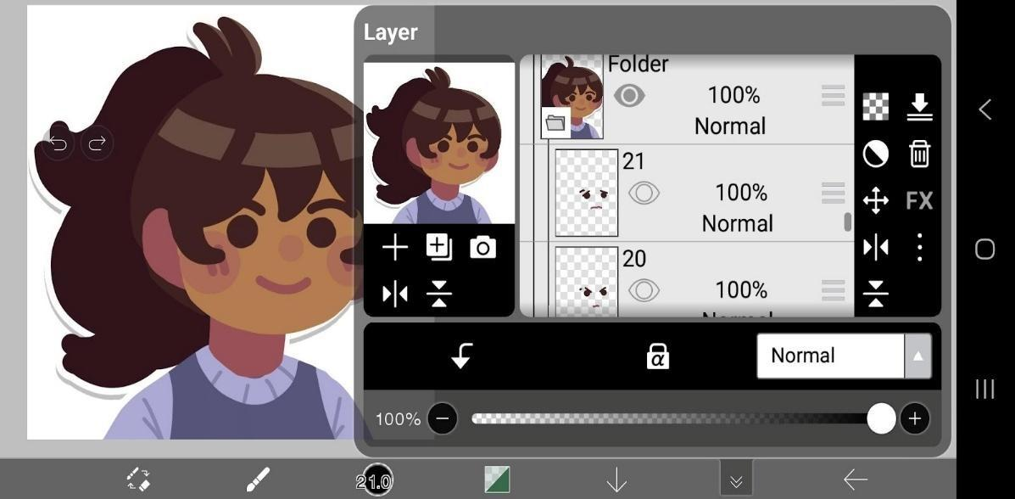
Figure 5. Character Designing in IbisPaint


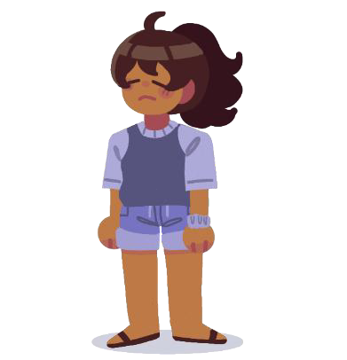


Figure 6. Character Emotions

Figure 6 illustrates the character’s range of emotional expressions, demonstrating variations in posture and facial features. The first image portrays confidence, the second shows a neutral or relaxed state, and the third portrays sadness or disappointment. These figures demonstrate how emotions can be effectively communicated via visual character design and nonverbal clues.
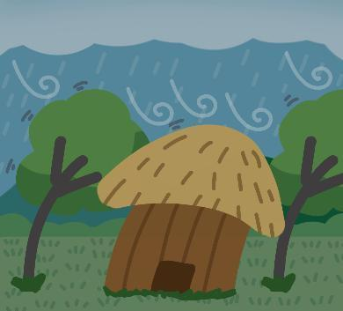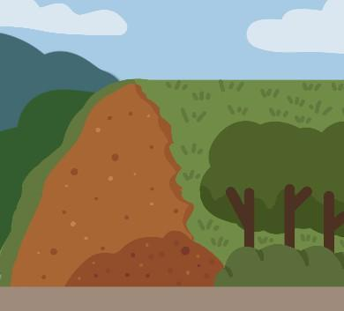
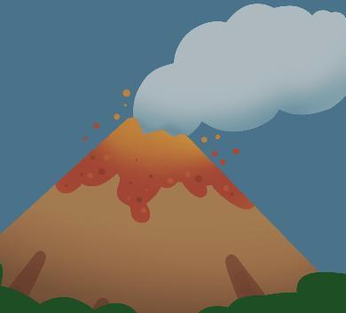
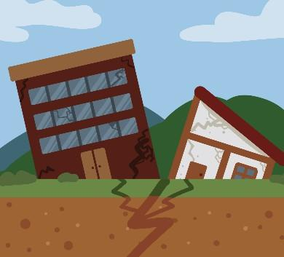
Figure 7. Environmental Assets



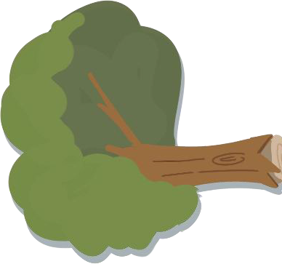
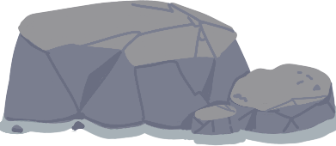
Figure 7 (page 48) displays the environmental assets developed for LigTask, showcasing 2D backgrounds and objects representing various disaster scenarios. Each illustration represents hazards such as floods, earthquakes, landslides, and volcanic eruptions. These resources help to make the game more engaging to the eye and serve its educational purpose of raising disaster awareness.




Figure 8. Disaster and Hazards Assets

Figure 8 presents the disaster and hazard assets, consisting of sprites and icons that symbolize various natural dangers. The visuals include elements like falling debris, fire, volcanic ash, and rocks. These assets symbolize a possible danger that could arise in the case of a disaster. These resources have been used to demonstrate various risky situations in a very interesting and informative manner.


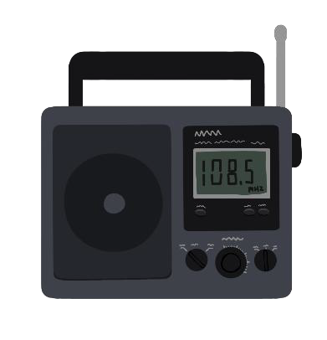


Figure 9. Interactive Objects and Task Items

Figure 9 illustrates the interactive objects and task items, including essential emergency tools such as a first-aid kit, radio, and raincoat. These items represent the basic supplies commonly found in an emergency go bag. These objects are uniquely made to present their practical use and significance in case of an emergency. Awareness and preparedness are established through the incorporation of real-life preparedness practices with interactive learning through the use of these visuals.
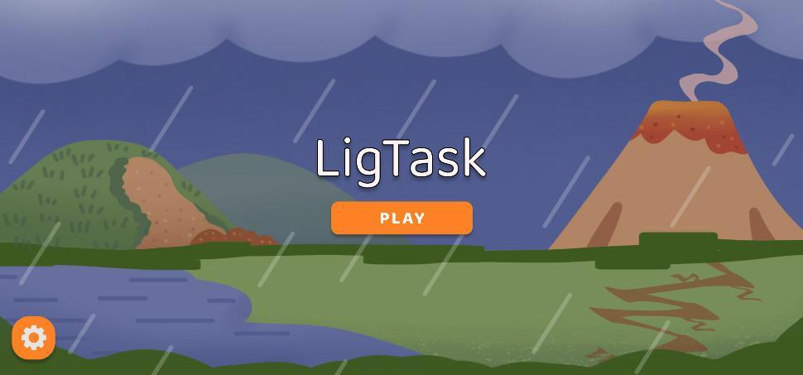
Figure 10: Main Menu


Figure 10 (page 50) displays the LigTask main menu, which include the game’s title and a central “Play” button. The background has natural disaster elements, such as rain, landslide, earthquake, flood, and volcanic eruption. These visuals established the theme of the game and highlight its focus on disaster preparedness. The menu provides a simple and engaging interface to encourage users to start playing.
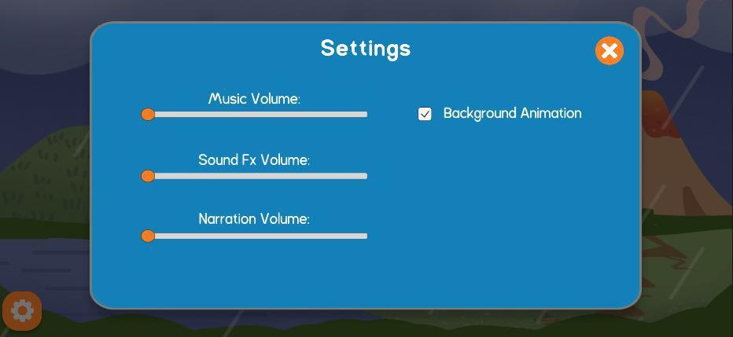

Figure 11. Settings
Figure 11 displays the settings of LigTask, which allows players to adjust the level of music, sound effects, and narration. The menu feature has bright sliders and clear labels that make it easy to read. The players can change their gaming experiences based on their preferences or surroundings. This promotes comfort and inclusivity for all users.

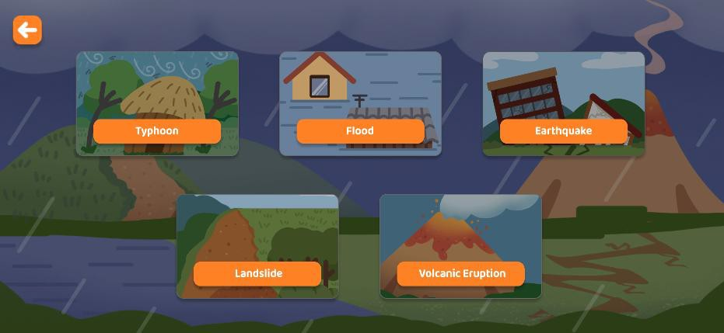

Figure 12. Disaster Selection Screen

Figure 12 presents the disaster selection interface, which allows players to select one of the five natural disasters, such as typhoon, flood, earthquake, landslide, and volcanic eruption. Each disaster option has a unique image and label so that it can be easily identified. The layout is visually appealing and easy to navigate. This selection screen is the central point that connects to all the different mini-games within LigTask.
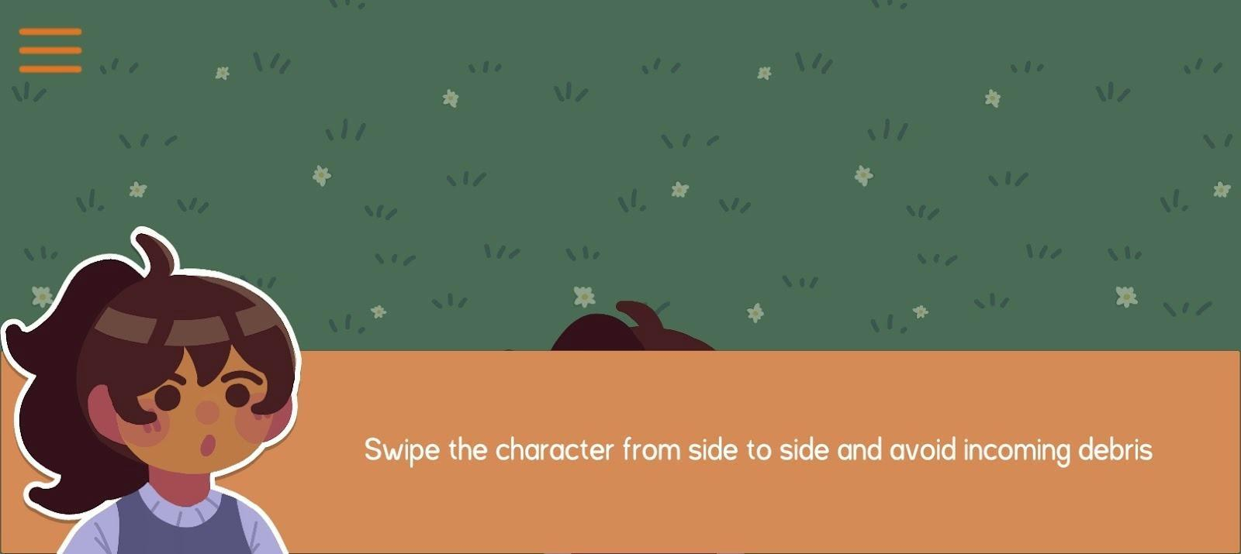
Figure 13. Narrative Example for Typhoon


Figure 13 (page 52) shows the narrative dialogue screen in LigTask, where the character explains the objective of the mini-game. The player is instructed to swipe the character to avoid falling debris during a disaster event. This scene combines learning and storytelling to help players understand both controls and disaster safety actions. It ensures that educational content is smoothly integrated with gameplay.
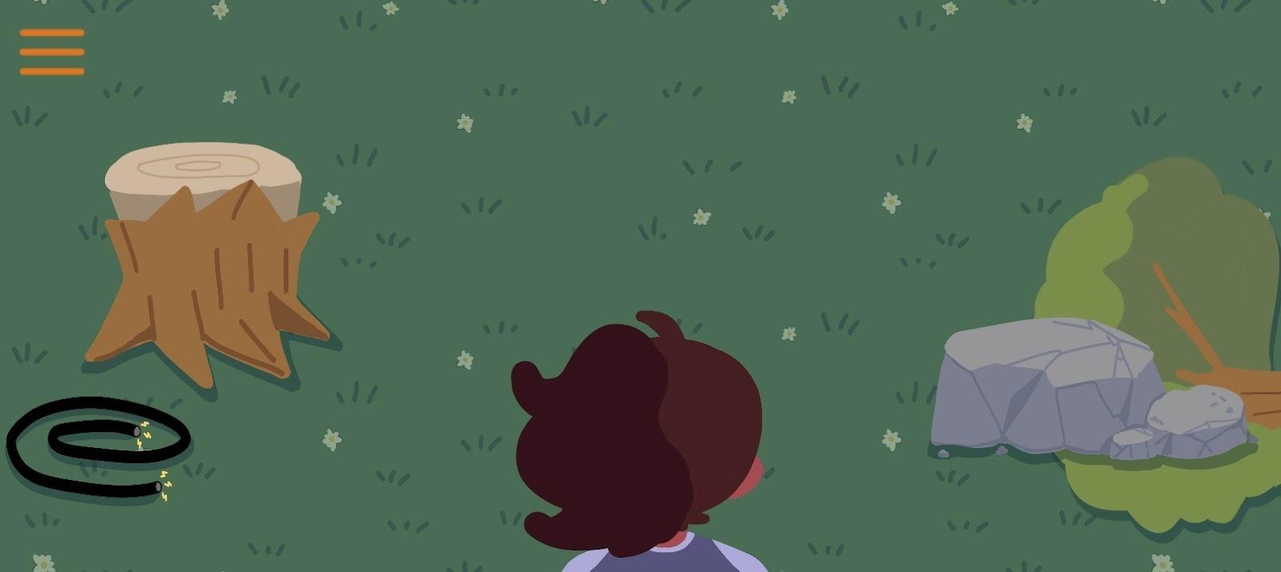
Figure 14. Typhoon Mini-game

Figure 14 displays on of the flood mini-games, in which players must avoid fallen objects to remain safe. The environment contains objects representative of real-world hazards, including electrical wires, rocks, and stumps. Moreover, players need to think quickly to find safe spaces amid heavy rain and strong winds. This activity reinforces situational awareness and knowledge of disaster hazard recognition.

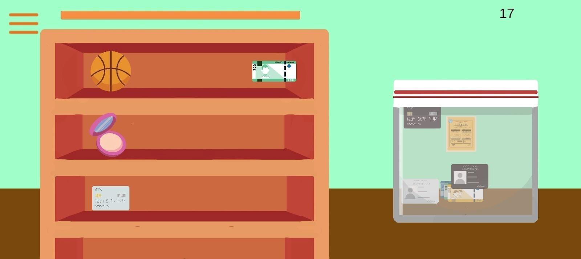

Figure 15. Flood Mini-game

Figure 15 illustrates the flood mini-game, where players must select essential items to protect against water damage. The task is to identify and store essential items, such as cards or cash, in a plastic envelope. This teaches players appropriate preparedness and the need to prioritize when floods occur. Simple representation helps bring clarity and focus to the learning objective.
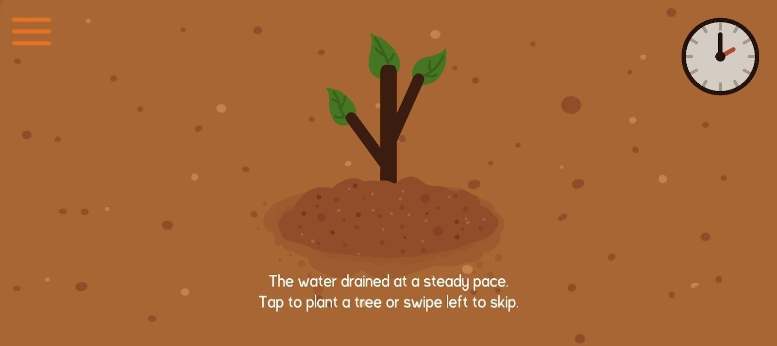
Figure 16. Landslide Mini-game


Figure 16 (page 54) presents the landslide mini-game, which encourages the player plants trees on a slope to prevent soil erosion. The game educates that tree roots keep the earth soil firmly and reduce the risk of landslides during heavy rain. Planting trees also contributes to absorption of water to stabilize the ground. It demonstrates that disaster prevention is very much about environmental care. In this activity, players can acquire basic yet useful methods of supporting safety and preparedness.
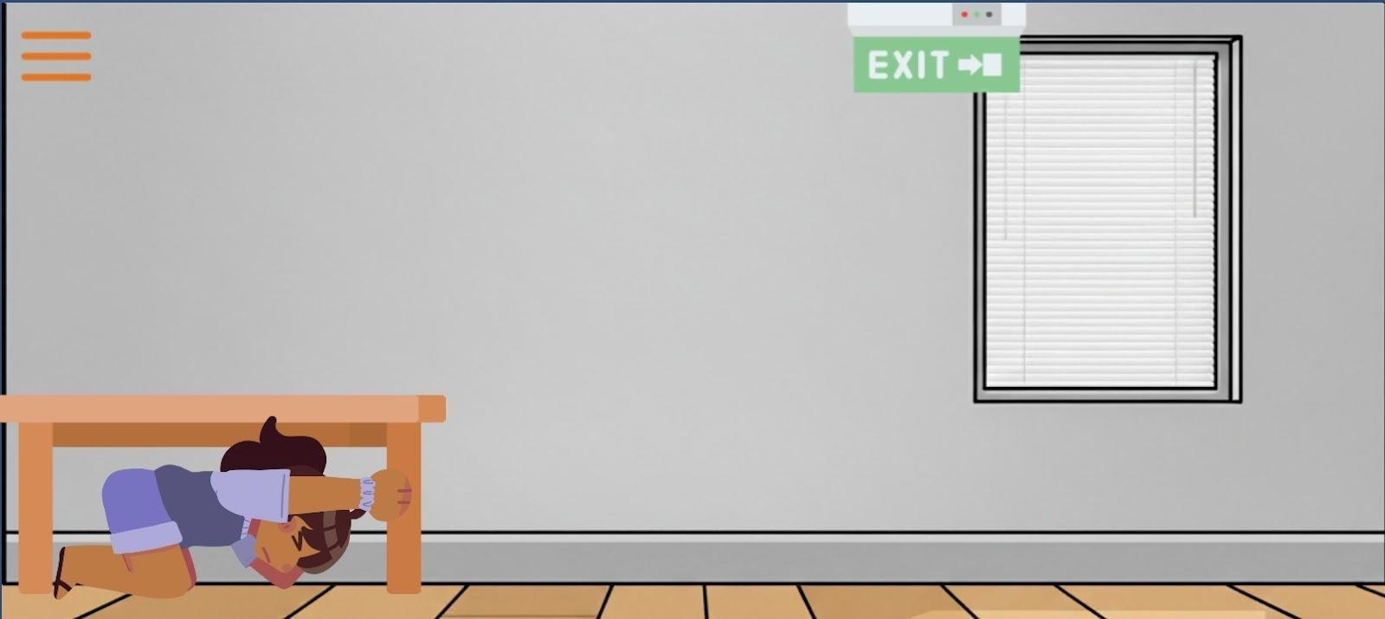
Figure 17. Earthquake Mini-game
Figure 17 shows the earthquake mini-game, in which the character practices the drop, cover, and hold method by taking cover under a table. The game setting recreates the interior aspect of furniture and exits in order to illustrate a more authentic earthquake situation. The game helps develop the awareness of the safe places and the safe behavior during shaking. The game leads to active learning on earthquake preparedness behaviors.

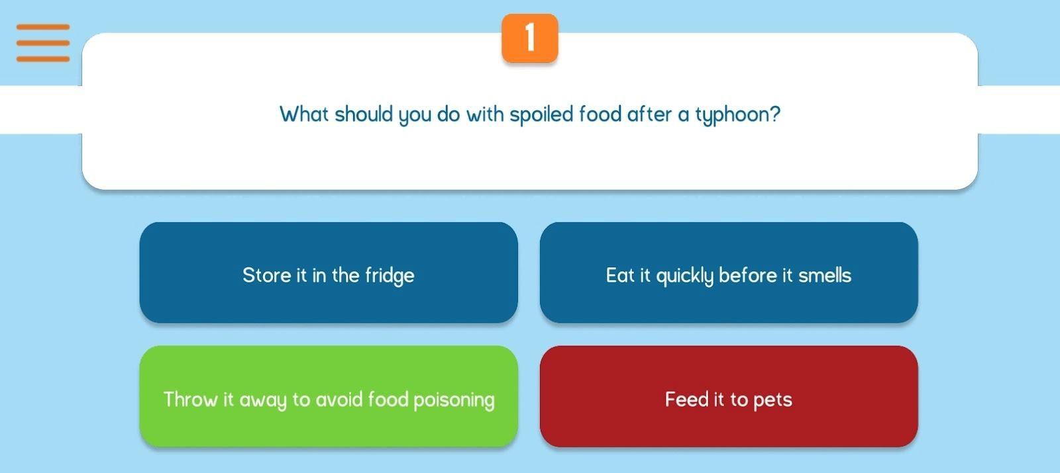

Figure 18: Quiz

Figure 18 displays the quiz interface, which appears after completing all the mini-games in the easy round. The game also has multiple-choice questions about disaster preparations to help players review and reinforce what they have learned through the mini-games. The quiz system is used to examine the level of knowledge of the players on the right emergency protocol and protective measures. The learning aspect is used as a memory aid, where the player gains new knowledge.
Each image was included to clearly show the gameplay, user interface, and visual elements of the game. The screenshots and assets demonstrated how the game design, mechanics, and educational content were applied in the final version of LigTask, including how players interact with tasks, receive instructions, and learn safety tips during disaster scenarios.
Determined the usability of the developed game using MEEGA+

To address the third research objective, the researchers conducted a
comprehensive usability and player experience evaluation of the LigTask mobile application using the MEEGA+ (Model for the Evaluation of Educational Games) framework. The structured questionnaire were distributed through Google Forms (see Appendix E) to test the game’s usability, the players’ overall experience, and the extent to which the game supported the intended learning objectives related to disaster preparedness. This process ensured that the feedback gathered was based on the participants’ direct interaction with the system.
A total of eighty-nine (89) respondents participated in the evaluation. The respondents were from the Zaragosa Integrated School, Naguilian National High School, and Basic Inclusive Education of LORMA Colleges. The responses obtained were evaluated with the help of MEEGA+ quality factors: Usability (aesthetics, learnability, operability, accessibility), Player Experience (fun, challenge, confidence, satisfaction, focused attention, social interaction, relevance, and perceived learning). MEEGA+ findings showed strong usability and positive player experience, indicating that users found the game easy to navigate, engaging, and effective in reinforcing disaster-preparedness concepts.
The results presented in table 15 (page 58) show the usability of the LigTask mobile application. The respondents agreed that the developed game was good, as evidenced with a rating of 4.13. LigTask received consistently high ratings from students, with mean scores ranging from 3.85 to 4.25, indicating strong agreement that the game is easy to use and visually well-designed.
Table 15: Level of Usability of LigTask for Students

 | Indicators |  | Mean | Descriptive Equivalent  Rating (DER) | Descriptive Interpretation
1. The | overall | game | 4.18 | Agree | Good
design is attractive.
2. The text font and colors |  |  | 4.25 | Agree | Good
are well blended and
consistent.
3. I needed to learn a few |  |  | 3.85 | Agree | Good
things before I could
play the game.
4. Learning to play this |  |  | 4.04 | Agree | Good
game was easy for me.
5. I think that most people |  |  | 4.12 | Agree | Good
would learn to play this
game very quickly.
6. I think that the game is |  |  | 4.13 | Agree | Good
easy to play.
7. The game rules and |  |  | 4.21 | Agree | Good
instructions are clear
and easy to
understand.
8. The font (size and style) |  |  | 4.19 | Agree | Good
used in the game are
easy to read.
9. The colors used in the |  |  | 4.18 | Agree | Good
game are meaningful.

Average 4.13 Agree Good

The highest score, 4.25, is associated with indicator 3, the text font, and colors are well blended and consistent, followed by a mean rating of 4.21 for the clarity of the game rules and instructions, which can be interpreted as LigTask doing a good job at offering precise guidance that allows young gamers to play
the game without any issues. Indicator 3 got the lowest rating of 3.85. This score is still considered good; the lower score indicates that some students have required a brief familiarization or preliminary instructions to grasp the possible way of playing. This is understandable in the case of educational games that present new mechanics or concepts of disaster preparedness to a novice. This small learning means that it can be possible to improve early tutorials, introduce more explicit steps of onboarding, or provide hints at the beginning of the initial few minutes of the game.
The game interface includes an easy-to-read font size and style, an overall attractive design, and a game that is easy to play; the belief that most people would learn to play very quickly also underscores that the interface is stimulating and suitable for students. These findings support the claim that LigTask provides an easy-to-use and student-friendly platform, which can facilitate the effective learning process with the help of gameplay.
This implies that the respondents considered the game applicable, easy to use, and helpful in achieving learning goals. These results support the assumption that LigTask is suitable for the target demographic, and this game is effective in disaster preparedness due to its user-friendly, clear, and engaging gameplay.
The results of table 16 (page 60) presents the overall player experience of the LigTask mobile application. As seen in the table, the respondents agree that the developed system is good, as evidenced with a rating of 4.05, which indicates
that students generally had a favorable and engaging experience while using the game. The highest mean rating of 4.26 was garnered by indicator 15.
Table 16: Level of Player’s Experience of Students

Indicators Mean
Descriptive Equivalent Rating (DER)
Descriptive Interpretation

1. The contents and structure | 4.21 | Agree | Good
helped me to become
confident that I would
learn with this game.
2. This game is appropriately | 3.85 | Agree | Good
challenging for me.
3. The game provides new | 4.21 | Agree | Good
challenges (offers new obstacles, situations, or variations) at an appropriate pace.
4. The | game | does | not | 3.70 | Agree | Good
become monotonous as it
progresses (repetitive or
boring)
5. Completing the game tasks |  |  |  | 4.13 | Agree | Good
me with a satisfying feeling
of accomplishment.
6. It is due to my personal |  |  |  | 4.10 | Agree | Good
effort that I managed to
advance in the game.
7. I feel satisfied with what I |  |  |  | 4.10 | Agree | Good
learned from the game.
8. I would recommend this |  |  |  | 4.17 | Agree | Good
game to others.
9. I had fun with the game. |  |  |  | 4.21 | Agree | Good
10. Something happened |  |  |  | 4.04 | Agree | Good
during the (game
elements, competition,
etc.) which made me smile.

Table 16 (continued)

Indicators Mean
Descriptive Equivalent Rating (DER)
Descriptive Interpretation
- There was something interesting at the beginning of the game that captured my attention.
- I was so involved in my gaming task that I lost track of time.
- I forgot about my immediate surroundings
4.04 Agree Good

3.72 Agree Good

3.76 Agree Good

while playing this game
14. The game contents are | 4.02 | Agree | Good
relevant to my interests.
15. It is clear to me how the | 4.26 | Agree | Good
contents of the game are
related to disaster
preparedness.
16. This game is an adequate | 4.21 | Agree | Good
teaching method for this

topic.
17. I prefer learning with this game to learning through ways (e.g. other teaching methods).

4.08 Agree Good

18. The game contributed to
my learning in this course. | 4.00 | Agree | Good
19. The game allowed for
efficient learning | 4.11 | Agree | Good
compared with other
activities in the course.

Average 4.05 Agree Good

This indicates how the contents of the game are relevant to disaster preparedness. Other indicators also implied that the game is an adequate learning and teaching method for the topic, that participants are having fun with the game,
and that there are new challenges at the right level. These show that students are intrigued by the game, it is educational, and interesting. Another aspect that students strongly agreed on included recommending the game to others, feeling a sense of accomplishment after completing tasks, progressing in the game through personal effort, satisfaction with what was learned, and perceiving the game as contributing to learning in the course. These results depict that LigTask manages to provide the participants with an engaging learning experience that allows them to reinforce their knowledge of disaster preparedness and maintains students motivated and engaged during the gameplay.
However, Indicator 4 has the lowest score of 3.63. The game does not become monotonous as it progresses. A slight decrease in the ratings was also obtained with regard to losing track of time and forgetting their surroundings. These findings imply that the game is an engaging form of entertainment. Based on the results, the respondents liked the game, considered it to be relevant to disaster preparedness, and discussed it as an effective teaching tool. In general, the results implied that LigTask is a valuable, entertaining, and informative gameplay experience with the ability to improve the skills of students in disaster awareness and preparedness.
Table 17 (page 63) presents the summary of the usability and player experience of the respondents. It can be seen from the table that the respondents agreed that the developed game is good, as evidenced with a rating of 4.09. Indicator 1 got the highest rating of 4.13, while indicator 2 got 4.05. It is evident
that the game was meaningful and engaging. It implies that the interface, navigation, task flow, and functionality of the game were very useful for the respondents and helped them interact with the system challenges. This indicates that students enjoyed, were motivated, and learned using the gameplay. The experience rating of the players implies that the game managed to incorporate the elements of interactivity that kept interest, engagement, and supported learning through immersive activities. These results highlight that the mobile game serves as an efficient integrative tool between usability and experiential quality, making it suitable as an educational tool to increase disaster preparedness knowledge. The positive rating reinforces the validity of the game as a learning tool and its possible role in leading to better learning of disaster-related education.
Overall, this evaluation provided valuable insights into the current state of disaster knowledge among the respondents, and it was proven that LigTask is a potentially useful and convenient educational tool that contributes to better safety, preparedness, and resilience both at school and in the community.
Table 17. Summary: Usability and Player Experience of Students

Indicators | Mean | Descriptive  Equivalent Rating (DER) | Descriptive Interpretation
- Usability  - Player’s Experience | 4.13  4.05 | Agree Agree | Good Good
Average | 4.09 | Agree | Good



CHAPTER IV

CONCLUSION AND RECOMMENDATIONS

This chapter summarizes the overall findings of the study and evaluates the outcomes of the LigTask educational game. It highlights the game’s effectiveness in promoting disaster preparedness and awareness among students and teachers through engaging, interactive learning. Based on the assessment results and user feedback, LigTask demonstrated potential as an effective tool for teaching proper safety actions before, during, and after disasters. Recommendations are presented to enhance the game’s design, functionality, and educational impact. The conclusion also provides insights for future updates and similar disaster-preparedness learning tools.

Conclusions
The researchers successfully designed and developed LigTask: A 2D Game-Based Learning Platform for Enhancing Disaster Awareness and Preparedness that promotes disaster awareness and preparedness through interactive mini-games based on the seven most common natural hazards in the Philippines - typhoons, earthquakes, floods, landslides, and volcanic eruptions. Each scenario teaches proper actions to take before, during, and after disasters, allowing players to practice preparedness behaviors in an engaging and safe environment.
For the first objective, the researchers measured the disaster knowledge, preparedness, and readiness, adaptation, awareness, and risk perception of the respondents. Findings indicated that the participants had exhibited good
Knowledge and high levels of preparedness, adaptation, and awareness, though risk perception was intermediate, suggesting differences in perception of vulnerability. The teachers had a higher level of disaster awareness and preparedness as compared to the students, as evidenced by the mean ratings of
3.86 and 4.86. These results support the fact that there is a need to have an effective instructional aid that can strengthen effective and correct disaster response measures.
For the second objective, the researchers designed and developed LigTask based on the Game Development Life Cycle (GDLC) model. The game also featured mini-games that are inspired by the five most common natural hazards in the Philippines, namely, typhoons, earthquakes, floods, landslides, and volcanic eruptions. The critical safety procedures that are operationalized as each mini-game (Before, During, and After stages of every disaster) made sure that the gameplay has an educational basis and a contextual aspect. The software that was applied to the design and development of LigTask is as follows: (1) Unity was used as the primary game engine to develop the 2D gameplay mechanics and interaction features; (2) Figma was used as the interface prototyping and user interface layout designing software; and (3) IbisPaint was used to create the 2D characters, animation, and visual effects that contributed to the educational and contextual aspects of the game.
For the third objective, the usability of LigTask was tested through the MEEGA+ model. The results indicated that the respondents agreed that the
developed system is good, as evidenced with a mean rating of 4.09. Such results suggest that the game is fun, challenging enough, user-friendly, and useful in increasing disaster awareness and preparedness knowledge. The players were very satisfied and admitted that the game was relevant to life-threatening situations.
In general, the findings demonstrate that LigTask effectively combines disaster education with interactive online gameplay, which serves the purpose of enhanced disaster awareness and preparedness, extension, and community resilience.

Recommendations

Based on player feedback and evaluation results, the following recommendations are suggested for improving and expanding LigTask:
- LigTask should be upgraded to Version 2 to deliver a more polished, engaging, and educational experience. The new version should integrate improved gameplay flow, enhanced learning modules, and clearer instructional elements.
- LigTask Version 2 should ensure multi-platform availability by supporting iOS devices and include a web-based version to widen accessibility across different platforms. The game should also be officially released on the Google Play Store and Apple App Store to increase reach and ensure convenient access for users.
- LigTask Version 2 should have some innovative interactive features, such as the chosen 3D visual effects and multiplayer capability. In the meantime, the multiplayer capabilities replicate the collaborative disaster response aspect that encourages teamwork, communication, and coordinated decision-making.
- The system should be optimized to perform smoothly across different screen sizes, device types, and connection conditions. Ensuring consistent responsiveness will make the game easier to use.

References

Published
Martinez, L., Gimenes, M., & Lambert, E. (2022). Entertainment Video Games for Academic Learning: A Systematic review. Journal of Educational Computing Research, 60(5), 1083–1109.
https://doi.org/10.1177/07356331211053848

Pasch, R. J., Berg, R., Roberts, D. P., & Papin, P. P. (2021). Hurricane Laura (AL132020). National Hurricane Center. https://www.nhc.noaa.gov/data/tcr/AL132020_Laura.pdf
Petri, G., Wangenheim, C.V., & Borgatto, A.F. (2018). MEEGA+: A Method for the Evaluation of Educational Games for Computing Education. https://www.researchgate.net/publication/326722665
Sharma, L. R., Bidari, S., Bidari, D., Neupane, S., & Sapkota, R. (2023). Exploring the mixed methods research design: types, purposes, strengths, challenges, and criticisms. Global Academic Journal of Linguistics and Literature. https://doi.org/10.36348/gajll.2023.v05i01.002
Tuc, N. D., Pha, P. D., & Huyen, N. X. (2015). The current situation of flash flood hazard in Tay Nguyen region. VIETNAM JOURNAL of EARTH SCIENCES, 37(2). https://doi.org/10.15625/0866-7187/37/2/7367
Utoyo, A. W. (2021b). Video games as tools for education. Journal of Games Game Art and Gamification, 3(2), 56–60. https://doi.org/10.21512/jggag.v3i2.7255

Online Resources

Abanto, R. (2025, November 5). Tino brought “worst flash flood” in history of Cebu, says governor | ABS-CBN News. ABS-CBN. https://www.abs-cbn.com/news/regions/2025/11/5/tino-brought-worst-flash-flood-in-history-of-cebu-governor-1027
Api. (n.d.-b). survey questionnaire - disaster awareness and preparedness - sti. Scribd. https://www.scribd.com/document/432296189/survey-questionnaire-disaster-awareness-and-preparedness-sti
Asian Disaster Reduction Center(ADRC). (n.d.). Information on disaster risk reduction of the member countries. https://www.adrc.asia/nationinformation.php?NationCode=608&Lang=en
Awais, M. (2024). Ibis Paint vs Ibis Paint X in 2024 – Major Differences & Benefits. https://khiredkids.com/ibis-paint-vs-ibis-paint-x/
Cebu Earthquake | UNHCR Philippines. (2025). UNHCR Philippines. https://www.unhcr.org/ph/cebu-earthquake
Citizens' Disaster Response Center. (2022). Philippine Disaster Report 2021. https://www.cdrc-phil.com/philippine-disaster-report-2021/
European Civil Protection and Humanitarian Aid Operations. (2023). Disaster Preparedness. https://civil-protection-humanitarian-aid.ec.europa.eu/what/humanitarian-aid/disaster-preparedness_en
Guardian staff reporter. (2025, November 6). Philippines declares state of emergency after typhoon Kalmaegi death toll passes 100. The Guardian;
The Guardian.

https://www.theguardian.com/world/2025/nov/06/philippines-state-of-emergency-typhoon-kalmaegi-death-toll
Hassan, M. (2024). Purposive Sampling - Methods, Types and Examples. Research Method. https://researchmethod.net/purposive-sampling/?fbclid=IwY2xjawJ0gnRleHRuA2FlbQIxMAABHicKsdZygQ796yxvs 34MyT7WTdwMy8KqQf5QCuDPDDJiv9iYr4dA1pnY9f7D_aem_LerjUdVmhO mf2sVtGeRlhg
IFRC. (2021). Hazard Definitions. www.ifrc.org/document/hazard-definitions IFRC. (2023). What Is a Disaster?. www.ifrc.org/our-work/disasters-climate-and-
crises/what-disaster.
Makwana, D., Engineer, P., Dabhi, A., & Chudasama, H. (2023). Sampling Methods in Research: A Review. https://www.researchgate.net/publication/371985656_Sampling_Methods
_in_Research_A_Review
OCHA. (2024). Philippines: Typhoon Rai (Odette) - Emergency Appeal No. MDRPH045 - Final Report - Philippines. https://reliefweb.int/report/philippines/philippines-typhoon-rai-odette-emergency-appeal-no-mdrph045-final-report
Office of Civil Defense – NDRRMC. (2023). The Philippines. https://theaseanmagazine.asean.org/article/the-philippines/
Ramadan, R. (2013). A Guidelines of Game Development Life Cycle (V2.0). https://personanonymous.wordpress.com/2013/07/17/a-guidelines-of-game-development-life-cycle-v2-0/#more-813
Ravikiran, A. S. (2021). What is SQLite And When to Use SQLite. https://www.simplilearn.com/tutorials/sql-tutorial/what-is-sqlite
Skillshare. (n.d.). What is Figma? A complete introduction for beginners. https://www.skillshare.com/en/blog/what-is-figma-a-complete-introduction-for-beginners/
United Nations. (2015). Transforming our world: The 2030 agenda for sustainable development. United Nations. https://sdgs.un.org/2030agenda
vietnam.vnanet.vn. (2025, September 30). Heavy rain and risks of flash floods persist across northern and central Vietnam. Vnanet.vn. https://vietnam.vnanet.vn/english/tin-van/heavy-rain-and-risks-of-flash-floods-persist-across-northern-and-central-vietnam-410352.html

APPENDICES

Appendix A
Letter to Conduct an Interview
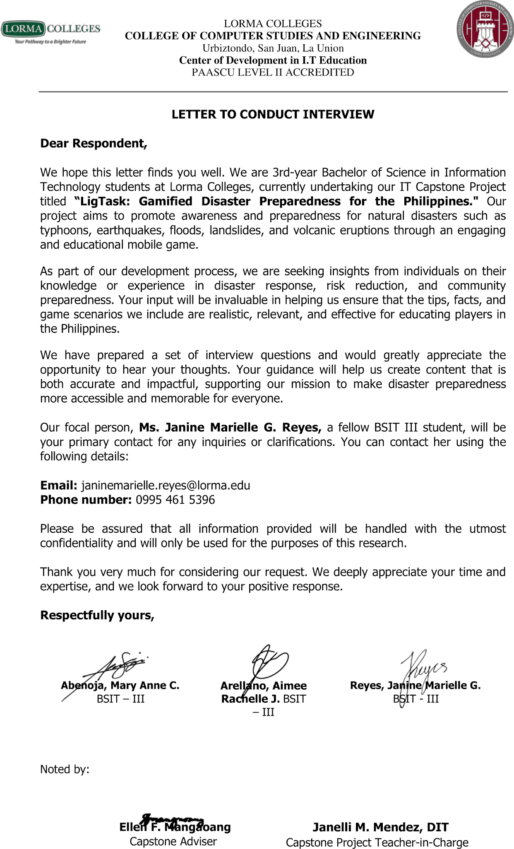

Appendix B

Interview Guide
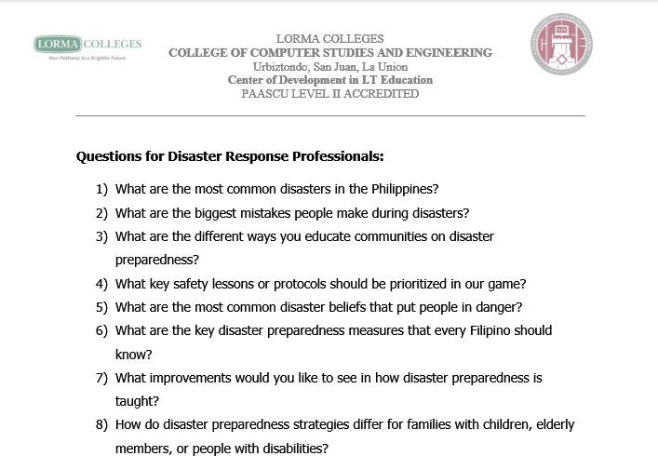
Appendix C

Transcript of Interview

Questions | Summary of the Respondent’s Answers
1. What are the most  common disasters in region 1? | The topmost hits of hazards/disasters in region 1 are typhoons.
2. What are the biggest mistakes  people make during (each mentioned  disaster)? | There are no mistakes during typhoons, only areas for improvement. While no response operations are perfect, local government units are generally well prepared, though natural disasters remain unpredictable.
3. What are the  different ways you educate  communities on disaster  preparedness? | Capacity building training for local DRRMOs, public seminars, student-focused training in schools, press conferences during disasters, and educational posters that outline actions before, during, and after hazards.
4. What key safety  lessons or protocols should be prioritized in our game? | Integrate the recommended safety actions from the provided posters, focusing on what to do before, during, and after a disaster. Also consider referencing materials like Project DINA, a video resource that effectively explains preparedness for multiple hazards and is widely used in educational and community settings.
5. What are the most common disaster beliefs that put  people in danger? | The complacency and lack of urgency of the people and not taking warnings seriously until they experience the actual event, making it difficult to encourage participation to preparedness and response programs  - People misunderstanding the Tropical Cyclone Warning Signals (TCWS). People often

misinterpret TCWS as reflecting current
weather conditions, when in fact they are forecasts indicating possible conditions within a lead time. This misunderstanding can lead to
a false sense of safety.
6. What are the key  disaster  preparedness  measures that every Filipino should know? | Be proactive toward preparedness measures,  participation of the public, awareness to hazards, and use tools like Hazard Hunter PH and Faultfinder PH to identify risks specific to their location and better prepare for potential hazards.
7. What improvements  would you like to  see in how disaster preparedness is done? | The main improvement needed is increased  public participation and reduced complacency in disaster preparedness activities. There's still a need to raise awareness of local hazards and encourage people to take preparedness efforts more seriously.
8. How do disaster  preparedness  strategies differ for families with  children, elderly  members, or people with disabilities? | Disaster preparedness for families with  children, elderly members, or people with disabilities should start at home with each household should have a designated disaster manager to ensure everyone is involved and informed. Safety starts from our home.
Additional Inputs | The importance of the participation of the  youth and academes to disaster preparedness as safety starts with the individual and can influence households and entire communities. Consultation on the word choices used in the game to ensure the language is appropriate  and easily understood by the public.

Appendix D

Survey Questionnaire Assessment of Disaster-Related knowledge, Preparedness and Readiness, Adaptation, Awareness, and Risk Perception

Dear Respondents,
We are conducting a study entitled “LigTask: Gamified Disaster Preparedness”, which seeks to develop an educational mobile game to promote disaster awareness and preparedness. Your honest responses to this questionnaire will provide valuable insights for the success of this research. Rest assured that all information will be kept strictly confidential and used only for academic purposes.

Respectfully yours, Mary Anne C. Abenoja Aimee Rachelle J. Arellano Janine Marielle G. Reyes Ellen F. Mangaoang, MIT

DIRECTIONS:
Read each statement carefully and check the response that best reflects your opinion: (1) Strongly Disagree, (2) Disagree, (3) Neutral, (4) Agree, (5) Strongly Agree. Your honest feedback is sincerely appreciated.
NAME: AGE: STUDENT/TEACHER: If student, GRADE/YEAR LEVEL: GENDER:
DISASTER-RELATED KNOWLEDGE
 | 1 | 2 | 3 | 4 | 5
1. I know when a disaster will occur.
2. I know disaster cannot be prevented.

3. I have participated in disaster risk education training or workshop.
DISASTER PREPAREDNESS AND READINESS
1. I know the importance of disseminating experiences or knowledge of disaster.
2. I know the government will provide enough facilities after a disaster and we will not face any problem.
3. I am confident for reconstruction activities from government after disaster.
4. I know the importance of talking about disasters with neighbors, friends, and colleagues.
5. used to listen to experts or DRR leaders who work or do activities for disaster management.
DISASTER ADAPTATION
1. I am aware of the shelter areas and open space in case of a disaster.
2. I have information about which government office needs to be contacted after the disaster.
3. I have knowledge about disaster prone areas.
4. I know the importance of community activities for disasters risk reduction.
DISASTER AWARENESS
1. I used to participate in voluntary activities for disaster awareness campaigns.
2. I am aware of retrofitting buildings.
3. I used to prepare emergency bags for disasters.
4. I have a good relationship with my neighbors and community.

5. I think repair of road blockage and transportation break are important.
6. I give priority to disaster awareness in local, regional and national level.
7. I know recovery after disaster is crucial work.
DISASTER RISK PERCEPTION
1. I am very sure that large-scale disasters will certainly occur in the next 10 years.
2. My locality is safe from all kinds of disasters.
3. I think my building is well designed and will withstand an earthquake event.
4. I am sure that my sleeping space is secure during and after disaster.

Appendix E

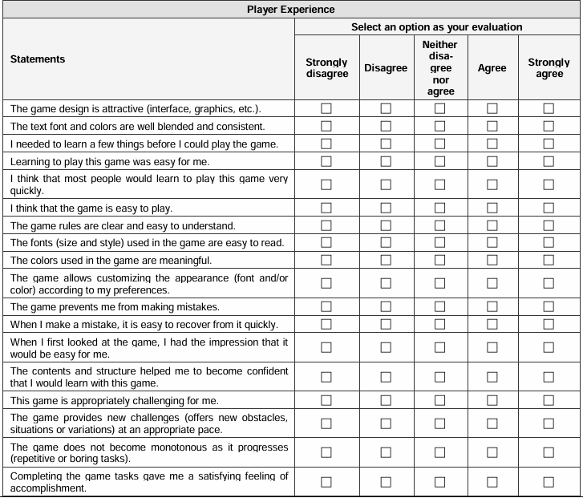
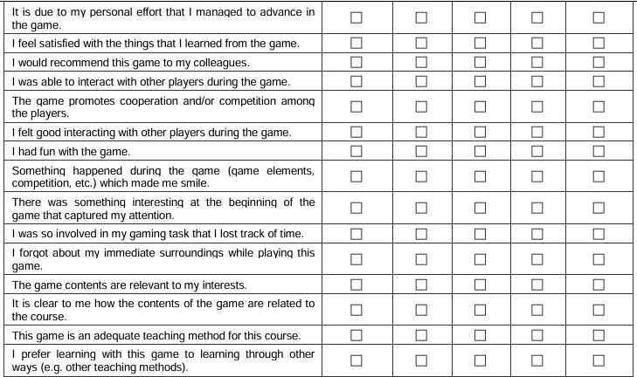
Meega+ Questionnaire for Digital Games

MEEGA+ Questionnaire xfor Digital Game

PHOTO DOCUMENTATION
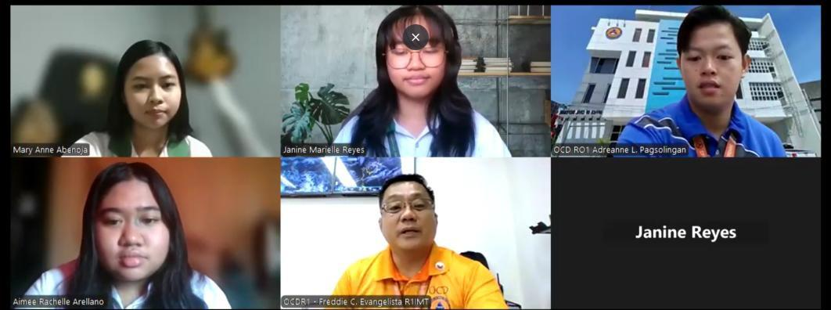


Interviews were conducted with the Office of Civil Defense Regional Office I and Disaster Risk Reduction and Management Council (DRRMC) of Bacnotan, La Union to gather information on community-level disaster risk reduction practices, planning, and implementation.

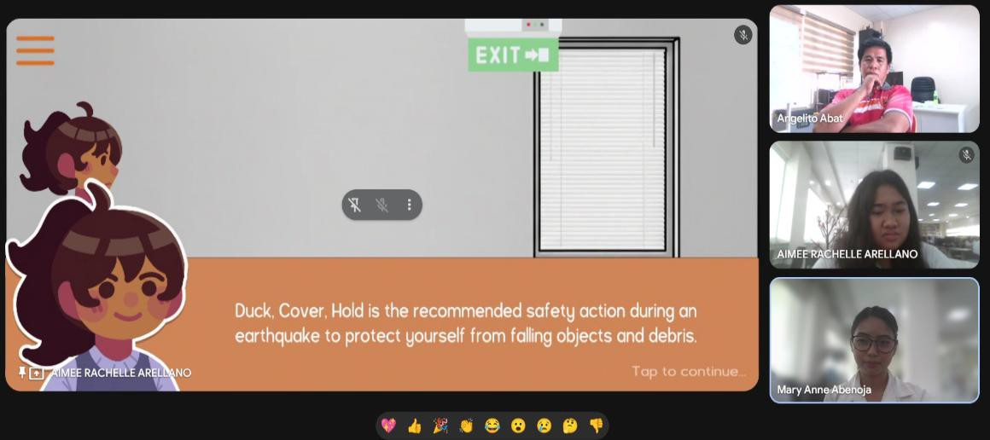

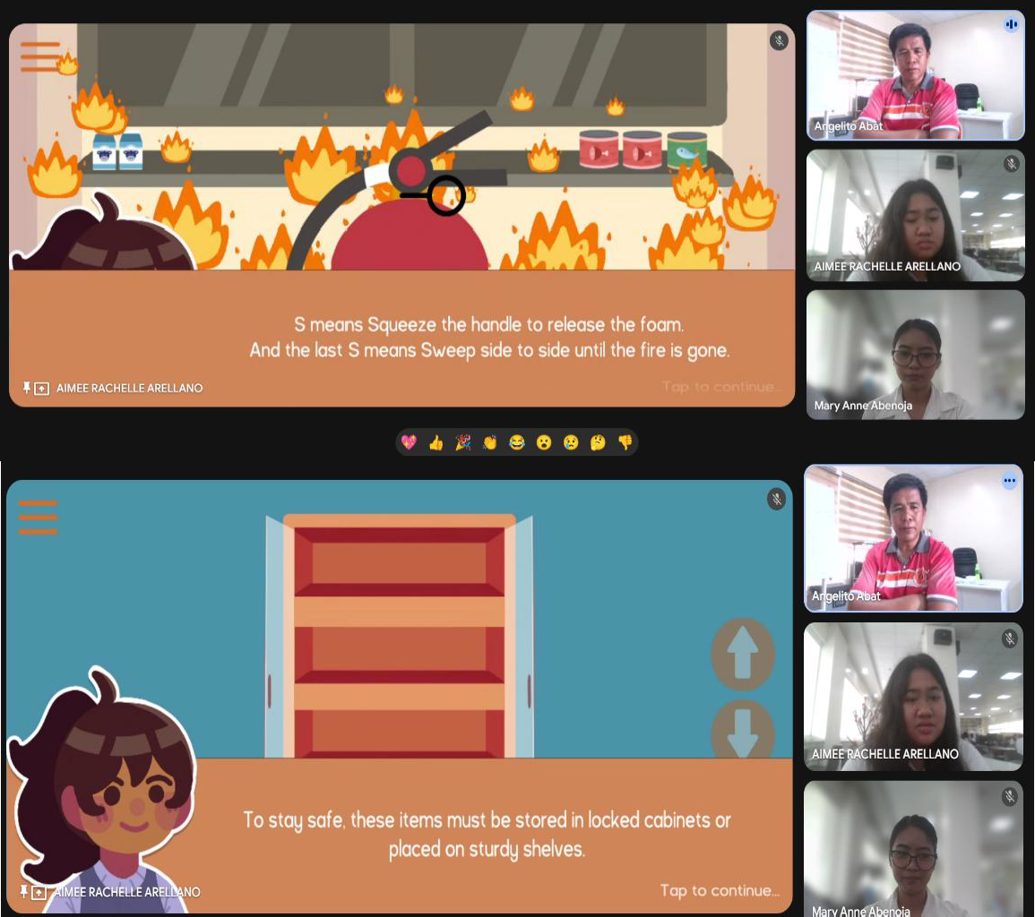
The LigTask application was presented to the professional DRRMC of Bacnotan for the evaluation of its content and game features.

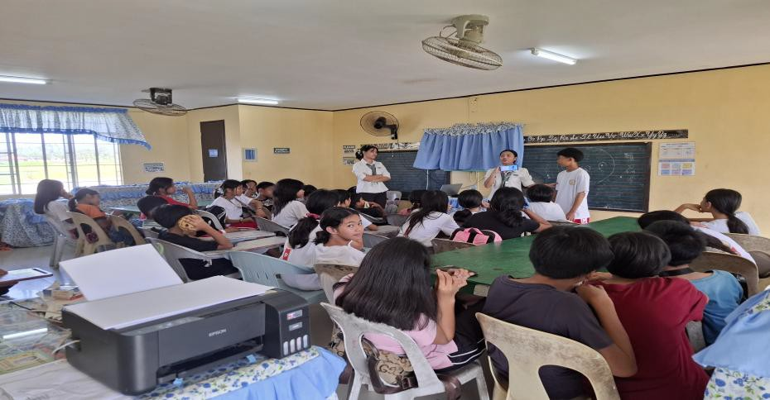

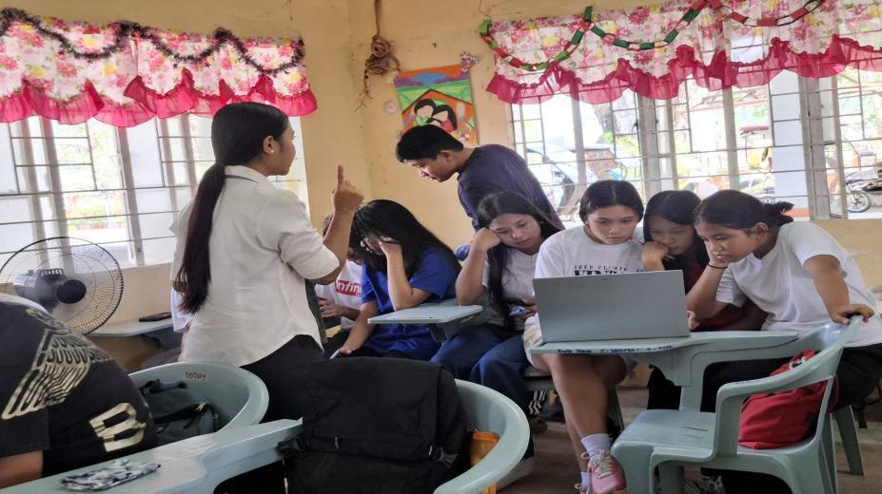

The application was tested with students from Zaragosa Integrated School, Bacnotan, La Union, to assess their disaster-related knowledge, preparedness, readiness, adaptation, awareness, and risk perception.

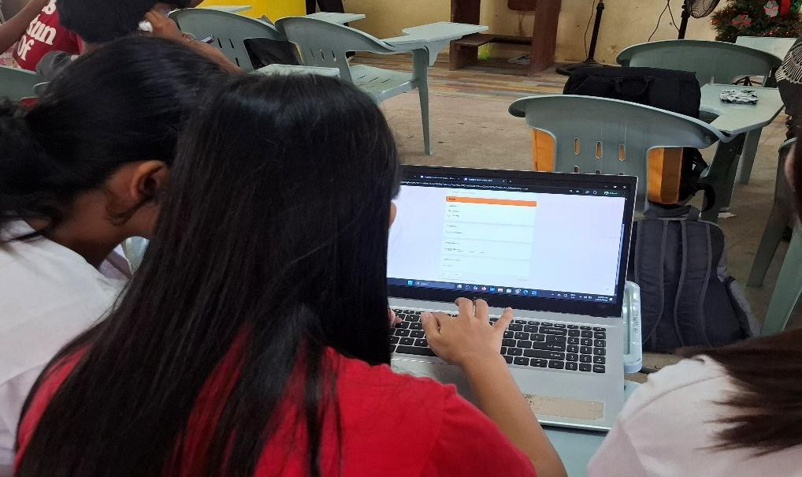

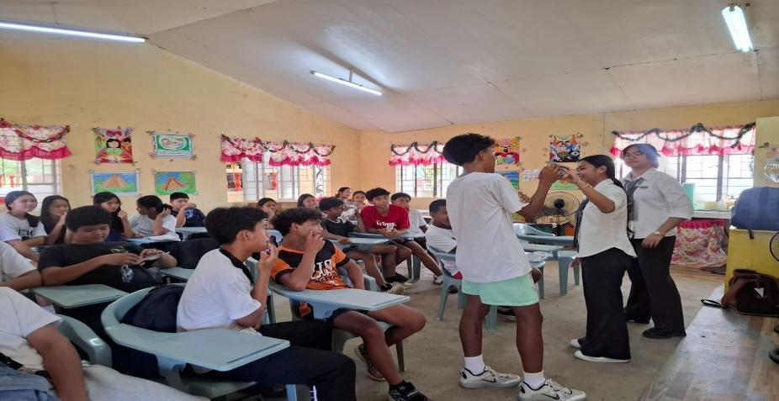
The application was evaluated using the MEEGA+ to measure the effectiveness of the game on player experience. The researchers observed and guided the students as they played the game to gather accurate feedback and insights.


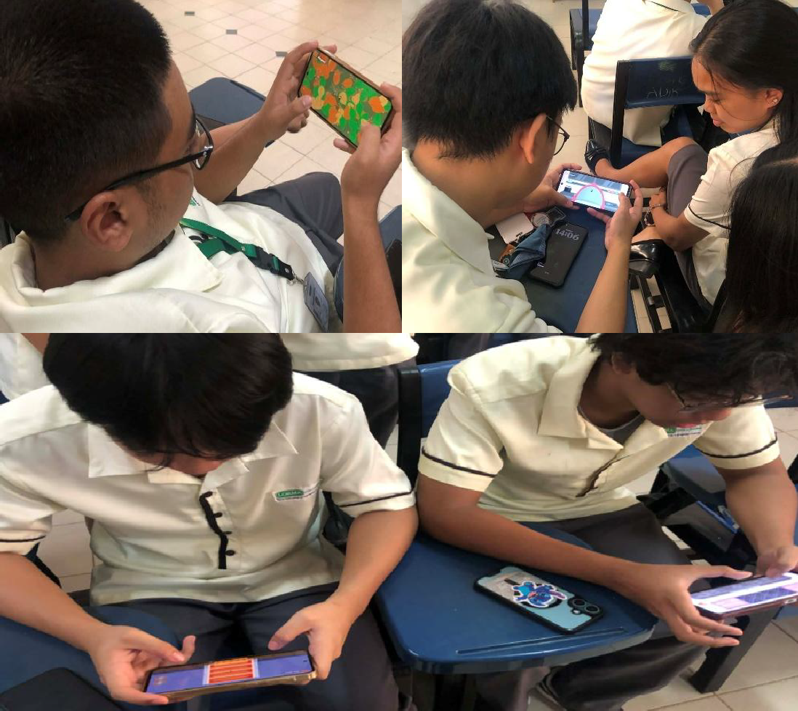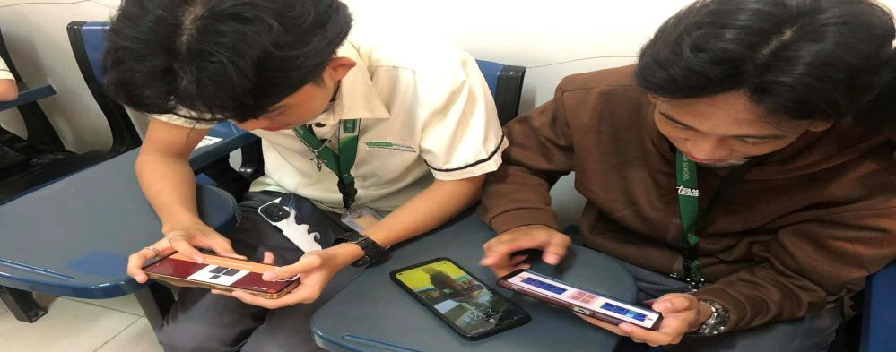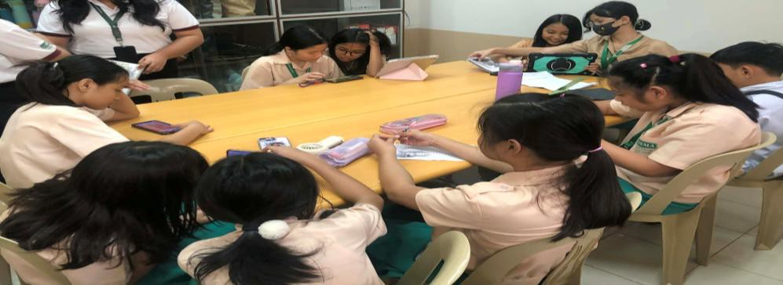

Testing and evaluation of the LigTask application by selected Senior High School students from the Basic and Inclusive Education.

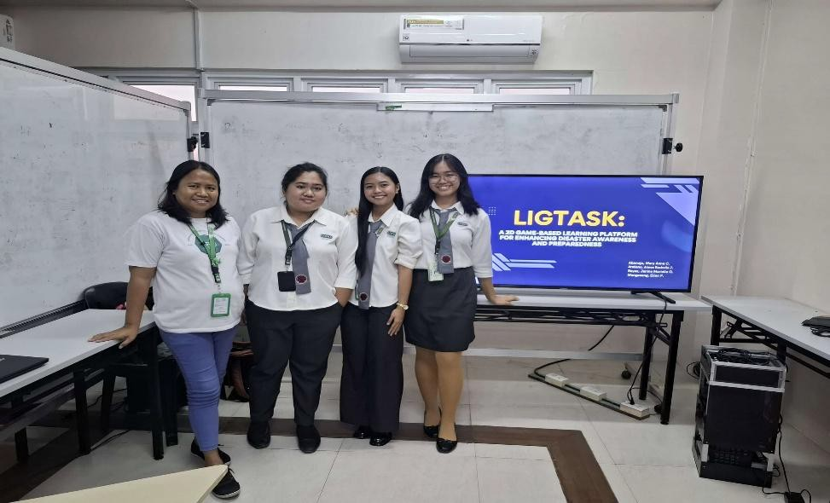

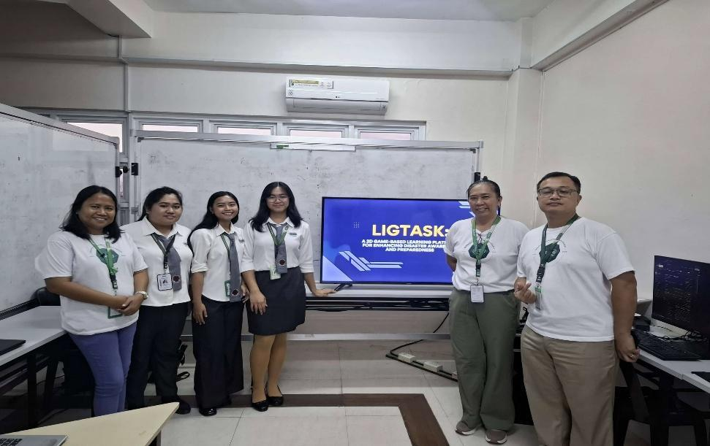

The researchers presented and defended their study. The panel members provided feedback, engaged in discussion, and conducted a thorough evaluation of the research work.

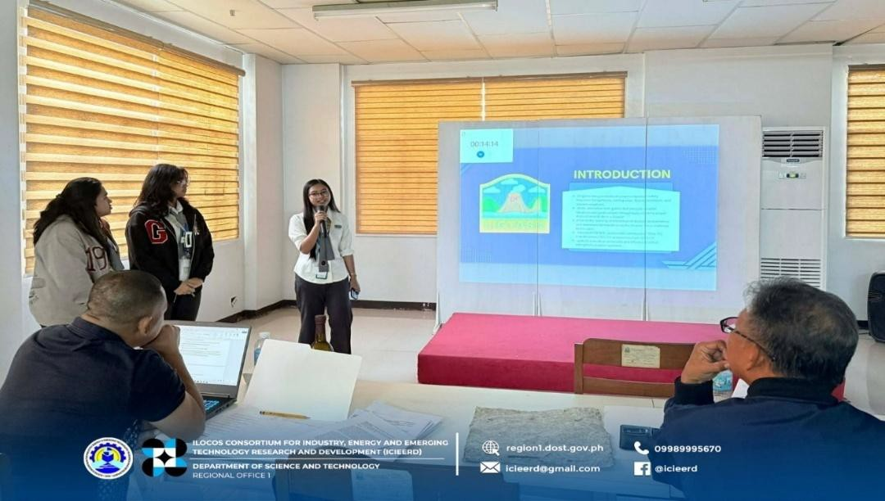

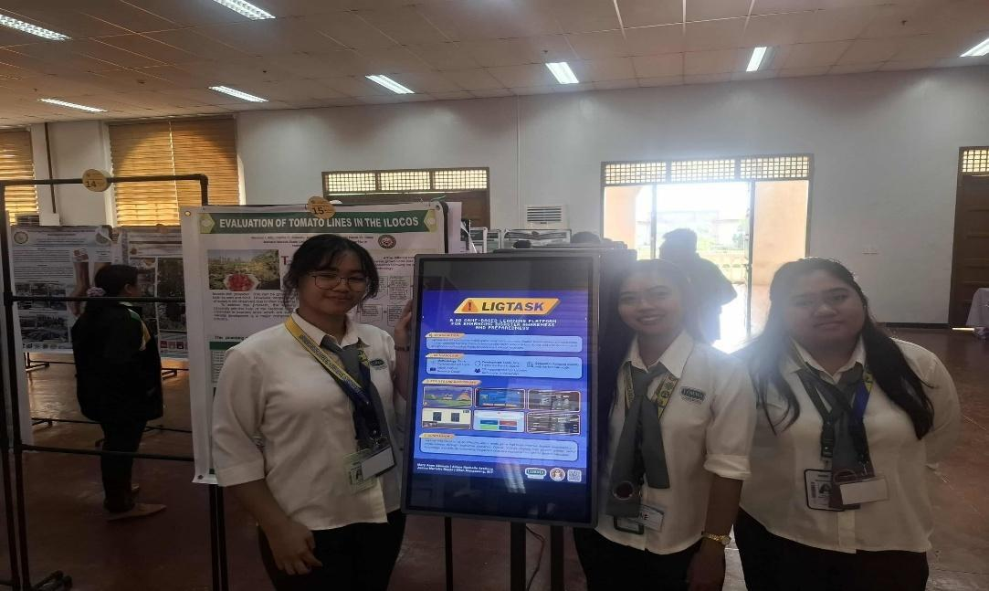

The ICIEERD conference was held in Batac, Ilocos Norte, where researchers presented the LigTask mobile application and a poster, demonstrating the system’s features and engaging with attendees to gather feedback and discuss.

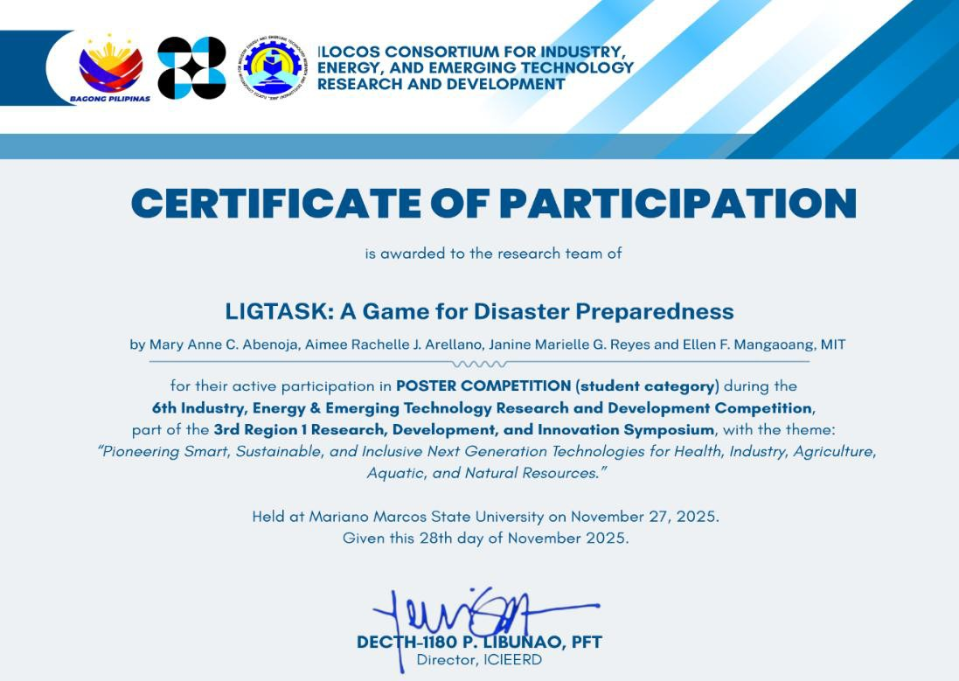

CURRICULUM VITAE

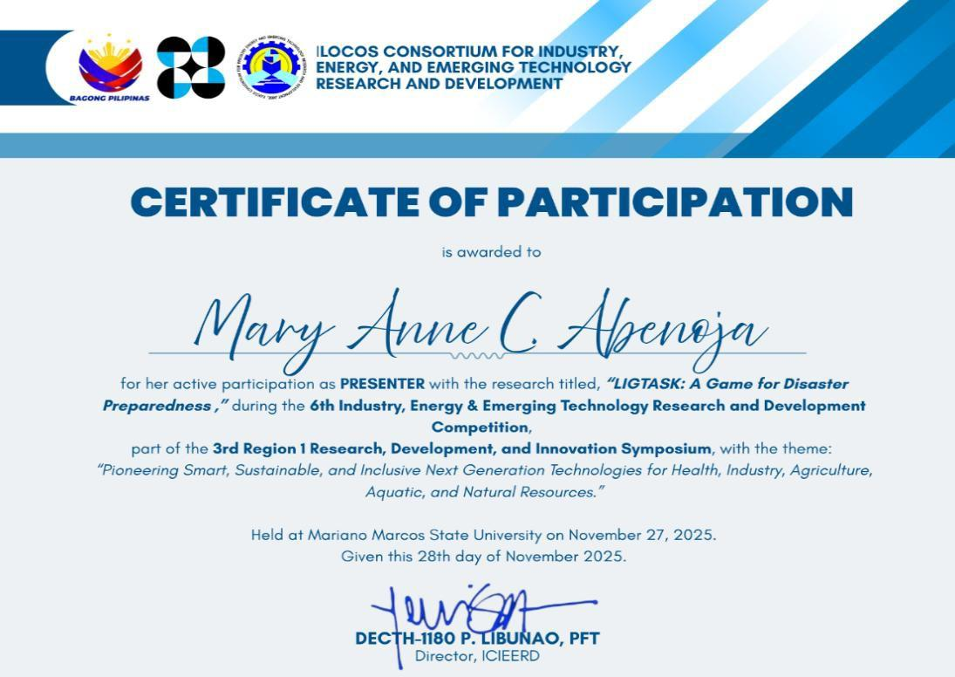
The researchers received recognition for presenting the LigTask mobile application and poster, highlighting their active participation and notable achievements in the event.

CURRICULUM VITAE


MARY ANNE CAMBA ABENOJA

PERSONAL INFORMATION
Address : Aglipay Street, Eastblock, Natividad,

Naguilian, La Union, Philippines 2511
Contact Number 09062700826
Email Address : maryanne.abenoja@lorma.edu
Date of Birth : July 26, 2004
Place of Birth : City of San Fernando, La Union

EDUCATIONAL BACKGROUND

Kindergarten (2010)
Saint Augustine School

Elementary (2011 – 2015)
Saint Augustine School

Junior High (2016 – 2019)
Colegio de La Union

Senior High (2020 – 2022)
Naguilian National High School - Senior High School

College (2022 – Present)
Lorma Colleges

AWARDS/CITATIONS/RECOGNITIONS RECEIVED

College Level:
- College Freshman 1st Semester Half Scholar (2022-2023)
- College Freshman 2nd Semester Half Scholar (2022-2023)
- College Sophomore 1st Semester Half Scholar (2023-2024)
- College Sophomore 2nd Semester Half Scholar (2023-2024)
- College Junior 1st Semester Half Scholar (2024-2025)
- College Junior 2nd Semester Half Scholar (2024-2025)
- CCSE SBO 3rd Year Treasurer (2024-2025)
- CCSE SBO 4th Year Vice-President (2025-2026)

Senior High School:
- With High Honors
- Academic Excellence Award
- Best Research

Junior High School:
- With Honors
- Best Research
- Leadership Award
- Perfect Attendance
- Student Leadership of the Year (SBO President)
- Outstanding Academic Performance

Elementary:
- Best in Mathematics
- Best in Science
- Best in Filipino
- Best in Values Education
- Creative Arts Award
- Reading and Writing Excellence Award
- Most Responsible Pupil
- Most Cooperative Pupil
- Perfect Attendance
- Sportsmanship Award
- Outstanding Behavior Award

WORK EXPERIENCE
- E-commerce

ELIGIBILITY
- N/A

SEMINARS ATTENDED
- 4th National Conference on Computing, Education and Business (NCCEB)
- National Book Week
- Global Conference on Robotics and Artificial Intelligence Technologies (GCRAIT)
- 2024 Lormanian Leaders’ Leadership Training
- 2024 DICT Regional Roadshow La Union
- AI and Media Literacy
- Introduction to IT Project Management
- 1st Provincial Information and Communications Technology (ICT) Program 2025: Provincial ICT Exhibition and Summit (PIES)
- 2025 Lormanian Leaders’ Leadership Training
- Click 2025: Collaborative Learning and Innovation Conference for Knowledge in Information Technology Education – UniFast Grantees
- Agentblazer Champion Workshop by SmartBridge in Collaboration with Salesforce
- Ilocos Consortium for Industry, Energy, and Emerging Technology Research and Development

INVOLVEMENT IN RESEARCH/RESEARCH CONDUCTED
- The Effectiveness of Distance Learning Modality to Grade 11-ABM Learners of Naguilian, National High – Senior High School, Naguilian, La Union
- Comparative Study of Tricycle Drivers' Daily Income Before and During the Pandemic in Natividad, Naguilian, La Union
- Gender Stereotyping: Self-Perceptions and Society Labeled Career Choices of College Students
- LigTask: A 2D Game-Based Learning Platform for Enhancing Disaster Awareness and Preparedness



AIMEE RACHELLE JUBILO ARELLANO

PERSONAL INFORMATION

Address : 5, Purok 2, Lisqueb, Bacnotan, La Union,
Philippines 2515
Contact Number 0949 359 9806
Email Address : aimeerachelle.arellano@lorma.edu
Date of Birth : September 23, 2004
Place of Birth : City of San Fernando, La Union

EDUCATIONAL BACKGROUND

Kindergarten (2009-2010)
Bacnotan Central School

Elementary (2010-2016) Bacnotan Central School Zaragosa Elementary School

Junior High (2016-2020)
Bacnotan National High School

Senior High (2020 – 2022)
Bacnotan National High School

College (2022 – Present)
Lorma Colleges

AWARDS/CITATIONS/RECOGNITIONS RECEIVED

College Level:
- College Freshman 1st Semester Dean’s Lister (2022-2023)
- College Freshman 2nd Semester Half Scholar (2022-2023)
- College Sophomore 1st Semester Half Scholar (2023-2024)
- College Sophomore 2nd Semester Half Scholar (2023-2024)


- College Junior 1st Semester Half Scholar (2024-2025)
- College Junior 2nd Semester Half Scholar (2024-2025)
- Sagisag Artistic Design Director (2024-2025)

Senior High School:
- With Honors

Junior High School:
- With Honors

Elementary:
- With Honors

Kindergarten:
- With Honors

WORK EXPERIENCE
- N/A

ELIGIBILITY
- N/A

SEMINARS ATTENDED
- 4th National Conference on Computing, Education and Business (NCCEB)
- Global Conference on Robotics and Artificial Intelligence Technologies (GCRAIT)
- AI and Media Literacy
- Ilocos Consortium for Industry, Energy, and Emerging Technology Research and Development

INVOLVEMENT IN RESEARCH/RESEARCH CONDUCTED
- Gender Neutral Uniforms in Lorma Colleges
- LigTask: A 2D Game-Based Learning Platform for Enhancing Disaster Awareness and Preparedness



JANINE MARIELLE GANADEN REYES

PERSONAL INFORMATION

Address : Cariño Street, Ili Sur, San Juan, La Union,
Philippines 2514
Contact Number 0995 461 5396
Email Address : janinemarielle.reyes@lorma.edu
Date of Birth : January 12, 2005
Place of Birth : San Juan City, Metro Manila

EDUCATIONAL BACKGROUND

Kindergarten (2010)
Popondetta International School

Elementary (2011 – 2015) Bethel Primary School Popondetta Primary School

Junior High (2016 – 2019) Popondetta Primary School Goroka Grammar School

Senior High (2020 – 2022)
San Juan Senior High School Stand Alone

College (2022 – Present)
Lorma Colleges

AWARDS/CITATIONS/RECOGNITIONS RECEIVED

College Level:
- College Freshman 1st Semester Dean’s Lister (2022-2023)
- College Freshman 2nd Semester Half Scholar (2022-2023)
- College Sophomore 1st Semester Half Scholar (2023-2024)
- College Sophomore 2nd Semester Half Scholar (2023-2024)
- College Junior 1st Semester Half Scholar (2024-2025)
- College Junior 2nd Semester Half Scholar (2024-2025)
- CCSE SBO 3rd Year IT/CS Representative (2024-2025)
- CCSE SBO 4th Year Secretary (2025-2026)

Senior High School:
- With Honors

Junior High School:
- Perfect Attendance
- Best in English
- Best in Math
- Best in Arts
- Best in Science
- Best in Social Science
- Best in Personal Development
- Best in Making a Living

Elementary:
- Best in Language
- Best in Mathematics
- Best in Culture and Community
- Best in Health and Physical Education

WORK EXPERIENCE
- N/A

ELIGIBILITY
- Passer on PhilNITS (Philippine National IT Standards Foundation) Information Technology Passport (IP) Certification Exam

SEMINARS ATTENDED
- 4th National Conference on Computing, Education and Business (NCCEB)
- 2024 DICT Regional Roadshow La Union
- 2024 Lormanian Leaders’ Leadership Training
- LEAD IT: Leadership and Empowerment through Ambassadorship in Digital Innovation for IT Webinar
- Global Conference on Robotics and Artificial Intelligence Technologies (GCRAIT)
- AI and Media Literacy
- Introduction to IT Project Management
- 1st Provincial Information and Communications Technology (ICT) Program 2025: Provincial ICT Exhibition and Summit (PIES)
- 2025 Lormanian Leaders’ Leadership Training
- Ilocos Consortium for Industry, Energy, and Emerging Technology Research and Development

INVOLVEMENT IN RESEARCH/RESEARCH CONDUCTED
- The Effect of Organic Powdered Fertilizer Made From Kitchen Waste on Calamansi Plant Growth
- Gender Neutral Uniforms in Lorma Colleges
- LigTask: A 2D Game-Based Learning Platform for Enhancing Disaster Awareness and Preparedness

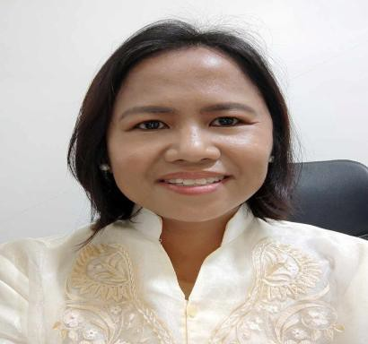

ELLEN F. MANGAOANG, MIT

PERSONAL INFORMATION

Address : 161 Governor Nisce Zone 2, Catbangen, City of San Fernando, La Union
Contact Number : 09196735689
Email address : ellen.mangaoang@lorma.edu

EDUCATIONAL BACKGROUND

Elementary
Christ the King College

Secondary
Christ the King College

College
Bachelor of Science in Computer Science, LORMA Colleges

Graduate School
- Master's in Information Technology, Don Mariano Marcos Memorial State University, Mid La Union Campus
- Doctor in Information Technology (dissertation), University of the Cordilleras

ELIGIBILITY
  - Civil Service Subprofessional eligibility
  - Civil Service Professional eligibility
  - Civil Service Electronic Data Processing Specialist
  - DICT Computer Programming Proficiency


IVI. INVOLVEMENT IN RESEARCH/RESEARCH CONDUCTED
- Development of a mobile based game with image recognition for preschoolers. Tuijin Jishu/Journal of Propulsion Technology, 45(04). https://www.propulsiontechjournal.com/index.php/journal/article/view/8299
- Common vulnerabilities and exposures assessment of private higher educational institutions using web application security. Journal of Electrical Systems, 20(5s), 668–676. https://doi.org/10.52783/jes.2288
- Analysis of deep learning algorithms for grape leaf disease detection. Journal of Information Systems Engineering and Management, 10(33s). https://doi.org/10.52783/jisem.v10i33s.5537
- Grape Leaf Disease Detection Using Deep Learning: A Hybrid Approach with Efficientnet and Mobilenet. (2025). International Journal of Environmental Sciences, 2811-2817. https://doi.org/10.64252/2g0eqc63
- LigTask: A 2D Game-Based Learning Platform for Enhancing Disaster Awareness and Preparedness

