Online Task & Productivity Tracker – Web Application

# Project Overview

This web-based productivity tracker was developed as part of the Flipkart Launchpad Internship.   
The application allows users to register, log in, manage tasks, track time, and analyze their productivity through a responsive and user-friendly dashboard.

- Duration: 45 Days  
- Assigned By: Flipkart Pvt Ltd  
- Tech Stack: Flask, HTML/CSS, Bootstrap, Chart.js, SQLite/PostgreSQL

# Architecture Overview

The application follows a full-stack architecture consisting of:  
- Frontend: HTML5, CSS3, JavaScript (Bootstrap)  
- Backend: Python Flask Framework  
- Database: SQLite (Local) and PostgreSQL (Production on Render)  
- Authentication: Flask-Login  
- Charts & Visualization: Chart.js  
- Hosting: Render (Cloud Deployment)

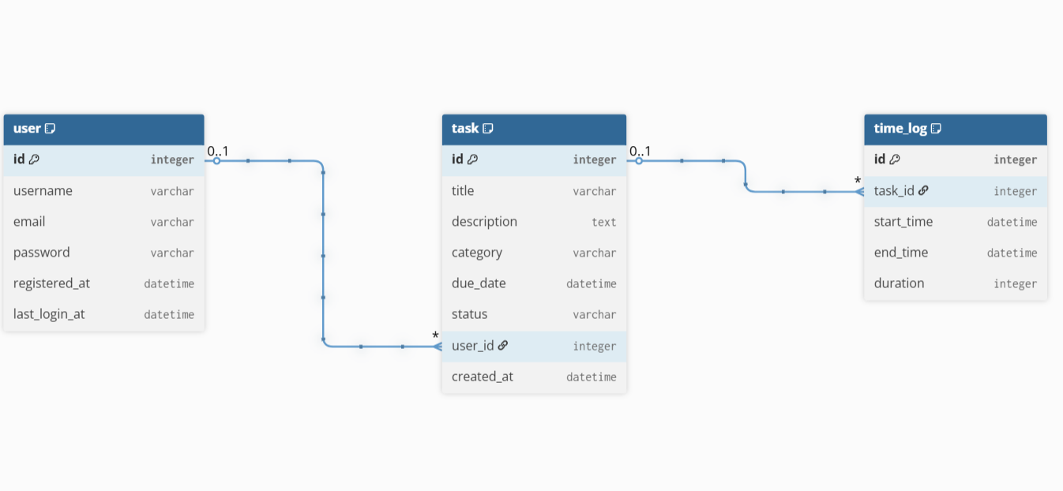

# Folder & Module Structure

FLIPKART/

• __pycache__/ ->Auto-generated folder for Python bytecode

• app.cpython-311.pyc ->Compiled version of app.py for faster execution

• instance/ -> Contains local application data (e.g., databases)

• users.db -> SQLite database storing user accounts and tasks

• static/ ->Static assets used in frontend (CSS, JS, images)

• styles.css ->Custom stylesheet for UI design and layout

• templates/ ->HTML templates rendered by Flask

• add_task.html ->Form to add a new task

• analytics.html ->Charts and visual reports (weekly/monthly)

• base.html ->Base layout reused by other templates

• dashboard.html -> Home screen after login with task summary

• edit_task.html ->Page to update/edit an existing task

• index.html -> Optional landing page or welcome screen

• login.html -> User login interface

• register.html ->New user signup page

• tasks.html -> View of all created tasks

• .gitignore ->Specifies files/folders to exclude from version control

• app.py ->Main Flask application: routes, logic, DB setup

• check_data.py -> Script for checking or testing data

• Procfile ->Tells Render how to launch the web server

• README.md ->Project documentation: overview, setup, features

• requirements.txt -> List of Python packages to install (via pip)

• runtime.txt ->Specifies Python version for deployment environment

# Core Functionalities

The Online Task & Productivity Tracker provides users with a seamless experience to manage and analyze their productivity. Its key features include:

**-**User Authentication: Secure user registration and login with timestamp tracking.

**-**Task Management: Full CRUD operations (Create, Read, Update, Delete) with category tagging.

**-**Time Tracking: Start, pause, and log time for each task, including a live timer.

**-**Productivity Analytics: Interactive weekly/monthly charts via Chart.js to visualize task progress.

**-**Export Reports: Download task summaries in both PDF and **CSV** formats.

**-**Responsive Interface: Designed using Bootstrap for smooth use on desktops and mobile devices.

# Setup & Deployment

To run locally:  
1. Clone the repository:  
 git clone https://github.com/Zuveriya-Tabassum/task-tracker.git  
  
2. Install dependencies:  
 pip install -r requirements.txt  
  
3. Run the application:  
 python app.py  
  
Deployment: Hosted on Render with PostgreSQL.

# Screenshots

Register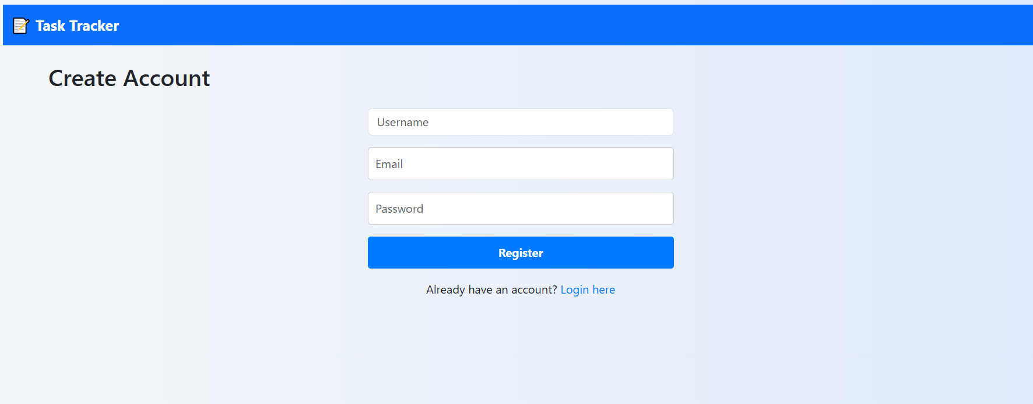

Login

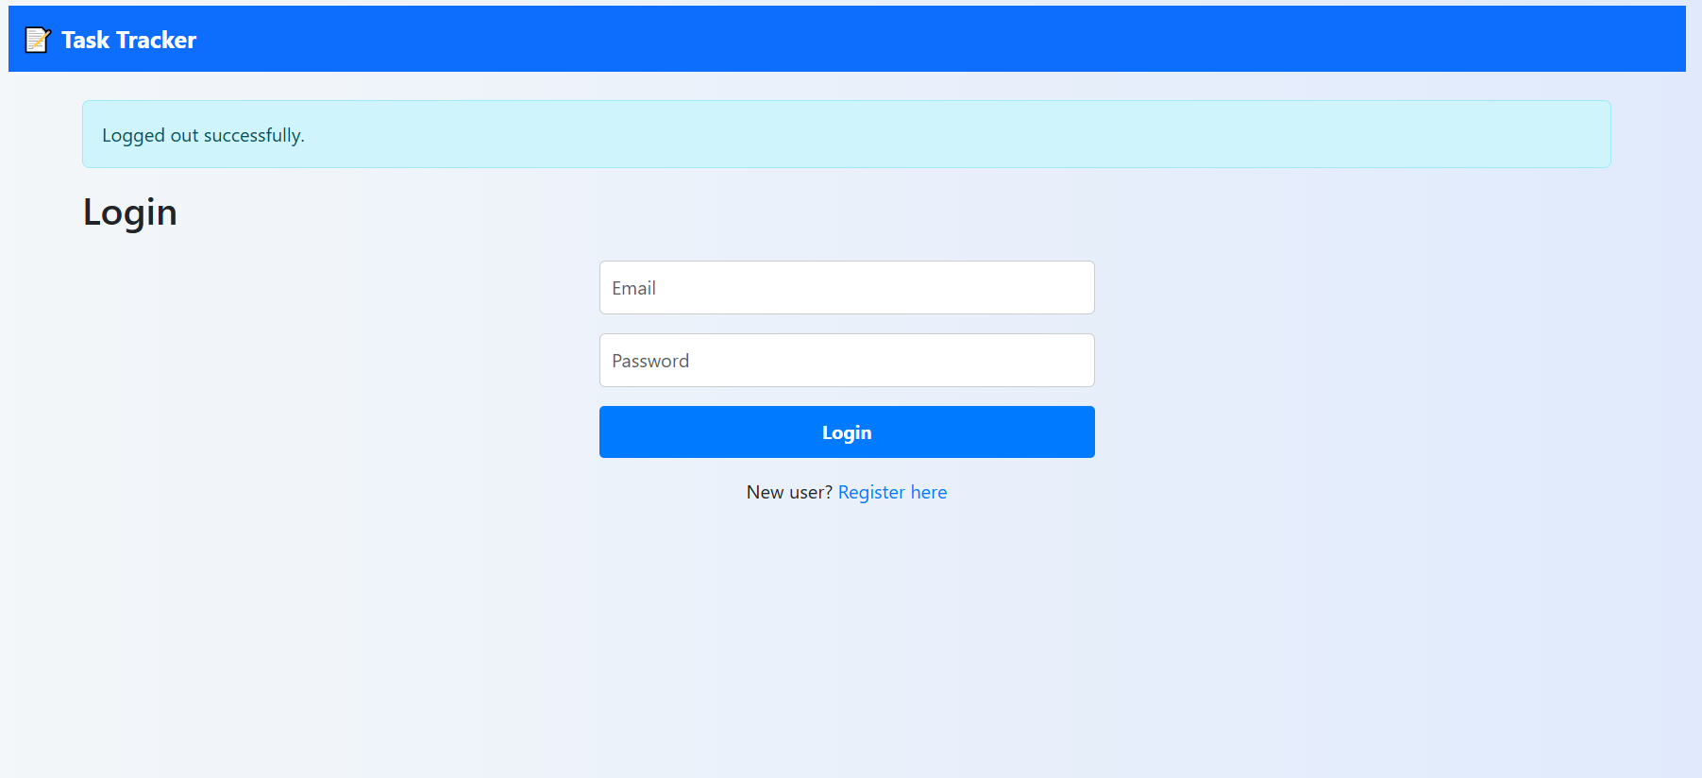

Dashboard 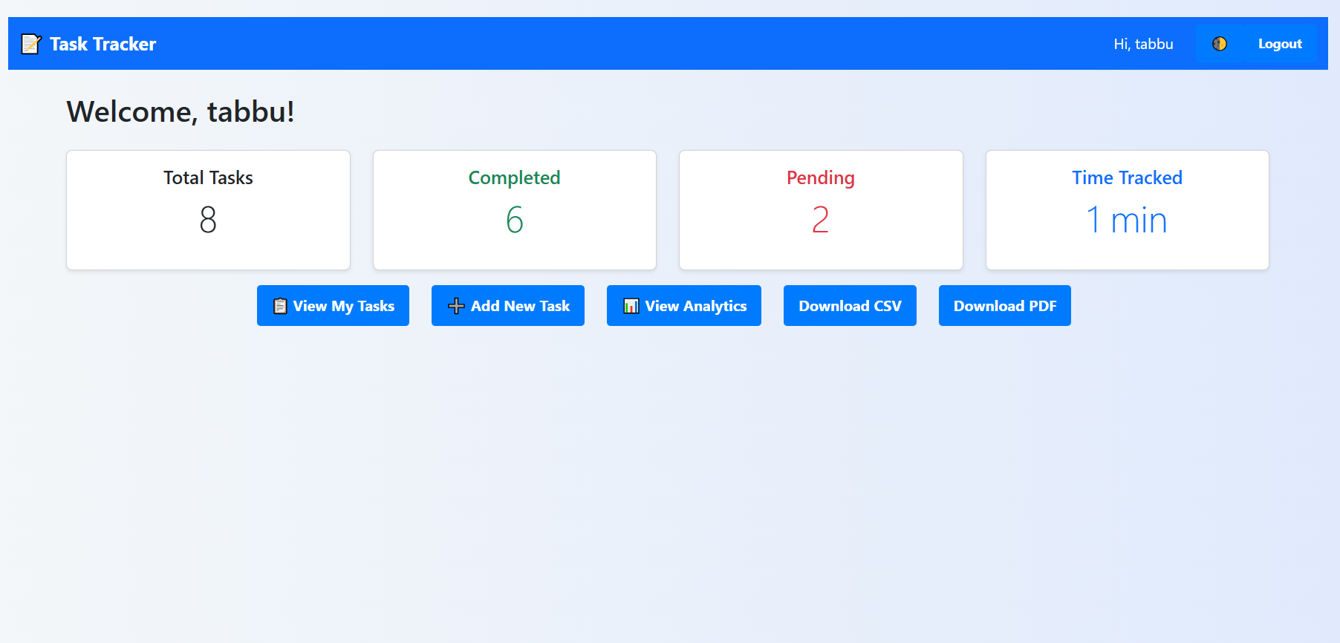

tasks 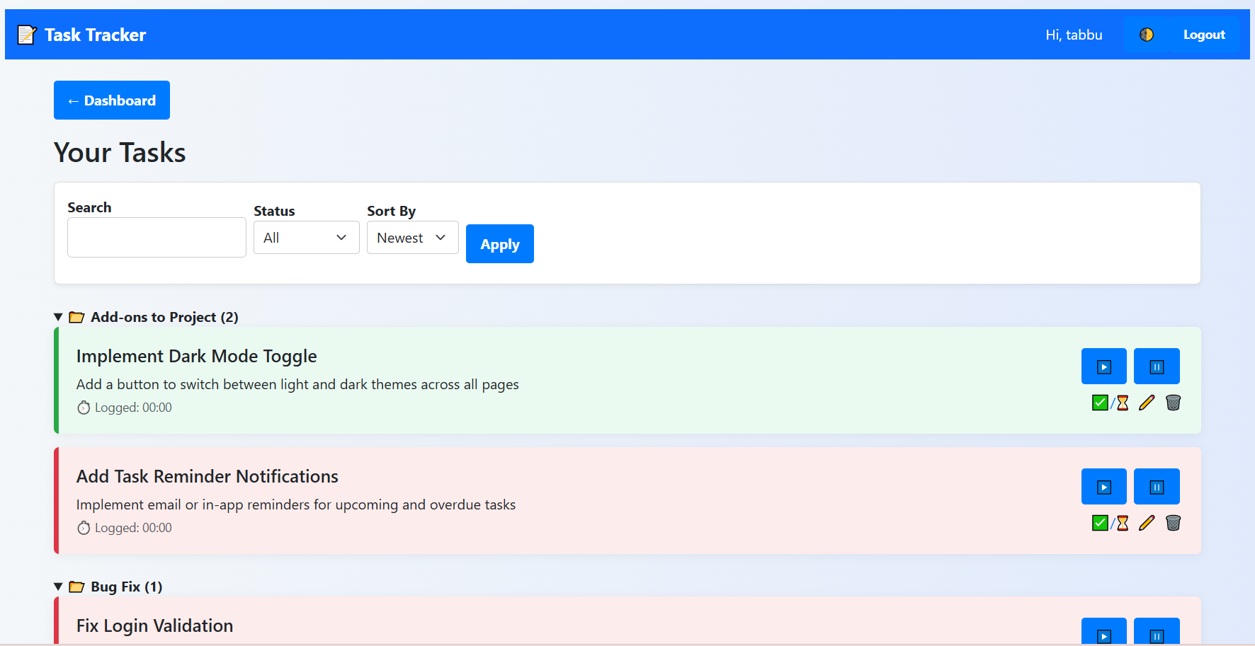 add-tasks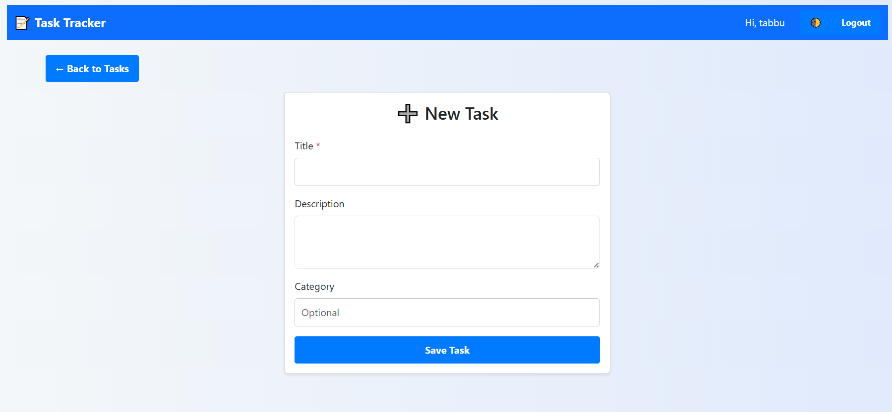

analytics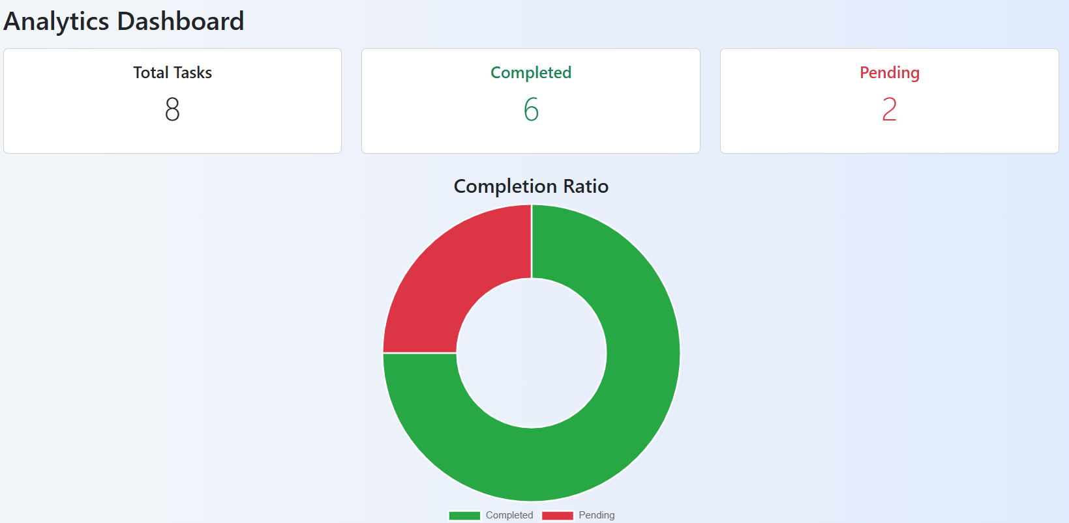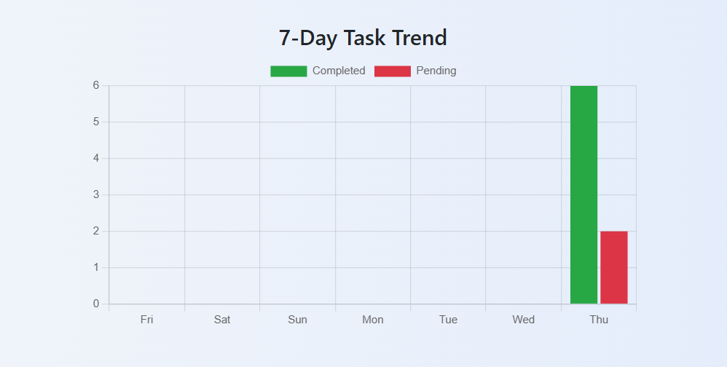

# Challenges & Learnings

- PostgreSQL deployment issues with remote sessions and psycopg2 config  
- Maintaining sync between local SQLite and Render PostgreSQL  
- Debugging login consistency across browsers  
- Learning advanced Flask concepts: application context, sessions, DB migrations

# Improvements & Future Scope

- Role-based UI enhancement (Admin, User, Manager views)  
- Scheduled reminders for due tasks  
- Improved error handling & UI feedback  
- Add notification/email integration for deadlines

# CONCLUSION

This project demonstrates a practical, full-stack web application built using Flask and deployed on Render. It effectively combines task tracking, time logging, and analytics into a single productivity-focused tool. The application not only meets the core requirements of the Flipkart Launchpad Internship but also goes a step further by integrating role-based support and real-time task timers.

By solving real-world problems such as task management and productivity tracking, the project showcases hands-on experience in backend logic, frontend design, and deployment. With room for future enhancements like scheduled reminders and email notifications, this tracker lays a strong foundation for scalable productivity solutions.

# developer info

**Project Title :** Online Task & Productivity Tracker – Web Application  
**Internship Program :** Flipkart Launchpad Internship (Summer 2025)  
**Developed by :** Shaik Zuveriya Tabassum  
**GitHub Repository :** <https://github.com/Zuveriya-Tabassum/task-tracker>  
**Email Id :** tabassumzuveriya@gmail.com