Hello,  
execute these commands one by one:  
commands are lines starting with a '>'  
  
0. if AutoCompile doesn't work as expected, execute make again  
> make clean && make  
  
1. start an M1 (u can stay in current directory where the makefile is)  
> make m1

Then you type ‘vote’ in its command window, it will propose to other members.

> vote  
  
2. start an M2  
> make m2

Then you type ‘vote’ in its command window, it will propose to other members.

> vote  
  
3. start an M3  
> make m3

Then you type ‘vote’ in its command window, it will propose to other members.

> vote  
  
4. Start M4-M9. One command starts these 5 NPC members.

> make m4-9

(Output information of M4-M9 are all shown in one command window. They just make response to incoming messages.)

Explanation:

Every member has a property called disconnectionRate, which means the chance a node goes disconnected. The random variable has nondeterministic value between 0 and 100 in every execution.

This random controls the following branch that program will execute. It can

1. Make no responses and pretend to be offline.
2. Make responses after a small delay of 2s.
3. Make responses after a large delay of 5s.
4. Otherwise, Make immediate responses.

By doing this, it simulates the different situations in real life.

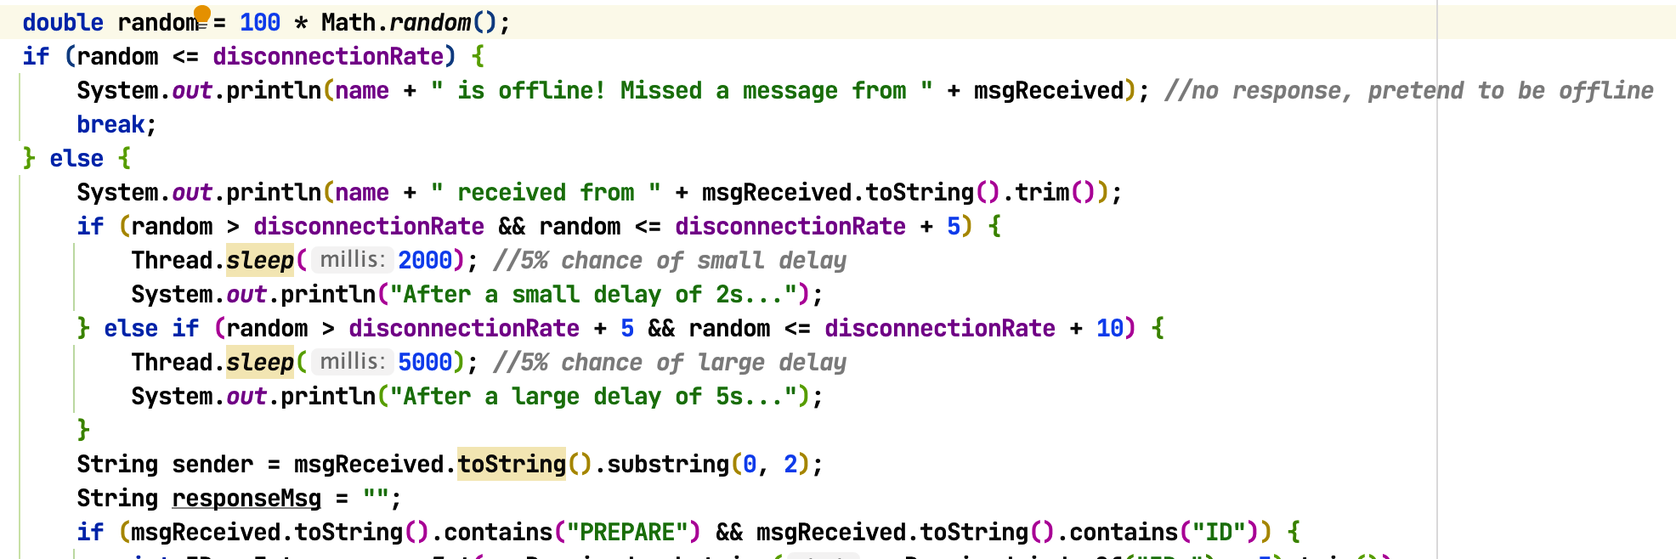

M1.discoonectionRate = 0 ***//0% offline, 100% online***

M2.discoonectionRate = 80 ***//80% offline, 20% online***

M3.discoonectionRate = 20 ***//20% offline, 80% online***

Other members are like NPC, so

M4~M9.discoonectionRate = 5 ***//5% offline, 95% online***