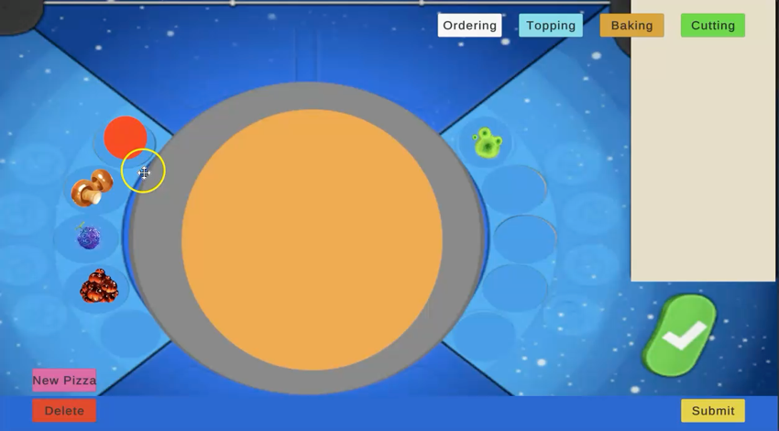
Pepperoni
★★★★★ (654 reviews)
Author: Emily Thomas
$0.10
Version: 1.0

Description: Pepperoni sprite that can be clicked and dragged onto a pizza game object. It can only be placed on certain points of the pizza game object.

Components:
- pepperoni – prefab asset (sprite)
- pepperoni_clone – prefab asset (sprite)
- Topping Controller – script
- Pepperoni - script
Features:
- Pepperoni visual
- Click-drag-place mechanic
- Will not place outside of the pizza game object
- Snap to one of eleven set positions on pizza game object
- Will not place more than eleven pepperonis
Requirements: Unity 6000.3.10f1

