★★★★★ (789 reviews)  Author: Sam Wood  $0.30  Version: 1.0 | 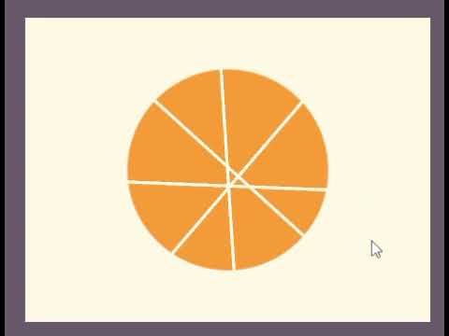

Cutting Manger

Description: Allows to add cuts to a pizza game object. That doesn’t need to go through the center of your object.
Components:
- Cutting Screen Manager - Script
- Cutline - Line Render
- Pizza Cut Color - Script
Features:
- Click-and-drag cutting mechanic
- Accurate line-to-circle intersection (cuts only appear when hitting the pizza)
- Supports multiple cuts on the same object
- Customizable cut colors using dynamic binding
- Ignores UI input to prevent accidental cuts
- Automatically attaches cut lines to the pizza object
Requirements: Unity 6000.3.10f1

