packetatortots.py

Description:
Tool to replay the traffic contained in a set of packet capture files.

Usage:
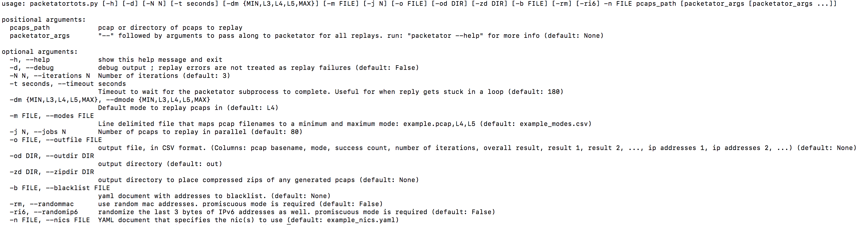
To define which interfaces to use the -n / --nics flag. Use example_nics.yaml as an example for nic configuration. Note. To replay IPv6 traffic, each nic used should have an IPv6 address assigned and the last 3 bytes of the address should be the value of the last_bytes_v6 filed in the nic config yaml.
example_nics.yaml content:
nics: # number of nics needs to equal to 2
- name: "eth2" # name of the interface
subnet: "10.3.0.0/16" # IPv4 subnet in CIDR notation
subnet_v6: "fdda:dead:beef:dab3::1:1/64" # IPv6 subnet in CIDR notation
gateway: "10.3.1.1" # default IPv4 gateway
gateway_v6: "fdda:dead:beef:dab3::1:1" # default IPv6 gateway
last_bytes_v6: 0xcccccc # last bytes of the random ip addresses used ; Needs to match at least the last 3 bytes of an IPv6 address assigned to this interface
- name: "eth3"
subnet: "10.3.0.0/16"
subnet_v6: "fdda:dead:beef:dab3::1:1/64"
gateway: "10.3.1.1"
gateway_v6: "fdda:dead:beef:dab3::1:1"
last_bytes_v6: 0xaaaaaa
To define the number of pcaps to replay in parallel use the -j flag. A good number is 10 * number of cpu cures. This is the default. The tool is cpu intensive so increasing this number won’t make it faster unless if a high timeout is set and if a security device is blocking the majority of the traffic.
It is important that there is no noise on the network (excludes ARP or NDP). If there is noise from other hosts on the network, then a blacklist file should be specified with the -b option.
example_block.yaml content:
---
mac:
- "00:50:56:bb:d6:25"
- "00:50:56:bb:3f:bb"
- "00:50:56:bb:ee:42"
- "00:50:56:bb:19:29"
- "00:50:56:bb:cb:ef"
ipv4:
- "10.3.31.1"
- "10.3.31.6"
- "10.1.31.101"
- "10.1.31.106"
- "10.3.31.101"
- "10.3.31.106"
- "10.1.31.151"
- "10.3.31.151"
- "10.1.31.99"
- "10.3.31.88"
- "10.1.1.100" # watchguard ARPs for this every couple seconds
ipv6:
- "fe80::41a4:babf:14a4:548c"
To define which mode(s) to replay traffic use the -dm flag to define the default mode and the -m flag to define mode ranges for specific pcaps.
For example:
-dm L5 -m example_modes.csv
where the content of modes.txt is:
example1.pcap,MAX
example2.pcap,L4
example3.pcap,MIN,L4
example4.pcap,L4,L5
example5.pcap,L4,L4
In this example:
example1.pcap can run in any mode upto and including mode MAX (= mode L5). So example1.pcap will run in L5 mode.
example2.pcap can run in any mode upto and including mode L4. So example2.pcap will run in L4 mode.
example3.pcap can run in any mode between and including mode MIN (= mode L4) and L4. So example3.pcap will run in L4 mode.
example4.pcap can run in any mode between and including L4 and L5. So example4.pcap will run in L5 mode.
example5.pcap can only run in L4 mode. So example4.pcap will run in L4 mode. And always will even if the default mode is less than L4.
All other pcaps will run in the default mode. So L5 in this example.
All arguments after the pcap directory will be passed to packetator .
Full example usage:
./packetatortots.py -b example_block.yaml -dm L4 -m example_modes.csv -od /tmp/output -j 10 -n example_nics.yaml /tmp/pcap_directory -- -b example_block.yaml -t 3 -w

Notes:
This is really CPU and memory intensive. 8 cores & 8 GB of ram is recommend to run 3 x 2000 pcaps in a reasonable time (~5 minutes, no dut). Use top to monitor load. Adjust number of jobs so that swap space usage is zero and so that CPU usage is maximized. Take note of the optimal number of jobs with and without a DUT.
Pcaps will be saved here:
{directory specified by -od}/{pcap file name}/{iteration number}/{original ip address}_{replayed ip address}.pcap

Recommended Usage:
Use a real high timeout (-t) like 5 minutes / 300 seconds. This timeout is so that a single run doesn’t get stuck and destroy the whole batch run
The ideal number of iterations (-N) is 3. Not all pcaps replay at 100% reliability. Reliability decreases when you introduce a device in and when you replay at max load. To compensate 3 iterations is sufficient. A replay success is defined as a replay success in any of the 3 runs.
The ideal number of jobs (-j) will be between 5*nprocs and 10*nprocs
Use L4 as the default mode (-dm). Anything > L4 doesn’t provide any benefit unless application data modification occurs (either by us or by an inline device).
In general:
- pcaps with fragments should be played in mode: <= L3
- pcaps with SCTP should be played (for now) in mode: <= L3
- pcaps without transport layer protocols should be played in mode: <= L3 (but > L3 would still work)
- pcaps with passive FTP should be played in mode: >= L5
- some application layer DoS exploits should be played in mode: < L5
If any inline device has different 5 tuples on both sides of their UDP/TCP proxies then you must use
the packetator parameter: ‘--ccm FourTuple' otherwise use '--ccm FiveTuple’

Modes:
The available modes are:
MIN, L3, L4, L5, MAX
modes are ordered with the following order:
MIN = L3 < L4 < L5 = MAX
Greater modes will result in a greater difference between the traffic in the capture files and the traffic on the wire. Also, greater modes will be more resilient to changes an inline device might make to the traffic.

MIN
This is defined to be the lowest mode. So as of right now, L3.

L3
This mode uses packet count to determine what and when to replay traffic.
Transport layer data is replayed as-is. Transport layer context is not considered.
IP addresses will be randomized.
Only use this mode when necessary since packet counting is not a good measure of success
If pcap contains fragments, this mode must be used.
See L3.yaml and the descriptions in packetator for specifics.

L4
This mode uses Transport level context to determine what and when to replay traffic.
Application layer data is replayed as-is. Application layer context is not considered.
IP addresses will be randomized.
This mode randomizes client port numbers, corrects acknowledgment numbers, and corrects timestamps.
This mode is resilient to changes a TCP proxy might make to fields such as seq/ack, options, client’s source ports.
This mode is the go-to mode
See L4.yaml and the descriptions in packetator for specifics.

L5
This mode uses Application layer context in addition to some Transport layer context to determine what and when to replay traffic. Only pcaps with UDP:DNS, TCP:HTTP, or TCP:FTP protocols will benefit from this mode.
IP addresses will be randomized.
Application layer data may be altered.
This mode is resilient to changes a DNS proxy might make to fields.
This mode is resilient to changes a HTTP proxy might make such as changes to the headers or normalization of the body.
This mode should only be used if an intermediary device modifies application layer data.
This mode should not be used when replaying pcaps that contain HTTP or DNS DoS exploits that DoS packetator (program may crash or halt forever).
This mode takes a performance hit and should be used on a case by case basis.
If pcap contains passive FTP, this mode should be used to replay correctly
See L5.yaml and the descriptions in packetator for specifics.

MAX
This is defined to be the lowest mode. So as of right now, L5.

