**Lab 5 – Files and Directories**

## Student Name:

## Student ID:

# Task 1: Understanding file functions

1. Paste screenshot of editor showing **shoppingsave.php** code

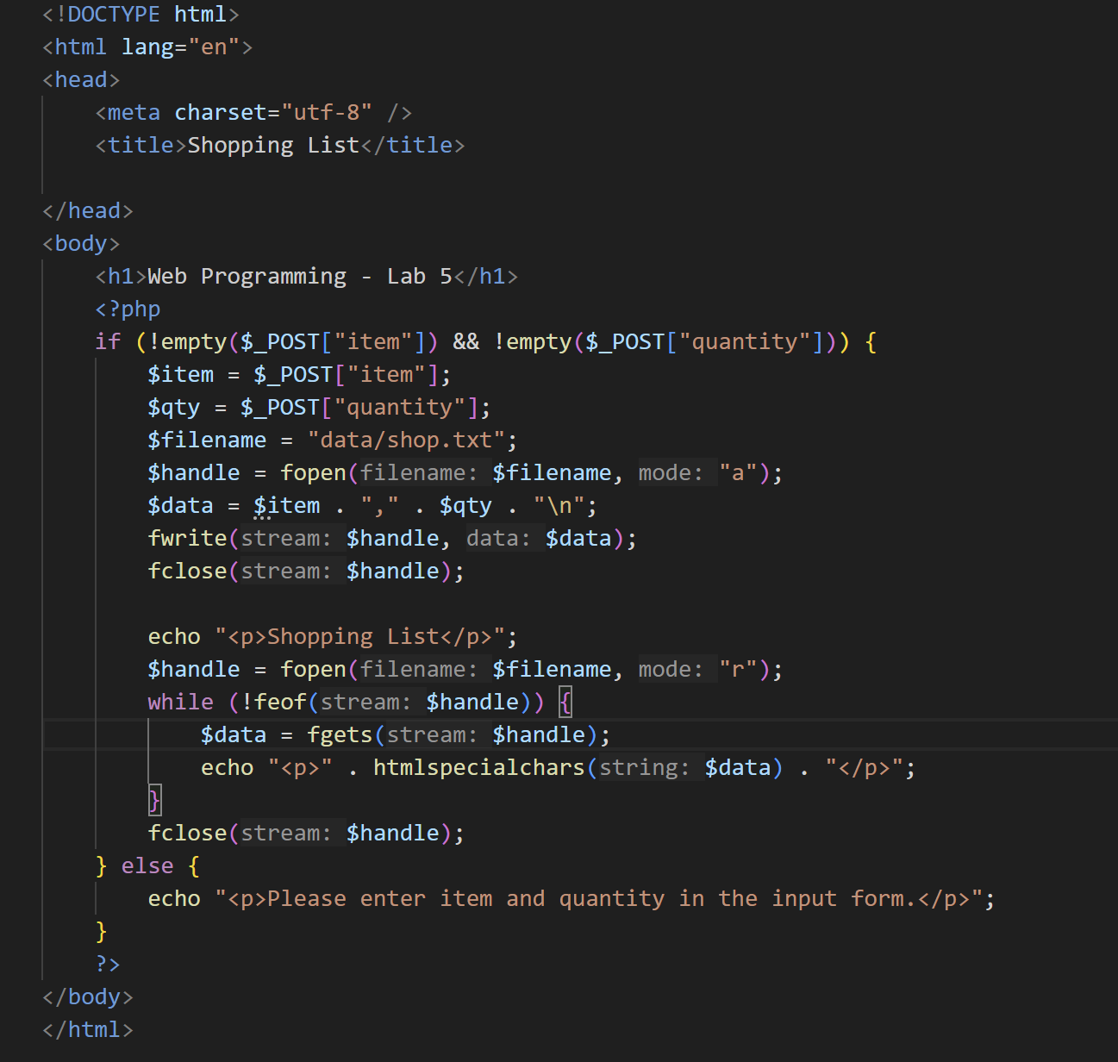

1. Paste screenshot of editor showing **shoppingform.php** code

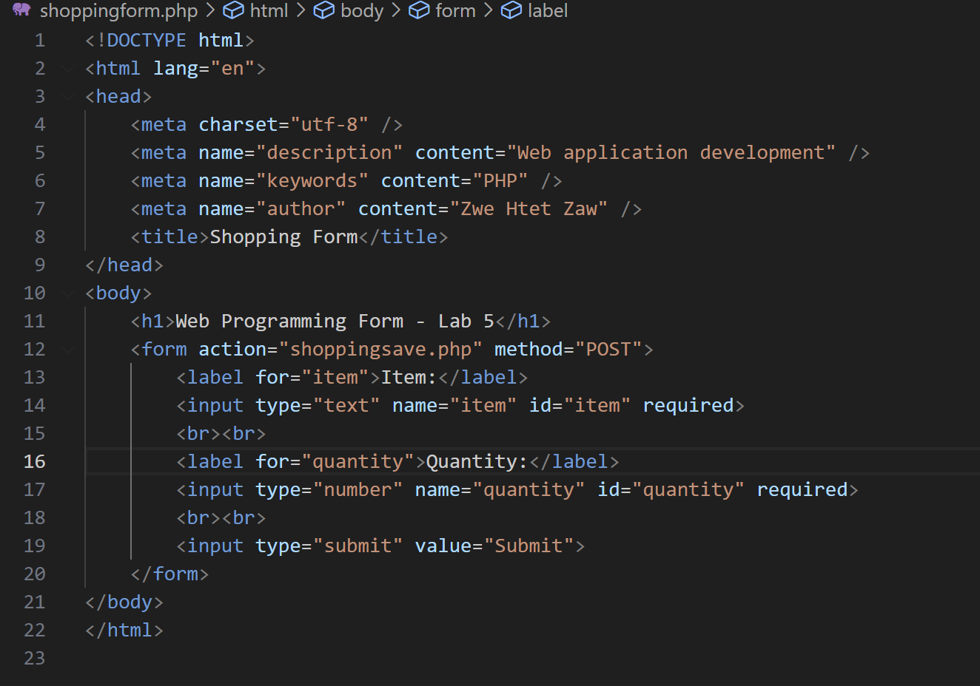

1. Paste screenshot of browser showing **shoppingform.php** page

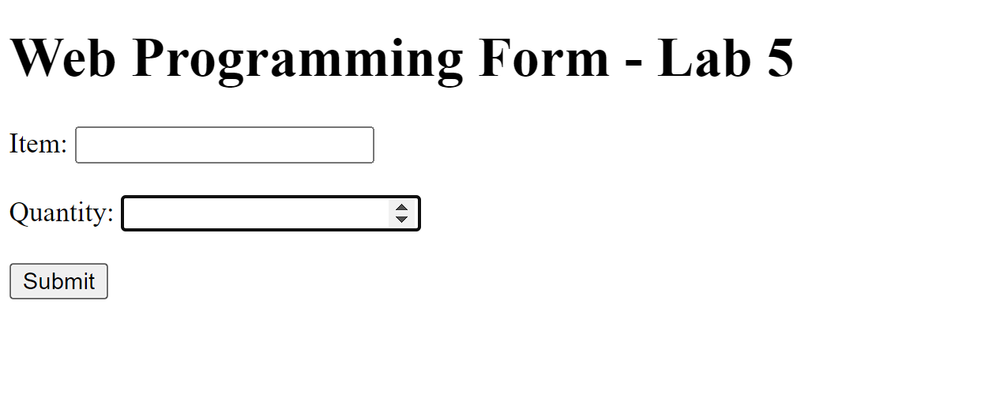

1. Paste screenshot of browser showing **shoppingsave.php** page

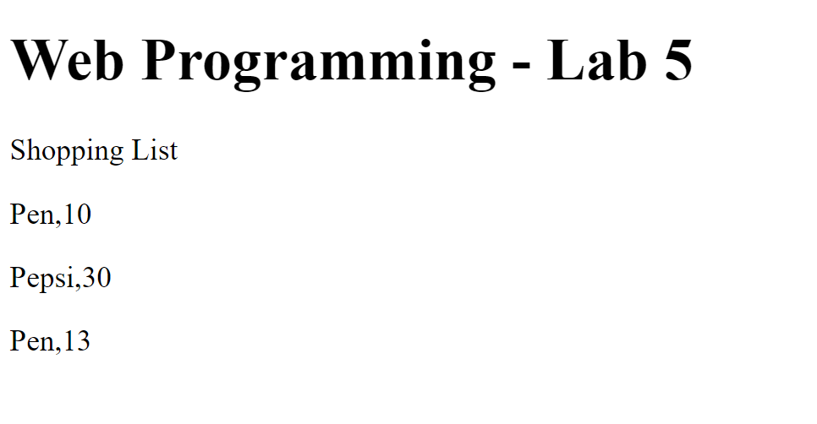

1. Paste screenshot showing **data** folder with **shop.txt** inside

1. Paste screenshot of editor showing **shop.txt** file contents

**Task 2: Creating a Guest Book**

1. Paste screenshot of editor showing **guestbookform.php** code

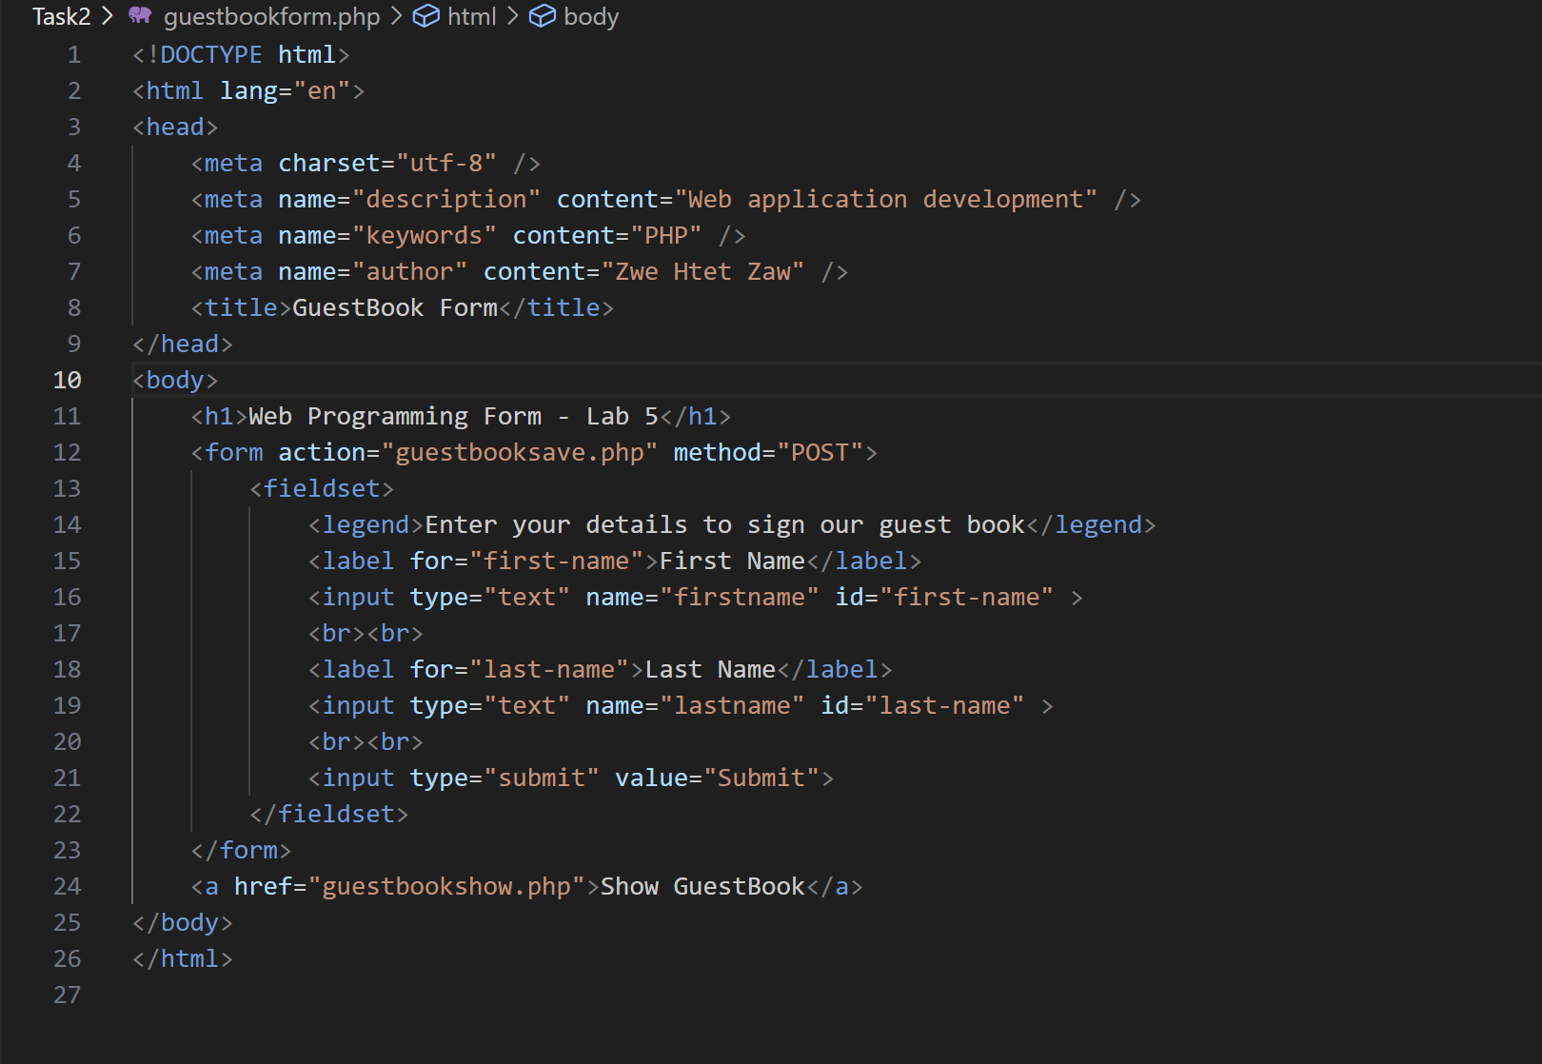

1. Paste screenshot of editor showing **guestbooksave.php** code

1. Paste screenshot of the pop-up alert message box

1. Paste screenshot of editor showing **guestbookshow.php** code

1. Paste screenshot of browser showing **guestbookform.php** page

1. Paste screenshot of browser showing **guestbooksave.php** page (successful)

1. Paste screenshot of browser showing **guestbookshow.php** page

1. Paste screenshot showing **data** folder with **guestbook.txt** inside

1. Paste screenshot of editor showing **guestbook.txt** file contents

